Financial News Sentiment and Stock Returns
  - A practical study of online financial news, company-level assessments and stock returns | 7 October 2026

What the study does and what it finds
This study follows one chain from news to returns. GDELT, a global index of online-news records, supplies article links and recorded dates. ReFinED, an entity-linking model, connects names in each article to companies. Jev, TypeSafe's language model, assigns a financial-sentiment category for each linked company. The project then combines these assessments by company and recorded date, matches them to adjusted stock returns and estimates before- and after-date associations.

Study process map
Stage | Method | Output
1. Collect news | GDELT records and saved pages | Distinct articles and recorded dates
2. Link companies | ReFinED plus explicit exchange-symbol fallback | Article-company pairs
3. Assess sentiment | Jev categories for each linked company | POSITIVE, NEGATIVE, MIX or NONE
4. Build daily measures | Pool completed assessments by company and date | Positive and negative shares
5. Match prices | Adjust stock returns for market and sector movement | Before- and after-date returns
6. Estimate and test | Regression plus recap sensitivity check | Fitted differences and uncertainty

Analysis population
Stage | Unit | Count | Why the count changes
Collected | Article | 239,233 | Starting set of distinct saved GDELT bodies
Company linked | Article | 202,518 | Only articles with at least one registry-company match
Linked | Article-company pair | 520,357 | One article can concern several companies
Completed | Sentiment assessment | 518,041 | 2,316 linked pairs have failed requests
Main analysis | Company-date | 78,215 | Pool by company and date, then apply page, price, control and eligibility checks

The research question is whether company-specific financial-news sentiment mainly reflects price moves that occurred before the recorded article date or also relates to returns after that date. The original assignment asked for a 2026 analysis. This report adds 2023–25 and the full period to test whether the recent pattern also appears over a longer record.
The price analysis contains 78,215 company-date observations for 487 companies from 16 June 2023 through 18 June 2026. In the full period, the fitted differences are much larger before the recorded article date: POSITIVE is +0.647 percentage points and NEGATIVE is −0.700 percentage points for the prior seven-day return. For the following seven days, the fitted differences are only +0.022 and +0.035 percentage points.
The 2026 following-week estimates are larger, at +0.254 for POSITIVE and +0.468 for NEGATIVE. Looking only at 2026 therefore gives a much stronger impression of later-return information than the longer record supports. The 2026 estimates are exploratory because their uncertainty is based on only seven 28-day time blocks and is wide. The coefficients compare POSITIVE or NEGATIVE with MIX after accounting for the other sentiment share, earlier price behavior, earlier news volume, company differences and conditions shared on each date.
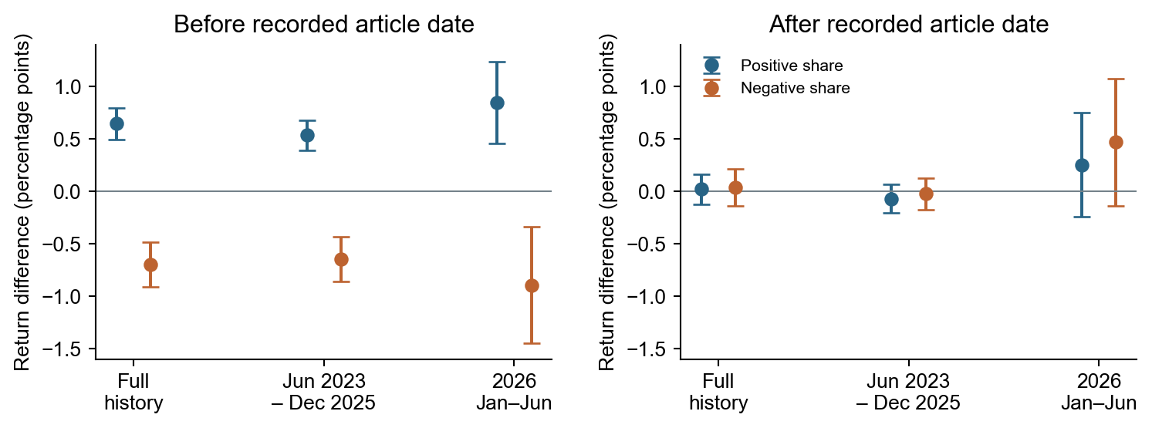
Figure 1. Estimated return differences associated with POSITIVE and NEGATIVE sentiment shares. A value of +0.50 means a fitted difference of half a percentage point for a complete change in the relevant share from 0 to 1, with MIX as the comparison category. A 10-percentage-point share change corresponds to one tenth of the displayed coefficient. Dots show estimates; lines show 95% confidence intervals based on 40, 34 and seven 28-day time blocks for the full period, 2023–25 and 2026. What to notice: the before-date estimates have much larger magnitudes, while the 2026 after-date intervals are especially wide.

1. Data foundation: where the articles came from and what is missing
GDELT is a global index of online news records. The collection searched selected publishers through GDELT's Global Knowledge Graph files and BigQuery tables. Company names and aliases were matched in GDELT organization and name fields. The saved URL was then used to extract the article headline, body, source and GDELT date.
The collection contains 239,233 distinct saved article bodies from 21 source domains. It covers 1 January 2023 through 18 June 2026. Duplicate copies were identified from cleaned body text so that the same saved body was counted once. If later copies linked the same body to additional companies, those links were added to the retained article record.
After collection, the date coverage was checked for gaps. GDELT's published source-file list and its BigQuery Global Knowledge Graph tables contain no records from 15 June through 1 July 2025. The report treats that interval as missing GDELT coverage and excludes observations whose article dates, earlier-news controls or later-return periods overlap it. The affected earlier-news controls and analysis windows were rebuilt after this exclusion.
June 2026 is also incomplete because the saved news ends on 18 June. Source coverage is concentrated: Forbes and Benzinga together supply 52.28% of the articles, and the ten most frequently linked companies account for about 41.5% of all article-company links. The results therefore describe this collected set of publishers and companies.
The saved body lengths range from 44 to 39,301 words. The lower quarter ends at 378 words, the median is 613 and the upper quarter begins at 907. Figure 2 uses a logarithmic horizontal scale because article lengths span almost three orders of magnitude. Equal horizontal distances represent equal ratios, such as 100 to 1,000 and 1,000 to 10,000 words. Each bar is the percentage of articles within one logarithmically spaced range.
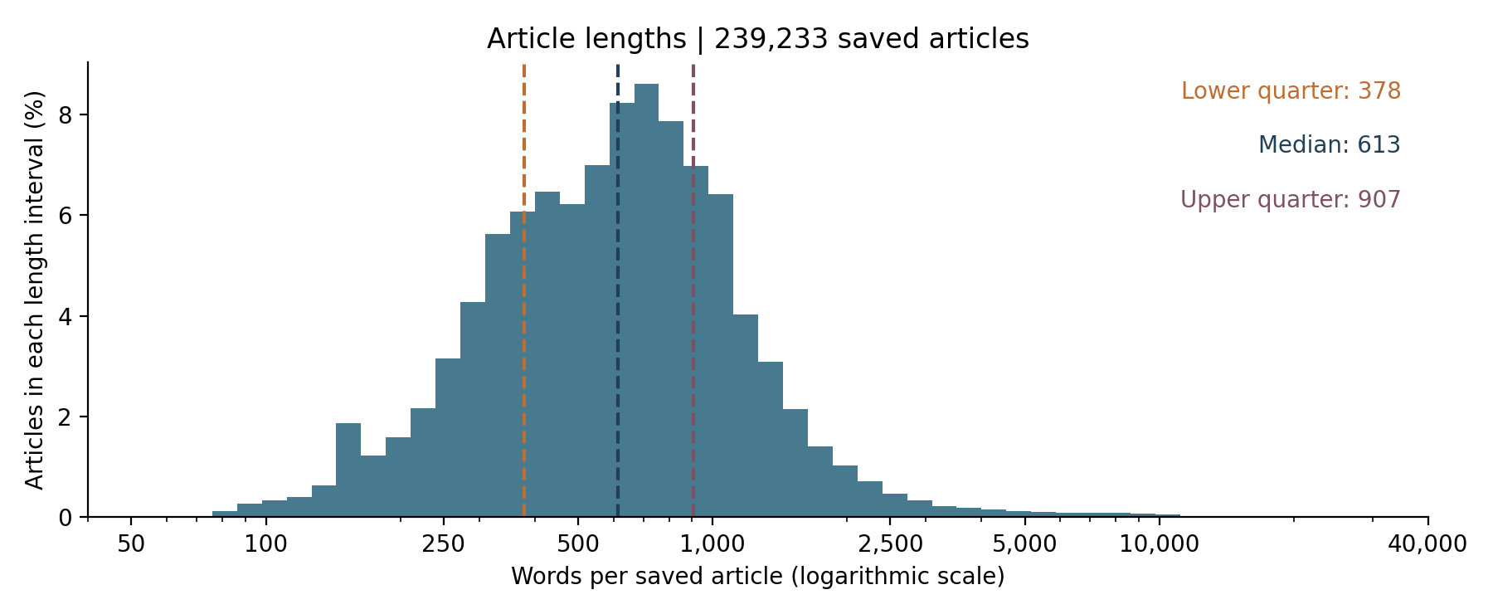
Figure 2. Saved-body word counts for all 239,233 GDELT articles. The observed range is 44–39,301 words; the lower quarter is 378, the median is 613 and the upper quarter is 907. The horizontal axis is logarithmic, and each bar shows the percentage of articles in one logarithmically spaced word-count range. What to notice: the logarithmic scale keeps the small group of very long articles visible without compressing most articles into the left edge.

2. Measurement: how articles were linked to companies and assessed
The company registry contains 503 traded securities representing 500 companies. It includes the company name, current and former stock symbols and Wikipedia identities. Companies with more than one listed share type are combined under one company identity for article linking and sentiment assessment.
ReFinED performs the first company-linking stage. The project used its pretrained AIDA model with the Wikipedia entity set. For each complete headline and body, ReFinED detects candidate name spans and assigns a Wikipedia entity to each span. The saved result includes the matched text, character positions, Wikipedia title, Wikidata identifier and linking confidence. The project normalizes the returned Wikipedia title, matches it to the fixed company registry and consolidates repeated mentions into one article-company pair. A ticker-like text span is not accepted through this name-linking route.
If ReFinED finds no company from the registry in an article, a second rule searches the same headline and body for an explicit exchange-and-symbol form, such as NASDAQ:TSLA. The symbol must match the same registry. This fallback added 5,641 article-company pairs in 5,468 articles. Together, the two stages linked 202,518 articles to 498 companies and produced 520,357 distinct article-company pairs. Another 36,715 articles had no match to the registry.
Jev performs the sentiment stage after company linking. The request places the complete saved headline and body in the API state. It then creates one choice question for each linked company, identified by its standard name and stock symbols. Several company questions from the same article are sent together, but Jev returns a separate answer for each company. The saved instructions ask Jev to decide the overall financial sentiment toward the target company from the complete article and headline. They tell it to weigh context rather than count statements, keep stated conditions, avoid invented financial consequences, decide which facts concern the target company and identify who is speaking.
Each saved answer contains one selected category, four category probabilities that sum to one and a separate confidence field derived from the highest category probability. The saved-run validator confirms the Jev version, the expected company questions, valid values from 0 to 1 and a selected category with the highest probability. The production run used Jev 1.13.0, one attempt per article and no additional training. The return analysis uses only the selected category; it does not use the category probabilities or confidence field.
The four requested categories have distinct meanings. POSITIVE means that favorable financial evidence for the company or its investors predominates. NEGATIVE means unfavorable evidence predominates. MIX means that substantial favorable and unfavorable evidence are both present without either clearly dominating. NONE means that the article provides no supported directional financial assessment of that company; a neutral fact, background description or mention alone is not enough.
Jev completed 518,041 article-company assessments in 201,758 articles. It returned POSITIVE for 149,538 pairs, NEGATIVE for 72,961, MIX for 20,889 and NONE for 274,653. Another 2,316 expected pairs are missing across 760 articles with failed requests. A failed request is not treated as NONE.
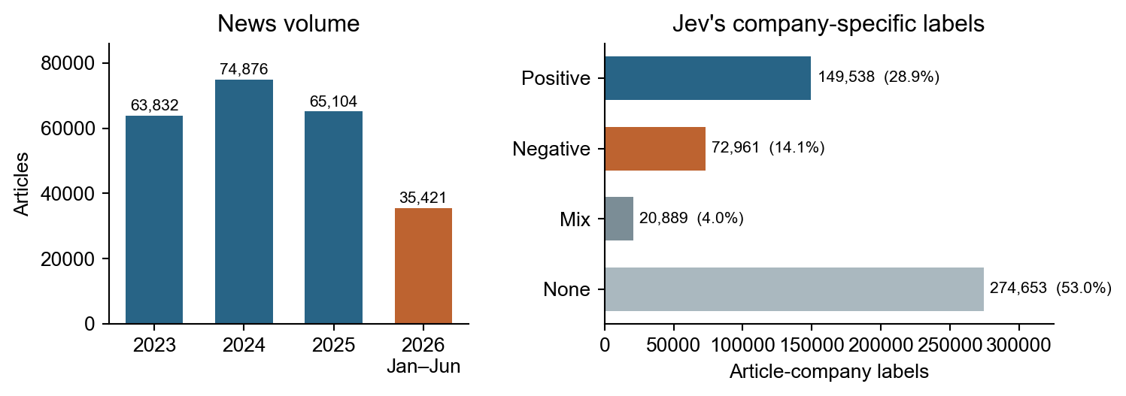
Figure 3. Saved news volume by period and Jev company-specific sentiment labels. The left panel counts distinct saved articles in each year; 2026 covers January through June. The right panel shows the category distribution across 518,041 completed article-company assessments. The 2,316 missing pairs from failed requests are excluded from the category percentages. What to notice: saved article volume is broadly similar across the three complete years, while NONE forms 53.0% of completed company assessments.

How the saved probabilities compare
The selected categories drive the main analysis, but the saved probabilities provide a separate view of how Jev distributed support across the four choices. The next two figures compare all 518,041 completed assessments with the 76,325 assessments dated in 2026. The full-period group includes the 2026 assessments. These are descriptive summaries of Jev outputs; they are not probabilities that a stock will rise or fall and they are not used as regression weights.
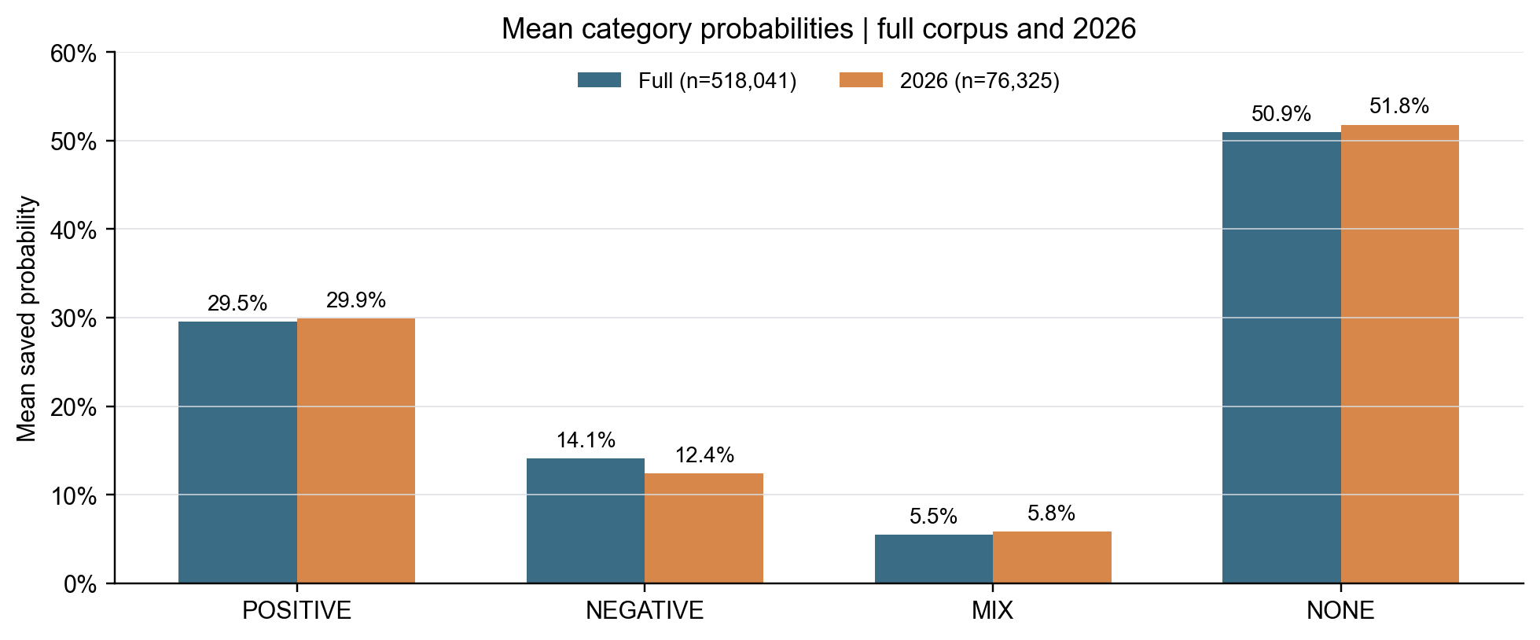
Figure 4. Mean saved probabilities for POSITIVE, NEGATIVE, MIX and NONE across all 518,041 completed article-company assessments and the 76,325 assessments dated in 2026. The four means within each period sum to approximately 100%, subject to saved two-decimal rounding. What to notice: the 2026 profile is close to the full-period profile, with a lower mean NEGATIVE probability and a slightly higher mean NONE probability.
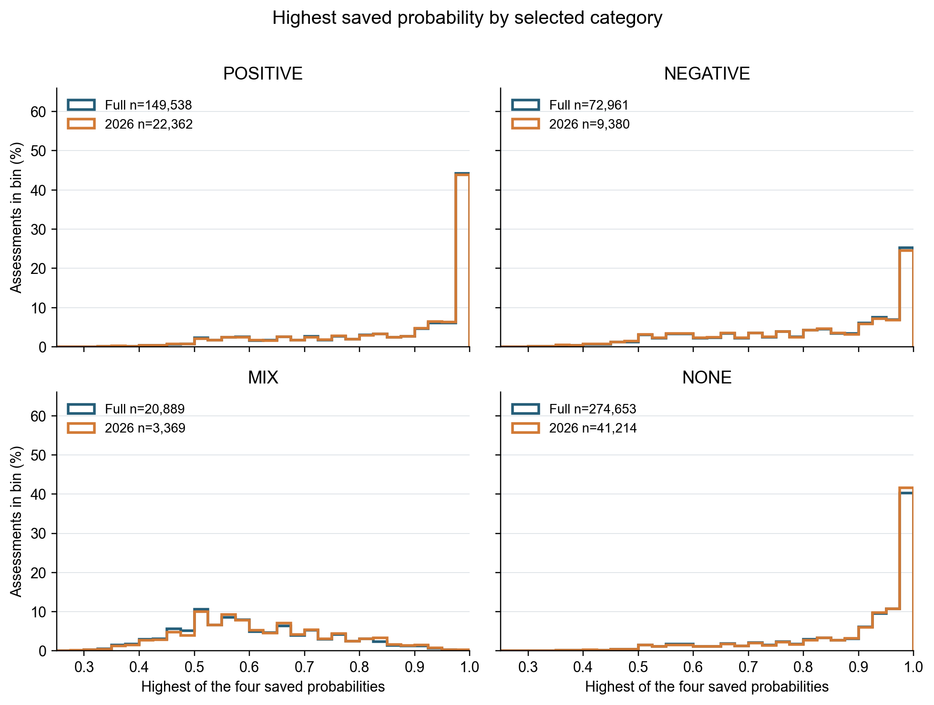
Figure 5. Distribution of the highest of the four saved category probabilities, grouped by the selected category. Each line shows the percentage of assessments in a probability interval for the full period and 2026. The full-period group includes 2026. The selected category shares the maximum saved probability in 545 rounded ties. What to notice: many assessments have a highest saved probability near 1.0, and the 2026 distributions closely follow the full-period distributions.

3. Measurement validation: how the two assessment steps were checked
Company linking and sentiment were evaluated separately. For company linking, 100 articles had human reference links to the companies mentioned in each article. ReFinED alone found 260 correct links, added seven links not in the references and missed 54 reference links. Precision was 97.4%, meaning that almost all returned links matched the references. Recall was 82.8%, meaning that it recovered about five sixths of the reference links. This check did not include the exchange-and-symbol fallback.
For sentiment, an earlier development set contained 50 articles and 264 supplied company targets. Reference categories were available for 237 targets; 27 targets without a reference were excluded from scoring. The initial categories were model annotations. A human then reviewed, corrected and approved them manually.
Jev matched the single preferred category in 210 of 237 cases, or 88.6%. It matched 221 of 237, or 93.2%, when alternatives documented before the Jev run were also accepted. The four-category macro F1 score was 84.0%, which gives each category equal weight. Figure 6 shows the separate POSITIVE and NEGATIVE results. POSITIVE precision was 96.25% and recall was 83.70%; NEGATIVE precision was 90.00% and recall was 75.00%.
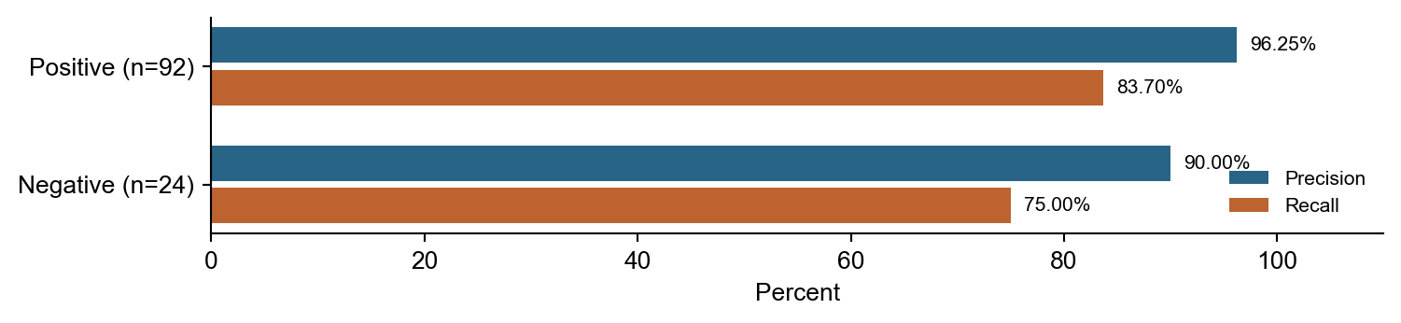
Figure 6. Jev precision and recall for POSITIVE and NEGATIVE in the earlier 237-pair development check. Values are percentages of returned or reference labels, respectively. The reference set contains 92 POSITIVE and 24 NEGATIVE pairs, and the scores use the single preferred category. What to notice: precision is higher than recall for both categories, so the check found fewer unsupported directional labels than missed directional labels.
This check addresses a separate methodological question: does sentence-by-sentence assessment lose information that Jev can use from the complete document? It used PerSenT, a published dataset about an author's attitude toward a named person. PerSenT tests the value of broader context in a different domain; it does not test financial-company sentiment. Both approaches used Jev 1.13.0, and the sentence-combination rule was fixed before the comparison.
The comparison used 568 documents with results from both methods. The complete-text method scored 0.429 on macro F1 and 0.467 on accuracy. The sentence method scored 0.441 on macro F1 and 0.447 on accuracy. The macro F1 difference, complete text minus sentences, was −0.0116, with a 95% paired-resampling interval of [−0.0564, +0.0318]. The check therefore did not show a clear advantage for either input method.

4. Main analysis: how news assessments were compared with returns
After the measurement checks, the main analysis asks how company-date sentiment relates to stock returns. Before article categories are combined, a page check compares the saved publisher domain and extracted date with the GDELT record. It removes pages from another domain, pages without an extracted date, pages dated after the GDELT record or more than seven days before it, generic or replaced titles, shopping pages and detected live updates. A page can pass if its extracted date is a few days earlier than the GDELT date. Passing means that the saved page is consistent with the source record.

What the main regression compares
Part | Definition
Outcome | Market- and sector-adjusted stock return for D−7 to D−1 or D+1 to D+7
Sentiment variables | Positive and negative shares enter together; MIX is the comparison category
Controls | Earlier price direction, recent price variation and earlier-news volume
Group adjustments | Separate company and recorded-date constants
Row weight | Each eligible company-date has equal weight
Uncertainty | Related observations within companies and within fixed 28-day time blocks, with a limited-group correction

Variable guide
Term | Window | Meaning
D | Recorded article date | Date used to anchor news and return periods
Earlier news | D−14 to D−8 | Recent volume before both the before-date return and current sentiment date
Before-date return | D−7 to D−1 | Adjusted return before the recorded article date
After-date return | D+1 to D+7 | Adjusted return after the recorded article date
Sentiment shares | On D | POSITIVE or NEGATIVE count divided by POSITIVE + NEGATIVE + MIX
Recap screen | Complete article body | Rule-based check for prominent reports of past price moves without a detected business event

Building the daily sentiment measures
For each company and recorded date, every completed assessment that passes the page check counts once. The positive share is POSITIVE divided by POSITIVE + NEGATIVE + MIX. The negative share uses the same denominator. NONE is excluded because it has no direction. The main return regression includes the positive and negative shares together, with MIX as their comparison category.
The earlier-news control measures recent news attention before the return and sentiment periods. For a recorded article date D, it counts all completed and page-checked assessments, including NONE, from D−14 through D−8. This seven-day block ends immediately before the before-date return period, D−7 through D−1. The regression uses log(1 + count), which limits the influence of unusually large counts. This control helps distinguish a date's mix of sentiment from a company that was already receiving unusually high news attention.

Which company-dates enter the comparison
A company-date enters the shared analysis only after several checks. First, it needs at least one POSITIVE, NEGATIVE or MIX assessment, because NONE alone cannot define the positive and negative shares. Second, the D−14 through D−8 news count must be available, so the earlier-news control is measured in the same way for every row. Third, the stock needs enough earlier price history to estimate its normal relationship with the wider market and its sector. Fourth, the date needs enough other covered companies for comparison: at least 20 other companies for the market benchmark and at least three other companies from the same sector. Fifth, valid returns are required for the seven days before the recorded article date and for 7, 14 and 30 days after it. Seven days is the primary horizon shown in this report. The broader shared cohort also requires the 14- and 30-day outcomes because the saved analysis was designed to compare several horizons from the same starting population. Finally, company or date groups with only one remaining row are removed because a single row cannot support a within-group comparison.
After these checks, 78,215 company-dates remain, covering 487 companies and 1,067 dates. The GDELT gap affects this sample: it contains no article dates from 15 June through 1 July 2025 and excludes rows whose earlier-news or later-return windows overlap the gap.

How the return periods are measured
The before and after periods each span seven calendar days and exclude the recorded article date. The before period runs from D−7 through D−1. The after period runs from D+1 through D+7. A return starts at the first market opening price inside the period and ends at the last market closing price inside it. Weekends and market holidays therefore change the number of trading sessions in a seven-calendar-day period.
The project downloaded daily prices from Yahoo Finance on 30 September 2026 with yfinance 1.2.1. The saved file contains 471,981 daily rows for 497 of 498 requested securities; SATS was not retrieved. Price history runs from 1 December 2022 through 30 September 2026. The download used automatic price adjustment and price repair and did not request separate corporate-action records (auto_adjust=True, repair=True, actions=False).
Yahoo's adjusted-close divided by close was applied to each day's open, high, low and close. The simple period return is the last adjusted close divided by the first adjusted open, minus one. Split and dividend adjustments therefore follow Yahoo's conventions. The project did not reconstruct corporate actions independently or add dividends separately. After time-zone information was removed, article dates were aligned with New York Stock Exchange trading days.
For companies with more than one traded share type, the analysis uses one available security rather than an average: GOOG for Alphabet, FOX for Fox, NWS for News Corporation and BRK.B for Berkshire Hathaway.

How market and sector movements are removed
The adjustment estimates the part of each stock's return that would normally be associated with broad market and sector moves. It uses four steps.

Step 1 — Build comparison groups
For each day, the project calculates an equal-weight market return from the other available companies and an equal-weight sector return from the other available companies in the same sector. The company being assessed is excluded. Every comparison stock has the same influence, regardless of company size. The historical comparison groups require at least 100 market peers and five sector peers.

Step 2 — Estimate normal price relationships
The estimation uses up to 250 earlier trading days, requires at least 100 usable observations and stops 30 trading days before the return period begins. The 30-day separation prevents prices close to the article period from determining the normal relationship. The sector return is first separated from the part that moves with the wider market. A historical regression then estimates how strongly the company's stock moved with the market and with the remaining sector-specific movement.

Step 3 — Calculate the expected return
The two historical relationships are applied to the market and sector returns observed during the study period. This gives the part of the stock's movement that its earlier behavior would lead us to expect from broad market and sector moves. The daily expected contributions omit the regression's constant term and are compounded across the period.

Step 4 — Calculate the adjusted return
The reported adjusted return is the stock's actual simple period return minus the compounded expected return. It is not created by subtracting expected movement from every daily return and then compounding those daily differences.
These comparison groups use the stocks available in this project. They are not standard market indexes that give larger companies more weight. The project did not test a different index.

Other controls and interpretation
The regression also accounts for recent price direction and variation. Recent direction is the compounded closing-price return over the 21 trading days immediately before the prior seven-day period. Recent variation is the standard deviation of 60 daily returns ending at the same point. These two price controls and the earlier-news control are identical in the before and after regressions.
The regression includes a separate constant adjustment for each company and each recorded date. The company adjustments remove persistent differences between companies, such as a stock's usual volatility or coverage level. The date adjustments remove conditions shared by companies on the same date. Every company-date receives equal weight.
The displayed coefficient represents a complete change in one sentiment share from zero to one while the other sentiment share and all controls stay fixed. Because POSITIVE, NEGATIVE and MIX shares sum to one, MIX is the omitted comparison category. For example, replacing one of ten MIX assessments with POSITIVE changes the positive share by 0.1, so the fitted return difference is one tenth of the displayed POSITIVE coefficient.
The 95% confidence intervals allow observations from the same company and the same fixed 28-day time block to move together. The calculation combines both sources of uncertainty and removes their overlap. A small number of groups can make an interval too narrow, so the method applies a limited-group correction. Its cutoff uses one fewer group than the smaller group count. This number is called the degrees of freedom: 39 for the full record, 33 for 2023–25 and six for 2026. The cutoff comes from a statistical reference distribution that describes how much estimates can vary when only that many independent groups are available. With only seven time blocks, the 2026 uncertainty estimates are exploratory.

Sample sizes and uncertainty
Period | Rows | Companies | Dates | 28-day blocks | Degrees of freedom
Full | 78,215 | 487 | 1,067 | 40 | 39
2023–25 | 65,742 | 483 | 898 | 34 | 33
2026 | 12,433 | 433 | 169 | 7 | 6

Separate-period removal of stand-alone rows makes the earlier and 2026 fit counts differ from the pooled cohort split of 65,745 and 12,470 rows.

Following-window estimates and 95% confidence intervals
Period / screen | POS: estimate [95% CI] | NEG: estimate [95% CI]
Full / all | +0.022 [-0.121, +0.165] | +0.035 [-0.141, +0.212]
Full / recap excluded | +0.002 [-0.139, +0.143] | +0.018 [-0.157, +0.193]
2023–25 / all | -0.070 [-0.207, +0.067] | -0.024 [-0.173, +0.126]
2023–25 / recap excluded | -0.076 [-0.212, +0.060] | -0.034 [-0.177, +0.108]
2026 / all | +0.254 [-0.241, +0.749] | +0.468 [-0.138, +1.074]
2026 / recap excluded | +0.175 [-0.348, +0.697] | +0.425 [-0.267, +1.116]

Units are percentage points for a 0-to-1 share change. POS and NEG are conditional on MIX; the 2026 intervals use seven 28-day time blocks.
The simple group summaries answer a different question from the regression. In 2026, the adjusted following-seven-day return averages +0.205 percentage points for 6,406 company-dates with POSITIVE but no NEGATIVE or MIX assessment. It averages +0.029 points for 2,258 dates with NEGATIVE but no POSITIVE or MIX assessment. The corresponding medians are −0.001 and −0.013 points. These summaries do not account for the controls, company differences or date-wide conditions.
After those factors are included, the full-period POSITIVE and NEGATIVE differences for the following week are +0.022 and +0.035 percentage points, compared with +0.254 and +0.468 in 2026. A positive following-week coefficient for NEGATIVE means that, conditional on the other variables, a greater NEGATIVE share relative to MIX is associated with a slightly higher adjusted return in the fitted sample. It does not mean that negative news is favorable, caused a price increase or provides a tested prediction.

5. Sensitivity analysis: could reports of past price moves explain the result?

The result from the price comparison
The fitted relationship is much stronger before the recorded article date than after it. Across the full period, POSITIVE sentiment is associated with a +0.647 percentage-point difference in the preceding seven-day return, while NEGATIVE sentiment is associated with −0.700 points. The corresponding following-week differences are +0.022 and +0.035 points. This pattern is consistent with many articles describing price changes or business developments that the market had already processed.

Why the article content is checked
Article content can explain part of the before-date pattern. If a POSITIVE article says that a stock already rose, or a NEGATIVE article says that it already fell, the sentiment assessment can describe a move that has already occurred. The content check asks whether the result depends on articles that prominently report a past price move without also naming a business event. It therefore tests one explanation for the before-date association while leaving the saved price returns unchanged.

How the article-content check works
Fixed text rules search each complete saved body for the assessed company's name or stock symbol. Around each match, they inspect up to 80 characters before and 400 characters after it without crossing a sentence boundary. A past price move is prominent when a relevant headline contains a cue such as “why,” “stock” or “shares,” or when the phrase appears near either of the first two body mentions of the company. The rules link each phrase to the assessed company and exclude statements about future moves.
The same search detects business events by combining event verbs with terms such as earnings, revenue, guidance, products or contracts. A prominent past price move without a detected event is marked as a recap. An article with both a price move and an event is retained, an event without a price move is marked as event related and other cases remain unclear. Removing one company's assessment does not remove other company assessments from the same article. These rules cannot capture the full meaning of every article.

What changes after recap assessments are removed
The sensitivity check removes 8,847 article-company assessments marked as recaps, then recalculates the sentiment shares. Price returns and all other model inputs remain unchanged. A total of 939 company-dates lose all their articles, and 364 more retain only NONE assessments. The resulting analysis contains 76,912 company-date observations.
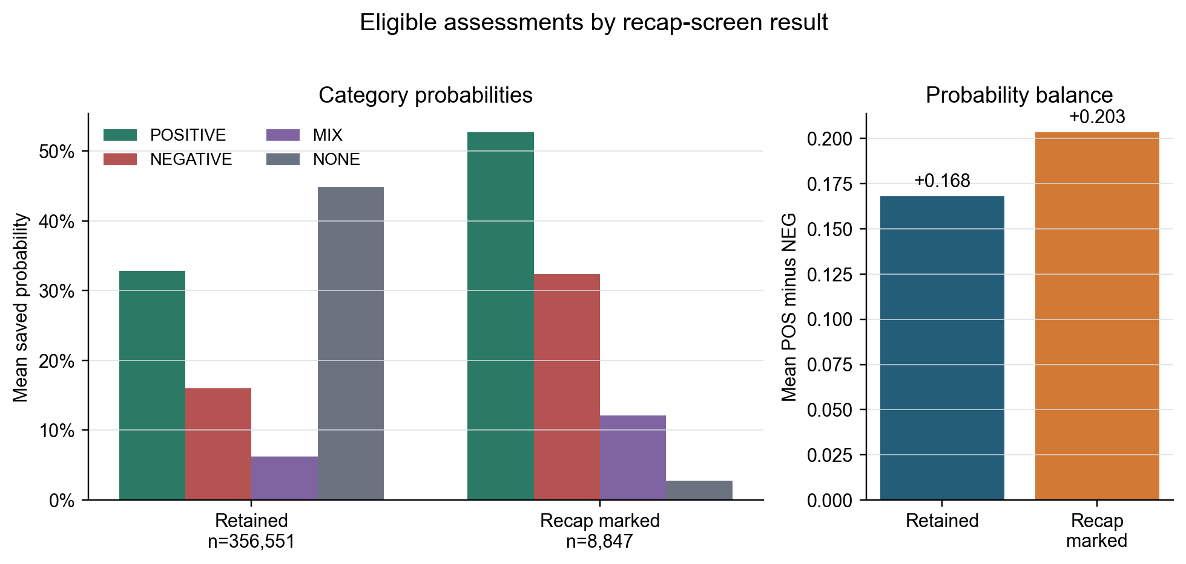
Figure 8. Mean category probabilities and mean POSITIVE-minus-NEGATIVE probability balance for 356,551 retained assessments and 8,847 assessments marked as price recaps among assessments that contribute to eligible company-dates. What to notice: recap-marked assessments have much lower mean NONE probability and higher directional probabilities, which is consistent with a screen designed to find prominent reports of past price moves.
The available-date comparison changes both the sentiment shares and the dates that remain eligible. In 2026, the unscreened analysis has 12,433 company-dates and the recap-screened analysis has 12,218. Across each version's available dates, the unscreened POSITIVE and NEGATIVE estimates are +0.254 and +0.468 percentage points, while the screened estimates are +0.175 and +0.425. On the same 12,218 retained dates, the unscreened estimates are +0.165 and +0.405, versus +0.175 and +0.425 after screening. The matched-date result shows that most of the available-date change cannot be assigned only to changed sentiment labels.
Period | All POS / NEG | Recap excluded POS / NEG
Full | +0.022 / +0.035 | +0.002 / +0.018
2023–25 | -0.070 / -0.024 | -0.076 / -0.034
2026 | +0.254 / +0.468 | +0.175 / +0.425

Some articles disclose that their text was produced automatically. Such a disclosure appears in 7,643 saved bodies, or 3.19%, including rating, short-interest and earnings-schedule summaries. Automatic production and a recap of past prices are separate article traits.

What the results mean
Across the full record, company sentiment aligns far more strongly with stock moves before the recorded article date than with returns in the following week. The result supports using these assessments to describe the financial tone associated with recent company events and price moves. It provides much weaker evidence of a stable relationship with later returns. The larger 2026 estimates do not replace the weaker pattern in the longer record.
The recap screen addresses one concrete explanation for the strong before-date relationship. Removing likely recap assessments changes the 2026 estimates only modestly on the same retained dates. The check is based on fixed phrases and cannot determine every article's meaning, so it does not establish why the period difference occurs.
The results are associations within this collected set of articles and eligible company-dates. The missing GDELT interval, concentrated publisher coverage, incomplete company-link recall, sentiment errors and Yahoo's adjustment conventions limit the conclusions. The analysis also does not model trading frequency, transaction costs, market impact or the cost of borrowing shares. The estimated return differences are not trading profit and do not establish that an article caused a price change.

Sources
GDELT source-file list: https://data.gdeltproject.org/gdeltv2/masterfilelist.txt . ReFinED model description: https://aclanthology.org/2022.naacl-industry.24/ . TypeSafe model, API and confidence documentation: https://docs.typesafe.ai/models ; https://docs.typesafe.ai/api ; https://docs.typesafe.ai/confidence . Price method: https://ranaroussi.github.io/yfinance/reference/api/yfinance.download.html ; https://github.com/ranaroussi/yfinance/blob/main/yfinance/utils.py ; https://ranaroussi.github.io/yfinance/advanced/price_repair.html . PerSenT: https://aclanthology.org/2020.coling-main.52/ ; https://github.com/MHDBST/PerSenT .

Appendix B. Complete saved-source counts
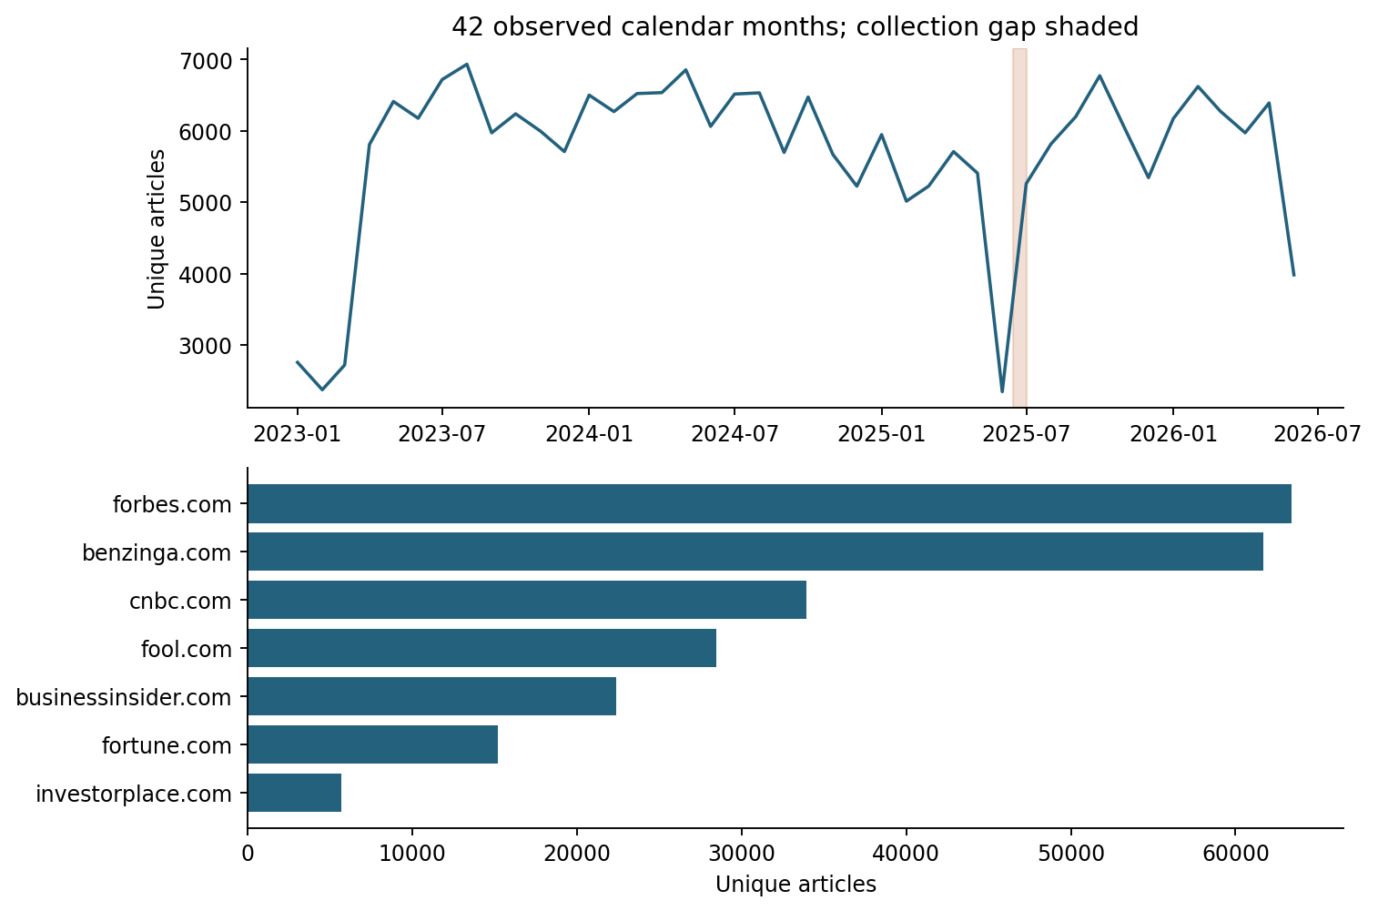
Figure 7. Saved news volume over time and across the seven largest source domains. The upper panel counts distinct saved articles by calendar month; the lower panel counts distinct saved articles by source. Shading marks 15 June–1 July 2025, when GDELT GKG has no records, and June 2026 covers only 1–18 June. Complete source counts appear below. What to notice: the shaded interval is a documented gap in the GDELT records used here, and the final month is incomplete.
Source domain | Articles | Source domain | Articles
forbes.com | 63,406 | benzinga.com | 61,672
cnbc.com | 33,924 | fool.com | 28,454
businessinsider.com | 22,358 | fortune.com | 15,190
investorplace.com | 5,708 | 247wallst.com | 5,479
kiplinger.com | 2,795 | seekingalpha.com | 78
finbold.com | 72 | marketbeat.com | 32
bloomberg.com | 22 | thestreet.com | 9
marketwatch.com | 7 | morningstar.com | 6
simplywall.st | 6 | barrons.com | 5
investing.com | 4 | ft.com | 4
reuters.com | 2

Total: 239,233 articles. The two Reuters and 22 Bloomberg articles do not constitute a representative wire-service feed.

Appendix C. Additional probability diagnostics
This annex provides the remaining descriptive views of the four saved category probabilities. Figures A1–A6 use completed article-company assessments. Figure A7 averages probabilities by company and recorded date and joins them to the saved 78,215-row analysis cohort. None of these figures refits the return regression.
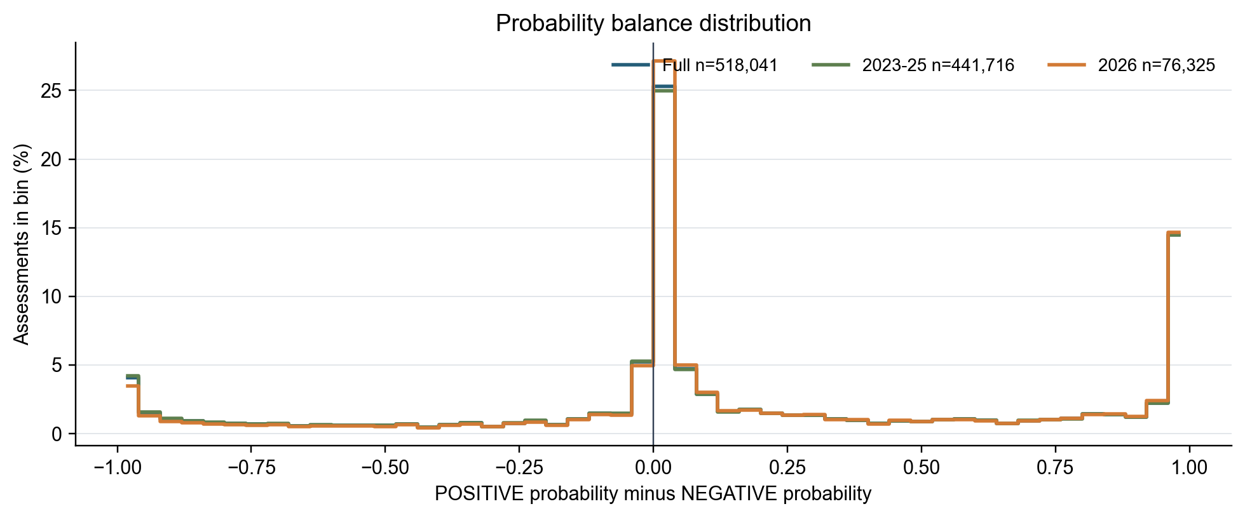
Figure A1. Distribution of POSITIVE probability minus NEGATIVE probability across all 518,041 completed assessments, the 441,716 assessments dated in 2023–25 and the 76,325 assessments dated in 2026. The full-period line includes both subperiods. Zero means equal saved support for POSITIVE and NEGATIVE. What to notice: the three distributions are similar, with large groups near zero and near the directional endpoints.
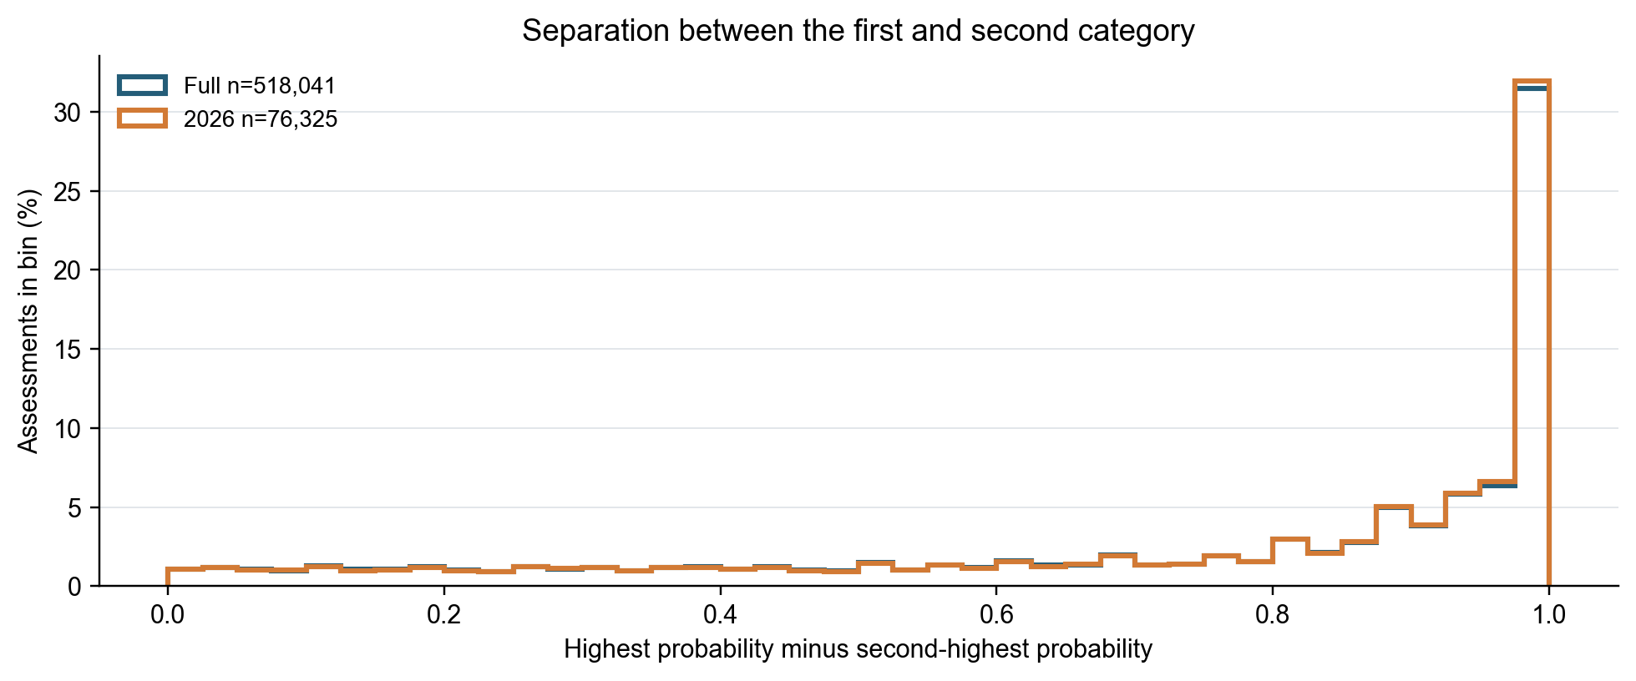
Figure A2. Distribution of the difference between the highest and second-highest saved category probabilities across all completed assessments and 2026. A larger value means greater separation between the first two categories. The median difference is 0.89 for the full period and 0.90 for 2026. What to notice: most assessments have a large gap between the first two saved probabilities, and the 2026 distribution is close to the full-period distribution.
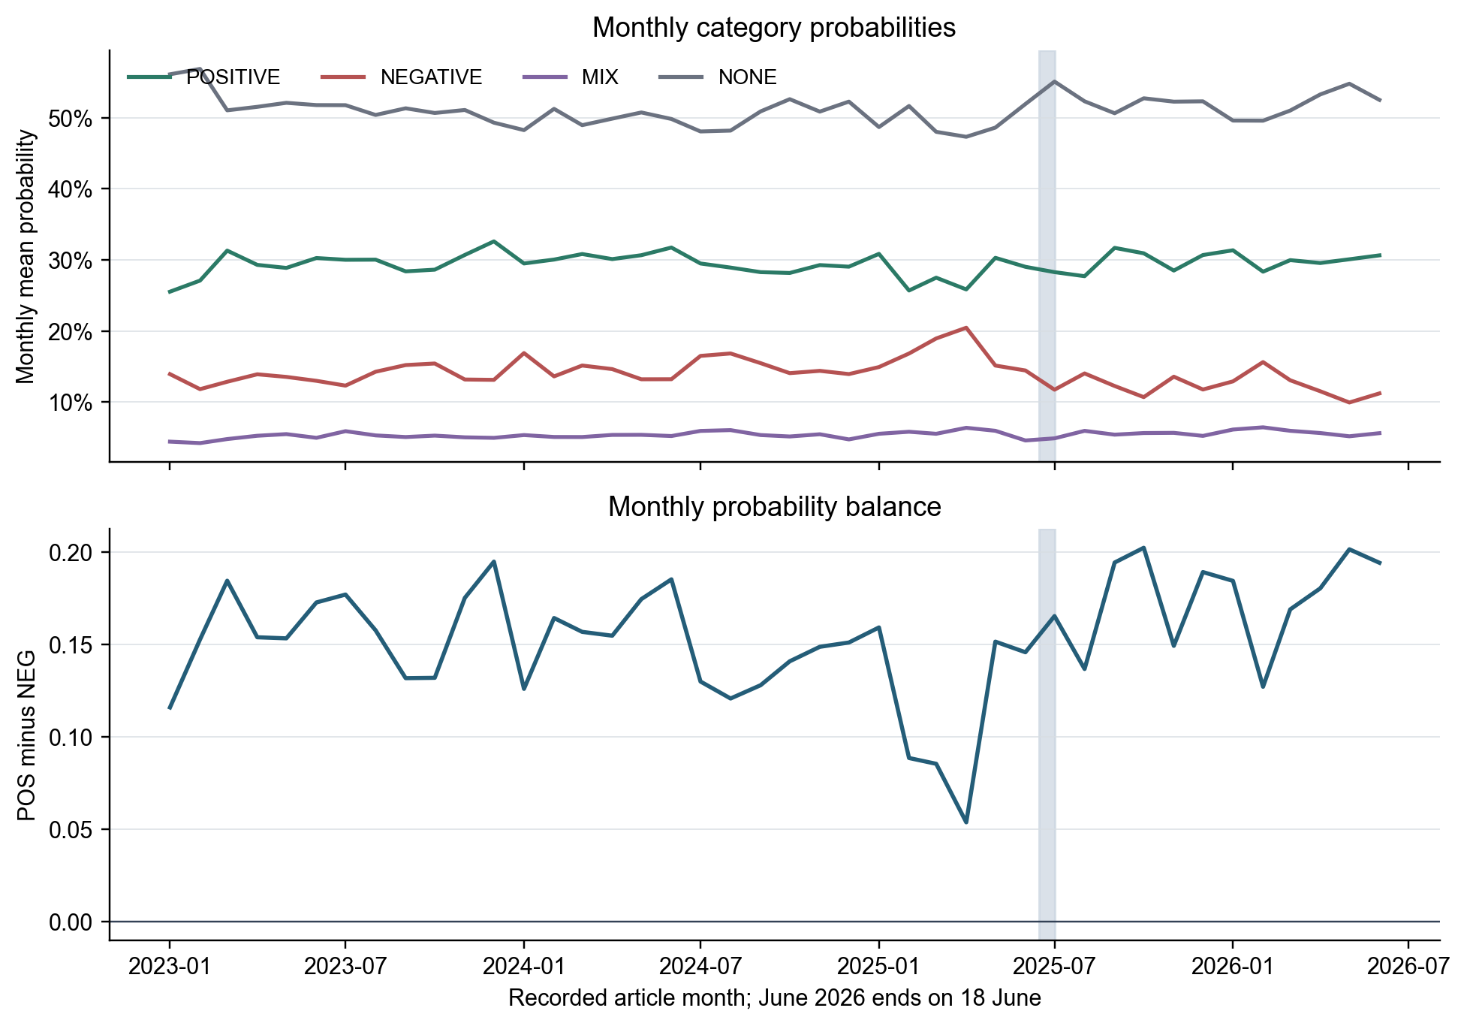
Figure A3. Monthly mean category probabilities and monthly POSITIVE-minus-NEGATIVE probability balance across completed assessments. The shaded area marks the missing GDELT interval from 15 June through 1 July 2025; June 2026 ends on 18 June. What to notice: NONE remains the largest mean probability in most months, while the balance varies more in 2025 and rises during parts of 2026.
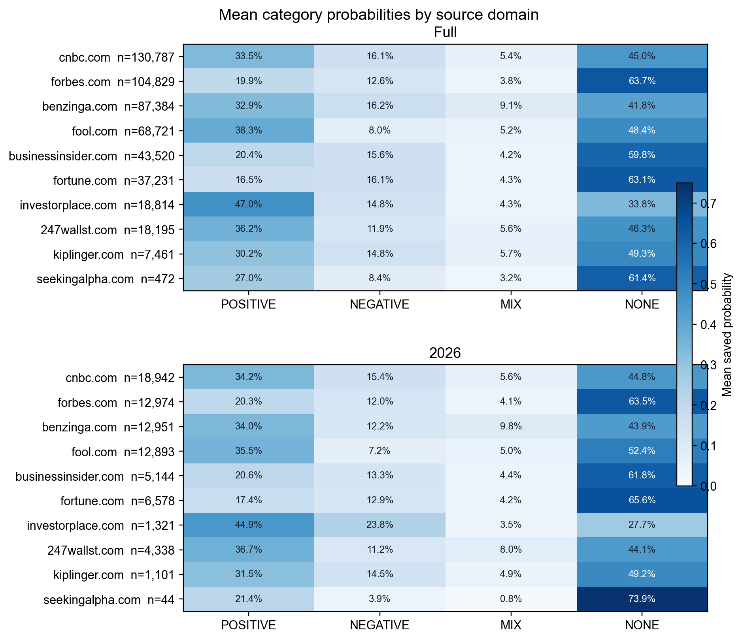
Figure A4. Mean category probabilities for the ten source domains with the most completed assessments in the full period. The first panel uses all assessments; the second uses 2026 assessments from the same domains. Each row reports its assessment count. What to notice: probability profiles differ across publishers, and several small 2026 cells, especially Seeking Alpha, should not be treated as stable source estimates.
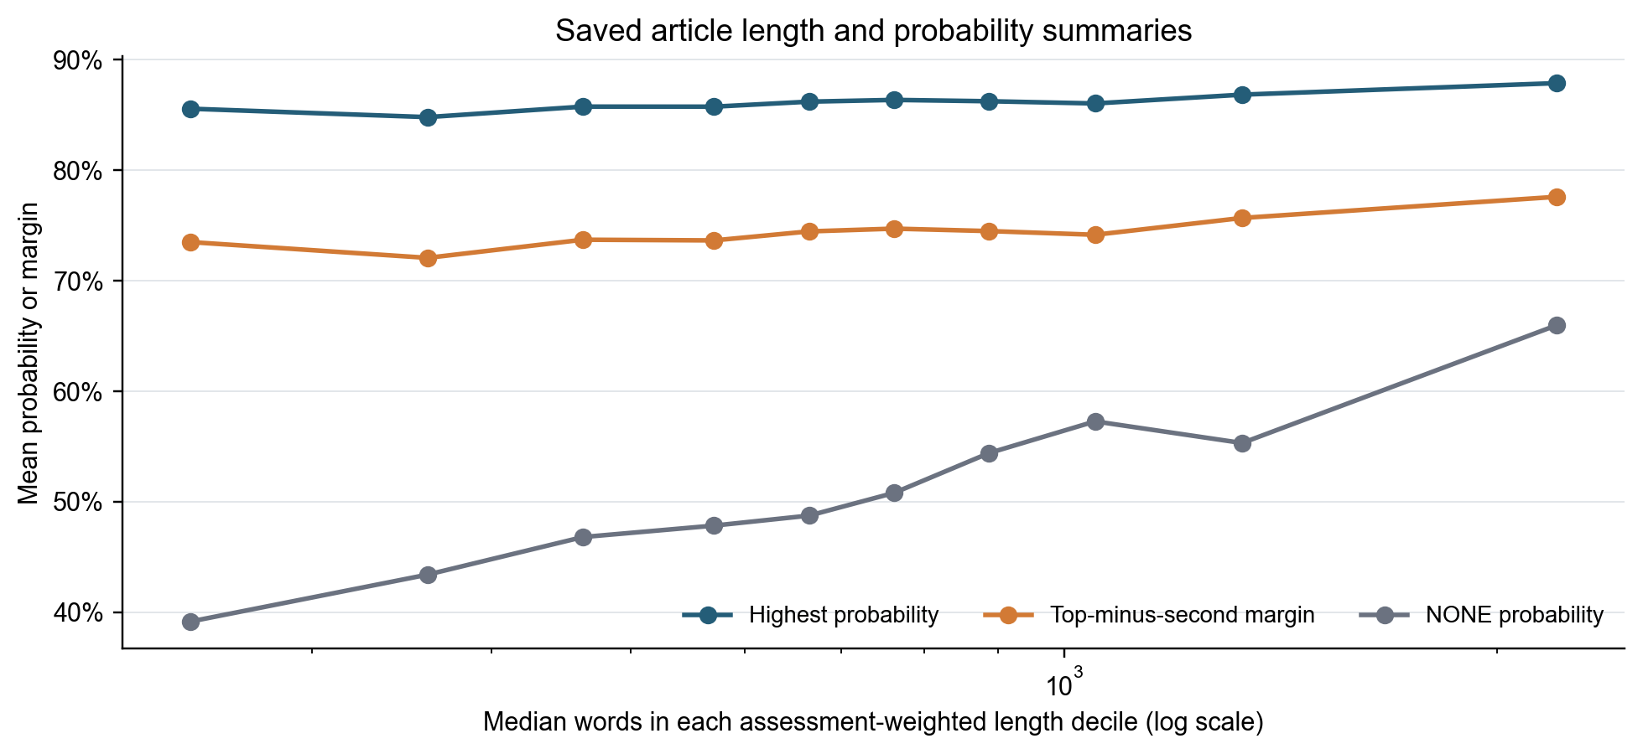
Figure A5. Mean highest probability, mean difference between the highest and second-highest probability and mean NONE probability across ten assessment-weighted article-length groups. The horizontal axis shows the median word count in each group on a logarithmic scale. What to notice: category separation changes little across length groups, while the mean NONE probability is higher among assessments of longer articles. Source and article composition can also differ across these groups.
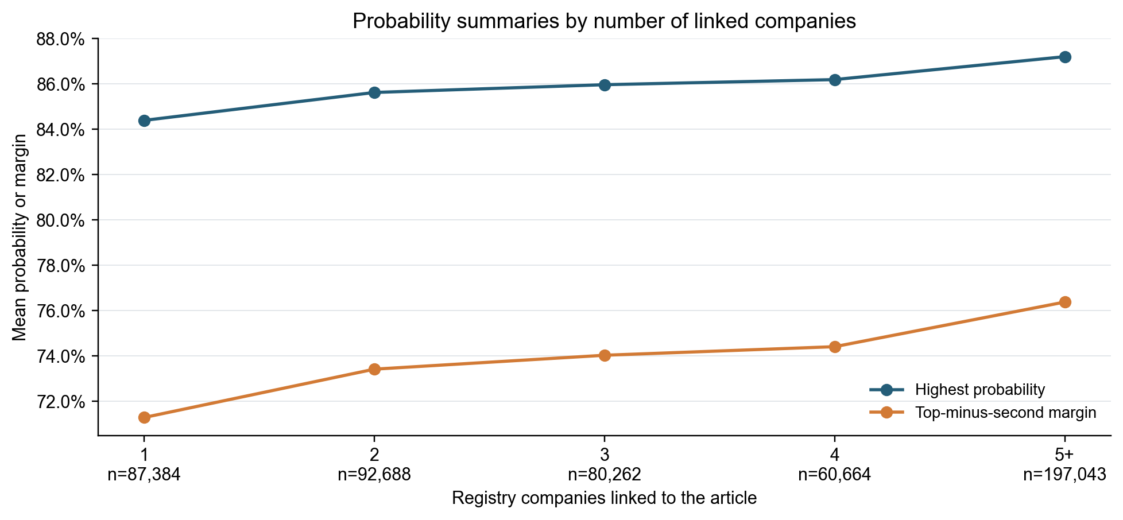
Figure A6. Mean highest probability and mean difference between the highest and second-highest probability by the number of registry companies linked to an article. The unit is an article-company assessment, and counts appear below each group. What to notice: both measures rise gradually as the number of linked companies increases; this is a descriptive relationship and does not identify its cause.
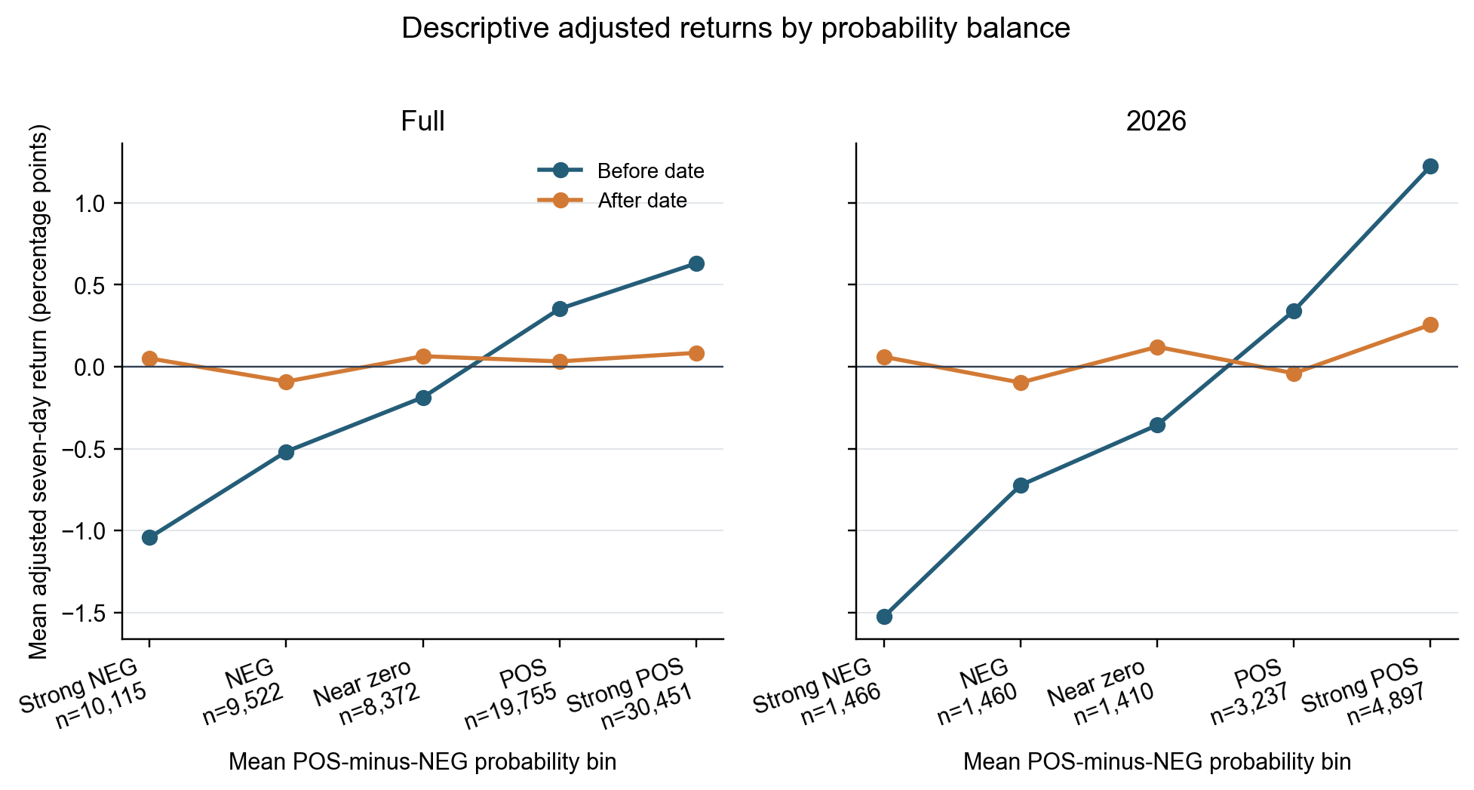
Figure A7. Mean adjusted seven-day returns before and after the recorded article date across five bins of company-date mean POSITIVE-minus-NEGATIVE probability. The left panel uses all 78,215 company-dates and the right panel uses the 12,470 company-dates dated in 2026. Counts appear below each bin. The values are unadjusted group means after the saved market and sector return adjustment; they do not include regression controls or confidence intervals. What to notice: the before-date return changes strongly across probability-balance bins. The after-date means are much flatter across the full period, while the strongest positive 2026 bin has a larger after-date mean.

