Automated Music Transcription
Final Project

By:
Tal Teri
Chen Shalev
Ilan Brilovitch
Yehuda Daniel
Lin Tibi

Supervisor:
Dr. Moshe Butman

Git:
Link to the git repository

Table of Contents
1. Project description 2
2. Related Work 2
3. Functional Description / Requirements 2
4. Architecture 3
4.1. Each Module description 3
5. Work plan 3
6. Client side 3
6.1. Usage Illustration 3
6.2. Mockup 3
7. Server Side 3
7.1. API 4

Project description

This project aims to develop a machine learning model capable of real-time music transcription. The model will be trained to identify individual musical notes from a polyphonic audio stream (a song with multiple instruments) and generate a corresponding sheet music representation.

Related Work

Going into this project, we’ll start by understanding the process of transforming sound into music transcription. In this article “A comprehensive Review on Music Transcription”:
https://www.mdpi.com/2076-3417/13/21/11882
we will study about the process of taking a recorded sound and transforming it into a MIDI file.
Another important article for us to grasp a knowledge of, will be about Automated Music Transcription(AMT). “Polyphonic music transcription using note event modeling”:
https://ieeexplore.ieee.org/abstract/document/1540233
The above article describes a method for an AMT, it is doing so by transcribing played notes.
In this method, musical notations (MIDI Files) are produced using probabilistic note event modeling, using HMM(Hidden Markov Method) to do so.

The last of articles would be “A comparison of Deep Learning methods for Timbre Analysis in Polyphonic Automatic Music Transcription”:
https://www.mdpi.com/2079-9292/10/7/810
Which talks about timbres (sharp, dull, compact, scattered etc) of different instruments.
The article will show how timbre affect monophonic transcription in a neural network.

Techniques: Our work will include different types of Deep Learning Techniques such as CNN or RNN for audio analysis or notes classification.
Helpful article about this topic can be found here, “AMT using CNN on segmented audio”:
https://ieeexplore.ieee.org/abstract/document/9770648
The method this article explored is by classifying musical notes from short time Fourier Transform (STFT).

The Dataset we will be using for our project would be MusicNet, This dataset contains 330 music recordings, with over 1 million annotated labels.

There are a couple of website that offer similar service of AMT, these website mostly allow a file only up to 1 minute long, usually focusing of guitar of piano, and the quality require manual correction. One of these website is called Melody Scanner, which is a subscription based website.

Functional Description / Requirements

This AMT will be designed to convert audio recordings of music into a music sheet. The user will be able to input an audio file and the system will analyze the file, identify the notes played and generate a corresponding music sheet.

The supported audio file format is WAV, no file lengths or complexity limitations are currently known.

At its core, this application will allow the user to identify the notes of a loved musical melody, while the system produce the played notes by the instrument. The system will support polyphonic melodies (multiple instruments playing together).

Architecture

This section dives into the architectural blueprint of our system. We'll dissect the various components that work together to achieve the desired functionalities. Each subsection will explore a specific layer or module, providing a clear understanding of its role and interaction with other elements.
server side, client side, DB, external resources. It should be graphically presented with a short description of each main module of the system.
Project with deep learning and algorithms that are based on large data must provide the source of the data in this section

Client Side

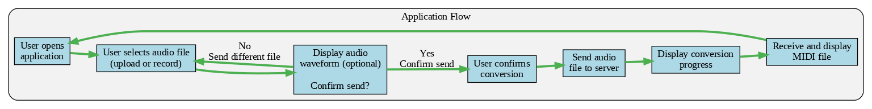

The client application provides a user-friendly UI for seamless audio-to-MIDI conversion. It supports file uploads, live recording, and visual feedback through audio waveform display. Users can confirm conversions before sending files to the server.

Server Side
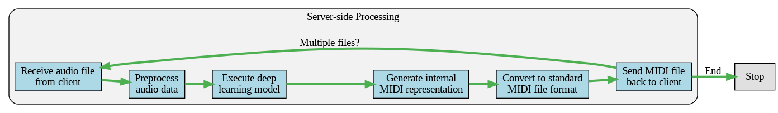

On the server-side, the system securely receives audio files, the preprocessing will occur in one stream to the server side, both in an uploaded file and in a recorded audio, and leverages a state-of-the-art deep learning model, which will run its calculations on the cloud, to generate high-quality MIDI representations. The generated MIDI files are then converted to standard format and delivered back to the client application.

Deep Learning Model
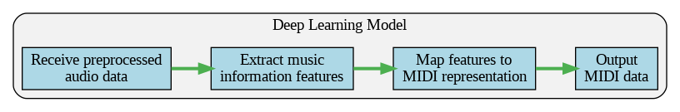

The deep learning model at the core of the server-side processing employs advanced feature extraction and mapping techniques, utilizing neural network architectures like RNNs with LSTM units, to ensure accurate and expressive MIDI conversion from the input audio signals.

Data Storage and Augmentation
The system utilizes the MusicNet dataset, a public collection of 330 paired audio recordings and MIDI files, as the primary data source. To enhance the model's capabilities, the system will explore data augmentation techniques, such as time-stretching and pitch-shifting, to expand the dataset size and improve generalizability. This curated and augmented dataset powers the deep learning model's training and evaluation, enabling accurate and expressive audio-to-MIDI conversions.

Work plan

This section will present the work plan of the project, the work plan must include milestone and responsibility of team members. This is the major work plan, the detailed work plan must be specified using a team management software like Monday, Trello, Jira etc.

Client side

In projects that include a client side – and app or website need to fill in this section.
This section describes the look and operation of the client UI:

Usage Illustration
In this section you will give a description of how the user will use the app. You should present several scenarios in which the user performs different operation with your app which summarize the purpose of the app.

Mockup
Graphic illustration of the different screens in your app.

Server Side
In this section you will provide more detailed description of the server side functionality and structure

API
This is the API that the server present to the rest of the world.

References
List of all the references used in the doc

