This window pops up after hitting F7:
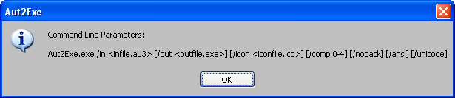

This is what follows:
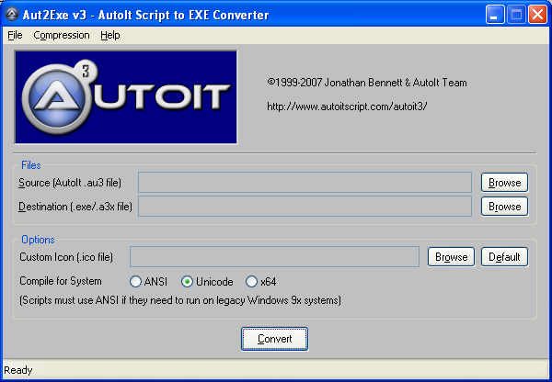
Then it forces me to complete the Source file path before I can convert.

