Walking through WMI (Author: Dimitri.Bertolami@Xylos.be)

Before I demonstrate this tool, please note that this can be quite a dangerous tool to use, as you have the option to delete and modify your entire WMI tree structure.
In case you want to make sure you don’t delete or modify crucial parts of your windows inner workings you can create a backup of your WMI Repository(namespace). You can do this in MMC → Add remove Snap IN → WMI Control → connect to local computer → Right click on WMI Control and click PROPERTIES → In this view the third TabPage is Backup/Restore, use this to backup your namespace.

That said I will only explain the viewing part. This can be considered safe to test out on any computer.

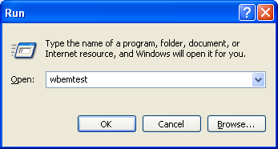
To manually view WMI (who besides from developers do this?) on your computer use the WBEMTEST Command.

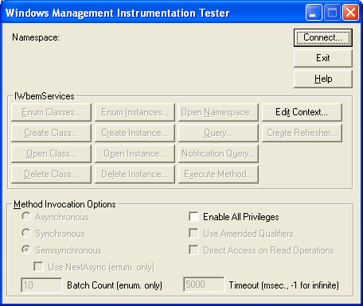

First we connect to our information store. From this repository we get all the info we need. In connect fill in the store: root\CIMV2. Other options you can leave default.

Now when you click on Enum Classes:
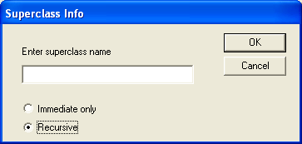
Make sure that recursive is selected and click OK

For this example search in your list 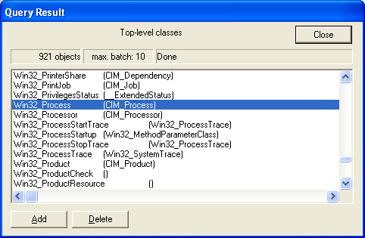
You can double click on this object.

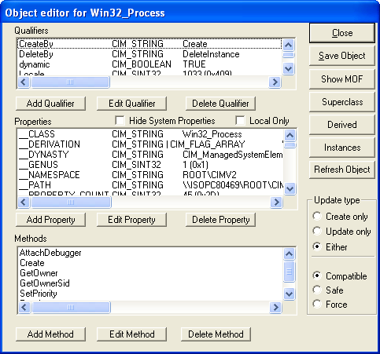
You can see the Methods and properties for this object.
If you find the provided information a bit overwhelming you can hide system properties that are useless for you in this view.
I deselect Hide system properties and Local Only as I won’t go into remote WMI (it’s one line difference in your script)
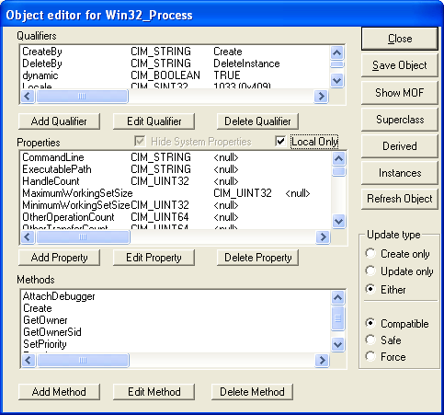

Let’s say I want to review the finer workings of with the Create method.
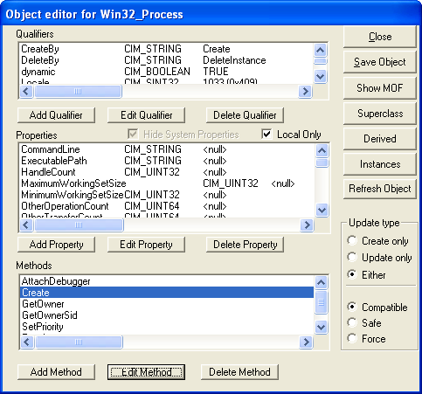
Double click on the method to view it or click EDIT Method

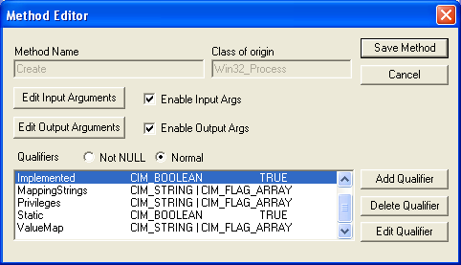
You can click on Edit input arguments (properties you need to fill in your script) or Output Arguments (what is returned after you execute this method)

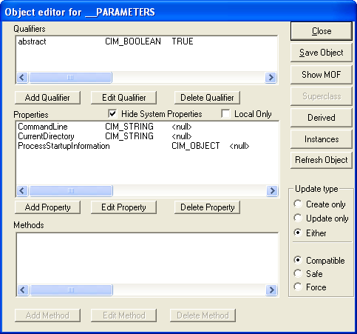
Input properties: Command line, Current Directory. This seems logic, if I want WMI to create a process I would need to specify my custom Command line, and the working directory.

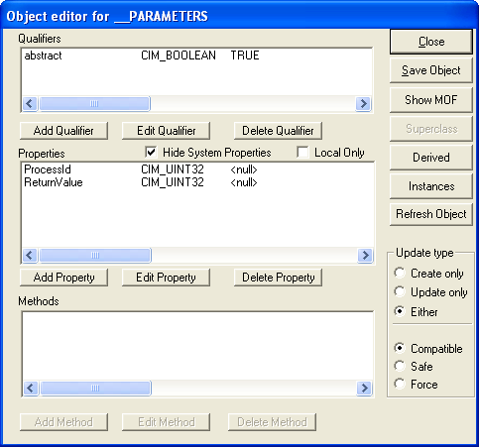
Output Properties: ProcessID And ReturnValue, again these two properties are nice to know and to have around as they will tell you what process ID you just created for further reference in your script, and the return value will tell you if your process was created or not.

From any object you can show the MOF File.
MOF Files are used to define classes in WMI.
MOF Files can be changed to your needs and you can compile it into a completely new WMI Class using the MOFCOMP Command.
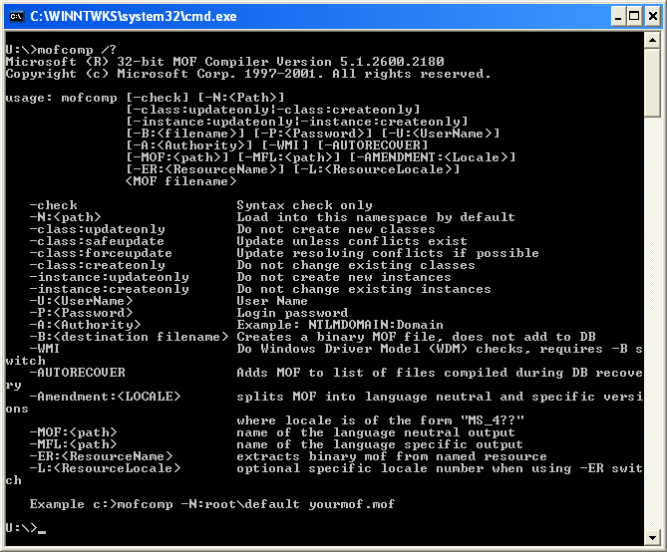
So to compile a MOF File type
MOFCOMP MYMOF.MOF

WQL queries
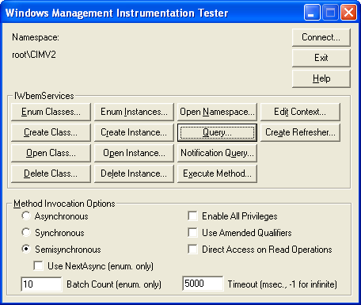

WMI uses WQL (read: WEEQUEL) to standardize the retrieval of data. WQL is a subset of the American National Standards Institute Structured Query Language (ANSI SQL), with some semantics (vocabulary) differences. One of the main differences is that it allows only queries and not updates, inserts or deletes. Queries are always executed against a namespace.

examples:

SELECT * FROM Win32_Process
Queries all classes in the provided namespace

SELECT * FROM Win32_Process WHERE __CLASS = "Win32_Process"
Queries for a class with the name Win32_Process.

List of WQL Keywords that you can use:
WQL keyword | Meaning
AND | Combines two Boolean expressions, and returns TRUE when both expressions are TRUE.
ASSOCIATORS OF | Retrieves all instances that are associated with a source instance.  Use this statement with schema queries and data queries.
__CLASS | References the class of the object in a query.  Windows NT 4.0 and Windows Me/98/95: Not available.
FROM | Specifies the class that contains the properties listed in a SELECT statement. Windows Management Instrumentation (WMI) supports data queries from only one class at a time.
GROUP Clause | Causes WMI to generate one notification to represent a group of events.  Use this clause with event queries.
HAVING | Filters the events that are received during the grouping interval that is specified in the WITHIN clause.
IS | Comparison operator used with NOT and NULL. The syntax for this statement is the following:  IS [NOT] NULL  (where NOT is optional)
ISA | Operator that applies a query to the subclasses of a specified class. For more information, see ISA Operator for Event Queries, ISA Operator for Data Queries, and ISA Operator for Schema Queries.
KEYSONLY | Used in REFERENCES OF and ASSOCIATORS OF queries to ensure that the resulting instances are only populated with the keys of the instances, which reduces the overhead of the call.  Windows 2000, Windows NT 4.0, and Windows Me/98/95: Not available.
LIKE | Operator that determines whether or not a given character string matches a specified pattern.
NOT | Comparison operator that use in a WQL SELECT query, for example:  SELECT * FROM meta_class WHERE NOT __class < "Win32" AND NOT __this ISA " Win32_Account"
NULL | Indicates an object does not have an explicitly assigned value. NULL is not equivalent to zero (0) or blank.
OR | Combines two conditions.  When more than one logical operator is used in a statement, the OR operators are evaluated after the AND operators.
REFERENCES OF | Retrieves all association instances that refer to a specific source instance. Use this statement with schema and data queries. The REFERENCES OF statement is similar to the ASSOCIATORS OF statement. However, it does not retrieve endpoint instances; it retrieves the association instances.
SELECT | Specifies the properties that are used in a query.  For more information, see SELECT Statement for Data Queries, SELECT Statement for Event Queries, or SELECT Statement for Schema Queries.
TRUE | Boolean operator that evaluates to -1 (minus one).
WHERE | Narrows the scope of a data, event, or schema query.
WITHIN | Specifies a polling or grouping interval.  Use this clause with event queries.
FALSE | Boolean operator that evaluates to 0 (zero).

WQL Reference (MSDSN)

As you can see there’s quite a bit of WMI you can see visually. This tool is a front end to the WMI API. MS Used this to help design the entire WMI Tree structure and left it in there for reference purposes.

