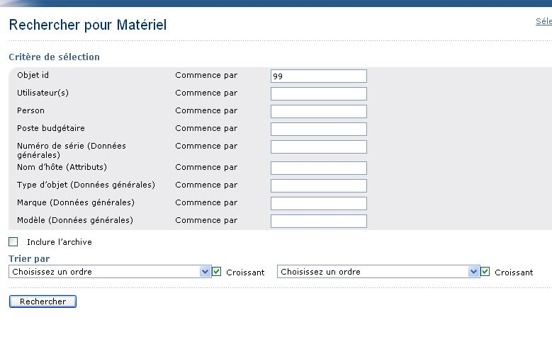
With autoit I fill the field Object ID, but if the records do not exit so I have the message

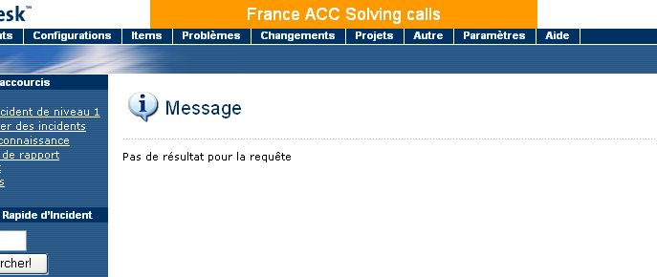

No result for your request, my question is how to manage this message.

Thank’s and Viva Las Vegas

Cameronsdad

