[config]
------------General--------------
1=Enter your password:
2=There is a wrong password entered.
3=The program automatically quits.
4=There is a new version of BackupSync
5=Do you want to download it?
6=Backupsync Configuration
7=This program is made by
-------------tab 1---------------
8=Backup
9=Name
10=From
11=Browse
12=To
13=Show if older then
14=Indicate here after how many days the backup job is visible in the menu.
15=If a backup job never started It always shows in the menu
16=day
17=days
18=Always visible
19=Filter
20=Click here for help on the filtering option
21=Encrypt Files
22=Enter a password if you want to copy encrypted files
23=Use Decrypter.exe to dycrypt the files
24=Decrypter.exe can be found in the Start menu
25=New backup
26=Save changes
27=Deleted backup entry
-------------tab 2---------------
28=Configuration
29=General
30=Auto start
31=Auto start with windows
32=OSD on top
33=OSD on top of all windows
34=Security
35=Password for Settings
36=Set a password if you want to protect the configuration
37=Set password
38=Set password
39=Delete
40=Password removal
-------------tab 3---------------
41=Scheduling tasks
42=1st task
43=2nd task
44=3rd task
45=4th task
46=5th task
47=6th task
48=mon
49=tue
50=wed
51=thu
52=fri
53=sat
54=sun
------------backup--------------
55=Are you sure you want to stop the backup while the backup is still running?
56=Are you sure you want to quit Backup?
57=Total progress
58=Progress delete files
59=The directory where the backup will be stored does not exist
60=Reading Files
61=Progress copying files
62=Progress
63=
64=The PC is automatically closed
65=Close
66=Cancel
67=never started
68=Open
69=Open Configuration
70=Open Decrypter
71=Summary log file
72=Extended log file
73=Controls
74=Auto shutdown after complete
75=Pause
76=Stop backup
77=Exit
78=Information
79=files copied
80=files deleted
81=Copy time
82=HH:MM:SS
83=Log file
84=Copied
85=Deleted
86=This backup entry does not exist, create it first

Also, take a look at these:

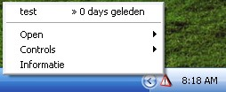
“0 days geleden” should be “0 days ago”
“Informatie” should be “Information”

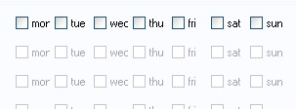
The spacing on Monday and Wednesday is cutting off part of the letter. It looks like “mor” and “wec”.

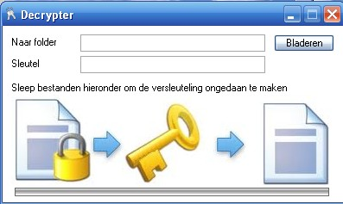
This all needs to be translated

