*The 32nd KKHTCNN Symposium on Civil Engineering*

*October 24-26, 2019, Daejeon, Korea*

**The Impact of Air Quality on Floating Population by Age Group in Yeouido, Seoul**

Yeji Kim1, Junyong Choi2 and David Lee3

*1 Department of Earth Science and Environmental Engineering, GIST, Gwangju 61005, Korea*

*2,3Department of Civil and Environmental Engineering, KAIST, Daejeon 34141, Korea*

[*yejikim93@gist.ac.kr*](mailto:yejikim93@gist.ac.kr)*, wnsdyd@kaist.ac.kr, david733@kaist.ac.kr*

ABSTRACT

Air quality plays a significant role in people’s respiratory health. In this paper, we use Air Quality Index (AQI) defined by the United States Environmental Protection Agency (USEPA) using 6 major air pollutants (PM10, PM2.5, CO, NO2, O3, SO2) for quantifying air quality. First, we calculated population-weighted exposure to air pollution for 9,123 neighborhoods in Seoul over four months, based on hourly floating population data derived from mobile network usage. We visualized these patterns using GIS software to identify areas with the highest active population exposure, separated by age group. Then, we analyzed air quality impacts on working age and elderly populations in the Yeouido district of Seoul, where both groups were highly exposed during this period. We found that the elderly population remained similar or even increased on highly polluted days (high AQI) compared to high reduction of population among working age groups. This response pattern suggests that elderly populations may not adjusting their behavior to avoid exposure to air pollution. For further research, a smaller scale of floating population is needed to distinguish whether people stay in buildings or not. In addition, Statistical tests would be conducted to verify AQI and human response among different age groups.

Keywords: Air quality index (AQI); Air pollution; Human exposure; Human response pattern

INTRODUCTION

Recently, the air pollution problem has become a serious issue in Korea. Air pollutants from industry, transport, and resident sector could damage human respiratory systems. The United States Environmental Protection Agency (US EPA) sets National Ambient Air Quality Standards for hazardous air pollutants to health effects which include particulate matter (PM10/PM2.5), ozone (O3), carbon monoxide (CO), nitrogen dioxide (NO2), and sulphur dioxide (SO2) (U.S. Environmental Protection Agency, 2018). After the World Health Organization (WHO) announced serious health impact of particulate matters, more people have interest about air quality of their living environment due to high air pollution in Korea (WHO, 2013).  In Korea, there are 333 air monitoring stations managed by Korean government and 25 air quality monitoring station managed by Seoul city in each district of Seoul. Air monitoring stations transmit air pollutant concentration measurements (PM10, PM2.5, Ozone, CO, NO2, SO2) to databases of the National Ambient air quality Monitoring Information System (NAMIS). Collected real-time data is provided in AirKorea website after correcting error data.

In this paper, we measured daily air pollution in 25 districts of Seoul using Air Quality Index (AQI), and population-weight exposure to air pollution to each dong-level neighbourhood. The AQI defined by the US EPA represents health risk associated with short-term exposure to ambient air pollution. The US EPA defined AQI considering the highest AQI value among criteria pollutants (PM10, PM2.5, Ozone, CO, NO2, SO2) at the moment. For calculating population-weighted exposure of each neighbourhood, we considered AQI of each district and floating population of each neighbourhood which is derived from mobile network usage. We studied patterns of population-weight exposure for working age and elderly groups in each neighbourhood in Seoul. Finally, we analyzed human response to air quality by age group in the highest population-weighted exposure place we identified, Yeouido neighborhood.

MATERIAL AND METHOD

Data

We used Korean government air pollution data (airKorea) and floating population data (Seoul Metropolitan Government’s website) for visualizing population-weight exposure using open-source geographic information system (GIS) software QGIS. We collected air pollution data in all 25 districts in Seoul in 2018. Air pollution data including PM10, PM2.5, Ozone, CO, NO2, SO2 were collected every hour.

Seoul open data provides floating population data as hourly counts by age in each dong-level neighbourhood of Seoul. The floating populations are estimated using mobile phone usage (LTE) provided by KT telephone company. The data are segmented by hour, age (0-9, 10-14, 15-19, 20-24, 25-29, 30-34, 35-39, 40-44, 45-49, 50-54, 55-59, 60-64, 65-69, over 70), and gender. Age groups who tend not to use mobile phones (younger than 10 or older than 80), are estimated by considering the ratio of resident registration population and movement of surrounding age people (Government Metropolitan Seoul, 2013).

To analyze human response patterns to air pollution among different age groups (Working age/elderly), we used air quality data over four months (January - April, 2018) and floating population data of Yeouido neighbourhood in Seoul.

Calculation of AQI (Air quality index)

AQI value is the highest AQI values among average daily concentration of 6 criteria pollutants calculated by following equation showing health risks associated with short-term exposure (U.S. Environmental Protection Agency, 2018).

$$I_{p}= \frac{I_{Hi}-I_{Lo}}{{BP}_{HI}-{BP}_{Lo}}\left(C_{p}-{BP}_{Lo}\right)+I_{Lo}$$

Where, $I_{p}$ is the index for pollutant p, $C_{p}$ is the truncated concentration of pollutant, ${BP}_{HI}$ is the concentration breakpoint that is greater than or equal to $C_{p}$, ${BP}_{Lo}$ is the concentration breakpoint that is less than or equal to $C_{p}$, $I_{Hi}$ is the AQI value corresponding to ${BP}_{HI}$, $I_{Lo}$ is the AQI value corresponding to ${BP}_{Lo}$

Table 1. Breakpoints and Category of AQI

|  |  |  |  |  |  |  |  |
| --- | --- | --- | --- | --- | --- | --- | --- |
| These Breakpoints is | | | | | | equal this AQI | and this category |
| O3 (ppm)  8 hour | PM2.5 $(μg/m^{3})$ 24 hour | PM10 $(μg/m^{3})$ 24 hour | CO (ppm)  8 hour | SO2 (ppb)  1 hour | NO2 (ppb)  1 hour | AQI | - |
| 0.000-0.054 | 0.0-12.0 | 0-54 | 0.0-4.4 | 0-35 | 0-53 | 0-50 | Good |
| 0.055-0.070 | 12.1-35.4 | 55-154 | 4.5-9.4 | 36-75 | 54-100 | 51-100 | Moderate |
| 0.071-0.085 | 35.5-55.4 | 155-254 | 9.5-12.4 | 76-185 | 101-360 | 101-150 | Unhealthy for Sensitive Groups |
| 0.086-0.105 | 55.5-150.4 | 255-354 | 12.5-15.4 | 186-304 | 361-649 | 151-200 | Unhealthy |
| 0.106-0.200 | 150.5-250.4 | 355-424 | 15.5-30.4 | 305-604 | 650-1249 | 201-300 | Very unhealthy |

Population-weight exposure

Population-weight exposure rate of air pollutants was calculated by following equation (Marguerite Nyhan etc., 2016).

$$E_{i}= \sum_{j=1}^{24}{C_{i}P_{ij}}$$

Where, $E_{i}$ is the daily total population exposure for each district i, $C_{i}$ is the calculated AQI value in district i on each day, $P_{ij}$ is the percent of the total population of Seoul present in district i at time j (which is hour of the day)

Human response pattern on air quality

We analyzed floating population pattern on weekdays and weekend with AQI by different age groups. Age groups are divided as Working age (15-64) and Elderly (over 65) by considering Organization for Economic Co-operation and Development (OECD) age group definition. We considered hourly air pollution data and hourly floating population data between January to April in 2018, when air pollution is highest in Korea. We focused on ‘Working hours’ (12pm to 5pm) as commuting time would show a different pattern. Then we selected the highest population-weighted exposed neighbourhood (for both age groups) to conduct deeper analysis on human response pattern on air quality.

RESULT AND DISCUSSION

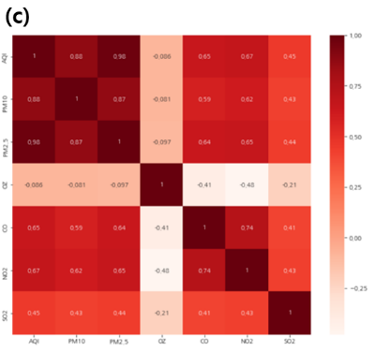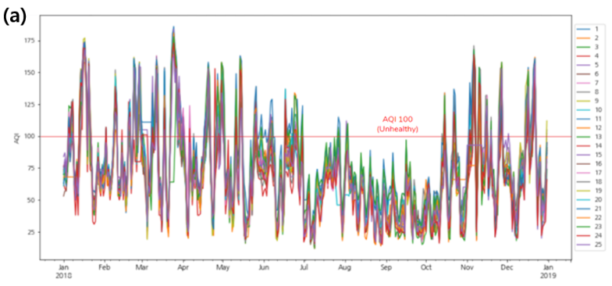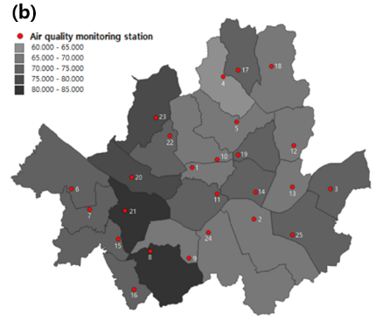Air quality Index of Seoul

Figure 1. Analysis of air pollution in Seoul in 2018 with AQI.

Figure 1 (a) shows fluctuating patterns of daily AQI of 25 districts in Seoul over 2018. High polluted days which are over 100 AQI (unhealthy for sensitive groups) are more frequent in Winter (November – February) and Spring (March - May) season in Korea. This seasonal difference of AQI might be attributed to higher fuel consumption and temperature inversion associated with the winter and Spring season. (Hyeran Choi etc., 2018), Figure 1 (b) shows the average of AQI in each district with air quality monitortinig stations in Seoul over 2018 using GIS software. The average value of AQI over 2018 of each district was between 60 to 85. The most polluted areas in 2018 were ‘Yengdeungpo-gu’ and ‘Gwanak-gu’. In figure 1(c), AQI were highly correlated with PM2.5 (0.98) and PM10 (0.88) compared to other pollutants such as Ozone (-0.086), CO (0.65), NO2 (0.67), and SO2 (0.45).

Population-weight exposure of Seoul

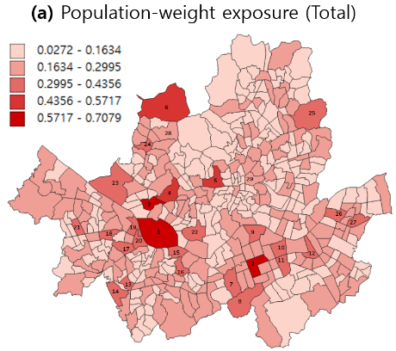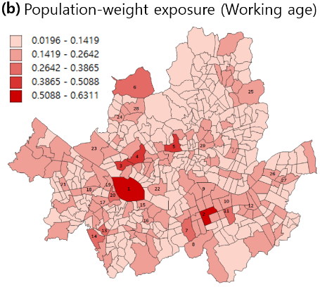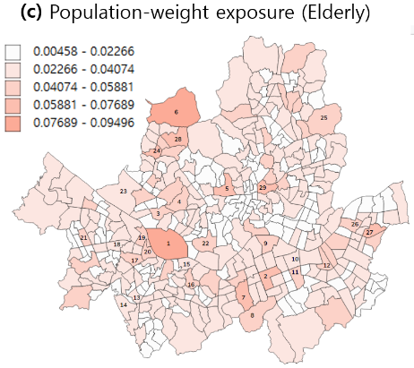

Figure 2. Population-weight exposure of 9,123 neighbourhoods in Seoul.

In figure 2(a), The highest population-weight exposed neighborhoods were Yeouido-dong, Yeoksam1-dong, and Seogyo-dong, labeled 1, 2, and 3. For working age people, Yeouido-dong and Yeoksam1-dong (labeled 1 and 2) showed the highest mean population-weighted exposure. On the other hand, for the elderly group, Yeouido-dong and Jingwan-dong (labeled 1 and 6) showed the highest mean population-weighted exposure. Working age (15 - 64) people were usually exposed to polluted air in business areas such as Yeouido-dong, and Yeoksam1-dong. However, elderly people (over 65) were less concentrated in the business area, but they were also exposed to polluted air in the residential areas. All things considered, Yeouido-dong was the most population-weight exposed neighbourhood in Seoul for both age groups (Working age/Elderly).

Response pattern on air quality for working age group and elderly

Figure 3 shows the impact of AQI on floating population of different age groups in Yeouido, Seoul. Each point represents an hourly measurement of AQI and floating population. As can be seen from Fig. 3 (a) and (b), there are differences between working age group and eldely, and weekday and weekend. The slope of the trendlines for both working-age and elderly groups is slightly negative on weekdays, showing that fewer people visited the area during more polluted hours, but not by much. This may be because many people spend time there for work, and are not able to change their work patterns easily in response to pollution. On the weekend, overall floating populations dropped significantly for both groups, but working-age were much more likely to visit during low AQI times. By contrast, elderly populations did not respond strongly to AQI, and even showed a slight increase at high pollution times.

We can see these trends in the change in slopes between the weekday and weekend graphs. The trendline slope of working age population showed significant change (-20.038 to -71.408) between the figure 3(a) and (b), while the value of slope of elderly population showed only a slight change (-6.0698 to 3.1442) between the weekday and weekend response patterns.

The relative inelasticity of elderly floating population response might have several causes: less awareness of the risks of air pollution exposure, less real-time awareness of the pollutant levels in their location, preference for outdoor activities, or dependence on jobs that lack flexibility in working hours and location. Ironically, elderly people end up relatively more exposed to air pollution, despite being physically the most susceptible to its negative health effects.

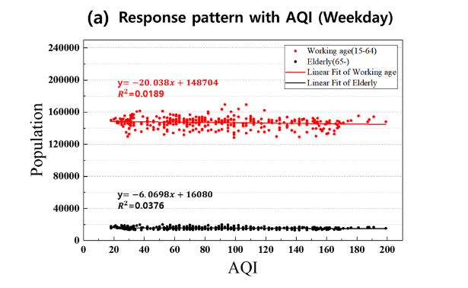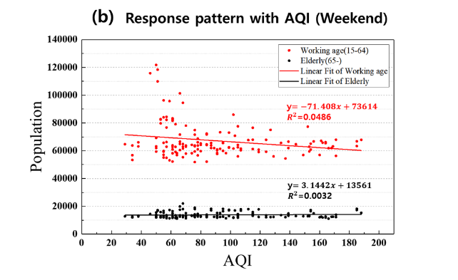

Figure 3. Population response pattern on air pollution of different age groups during weekday and weekend

CONCLUSION

In this research, we visualized Seoul’s population-weight exposure and found Yeouido-dong neighbourhood was the highest exposure place for both working age and elderly visitors to the area. Then, we analyzed the hourly population response pattern of working and elderly people when they were highly exposed to air pollution in Yeouido in 2018. As air pollution has become a serious issue in Korea, working age visitors were more likely to avoid the area during the most polluted times. On the other hand, floating populations of the elderly were less affected by air pollution, even though air pollution causes more serious health problems to the elderly. As the floating population does not distinguish whether people are inside of a building or outside, further research has to change the scale of floating population to smaller scale, to distinguish whether people stay in buildings or not. Furthermore, statistical tests need to be conducted to verify AQI and human response among different age groups.

**Acknowledgements** This work is financially supported by Korea Ministry of Land, Infrastructure and Transport(MOLIT) as 『Innovative Talent Education Program for Smart City』

REFERENCES

Marguerite Nyhan, Sebastian Grauwin, Rex Britter, Bruce Misstear, Aonghus McMabola, Francine Laden, Steven R. H. Barrett, and Carlo Ratti (2016), ““Exposure Track”-The impact of Mobile-Device-Based Mobility Pattern on Quantifying Population Exposure to Air Pollution”, Journal of Environmental Science & Technology, 50, 9671-9681.

Hyeran Choi and Jun-Pyo Myong (2018), “Association between air pollution in the 2015 winter in South Korea and population size, car emissions, industrial activity, and fossil-fuel power plants: an ecological study”, Annals of Occupational and Environ Medicine, Vol.30, 30-60.

U.S. Environmental Protection Agency (2018), “Technical Assistance Document for the Reporting of Daily Air Quality - the Air Quality Index (AQI)”, 454, B-18-007

World Health Organization (2013), “Health effects of particulate matter”, ISBN 978 92 890 0001 7.

U.S. Environmental Protection Agency (2018), “Criteria Air Pollutant”, American’s Children and the Environment, third-edition.

 Government Metropolitan Seoul (2013), “Seoul Living Population”, Seoul Open Data Plaza,<https://data.seoul.go.kr/dataVisual/seoul/seoulLivingPopulation.do>