TSIS 1
Reverse-Engineering the Deal: Valuation & Cap Table Analysis
23B151046-Pyurko Yekaterina

1. Selection & News Reconnaissance
- Target: Higgsfield AI (Founded by Alex Mashrabov & Yerzat Dulat)
- Trigger Event: Series A Extension Round
- Date: January 15, 2026
- Source: TechFundingNews: Higgsfield raises $80M extension at $1.3B Valuation
- Core Data:
  - Investment Amount (I): $80,000,000
  - Post-Money Valuation (V_{post}​): $1,300,000,000
  - Key Growth Metric: Hit a $200M Annual Recurring Revenue (ARR) run rate.

2. Financial Reconstruction
Using the "Reverse-Engineering" method, we solve for the pre-money value and the exact entry stake.
A. Pre-Money Valuation (Vpre​) The value before the $80M check was signed:
V_{pre}​ = V_{post​} - I
V_{pre}​ = $1,300,000,000 - $80,000,000 = $1,220,000,000
B. Investor Stake % The equity percentage acquired by the new syndicate (Accel, Menlo Ventures, GFT):
Investor Stake = I / V_{post​}​
Investor Stake = 80,000,000​ / 1,300,000,000≈6.15%
C. Dilution Factor Existing shareholders (Founders/Seed) were diluted by:
Dilution= 1 - ( V_{pre} / V_{post​}​) ​= 6.15%

3. Cap Table Modeling (Higgsfield AI)
Following your requested format, here is the reconstruction of the share distribution.
Pre-money:
6.15%→61,538 | 100%→1,000,000
Post-money:
6.15%→65,574 | 100%→1,065,574

Shareholder | Pre-Money (idea) | Post-Money (pre-seed) | Shares (Post)
Founders | 80.00% | 75.08% | 800,000
Alex Mashrabov (CEO) | 40.00% | 37.54% | 400,000
Yerzat Dulat (CTO) | 40.00% | 37.54% | 400,000
Option Pool | 20.00% | 18.77% | 200,000
Series A Ext. Investors | - | 6.15% | 65,574
Accel (Lead) | - | 3.50% | 37,295
Menlo Ventures | - | 1.50% | 15,984
GFT Ventures | - | 1.15% | 12,295
TOTAL | 100% (1,000,000) | 100% (1,065,574) | 1,065,574
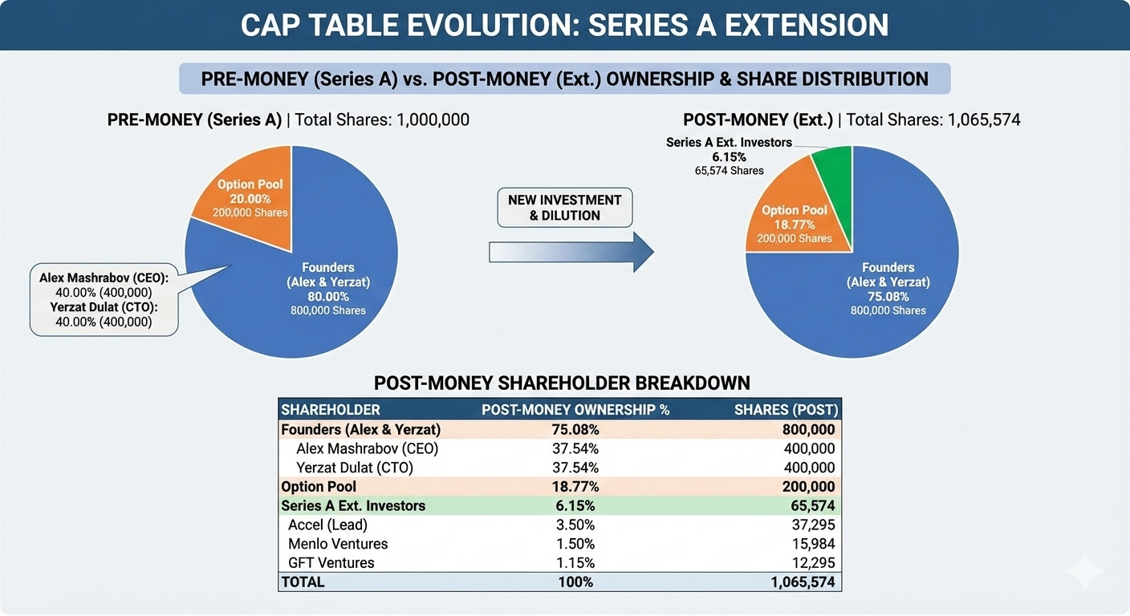

4. Contextual Analysis (The "Why")
The "AI Multiplier" vs. Regional Premium Higgsfield's valuation is a masterclass in the "AI Infrastructure Premium." While regional giants like Uzum command a premium for dominating a specific market (Uzbekistan’s 35M+ population), Higgsfield's $1.3B tag is globally benchmarked. At a $200M ARR, they are trading at a 6.5× revenue multiple. This is remarkably efficient compared to the "AI Hype" of 2024, where multiples reached 50×, suggesting that Higgsfield is being valued as a "Production Utility" rather than a speculative play.
Jurisdiction: AIFC vs. Delaware The founders utilize a Delaware C-Corp structure for the parent company to facilitate investment from Tier-1 US VCs like Accel. However, their presence in the Central Asian ecosystem is a strong signal for AIFC (English Law). For Kazakhstani founders, the AIFC acts as a "testing ground" for English Law principles, allowing them to speak the same legal language as Silicon Valley investors.
Investor Confidence The confidence stems from the company's pivot to Enterprise B2B. By focusing on social media marketers rather than general consumers, they transitioned from "Viral Tool" to "Daily Workflow," which significantly lowers churn and justifies the $80M injection during a period of tighter VC liquidity in early 2026.

