**Lab III: HBase Hands-on Exercises**

1. Experimental environment

OS: CentOS-7.5-x86_64

JDK: 1.8.0_212

Hadoop version: 3.1.3

IDE: IntelliJ IDEA Community Edition 2023.1.1

Hbase version:2.4.11

1. Use HBase shell commands for the following tasks:

1) List all the tables in HBase.

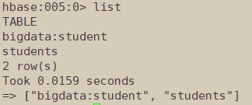

2)Print the description of a user-specified table.

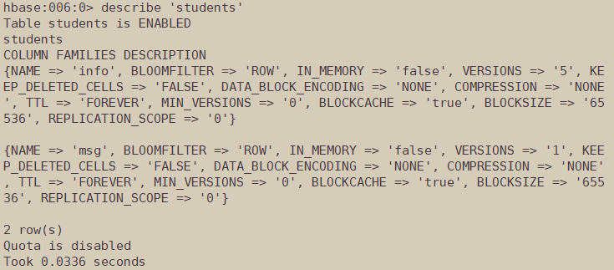

3) Scan a user-specified table and print the table contents.

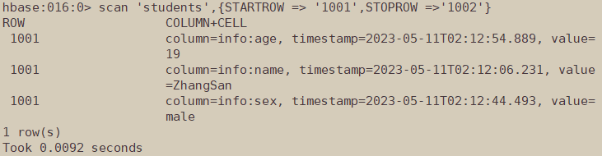

4) Add and delete a column family in an existing table.

Add:

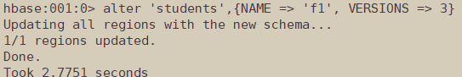

Delete:

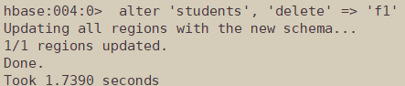

5) Add and delete a column in an existing table.

Add:

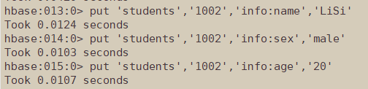

Delete:



6) Empty a given table.

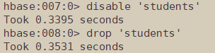

7) Count the number of rows in a table.

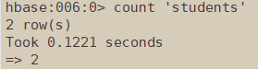

1. Write Java programs using HBase Java API for the same tasks.

1) List all the tables in HBase.

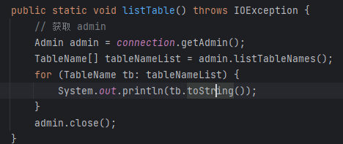



2)Print the description of a user-specified table.

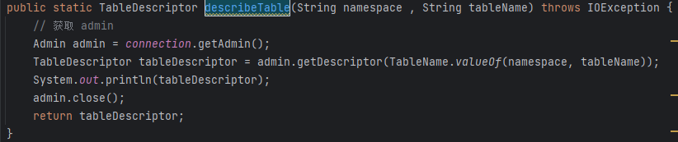



'students', {NAME => 'info', BLOOMFILTER => 'ROW', IN_MEMORY => 'false', VERSIONS => '5', KEEP_DELETED_CELLS => 'FALSE', DATA_BLOCK_ENCODING => 'NONE', COMPRESSION => 'NONE', TTL => 'FOREVER', MIN_VERSIONS => '0', BLOCKCACHE => 'true', BLOCKSIZE => '65536', REPLICATION_SCOPE => '0'}

3) Scan a user-specified table and print the table contents.

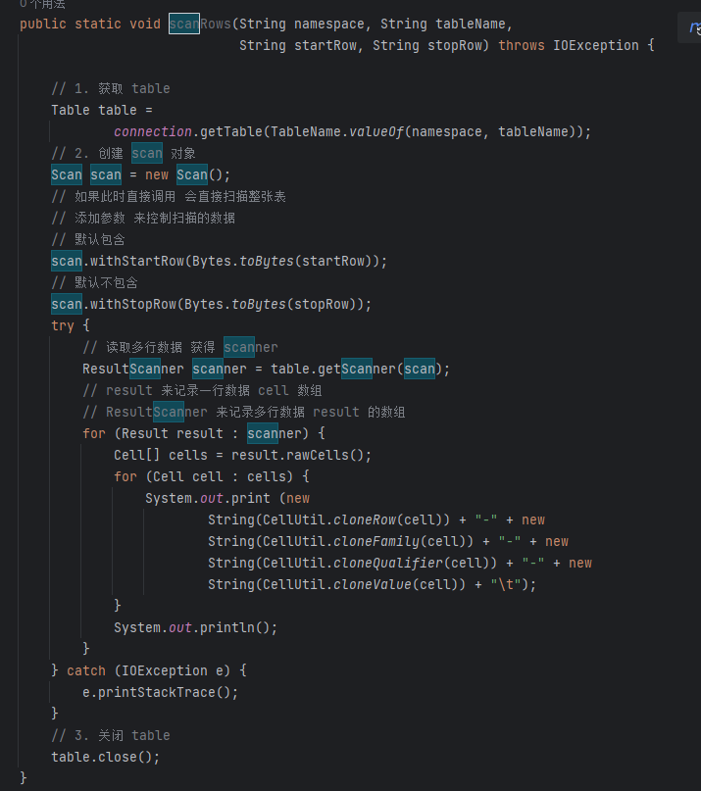

4) Add and delete a column family in an existing table.

Add:

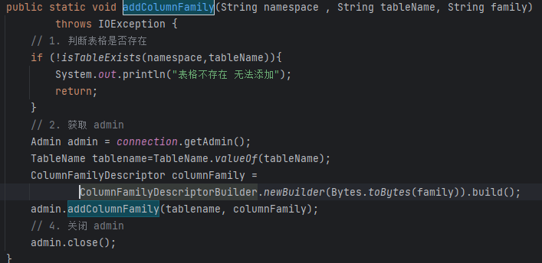



'students', {NAME => 'info', BLOOMFILTER => 'ROW', IN_MEMORY => 'false', VERSIONS => '5', KEEP_DELETED_CELLS => 'FALSE', DATA_BLOCK_ENCODING => 'NONE', COMPRESSION => 'NONE', TTL => 'FOREVER', MIN_VERSIONS => '0', BLOCKCACHE => 'true', BLOCKSIZE => '65536', REPLICATION_SCOPE => '0'}, {NAME => 'msg', BLOOMFILTER => 'ROW', IN_MEMORY => 'false', VERSIONS => '1', KEEP_DELETED_CELLS => 'FALSE', DATA_BLOCK_ENCODING => 'NONE', COMPRESSION => 'NONE', TTL => 'FOREVER', MIN_VERSIONS => '0', BLOCKCACHE => 'true', BLOCKSIZE => '65536', REPLICATION_SCOPE => '0'}

Delete:

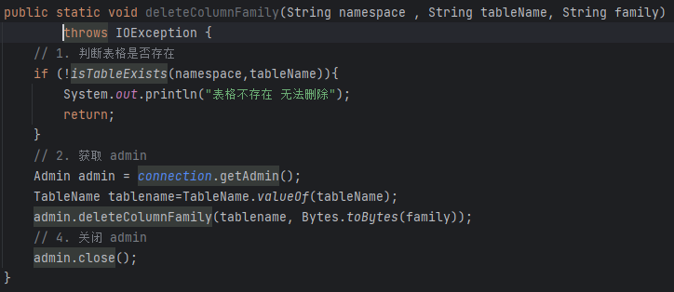

'students', {NAME => 'info', BLOOMFILTER => 'ROW', IN_MEMORY => 'false', VERSIONS => '5', KEEP_DELETED_CELLS => 'FALSE', DATA_BLOCK_ENCODING => 'NONE', COMPRESSION => 'NONE', TTL => 'FOREVER', MIN_VERSIONS => '0', BLOCKCACHE => 'true', BLOCKSIZE => '65536', REPLICATION_SCOPE => '0'}

5) Add and delete a column in an existing table.

Add:

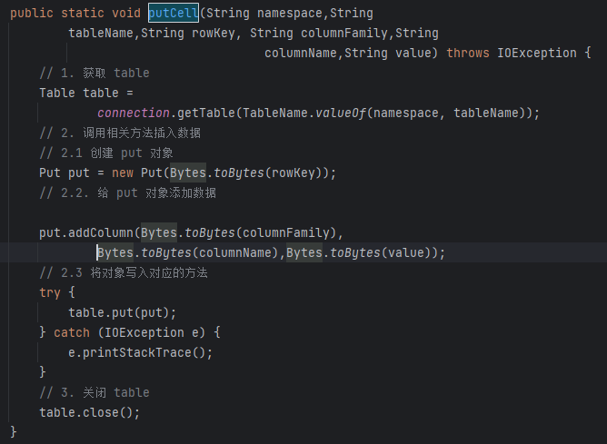

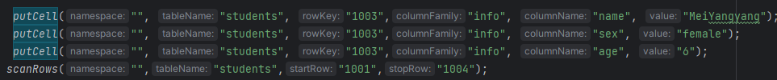



Delete:

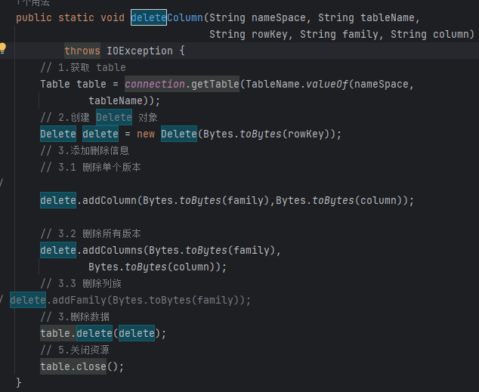

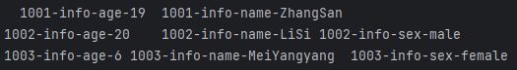

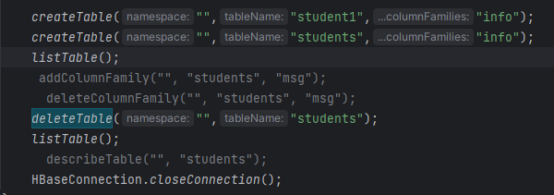

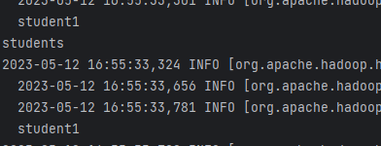

6) Empty a given table.

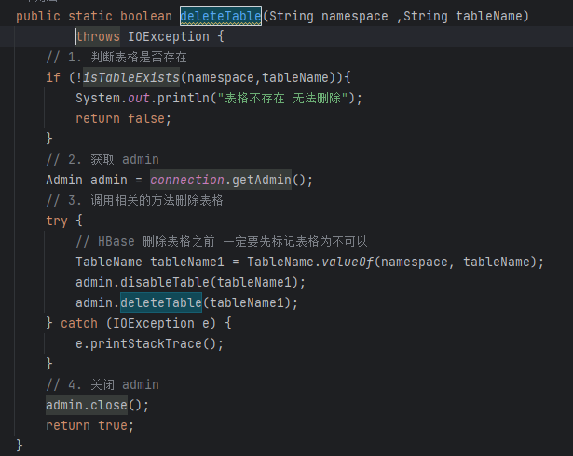

7) Count the number of rows in a table.

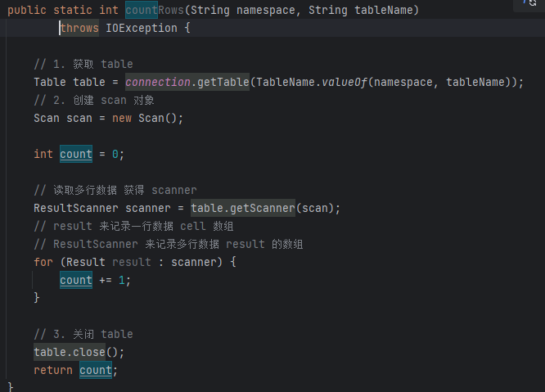

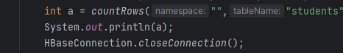



4. Problems

A. When I scan Rows, the scope of scan is usually the left closed right open interval, so I always miss row.

B. When I install the Hbase, I also need to install zookeeper first.