Question 1:
Step 1.1: Plotting Training and Testing Data
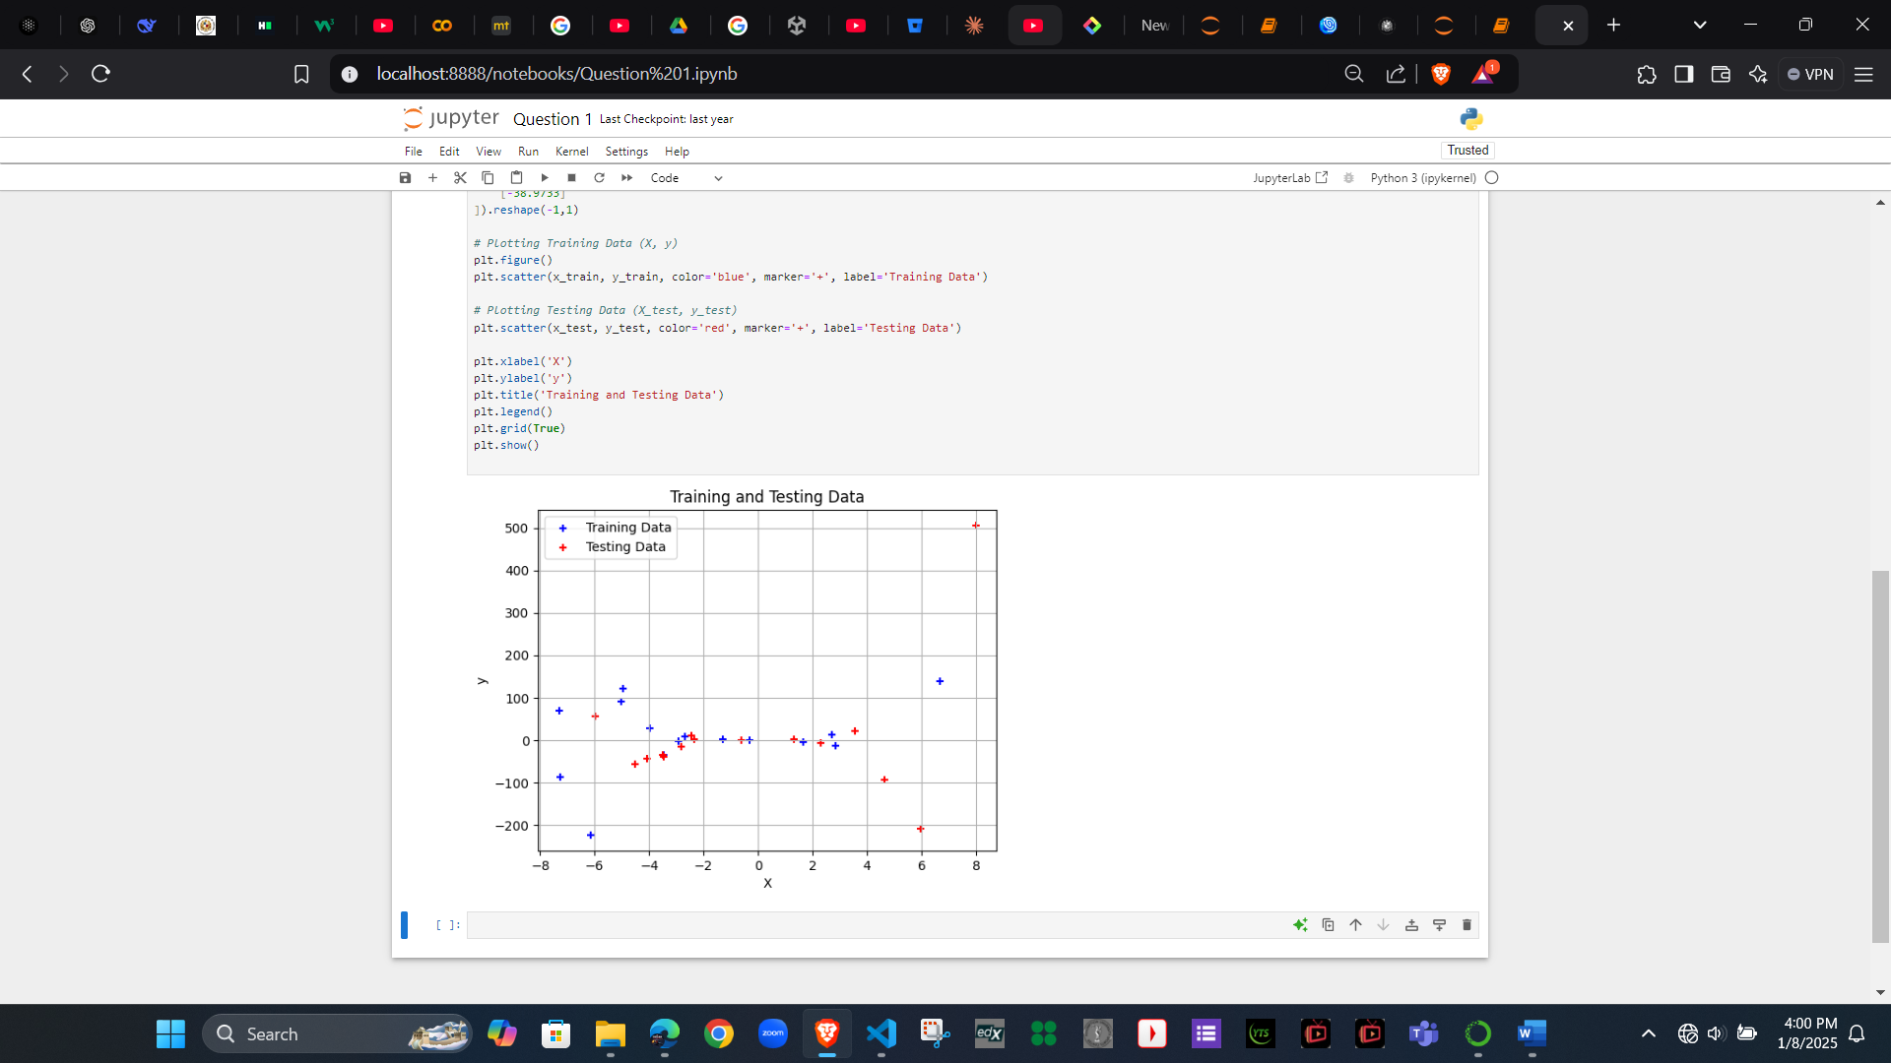

Step 1.2: Feature Transformation
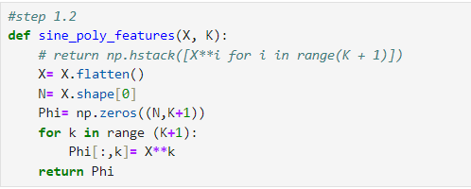
The purpose and the effect of this transformation:
Polynomial transformation enables linear models to fit nonlinear data by adding higher-degree features. It improves flexibility but risks underfitting with low degrees or overfitting with high degrees. The right degree balances accuracy and complexity for better generalization.

Step 1.3: Fitting the model using Maximum Likelihood
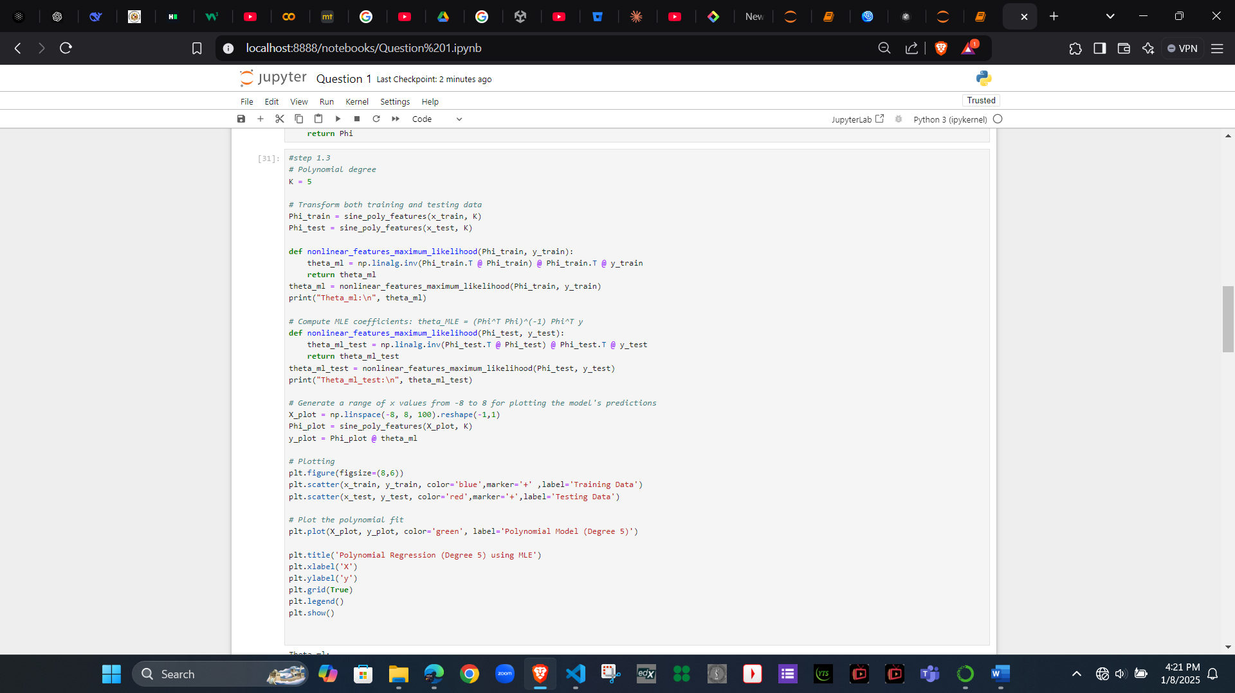
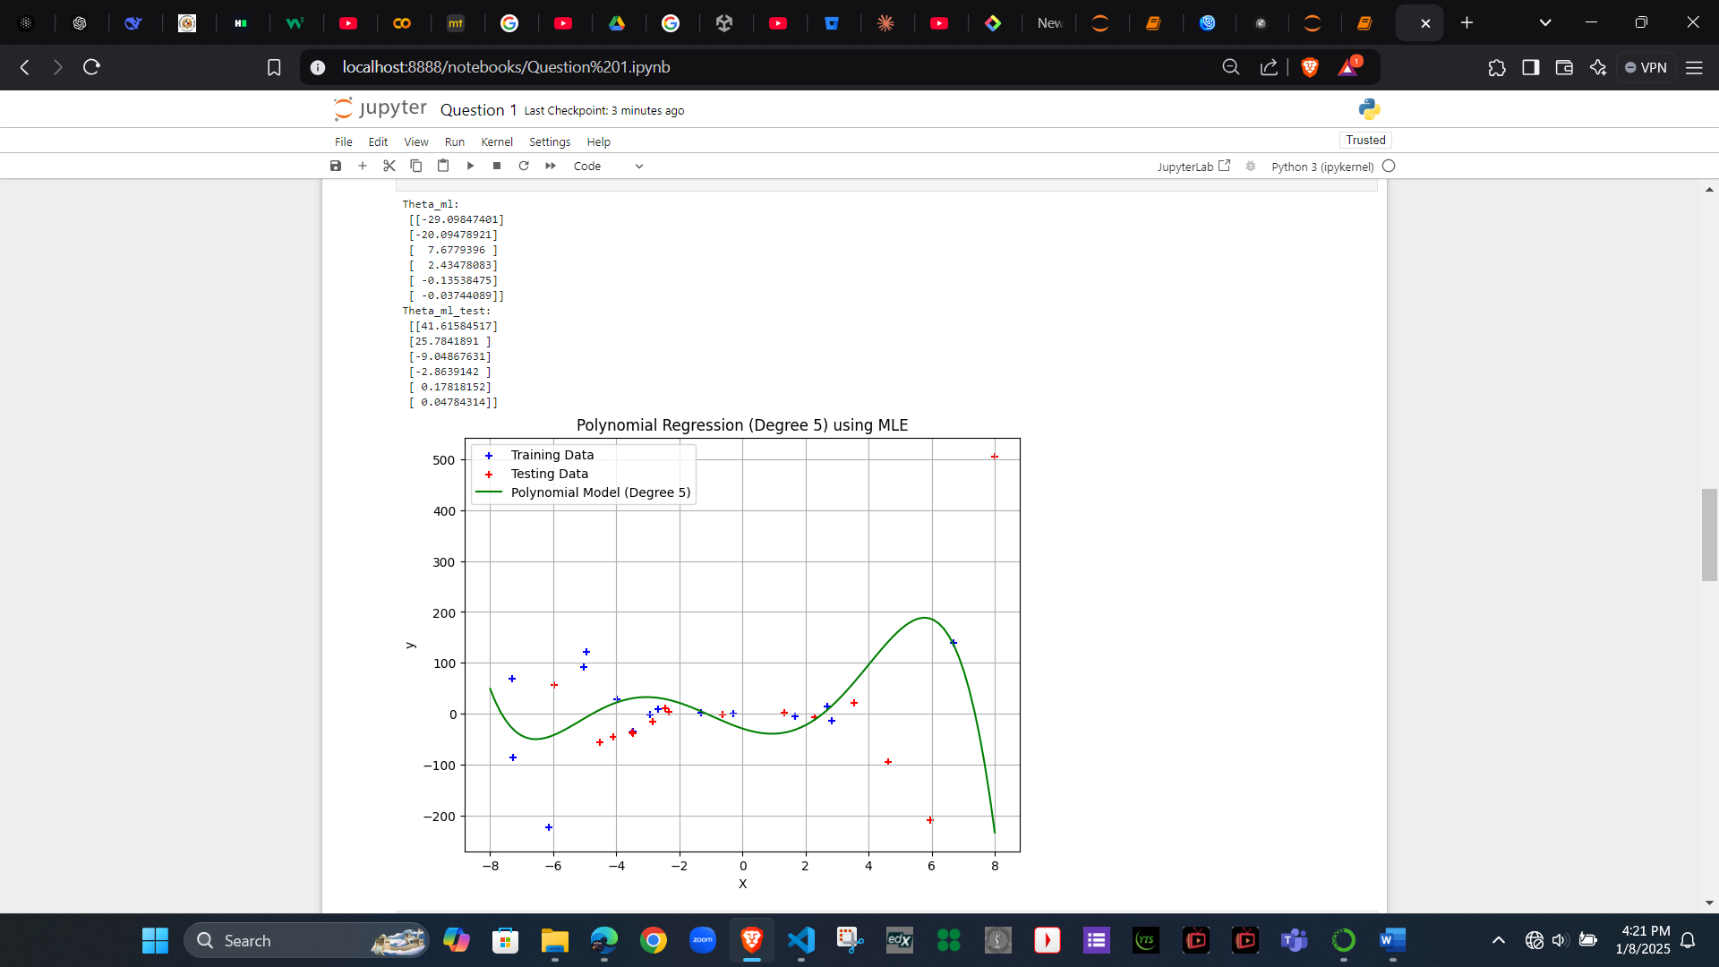

Step 1.4: Model Evaluation
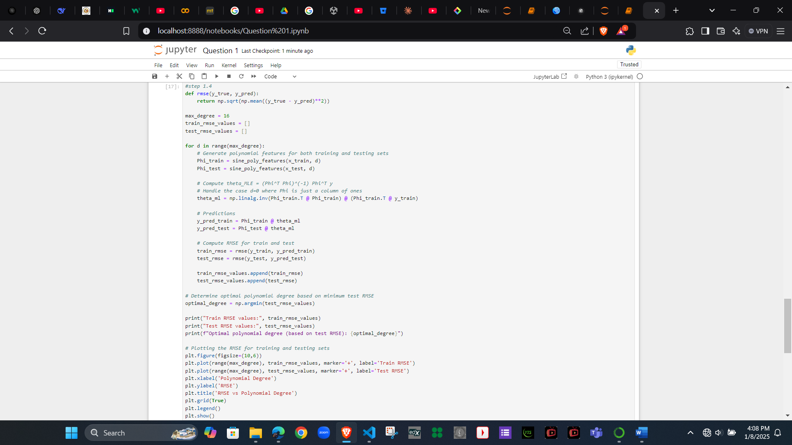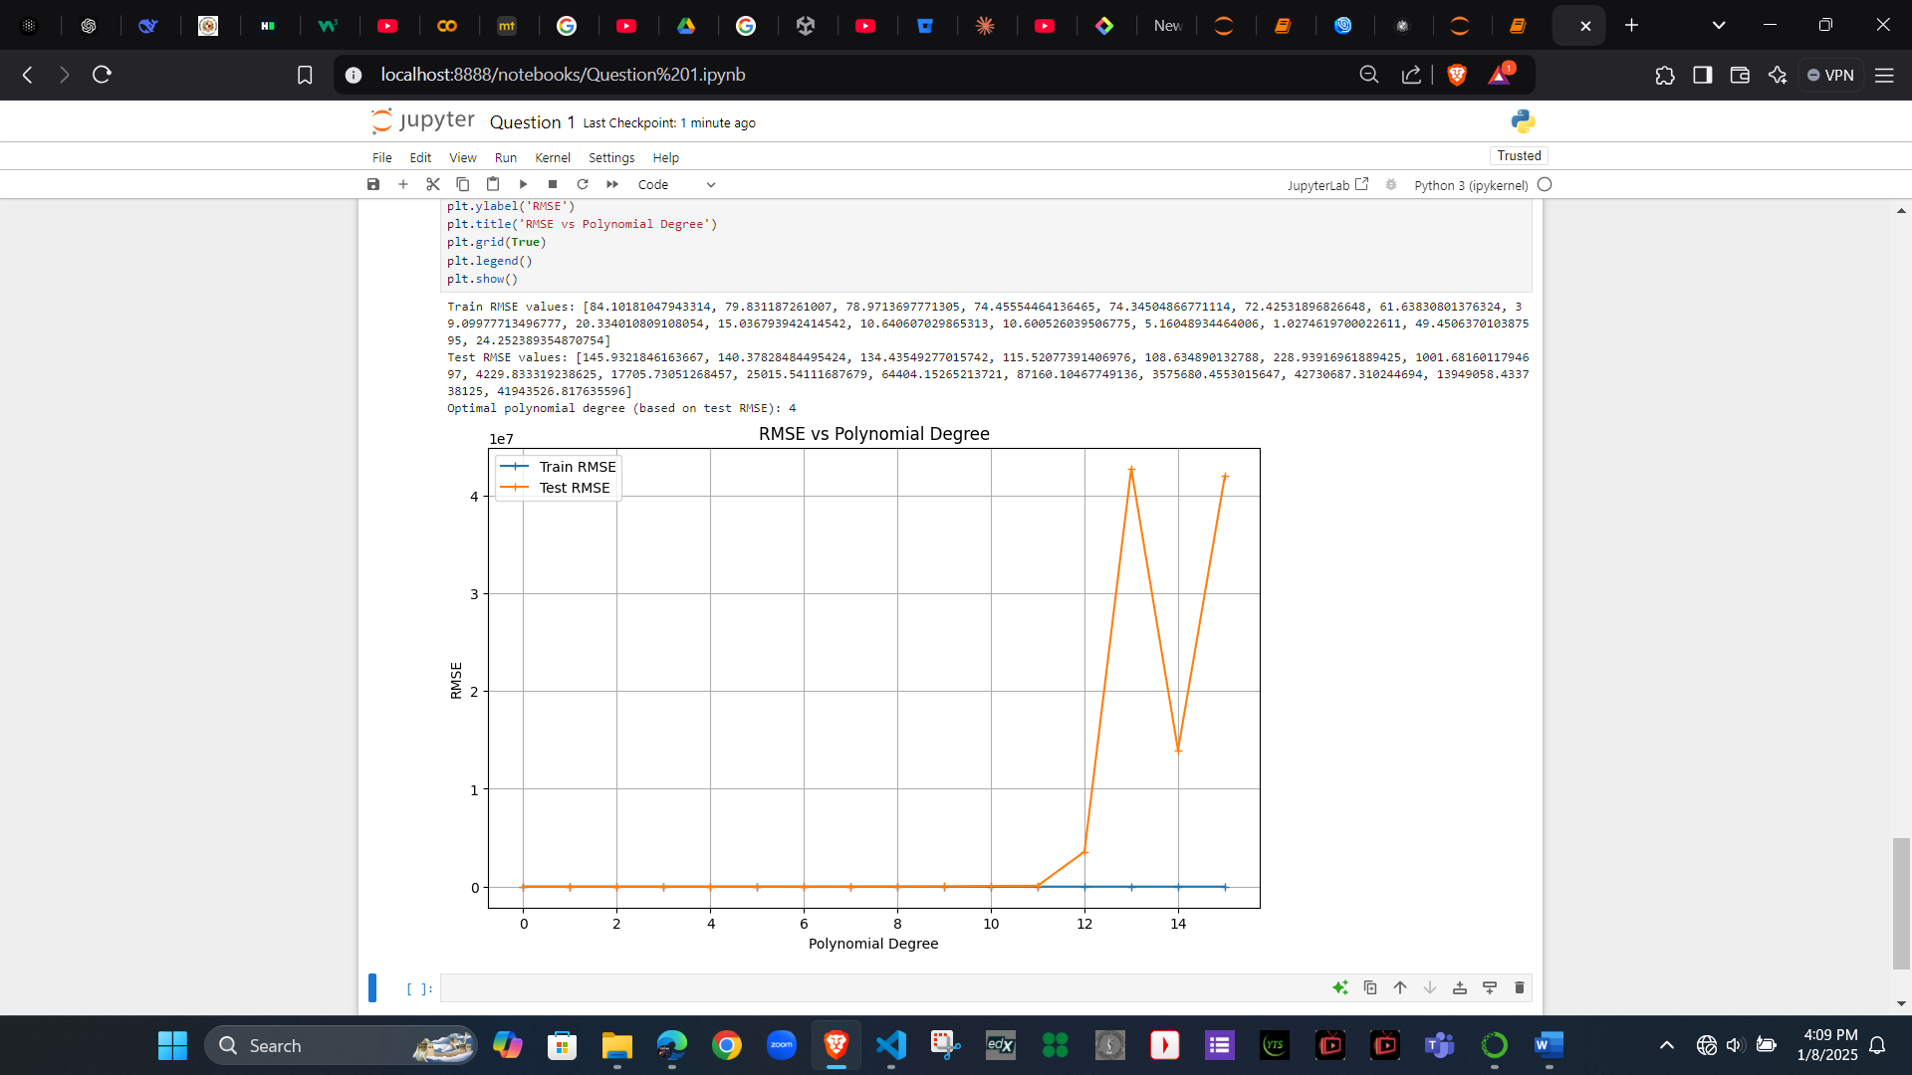
Train RMSE values: [84.10181047943314, 79.831187261007, 78.9713697771305, 74.45554464136465, 74.34504866771114, 72.42531896826648, 61.63830801376324, 39.09977713496777, 20.334010809108054, 15.036793942414542, 10.640607029865313, 10.600526039506775, 5.16048934464006, 1.0274619700022611, 49.450637010387595, 24.252389354870754]
Test RMSE values: [145.9321846163667, 140.37828484495424, 134.43549277015742, 115.52077391406976, 108.634890132788, 228.93916961889425, 1001.6816011794697, 4229.833319238625, 17705.73051268457, 25015.54111687679, 64404.15265213721, 87160.10467749136, 3575680.4553015647, 42730687.310244694, 13949058.433738125, 41943526.817635596]
Optimal polynomial degree (based on test RMSE): 4

Step 1.5: Selecting the best model
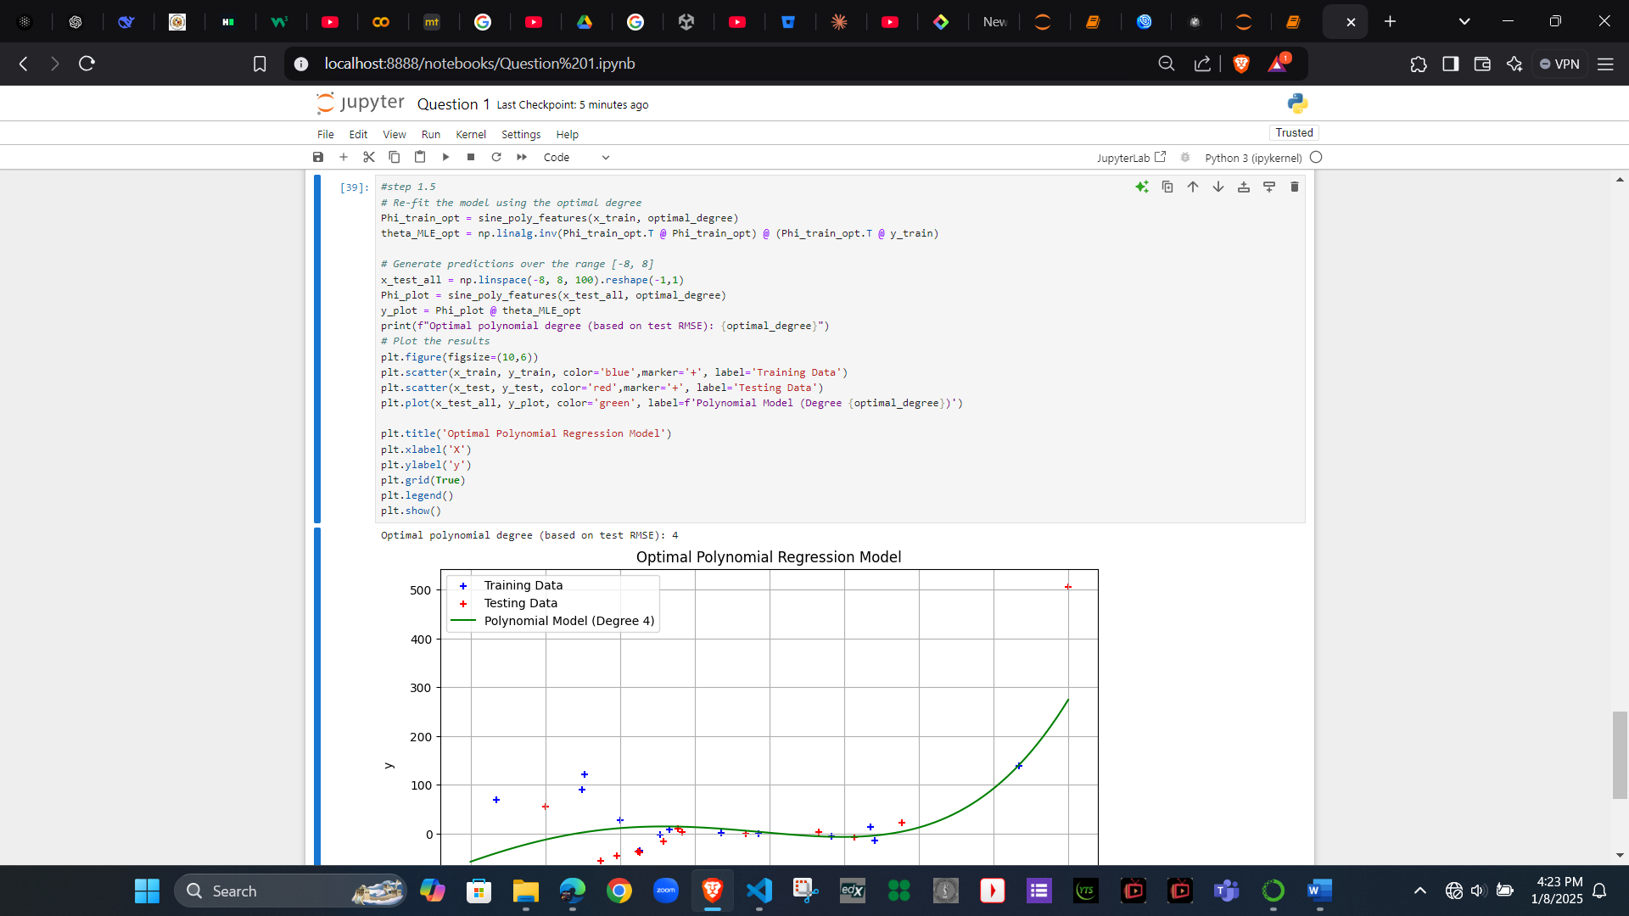
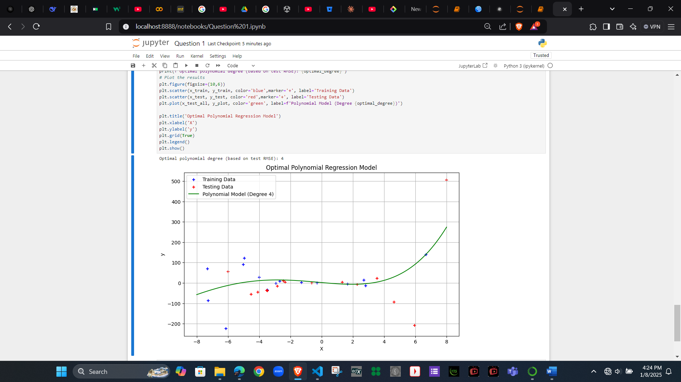
Why was this degree optimal?
- The optimal degree minimizes the RMSE for the test dataset, striking a balance between underfitting (too simple) and overfitting (too complex).
- Degrees that are too low (e.g., 0 or 1) underfit, being too simple and cannot catch the small details in the data, so they don’t fit well.
- Degrees that are too high (e.g., >10) overfit, capturing noise rather than the true relationship.
Model Complexity and Overfitting/Underfitting:
- Lower degrees: Underfitting, as the model cannot capture complex patterns.
- Higher degrees: Overfitting, as the model tries to fit every data point, including noise.
- Optimal degree: Provides the best generalization for unseen data (test set).

Question 2:
Step 2: Feature transformation
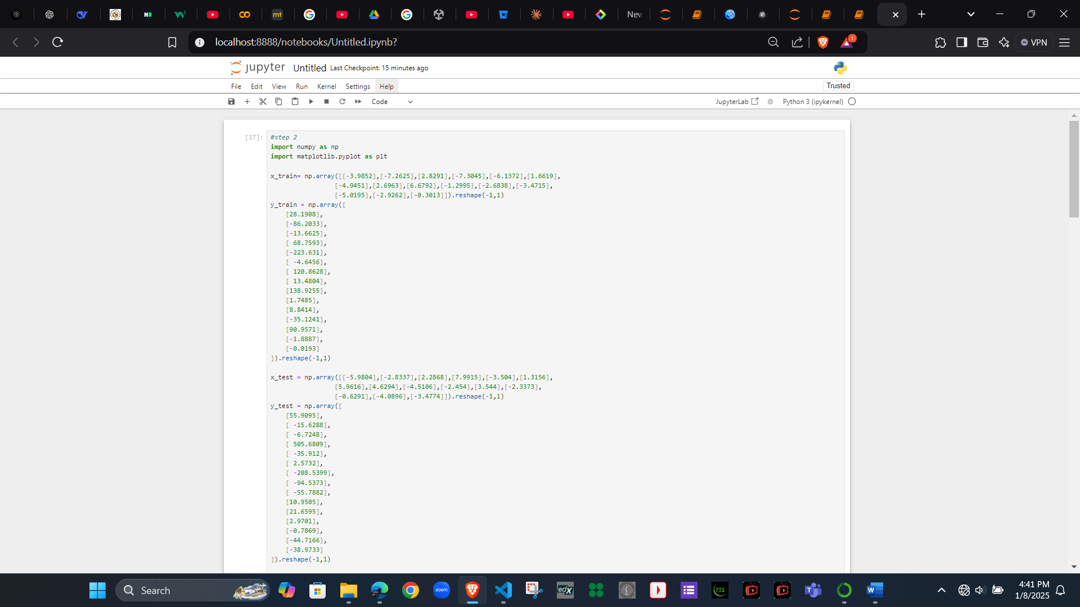


Step 3: Implement gradient descent
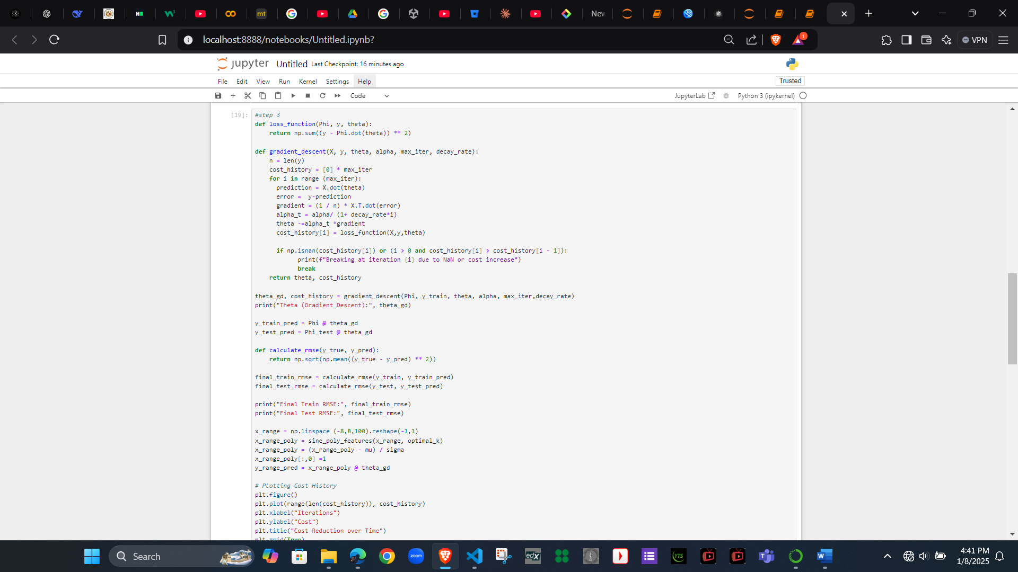
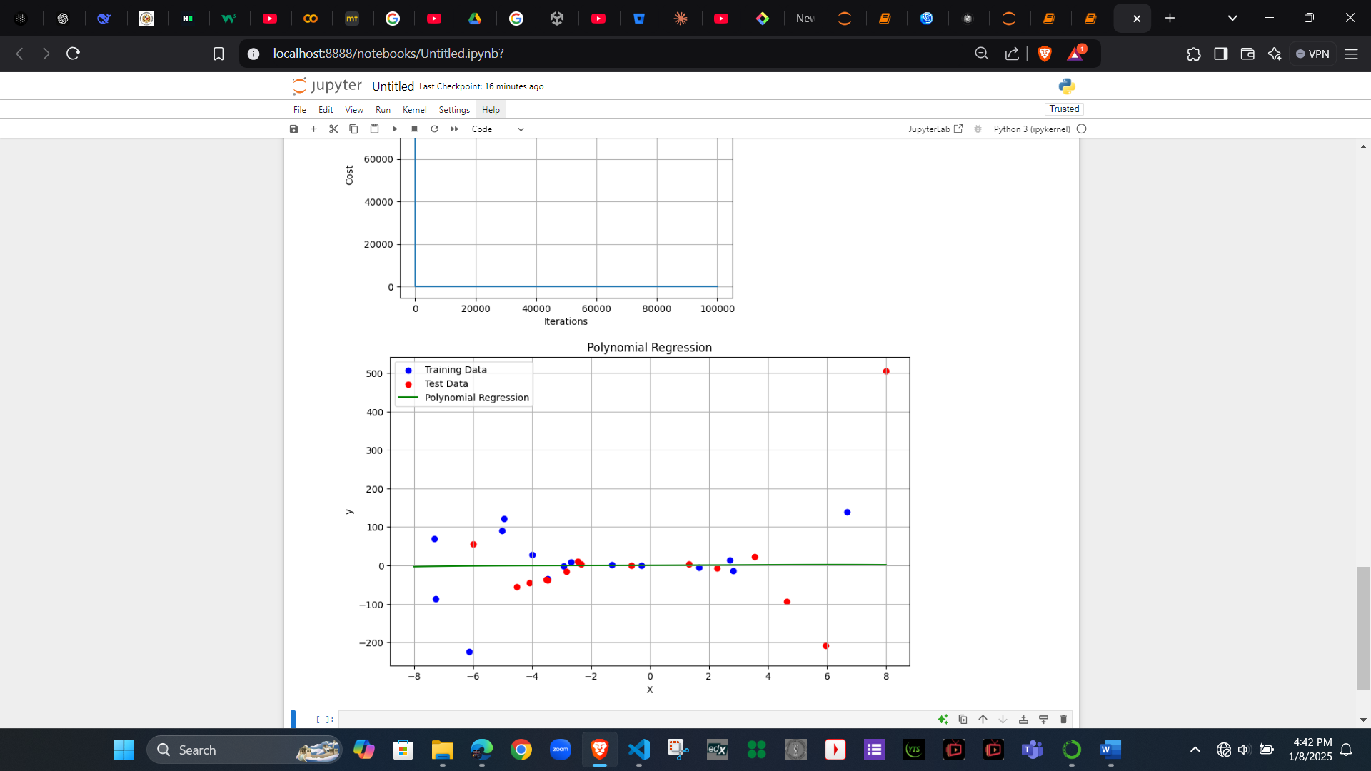

Step 4: Model Evaluation and Comparison
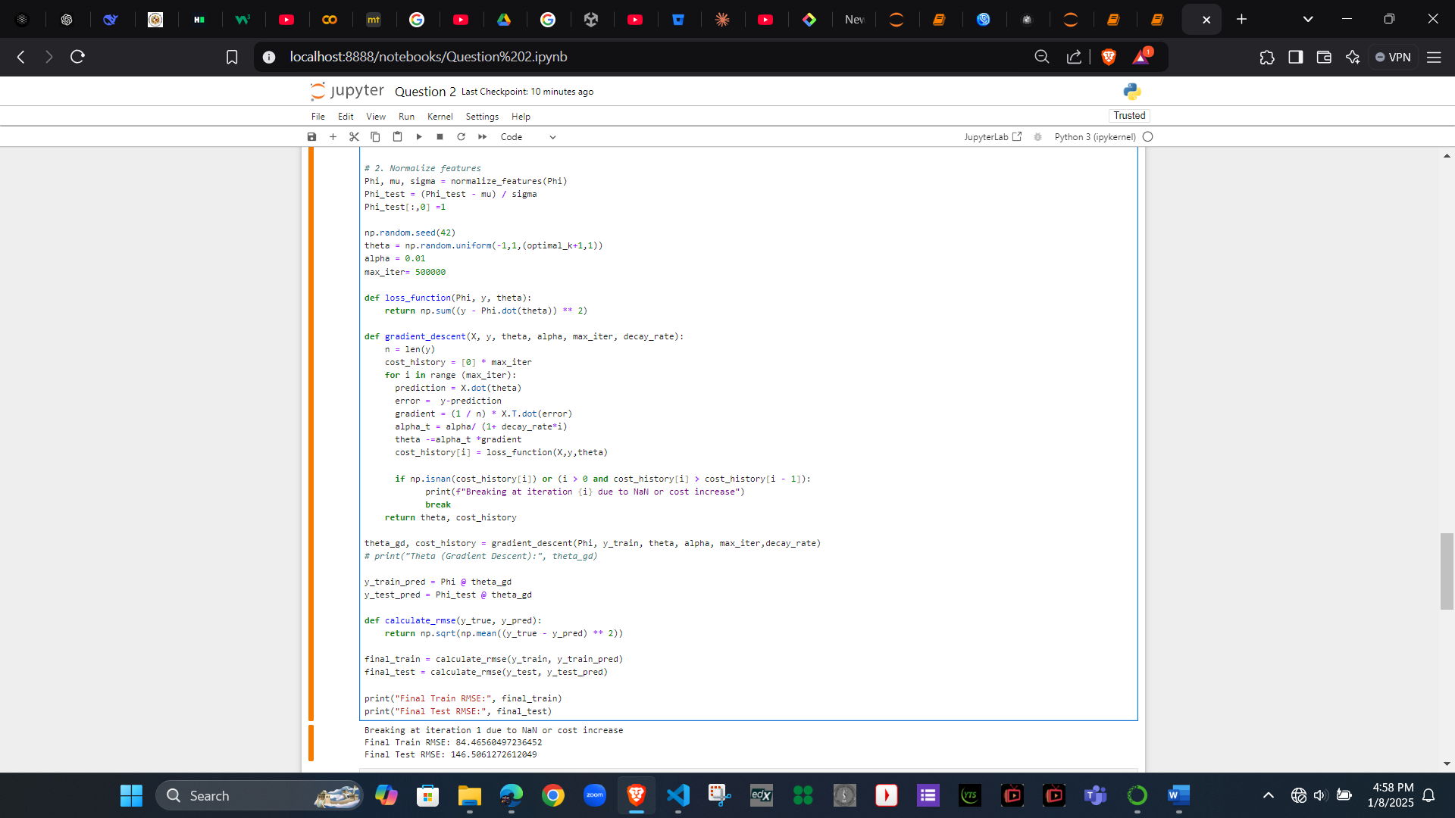

Step 5: Code and analysis

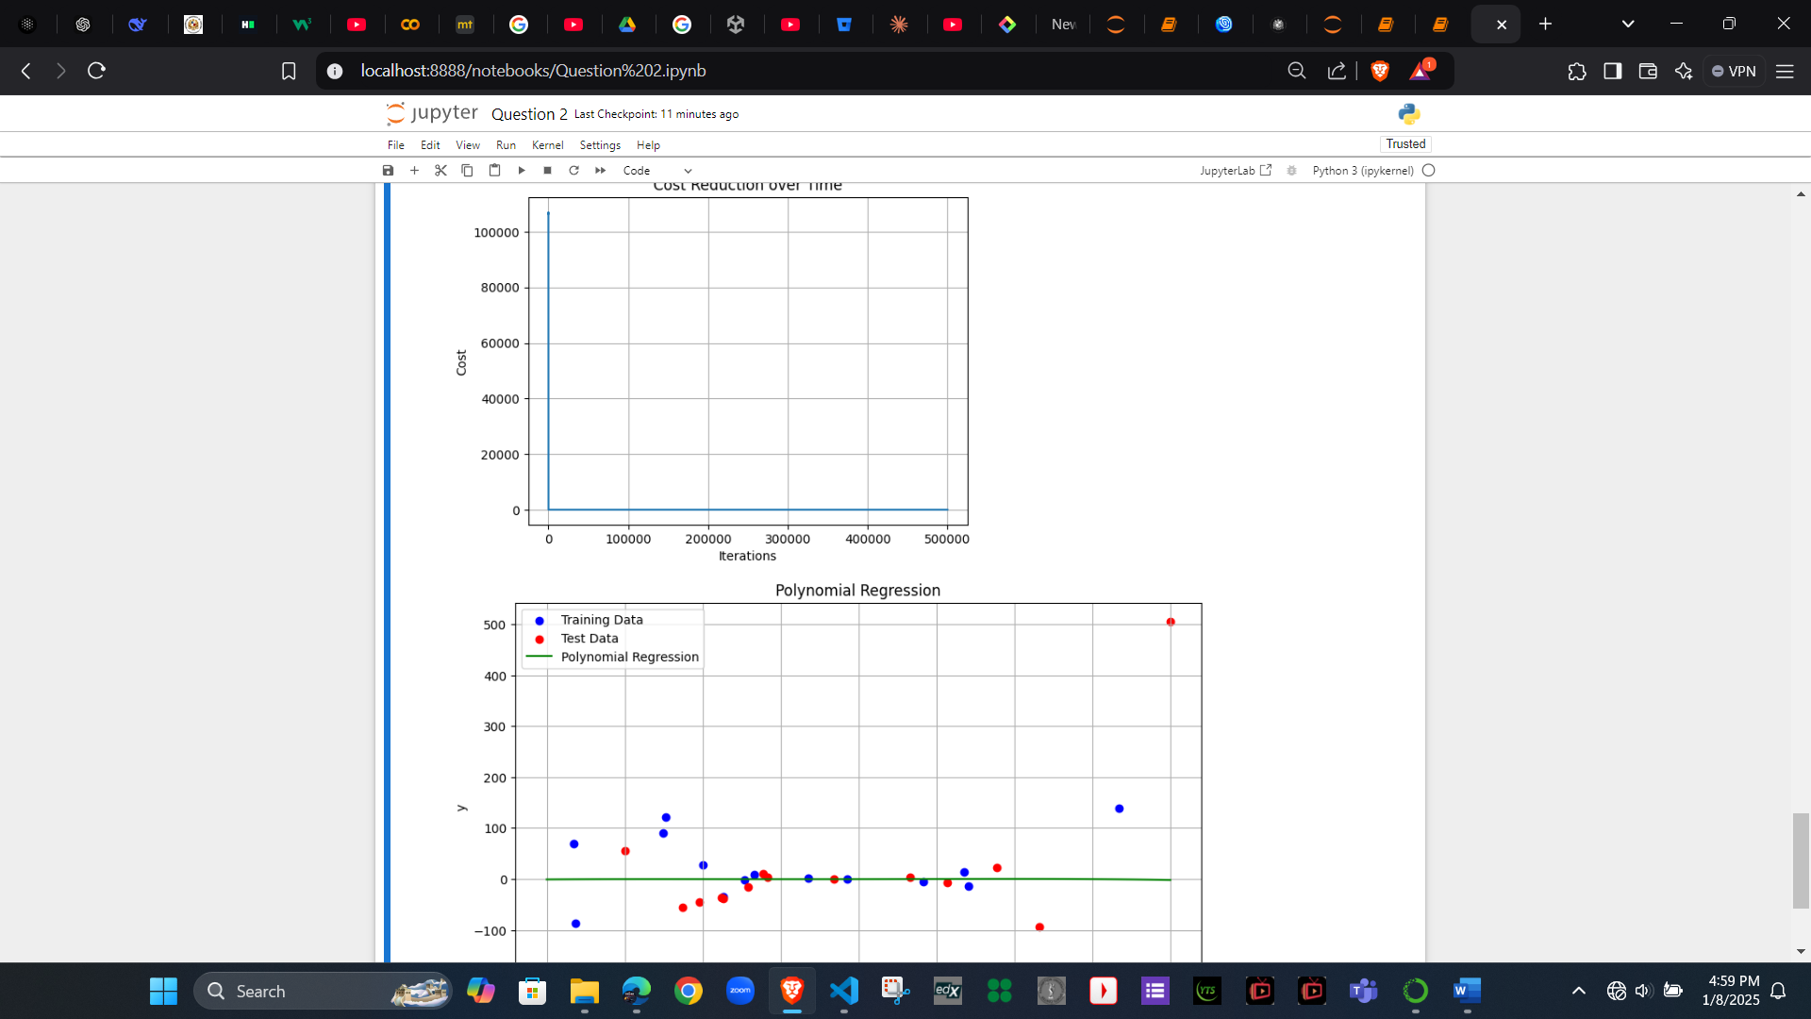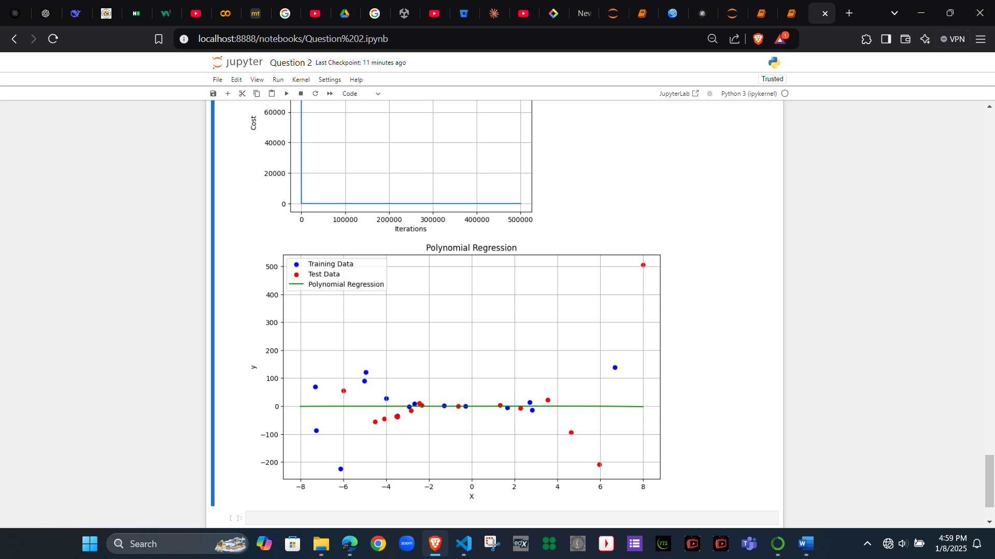

Question 3
K- means and DB scan clustering
Step 1: Visualize Data Before Clustering
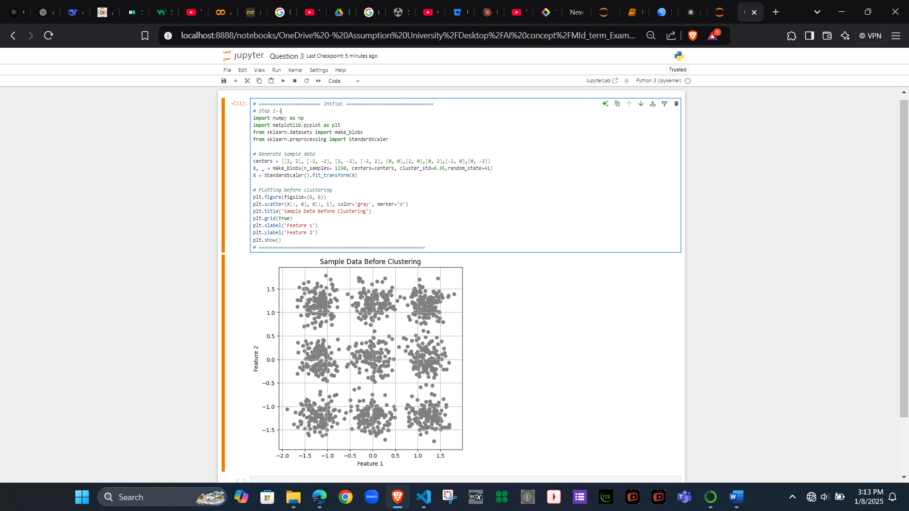

Step 2 : Implement K-means Clustering and Determine Optimal Clusters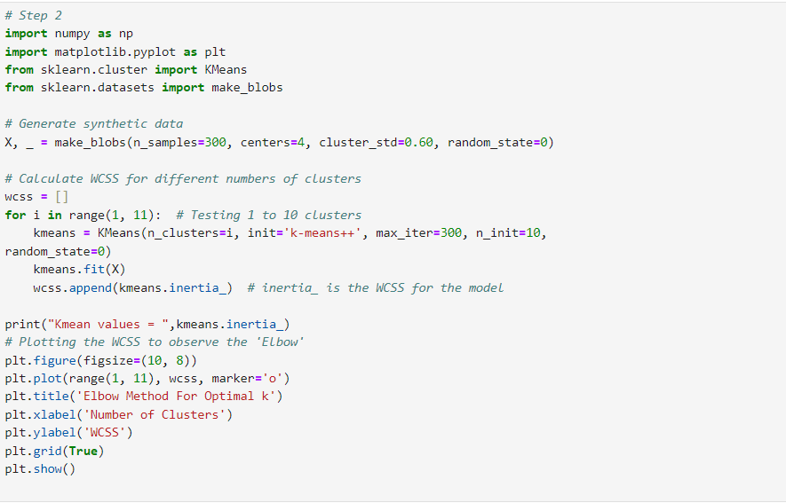
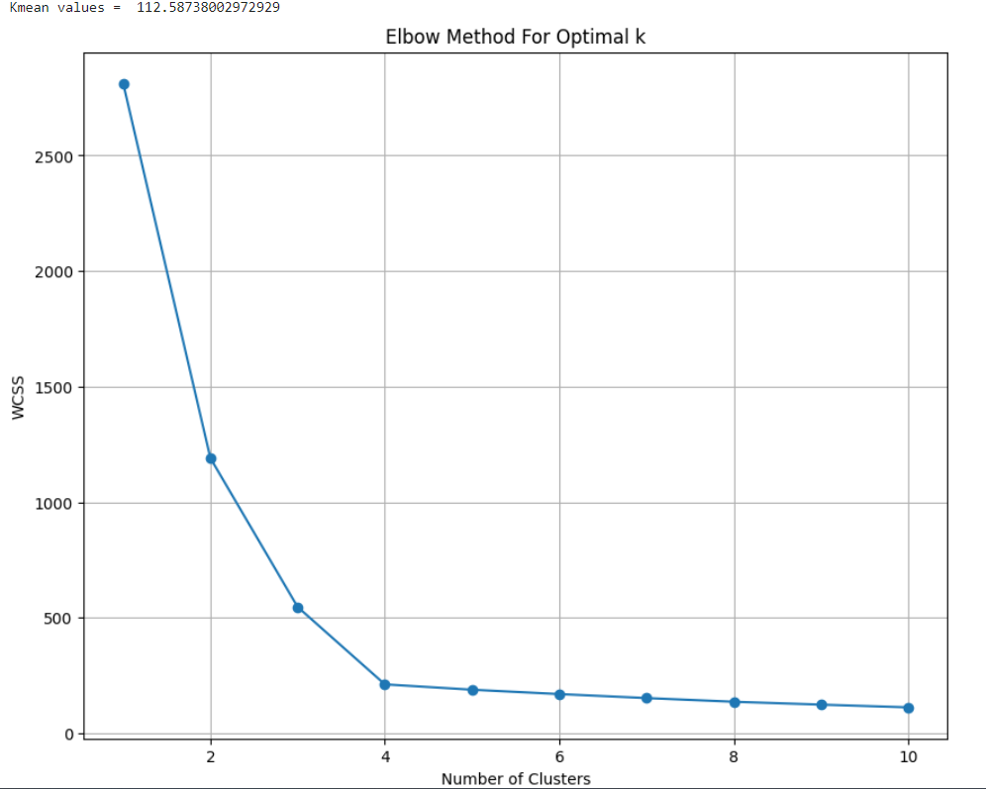
Kmean values = 112.58738002972929

Step 3: Visualizing Data After Clustering
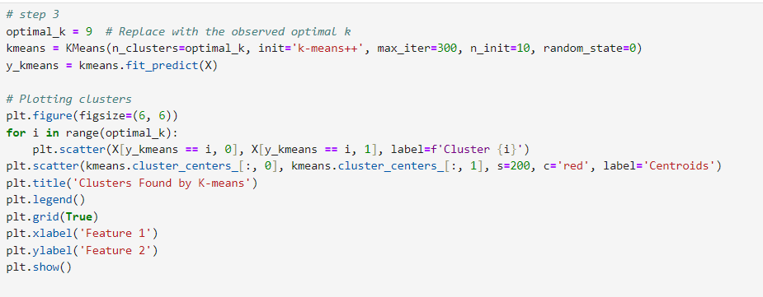
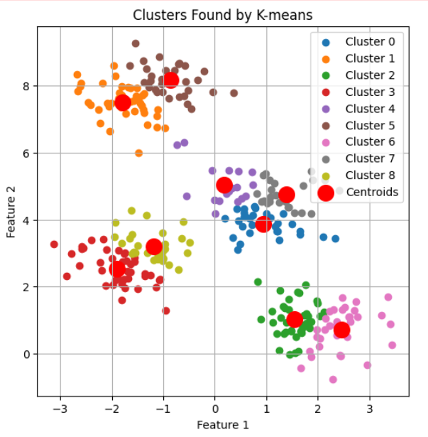

Step 4: Applying data from step 1 with DB scan
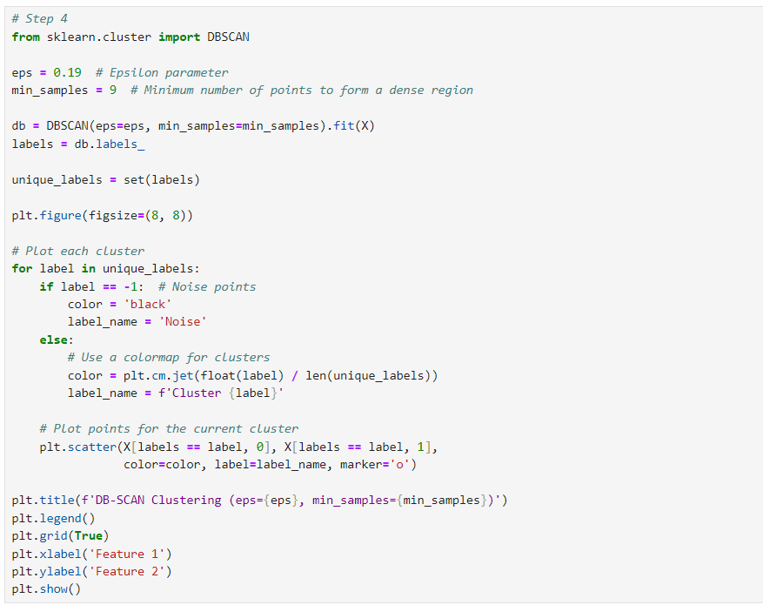
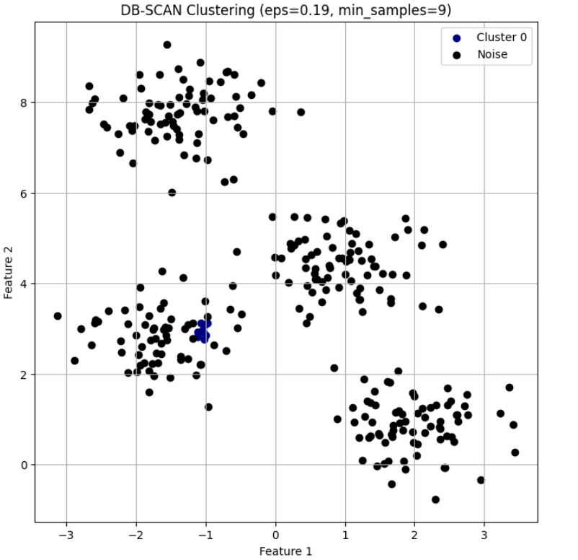

Step 5 : Interpret the results
Interpretation of Results: K-means vs. DB-SCAN
- K-means Clustering:
  - Output: K-means groups the data into a predefined number of clusters (k). It assigns every data point to the nearest cluster center.
  - Visualization: You can observe well-separated clusters if the data is spherical and evenly distributed.
  - Key Observations:
    - K-means successfully clustered the dataset into distinct groups when the clusters were clearly separated.
    - It assigned all points to clusters, meaning no noise was detected.
    - The elbow method was helpful in determining the optimal number of clusters.
- DB-SCAN Clustering:
  - Output: DB-SCAN forms clusters based on density and marks points that don't belong to any cluster as noise (-1).
  - Visualization: DB-SCAN effectively separated clusters and identified outliers or noise points in the dataset.
  - Key Observations:
    - DB-SCAN handled non-spherical clusters well and separated clusters based on density rather than distance from the center.
    - It detected noise in areas where the density was too low to form a cluster.

Pros and Cons of Each Algorithm:
- K-means Clustering:
  - Pros:
    - Fast and computationally efficient for large datasets.
    - Works well for spherical, well-separated clusters.
    - Easy to understand and implement.
  - Cons:
    - Requires predefining the number of clusters (k).
    - Sensitive to initialization of centroids and outliers.
    - Poor performance on datasets with non-spherical or overlapping clusters.
- DB-SCAN Clustering:
  - Pros:
    - Can detect clusters of arbitrary shapes.
    - Identifies noise and handles outliers effectively.
    - Does not require the number of clusters to be predefined.
  - Cons:
    - Sensitive to the choice of eps and min_samples parameters.
    - Struggles with datasets that have varying densities.
    - Computationally expensive for large datasets.
Additional code :
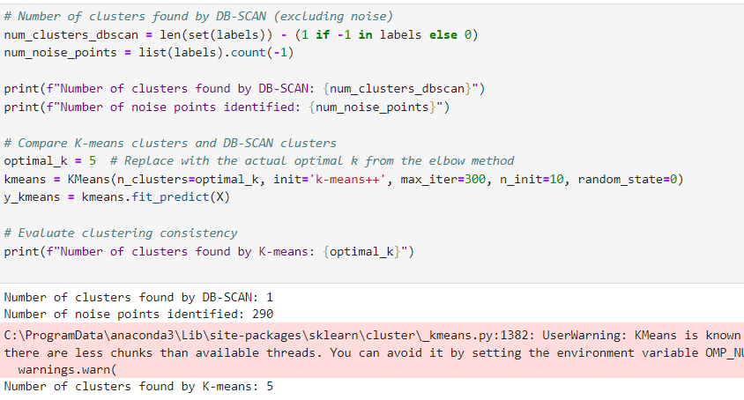
Number of clusters found by DB-SCAN: 1
Number of noise points identified: 290
Number of clusters found by K-means: 5

