A Review on Latest Trends in Development of Remotely Operated Marine Robots.

*Yelagandula Vineeth*

*Computer Science and Engineering, Sreenidhi Institute of Science and Technology,*

*Hyderabad, India* [*vineethyela*](mailto:vineethyelagandula9901@gmail.com)[*gandula9901@gmail.com*](mailto:gandula9901@gmail.com)

*Vishnu Vardhan Julakanti Computer Science and Engineering, Sreenidhi Institute of Science and Technology,*

*Hyderabad, India* [*vishnu.julakanti@gmail.com*](mailto:vishnu.julakanti@gmail.com)

*P. Saikrishna*

*Electronics and Communication Engineering, Sreenidhi Institute of Science and*

*Technology,*

*Hyderabad, India* [*Saipr*](mailto:Saiprathapaneni23@gmail.com)[*athapaneni23@gmail.com*](mailto:athapaneni23@gmail.com)

*D. Ajitha*

*Electronics and communication engineering, Sreenidhi Institute of Science and Technology,*

*Hyderabad, India* [*ajithad@sreenidhi.edu.in*](mailto:ajithad@sreenidhi.edu.in)

*Bhuvan Pratap Agarwal Computer Science and Engineering, Sreenidhi Institute of Science and Technology,*

*Hyderabad, India* [*bhuvanpratapa*](mailto:bhuvanpratapagarwal@gmail.com)[*garwal@gmail.com*](mailto:garwal@gmail.com)

*Joydeb Chattopadhyay Electronics and communication engineering,*

*Sreenidhi Institute of Science and Technology,*

*Hyderabad, India* [*chattopadhyayd@sreenidhi.edu.in*](mailto:chattopadhyayd@sreenidhi.edu.in)

***Abstract*—Abstract— oceans, seas, and enormous water bodies have always been a long unexplored piece of area, which in recent years has taken its place for exploration because of sophisticated marine robots (ROUV – remotely operated underwater vehicles and UUV – Unmanned underwater vehicle or Autonomous underwater vehicle/AUV- Autonomous underwater vehicle) that are developed in recent years. This paper explores the growth of marine robots and analysis of the key concepts of controllers, navigation algorithm, power systems employed, sensor network, and other key concepts of ROUVs and UUVs which have a significant growth in recent years as development in AI, Big data, greater computational capabilities of the embedded systems increase. Finally, a comparative analysis of some of the recent robots is mentioned in this paper.**

***Index Terms*—component, formatting, style, styling, insert**

***Keywords — marine robots, ROU, UUV, AI, Embedded systems.***

1. INTRODUCTION

Marine technology has been developing from the ages for deep-water explorations and other forms of analysis of large water bodies. Aquatic conditions have never been easy for inquiry tasks, and a lot of research has been put in recent years, to explore the oceans and seas in harsh climatic conditions. ROUVs and UUVs have substantial applications in surveillance, ocean exploration, pollution monitoring, sea patrolling etc. The deep-water quest is one of the essential applications for which the research has picked up the pace in recent years. Marine robots are the composition of many different aspects of navigation, processing systems, power systems, and sensor systems that should work together to give the preferred output they are intended to provide. Large water bodies have turbulent waters, making it difficult for exploration, monitoring, and other related tasks of UUVs and ROUVs; a control system should adjust itself for such

turbulence, complications to complete the trajectory designed for it. Power systems play one of the crucial roles because of the complicated situations present underwater; sensor systems are used with both trajectory planning and ocean monitoring, making them one of the vital onboard equipment. Much research has been employed in the design and construction of ROUVs and UAVs due to the complex environment they are placed in and the harsh environments of substantial water bodies such as oceans and seas. A lot of research has been employed with the help of an equipped gripper that can grasp an object and the camera sensors along with it [1]. In these designs, additional equipment is required for trajectory maintenance and stability of the system because of the adverse conditions of the ocean, which were mentioned earlier. The dynamic equilibrium is achieved with the help of sensors that maintains the precise position of the entire UAVs and ROUVs and shall be achieved through INS (inertial navigation systems), PIDs (Proportional integral derivative systems), ARC (Adaptive robotic control), Intelligent automated control or smart mechanical control [2][3].

1. LITERATURE REVIEW

Underwater vehicles have been here around since the 1990s and have been under constant development since then. The development of UUVs and ROUVs has become a challenge due to the unpredictable changes that induce turbulence throughout the ocean, making it difficult for UUV or ROUV to carry out the assigned work. A significant part of development came in recent years due to their growing importance in defense, commercial use, and growth of research, in recent years. figure1 shows the trend in UUVs and ROVs growth in market size [4]. Recent growth in terms of various technologies in UUVs and ROUVs is presented and reviewed. Underwater

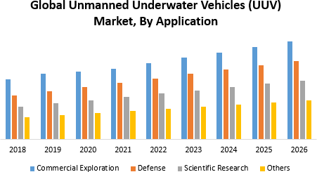

Fig. 1. trend in market size of UUVs and ROVs [4].

vehicle building started way back in 1953 when Dimitri Rebikoffin developed the 1st fully functional underwater vehicle. From the 1st UUV to the latest intelligent UUVs created, a lot of technological change and research is put in for innovating such robots. Figure 2 shows the significant types of underwater vehicles available today and a detailed analysis of factors required to create these projects in other sections. Recent advancements

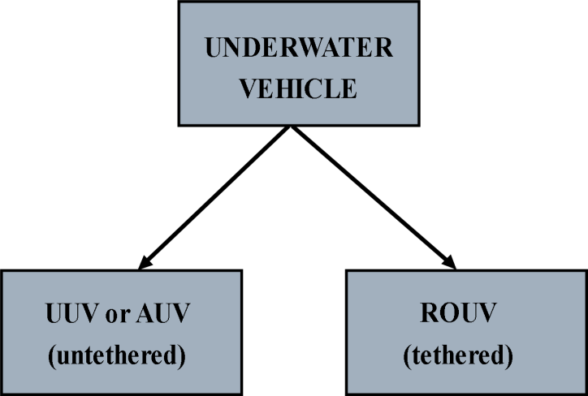

Fig. 2. major types underwater vehicles

and improvements include the creation of intelligent dynamic controller, high accurate sensor system, efficient power supply, dynamic propulsion system, sensing agents, and effective control of mechanical, software aspects of robotic systems that have been improving and developing in the field of ROUV and UUV one such project is object avoidance using RNN (Recurrent Neural Networks) along with CNN (Convolution Neural Networks) by Changjian Lin [5]. This project shows how the development in intelligent control systems, in this case, the result of an object avoidance system, can be achieved with the help of NN (Neural Network). Stabilization is also one of the main problems that are encountered in recent times

wherein intelligent stabilization could be achieved through ANN (Artificial Neural Network); the paper analyzes how external disturbances could be an input to the neural net, and necessary adjustments could be made with the output of NN [6]. Internet of Underwater Things (IoUT) has become popular with the recent data explosion and need of data in recent years, which relies on the Underwater Acoustic wireless Sensor Networks (UASN); an efficient path planning algorithm has been developed for data collection and energy usage reduction using clustering algorithms [7]. Another algorithm based on reinforcement learning which takes sensor data as input and outputs continuous surge force and yaw moment [8]. Propeller systems play an important in the tasks of completing the recent trajectory developments in propulsion system for UUVs which deals with fault diagnosis in propeller systems using deep learning has been developed [9]. These recent developments have been paving paths for advanced futuristic UUVs and ROUVs

1. MAIN FEATURES OF UUVS AND ROUVS
2. *Design of the UUVs and ROUVs*

The design of the vehicle depends on many factors. The main problem regarding underwater vehicles is the shape of the vehicle, which decides how easily it can move through and in water and also determines the fluid resistance or “drag” acting on the vehicle. Greater the drag, greater the turbulence which would put pressure on the fuselage of the vehicle. The turbulence may also affect the data collection of the AUV, as it may cause tremors throughout the bot. For camera-based application this is a huge threat, so the design of the vehicle is done generally fluid dynamic. Commonly used shapes are the torpedo or the curved rectangle shaped. Curved-rectangle shape objects also reduce drag but not as much as the torpedo shaped objects. The torpedo design which is frequently used in the designing of the UUVs and ROUVs will make the vehicle more fluid dynamic. To maneuver the vehicle in four degrees of freedom for this, many of the applications seen here may have extra motors or diving planes which use the dynamic lift concept to realize degrees of freedom. For the sinking and rising of the vehicles we need to increase and decrease the density of the bot. For many applications, we see widespread use of the ballast tank method, which uses water to fill the ballast tanks and increase the mass of the vehicle which helps it sink into the water. The other widespread method is to use a vertical thruster for making the bot sink into the water. The recent trends of the design have been referred here to compare and analyze the designs of the following vehicles which are used. The first reference is having a cuboidal design which takes ROV from the BlueROV2 designed by the Blue Robotics company. The BluROV in design figure3 used the extra thrusters to maneuver the bot sideways and forwards and backwards for the sinking and rising motion this design uses the ballast weights to ensure the weight of the bot is more than the buoyancy provided by the water. The weight plays a crucial role in the sinking of the vehicle as greater the weight, denser the vehicle becomes thereby increasing the buoyancy force acting upon the vehicle.

[10]. The design in fig5 by uses big dynamos which are there for using the water currents to turn the dynamos which in turn produces power. This design of the bot is almost like a torpedo shaped with the diving planes which consists of the dynamos, this design is inspired by the design of a submarine and also shares the same concepts like streamlined body which reduces drag [11]. This design in fig 4 is inspired by the commercial aircraft method which has wings or diving planes in this case and a fin which helps it to move in all directions. This kind of design uses the concept of dynamic lift where the vehicles wings control the amount of fluid under the vehicle or over the vehicle which helps it to move upwards or downwards [12].

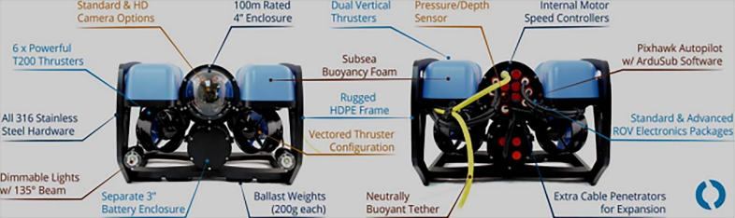

Fig. 3. The BluROV2 which is a design used in the development of a Small-sized Autonomous Underwater Vehicle Architecture for Regular Periodic Fish-cage Net Inspection.[13]

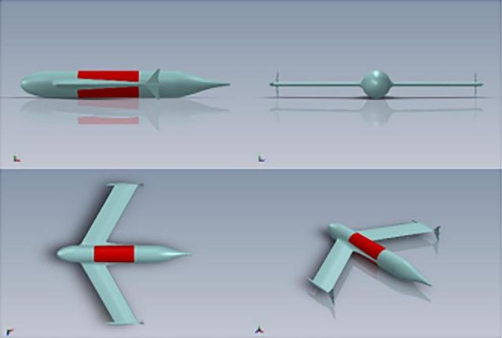

Fig. 4. SQUID TUG (Tailless Underwater Glider) view.[12]

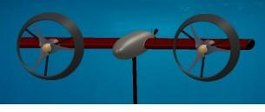

Fig. 5. Conceptual design of the autonomous underwater vehicle mounted ocean current turbine.[11]

1. *Control systems*

The control system for an AUV or an ROV is fundamental as it is required to control the AUV or the ROV. Generally,

the control system is responsible for the navigation and the movement of the vehicle. It is used to contact the base station in case of autonomous or remote vehicles. The control system can be of many types; the processor power and capabilities can be chosen according to the vehicle’s primary purpose of functioning. For example, Many ROV and AUV applications depend on the OpenCV capabilities and use machine learning algorithms to analyze the area underwater. It is well known that this process requires a considerable demand of processing for power. Therefore, those applications with higher-end control systems such as the NVIDIA TX2 are suitable for applications like the OpenCV application discussed before. To facilitate online deployment, the algorithm is deployed on a portable machine such as the NVIDIA TX2 or the Intel neural compute stick. The system can achieve 12 frame per second on Nvidia TX2[11]. In fig 6, the control system design is depicted.

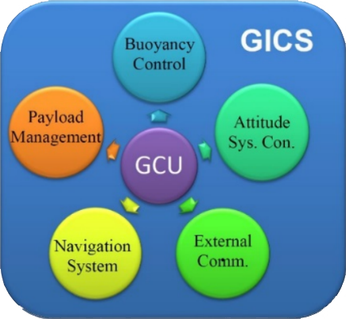

Fig. 6. The above figure uses the control system architecture which is used to handle multiple processes which are used in the navigation, and movement of the bot. [12]

1. *Sensor Networks*

A sensor network plays a crucial role in the collection of data which the control system could use for navigation, trajectory, and planning where each sensor observes data in different locations and then sends the data to a storage unit for storage and analysis. Sensor network controls nodes that cooperatively

sense and control the environment. They enable interaction between people or computers with the environment. Sensor networks are wired or wireless. Wired sensor networks utilize ethernet cables to connect sensors. Wireless sensor networks (WSNs) use Wi-Fi, near field communication (NFC), etc., to connect sensors. Sensor networks are often installed under challenging environments to monitor structures and infrastructure.

An ROV camera allows users to see underwater to perform the specific purpose of collecting high-definition images that aid scientific research and undertake various tasks, including inspection, retrieval, and observation, among other applications. It can also help in maneuverability in case of manual operation of the underwater vehicle. ROVs can deploy passive sound monitoring sensors to detect environmental noise and monitor vocalizing marine fauna or evaluate changes in the ecosystem that are apparent in the soundscape. Hardware such as the differential GPS, gyroscopes, and acceleration sensors, is used to combine information to refine the positional accuracy. At the front, there is a dome a contains the sensors kit. A computer manages the collected data. For visual assessment and object detection at a distance, a digital camera is used. On the bulkhead, a 106 candle and a flat LED have been mounted. In the case of turbid waters, where it isn’t easy to see, lighting plays a crucial role in detecting objects [14]. The SICK LMS511 LIDAR is equipped with a rotating mirror mechanism, which deflects the emitted laser beam. LIDAR allows for time-of-flight calculation, where time-of-flight is a method for measuring the distance between a sensor and an object and gives a 2D slice of the environment. In the case of unsuitable weather conditions such as rain, the laser beam will most likely be reflected by a raindrop and therefore prevent it from measuring the object of interest with accuracy. A multi-echo LIDAR emits many echoes of the same pulse, which can then be monitored, improving the likelihood of striking the intended target. At a range of 0.8 to 80 m, the LIDAR has a 190° scanning angle and a resolution of 0.166°. The achieved LIDAR accuracies are on the order of 5 cm. [15].

1. *Navigation systems of ROUV/UUV*

Navigation in AUV is a challenging task for achieving high accuracy. There are numerous obstacles to underwater navigation. When a vehicle is submerged, radio frequencies, or electromagnetic frequencies, cannot penetrate the sea surface, making GPS information difficult to receive. Instead of using GPS modules, alternate methods include using the following sensors such as accelerometers and gyroscopes to visualize the vehicle’s orientation. These sensor helps to give an approximate understanding of the position of the vehicle underwater. Auxiliary sensors or other navigation systems, such as a Doppler velocity log (DVL), compass, pressure sensor, global positioning system (GPS), acoustic positioning system (APS), or geophysical navigation system, are often combined with the INS to form an integrated navigation system for end-to-end AUV navigation [16]. The proposed navigation is depicted in fig7. This system helps get the following information from the bot and is run through the Kalman filter, giving an approximate position of the vehicle. [17] As shown in Fig.8, These systems have two local (body-fixed) borders and a global frame in north-east-down (NED) coordinates. To estimate the 6-DOF poses of the vehicle and the structure, monocular vision is combined with measurements from navigation sensors such as a Doppler velocity log (DVL) for linear velocity, an inertial measurement unit (IMU) for linear acceleration and angular momentum, and an attitude and heading reference system (AHRS) for roll and pitch angle.

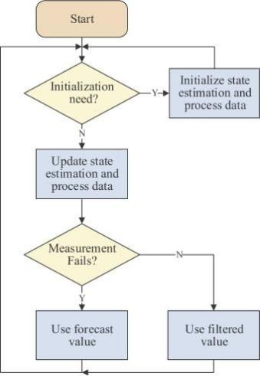

Fig. 7. The kalam adaptive filter flowchart [16]

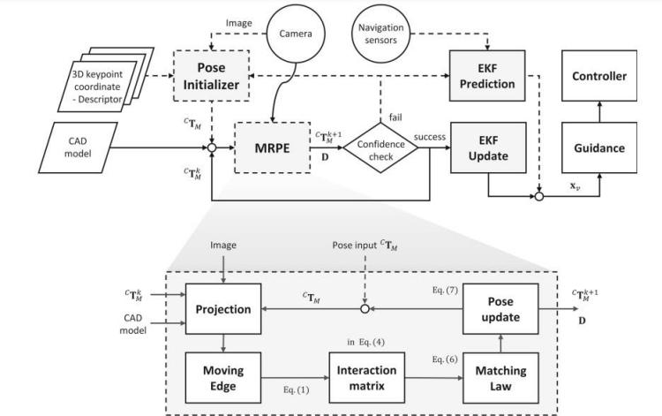

Fig. 8. Navigation systems in [17]

1. *Power Systems*

AUVs and UUVs are powered primarily by gas and chemical batteries and lithium-ion as secondary batteries, which are insufficient to power the vehicle. In order to increase the run time of vehicles, endurance needs to be increased. Fuel Cell Energy Power System (FCEPS) has been found as a viable option for achieving this endurance. Considering the present-day literature, it is found that the present technology being used in the AUVs and UUVs rechargeable batteries are used extensively. [18]

1. *Comparative analysis of latest UUVs and ROUVs projects*

|  |  |  |  |  |  |  |
| --- | --- | --- | --- | --- | --- | --- |
| **S.No.** | **Title** | **Specific**  **Application** | **Algorithm for navigation** | **Controller used** | **Sensor network** | **Power Systems** |
| 1. | Coral  Identification and Counsting with an Autonomous Underwater Vehicle. [10] | Analyze the coral  reef visual data and automating the task of  estimating the population of a coral reef. The modified network identifies and localizes different coral species in an image.[10] | Navigation through a  camera and manual operation. [10] | NVIDIA TX2(controller)  (Portable system). [10] | The data collection for  the following is done with stereo cameras powered by open cv and a complex neural network that determines the coral reef species by localizing it, and it is further tracked. [10] | Cable power  supply. [10] |
| 2. | High Accuracy  Altitude and Navigation System for an Autonomous Underwater Vehicle (AUV) [12] | To design an  underwater glider that is an AUV, by changing  its buoyancy which moves it up and down in the ocean. An underwater glider uses hydrodynamic wings to convert the vertical motion to horizontal, moving forward with meager power consumption. [12] | Figure 9 shows the  navigation algorithm that’s been used for the AUV. [12] | The ancillary systems,  based on the new Raspberry system it contains the INS (Inertial Navigation System) platform, Glider Integrated Control System (GICS), and the radio communication systems (Global Positioning System-GPS, Iridium TX, and HF emergency beacon). The GICS is in charge of all navigation, guiding, and vehicle control tasks. For glider management, a centralised control system called "Glider Integrated Control System (GICS)" was created. The GICS keeps track of the payload's buoyancy and attitude control, as well as the data package it provides and any communications with the "outside world." [12] | Gyros, accelerometers,  servo motors, for trajectory and position optimization Fig shows the sensor network interaction. [12] | Onboard battery  systems. [12] |
| 3. | Designing a  Small-sized Autonomous Underwater Vehicle Architecture for Regular Periodic Fish-cage Net Inspection [13] | Small-sized, low-  cost autonomous devices can offer a lower-cost alternative to the solution, providing  more frequent inspection  and efficient, timely alarming capabilities. [13] | The navigation technique is based on a photogrammetry-based optical recognition/validation system that is applied to a known-characteristics reference target attached to the net. To make measurements from photographs, Photogrammetry techniques are used to reconstruct the motion pathways of designated reference points on any moving object. [13] | The equipment  Configuration follows Pixhawk PX4 with Raspberry Pi3 (Raspbian equipped) for “companion” computer. The communication with the Blue ROV is established via an Ethernet cable under IP protocol. [13] | 3-DOF Gyroscope, 3-  DOF Accelerometer, 3-DOF Magnetometer, Internal barometer, Blue Robotics Bar 30 Pressure/Depth, Temperature Sensor Current and Voltage Sensing Have been used for tasks for trajectory planning, pose estimation, environment sensing, etc. [13] | Power cable to  power the on- board equipment and data link through the same cable. [13] |

|  |  |  |  |  |  |  |
| --- | --- | --- | --- | --- | --- | --- |
| 4. | End-to-end  Navigation for Autonomous Underwater Vehicle with Hybrid Recurrent Neural Networks [16]. | This paper  presents a  novel end-to-  end navigation algorithm based on deep neural networks that directly uses raw data from sensors to obtain position estimation. [16] | The algorithm is based on  LSTM (long short-term memory), a class of NNs used to predict time series data that has been employed to calculate the next position of the system. [16] | \  To achieve autonomy and data acquisition MOOS-IVP is the  software used. [16] | The IMU device  significantly increases the cost of GPS. The Kalman filter is adopted to address this issue by building a robust pure- software filter to solve this problem. Attitude and Heading Reference System (AHRS) the wide array of sensor systems is to have the necessary parameters for training and testing purposes. [16] | - |
| 5. | Three-  dimensional trajectory tracking of a hybrid  autonomous underwater vehicle in the presence of underwater current [19] | The conventional  AUV has a  torpedo shape driven by at least one propeller to go forward and control surfaces to change direction and altitude; The linearization algorithm was  developed for the HAUV’s propulsive mode only is extended to include the gliding dynamics of the vehicle. It autonomously switches the vehicle’s operation mode. [19] | The traditional AUV features a torpedo form that is propelled forward by at least one propeller, as well as control surfaces that allow it to alter direction and altitude. The linearization algorithm was developed for the H-AUV’s propulsive mode only is extended to include the gliding dynamics of the vehicle. It autonomously switches the vehicle’s operation mode. The algorithm for the trajectory is shown in figure 10. [19] | In the presence of an unknown underwater current, a linear controller to instruct the vehicle to trace a 3D trajectory is examined, and the results are recorded. Courses with linear control have shown to have good effects. [19] | - | - |
| 6. | Acoustic Search  and Detection of Oil fumes Using an autonomous Underwater Vehicle [20]. | Based on  an acoustic detection and in-situ analysis program that allows an AUV to perform automatic detection and autonomous tracking of an oil plume. [20] | Sonar Imaging Sensor  uses a non-contact method for oil detection by utilizing a forward scanning sonar on the AUV. [20] | Software Used: BV5000  3D scanning sonar uses ProScan, and the M450 2D sonar uses Pro Viewer. [20] | BV5000 3D scanning uses  a high-frequency sonar, and the M450 2D sonar uses low-frequency sonar. The sensors are used for the detection of micro- droplets that form the oil plume. [20] | Batteries are  placed in the AUV. [20] |
| 7. | Basic Design for  the development of Autonomous Underwater Vehicle [21]. | An AUV must  be autonomous for searching  and decision  making based on real-time data or current condition. It must make intelligent decisions based on the immediate surrounding environment  or situation.  It should be able to detect any abnormal condition. [21] | An AUV must be  autonomous for searching and decision making based on real-time data or current condition. It must make intelligent decisions based on the immediate surrounding environment or situation. It should be able to detect any abnormal condition. [21] | Computer microcontroller  can be used. [21] | Computer  Microcontroller, SONAR System, Vision system, Depth System, Infrared distance sensor, Magnetic Compass, Accelerometer, Camera. [21] | The battery is  the primary  power source, notably supplied by the onboard Lithium-ion batteries. [21] |

|  |  |  |  |  |  |  |
| --- | --- | --- | --- | --- | --- | --- |
| 8. | Autonomous  Underwater Vehicles: Instrumentation and Measurements [22]. | An AUV is  a submerged system that  contains the power source and onboard computer. AUVs can follow a preset trajectory. [22] | AUV navigation and  localization techniques can be divided into acoustic transponders and modems, Inertial/dead reckoning, and Geophysical methods. [22] | Microcontroller is used. [22] | Geophysical Sensors,  Inertial Sensors, Beacon, Imaging Type Sensor, Rating Type sensor. [22] | Batteries  developed, magnesium seawater battery, a pressure tolerant Li-ion battery and an aluminum- hydrogen peroxide semi fuel cell, e.g., alkaline cell or fuel cell. [22] |
| 9. | Autonomous  underwater vehicle challenge:  design and construction of a medium-sized, AI-enabled low- cost prototype [23]. | Development  of a low-cost AUV(Synoris).  It is developed for low power applications which involve surveillance, tasks involving ML features, etc. [23] | The navigation system  is based on (GCS) guidance and navigation system, which is enabled with GPS and other navigational devices for maneuvering. [23] | The central  controller/processor consists of a Raspberry Pi Model4 running Ubuntu 20.04.1 LTS, the main kernel for housing MSS, MDS, and parts of GCS and INS. MCC is the vehicle’s center of command. It is also responsible for deep- learning techniques used for mission planning, navigation, situational awareness, etc. [23] | Inertial measurement unit, accelerometers, magnetometers, gyroscopes, altitude indicators, depth sensors have been included for various tasks of navigation and exploration. [23] | Two lithium-  ion batteries (14.8V,18Ah)  with high  capacity is the energy source for the prototype vehicle.  Additionally,  two extra battery tubes containing a total of four batteries could provide enough energy for four days of operation.[23] |
| 10. | Visual tracking  of deep-water animals using machine  learning- controlled robotic underwater vehicles. [24]. | Multi-class  object detection algorithms have been employed to observe deep waters and detect undiscovered aquatic life.  These systems demonstrate  how tracking through detection algorithms  can have on  exploring new environments  and discovering undiscovered life in the ocean. [24] | The 3d positions of the detected objects are developed, and the corresponding supervisor controller adopts itself (moving, aligning, etc.) and, if at all, to decrease the distance or increase the stretch. Search continues till the object is found. [24] | Hardware control:  Supervisor controller [25][26][27]: Two states search mode and detection mode are employed for the whole task PID used to manure according to the requirement. Software: Software of the system extensively uses LCM (lightweight communications  and marshaling) to communicate between various modules. [24] | Sensing is done through  various stereo cameras to localize the object, and then the supervisor controller takes care of the rest of the maneuvering. [24] | Power for the on-  board systems is done through the cable attached to the base station. [24] |
| 11. | Collaborative  Control of Unmanned Underwater Vehicles [28]. | Complex  underwater understanding and development of a collaborative control for UUV. [28] | Understanding  collaborative behavior in three main aspects I. collaboration with the leader II. Collaboration without a leader III. collaboration with multiple leaders These three aspects are analyzed and made explicit through task-oriented cooperative control of UUV to achieve rendezvous of UUV. [28] | - | - | - |

|  |  |  |  |  |  |  |
| --- | --- | --- | --- | --- | --- | --- |
| 12. | Design and  Testing of a Spherical Autonomous Underwater Vehicle for Shipwreck Interior Exploration  [29] | The nature  of shipwreck interiors, the  exploration of which the vehicle was initially designed, imposes unique risks that  constrain system requirements while promoting other attributes uncommon  in typical  open-water UUV designs.  So, design (Wreck Interior Exploration Vehicle (WIEVLE))  suitable for such applications is developed here. [29] | The algorithm developed  for mere exploration is through a tethered cable, and simple maneuvers have been realized through the proposed propeller system of spherical design of UUV. [29] | The controller is computer  software (SIMULINK) used for task completion through Raspberry pi 3B+; the controller is yet to be developed. [29] | Multiple cameras are used  and deployed around the robot for analyzing its surroundings. [29] | 14.8v lithium-ion  batteries have been used for powering up the four motors and other hardware. [29] |

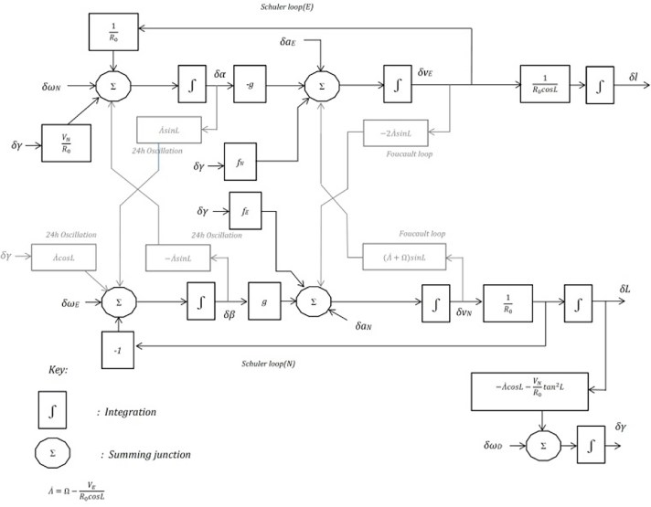

Fig. 9. Algorithm for object detection/tracking/data used in [12]

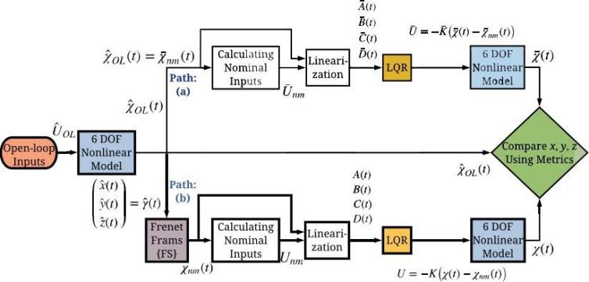

Fig. 10. shows algorithm used in [18]

CONCLUSION

Autonomous underwater vehicle development is a critical field of study for scientific research in numerous industrial applications such as defense, ocean future uses and development, a summary of the main navigation, mapping, sampling technologies, and their applications. This paper also considers the structural representation of the vehicle as the shape largely determines the movement, stability, fluid resistance, etc. The control system This paper also gives a comprehensive analysis between various UUVs and ROUVs.

REFERENCES

1. Li, Monica S., et al.” Gripper design with rotation-constrained teeth for mobile manipulation of hard, plating corals with human-portable rovs.” OCEANS 2019-Marseille. IEEE, 2019
2. Matsuda T, Maki T and Sakamaki T. “Accurate and efficient seafloor observations with multiple autonomous underwater vehicles: theory and experiments in a hydrothermal vent field”. IEEE Robot Autom Lett 2019; 4(3): 2333–2339.
3. Zendehdel, N., S. J. Sadati, and A. Ranjbar Noei.” Adaptive robust control for trajectory tracking of autonomous underwater vehicles on horizontal plane.” Journal of AI and Data Mining 7.3 (2019): 475-486.
4. Underwater Robotics Market Size, Share Trends Analysis Report by Type (ROV, AUV), By Application (Commercial Exploration, Defense Security, Scientific Research), By Region, And Segment Forecasts, 2018- 2025.
5. Lin, Changjian, et al.” An improved recurrent neural network for unmanned underwater vehicle online obstacle avoidance.” Ocean Engineering 189 (2019): 106327.
6. Setyawan, A.” Remotely Operated underwater Vehicle (ROV) stabilization with Artificial Neural Networks (ANN).” Journal of Physics: Conference Series. Vol. 1833. No. 1. IOP Publishing, 2021
7. Al-Bzoor, Manal, et al.” Autonomous underwater vehicles support for enhanced performance in the Internet of underwater things.” Transactions on Emerging Telecommunications Technologies 32.3 (2021): e4225.
8. Sun, Yushan, et al.” Mapless motion planning system for an autonomous underwater vehicle using policy gradient-based deep reinforcement learning.” Journal of Intelligent Robotic Systems 96.3-4 (2019): 591- 601.
9. Wang, Ying, and Yourong Li.” Fault Diagnosis of Underwater Vehicle Propulsion System Based on Deep Learning.” Journal of Coastal Research 107.SI (2020): 65-68.
10. Modasshir, Md, et al.” Coral identification and counting with an autonomous underwater vehicle.” 2018 IEEE International Conference on Robotics and Biomimetics (ROBIO). IEEE, 2018.
11. Bin-Karim, Shamir, et al.” Control of a relocatable energy-harvesting autonomous underwater vehicle in a spatiotemporally-varying gulf stream resource.” 2018 Annual American Control Conference (ACC). IEEE, 2018.
12. Petritoli, Enrico, and Fabio Leccese.” High accuracy attitude and navigation system for an autonomous underwater vehicle (AUV).” Acta Imeko 7.2 (2018): 3-9.
13. Chalkiadakis, Vaggelis, et al.” Designing a small-sized autonomous underwater vehicle architecture for regular periodic fish-cage net inspection.” 2017 IEEE International Conference on Imaging Systems and Techniques (IST). IEEE, 2017.
14. Petritoli, Enrico, Marco Cagnetti, and Fabio Leccese.” Simulation of Autonomous Underwater Vehicles (AUVs) Swarm Diffusion.” Sensors 20.17 (2020): 4950.
15. https://sherpa-project.eu/sherpa/content/onboard-sensor-technologies
16. Mu, Xiaokai, et al.” End-to-end navigation for autonomous underwater vehicle with hybrid recurrent neural networks.” Ocean Engineering 194 (2019): 106602.
17. Park, Jisung, Taeyun Kim, and Jinwhan Kim.” Model-referenced pose estimation using monocular vision for autonomous intervention tasks.” Autonomous Robots 44.2 (2020): 205-216.
18. Borgogna, Gerardo, Thomas Lamberti, and Aristide Fausto Massardo.” Innovative power system for autonomous underwater vehicle.” OCEANS 2015-Genova. IEEE, 2015.
19. Al Makdah, Abed Al Rahman, et al.” Three-dimensional trajectory tracking of a hybrid autonomous underwater vehicle in the presence of underwater current.” Ocean Engineering 185 (2019): 115-132.
20. Hwang, Jimin, et al.” Acoustic search and detection of oil plumes using an autonomous underwater vehicle.” Journal of Marine Science and Engineering 8.8 (2020): 618.
21. Elangovan, Muniyandy.” Basic Design for the development of Autonomous Underwater Vehicle.” International Research Journal on Advanced Science Hub 2.11 (2020): 12-17.

[22] S a´nchez, Pedro Jose´ Bernalte, Mayorkinos Papaelias, and Fausto Pedro Garc´ıa Ma´rquez. ” Autonomous underwater vehicles: Instrumentation and measurements.” IEEE Instrumentation Measurement Magazine 23.2 (2020): 105-114.

1. Paraschos, Dimitrios, and Nikolaos K. Papadakis.” Autonomous underwater vehicle challenge: design and construction of a medium- sized, AI-enabled low-cost prototype.” The Journal of Defense Modeling and Simulation (2021): 15485129211027236.
2. Katija, Kakani, et al.” Visual tracking of deepwater animals using machine learning-controlled robotic underwater vehicles.” Proceedings of the IEEE/CVF Winter Conference on Applications of Computer Vision. 2021.
3. Yamahara, Kevan M., et al.” In situ autonomous acquisition and preservation of marine environmental DNA using an autonomous underwater vehicle.” Frontiers in Marine Science 6 (2019): 373.
4. Yao, Xuliang, et al.” Path following based on waypoints and real- time obstacle avoidance control of an autonomous underwater vehicle.” Sensors 20.3 (2020): 795.
5. Bernalte S a´nchez, Pedro Jose´, Papaelias Mayorkinos, and Fausto Pedro Garc´ıa Ma´rquez. ” Autonomous Underwater Vehicles: Instrumentations and Measurements.” Institute of Electrical and Electronics Engineers, 2020.
6. Wang, Huailong, Zhenxing Yao, and Yinghui Guo. “Collaborative Control of Unmanned Underwater Vehicles.” Journal of Physics: Conference Series. Vol. 1887. No. 1. IOP Publishing, 2021.
7. Eldred, Ross, Johnathan Lussier, and Anthony Pollman.” Design and Testing of a Spherical Autonomous Underwater Vehicle for Shipwreck Interior Exploration.” Journal of Marine Science and Engineering 9.3 (2021): 320.