[Oscars Hall of Fame] Site Plan

[Connor Sturgeon]

WDD 130

Overview

Purpose
My porpoise is to have a website created for me to celebrate the best picture winners, best actors and actresses, and best animated features from the past 5 years.

Audience
Movies Lovers and Freaks

Branding

Website Logo


Style Guide

Color Palette
Primary | Secondary | Accent 1 | Accent 2
#C79F27 | #FFFFFF | #212529 | #D6D6D6

Typography

Heading & Paragraph Font: [PT Sans]

Copy Right Font: [Google Sans Flex]

Navigation
Best Picture Best Actor/Actress Best Animated

Content
Best Picture Section
2019: Parasite
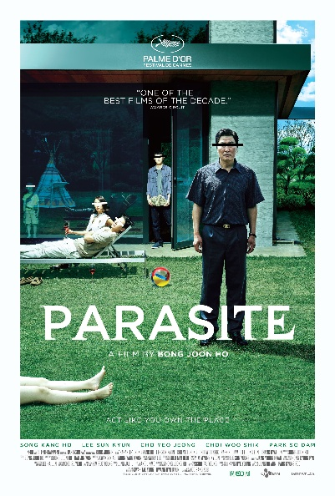
Parasite is a 2019 South Korean black comedy thriller film directed by Bong Joon Ho, who co-wrote the screenplay with Han Jin-won. It stars Song Kang-ho, Lee Sun-kyun, Cho Yeo-jeong, Choi Woo-shik, Park So-dam, Jang Hye-jin, Park Myung-hoon, and Lee Jung-eun. The film follows a poor family who infiltrate the home and life of a wealthy family.

2020: Nomadland


Nomadland is a 2020 American drama film written, produced, edited and directed by Chloé Zhao. Based on the 2017 nonfiction book Nomadland: Surviving America in the Twenty-First Century by Jessica Bruder, it stars Frances McDormand as a widow who leaves her life in Nevada to drift around the United States in her van. A number of real-life nomads appear as fictionalized versions of themselves, including Linda May, Swankie, and Bob Wells. David Strathairn also stars in a supporting role.

2021: Coda
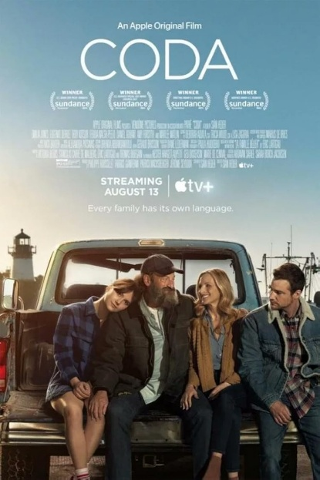

CODA is a 2021 coming-of-age comedy-drama film written and directed by Sian Heder. An English-language remake of the 2014 French-Belgian film La Famille Bélier, it stars Emilia Jones as Ruby Rossi, the child of deaf adults (CODA) and only hearing member of her family, who attempts to help her family's struggling fishing business while pursuing her aspirations to become a singer.

2022: Everything Everywhere All At Once

Everything Everywhere All at Once is a 2022 American independent absurdist comedy-drama film written and directed by Daniel Kwan and Daniel Scheinert, who produced it with Anthony and Joe Russo and Jonathan Wang. The film incorporates media from several genres and film mediums, including surreal comedy, science fiction, fantasy, martial arts films, immigrant narrative, and animation. Michelle Yeoh stars as Evelyn Quan Wang, a Chinese-American immigrant who, while being audited by the IRS, discovers that she must connect with parallel universe versions of herself to prevent a powerful being from destroying the multiverse. The film also stars Stephanie Hsu, Ke Huy Quan, James Hong, and Jamie Lee Curtis.

2023: Oppenheimer
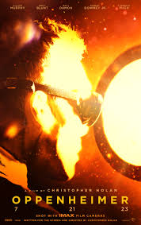

Oppenheimer is a 2023 epic biographical thriller film written, co-produced, and directed by Christopher Nolan. It follows the life of J. Robert Oppenheimer, the American theoretical physicist who helped develop the first nuclear weapons during World War II. Based on the 2005 biography American Prometheus by Kai Bird and Martin J. Sherwin, the film dramatizes Oppenheimer's studies, his direction of the Los Alamos Laboratory and his 1954 security hearing. Cillian Murphy stars as Oppenheimer, alongside Robert Downey Jr. as the United States Atomic Energy Commission member Lewis Strauss. The ensemble supporting cast includes Emily Blunt, Matt Damon, Florence Pugh, Josh Hartnett, Casey Affleck, Rami Malek, and Kenneth Branagh.

2024: Anora
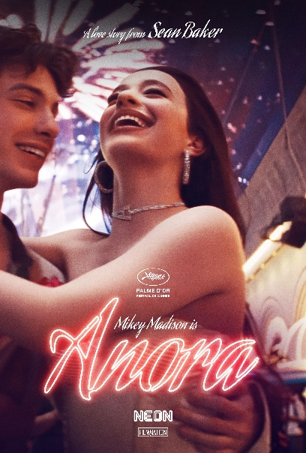

Anora is a 2024 American romantic comedy-drama film written, directed, produced, and edited by Sean Baker. It stars Mikey Madison as Anora "Ani" Mikheeva, a “dancer” from New York who marries the wealthy son of a Russian oligarch played by Mark Eydelshteyn. The supporting cast includes Yura Borisov, Karren Karagulian, Vache Tovmasyan, Darya Ekamasova, and Aleksei Serebryakov.
Best Actor/Actress Section
2019: Joaquin Phoenix
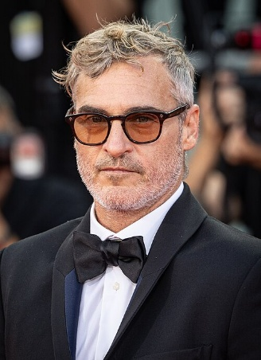
Joaquin won his Oscar for his leading role in “Joker”.

Renée Zellweger
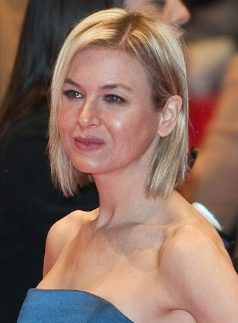

Renee won her Oscar for her role in “Judy”.

2020: Anthony Hopkins
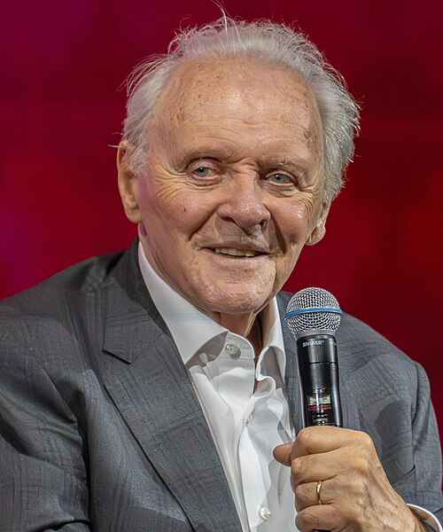

Anthony Hopkins won his Oscar for his role in “The Father”.

Frances McDormand
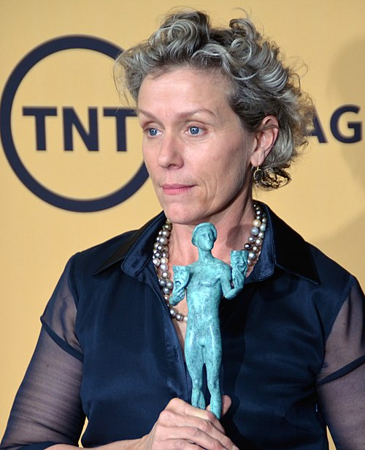
Frances won her Oscar for her role in “Nomadland”.

2021: Will Smith
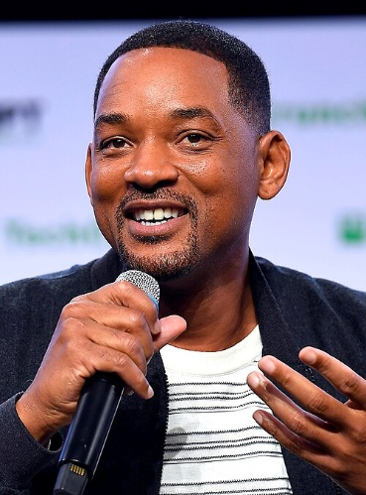

Will won his Oscar for his role in “King Richard”.

Jessica Chastain
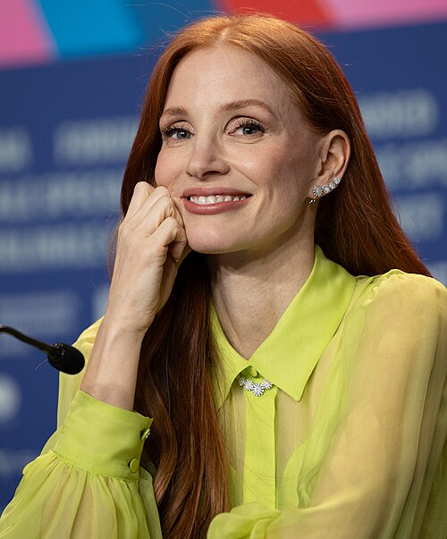

Jessica won her Oscar for her role in “The Eyes of Tammy Faye”.

2022: Brendan Fraser
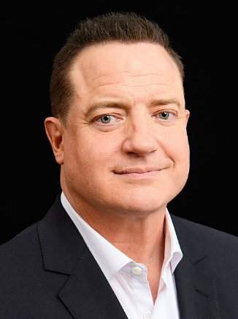
Brendan won his Oscar for his role in “The Whale”.

Michelle Yeoh
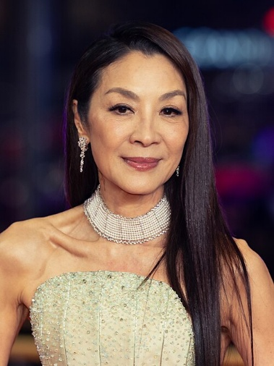

Michelle won her Oscar for her role in “Everything Everywhere All At Once”.

2023: Cillian Murphy
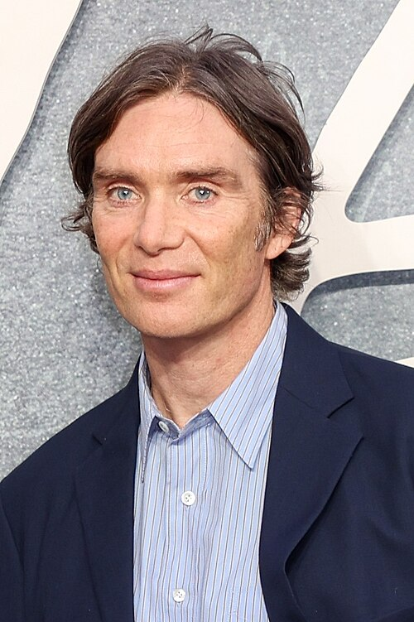
Cillian won his Oscar for is role in “Oppenheimer”.

Emma Stone
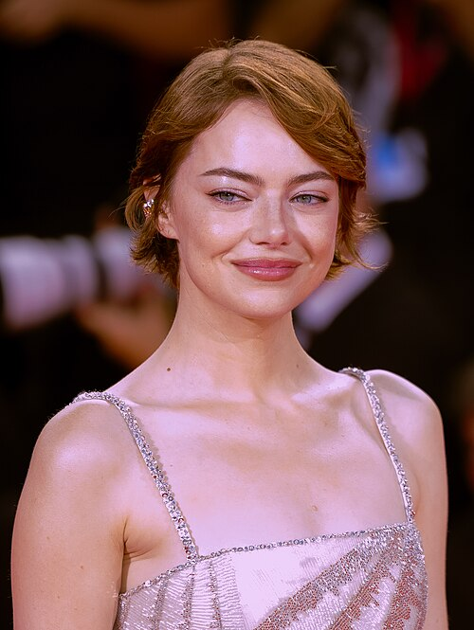
Emma won her Oscar for her role in “Poor Things”.

2024: Adrien Brody
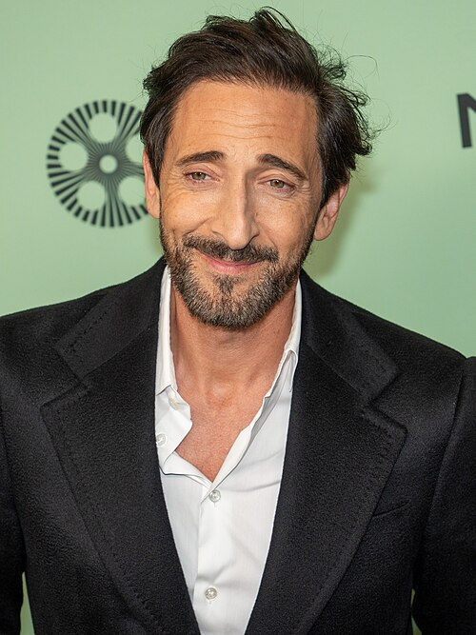
Adrien won his Oscar for his role in “The Brutalist”.

Mikey Madison

Mikey won her Oscar for her role in “Anora”.
Animated Section
2019: Toy Story 4
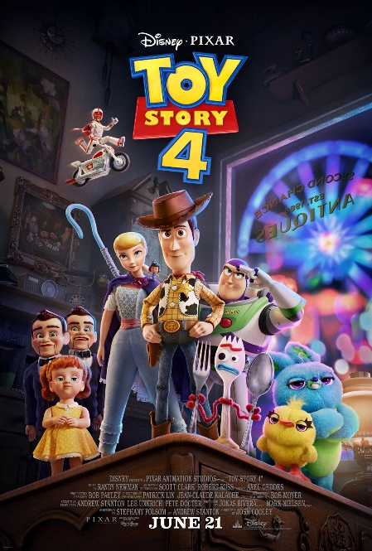

2020: Soul
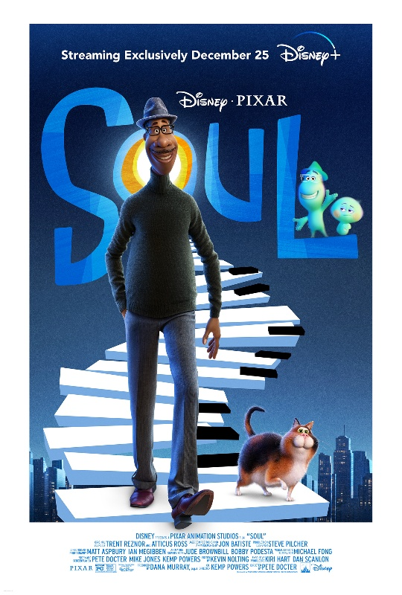

2021: Encanto
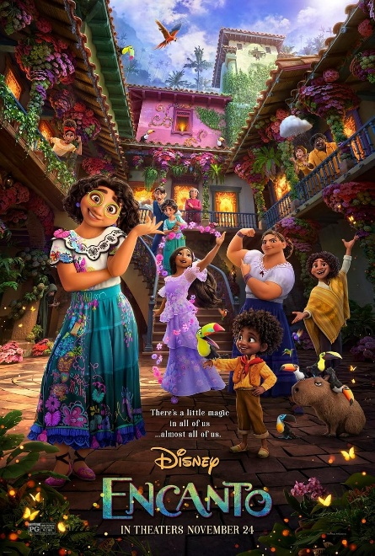

2022: Guillermo del Toro's Pinocchio
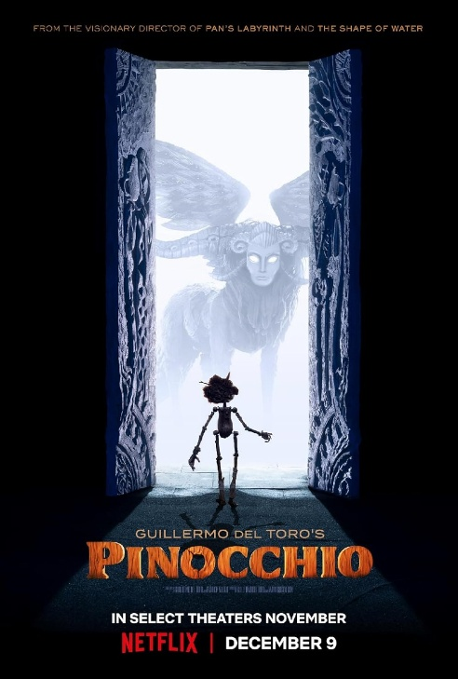

2023: The Boy and the Heron
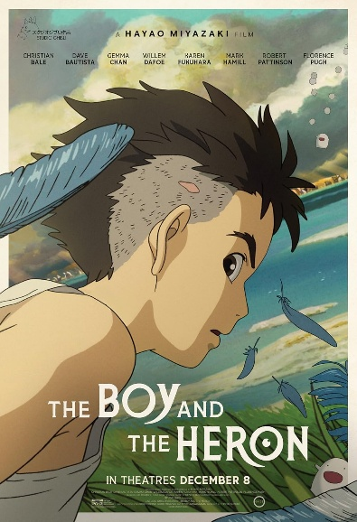

2024: Flow
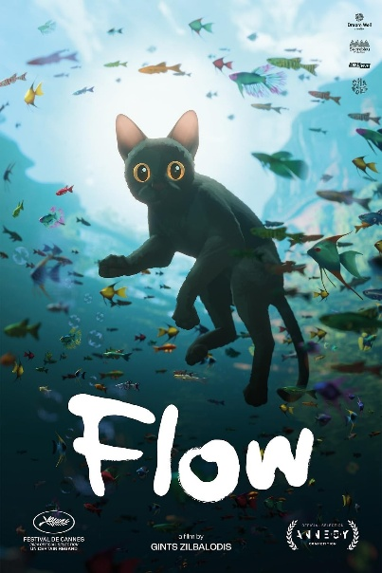

Wireframes



For some reason I can’t edit it. The best picture section will only be from 2020 – 2025 and the page should be long enough to show all 5 movies and descriptions.



Same thing for the Actors/Actresses


And the Animated ones.

