1. Before starting work in ToposPro, set the following parameters in the TOPOS Parameters tab for convenience.
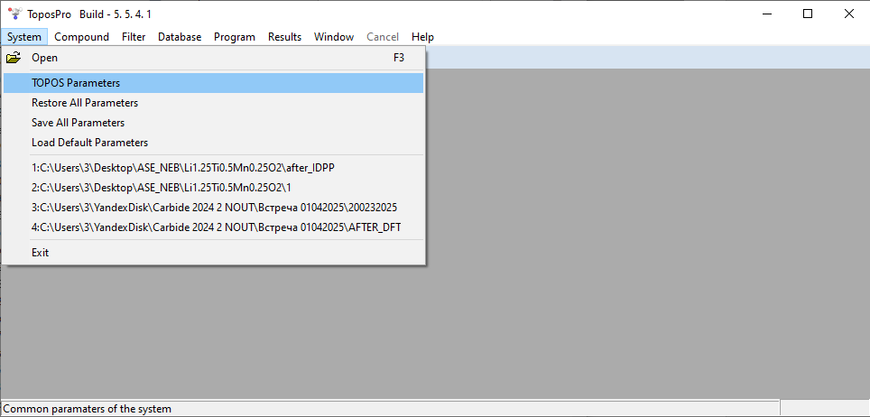
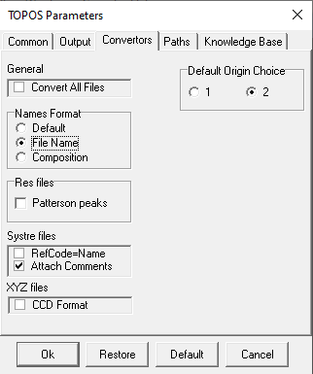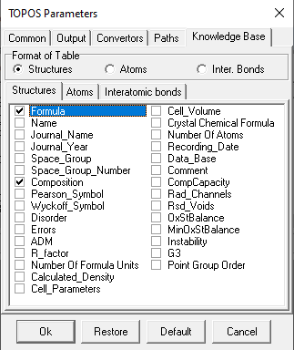

2. Next, create a database from the CIF files stored in the 593structures.rar archive.
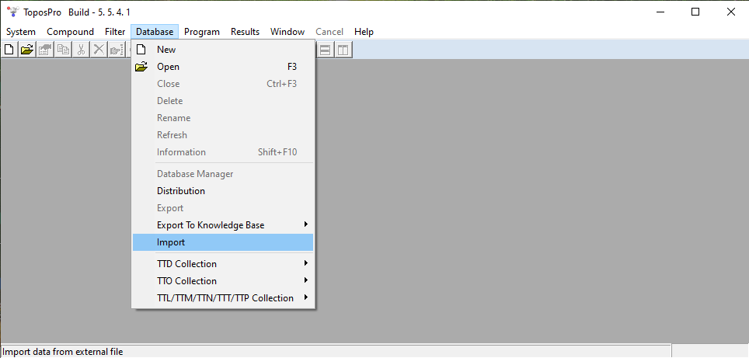
3. Select all the CIF files and click Open.
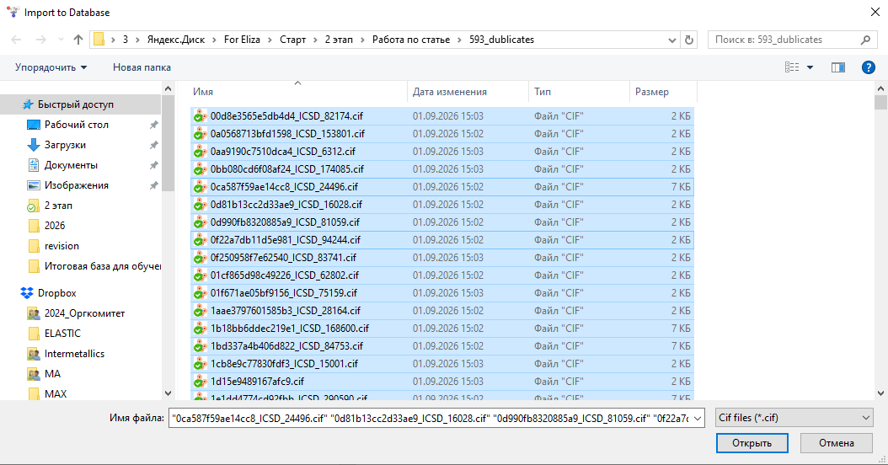

4. The program will prompt you to name the database. Let's call it, for example, Compare_structures. Click Open.
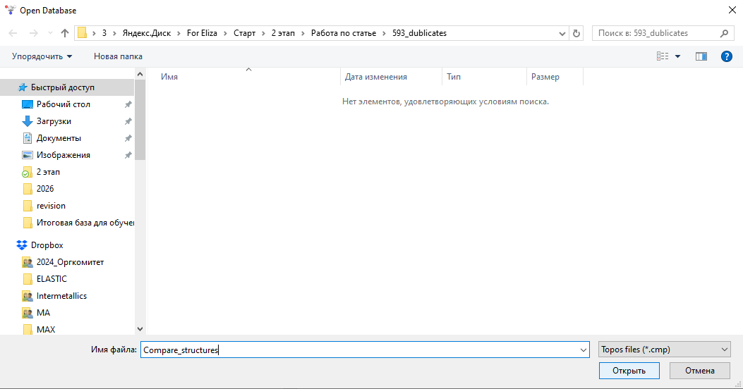
5. Click Yes.
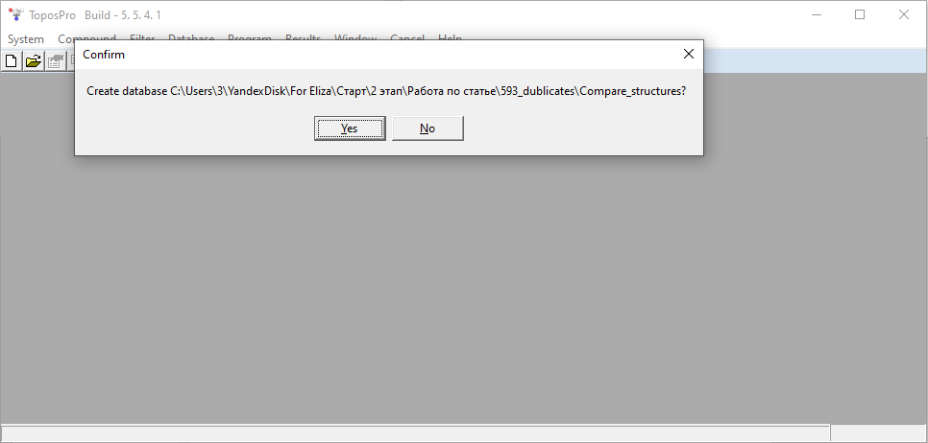

6. Enter 1.
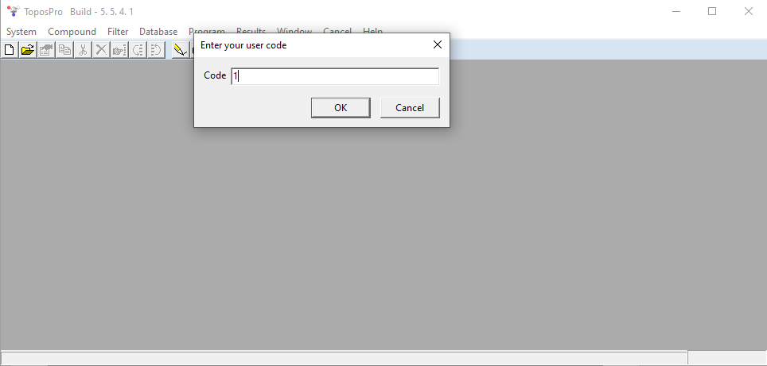
7. Our database will contain information about 593 structures. Click OK.
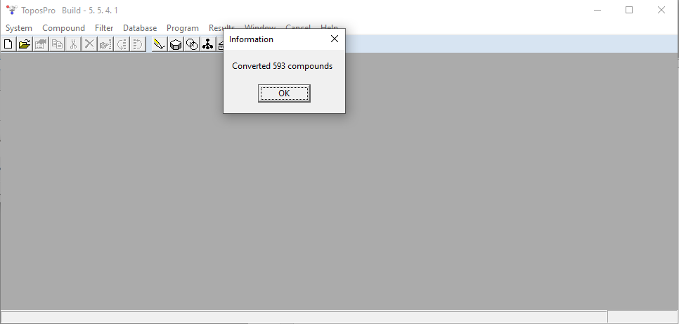

8. Right-click the Compaunds field and select Ref. Code.
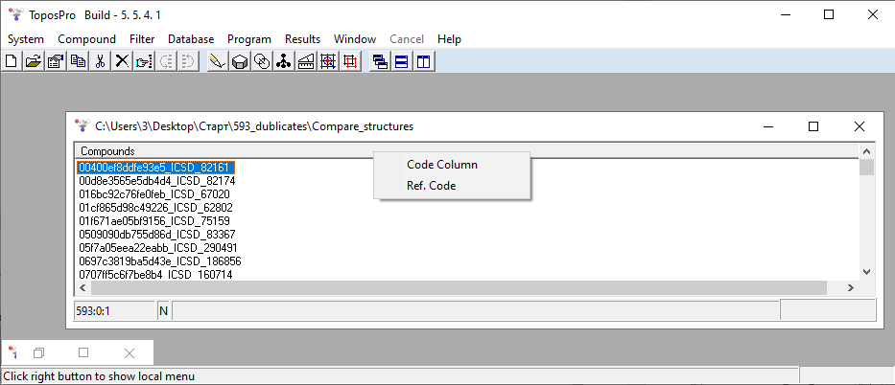
9. Now we see notes about which databases the structures belong to in the Ref. Code field.
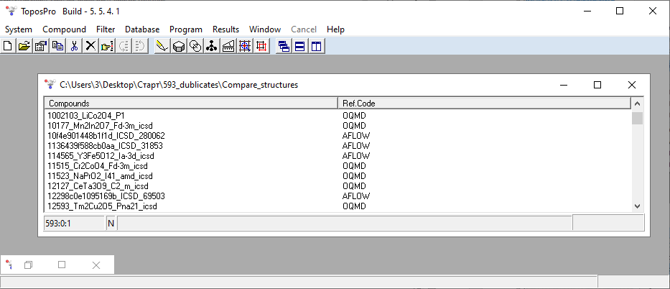

10. Next, select all the compounds.
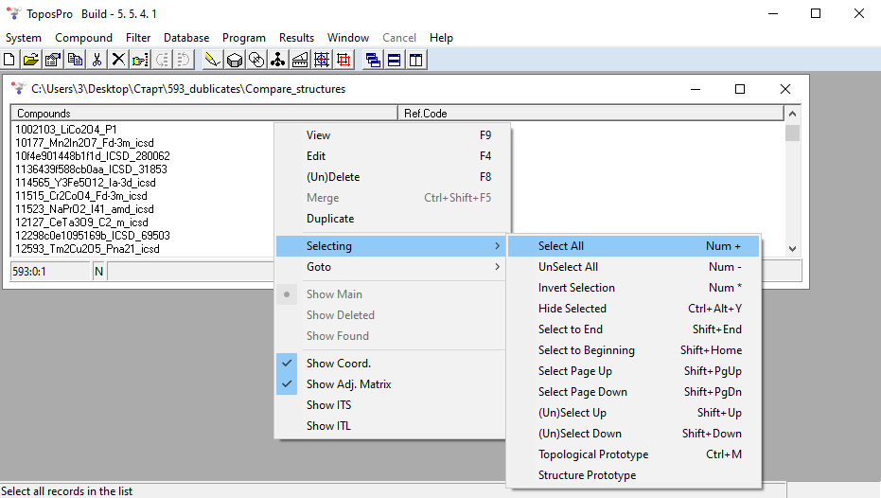
11. Then, calculate the adjacency matrix for the structures. Based on the adjacency matrix, the topology of the structures will be determined and corresponding (anti-)types among the structures will be identified.
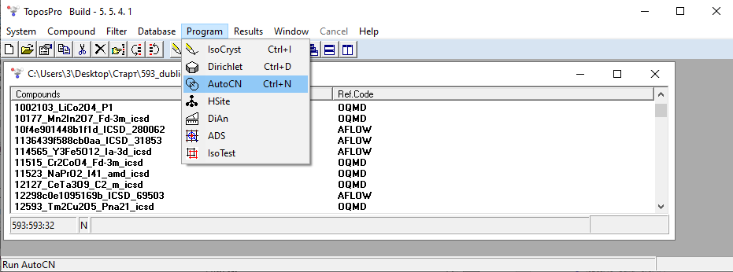

12. Click Run.
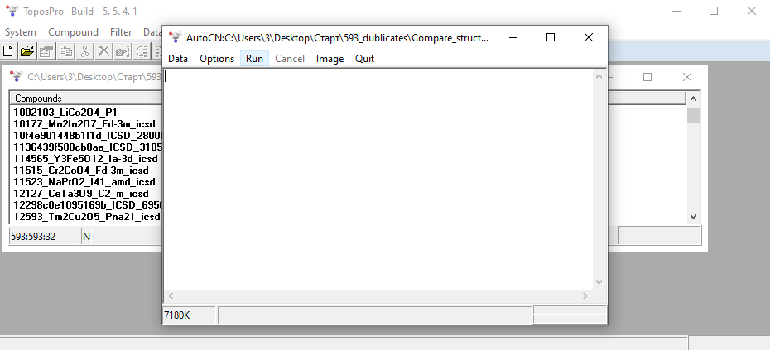
13. The adjacency matrix calculation is complete. You will see a comment from the program: "16 compounds were not computed." Don't worry, everything has been calculated. Click OK.
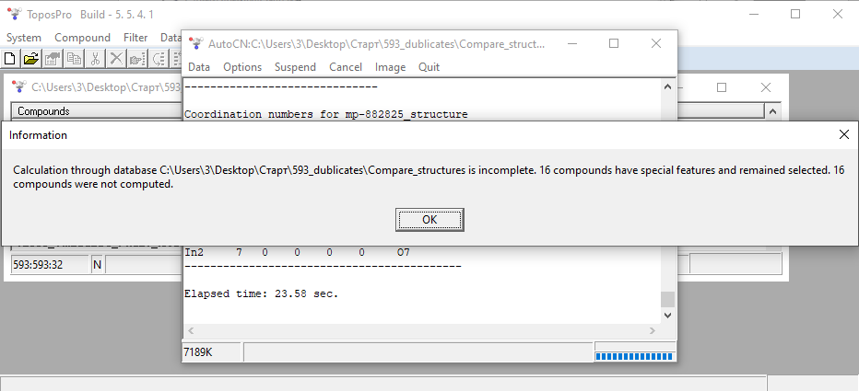

14. Next, we'll use the Acquisition Data filter.
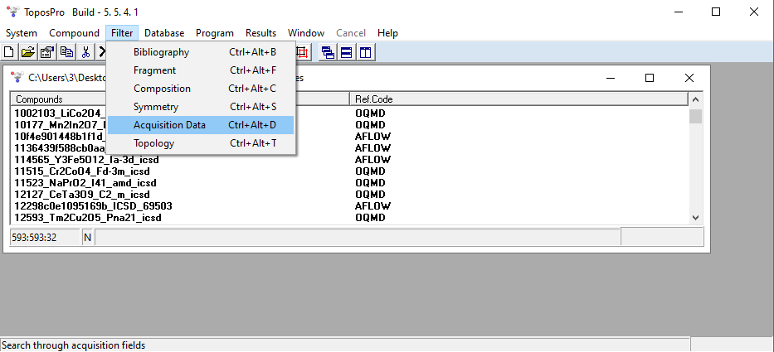
15. Leave the marks as shown below to select duplicates only with the same composition. Click OK.
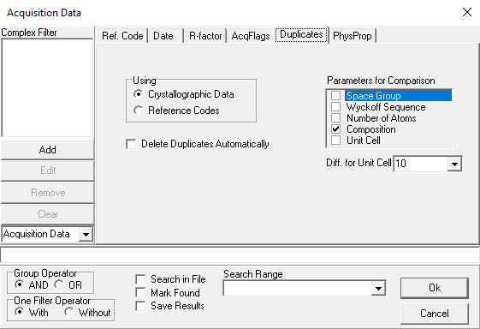

16. Click OK. You will see that the format of the database records has changed.
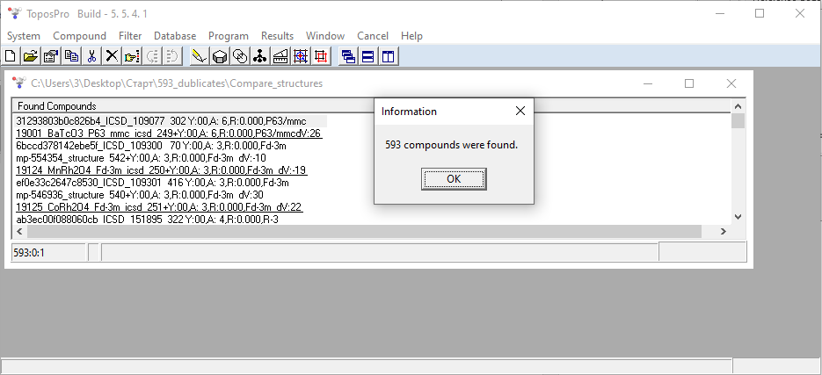
17. Next, we'll export the information we need about the composition, structure name, base, and group number of duplicates (we specified these in TOPOS Parameters) to a text file.
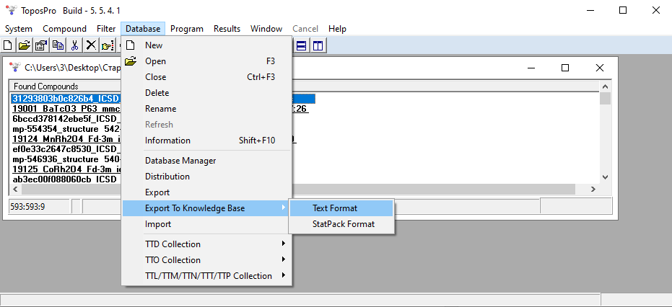

18. After this, a file named Compare_structures_kb.txt will appear in the folder where your database is stored.
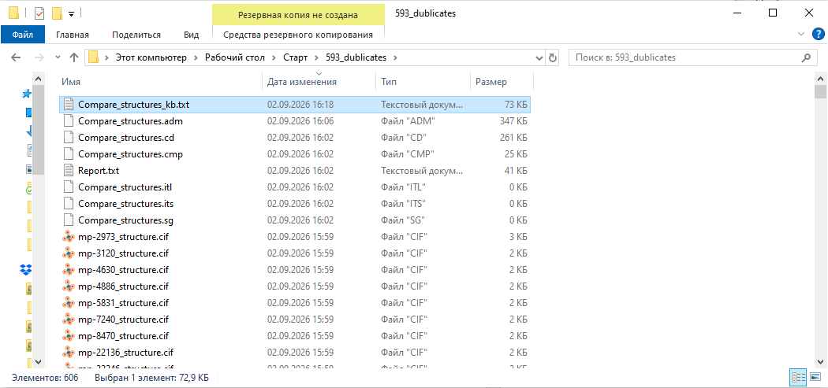
19. Open this file in Excel. You can see that ToposPro has assigned a common duplicate group number (Dupl_Group_No) to structures similar in composition.
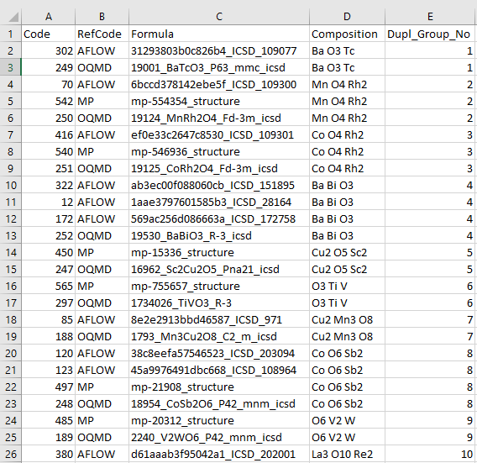

20. Next, we'll determine the structure topologies using ADS.
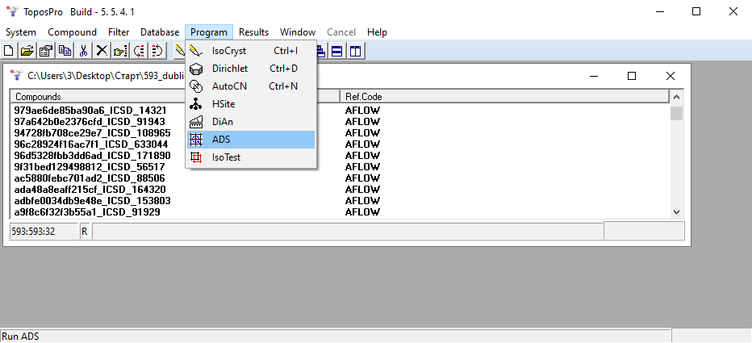
21. Click Options.
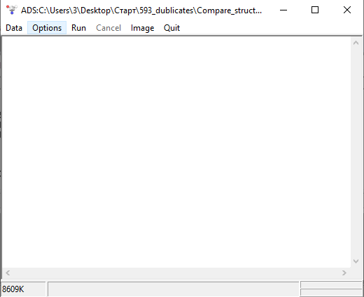

22. Select the desired options as indicated below in the Common and Topology tabs. The Colored option in the Topology tab is necessary to distinguish between (anti-)types that are identical in topology but differ in the arrangement of atoms of different sorts.
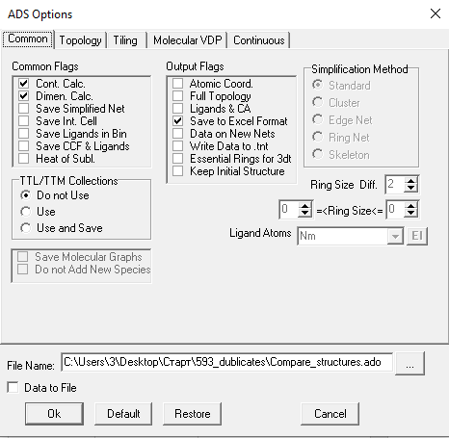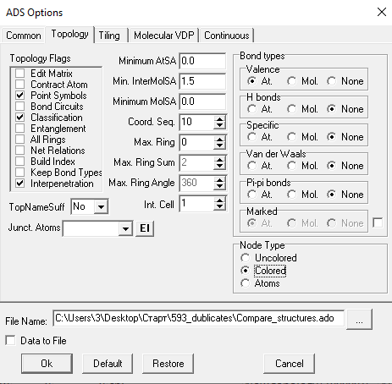
23. Next, click Run. Select No.
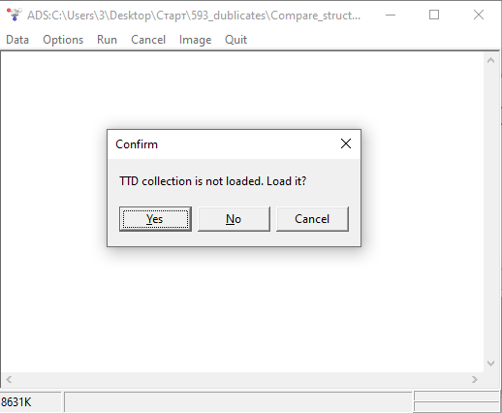

24. The ADS calculation is complete. Click OK.
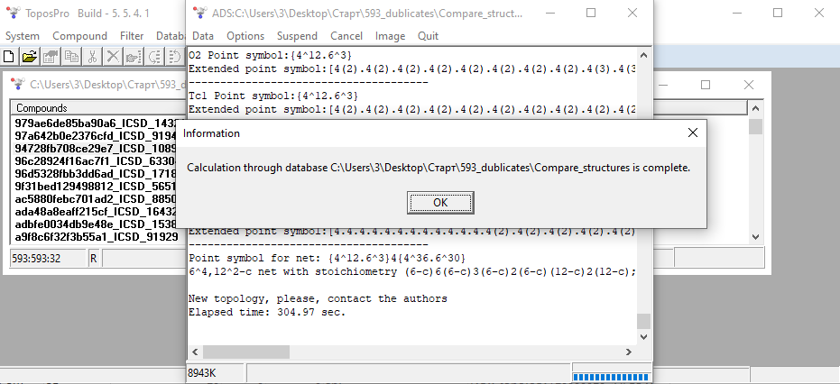
25. A Compare_structures.txt file was automatically created in the same folder after the topology calculation.
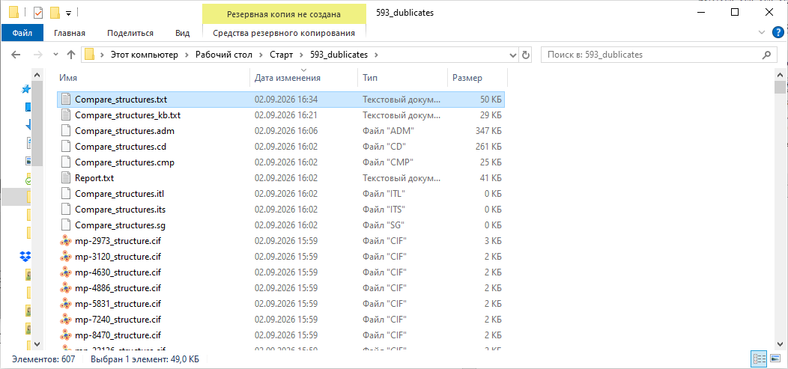

26. Open this file in Excel. Column L shows the structure topologies, taking into account the differences in atom arrangement within structures of the same composition.
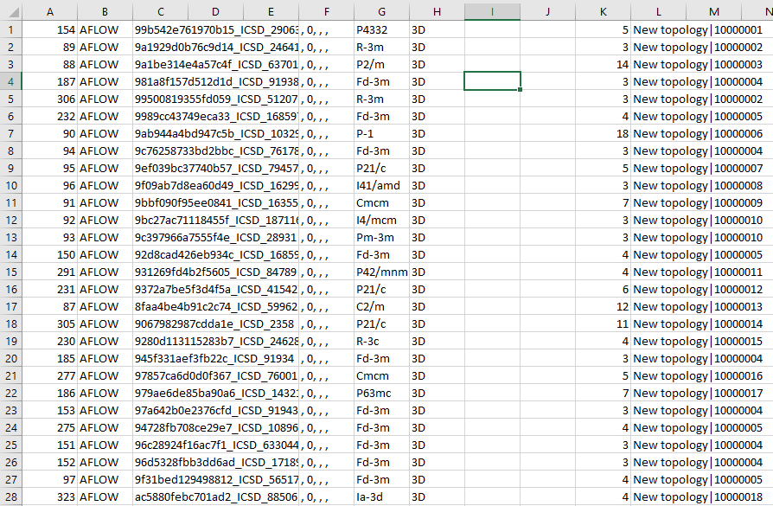
27. Next, using three files with duplicate group numbers (Compare_structures_kb.txt), topologies (Compare_structures.txt), and band gap values ​​(Errors&(anti-)type_ Eg.xlsx), you can create a table similar to the one in Errors&(anti-)type_compare.xlsx. This table will show that some structures with the same composition have different Eg values ​​and different topologies – these are (anti-)types, or have different Eg values, but the same topologies – these are erroneous structures.

