# Winter 2019

Name: Matthew Neighbour

G#:

# Total Points: 100

Note: This is individual assignment. You can’t take help from colleagues. Your solution (answers of all questions) should be in one word/pdf file and submitted to Moodle. Follow naming convention given in syllabus file. No late submission will be accepted. For questions in section II, wherever it is asked, screen shots should be submitted, and its explanation should also be provided.

***Section 1 Basic Netowrk Commands (0.5*30=15 points)***

Using **all-in-one computer in lab (or your personal computer)**, open the command prompt and type the following commands:

***NSLOOKUP***

>nslookup

Q1- What information did this command provide you with?

Default server name, and ip address

>For Q2, refer following URL [www.oakland.edu](http://www.oakland.edu)

Q2- What is/are the IP address/addresses that correspond to this domain name? What does this means?

141.210.5.108, this means that the representation for the address [www.oakland.edu](http://www.oakland.edu) is 141.210.5.108

For Q3 and 4, refer following URL

>[www.google.com](http://www.google.com/)

Q3- What is/are the IP address/addresses that correspond to this domain name? What does this mean? What are the versions of the IP addresses that have been used?

Server: UnKnown

Address: 2600:1700:d660:4fd1::1

Non-authoritative answer:

Name: www.google.com

Addresses: 2607:f8b0:4000:80e::2004

216.58.194.36

The multiple addresses mean that the page is cached on a closer server. It uses the IPv6 protocol.

Q4- What does the statement Non-authoritative answer mean?

It means that the server that gave the response is not the actual nameserver.

For Q5, use following IP address:

>141.210.2.69

Q5- What is the domain name that corresponds to this IP address?

Name: ezproxy1.sys.oakland.edu

Address: 141.210.2.69

***IPCONFIG***

**> Ipconfig**

Q6- Print screen part of your output to here.

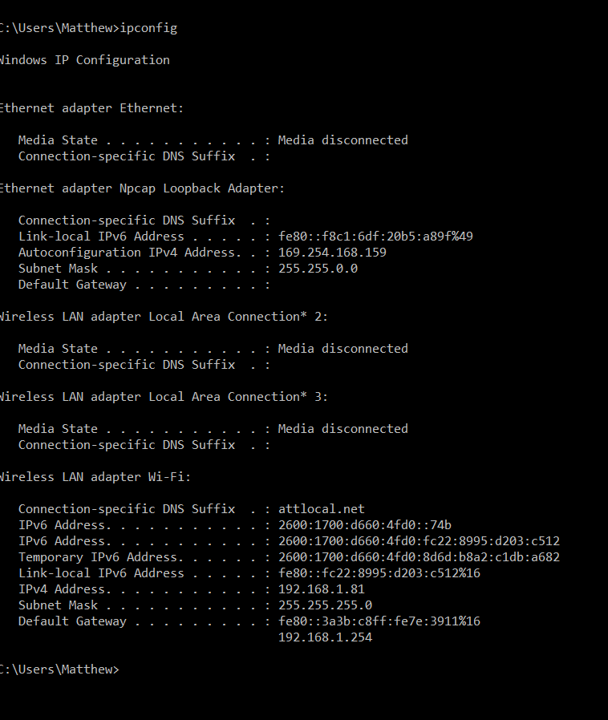

Q7- What information did this command provide you with?

Provide network adapter information. Such as address and whether or not it is connected.

Q8- What is the IP address of your PC?

192.168.1.81

Q9- How can you perform this command on Linux? (Note: windows command might not work on Linux, find the appropriate command to use on Linux).

ifconfig

**> Ipconfig/all**

Q10- Print screen part of your output to here.

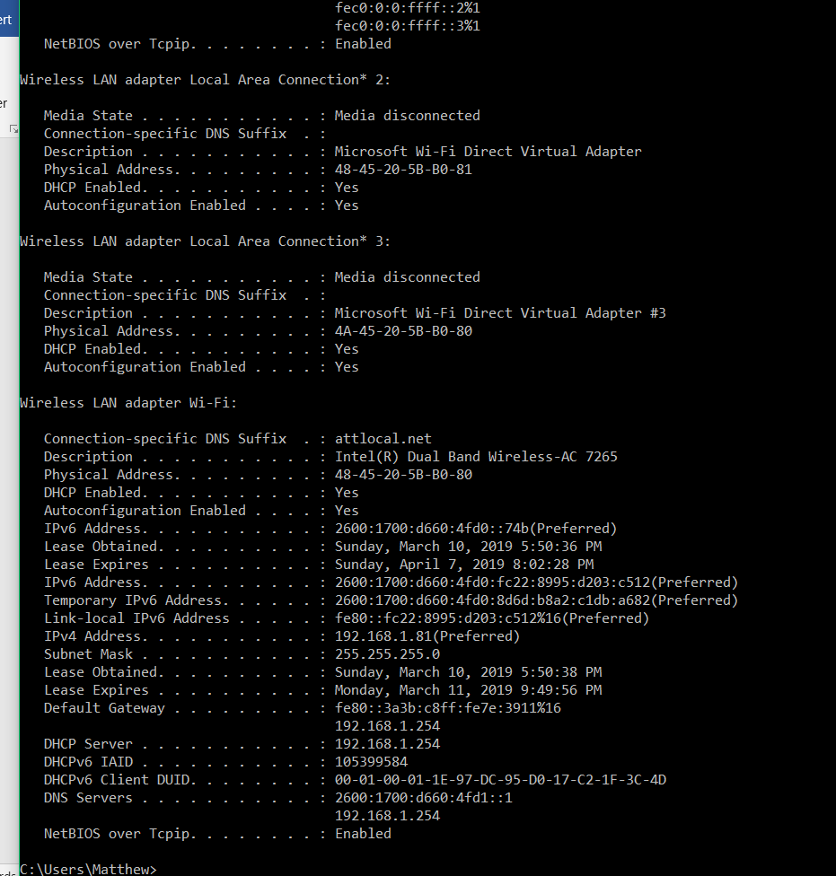

Q11- What is the domain name that corresponds to your IP address?

Attlocal.net

Q12- what is the difference between Ipconfig and Ipconfig/all.

The /all flag provides a lot more detailed information.

Q13- How can you perform this command on Linux? (Note: windows command might not work on Linux, find the appropriate command to use on Linux).

Ifconfig -a

***PING***

**>ping 23.6.64.128**

Q14- Print screen part of your output to here.

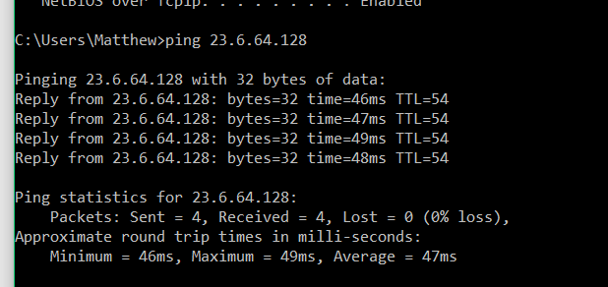

Q15- How many ICMP echo requests were generated from your computer?

4 echo requests.

Q16- How many ICMP replies did you receive?

4 ICMP replies

Q17- How many packets were lost?

0 packets were lost

Q18- What was the average of packet times?

47ms

Q19- How can you perform this command on Linux? (Note: windows command might not work on Linux, find the appropriate command to use on Linux).

ping 23.6.64.128

**>ping -a 23.6.64.128**

Q20- Print screen part of your output to here.

Q21- Do you think this command more useful than the previous one? Why?

**>ping -n 8 23.6.64.128**

Q22- Print screen part of your output to here.

Q23- Why did the output look like that?

**>ping -t 23.6.64.128**

Q24- Print screen part of your output to here.

Q25- Why did the output look like that?

***TRACEROUTE***

Q26- Use tracert to find the path to **mit.edu**

Q27- Do another tracert, this time to [**www.oxford.ac.uk**.](http://www.oxford.ac.uk/) This destination is in the UK. In your traceroute output, what is the first hop across the ocean? How can you tell?

Q28- Now, on one hop you should see three '*'s in the output instead of a RTT. What do you think is happening to cause this?

Q29- How many routers did each packet pass to reach the destination? How many packets does tracert command use to investigate the route?

Q30- How can you perform this command on Linux? (Note: windows command might not work on Linux, find the appropriate command to use on Linux).

**Section II- Home assignment 04**

**Lab 04 (40 points)**

# Instructions: Every group (consisting of either one individual or maximum of two members) should finish the lab independently. Discussion about the big picture is allowed among groups. When submitting your homework 04, you should incorporate answers of this lab with other questions of home work4). Submit only one-word file that includes the full name of each member. No late submission will be accepted. No print screen will be accepted for the answers unless mentioned otherwise (Please type). Each group should show that they understand what they are doing and ask the instructor or the TA when a question is unclear. Please read the lab material before answering the questions.

# Objectives

This lab is designed to teach students how to configure computers, and routers. Additionally, this lab provides further practice in learning and using more features of Cisco’s **Packet Tracer**

**Part 1: Configuring Routers using Packet Tracer**

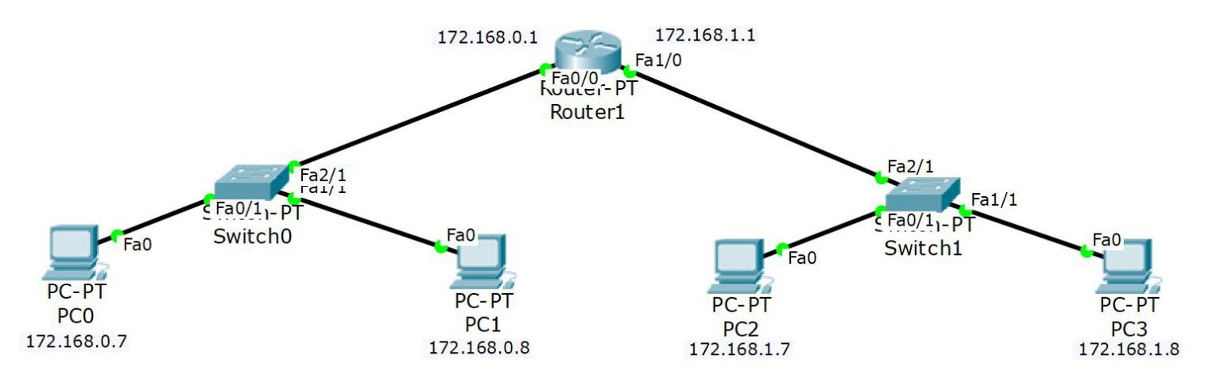

1. Create a **network** using **4 PC** hosts, **2 switches**, and **1 Router** connected with **6 copper straight-through** cables. Your IP addresses should be different than given in figure above.

**Q1.** Print your screen to show that you developed your network successfully (same like above figure. ( 5 points)

1. Click on **PC0** and select the **Desktop** tab.

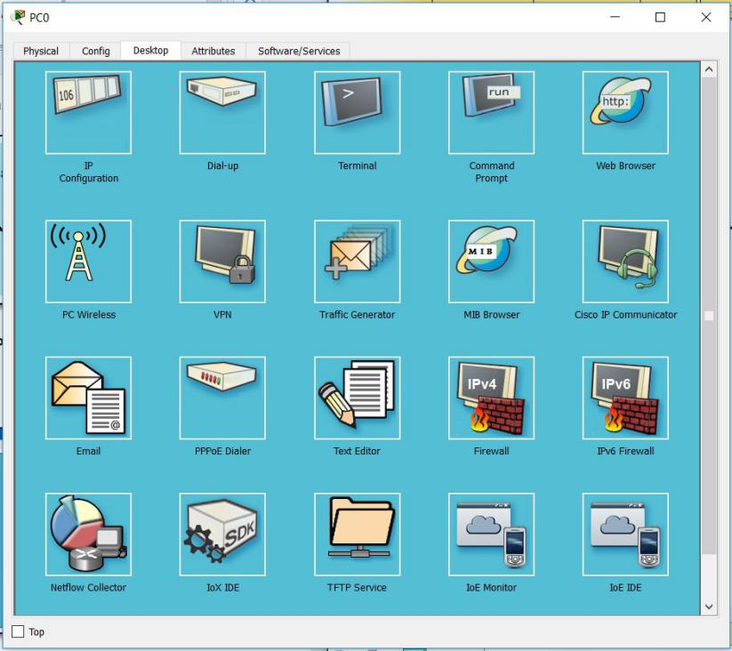

1. Select **IP Configuration**, and enter the following **address information**:

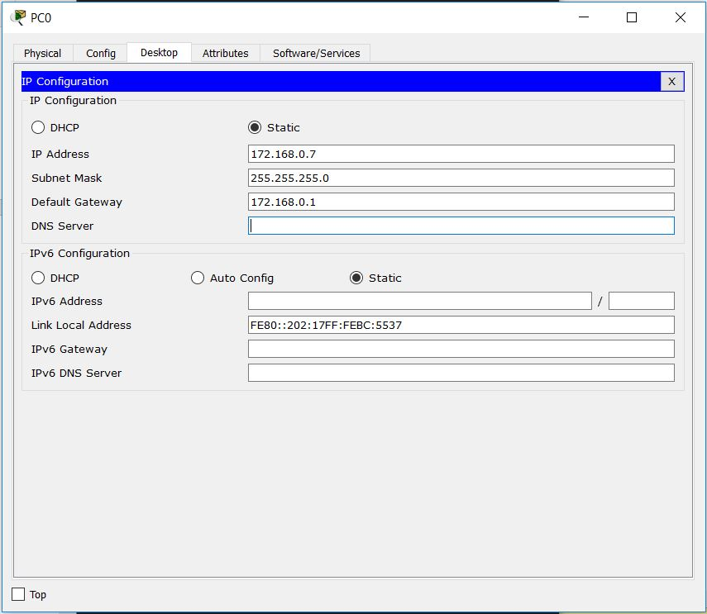

1. Click on **PC1** and select the **Desktop** tab.
2. Select **IP Configuration**, and enter the following **address information**:

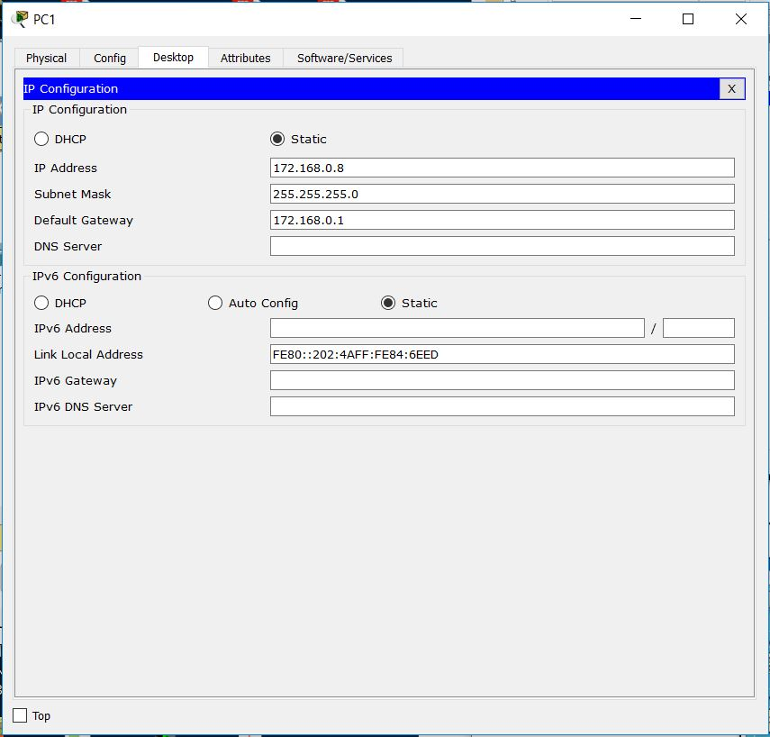

1. Click on **PC2** and select the **Desktop** tab.
2. Select **IP Configuration**, and enter the following **address information**:

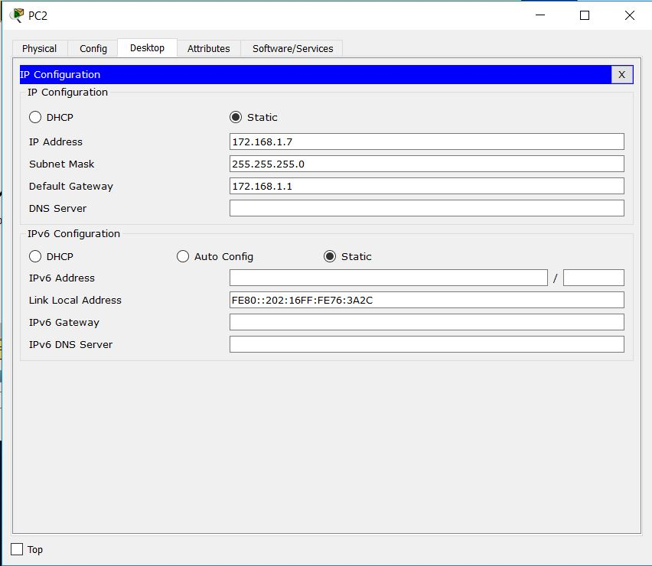

1. Click on **PC3** and select the **Desktop** tab.
2. Select **IP Configuration**, and enter the following **address information**:

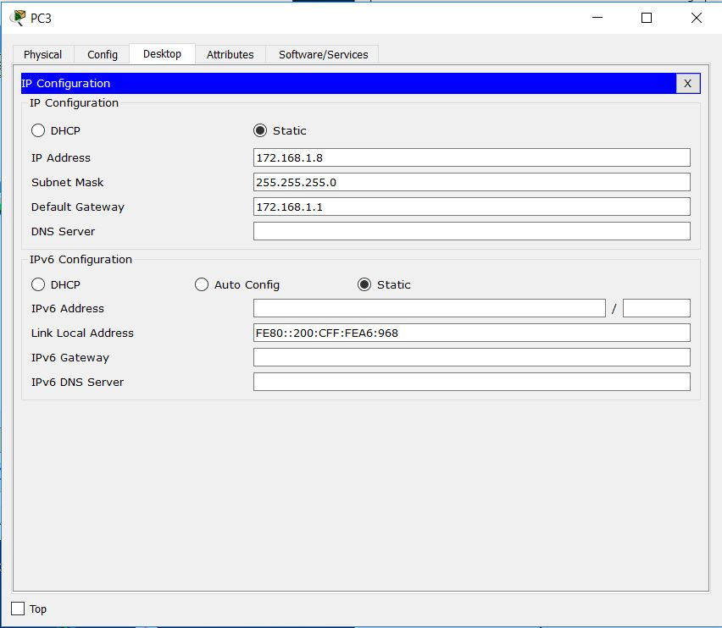

1. Roll the mouse cursor over **PC 1** to confirm the **address configuration** on the **popup box**.

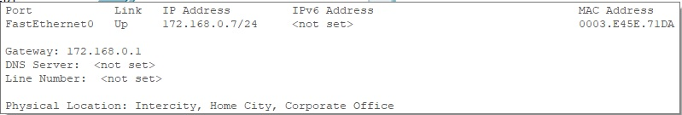

1. Roll the mouse cursor over **PC 2** to confirm the **address configuration** on the **popup box**.

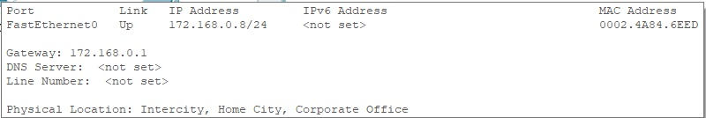

1. Roll the mouse cursor over **PC 3** to confirm the **address configuration** on the **popup box**.

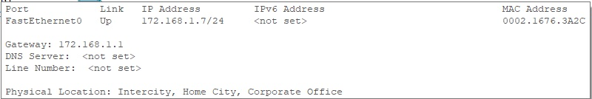

1. Roll the mouse cursor over **PC 4** to confirm the **address configuration** on the **popup box**.

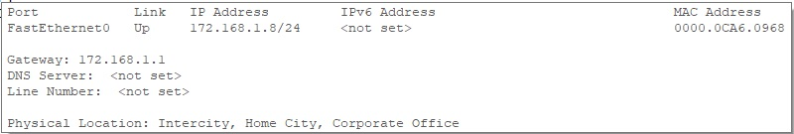

1. Click on **Router 1**, and select the **CLI** (*IOS Command-Line Interface*) tab.

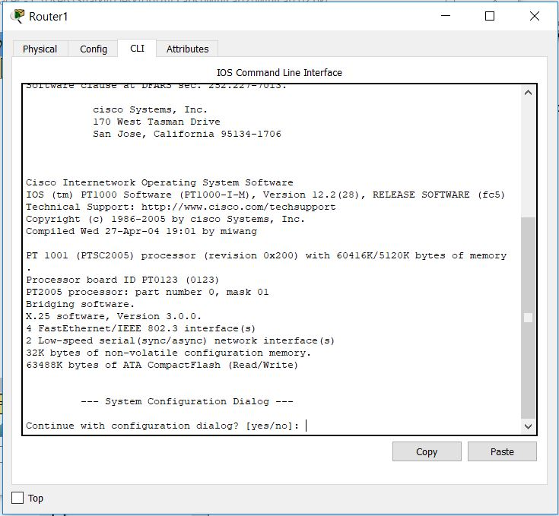

1. At the **Continue with configuration dialog?** type **n** (or **no**), then hit the **Enter**

key. After that, press **Enter** again to get started.

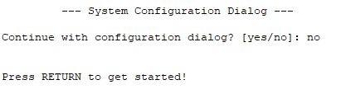

1. At the **Router>** prompt, type **enable**, then hit the **Enter** key. The **Router>** prompt changes to **privileged exec mode**, showing **Router#**



1. Next, type **configure terminal** (or **configure t** or **config t**, for short), then hit the **Enter** key. The **Router#** prompt changes to **global configuration mode**, showing **Router(config)#**

**Note: when starting a keyword like ‘configure’, if you hit the Tab key it will auto-fill the rest of the word for you (“conf” becomes “configure”).**

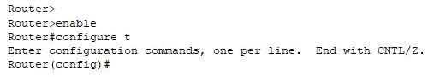

1. You’ll need to configure both the router interfaces to communicate with the two networks, so start by typing **interface fastEthernet 0/0** , then hit the **Enter** key. The **Router(config)#** prompt changes to **interface configuration mode**, showing   
   Router(config-if)#

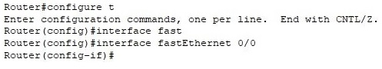

1. Now you need to give the **fastEthernet 0/0** interface an **IP address**, so type all on the same line

**ip address 172.168.0.1 255.255.255.0,** then hit the **Enter** key

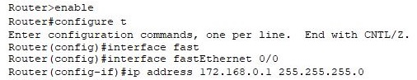

1. Back at the **Router(config-if)#** prompt, type **no shutdown** to keep the interface **up**

and running.

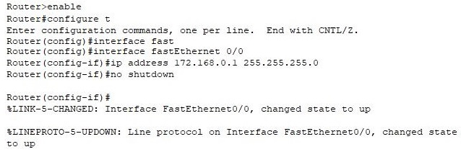

1. The **fastEthernet 0/0** (or **fa0/0** for short) **interface** has now be set up.
2. Now you need to configure the other interface, so at the prompt type **exit**



1. **Next, type in the following at each prompt, always followed by hitting the Enter key**

* **interface fastEthernet 1/0**
* **ip address 172.168.1.1 255.255.255.0**
* **no shutdown**

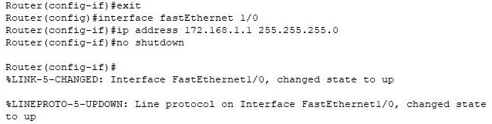

**That’s it! Both the fast Ethernet interfaces on the router have been set up.**

**But let’s test the setup by pinging both the PCs, one from the other.**

1. Click on **PC0** and select the **Desktop** tab.
2. Select the **Command Prompt**, and ping **PC2**, using **ping 172.168.1.7**

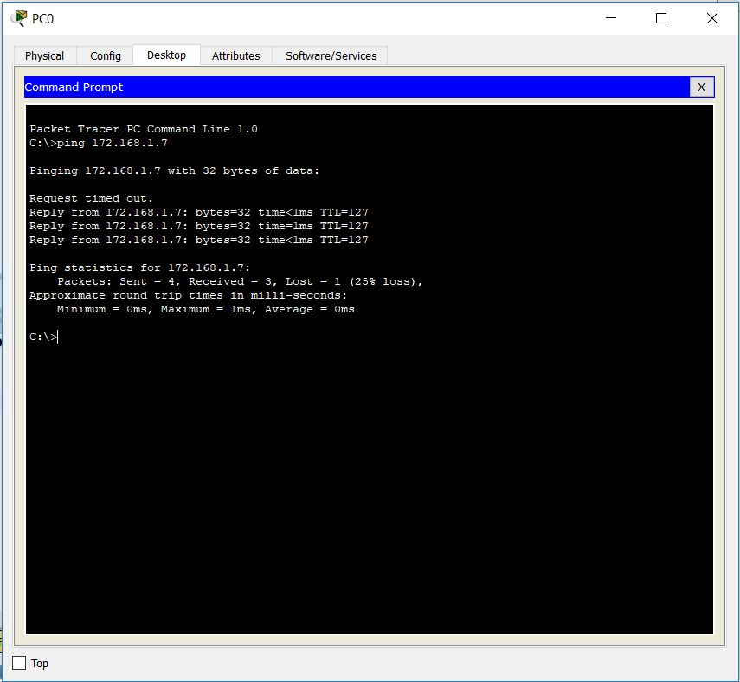

*The first request may time out as the process works through the router*

1. Click on **PC3** and select the **Desktop** tab.
2. Select the **Command Prompt**, and ping **PC0**, using: **ping 172.168.0.7**

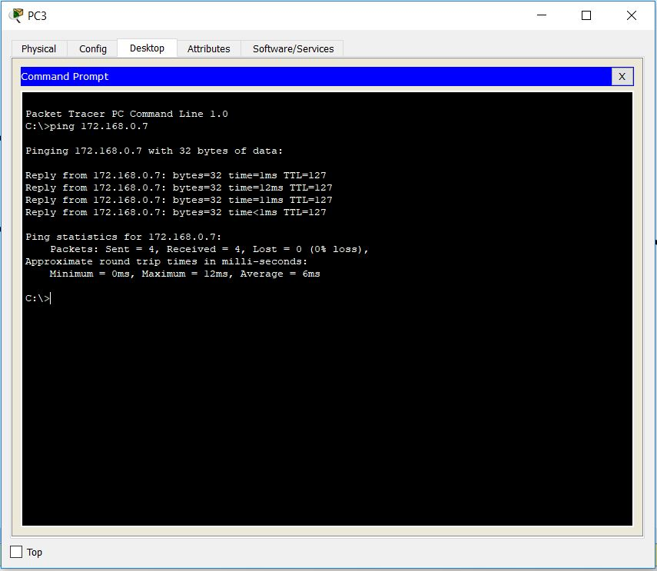

Q2: What did you learn in this part of lab? 2 points

Q3: How confident are you if you have been given the hardware to setup actual network in some organization? How will you apply your knowledge gained from this lab? Are you going to require any further knowledge to setup actual network in any organization (except you learned in this lab)? 5 points

Q4. From any computer, you want to test its connectivity to any router, how are you going to do it? Give a proof that PC3 is reachable from PC1 (provide screen shot) 8 points

Q 5. Summarize the different modes of router configuration and process of configuring the interface of router ( 5 points)

**Part 2: Setting Up DHCP on a Router with CLI using Packet Tracer**

This lab demonstrates how to configure DHCP on a Cisco router instead of a server. As you know by now, the Dynamic Host Configuration Protocol (DHCP) is a network protocol used to automatically configure network devices with IP addresses. DHCP allows a computer to join an IP-based network without having a pre-configured static IP address. DHCP is a protocol that assigns unique IP addresses to devices, then releases and renews these addresses as devices leave and re-join the network.

Internet Service Providers (ISPs) usually use DHCP to allow customers to join the Internet with minimum effort. The DHCP server maintains a database of available IP addresses and configuration information. When it receives a request from a client, the DHCP server determines the network to which the DHCP client is connected, and then allocates an IP address.

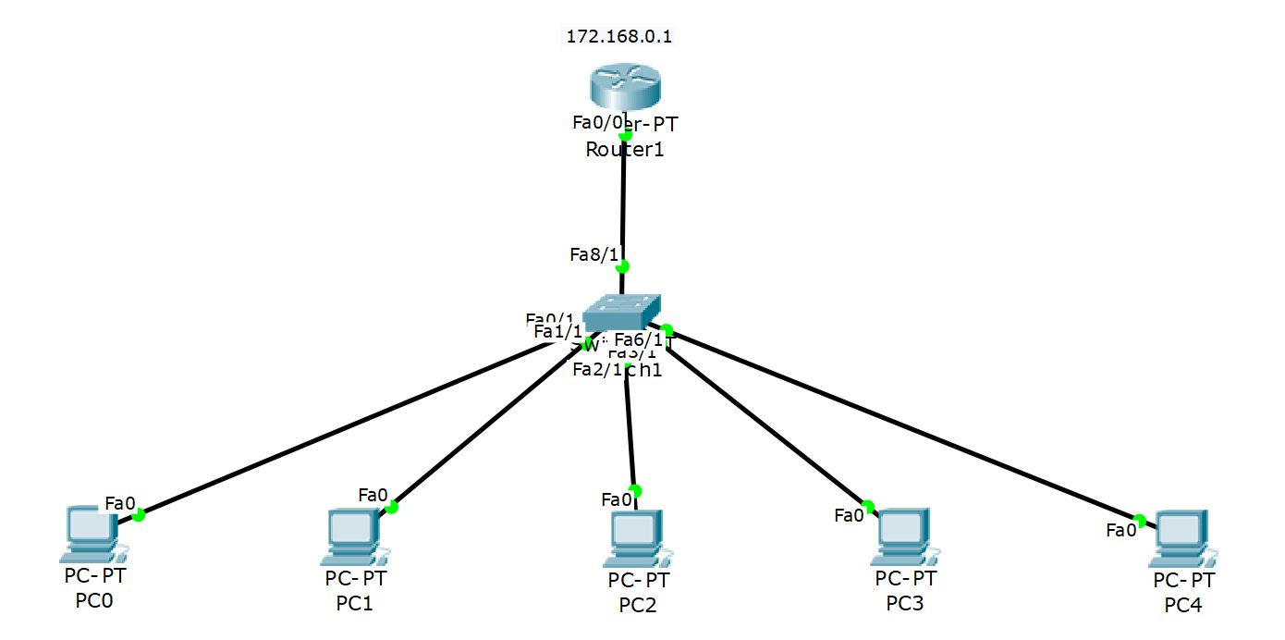

1. Create a small **network** using **5 PC** hosts, **1 Switch**, and **1 Router** connected with **6 copper straight-through** cables.
2. Click on **Router 1**, and select the **CLI** (*IOS Command-Line Interface*) tab.



1. At the **Continue with configuration dialog?** type **n** (or **no**), then hit the **Enter**

key. After that, press **Enter** again to get started.**

1. At the **Router>** prompt, type **enable**, then hit the **Enter** key. The **Router>** prompt changes to **privileged exec mode**, showing **Router#**



1. Next, type **configure terminal** (or **configure t** or **config t**, for short), then hit the **Enter** key. The **Router#** prompt changes to **global configuration mode**, showing **Router(config)#**

**Note: when starting a keyword like ‘configure’, if you hit the Tab key it will auto-fill the rest of the word for you (“conf” becomes “configure”).**



1. You’ll need to configure both the router interfaces to communicate with the two networks, so start by typing **interface fastEthernet 0/0** , then hit the **Enter** key. The **Router(config)#** prompt changes to **interface configuration mode**, showing   
   Router(config-if)#



1. Now you need to give the **fastEthernet 0/0** interface an **IP address**, so type all on the same line

**ip address 172.168.0.1 255.255.255.0,** then hit the **Enter** key



1. Back at the **Router(config-if)#** prompt, type **no shutdown** to keep the interface **up**

and running.



1. The **fastEthernet 0/0** (or **fa0/0** for short) **interface** has now be set up.
2. At the **Router(config-if)#** prompt, type **exit**, then hit the **Enter** key. The **Router(config-if)#** prompt changes to **interface configuration mode**, showing **Router(config)#**
3. At the **Router(config)#** prompt, type **ip dhcp pool MyDHCP**

**Note: MyDHCP is the name I am giving the name of the pool, although it could be any name**

**

1. At **Router(dhcp-config)#** prompt, type **network 172.168.0.0 255.255.255.0**



1. At **Router(dhcp-config)#** prompt, type **default-router 172.168.0.1**. Then, at **Router(dhcp-config)#** prompt, type **exit** to return to the **Router(config)#**

prompt.

**Note: In the command “default-router” we are telling the DHCP about the default route to follow.**



1. At the **Router(config)#** prompt, type:

## ip dhcp excluded-address 172.168.0.3 172.168.0.9

**Note: We are excluding some IP addresses by applying this command “ip dhcp excluded-addresses 172.168.0.3 172.168.0.9”, where 172.168.0.3 is the starting range and 172.168.0.9 is the ending range of IP addresses we are reserving for later use. These reserved addresses can be used to attach printers, or to assign to some specific users for security purposes.**



1. At the **Router(config)#** prompt, type **exit**



1. Now, click on each of the five **PC**s, select **Desktop** tab, then **IP Configuration**, and change the IP Configuration from **Static** to **DHCP** to have the **DHCP** from the **Router** to automatically assign the **IP address** (as per this example from **PC0** below):

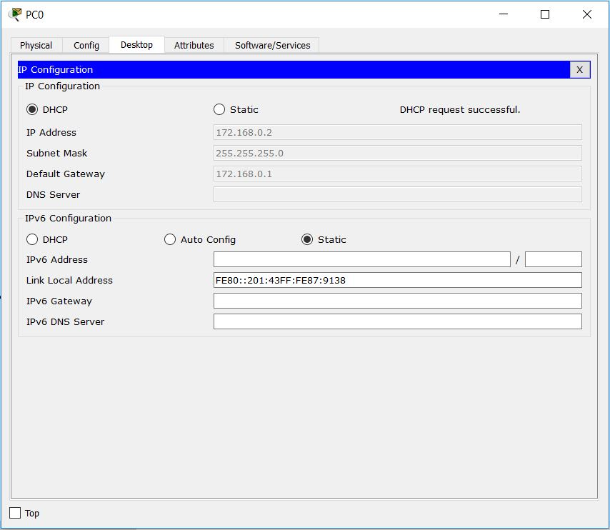

1. As you work through each of the **PC**s, you’ll see that the IP addresses **172.168.0.3**, **172.168.0.4**, **172.168.0.5**, **172.168.0.6**, **172.168.0.7**, **172.168.0.8**, and **172.168.0.9** were skipped because we specifically excluded them from the **DHCP address pool**.
2. At this point, we might test our **configuration** by doing a few test **pings** from the **PC**s.

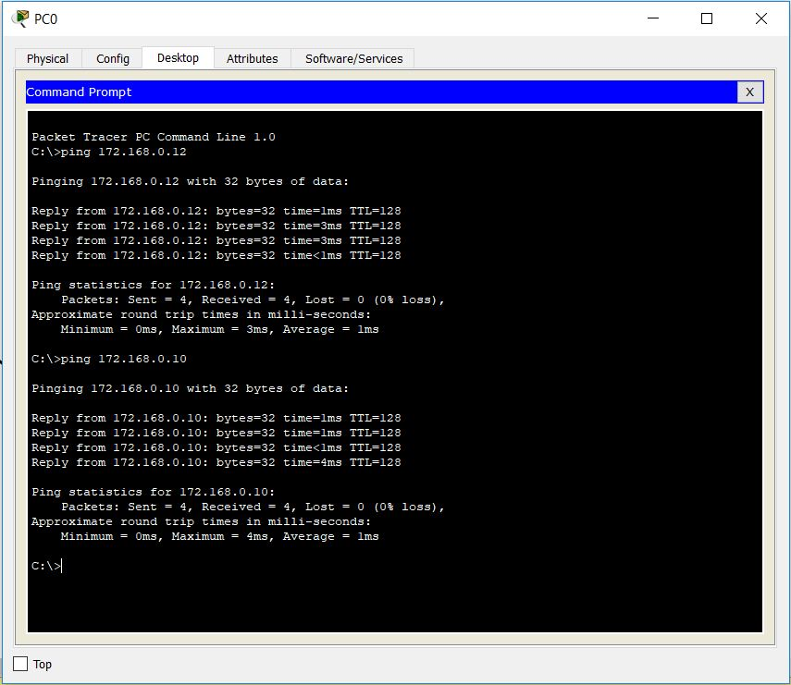

That’s it! We have set up **DHCP** on a **Router** in **Packet Tracer**

Question 06 What did you learn in this part of lab? 3 points

Question 07: Now visit any host(PC) that is getting its IP from DHCP server you configured ( by doing ipconfig) to display its IP address, network mask, default router, and Ip address of DNS server . What value you got for each? Explain. If you didn’t get any, also explain why? Provide print screen of your obtained answer (and don’t forget to provide why did you get this answer.) 12 points

# Section 3 (35 points)

1. 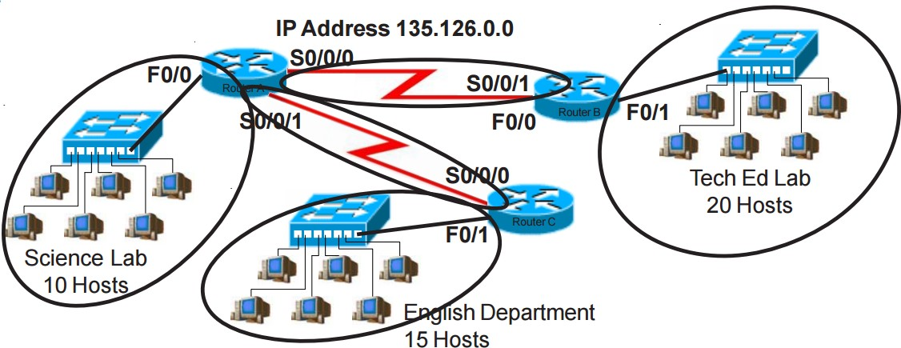Suppose we have Network address 135.126.0.0 and based on the information given in figure below, network administrator has been asked to design a network addressing scheme that will supply the minimum number of hosts per subnet and allow enough extra subnets and hosts for 30% growth in all areas.
2. What is address class of given network address? (1 point)
3. What is default subnet mask? (1 point)
4. What is custom Subnet mask? (1 point)
5. Total Number of subnets needed (after 30% growth) (2 point)
6. Total number of host address needed for the largest subnet (after 30% growth) (2 points)
7. Number of bits borrowed from host part for Subnetting? (1 point)
8. IP address range for Tech Ed (2 point)
9. What are the assignable addresses for the Tech Ed subnet a) if classful addressing is used and b) if classless addressing is used? (2+2 point)
10. IP address range for English (2 points)
11. IP address range for Science (2 points)
12. IP address range for Router A to Router B Serial connection (2 points)
13. IP address range for Router A to Router C Serial Connection (1 point)

**Question 02 (15 points)**

Consider the scenario below in which three hosts, with private IP addresses 10.0.1.11, 10.0.1.17, 10.0.1.19 are in a local network behind a NATted router that sits between these three hosts and the larger Internet. IP datagrams being sent from, or destined to, these three hosts must pass through this NAT router. The router’s interface on the LAN side has IP address 10.0.1.25, while the router’s address on the Internet side has IP address 135.122.201.209.

Before doing this problem, you might want to reread the section on the NAT protocol in section 4.3.4 in the text.

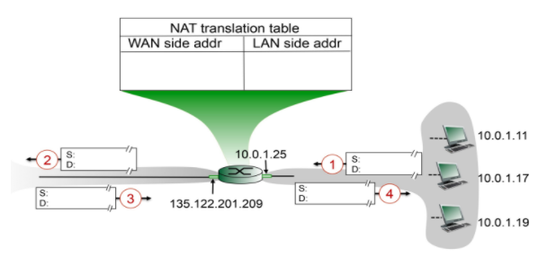

Suppose that the host with IP address 10.0.1.19 sends an IP datagram destined to host 128.119.160.183. The source port is 3324, and the destination port is 80.

1. Consider the datagram at step 1, after it has been sent by the host but before it has reached the NATted router. What are the source and destination IP addresses for this datagram? What are the source and destination port numbers for the TCP segment in this IP datagram? ( 3 points)
2. Now consider the datagram at step 2, after it has been transmitted by the NATted router. What are the source and destination IP addresses for this datagram? What are the source and destination port numbers for the TCP segment in this IP datagram? Identify the differences in datagram's IP addresses and port numbers between step 1 and step 2. Specify the entry that has been made in the router's NAT table. ( 4 points)
3. Now consider the datagram at step 3, just before it is received by the NATted router. What are the source and destination IP addresses for this datagram? What are the source and destination port numbers for the TCP segment in this IP datagram? ( 4 points)
4. Last, consider the datagram at step 4, after it has been transmitted by the NATted router but before it has been received by the host. What are the source and destination IP address for this datagram? What are the source and destination port numbers for the TCP segment in this IP datagram? Identify the differences in datagram's IP addresses and port numbers between step 3 and step 4. Has a new entry been made in the router's NAT table, or removed from the NAT table? Explain your answer.( 4 points)

**Section 4 - IP Wireshark Lab**

**(10 points)**

Question 1. To answer the following questions, follow the IP wireshark lab uploaded on Moodle. Capture

ICMP Echo Request message of size 3500 (for details see IP wireshark lab)

* + 1. How many fragments were created from the original datagram of 3500 bytes? (2 points)
    2. Describe the size of each segment. What fields change in the IP header among the fragments of datagram of 3500 bytes? (2 points)

Question 02 **(2+2+2)**

* Explain the purpose of ipconfig, “ipconfig /renew”, and “ipconfig /release”.
* Open the Windows Command Prompt application enter ipconfig and then “ipconfig /release”. The executable for ipconfig is in C:\windows\system32. What is result of these command? What does “ipconfig /release” means? Attach screenshot to support your answer
* Now go back to the Windows Command Prompt and enter “ipconfig /renew”. What happened? Attach screen shots and explain the outputs of three commands. Attach screenshot to support your answer