

ECE 5415
MICROCOMPUTER-BASED CONTROL SYSTEMS

Term Project Proposal

Self-Balancing Robot

Submitted to – Hamzeh Alzu'bi
Submitted by-
Noor Hasan Ahmed
Shivaram Nikhil Yella
Mohammad Amer Ahsan

Monday, January 29, 2024

Top of Form
Contents
Abstract: 5
Introduction: 6
Objective: 7
System Integration: 7
Sensor Fusion: 7
Control Algorithm Development: 7
Autonomous Operation: 7
Testing and Optimization: 7
Documentation and Presentation: 7
Approach 8
Research and Planning: 8
Component Selection: 8
Hardware Assembly: 8
Software Development: 8
PID Controller logic: 9
Complementary Filter: 11
Integration and Testing: 11
Optimization and Refinement: 11
Documentation and Presentation: 12
Potential Benefits: 13
Education and Learning: 13
Problem-Solving Skills: 13
Hands-On Experience: 13
STEM Education: 13
Innovation and Creativity: 13
Problem Identification: 13
Practical Applications: 13
Personal Satisfaction: 13
Milestone and Schedule: 14
Milestone: 14
Project Initiation and Planning (Week 1-2): 14
Mechanical Assembly and Hardware Integration (Week 3-4): 14
Software Development (Week 5-8): 14
Testing and Calibration (Week 9-10): 14
Optimization and Refinement (Week 11-12): 14
Documentation and Presentation (Week 13): 15
Schedule: 15
Personnel 16
Facilities and Resources: 17
Budget: 18
References: <NIKHIL>add anything that should be here. 19

Figure 1:Standard Self Balancing Robot (Example) 5
Figure 2:Arduino Uno Board 6
Figure 3: Complementary Filter 11

Abstract:
This project aims to develop a self-balancing robot using Arduino-based hardware, PID controller and a complementary filter approach for sensor fusion. Integrating an accelerometer and gyroscope, the robot utilizes a PID controller to maintain stability by adjusting motor commands based on real-time sensor data. The project encompasses hardware assembly, software development, and iterative testing for optimization. Through this endeavor, we seek to demonstrate the feasibility of creating a robust self-balancing robot while exploring concepts in robotics, control theory, and sensor integration.

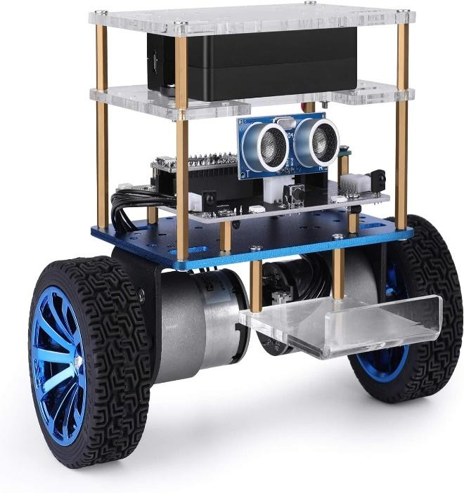
Figure 1:Standard Self Balancing Robot (Example)

Introduction:
In the realm of robotics, the pursuit of balance represents a fundamental challenge. It is a task that bridges the realms of physics, engineering, and programming, pushing the boundaries of what is achievable with modern technology. The concept of a self-balancing robot stands as a testament to human ingenuity, demonstrating our ability to mimic and even surpass nature's own mechanisms of stability.

In this proposal, we present a project aimed at the creation of a self-balancing robot utilizing the versatile Arduino platform. Our design integrates a range of essential components including ultrasonic sensors for distance measurement, the GY-521 module featuring the MPU-6050 gyroscope and accelerometer, as well as motors, wheels, and accompanying circuitry. This amalgamation of hardware and software aims to achieve a delicate equilibrium, enabling the robot to maintain its upright posture autonomously in the face of external disturbances.

Central to the success of this endeavor is the implementation of a Proportional-Integral-Derivative (PID) controller. The PID controller serves as the backbone of our control system, enabling precise adjustment of motor commands based on real-time feedback from the sensors. By intelligently combining proportional, integral, and derivative control actions, the PID controller ensures swift and accurate responses to deviations from the desired balance point, thereby enhancing the stability and performance of the self-balancing robot.

Through this endeavor, we seek not only to develop a functioning self-balancing robot but also to delve into the intricacies of sensor fusion, control algorithms, and real-time feedback mechanisms. Our project promises not only a practical application of robotics but also a valuable learning experience for enthusiasts and professionals alike. We anticipate that the insights gained from this endeavor will contribute to advancements in fields ranging from automation to assistive technology, laying the groundwork for future innovations in the realm of robotics and beyond.
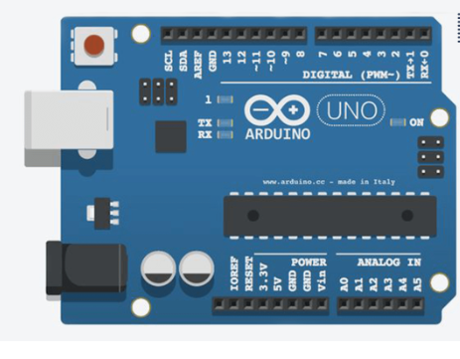
Figure 2:Arduino Uno Board

Objective:

The primary objective of this project is to design, build, and program a self-balancing robot utilizing Arduino-based hardware and various sensors, including ultrasonic sensors and the GY-521 module with the MPU-6050 gyroscope and accelerometer. The specific objectives include:

System Integration: Integrate the selected hardware components, including motors, wheels, sensors, and the Arduino microcontroller, into a cohesive robotic platform.

Sensor Fusion: Develop algorithms to fuse data from multiple sensors, including the ultrasonic sensor for distance measurement and the MPU-6050 gyroscope and accelerometer for detecting orientation and motion.

Control Algorithm Development: Design and implement control algorithms, notably the Proportional-Integral-Derivative (PID) controller, to interpret sensor data, calculate the appropriate motor commands, and maintain the robot's balance in real-time.

Autonomous Operation: Enable the robot to autonomously adjust its position and velocity to counteract external disturbances and maintain its upright posture.

Testing and Optimization: Conduct rigorous testing and iteration to optimize the performance of the self-balancing robot, including fine-tuning PID controller parameters and addressing any hardware or software limitations.

Documentation and Presentation: Document the design process, implementation details, and experimental results comprehensively. Present the project findings through written reports, presentations, and potential demonstrations.

By achieving these objectives, the project aims to demonstrate the feasibility of creating a self-balancing robot using readily available components and open-source software tools. Additionally, it seeks to provide valuable insights into the principles of sensor integration, control theory, and robotic system development, fostering learning and innovation in the field of robotics and beyond.

Approach
Approach for Self-Balancing Robot Project:

Research and Planning:
Familiarize ourselves with the Arduino platform, including its programming environment and compatible hardware.
Research existing self-balancing robot designs and control algorithms, particularly those utilizing PID controllers.
Create a detailed project plan outlining the required components, tasks, and timeline.

Component Selection:
Choose suitable motors, wheels, chassis, and other mechanical components based on the size and weight requirements of your robot.
Selection of sensors, such as ultrasonic sensors and the MPU-6050 module, ensuring compatibility with Arduino and adequate performance for balance detection.

Hardware Assembly:
Assemble the mechanical components to construct the robot's chassis and ensure proper mounting of motors, wheels, and sensors. Connecting the selected hardware components to the Arduino microcontroller, following datasheets and pinout diagrams.

Software Development:
Writing Arduino sketches to interface with sensors and reading data from the ultrasonic sensor and MPU-6050 module.
Implementation of sensor fusion algorithms to combine data from the gyroscope and accelerometer for accurate orientation detection.
Development of the PID controller algorithm to calculate motor commands based on sensor feedback and desired balance setpoint.
Fine-tune PID controller parameters through iterative testing and experimentation to achieve optimal balance performance.

PID Controller logic:

To develop the PID controller for a self-balancing robot, let's consider the following variables and their meanings:

θdesired: The desired angle (setpoint) at which the robot should balance.
θcurrent: The current angle measured by the gyroscope and accelerometer sensors.
e(t): The error at time t, defined as θdesired – θcurrent.​
P(t): The proportional term, which is proportional to the current error.
I(t): The integral term, which takes into account the accumulated past errors.
D(t): The derivative term, which anticipates the future trend of the error based on its rate of change.
U(t): The PID output, which is the sum of the proportional, integral, and derivative terms.
Let's define the mathematical equations for each term:
Proportional Term (P):
The proportional term is given by:
P(t)=Kp​⋅e(t)
Integral Term (I):
The integral term is the sum of all past errors up to time Δ t, multiplied by the integral gain:
$I\left(t\right)=K_{i}.\sum_{i=0}^{t}{}e(i)⋅Δt$

Derivative Term (D):
The derivative term estimates the future trend of the error based on its rate of change. It is calculated as the change in error divided by the change in time, multiplied by the derivative gain Kd​:
D(t)=Kd​⋅dt/de(t)​
PID Output (U):
The PID output is the sum of the proportional, integral, and derivative terms:
U(t)=P(t)+I(t)+D(t)
In summary, the PID controller adjusts the motor commands (output) based on the error between the desired angle and the current angle measured by sensors, as well as the historical behavior of the error. The tuning parameters:
Kp​, Ki and Kd​
determine the behavior and performance of the PID controller and need to be carefully adjusted through experimentation and tuning.
We have two measurements of the angle from two different sources. The measurement from accelerometer gets affected by sudden horizontal movements and the measurement from gyroscope gradually drifts away from actual value.
We will be using Complementary Filter to combine these two data points:

Complementary Filter:

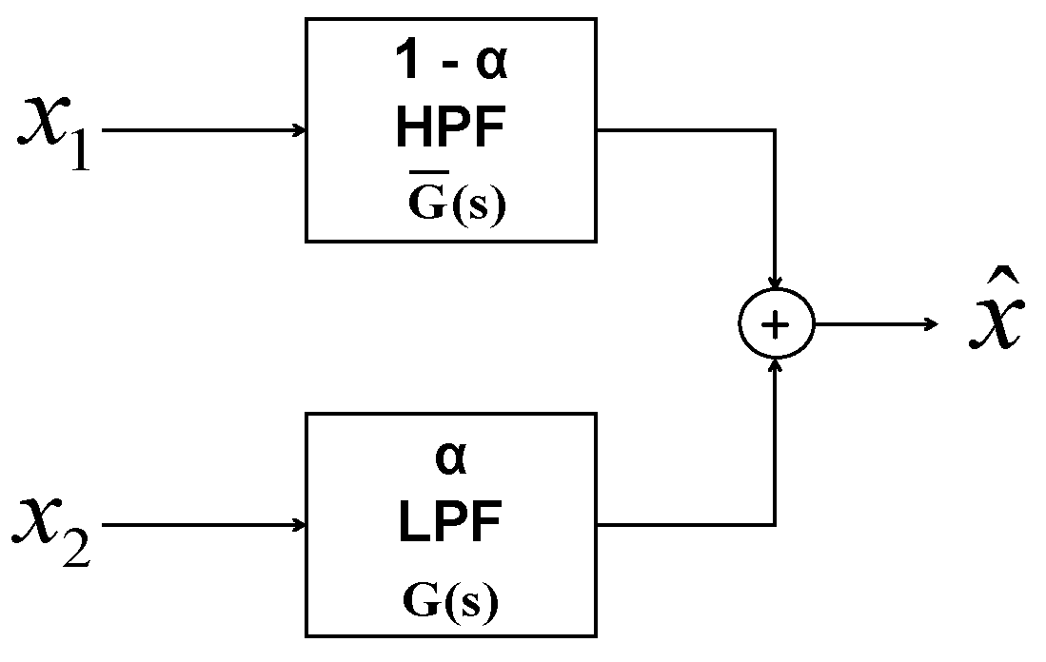
Figure 3: Complementary Filter

A complementary filter combines accelerometer and gyroscope data to enhance orientation estimation by compensating for each sensor's strengths and weaknesses. It utilizes gyroscope data for short-term changes and accelerometer data for long-term changes, yielding a more accurate and stable orientation estimate. By adjusting filter coefficients, it achieves a balance between responsiveness and stability in inertial navigation and motion tracking applications.

Integration and Testing:
Integration of the hardware and software components to create a functioning self-balancing robot prototype.
Performing initial tests to verify sensor readings, motor control, and overall stability.
We plan to gradually increase the complexity by introducing external disturbances and evaluating the robot's ability to maintain balance under different conditions.

Optimization and Refinement:
We will continuously refine the control algorithm and PID parameters based on testing results to improve balance performance and responsiveness.
We will also address any mechanical issues or hardware limitations that may affect the robot's stability or functionality.
Documentation of observations and modifications made during the optimization process for future reference.

Documentation and Presentation:
Documenting the project progress, including design choices, implementation details, and testing outcomes. Preparation of written reports, presentations, or video demonstrations to showcase the self-balancing robot and its capabilities.
By following this approach, we can systematically design, build, and test a self-balancing robot using Arduino and various sensors, culminating in a successful project that demonstrates our skills in robotics and control systems.

Potential Benefits:

The self-balancing robot project offers several potential benefits, including:
Education and Learning: Engaging in this project provides an excellent opportunity for individuals to learn about various aspects of robotics, including hardware integration, sensor fusion, control theory, and programming with Arduino.
Problem-Solving Skills: Participants can develop problem-solving skills by overcoming challenges related to mechanical design, software development, and optimization of control algorithms.
Hands-On Experience: Building and programming a self-balancing robot offers hands-on experience in robotics, enhancing practical skills and understanding of concepts beyond theoretical knowledge.
STEM Education: It serves as an effective tool for promoting STEM (Science, Technology, Engineering, and Mathematics) education, particularly among students, by making complex concepts accessible and engaging.
Innovation and Creativity: Participants are encouraged to explore innovative solutions and apply creative thinking to improve the design, functionality, and performance of the self-balancing robot.
Problem Identification: Identifying and addressing challenges encountered during the project encourages critical thinking and analytical skills, preparing participants to tackle real-world problems in their future endeavors.
Practical Applications: Balancing robots with trays or compartments could navigate uneven terrain and deliver packages, especially in areas with limited infrastructure. Small, agile balancing robots could navigate disaster zones to locate survivors and assess damage. [The skills and knowledge gained from this project can be applied to develop other robotics projects and potentially contribute to real-world applications such as assistive technology, automation, and industrial robotics.]
Personal Satisfaction: Successfully completing the project can provide a sense of accomplishment and personal satisfaction, motivating participants to pursue further learning and exploration in the field of robotics.

Milestone and Schedule:

Milestone:
Here's a proposed milestone breakdown for the self-balancing robot project:

Project Initiation and Planning (Week 1-2):
Research existing self-balancing robot designs, control algorithms, and hardware components. Create a detailed project plan outlining tasks, timeline, and resource requirements. Procure necessary materials and components.

Mechanical Assembly and Hardware Integration (Week 3-4):
Assemble the robot chassis, attach motors, wheels, and other mechanical components. Mount sensors, including the MPU-6050 gyroscope and accelerometer, and connect them to the Arduino. Test mechanical components for proper fit and functionality.

Software Development (Week 5-8):
Develop Arduino sketches to interface with sensors and read data from the MPU-6050 module and ultrasonic sensor. Implement sensor fusion algorithms to combine data from the gyroscope and accelerometer. Design and implement the PID controller algorithm for balance control. Test software components individually and integrate them into a cohesive codebase.

Testing and Calibration (Week 9-10):
Conduct initial tests to verify sensor readings, motor control, and balance performance. Fine-tune PID controller parameters through iterative testing and calibration. Evaluate the robot's ability to maintain balance under various conditions and external disturbances.

Optimization and Refinement (Week 11-12):
Address any mechanical issues, hardware limitations, or software bugs identified during testing. Optimize code efficiency and performance to enhance real-time responsiveness. Document observations and modifications made during the optimization process.

Documentation and Presentation (Week 13):
Document the project progress, including design choices, implementation details, and testing outcomes. Prepare written reports, presentations, or video demonstrations showcasing the self-balancing robot and its capabilities.
Share project findings and experiences with the robotics community through online forums, blogs, or social media platforms.
By breaking down the project into these milestones, we can track progress, manage tasks effectively, and ensure timely completion of the self-balancing robot project. Adjustments to the timeline may be necessary based on project complexity, resource availability, and unforeseen challenges encountered during implementation. We will make sure that any diversion in this plan is well informed and shared with the professor.

Schedule:
<Nikhil>

Personnel

Noor Hasan Ahmed- MS-Embedded Systems
Shivakumar Nikhil Yella – MS- Embedded Systems
Abdul Amer Ahsen – MS – Electronics and Electrical Engineering

Facilities and Resources:

- Arduino Starter Kit UNO R3.
- MATLAB (Student Release)
- Simulink
- Arduino IDE
- Robot Vehicle
- GY-521 module with MPU-6050
- DRV8833 Dual Motor Driver Carrier
- 5V DC-DC boost converter
- US-020 ultrasonic distance sensor
- NCR18650 battery
- DC 6V 200RPM Speed Reduction Motor N20
- 42x19mm wheels
- Prototype PCB (4x6 cm)

Budget:

To estimate the budget for the project, we'll consider the approximate costs of each component based on current market prices. Please note that prices may vary depending on many factors. Additionally, some items may already be owned while we may need to buy multiple numbers of certain items. Here's a breakdown of the estimated budget:

Arduino Starter Kit UNO R3: $60
MATLAB (Student Release): Free
Simulink: Included with MATLAB
Arduino IDE: Free
Robot Vehicle: $30
GY-521 module with MPU-6050: $10
DRV8833 Dual Motor Driver Carrier: $15
5V DC-DC boost converter: $8
US-020 ultrasonic distance sensor: $15
NCR18650 battery: $10 (for a pair)
DC 6V 200RPM Speed Reduction Motor N20: $14 (for a pair)
42x19mm wheels: $8 (for a pair)
Prototype PCB (4x6 cm): $6 (for a pack of 3)
Total Estimated Budget: $176

Please note that this is a rough estimate and actual costs may vary. Additionally, we have not included any labor, assembly, transportation, resources, and data storage costs.

References: <NIKHIL>add anything that should be here.
Dursun, Emre Hasan, and Akif Durdu. “Speed Control of a DC Motor with Variable Load Using Sliding Mode Control.” International Journal of Computer and Electrical Engineering 8, no. 3 (2016): 219–26. https://doi.org/10.17706/ijcee.2016.8.3.219-226.
Khan, Muhammad rafa. “Speed Control of DC Motor under Varying Load Using PID Controller.” International journal for engineering 9, no. 3 (2015).
Jain, Hardik S, Sandesh Agrawal, and krishnman Tibrewal. “DC Motor Speed Control Using PID Controller, IR Sensor and PWM Hysteresis .” International Journal of Innovative Technology and Exploring Engineering 8, no. 6 (April 2019).

