現代控制理論HW4

104303206 黃筱晴

甲.

a.

x1_dot=x12+x2

x2_dot=-x1+u

取z1=x1,z2=z1_dot= x1_dot=x12+x2

則z2_dot=2x1x1_dot+x2_dot=2x1(x12+x2)+(-x1+u)≡α(x)+ β(x)u

α(x)=2x13+2x1x2-x1

β(x)=1

b.

zdot=[]z，目標極點位置s=-1+9i, -1-9i

det([])=s2-k2s-k1=s2+2s+82，經比較係數得

k1=-82,k2=-2

設計

u=(-α(x)+ (k1z1+k2z2))/β(x)

=-(2x13+2x1x2-x1)+(-82)z1+(-2)z2

=-(2x13+2x1x2-x1)+(-82)x1+(-2)( x12+x2)

c.模擬結果：

註：初值x1=2,x2=-1

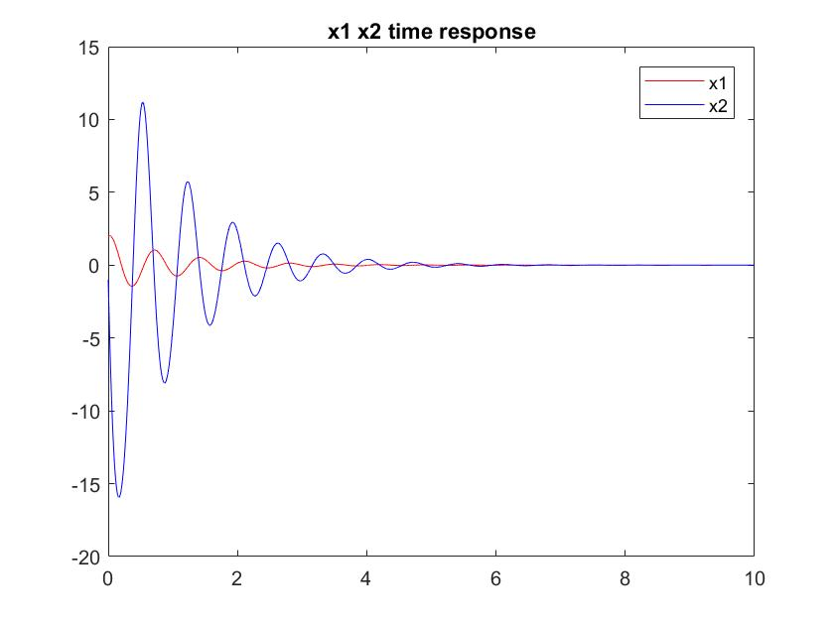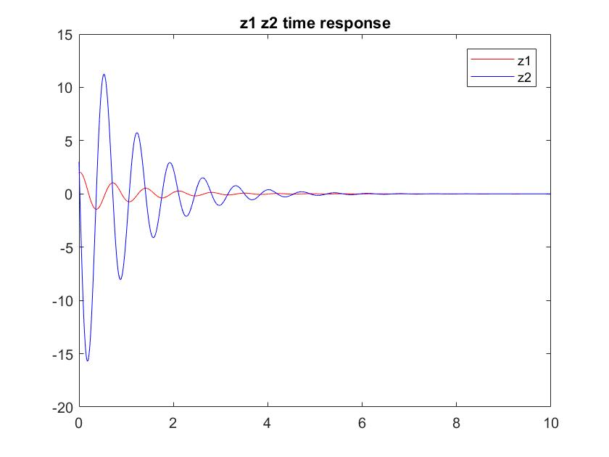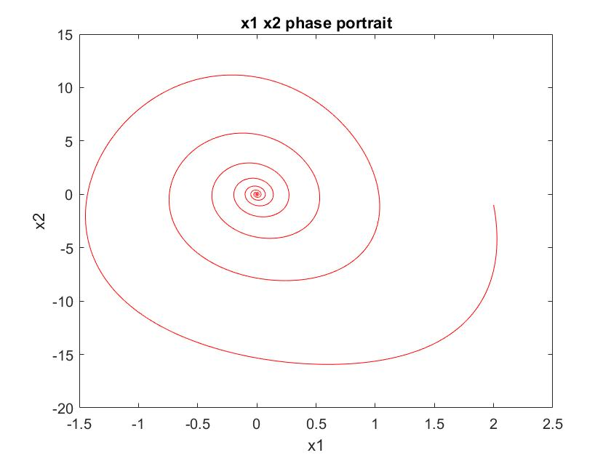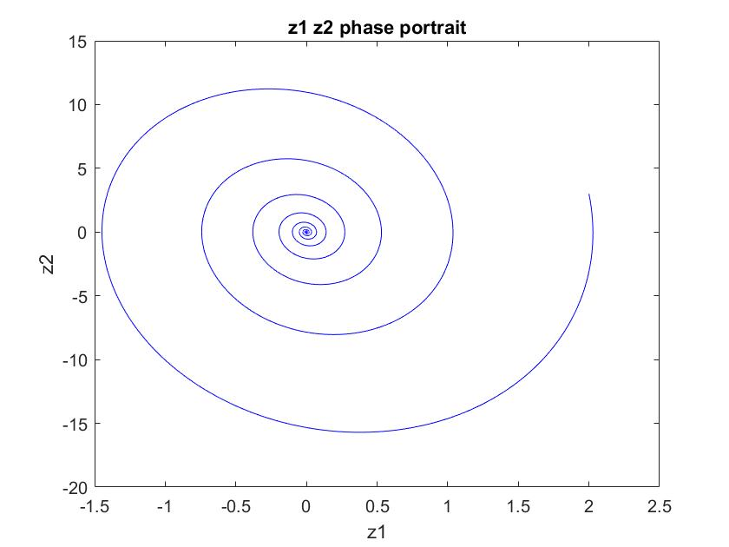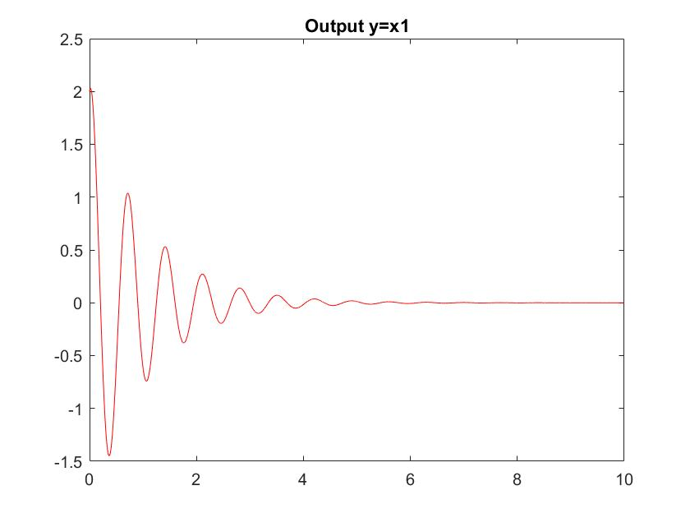

乙.

zdot=[]x，目標極點位置s=-1+9i, -1-9i, -1

det([])=-s3+k3s2+k2s+k1=-(s3+3s2+84s+82)，比較係數得

k1=-82,k2=-84,k3=-3

x1_dot=x2+x13

x2_dot=x3

x3_dot=u

取z1=x1

z2=z1_dot

z3=z2_dot

z3_dot

=(x1)'''= (x2+x13 )''=(x2_dot+3x12x1_dot)'=(( x3)+3x12(x2+x13))'

= u +3(2x1(x2+x13)x2+x12(x3))+15x14(x2+x13) ≡α(x)+ β(x)u

α(x)=3(2x1x1_dot(x2+x13)+x12(x2_dot+3x12x1_dot));

β(x)=1;

設計

u=(-α(x)+ (k1z1+ k2z2+k3z3))/β(x)

模擬結果：

註：初值x1=2,x2=-1,x3=1

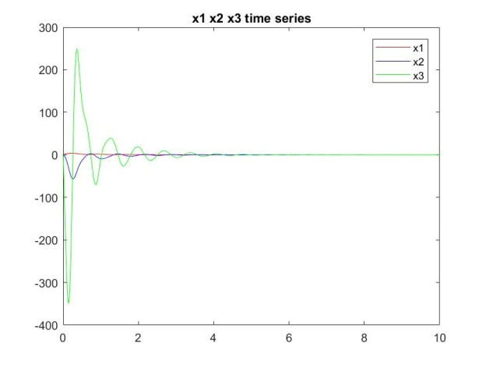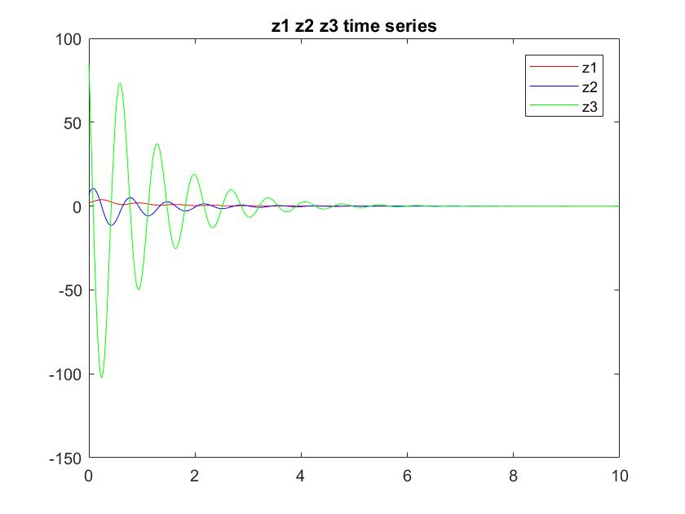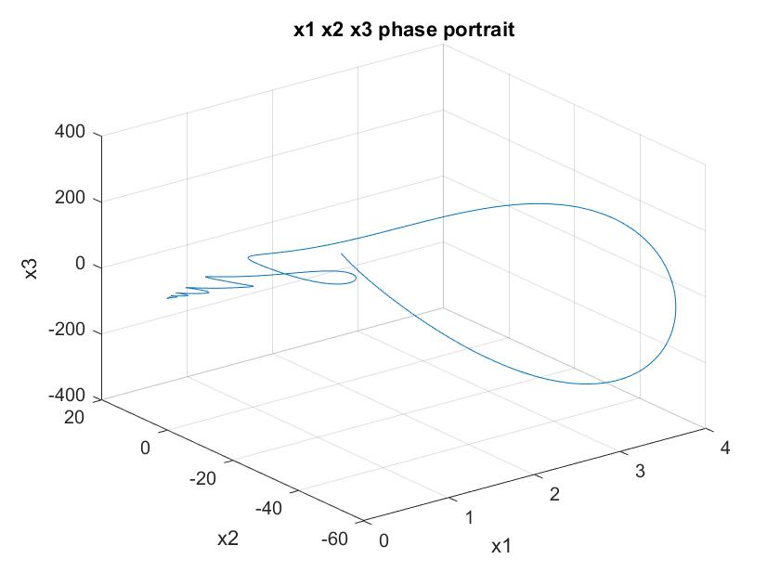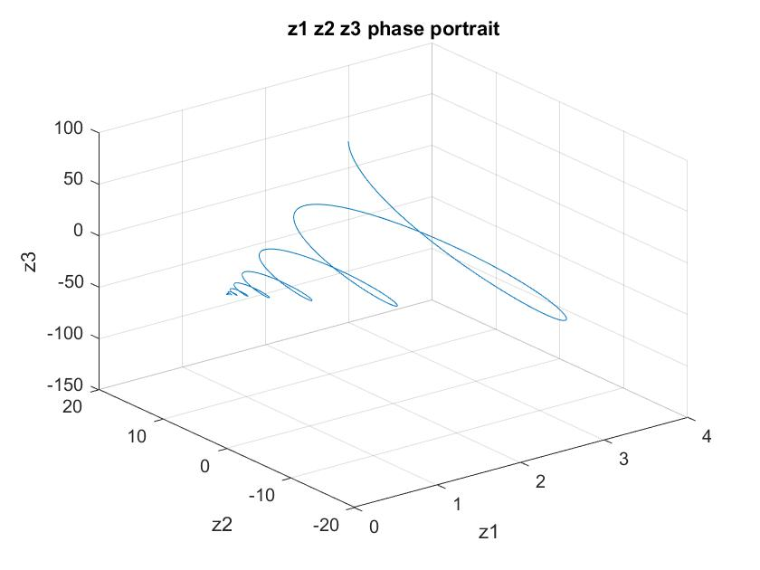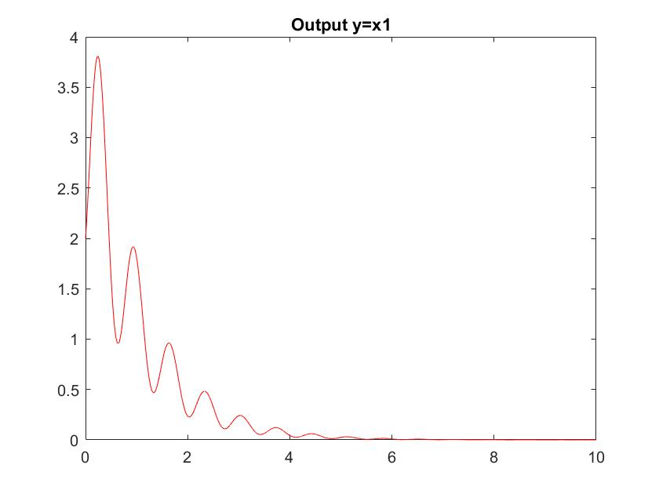

丙.

zdot=[]z，目標極點位置s=-1+9i, -1-9i

det([])=s2-k2s-k1=s2+2s+82，經比較係數得

k1=-82,k2=-2

x1_dot=0.5x13+7x2

x2_dot=2x1x2+u

取z1=x1

z2= z1_dot=x1_dot=0.5x13+7x2

z2_dot=1.5x12(0.5x13+7x2)+7(2x1x2+u) ≡α(x)+ β(x)u

α(x)= 7.5 x15+10.5 x12 x2+14x1x2

β(x)=7

設計

u=(-α(x)+ (k1z1+k2z2))/β(x)

=(-(7.5 x15+10.5 x12 x2+14x1x2)-82 x1-2(0.5x13+7x2))/7

模擬結果1(無誤差)：

註：初值x1=2,x2=-1

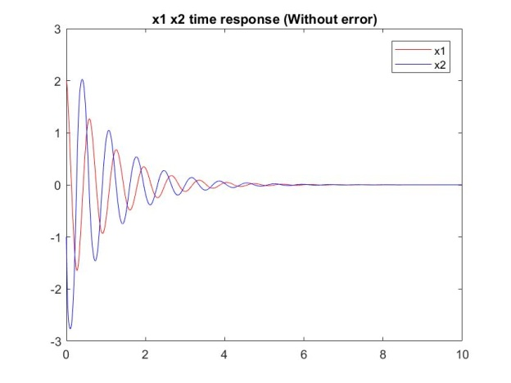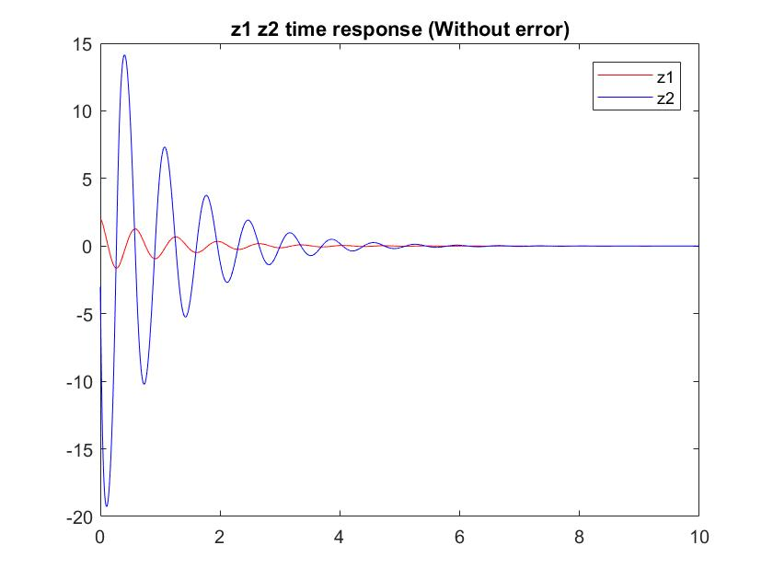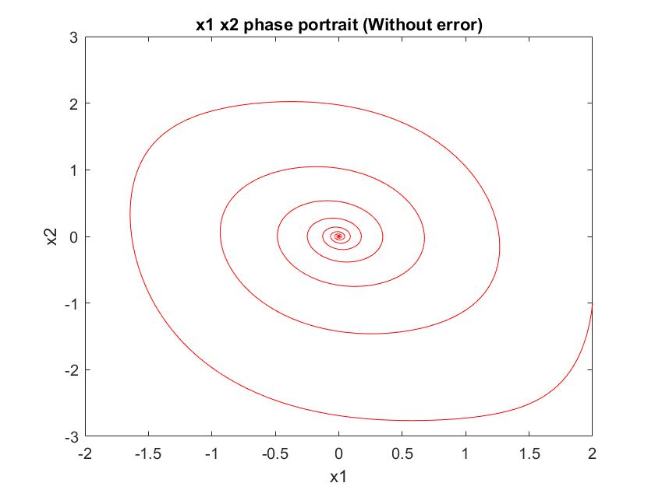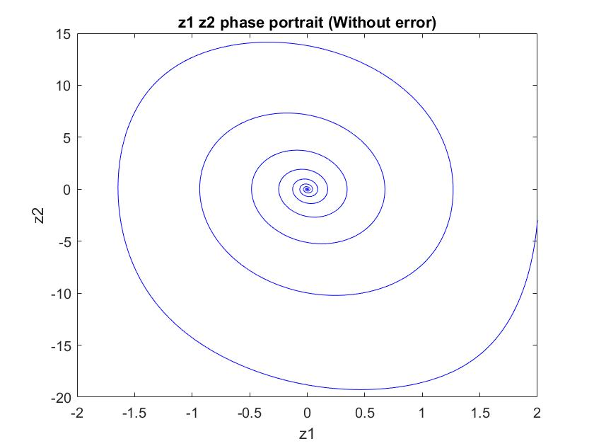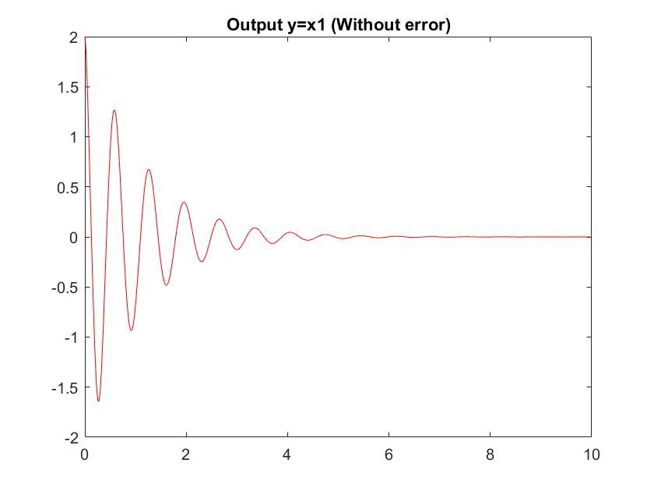

模擬結果2(有誤差)：

註：初值x1=2,x2=-1

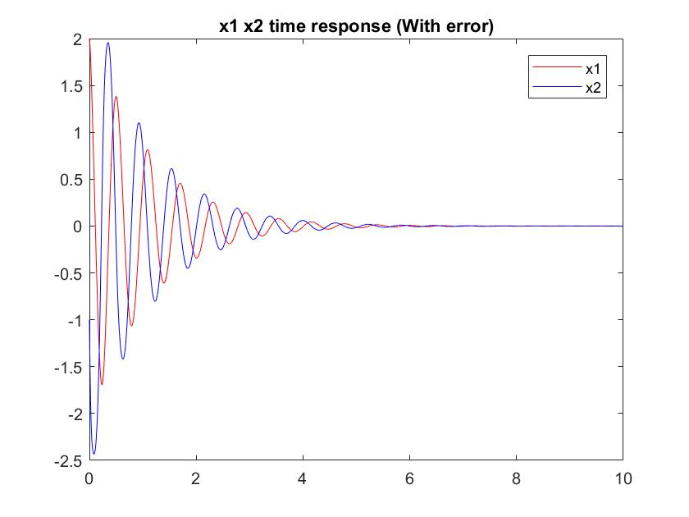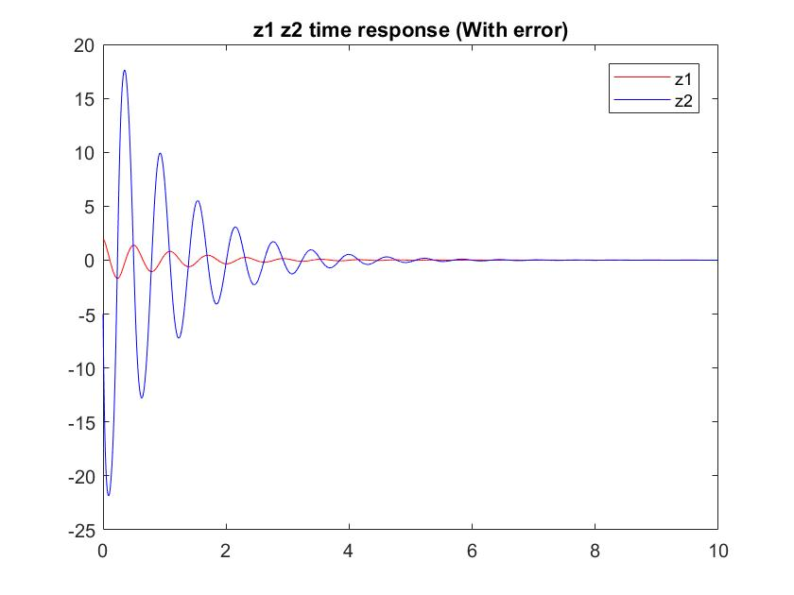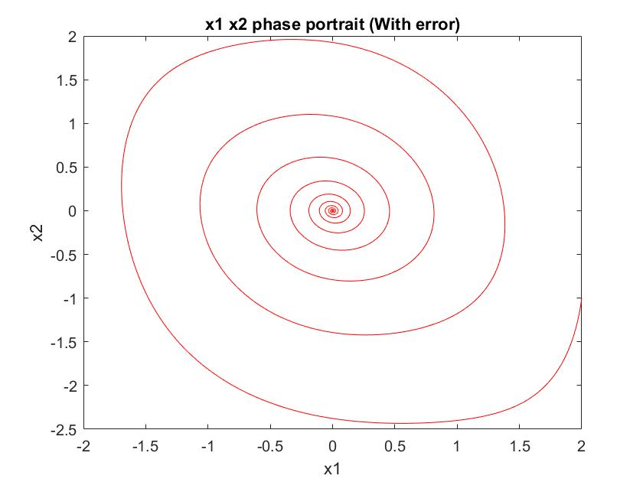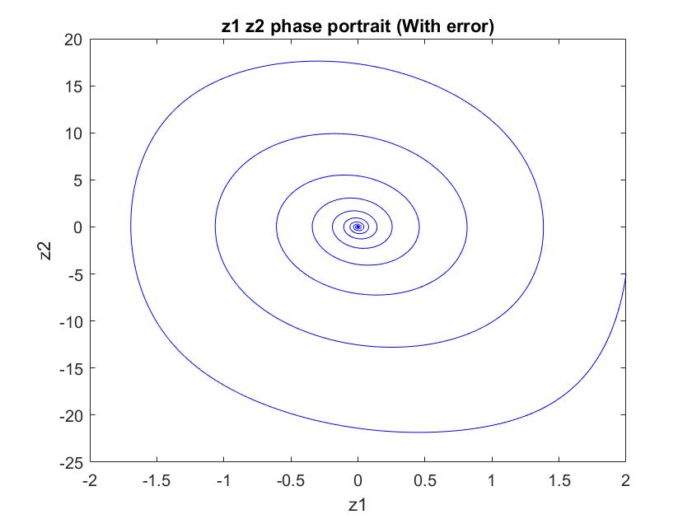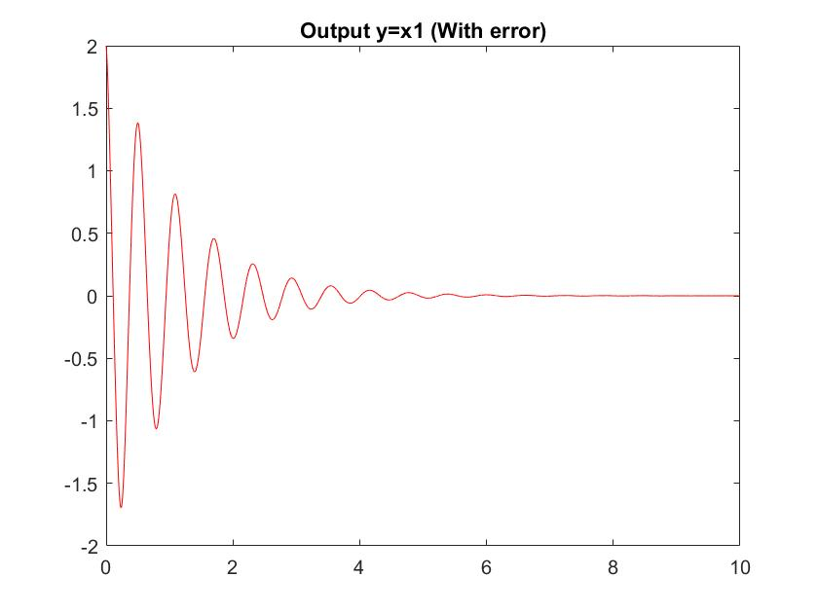

比較：相同控制器，誤差對輸出(x1)之影響：

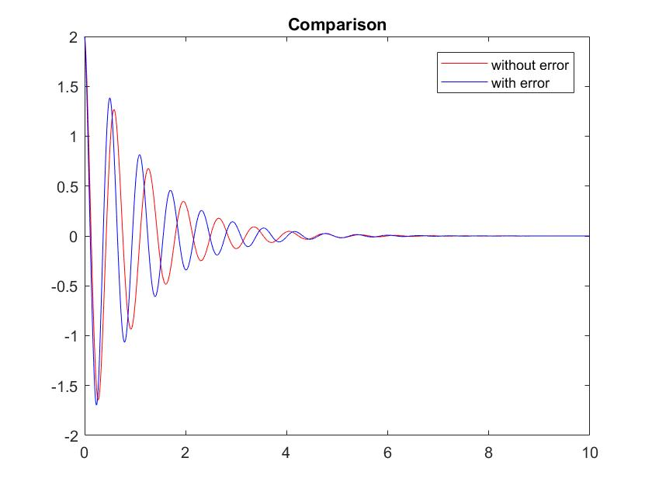

附錄(程式碼)

甲.

clear;clc;

delta=0.001;

totalTime=10;

totalStep=totalTime/delta;

x1array=[1:totalStep]*0;x2array=x1array;

z1array=x1array;z2array=x1array;

x1array(1)=2;x2array(1)=-1;%init condition

for i=1:totalStep

x1=x1array(i);x2=x2array(i);

u=-(2*x1^3+2*x1*x2-x1)+(-82)*x1+(-2)*(x1^2+x2);

x1_dot=x1^2+x2;

x2_dot=-x1+u;

z1array(i)=x1;

z2array(i)=x1_dot;

x1array(i+1)=x1+x1_dot*delta;

x2array(i+1)=x2+x2_dot*delta;

end

figure(1);

plot([0:1:totalStep]*delta,x1array,'r');

hold on;

plot([0:1:totalStep]*delta,x2array,'b');

legend('x1','x2');

title('x1 x2 time response');

figure(2);

plot([0:1:totalStep-1]*delta,z1array,'r');

hold on;

plot([0:1:totalStep-1]*delta,z2array,'b');

legend('z1','z2');

title('z1 z2 time response');

figure(3);

plot(x1array,x2array,'r');

title('x1 x2 phase portrait');

xlabel('x1');ylabel('x2');

figure(4);

plot(z1array,z2array,'b');

title('z1 z2 phase portrait');

xlabel('z1');ylabel('z2');

figure(5);

plot([0:1:totalStep]*delta,x1array,'r');

title('Output y=x1');

乙.

clear;clc;

delta=0.001;

totalTime=10;

totalStep=totalTime/delta;

x1array=[1:totalStep]*0;x2array=x1array;x3array=x1array;

z1array=x1array;z2array=x1array;z3array=x1array;

x1array(1)=2;x2array(1)=-1;x3array(1)=1;%init condition

for i=1:totalStep

x1=x1array(i);x2=x2array(i);x3=x3array(i);

x1_dot=x2+x1^3;

x2_dot=x3;

z1=x1;

z2=x2+x1^3;

z3=x2_dot+3*x1^2*x1_dot;

k1=-82;k2=-84;k3=-3;

arpha=3*(2*x1*x1_dot*(x2+x1^3)+x1^2*(x2_dot+3*x1^2*x1_dot));

u=-1*arpha+(k1*z1+k2*z2+k3*z3);

x3_dot=u;

z1array(i)=z1;

z2array(i)=z2;

z3array(i)=z3;

x1array(i+1)=x1+x1_dot*delta;

x2array(i+1)=x2+x2_dot*delta;

x3array(i+1)=x3+x3_dot*delta;

end

figure(1);

plot([0:1:totalStep]*delta,x1array,'r');

hold on;

plot([0:1:totalStep]*delta,x2array,'b');

hold on;

plot([0:1:totalStep]*delta,x3array,'g');

legend('x1','x2','x3');

title('x1 x2 x3 time series');

figure(2);

plot([0:1:totalStep-1]*delta,z1array,'r');

hold on;

plot([0:1:totalStep-1]*delta,z2array,'b');

hold on;

plot([0:1:totalStep-1]*delta,z3array,'g');

legend('z1','z2','z3');

title('z1 z2 z3 time series');

figure(3);

plot3(x1array,x2array,x3array);

xlabel('x1');ylabel('x2');zlabel('x3');

title('x1 x2 x3 phase portrait');

grid on;

figure(4);

plot3(z1array,z2array,z3array);

xlabel('z1');ylabel('z2');zlabel('z3');

title('z1 z2 z3 phase portrait');

grid on;

figure(5);

plot([0:1:totalStep]*delta,x1array,'r');

title('Output y=x1');

丙.

clear;clc;

delta=0.001;

totalTime=10;

totalStep=totalTime/delta;

x1array=[1:totalStep]*0;x2array=x1array;

z1array=x1array;z2array=x1array;

x1array(1)=2;x2array(1)=-1;%init condition

for i=1:totalStep

x1=x1array(i);x2=x2array(i);

u=(-(7.5*x1^5+10.5*x1^2*x2+14*x1*x2)-82*x1-2*(0.5*x1^3+7*x2))/7;

% x1_dot=0.5*x1^3+7*x2;

% x2_dot=2*x1*x2+u;

x1_dot=0.5*x1^3+9*x2;

x2_dot=1.5*x1*x2+u;

z1array(i)=x1;

z2array(i)=x1_dot;

x1array(i+1)=x1+x1_dot*delta;

x2array(i+1)=x2+x2_dot*delta;

end

figure(1);

plot([0:1:totalStep]*delta,x1array,'r');

hold on;

plot([0:1:totalStep]*delta,x2array,'b');

legend('x1','x2');

title('x1 x2 time response (With error)');

figure(2);

plot([0:1:totalStep-1]*delta,z1array,'r');

hold on;

plot([0:1:totalStep-1]*delta,z2array,'b');

legend('z1','z2');

title('z1 z2 time response (With error)');

figure(3);

plot(x1array,x2array,'r');

title('x1 x2 phase portrait (With error)');

xlabel('x1');ylabel('x2');

figure(4);

plot(z1array,z2array,'b');

title('z1 z2 phase portrait (With error)');

xlabel('z1');ylabel('z2');

figure(5);

plot([0:1:totalStep]*delta,x1array,'r');

title('Output y=x1 (With error)');