現代控制理論HW5

104303206 黃筱晴

a.

x1_dot=x2

x2_dot=x13x2+9x1x23+(x12+x22)u

令f=x1+λx2

則f_dot

=x2_dot+λx1_dot

= x13x2+9x1x23+(x12+x22)u+λx2

=-sign(f)*K

設計u=(-sign(f)*K- x13x2-9x1x23)/ (x12+x22)

模擬結果1(K=1,λ=0.5,初值 x1=3,x2=-3)

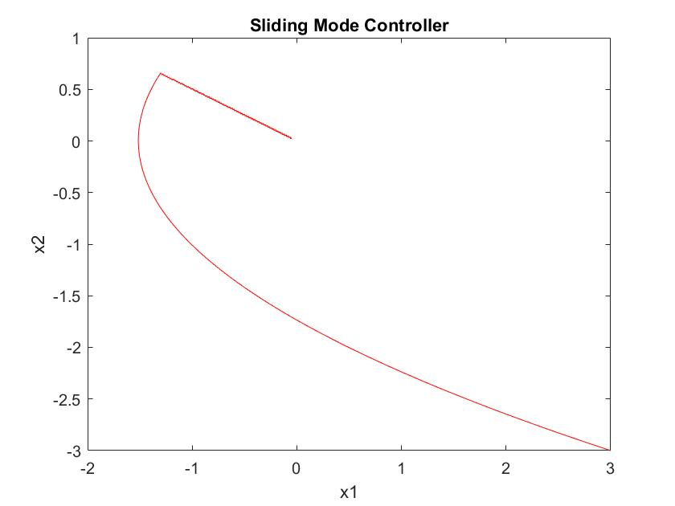

模擬結果2(比較K和λ對收斂情形的影響)

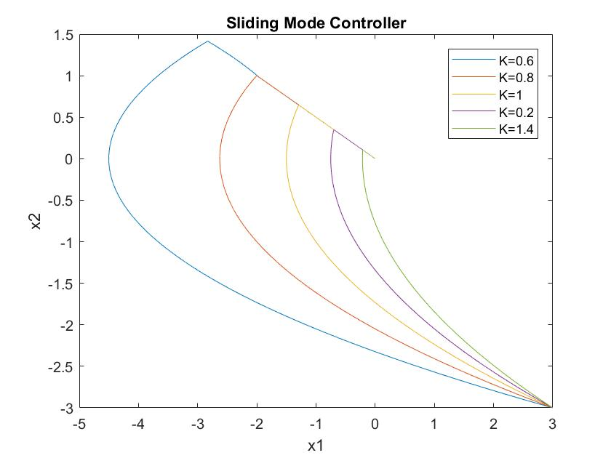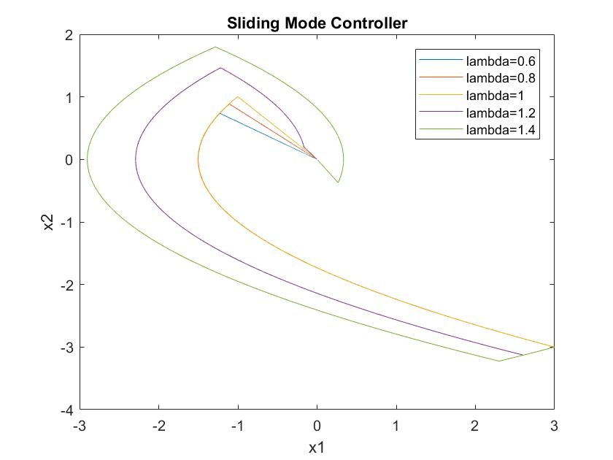

λ=0.5時不同K對收斂情形影響 K=1時不同λ對收斂情形影響

b.

x1_dot=x2

x2_dot=x13x2+9x1x23+(x12+x22)u+d(t)

d(t)=0.1sin(10πt)

控制器設計同上題

模擬結果1(λ=0.5,初值 x1=3,x2=-3)

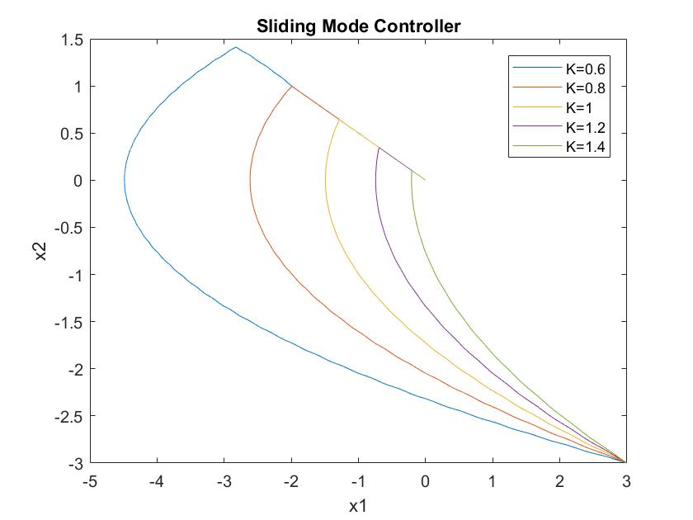

模擬結果(2)

將干擾放大為d(t)=sin(10πt)效果比較明顯

K值越大，對抗干擾能力較佳

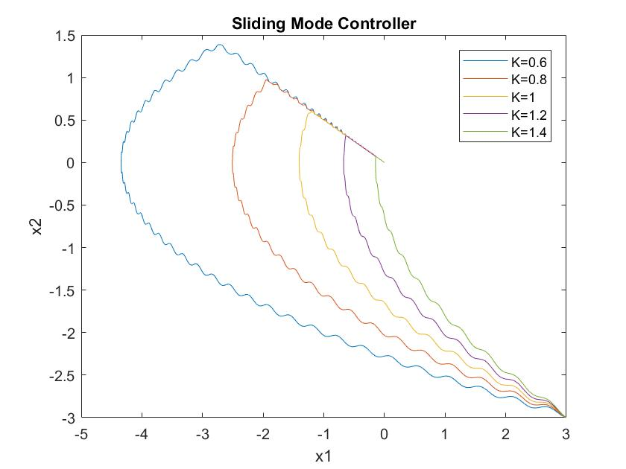

c.

1.Sliding Mode Control

x1_dot=x2

x2_dot=(1±0.2)x13x2+(9±0.4)x1x23+(x12+x22)u+d(t)

u=(-sign(f)*K- x13x2-9x1x23)/ (x12+x22)

模擬結果(K=1,λ=0.5, 初值x1=3,x2=-3)

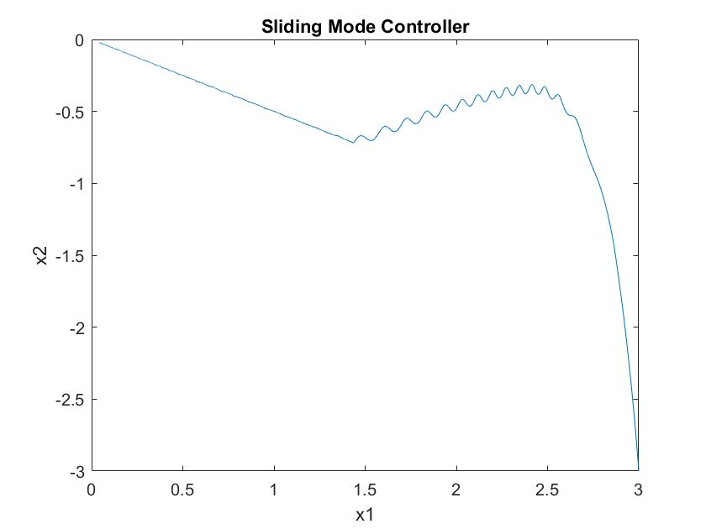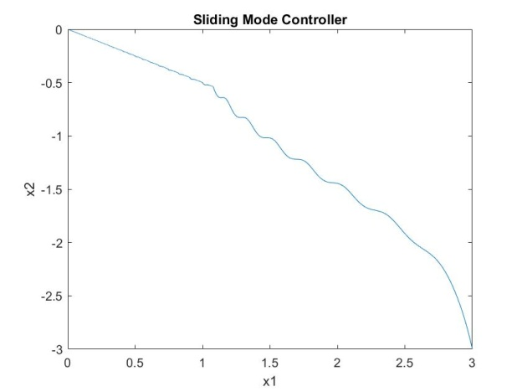

a=1-0.2,b=9-0.4(仍然收斂) a=1+0.2,b=9-0.4(仍然收斂)

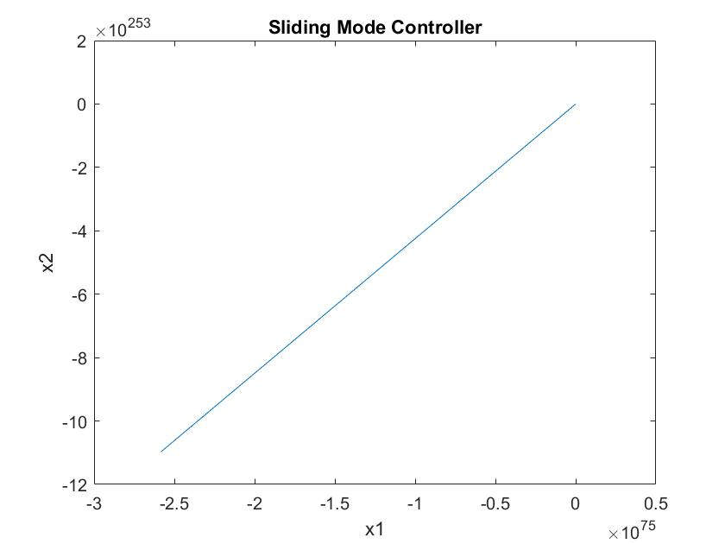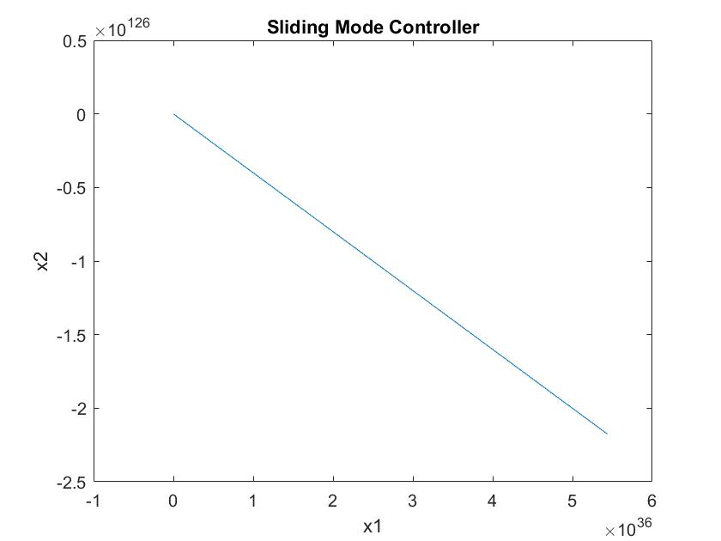

a=1-0.2,b=9+0.4(發散) a=1+0.2,b=9+0.4(發散)

解決方法：將K設計大一點

當K=100時，剛剛四種誤差情形皆收斂

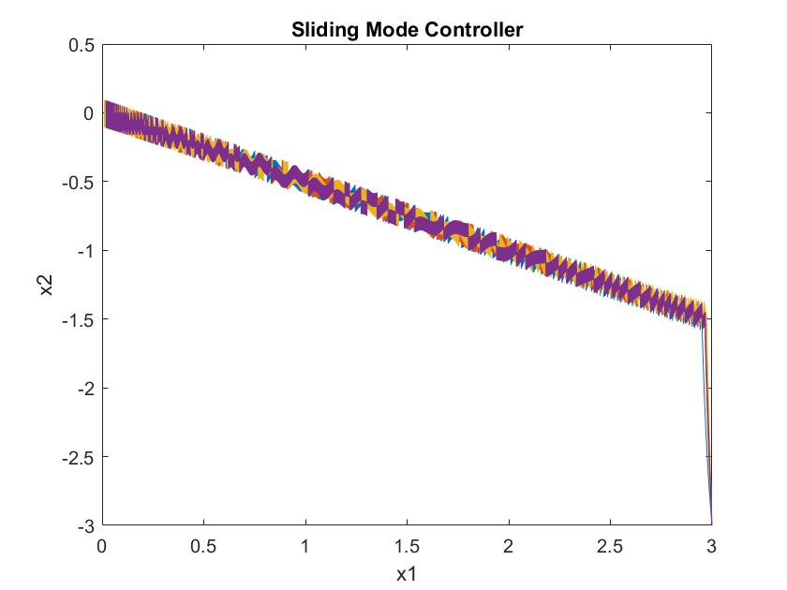

2.Feedback Linearization

x1_dot=x2

x2_dot=(1±0.2)x13x2+(9±0.4)x1x23+(x12+x22)u+d(t)

取z1=x1

z2=z1_dot= x1_dot=x2

z2_dot= x2_dot=x13x2+9x1x23+(x12+x22)u≡α(x)+ β(x)u

α(x)= x13x2+9x1x23

β(x)= (x12+x22)

zdot=[]z，目標極點位置s=-1+9i, -1-9i

det([])=s2-k2s-k1=s2+2s+82，經比較係數得 k1=-82,k2=-2

u=(-α(x)+ (k1z1+k2z2))/β(x)

=(-( x13x2+9x1x23)+(-82 x1-2 x2))/ (x12+x22)

模擬結果(初值x1=3,x2=-3)

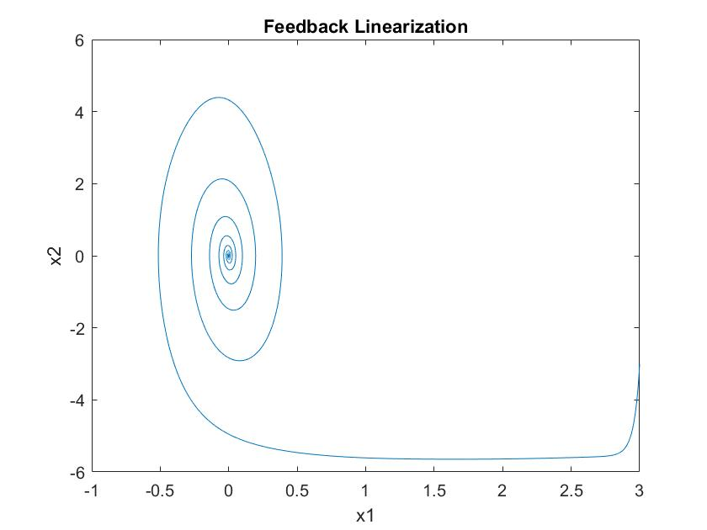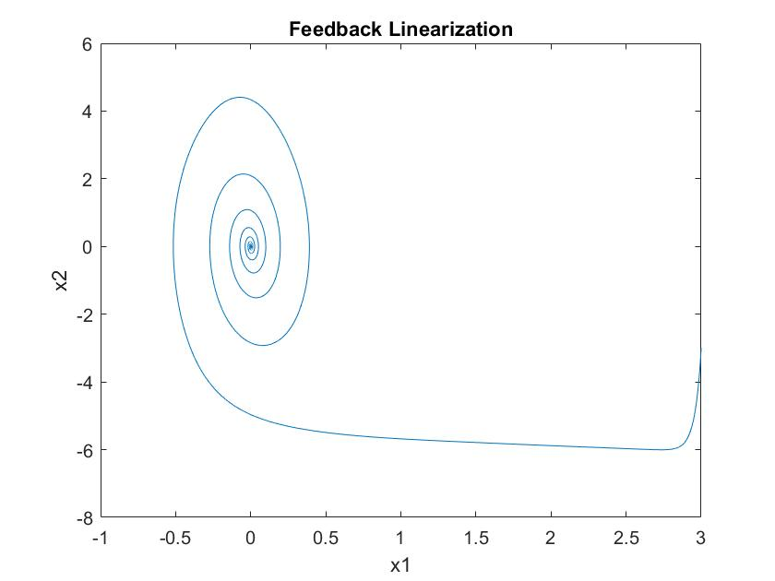

a=1-0.2,b=9-0.4(仍然收斂) a=1+0.2,b=9-0.4(仍然收斂)

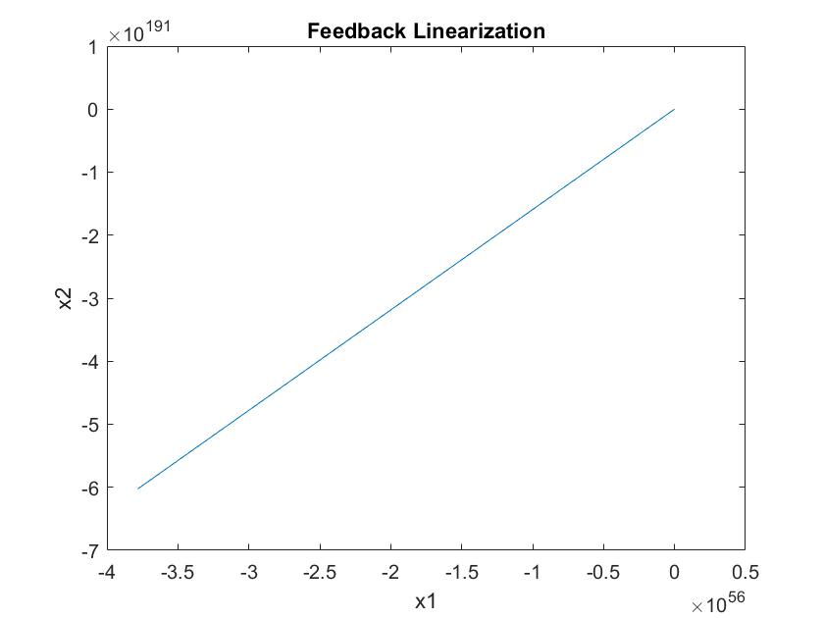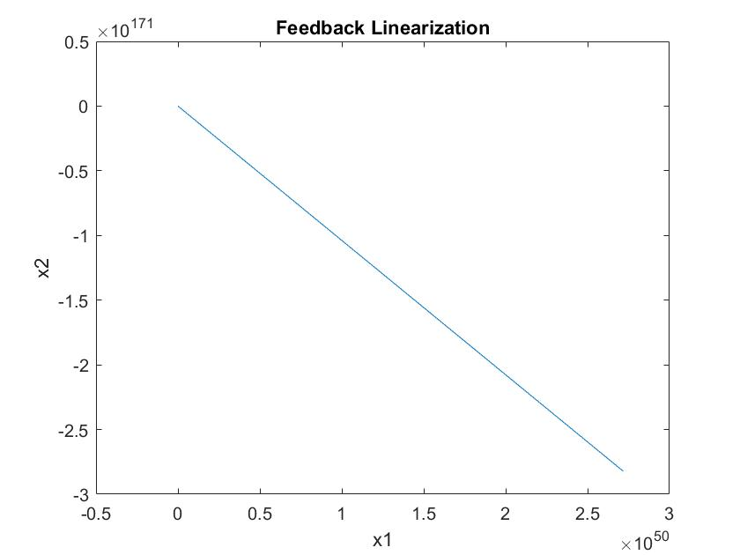

a=1-0.2,b=9+0.4(發散) a=1+0.2,b=9+0.4(發散)

解決方法：Feedback Linearization無法解決誤差

附錄(Matlab Code)

1.Sliding Mode Control

(此為(b)小題程式碼，(a)和(c)也都差不多只調整一些參數)

clc;clear;

lambda=0.5;

K=1;

delta=0.001;

totalTime=10;

totalStep=totalTime/delta;

for K=0.6:0.2:1.4%compare with different K

x1array=[1:totalStep]*0;x2array=x1array;

x1array(1)=3;x2array(1)=-3;%init condition

for i=1:totalStep

x1=x1array(i);x2=x2array(i);

f=x2+lambda*x1;

u=(-sign(f)*K-x1^3*x2-9*x1*x2^3)/((x1^2+x2^2));

d=0.1*sin(10*pi*(i*delta));

x1_dot=x2;

x2_dot=(1)*x1^3*x2+(9)*x1*x2^3+(x1^2+x2^2)*u+d;

x1array(i+1)=x1+x1_dot*delta;

x2array(i+1)=x2+x2_dot*delta;

end

plot(x1array,x2array);

hold on;

end

xlabel('x1');

ylabel('x2');

title('Sliding Mode Controller');

legend({'K=0.6','K=0.8','K=1','K=1.2','K=1.4'});

2. Feedback Linearization

clear;clc;

delta=0.001;

totalTime=10;

totalStep=totalTime/delta;

x1array=[1:totalStep]*0;x2array=x1array;

x1array(1)=3;x2array(1)=-3;%init condition

for i=1:totalStep

x1=x1array(i);x2=x2array(i);

u=(-(x1^3*x2+9*x1*x2^3)+(-82*x1-2*x2))/(x1^2+x2^2);

d=0.1*sin(10*pi*(i*delta));

x1_dot=x2;

x2_dot=(1-0.2)*x1^3*x2+(9-0.4)*x1*x2^3+(x1^2+x2^2)*u+d;

x1array(i+1)=x1+x1_dot*delta;

x2array(i+1)=x2+x2_dot*delta;

end

plot(x1array,x2array);

xlabel('x1');

ylabel('x2');

title('Feedback Linearization');