現代控制理論HW6

104303206 黃筱晴

1.

x1_dot=x2

x2_dot=x3

x3_dot=α(x12sin(x2)+x22sin(x3))+(x1+x32)cos(x3)+u+d(t)

令f=x3+2λx2+λ2 x1

則f_dot

= x3_dot +2λx2_dot+λ2x1_dot

= x3_dot +2λx3+λ2 x2

=α(x12sin(x2)+x22sin(x3))+(x1+x32)cos(x3)+u+d(t)+ 2λx3+λ2 x2

=-sign(f)*K

設計u=-sign(f)*K-(α(x12sin(x2)+x22sin(x3))+(x1+x32)cos(x3) + 2λx3+λ2 x2)

模擬結果(初值(-10,-10,-10),K=10,λ=1)：

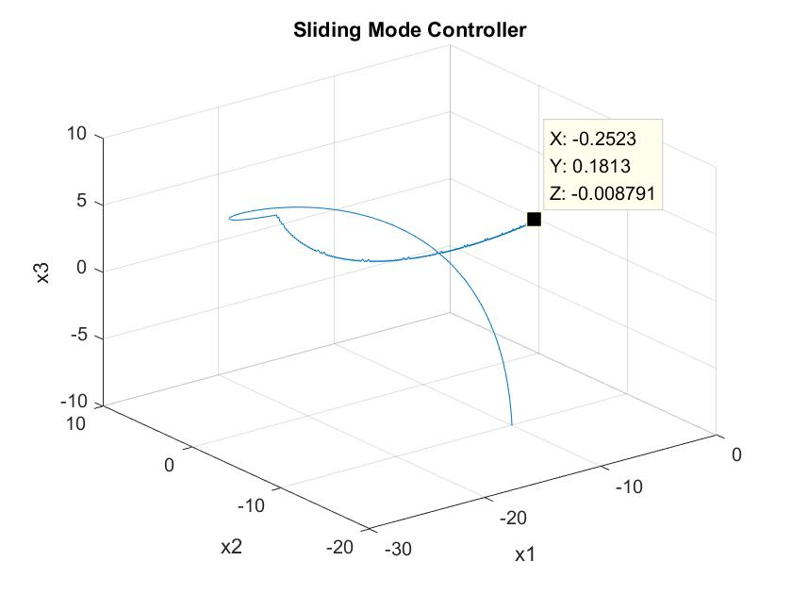

程式碼：

clc;clear;

delta=0.01;

totalTime=10;

totalStep=totalTime/delta;

x1array=[1:totalStep]*0;x2array=x1array;x3array=x1array;

x1array(1)=-10;x2array(1)=-10;x3array(1)=-10;%init condition

alpha=0.9;

K=10;lambda=1;

for i=1:totalStep

x1=x1array(i);x2=x2array(i);x3=x3array(i);

f=x3+2*lambda*x2+lambda^2*x1;

u=-sign(f)*K-(alpha*(x1^2*sin(x2)+x2^2*sin(x3))+(x1+x3^2)*cos(x3)+2*lambda*x3+lambda^2*x2);

d(i)=0.2*sin(i)+0.1*cos(5*i+pi);

x1_dot=x2;

x2_dot=x3;

x3_dot=alpha*(x1^2*sin(x2)+x2^2*sin(x3))+(x1+x3^2)*cos(x3)+u+d(i);

x1array(i+1)=x1+x1_dot*delta;

x2array(i+1)=x2+x2_dot*delta;

x3array(i+1)=x3+x3_dot*delta;

end

plot3(x1array,x2array,x3array);

grid on;

xlabel('x1');

ylabel('x2');

zlabel('x3');

title('Sliding Mode Controller');

2.

測試1：

disturbance(i)=10*(-1+rand);

noise(i)=0.001*sin(25*i)+0.005*cos(100*i+pi);

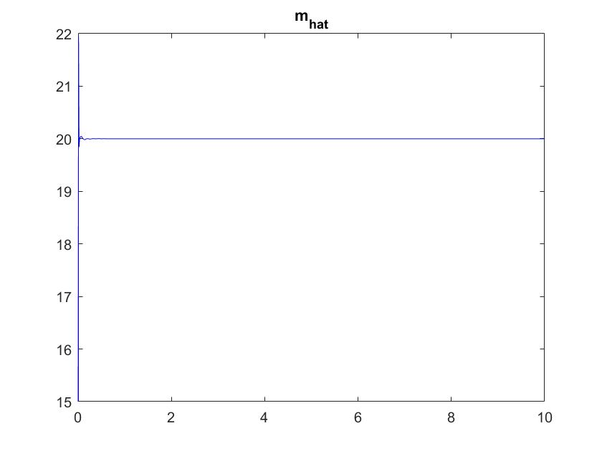

測試2：

disturbance(i)=10*(-1+rand);

noise(i)=0

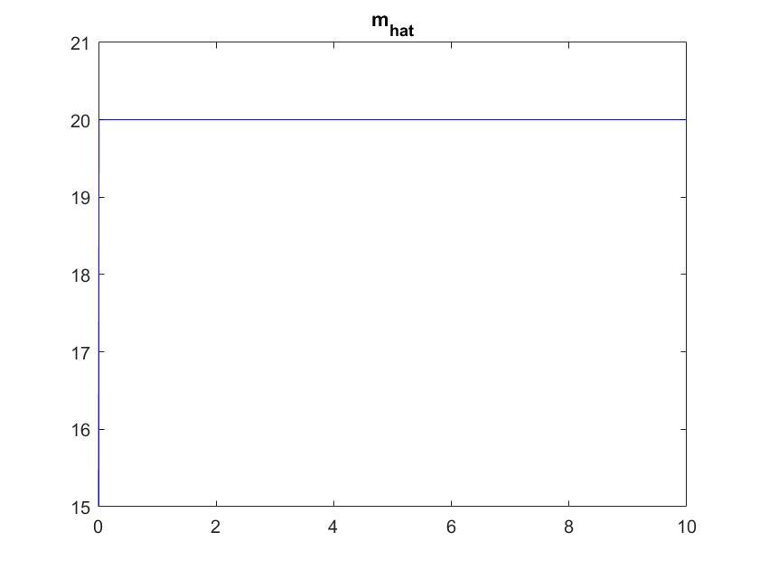

測試3：

disturbance(i)=0

noise(i)=0.001*sin(25*i)+0.005*cos(100*i+pi);

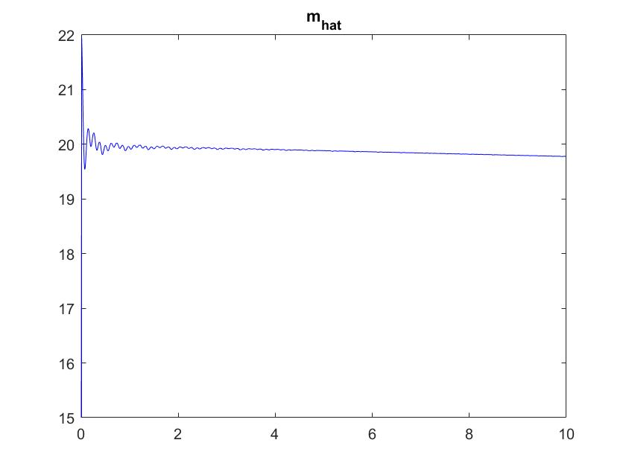

測試4(noise很大則mhat無法收斂到m=20)：

disturbance(i)=0.1*(-1+rand);

noise(i)=0.1*sin(25*i)+0.5*cos(100*i+pi);

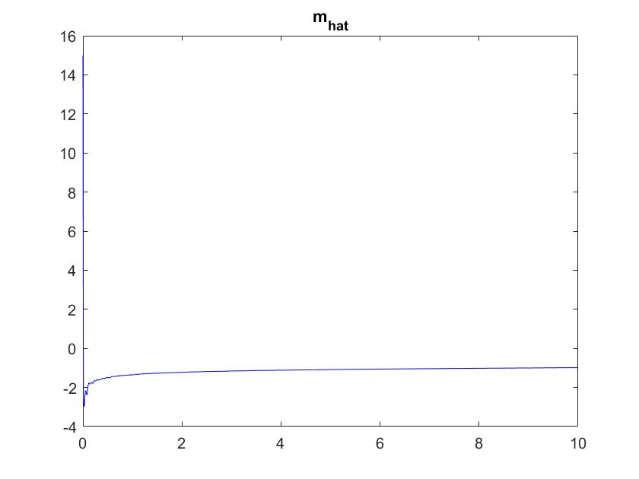

經多次測試結論：

1.mhat收斂情形受到disturbanse影響很小，但是對noise非常敏感。

2.兩條線重疊，用m和m_dot做出來的結果一模一樣@@????????????

程式碼：

clear;clc;

totaltime=10;

delta=0.01;

totalstep=totaltime/delta;

m=20;

m_hat1(1)=15;

u(1)=1;

%make n,d

for i=1:totalstep

disturbance(i)=10*(-1+rand);

noise(i)=0.001*sin(25*i)+0.005*cos(100*i+pi);

end

% use m

for i=1:totalstep

yarray(i)=(u(i)/m)+noise(i);

num=delta*sum(yarray.*u);

den=delta*sum(yarray.*yarray);

m_hat1(i+1)=(num/den);

u(i+1)=m_hat1(i+1)*(yarray(i))+disturbance(i);

end;

%clear var.

yarray=[0:1:totalstep-1]*0;

u=yarray;

m_hat2(1)=15;

u(1)=1;

%use m_dot

for i=1:totalstep

yarray(i)=(u(i)/m)+noise(i);

num=(u(i)-m_hat2(i)*yarray(i))*yarray(i);

den=delta*sum(yarray.*yarray);

m_hat_dot(i)=(num/den);

m_hat2(i+1)=m_hat2(i)+m_hat_dot(i)*delta;

u(i+1)=m_hat2(i+1)*(yarray(i))+disturbance(i);

end;

plot([0:1:totalstep]*delta,m_hat1,'r');

hold on;

plot([0:1:totalstep]*delta,m_hat2,'b');

title('m_h_a_t');

3.

算出答案：a1=0.453557 a2=0.250984 b1=-0.356244 b2=0.168191。

使用算出的答案和同樣u做模擬，並和所給的y做比較：

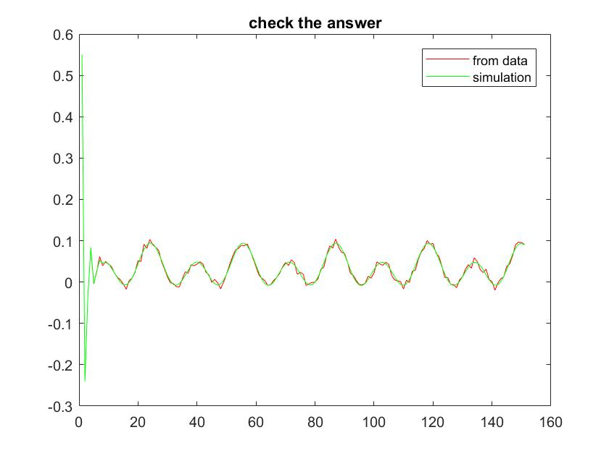

Matlab程式碼：

clear;clc;

%read data%%%%%%%%%%%%%%%%%%%%%%%%%%%%%%%%%%%%%%%%%%%%%%%%%%%

Data=textread('hw6Data.txt','%f');

y=zeros(1,length(Data)/2);u=zeros(1,length(Data)/2);k=1;

for i=1:length(Data)

if mod(i,2)==0

y(k)=Data(i);

k=k+1;

else

u(k)=Data(i);

end

end

%find matrix phi%%%%%%%%%%%%%%%%%%%%%%%%%%%%%%%%%%%%%%%%%%%%%%

for k=3:length(y)+1

phi(k-1,1)=y(k-1);

phi(k-1,2)=y(k-2);

phi(k-1,3)=u(k-1);

phi(k-1,4)=u(k-2);

end

%find matrix theta%%%%%%%%%%%%%%%%%%%%%%%%%%%%%%%%%%%%%%%%%%%%

tmpA=[0 0 0 0;0 0 0 0;0 0 0 0;0 0 0 0];

tmpB=[0 0 0 0];

for k=3:151

for i=1:4

for j=1:4

tmpA(i,j)=tmpA(i,j)+phi(k-1,j)*phi(k-1,i);

end

tmpB(i)=tmpB(i)+y(k)*phi(k-1,i);

end

end

theta=inv(tmpA)*tmpB';

a1=-theta(1);

a2=-theta(2);

b1=theta(3);

b2=theta(4);

fprintf('a1=%f a2=%f b1=%f b2=%f \n',a1,a2,b1,b2);

%check the answer%%%%%%%%%%%%%%%%%%%%%%%%%%%%%%%%%%%%%%%%%%%%%

yy(1)=y(1);yy(2)=y(2);

for k=3:151

yy(k)=-a1*yy(k-1)-a2*yy(k-2)+b1*u(k-1)+b2*u(k-2);

end

plot(y,'r');

hold on;

plot(yy,'g');

legend('from data','simulation');

title('check the answer');