現代控制理論 HW7

104303206黃筱晴

1-a-A 已知G(z)求輸出 (u=1)

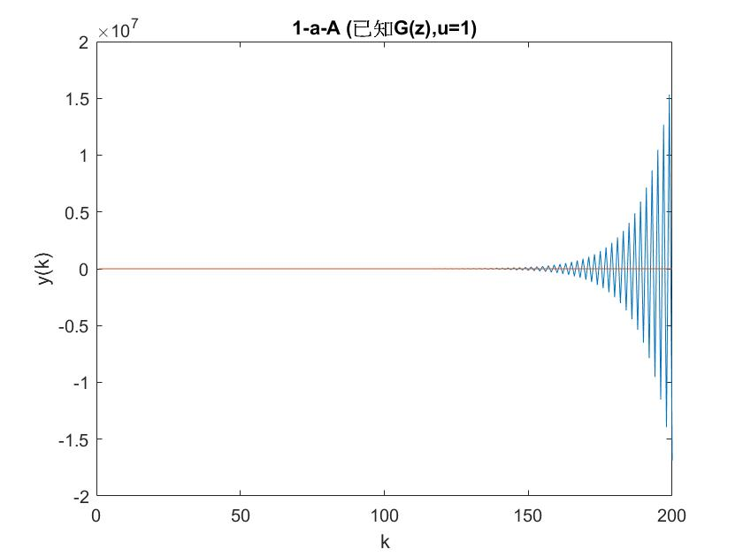

1-a-B 已知G(z)求輸出 (u=一堆弦波的合成)

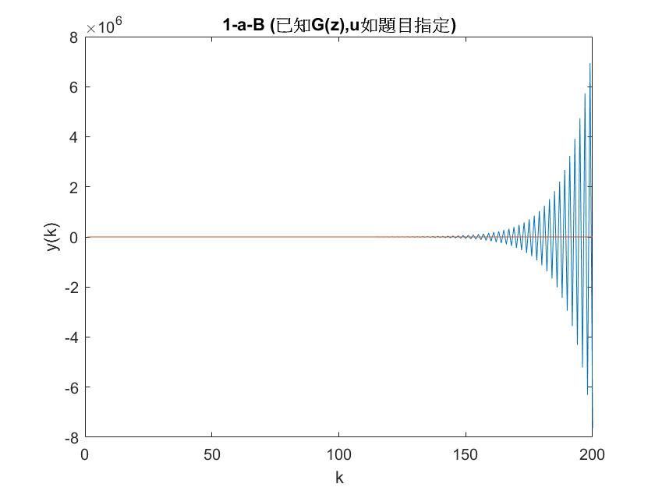

1-b-A

a1=0.298118 (error=-0.001882 )

a2=-0.881307 (error=-0.001307 )

b1=0.940994 (error=0.040994 )

b2=0.543759 (error=-0.056241 )

1-b-B

a1=0.299174 (error=-0.000826 )

a2=-0.881930 (error=-0.001930 )

b1=0.922097 (error=0.022097 )

b2=0.575913 (error=-0.024087 )

1-b-C

大部分測試結果是A(unit step輸入)較精準

Note:在做1-b-A的時候，欲使用最佳化方法(∂J/∂θ=0)求參數。其中計算到θ=[Σφ(k-1) φ(k-1)T]-1(Σy(k)φ(k-1))時，因為奇異方陣沒辦法算反矩陣卡住。將u的第一筆先改成零後解決。但是之後測試過程也常常遇到Matlab說太接近奇異方陣的Warning訊息。

1-c

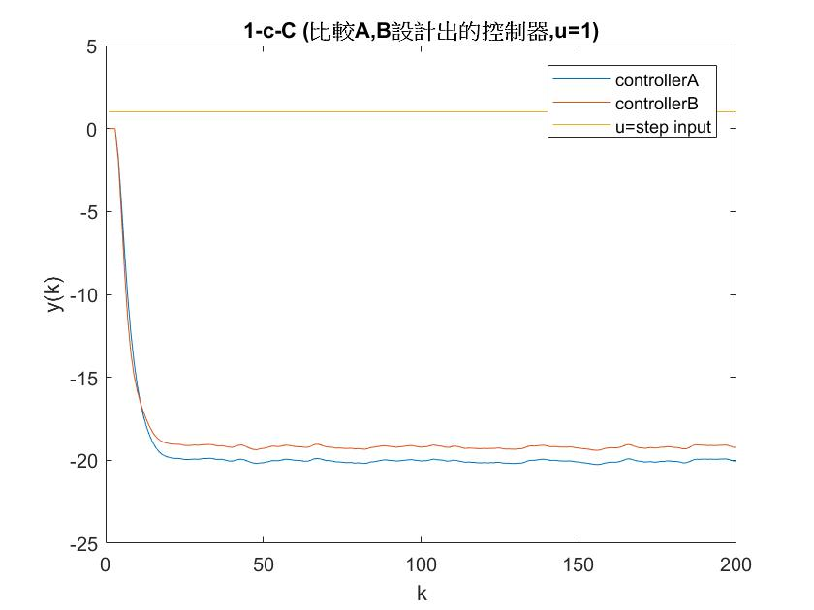

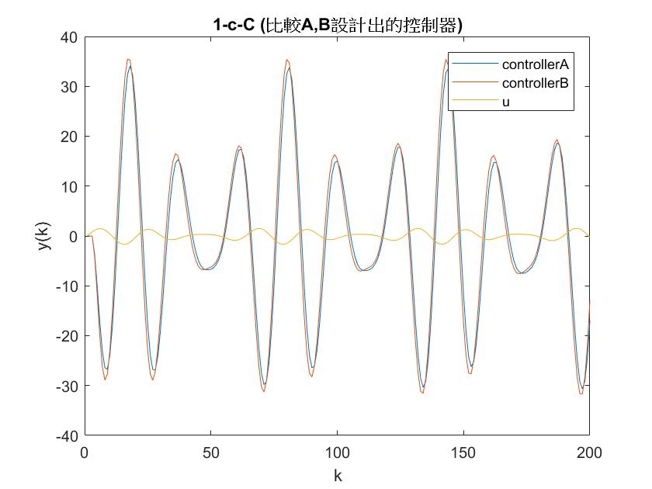

Note:當K再多一點(千筆以上)兩個控制器因為參數不完全精準，系統都會發 散。所以要用下一題(1-d)的adaptive control。

(1)pole assignment

目標極點位置0.5+0.5j,0.5-0.5j,0.82

φ(z)=(z-0.5+0.5j)*(z-0.5+0.5j)*(z-0.82)=z3-1.82z2+1.32z-0.41

設計C(z)=(β0z+β1)/(z+α1)，單回授系統，令等效開環轉移函數分母

(z+α1)(z2+a1z+a2)+ (β0z+β1)(b1z+b2)= z3-1.82z2+1.32z-0.41。比較係數法。

解聯立方程式矩陣 [][]=[] 得到α1、β0、β1

(2)回授控制程式實作(程式碼於附錄)

<1>等效開環轉移函數 $\frac{C\left(z\right)G(z)}{1+C(z)G(z)}$

<2>寫一個這種迴圈來疊代

r(k+1)=1;

e(k+1)=r(k+1)-y(k+1); %%這裡好奇怪@@????

u(k+1)=-α1u(k)+β0e(k+1)+β1e(k);

y(k+2)=-a1y(k+1) -a2y(k)+b1u(k+1)+b2u(k)+d(k+2);

但是剛開始做的時候一直發散，後來反覆嘗試修改步數的地方，終 於試出一組答案，能做出和使用等效開環轉移函數相同的結果。

1-d-A

(1)1~5蒐集數據，6~900 online adaptive control，901~1000不再修改控制器。

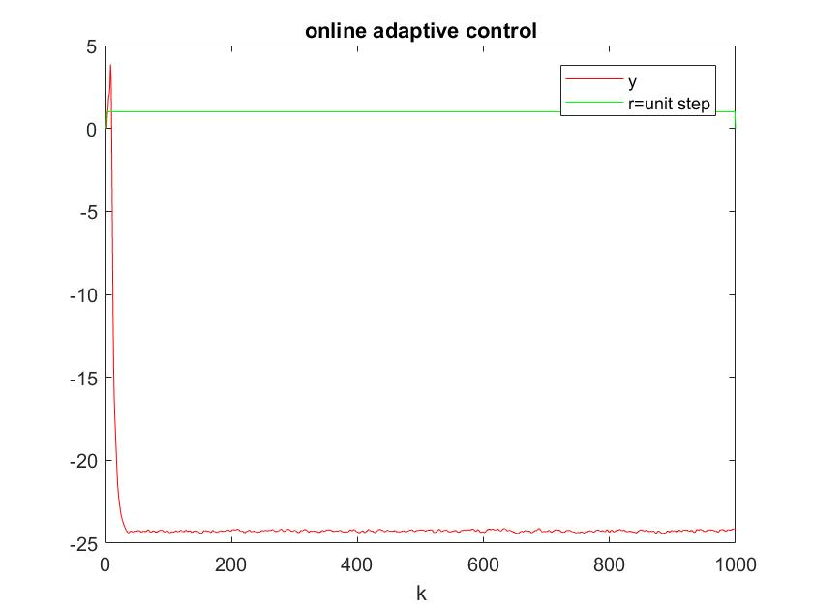

(2)1~50蒐集數據，51~900 online adaptive control，901~1000不再修改控制器。

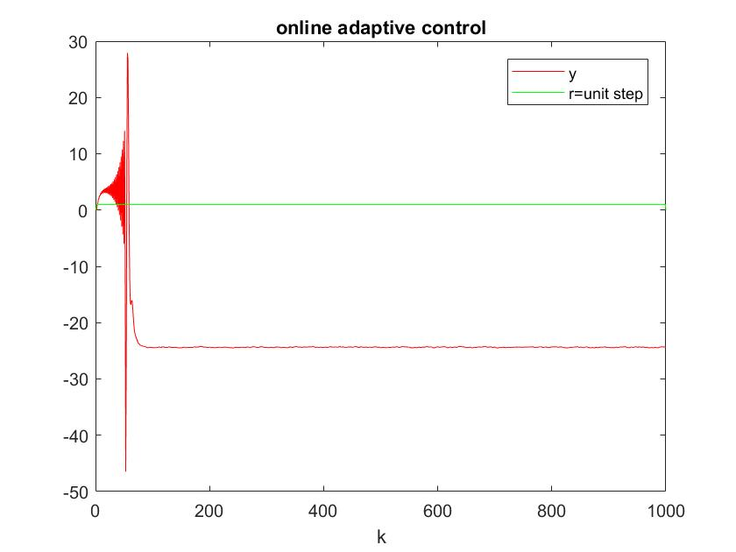

1-d-B

(1)1~5蒐集數據，6~900 online adaptive control，901~1000不再修改控制器。

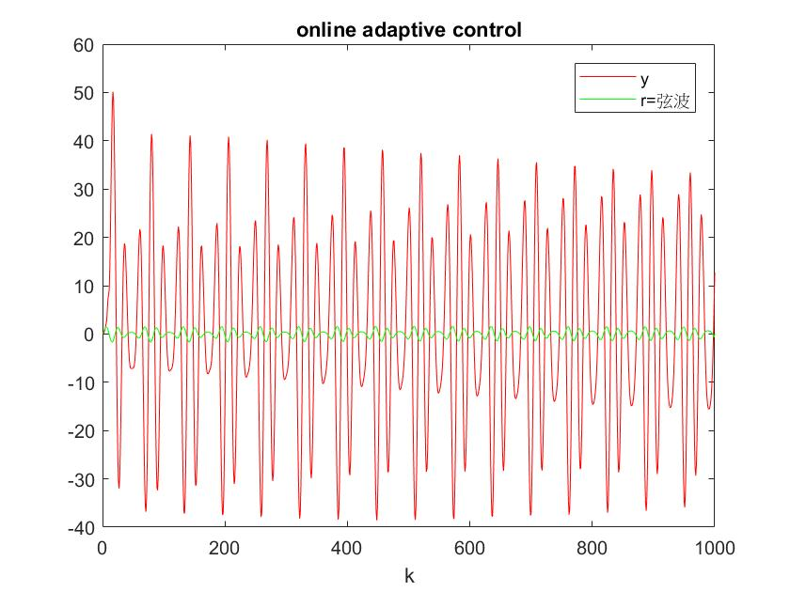

(2)1~100蒐集數據，101~900 online adaptive control，901~1000不再修改控制器。

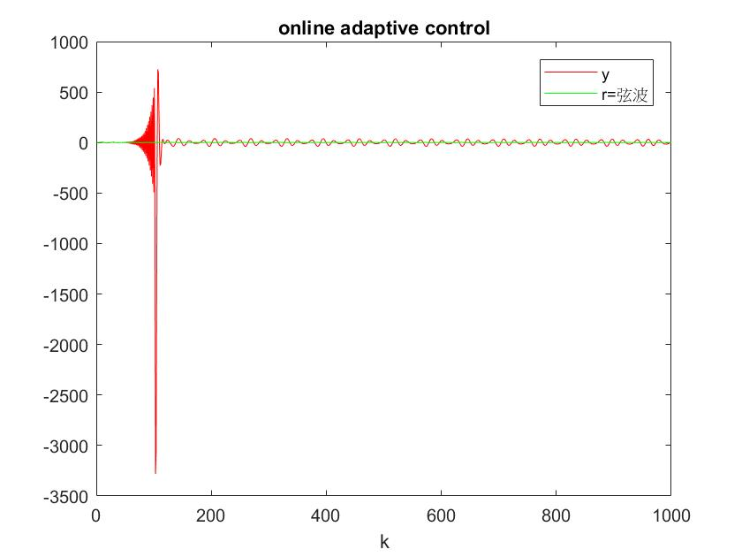

2-A. MRAC unit step輸入模擬

(1) unit step對照組γ0=0.025 γ1=0.5 γ2=0.005 Q22=1000

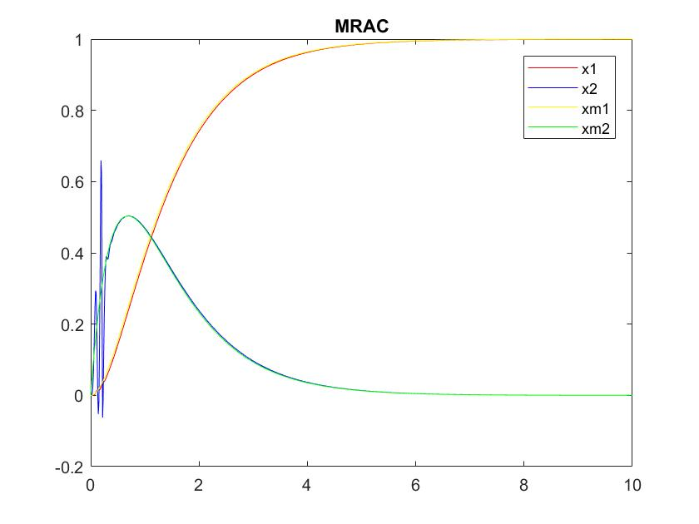

(2)Q=[] ,明顯Q22值越大，系統越穩定，若Q22值不夠系統會發散。

降低Q22 (γ0=0.025 γ1=0.5 γ2=0.005 **Q22=10**)

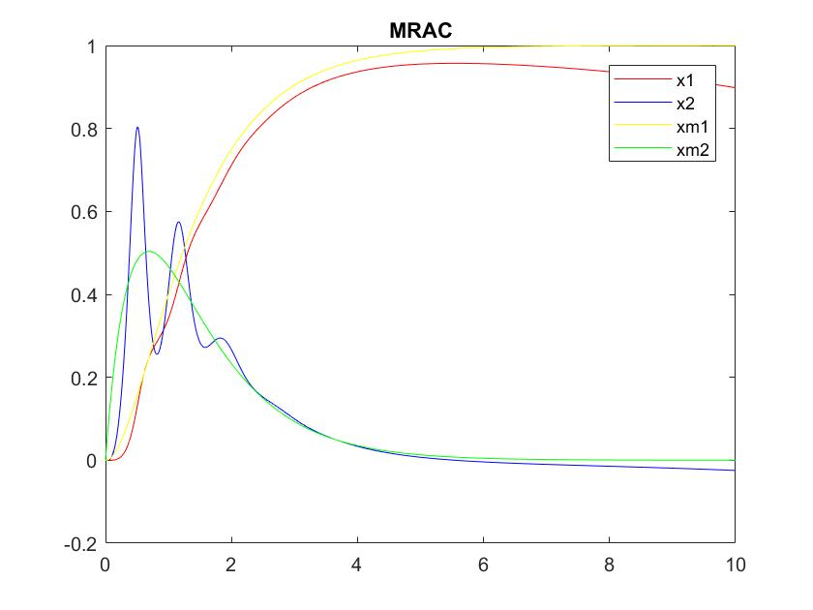

(2) γ0越大，x1穩態誤差越糟，x1,x2震盪情形持續較久。

增大γ0 (**γ0=2.5** γ1=0.5 γ2=0.005 Q22=10)

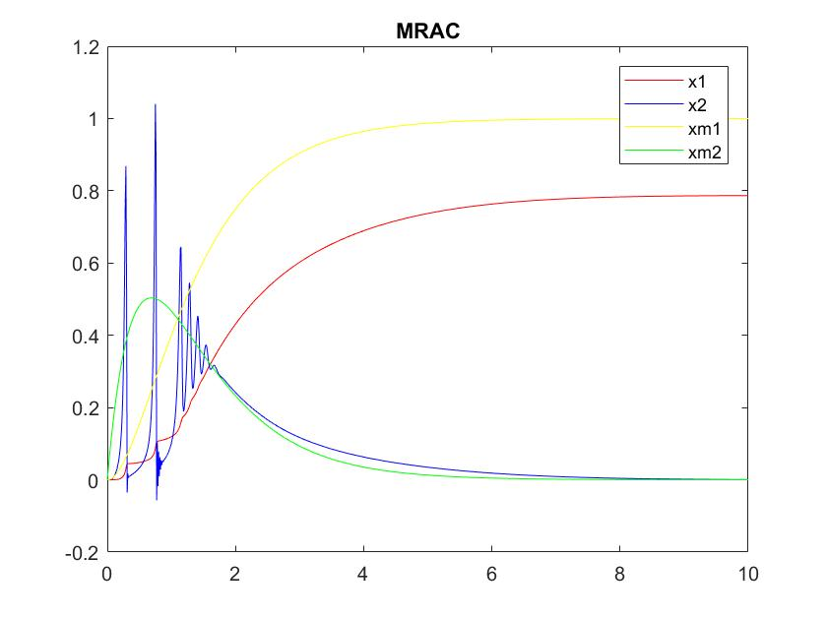

(3) γ1=越小，x2震盪越久。貌似越大越好，也不會發散，但是往上調至定 值後看起來效果都一樣。

降低γ1 (γ0=0.025 **γ1=0.005** γ2=0.005 Q22=1000)

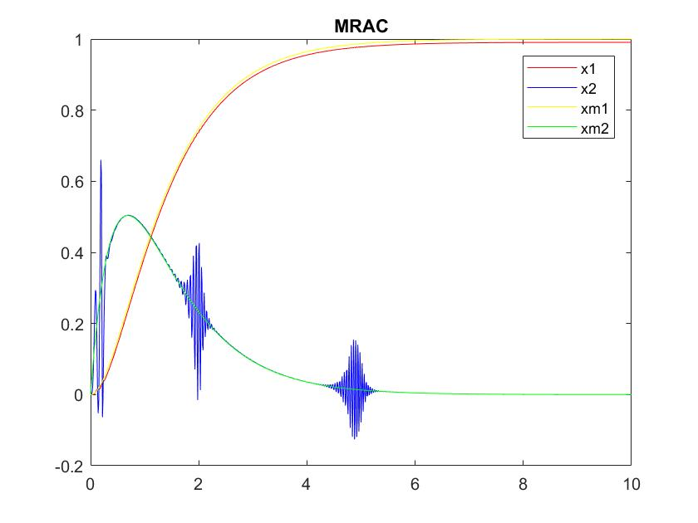

(4) γ2越大，x1、x2的振幅都會變大也會振比較久，其中x2影響非常嚴重。

增加γ2 (γ0=0.025 γ1=0.5 **γ2=0.5** Q22=1000)

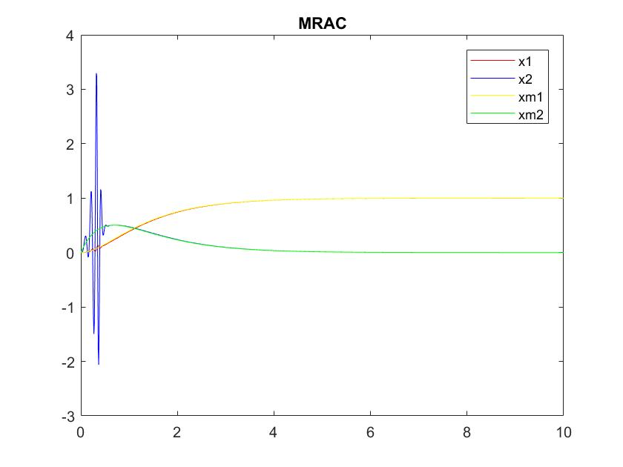

經多次測試結論：

Q22要大、γ0要小 γ1可大 γ2盡量小，但這些參數太小系統都容易發散。 在三個γ中γ2最為敏感也最重要。

2-B.MRAC弦波輸入模擬

(1)弦波對照組γ0=1 γ1=0.5 γ2=0.4 Q22=1000

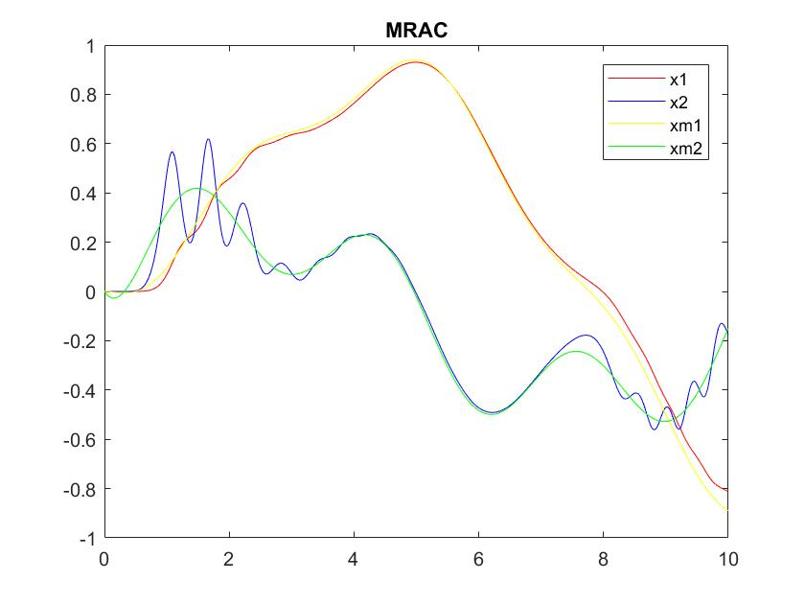

(2)同樣Q22越大越穩定

降低Q22 (γ0=1 γ1=0.5 γ2=0.4 **Q22=10**)

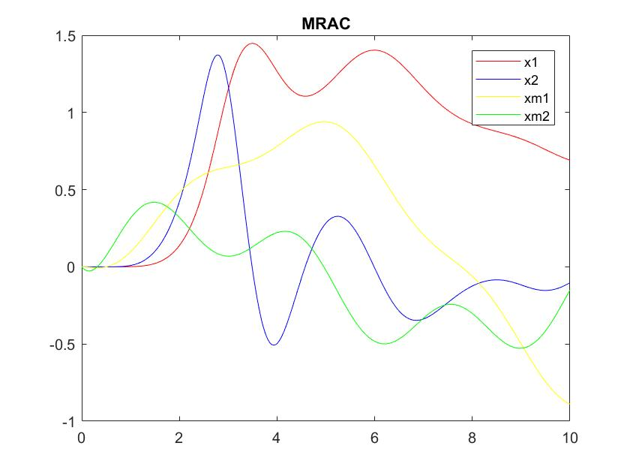

(2)

增加γ0=(**γ0=10** γ1=0.5 γ2=0.4 Q22=1000)，誤差變大

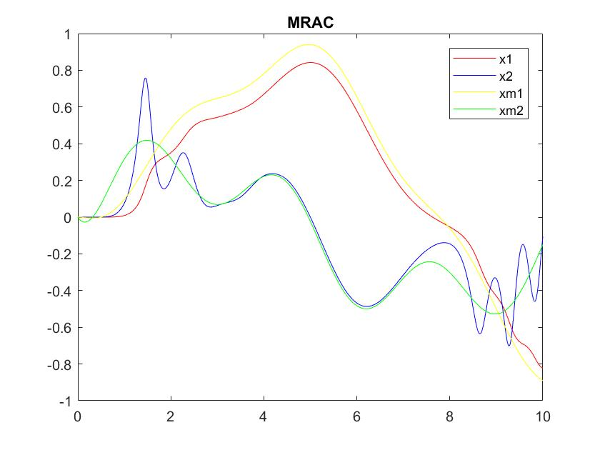

降低γ0=(**γ0=0.05** γ1=0.5 γ2=0.4 Q22=1000)，暫態響應的震盪變嚴重。

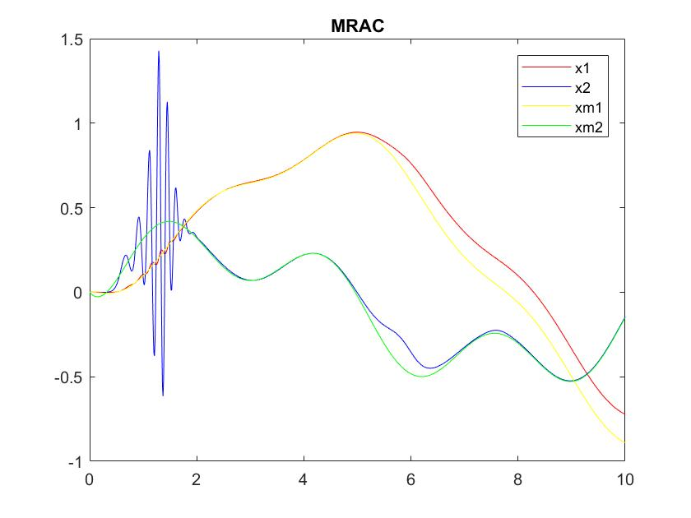

(3)

增加γ1 (γ0=1 **γ1=5** γ2=0.4 Q22=1000)，誤差變大。

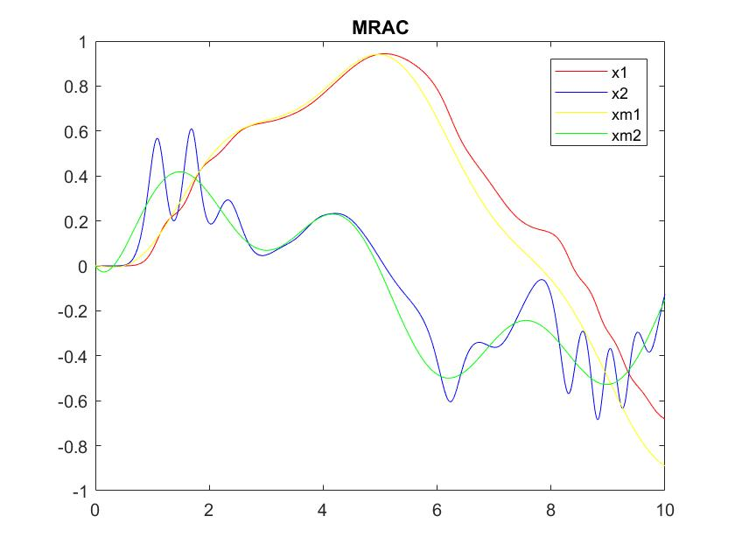

降低γ1 (γ0=1 **γ1=0.005** γ2=0.4 Q22=1000)，震盪情形持續較久。

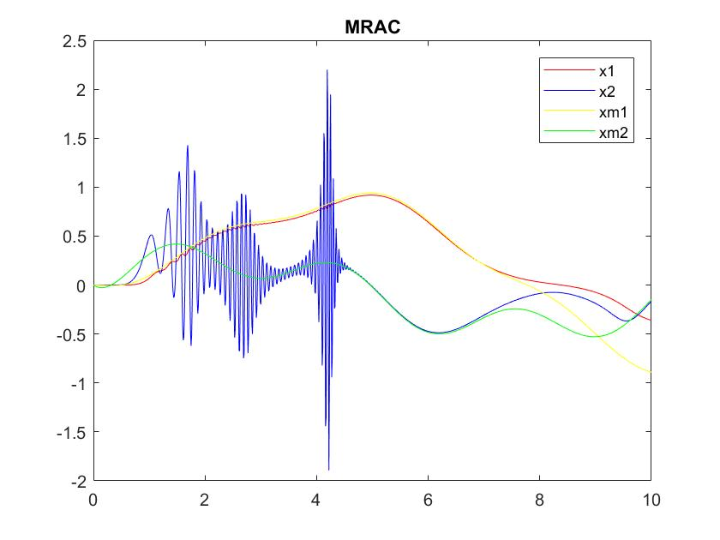

(4)

增加γ2 (γ0=1 γ1=0.5 **γ2=4** Q22=1000)，X要花更多時間追上Xm。

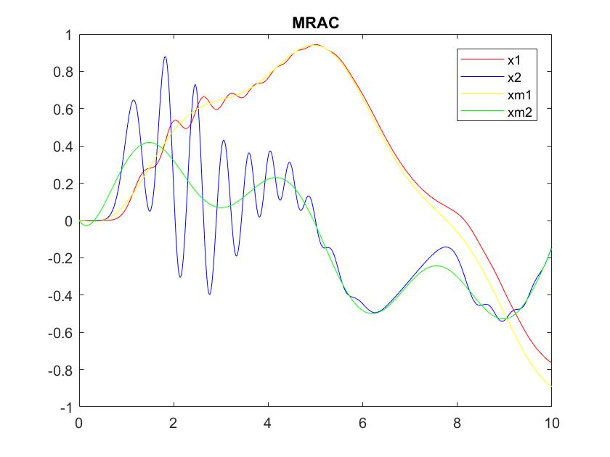

降低γ2 (γ0=1 γ1=0.5 **γ2=0.005** Q22=1000)，後期震盪變明顯。

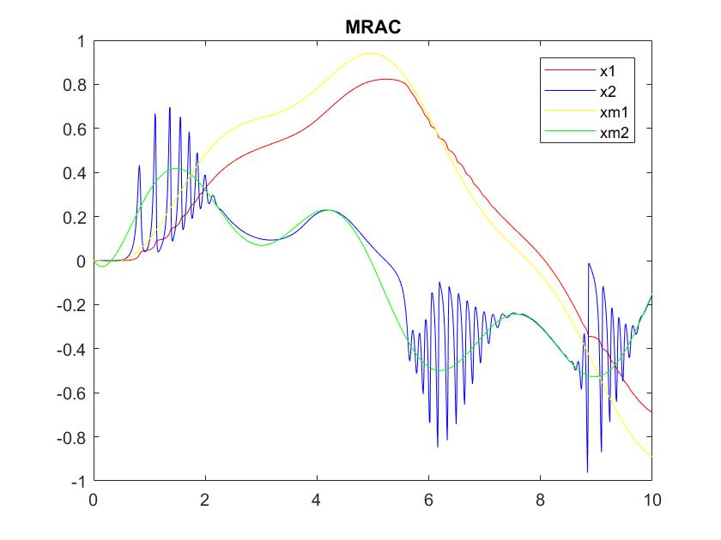

經多次測試結論：

Q22要大，三個γ都有其較適當的範圍，不能太大或太小。

附錄(程式碼)

(1)閉迴路控制器

%close loop control

%result same as using equivalent open loop transfer func.

clear;clc;

totalStep=1000;

a1=0.3;a2=-0.88;b1=0.9;b2=0.6;%system

for k=1:totalStep

d(k)=0.01*(rand-0.5);

end

poly=conv([1,-0.82],conv([1,-0.5+0.5i],[1,-0.5-0.5i]));%pole assignment

A=[1 b1 0;a1 b2 b1;a2 0 b2];

b=[poly(2)-a1;poly(3)-a2;poly(4)];

x=inv(A)*b;

alpha1=x(1);beta0=x(2);beta1=x(3);

y=[1:totalStep]*0;

u=[1:totalStep]*0;

r=[1:totalStep]*0;

e=[1:totalStep]*0;

r(1)=0;

r(2)=1;

r(3)=1;

for k=1:totalStep-2

r(k+1)=1;

e(k+1)=r(k+1)-y(k+1);

u(k+1)=(-alpha1*u(k)+beta0*e(k+1)+beta1*e(k));

y(k+2)=-a1*y(k+1)-a2*y(k)+b1*u(k+1)+b2*u(k)+d(k+2);

end

figure(1)

plot(y,'b');hold on;plot(u,'g');hold on;plot(r,'y');plot(e,'r');

xlabel("k");

legend('y','u','r','e');

title("³á³á³á§Ú°µ¥X­t¦^±Â¤F (r=unit step)");

y=[1:totalStep]*0;

u=[1:totalStep]*0;

r=[1:totalStep]*0;

e=[1:totalStep]*0;

r(1)=sin(6*1/20)+0.5*cos(6*1/15+3.2)+0.2*sin(2.57*1/13+1.36);

r(2)=sin(6*2/20)+0.5*cos(6*2/15+3.2)+0.2*sin(2.57*2/13+1.36);

r(3)=sin(6*3/20)+0.5*cos(6*3/15+3.2)+0.2*sin(2.57*3/13+1.36);

for k=1:totalStep-2

r(k+1)=sin(6*(k+1)/20)+0.5*cos(6*(k+1)/15+3.2)+0.2*sin(2.57*(k+1)/13+1.36);

e(k+1)=r(k+1)-y(k+1);

u(k+1)=(-alpha1*u(k)+beta0*e(k+1)+beta1*e(k));

y(k+2)=-a1*y(k+1)-a2*y(k)+b1*u(k+1)+b2*u(k)+d(k+2);

end

figure(2)

plot(y,'b');hold on;plot(u,'g');hold on;plot(r,'y');plot(e,'r');

xlabel("k");

legend('y','u','r','e');

title("³á³á³á§Ú°µ¥X­t¦^±Â¤F (r=©¶ªi)");

(2)閉迴路控制器使用等效開環轉移函數

%design C(z) and using equivalent open loop transfer func.

clear;clc;

totalStep=1000;

a1=0.3;a2=-0.88;b1=0.9;b2=0.6;%system

for k=1:totalStep

d(k)=0.01*(rand-0.5);

end

poly=conv([1,-0.82],conv([1,-0.5+0.5i],[1,-0.5-0.5i]));%pole assignment

A=[1 b1 0;a1 b2 b1;a2 0 b2];

b=[poly(2)-a1;poly(3)-a2;poly(4)];

x=inv(A)*b;

alpha1=x(1);beta0=x(2);beta1=x(3);

fprintf("alpha1=%f;beta0=%f;beta1=%f;\n",alpha1,beta0,beta1);

num=conv([b1,b2],[beta0,beta1]);%C(z)*G(z)

den=conv([1,a1,a2],[1,alpha1]);%C(z)*G(z)

fb_num=num;%equivalent open loop sys.

fb_den=[0,num]+den;%equivalent open loop sys.

y=[1:totalStep]*0;

u=[1:totalStep]*0;

r=[1:totalStep]*0;

y(1)=0;y(2)=0;y(3)=0;

u(1)=0;u(2)=1;u(3)=1;

for k=1:totalStep-3

u(k+3)=1;

y(k+3)=-fb_den(2)*y(k+2)-fb_den(3)*y(k+1)-fb_den(4)*y(k)+fb_num(1)*u(k+2)+fb_num(2)*u(k+1)+fb_num(3)*u(k)+d(k+3);

end

figure(1);

plot(y);hold on;plot(u);

legend('y','u=unit step');

title("design C(z) and using equivalent open loop transfer func.");

y=[1:totalStep]*0;

u=[1:totalStep]*0;

r=[1:totalStep]*0;

y(1)=0;y(2)=0;y(3)=0;

u(1)=sin(6*1/20)+0.5*cos(6*1/15+3.2)+0.2*sin(2.57*1/13+1.36);

u(2)=sin(6*2/20)+0.5*cos(6*2/15+3.2)+0.2*sin(2.57*2/13+1.36);

u(3)=sin(6*3/20)+0.5*cos(6*3/15+3.2)+0.2*sin(2.57*3/13+1.36);

for k=1:totalStep-3

u(k+3)=sin(6*(k+2)/20)+0.5*cos(6*(k+2)/15+3.2)+0.2*sin(2.57*(k+2)/13+1.36);

y(k+3)=-fb_den(2)*y(k+2)-fb_den(3)*y(k+1)-fb_den(4)*y(k)+fb_num(1)*u(k+2)+fb_num(2)*u(k+1)+fb_num(3)*u(k)+d(k+3);

end

figure(2);

plot(y);hold on;plot(u);

legend('y','u=©¶ªi');

title("design C(z) and using equivalent open loop transfer func.");

(3)1-a,b,c總程式碼

clear;clc;

totalStep=200;

a1=0.3;a2=-0.88;b1=0.9;b2=0.6;%system

for k=1:totalStep

d(k)=0.1*(rand-0.5);

end

%1-a-A%%%%%%%%%%%%%%%%%%%%%%%%%%%%%%%%%%%%%%%%%%%%%%%%%%%%%%%%%%%%%%%%%%%%

%just run with unit step input

y1A=[1:totalStep]*0;

u1A=[1:totalStep]*0;

y1A(1)=0;y1A(2)=0;u1A(1)=0;u1A(2)=1;

for k=1:totalStep-2

u1A(k+2)=1;

y1A(k+2)=-a1*y1A(k+1)-a2*y1A(k)+b1*u1A(k+1)+b2*u1A(k)+d(k+2);

end

figure(1);

plot(y1A);hold on;plot(u1A);

xlabel("k");

ylabel("y(k)");

title("1-a-A (¤wª¾G(z),u=1)");

%1-a-B%%%%%%%%%%%%%%%%%%%%%%%%%%%%%%%%%%%%%%%%%%%%%%%%%%%%%%%%%%%%%%%%%%%%

%just run with the given input

y1B=[1:totalStep]*0;

u1B=[1:totalStep]*0;

y1B(1)=0;y1B(2)=0;

u1B(1)=sin(6*1/20)+0.5*cos(6*1/15+3.2)+0.2*sin(2.57*1/13+1.36);

u1B(2)=sin(6*2/20)+0.5*cos(6*2/15+3.2)+0.2*sin(2.57*2/13+1.36);

for k=1:totalStep-2

u1B(k+2)=sin(6*(k+2)/20)+0.5*cos(6*(k+2)/15+3.2)+0.2*sin(2.57*(k+2)/13+1.36);

y1B(k+2)=-a1*y1B(k+1)-a2*y1B(k)+b1*u1B(k+1)+b2*u1B(k)+d(k+2);

end

figure(2);

plot(y1B);hold on;plot(u1B);

xlabel("k");

ylabel("y(k)");

title("1-a-B (¤wª¾G(z),u¦pÃD¥Ø«ü©w)");

%1-b-A%%%%%%%%%%%%%%%%%%%%%%%%%%%%%%%%%%%%%%%%%%%%%%%%%%%%%%%%%%%%%%%%%%%%

%use the optimal method to find the system parameter whit dataA

%find matrix phi%%%%%%%%%%%%%%%%%%%%%%%%%%%%%%%%%%%%%%%%%%%%%%

for k=3:length(y1A)+1

phiA(k-1,1)=y1A(k-1);

phiA(k-1,2)=y1A(k-2);

phiA(k-1,3)=u1A(k-1);

phiA(k-1,4)=u1A(k-2);

end

%find matrix theta%%%%%%%%%%%%%%%%%%%%%%%%%%%%%%%%%%%%%%%%%%%%

tmp1A=[0 0 0 0;0 0 0 0;0 0 0 0;0 0 0 0];

tmp2A=[0 0 0 0];

for k=3:totalStep

for i=1:4

for j=1:4

tmp1A(i,j)=tmp1A(i,j)+phiA(k-1,j)*phiA(k-1,i);

end

tmp2A(i)=tmp2A(i)+y1A(k)*phiA(k-1,i);

end

end

thetaA=inv(tmp1A)*tmp2A';

a1A=-thetaA(1);

a2A=-thetaA(2);

b1A=thetaA(3);

b2A=thetaA(4);

%1-b-B%%%%%%%%%%%%%%%%%%%%%%%%%%%%%%%%%%%%%%%%%%%%%%%%%%%%%%%%%%%%%%%%%%%%

%use the optimal method to find the system parameter whit dataB

%find matrix phi%%%%%%%%%%%%%%%%%%%%%%%%%%%%%%%%%%%%%%%%%%%%%%

for k=3:length(y1B)+1

phiB(k-1,1)=y1B(k-1);

phiB(k-1,2)=y1B(k-2);

phiB(k-1,3)=u1B(k-1);

phiB(k-1,4)=u1B(k-2);

end

%find matrix theta%%%%%%%%%%%%%%%%%%%%%%%%%%%%%%%%%%%%%%%%%%%%

tmp1B=[0 0 0 0;0 0 0 0;0 0 0 0;0 0 0 0];

tmp2B=[0 0 0 0];

for k=3:totalStep

for i=1:4

for j=1:4

tmp1B(i,j)=tmp1B(i,j)+phiB(k-1,j)*phiB(k-1,i);

end

tmp2B(i)=tmp2B(i)+y1B(k)*phiB(k-1,i);

end

end

thetaB=inv(tmp1B)*tmp2B';

a1B=-thetaB(1);

a2B=-thetaB(2);

b1B=thetaB(3);

b2B=thetaB(4);

%1-b-C%%%%%%%%%%%%%%%%%%%%%%%%%%%%%%%%%%%%%%%%%%%%%%%%%%%%%%%%%%%%%%%%%%%%

%compare the ans

fprintf("Ans from A:\n");

fprintf("a1=%f (error=%2f )\n",a1A,(a1A-a1));

fprintf("a2=%f (error=%2f )\n",a2A,(a2A-a2));

fprintf("b1=%f (error=%2f )\n",b1A,(b1A-b1));

fprintf("b2=%f (error=%2f )\n",b2A,(b2A-b2));

fprintf("Ans from B:\n");

fprintf("a1=%f (error=%2f )\n",a1B,(a1B-a1));

fprintf("a2=%f (error=%2f )\n",a2B,(a2B-a2));

fprintf("b1=%f (error=%2f )\n",b1B,(b1B-b1));

fprintf("b2=%f (error=%2f )\n",b2B,(b2B-b2));

%1-c-A%%%%%%%%%%%%%%%%%%%%%%%%%%%%%%%%%%%%%%%%%%%%%%%%%%%%%%%%%%%%%%%%%%%%

%pole assignment

poly=conv([1,-0.82],conv([1,-0.5+0.5i],[1,-0.5-0.5i]));%characteristic poly.

const=[1 b1A 0;a1A b2A b1A;a2A 0 b2A];

b=[poly(2)-a1A;poly(3)-a2A;poly(4)];

x=inv(const)*b;

alpha1A=x(1);beta0A=x(2);beta1A=x(3);

%1-c-B%%%%%%%%%%%%%%%%%%%%%%%%%%%%%%%%%%%%%%%%%%%%%%%%%%%%%%%%%%%%%%%%%%%%

%pole assignment

poly=conv([1,-0.82],conv([1,-0.5+0.5i],[1,-0.5-0.5i]));%characteristic poly.

const=[1 b1B 0;a1B b2B b1B;a2B 0 b2B];

b=[poly(2)-a1B;poly(3)-a2B;poly(4)];

x=inv(const)*b;

alpha1B=x(1);beta0B=x(2);beta1B=x(3);

%1-c-C%%%%%%%%%%%%%%%%%%%%%%%%%%%%%%%%%%%%%%%%%%%%%%%%%%%%%%%%%%%%%%%%%%%%

%compare the control design from dataA and dataB

%controller A

numA=conv([b1,b2],[beta0A,beta1A]);%C(z)*G(z)

denA=conv([1,a1,a2],[1,alpha1A]);%C(z)*G(z)

fb_numA=numA;%equivalent open loop sys.

fb_denA=[0,numA]+denA;%equivalent open loop sys.

%controller B

numB=conv([b1,b2],[beta0B,beta1B]);%C(z)*G(z)

denB=conv([1,a1,a2],[1,alpha1B]);%C(z)*G(z)

fb_numB=numB;%equivalent open loop sys.

fb_denB=[0,numB]+denB;%equivalent open loop sys.

%controller A with unit step input

y3A=[1:totalStep]*0;

u3A=[1:totalStep]*0;

y3A(1)=0;y3A(2)=0;y3A(3)=0;

u3A(1)=1;u3A(2)=1;u3A(3)=1;

for k=1:totalStep-3

u3A(k+3)=1;

y3A(k+3)=-fb_denA(2)*y3A(k+2)-fb_denA(3)*y3A(k+1)-fb_denA(4)*y3A(k)+fb_numA(1)*u3A(k+2)+fb_numA(2)*u3A(k+1)+fb_numA(3)*u3A(k)+d(k+3);

end

%controller B with unit step input

y3B=[1:totalStep]*0;

u3B=[1:totalStep]*0;

y3B(1)=0;y3B(2)=0;y3B(3)=0;

u3B(1)=1;u3B(2)=1;u3B(3)=1;

for k=1:totalStep-3

u3B(k+3)=1;

y3B(k+3)=-fb_denB(2)*y3B(k+2)-fb_denB(3)*y3B(k+1)-fb_denB(4)*y3B(k)+fb_numB(1)*u3B(k+2)+fb_numB(2)*u3B(k+1)+fb_numB(3)*u3B(k)+d(k+3);

end

figure(3);

plot(y3A);hold on;plot(y3B);hold on;plot(u3B);

xlabel("k");

ylabel("y(k)");

legend('controllerA','controllerB','u=step input');

title("1-c-C (¤ñ¸ûA,B³]­p¥Xªº±±¨î¾¹,u=1)");

%controller A with given input

y3A=[1:totalStep]*0;

u3A=[1:totalStep]*0;

y3A(1)=0;y3A(2)=0;y3A(3)=0;

u3A(1)=sin(6*1/20)+0.5*cos(6*1/15+3.2)+0.2*sin(2.57*1/13+1.36);

u3A(2)=sin(6*2/20)+0.5*cos(6*2/15+3.2)+0.2*sin(2.57*2/13+1.36);

u3A(3)=sin(6*3/20)+0.5*cos(6*3/15+3.2)+0.2*sin(2.57*3/13+1.36);

for k=1:totalStep-3

u3A(k+3)=sin(6*(k+3)/20)+0.5*cos(6*(k+3)/15+3.2)+0.2*sin(2.57*(k+3)/13+1.36);

y3A(k+3)=-fb_denA(2)*y3A(k+2)-fb_denA(3)*y3A(k+1)-fb_denA(4)*y3A(k)+fb_numA(1)*u3A(k+2)+fb_numA(2)*u3A(k+1)+fb_numA(3)*u3A(k)+d(k+3);

end

%controller B with given input

y3B=[1:totalStep]*0;

u3B=[1:totalStep]*0;

y3B(1)=0;y3B(2)=0;y3B(3)=0;

u3B(1)=sin(6*1/20)+0.5*cos(6*1/15+3.2)+0.2*sin(2.57*1/13+1.36);

u3B(2)=sin(6*2/20)+0.5*cos(6*2/15+3.2)+0.2*sin(2.57*2/13+1.36);

u3B(3)=sin(6*3/20)+0.5*cos(6*3/15+3.2)+0.2*sin(2.57*3/13+1.36);

for k=1:totalStep-3

u3B(k+3)=sin(6*(k+3)/20)+0.5*cos(6*(k+3)/15+3.2)+0.2*sin(2.57*(k+3)/13+1.36);

y3B(k+3)=-fb_denB(2)*y3B(k+2)-fb_denB(3)*y3B(k+1)-fb_denB(4)*y3B(k)+fb_numB(1)*u3B(k+2)+fb_numB(2)*u3B(k+1)+fb_numB(3)*u3B(k)+d(k+3);

end

figure(4);

plot(y3A);hold on;plot(y3B);hold on;plot(u3B);

xlabel("k");

ylabel("y(k)");

legend('controllerA','controllerB','u');

title("1-c-C (¤ñ¸ûA,B³]­p¥Xªº±±¨î¾¹)");

(4)1-d Online Adaptive Control (A、B小題大同小異就只附上一個)

%online adaptive control

%(unit step input)

clear;clc;

totalStep=1000;step1=50;step2=900;

a1=0.3;a2=-0.88;b1=0.9;b2=0.6;%system

Correctalpha1=4.435315;%C(z) design from the real sys.

Correctbeta0=-7.283683;

Correctbeta1=5.821795;

for k=1:totalStep

d(k)=0.01*(rand-0.5);

end

y=[1:totalStep]*0;

u=[1:totalStep]*0;

r=[1:totalStep]*0;

e=[1:totalStep]*0;

%k=1~step1%%%%%%%%%%%%%%%%%%%%%%%%%%%%%%%%%%%%%%%%%%%%%%%%%%%%%%%%%%%%%%%%

%just run with unit step input

r(1)=0;r(2)=1;r(3)=1;%unit stpe input

u(1)=0;u(2)=1;u(3)=1;

for k=1:step1

r(k+2)=1;%unit stpe input

u(k+2)=r(k+2);

y(k+2)=-a1*y(k+1)-a2*y(k)+b1*u(k+1)+b2*u(k)+d(k+2);

end

%first time to find the system parameter

%find matrix phi%%%%%%%%%%%%%%%%%%%%%%%%%%%%%%%%%%%%%%%%%%%%%%

for k=3:step1

phiA(k-1,1)=y(k-1);

phiA(k-1,2)=y(k-2);

phiA(k-1,3)=u(k-1);

phiA(k-1,4)=u(k-2);

end

%find matrix theta%%%%%%%%%%%%%%%%%%%%%%%%%%%%%%%%%%%%%%%%%%%%

tmp1A=[0 0 0 0;0 0 0 0;0 0 0 0;0 0 0 0];

tmp2A=[0 0 0 0];

for k=3:step1

for i=1:4

for j=1:4

tmp1A(i,j)=tmp1A(i,j)+phiA(k-1,j)*phiA(k-1,i);

end

tmp2A(i)=tmp2A(i)+y(k)*phiA(k-1,i);

end

end

thetaA=inv(tmp1A)*tmp2A';

a1A=-thetaA(1);

a2A=-thetaA(2);

b1A=thetaA(3);

b2A=thetaA(4);

fprintf("a1=%f (error=%2f )\n",a1A,(a1A-a1));

fprintf("a2=%f (error=%2f )\n",a2A,(a2A-a2));

fprintf("b1=%f (error=%2f )\n",b1A,(b1A-b1));

fprintf("b2=%f (error=%2f )\n",b2A,(b2A-b2));

%design C(z) with optimal parameter (pole assignment)

poly=conv([1,-0.82],conv([1,-0.5+0.5i],[1,-0.5-0.5i]));%characteristic poly.

const=[1 b1A 0;a1A b2A b1A;a2A 0 b2A];

b=[poly(2)-a1A;poly(3)-a2A;poly(4)];

x=inv(const)*b;

alpha1A=x(1);beta0A=x(2);beta1A=x(3);%C(z) with optimal parameter

fprintf("alpha1=%f (err=%f) \n",alpha1A,abs(Correctalpha1-alpha1A));

fprintf("beta0=%f (err=%f) \n",beta1A,abs(Correctbeta0-beta0A));

fprintf("beta1=%f (err=%f) \n",beta1A,abs(Correctbeta1-beta1A));

%k=step1+1~step2%%%%%%%%%%%%%%%%%%%%%%%%%%%%%%%%%%%%%%%%%%%%%%%%%%%%%%%%%%

%online adaptive

%close loop control & redesign C(z)

for k=step1+1:step2

fprintf("Now Step:k=%d !!!!!!!!!!!!!!!!!!!!!!!!!!!!!!!!!!\n",k);

r(k+1)=1;

e(k+1)=r(k+1)-y(k+1);

u(k+1)=(-alpha1A*u(k)+beta0A*e(k+1)+beta1A*e(k));

y(k+2)=-a1*y(k+1)-a2*y(k)+b1*u(k+1)+b2*u(k)+d(k+2);

%redesign C(z)

%find matrix phi%%%%%%%%%%%%%%%%%%%%%%%%%%%%%%%%%%%%%%%%%%%%%%

for i=3:k

phiA(i-1,1)=y(i-1);

phiA(i-1,2)=y(i-2);

phiA(i-1,3)=u(i-1);

phiA(i-1,4)=u(i-2);

end

%find matrix theta%%%%%%%%%%%%%%%%%%%%%%%%%%%%%%%%%%%%%%%%%%%%

tmp1A=[0 0 0 0;0 0 0 0;0 0 0 0;0 0 0 0];

tmp2A=[0 0 0 0];

for m=3:k

for i=1:4

for j=1:4

tmp1A(i,j)=tmp1A(i,j)+phiA(m-1,j)*phiA(m-1,i);

end

tmp2A(i)=tmp2A(i)+y(m)*phiA(m-1,i);

end

end

thetaA=inv(tmp1A)*tmp2A';

a1A=-thetaA(1);

a2A=-thetaA(2);

b1A=thetaA(3);

b2A=thetaA(4);

fprintf("a1=%f (error=%2f )\n",a1A,(a1A-a1));

fprintf("a2=%f (error=%2f )\n",a2A,(a2A-a2));

fprintf("b1=%f (error=%2f )\n",b1A,(b1A-b1));

fprintf("b2=%f (error=%2f )\n",b2A,(b2A-b2));

%design C(z) (pole assignment)

poly=conv([1,-0.82],conv([1,-0.5+0.5i],[1,-0.5-0.5i]));%characteristic poly.

const=[1 b1A 0;a1A b2A b1A;a2A 0 b2A];

b=[poly(2)-a1A;poly(3)-a2A;poly(4)];

x=inv(const)*b;

alpha1A=x(1);beta0A=x(2);beta1A=x(3);%C(z) with optimal parameter

fprintf("alpha1=%f (err=%f) \n",alpha1A,abs(Correctalpha1-alpha1A));

fprintf("beta0=%f (err=%f) \n",beta1A,abs(Correctbeta0-beta0A));

fprintf("beta1=%f (err=%f) \n",beta1A,abs(Correctbeta1-beta1A));

end

%k=step2+1~end%%%%%%%%%%%%%%%%%%%%%%%%%%%%%%%%%%%%%%%%%%%%%%%%%%%%%%%%%%%%

%close loop control only

for k=step2+1:totalStep-2

r(k+1)=1;

e(k+1)=r(k+1)-y(k+1);

u(k+1)=(-alpha1A*u(k)+beta0A*e(k+1)+beta1A*e(k));

y(k+2)=-a1*y(k+1)-a2*y(k)+b1*u(k+1)+b2*u(k)+d(k+2);

end

plot(y,'r');hold on;plot(r,'g');

xlabel("k");

legend('y','r=unit step');

title("online adaptive control");

(5)MRAC

%MRAC

clear;clc;

totaltime=10;

delta=0.01;

totalstep=totaltime/delta;

%model

xm1(1)=0;xm2(1)=0;

for k=1:totalstep

% r(k)=1;

r(k)=sin(0.5*k*delta)+0.3*cos(2*k*delta+4);

xm1_dot(k)=xm2(k);

xm2_dot(k)=-2*xm1(k)-3*xm2(k)+2*r(k);

xm1(k+1)=xm1(k)+xm1_dot(k)*delta;

xm2(k+1)=xm2(k)+xm2_dot(k)*delta;

end

%select para.

Q=[1 0;0 1000];

Am=[0 1;-2 -3];bm=2;

b=1;

P=lyap(Am,Q);

gamma0=1;gamma1=0.5;gamma2=4;

theta0(1)=0;theta1(1)=0;theta2(1)=0;

x1(1)=0;x2(1)=0;

for k=1:totalstep

% r(k)=1;

r(k)=sin(0.5*k*delta)+0.3*cos(2*k*delta+4);

u(k)=theta0(k)*r(k)+theta1(k)*x1(k)+theta2(k)*x2(k);

x1_dot(k)=x2(k);

x2_dot(k)=0.4*x1(k)+1.8*x2(k)+1*u(k);

x1(k+1)=x1(k)+x1_dot(k)*delta;

x2(k+1)=x2(k)+x2_dot(k)*delta;

e1(k)=xm1(k)-x1(k);

e2(k)=xm2(k)-x2(k);

zeta(k)=0.5*(P(1,2)*e1(k)+P(2,2)*e2(k));

theta0_dot(k)=zeta(k)*r(k)/(b*gamma0);

theta1_dot(k)=zeta(k)*x1(k)/(b*gamma1);

theta2_dot(k)=zeta(k)*x2(k)/(b*gamma2);

theta0(k+1)=theta0(k)+theta0_dot(k)*delta;

theta1(k+1)=theta1(k)+theta1_dot(k)*delta;

theta2(k+1)=theta2(k)+theta2_dot(k)*delta;

end

plot([0:1:totalstep]*delta,x1,'r');hold on;

plot([0:1:totalstep]*delta,x2,'b');hold on;

plot([0:1:totalstep]*delta,xm1,'y');hold on;

plot([0:1:totalstep]*delta,xm2,'g');hold on;

legend('x1','x2','xm1','xm2');

title('MRAC');