現代控制理論報告

104303206黃筱晴

1.

考慮三階系統T(s)==(s3+a1s2+a2s+a3)-1，極點為使(s3+a1s2+a2s+a3)=0的s。

則此系統的微分方程式為：y'''+a1y''+a2y'+a3y=u

令x1=y ; x2=x1'=y' ; x3=x2'=y'' ;

則x3'=y'''=-a1y''-a2y'-a3y+u=-a3x1-a2x2-a1x3+u

u=0則有 []=[][]

(1)虛軸上有≧2極點：系統發散

s=-(10),-(0+1i),-(0+1i)

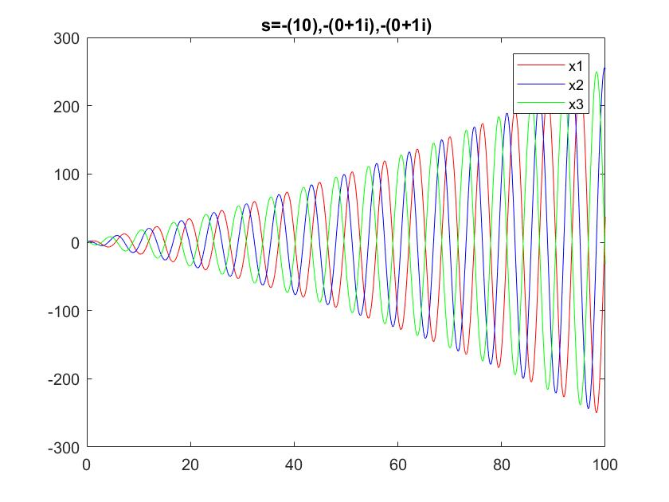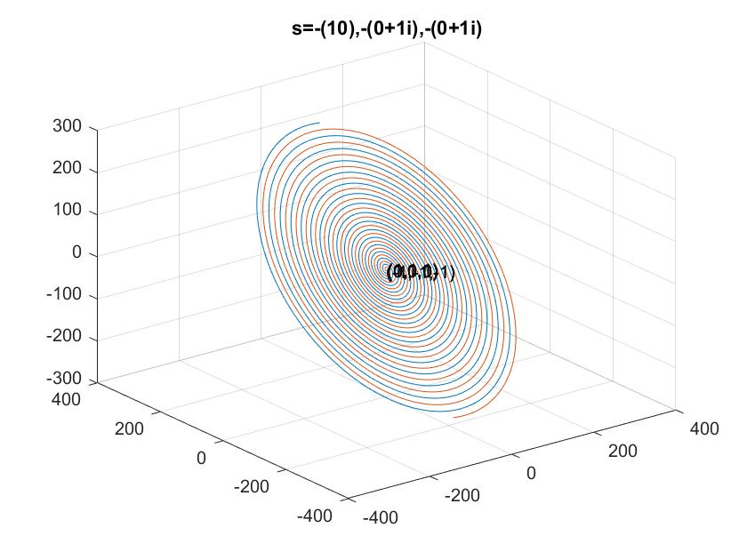

(2)虛軸上有1極點

s=-(0),-(0.1+1i),-(0.1-1i)

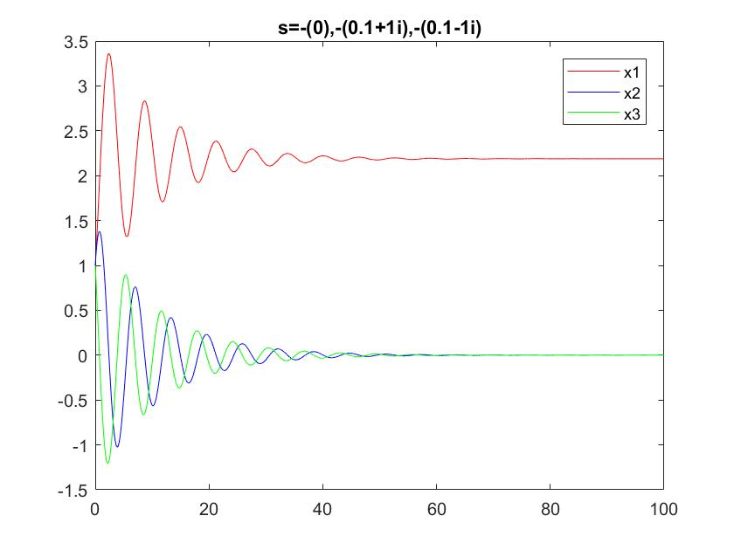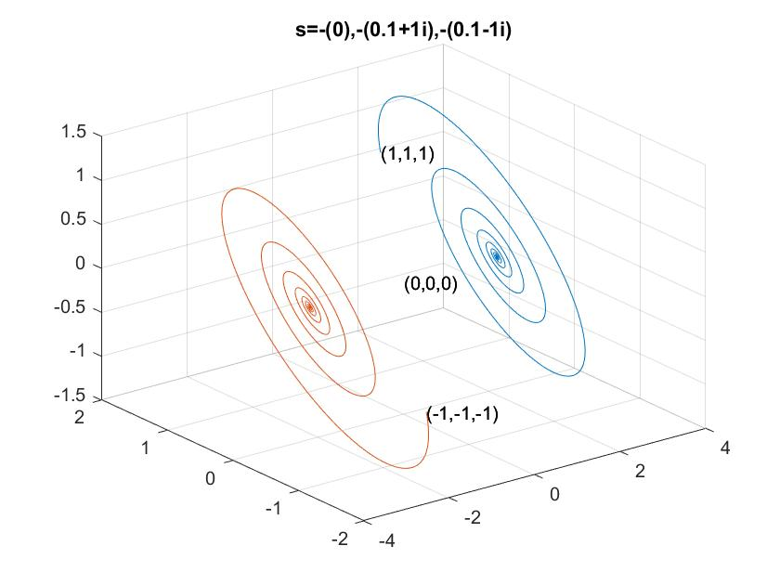

(3)3實根

s=-(0.5),-(1),-(1.5)

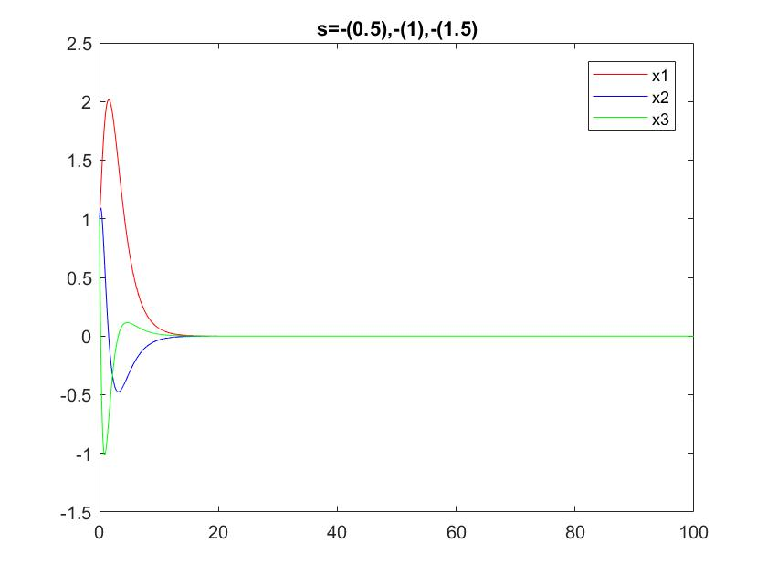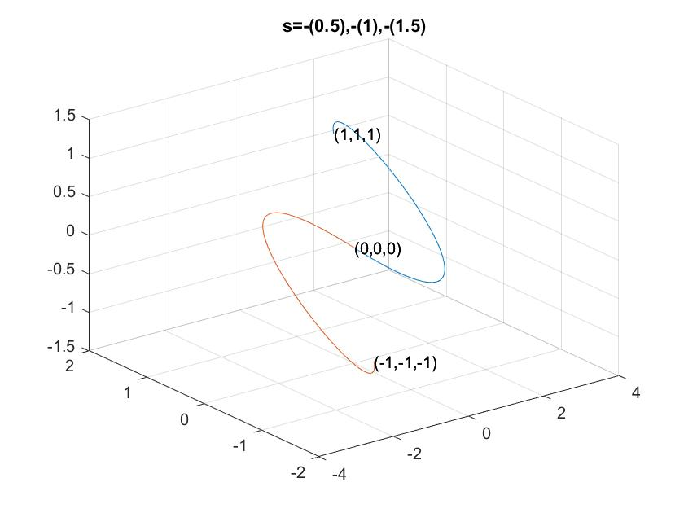

(4)共軛虛根為主極點

s=-(10),-(1+5i),-(1-5i)

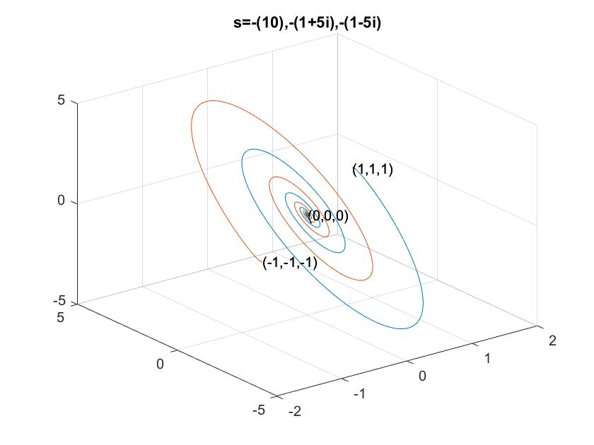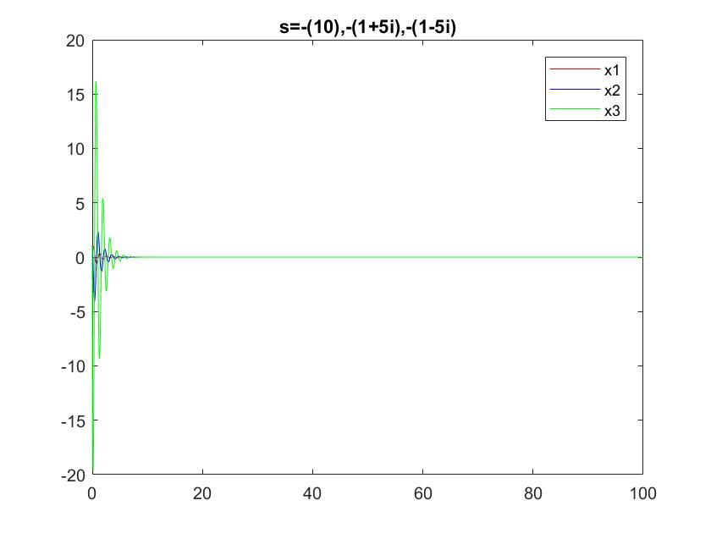

(5)共軛虛根不是主極點

s=-(1),-(10+5i),-(10-5i)

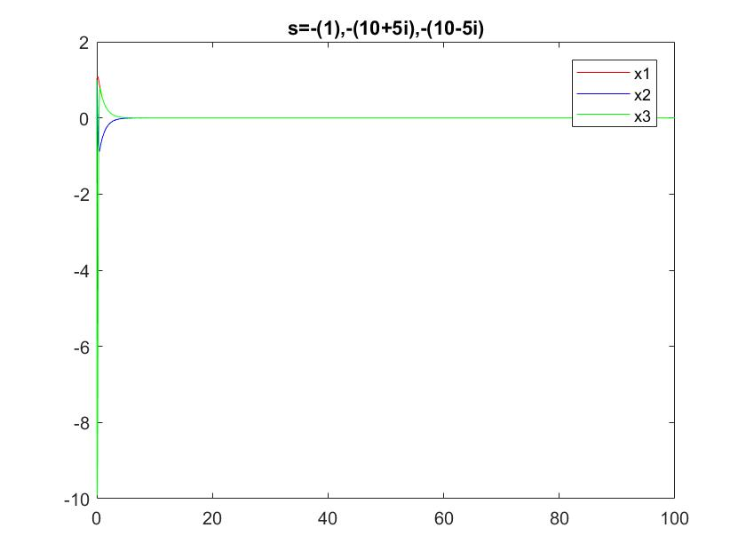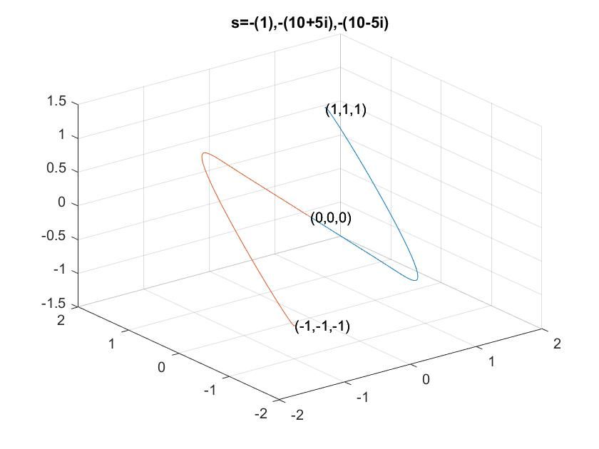

程式碼

clear;clc;

totaltime=100;

delta=0.01;

totalstep=totaltime/delta;

pole1=[1 0];pole2=[1 0.1-2i];pole3=[1 0.1+2i];

char_poly=conv(pole1,conv(pole2,pole3));%(s+p1)*(s+p2)*(s+p3)=0

A=[0 1 0;0 0 1;-char_poly(4) -char_poly(3) -char_poly(2)];%x_dot=A*x

IC=[1,1,1;-1,-1,-1];%initial condition

for i=1:2

x1=[1:totalstep]*0;x2=x1;x3=x1;

x1_dot=x1;x2_dot=x1;x3_dot=x1;

x1(1)=IC(i,1);

x2(1)=IC(i,2);

x3(1)=IC(i,3);

fprintf('init. condidtion:(%d,%d,%d)\n',x1(1),x2(1),x3(1));

for k=1:totalstep

x1_dot(k)=x2(k);

x2_dot(k)=x3(k);

x3_dot(k)=A(3,1)*x1(k)+A(3,2)*x2(k)+A(3,3)*x3(k);

x1(k+1)=x1(k)+x1_dot(k)*delta;

x2(k+1)=x2(k)+x2_dot(k)*delta;

x3(k+1)=x3(k)+x3_dot(k)*delta;

end

if mod(i,2)==1

figure(1);

plot([0:1:totalstep]*delta,x1,'r');hold on;

plot([0:1:totalstep]*delta,x2,'b');hold on;

plot([0:1:totalstep]*delta,x3,'g');hold on;

legend('x1','x2','x3');

str1=num2str(pole1(2));str2=num2str(pole2(2));str3=num2str(pole3(2));

str=['s=-(' str1 '),-(' str2 '),-(' str3 ')'];

title(str);

end

figure(2);

time=1:totalstep-1;

xt=x1(time);yt=x2(time);zt=x2(time);

plot3(xt,yt,zt);hold on;

text(0,0,0,'(0,0,0)');text(1,1,1,'(1,1,1)');text(-1,-1,-1,'(-1,-1,-1)');

grid on;

end

title(str);

fprintf(str);

2.

(1)Lyap. controller

令v(x)=0.5*(x1+x2+x3)2，恆≧0。

則v'=(x1+x2+x3)( x1'+x2'+x3')≡α(x)+β(x)*u

設計u=(α(x)+1)/β(x)使v'恆等於-1。

這題超困難的，怎麼做都發散。後來嘗試先算出系統的其中一個平衡點(x1,x2,x3)=(π-π2,-π,-π2)，直接將初值設在這裡。原本預期它會一直停在這裡，但過了一陣子它又跑向另一個平衡點了。

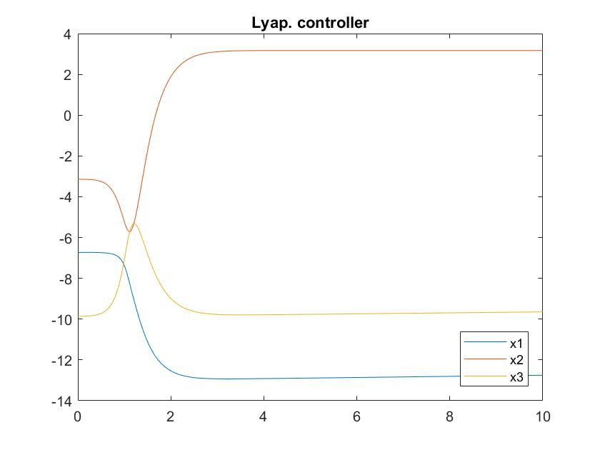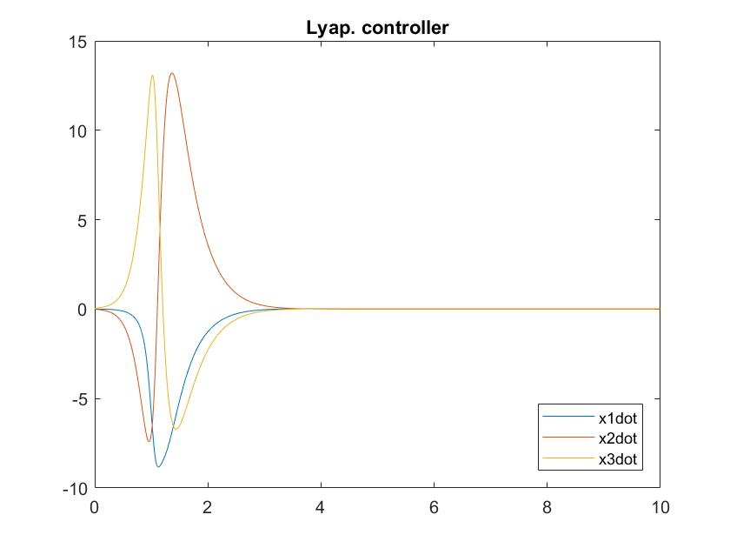

它在下一個平衡過了一陣子後，開始衝向原點。但是因為u的設計在原點會發散，所以加入了一些判斷式適時將u鬆開，結果鬆開幾次系統就再也控不下來了(大概在196秒發散)

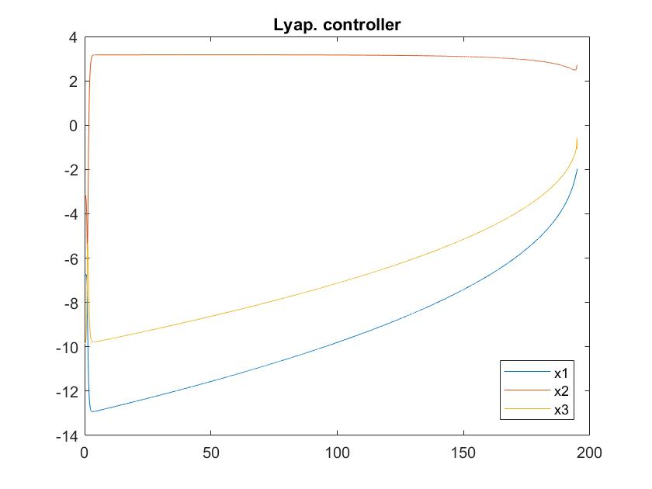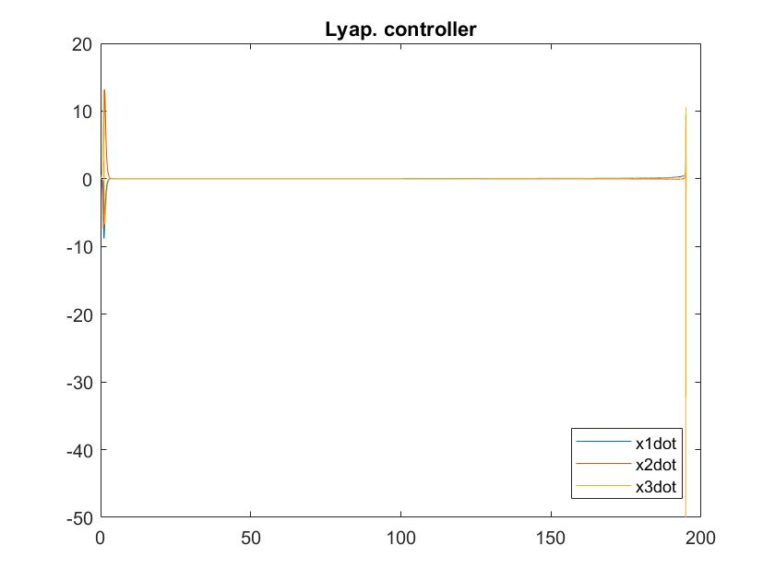

程式碼

%lyap.

clc;clear;

delta=0.01;

totalTime=200;

totalStep=totalTime/delta;

x1array=[1:totalStep]*0;x2array=x1array;x3array=x1array;

x1_dot=x1array;x2_dot=x1array;x2_dot=x1array;

x1array(1)=pi-(pi)^2;x2array(1)=-pi;x3array(1)=-pi^2;%init condition

for i=1:totalStep

x1=x1array(i);x2=x2array(i);x3=x3array(i);

v(i)=0.5*(x1+x2+x3)^2;

u(i)=(-(x2+x1+2*sin(x1-x3)+(x1-x3)^2)-1/(x1+x2+x3));

v_dot(i)=(x1+x2+x3)*(x2+x1+2*(sin(x1-x3))+(x1-x3)^2+u(i));

fprintf('i=%d v=%f v_dot=%f u=%f\n',i,v(i),v_dot(i),u(i));

if v(i)<0.001

u(i)=0;

fprintf('DANGER1 !!!\n');

end

if abs(u(i))>10^10

u(i)=10^10*sign(u(i));

fprintf('DANGER2 !!!\n');

end

x1_dot(i)=x2+x1-x3+sin(x1-x3);

x2_dot(i)=x3+(x1-x3)^2;

x3_dot(i)=sin(x1-x3)+u(i);

x1array(i+1)=x1+x1_dot(i)*delta;

x2array(i+1)=x2+x2_dot(i)*delta;

x3array(i+1)=x3+x3_dot(i)*delta;

end

figure(1);

plot([0:1:totalStep]*delta,x1array);hold on;

plot([0:1:totalStep]*delta,x2array);hold on;

plot([0:1:totalStep]*delta,x3array);legend('x1','x2','x3','location','southeast');

title('Lyap. controller');

figure(2);

plot([0:1:totalStep-1]*delta,x1_dot);hold on;

plot([0:1:totalStep-1]*delta,x2_dot);hold on;

plot([0:1:totalStep-1]*delta,x3_dot);legend('x1dot','x2dot','x3dot','location','southeast');

title('Lyap. controller');

(2)sliding control

<1>

令f= (D+λ)(x1)= x1'+λx1=x2+x1-x3+sin(x1-x3)+λx1;

則f'= x2'+x1'-x3'+(sin(x1-x3))'+λx1'≡α(x)+β(x)*u;

設計u使f'=-K*sign(f)，讓f以e-λt收斂。最後收斂到x1=0。

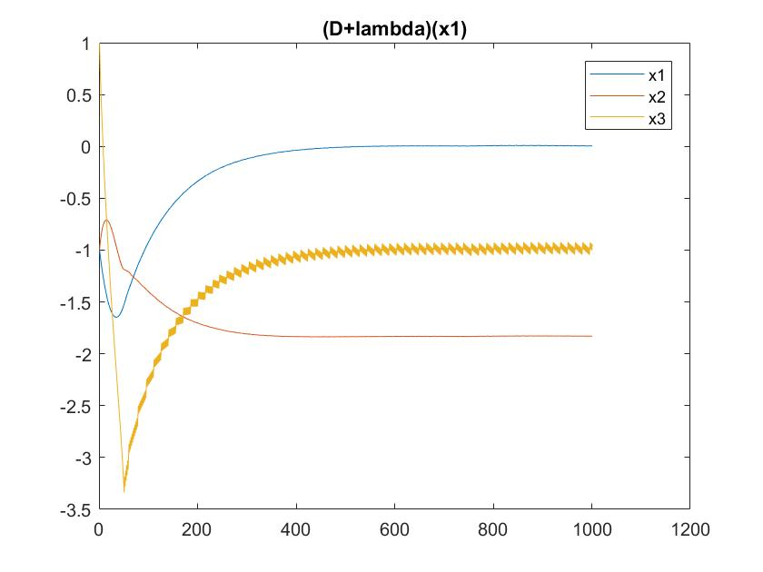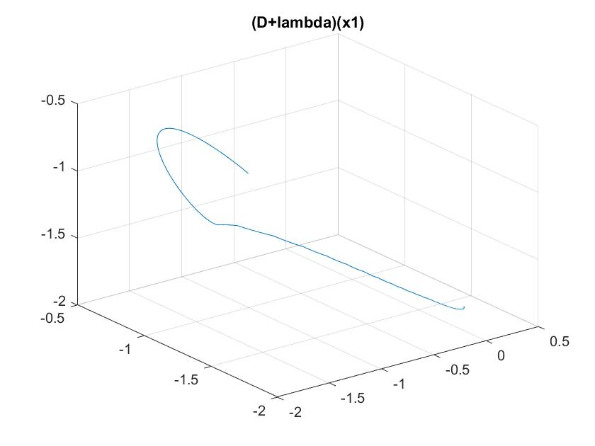

<2>

令f=(D+λ)(x1+x2)=x1+x2+sin(x1-x3)+(x1-x3)2+λ(x1+x2);

則f'= x1'+x2'+(sin(x1-x3))'+2(x1-x3)(x1'-x3')+λ(x1'+x2');≡α(x)+β(x)*u;

設計u使f'=-K*sign(f)，讓f以e-λt收斂。最後收斂到x1+x2=0。

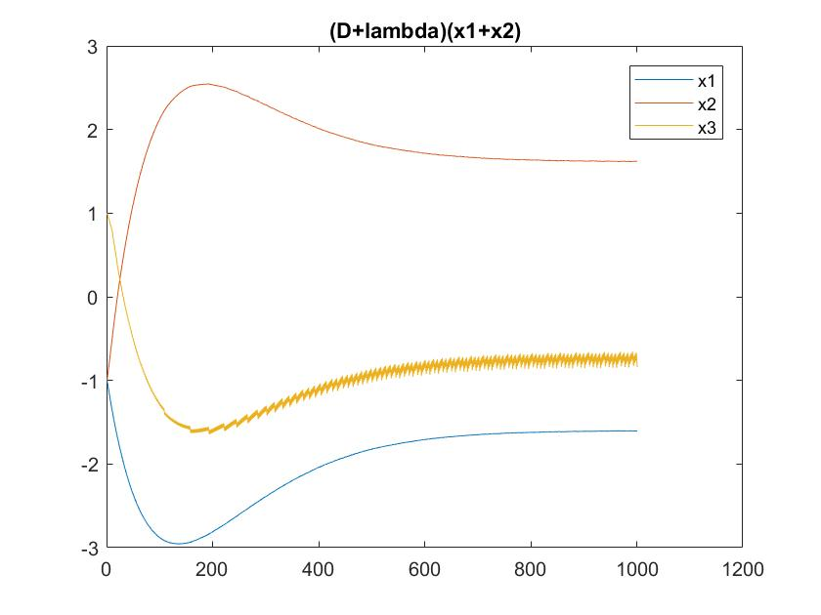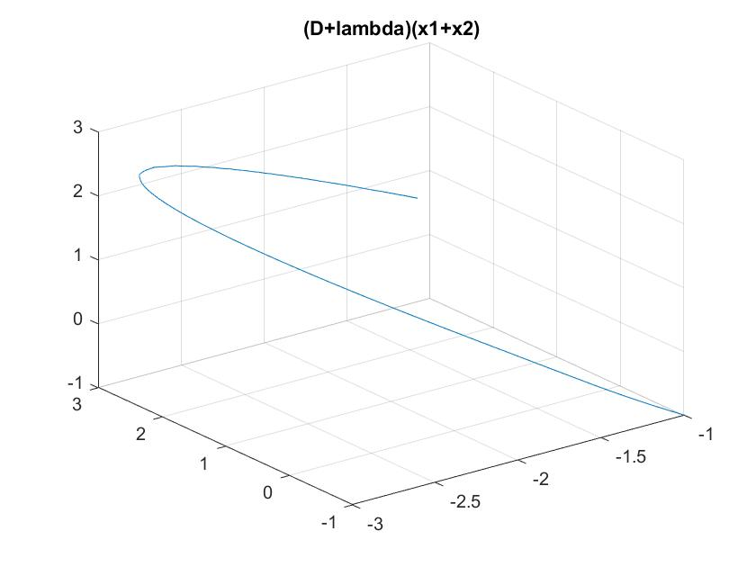

程式碼

%f=(D+lambda)(x1+x2)

clc;clear;

lambda=1;

K=10;

delta=0.01;

totalTime=10;

totalStep=totalTime/delta;

x1array=[1:totalStep]*0;x2array=x1array;x3array=x1array;

x1_dot=x1array;x2_dot=x1array;x2_dot=x1array;

x1array(1)=-1;x2array(1)=-1;x3array(1)=1;%init condition

for i=1:totalStep

x1=x1array(i);x2=x2array(i);x3=x3array(i);

f(i)=x1+x2+sin(x1-x3)+(x1-x3)^2+lambda*(x1+x2);

u(i)=(K*sign(f(i))+(1+lambda)*((x2+x1-x3+sin(x1-x3))+(x3+(x1-x3)^2))+(cos(x1-x3)+2*(x1-x3))*(x2+x1-x3))/(cos(x1-x3)+2*(x1-x3));

x1_dot(i)=x2+x1-x3+sin(x1-x3);

x2_dot(i)=x3+(x1-x3)^2;

x3_dot(i)=sin(x1-x3)+u(i);

x1array(i+1)=x1+x1_dot(i)*delta;

x2array(i+1)=x2+x2_dot(i)*delta;

x3array(i+1)=x3+x3_dot(i)*delta;

end

figure(1);

plot(x1array);hold on;

plot(x2array);hold on;

plot(x3array);legend('x1','x2','x3');

title('(D+lambda)(x1+x2)')

figure(2);

time=1:totalStep-1;

xt=x1array(time);

yt=x2array(time);

zt=x2array(time);

plot3(xt,yt,zt);

grid on;title('(D+lambda)(x1+x2)')

3.

設計modle的極點為s=-11,s=-12,s=-13，要離虛軸夠遠系統才不會發散。

經計算得Am=[$\begin{matrix}0 & 1 & 0 \\ 0 & 0 & 1 \\ -14 & -4 & -3\end{matrix}$]

(1)r=unit step

一開始先預設Q為單位矩陣，γ皆為1。

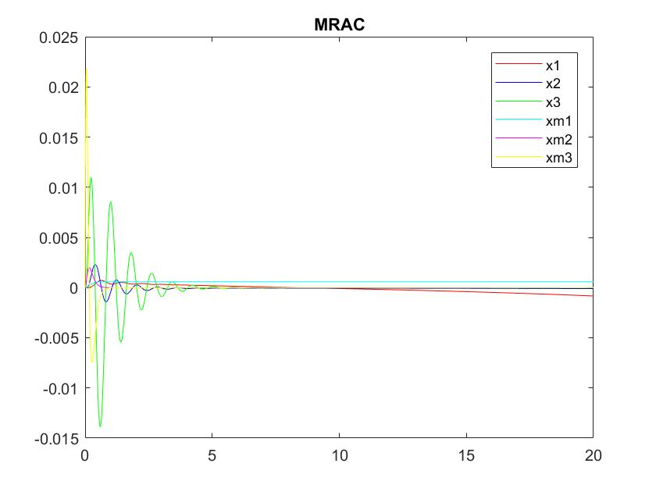

發現它快追上之後又會垂下來，其中x1的誤差最嚴重而且越來越大，最後導致發散。故調整權重，改成Q=[$\begin{matrix}0.0001 & 0 & 0 \\ 0 & 1 & 0 \\ 0 & 0 & 1000\end{matrix}$]，也試過調γ但是效果不彰。

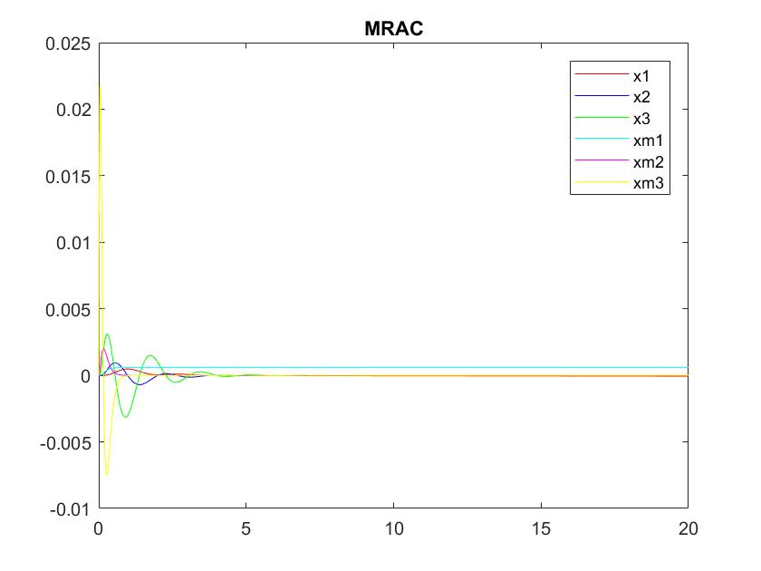

(2)r=弦波的合成

再改成Q=[$\begin{matrix}0.00001 & 0 & 0 \\ 0 & 0.00001 & 0 \\ 0 & 0 & 100000\end{matrix}$]，γ仍為1。

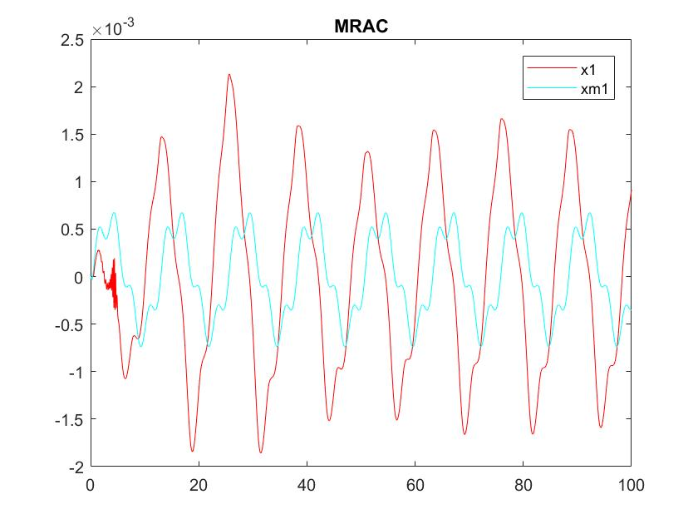

程式碼

%MRAC

clear;clc;

totaltime=100;

delta=0.01;

totalstep=totaltime/delta;

%select para.

Q=[0.00001 0 0;0 0.00001 0;0 0 100000];

pole=conv([1 13],conv([1 12],[1 11]));

Am=[0 1 0;0 0 1;-pole(4) -pole(3) -pole(2)];bm=1;%model

A=[0 1 0;0 0 1;-12 -4 -3];b=1;%real sys.

P=lyap(Am,Q);

gamma0=1;gamma1=1;gamma2=1;gamma3=1;

%model

xm1(1)=0;xm2(1)=0;xm3(1)=0;

for k=1:totalstep

% r(k)=1;

r(k)=sin(0.5*k*delta)+0.3*cos(2*k*delta+4);

xm1_dot(k)=xm2(k);

xm2_dot(k)=xm3(k);

xm3_dot(k)=Am(3,1)*xm1(k)+Am(3,2)*xm2(k)+Am(3,3)*xm3(k)+bm*r(k);

xm1(k+1)=xm1(k)+xm1_dot(k)*delta;

xm2(k+1)=xm2(k)+xm2_dot(k)*delta;

xm3(k+1)=xm3(k)+xm3_dot(k)*delta;

end

%real sys.

theta0(1)=0;theta1(1)=0;theta2(1)=0;theta3(1)=0;

x1(1)=0;x2(1)=0;x3(1)=0;

for k=1:totalstep

u(k)=theta0(k)*r(k)+theta1(k)*x1(k)+theta2(k)*x2(k)+theta3(k)*x3(k);

x1_dot(k)=x2(k);

x2_dot(k)=x3(k);

x3_dot(k)=A(3,1)*x1(k)+A(3,2)*x2(k)+A(3,3)*x3(k)+1*u(k);

x1(k+1)=x1(k)+x1_dot(k)*delta;

x2(k+1)=x2(k)+x2_dot(k)*delta;

x3(k+1)=x3(k)+x3_dot(k)*delta;

e1(k)=xm1(k)-x1(k);

e2(k)=xm2(k)-x2(k);

e3(k)=xm3(k)-x3(k);

zeta(k)=0.5*(P(1,3)*e1(k)+P(2,3)*e2(k)+P(3,3)*e3(k));

theta0_dot(k)=zeta(k)*r(k)/(b*gamma0);

theta1_dot(k)=zeta(k)*x1(k)/(b*gamma1);

theta2_dot(k)=zeta(k)*x2(k)/(b*gamma2);

theta3_dot(k)=zeta(k)*x3(k)/(b*gamma3);

theta0(k+1)=theta0(k)+theta0_dot(k)*delta;

theta1(k+1)=theta1(k)+theta1_dot(k)*delta;

theta2(k+1)=theta2(k)+theta2_dot(k)*delta;

theta3(k+1)=theta3(k)+theta3_dot(k)*delta;

end

plot([0:1:totalstep]*delta,x1,'r');hold on;

% plot([0:1:totalstep]*delta,x2,'b');hold on;

% plot([0:1:totalstep]*delta,x3,'g');hold on;

plot([0:1:totalstep]*delta,xm1,'c');hold on;

% plot([0:1:totalstep]*delta,xm2,'m');hold on;

% plot([0:1:totalstep]*delta,xm3,'y');hold on;

legend('x1','xm1');

title('MRAC');

4.