Checkpoint4 Report
一、大綱
延續checkpoint3基礎，新增IR接收器，以及控制程式中，有限狀態機中的相關state。

二、IR接收器配線與通訊設定

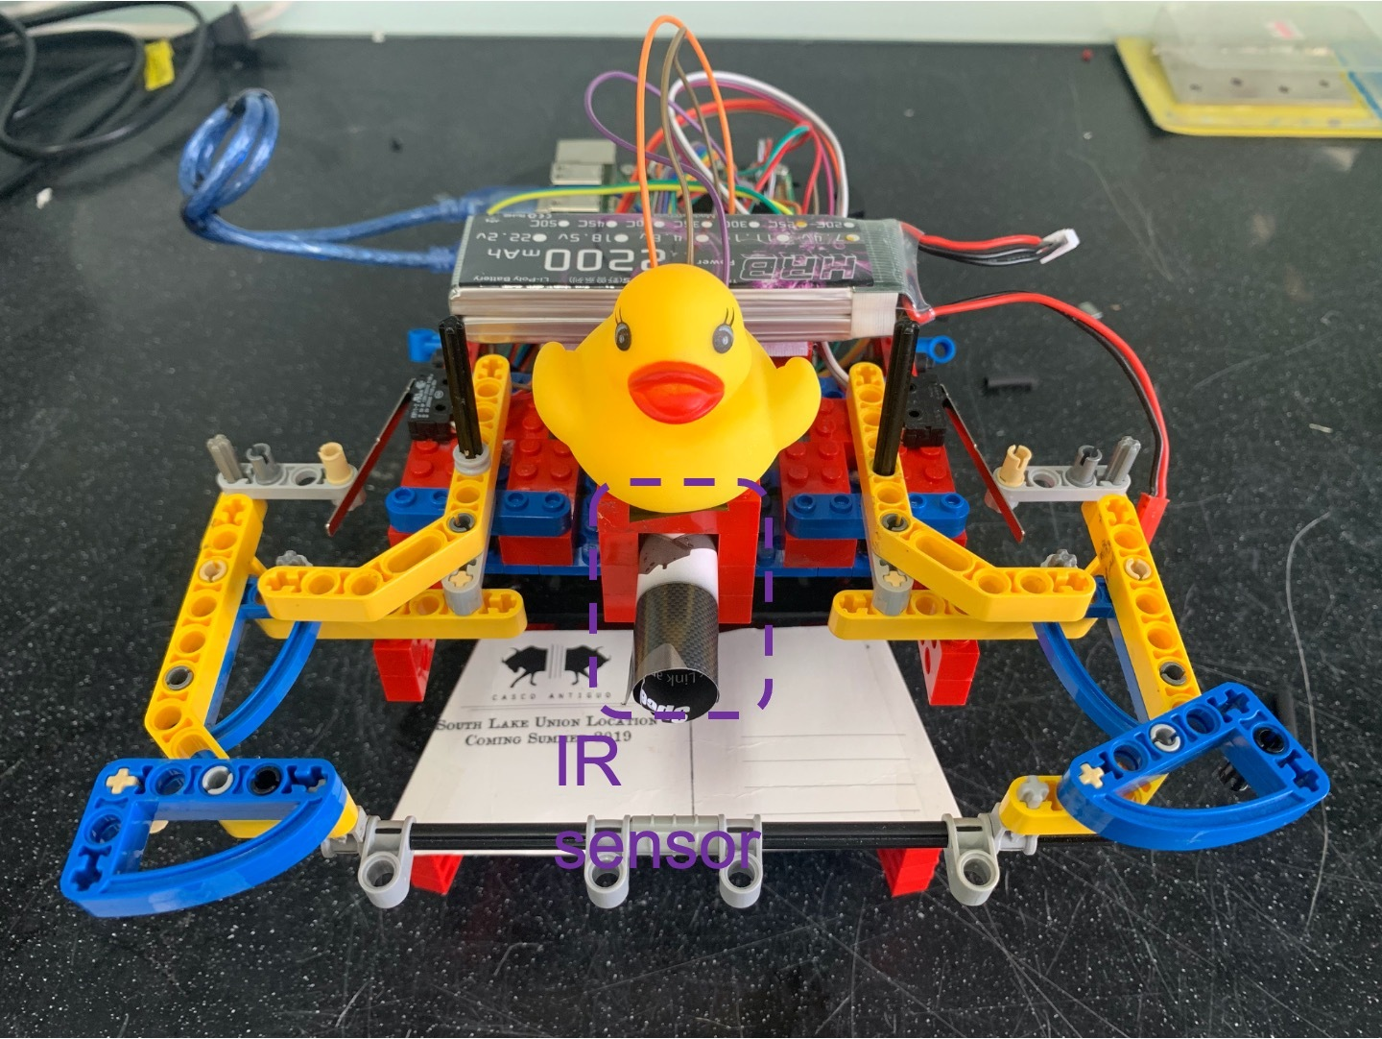
IR硬體配置

IR接收器的訊號線接到Arduino中的A1腳位，Arduino端程式在loop中不斷讀值並publish到ROS topic上。在RPI端程式透過ROS接收，每subscribe 50次計算一次平均，已平均值來判斷IR訊號的pulse proportion。
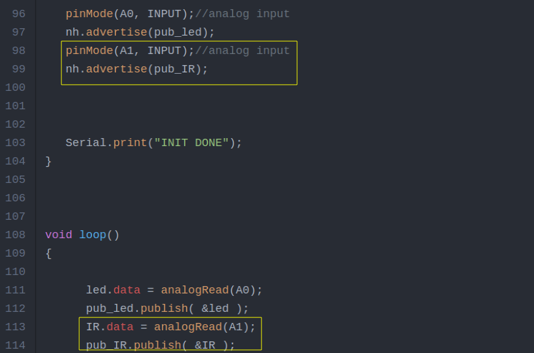
Arduino端程式 IR相關配置

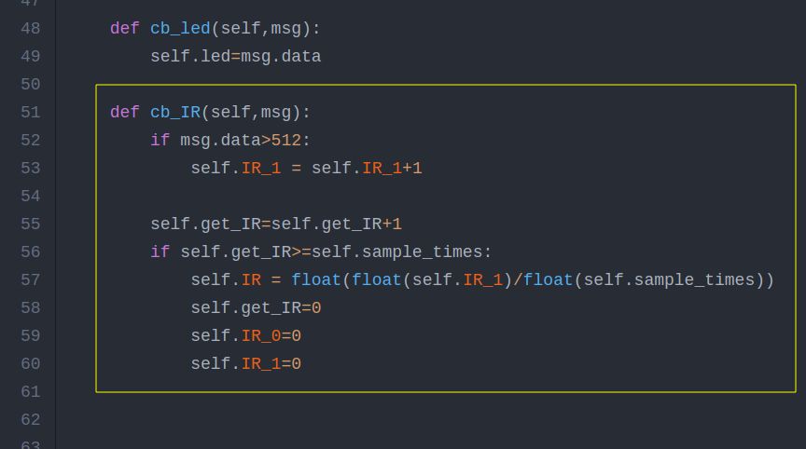
RPI端程式IR相關配置

三、有限狀態機
起始狀態由NoGoal開始
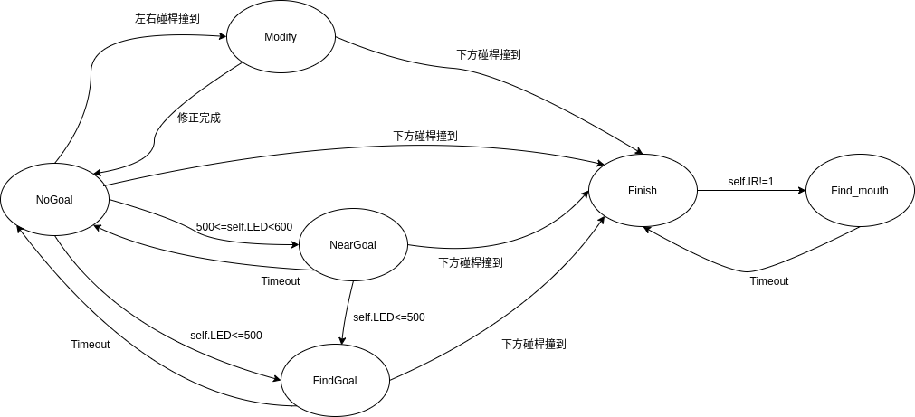

四、各state對應active
1.NoGoal：直走
2.Modify:（撞到後修正）
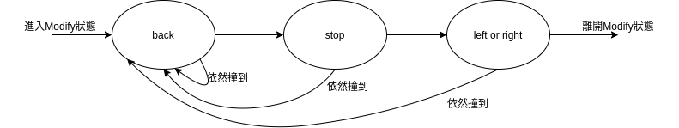
3.NearGoal:(附近可能有球，開始搜尋)
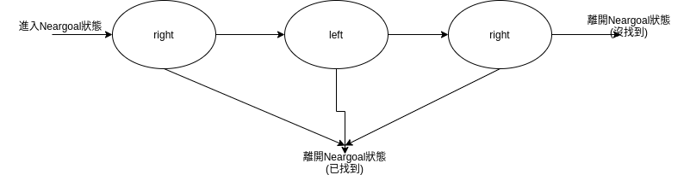
4.FindGoal:直走(確定前方有球)
5.Finish:（已吃到球，開始找門）
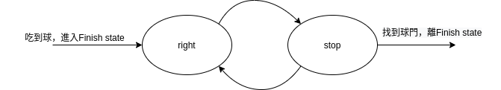
6.Find_mouth:直走(確定前方有門)

五、程式碼
A.RPI端程式
#!/usr/bin/env python
import wiringpi
import time
import random
import rospy
import numpy as np
from std_msgs.msg import Int32

class Control(object):
def __init__(self):
wiringpi.wiringPiSetup()
wiringpi.pinMode(7, 0)
wiringpi.pinMode(8, 0)
wiringpi.pinMode(9, 0)
self.excute_time=0
self.led=-1000
self.last_led=-1000
self.last_action=None
self.now_action=None
self.next_next_action=None
self.state="NoGoal"
self.time=0
self.sub_led = rospy.Subscriber("pub_led", Int32, self.cb_led, queue_size=1)
self.sub_IR = rospy.Subscriber("pub_IR", Int32, self.cb_IR, queue_size=1)
self.pub_int = rospy.Publisher("array", Int32, queue_size=1)
self.timer = rospy.Timer(rospy.Duration(0.1), self.control_loop)
self.get_IR=0
self.IR_1=0
self.IR=0
self.sample_times=50
self.search_goal_mouth_points=11
self.search_goal_mouth_array=np.zeros(self.search_goal_mouth_points)
self.have_eat_ball=False
print("init done")

def cb_led(self,msg):
self.led=msg.data

def cb_IR(self,msg):
if msg.data>512:
self.IR_1 = self.IR_1+1
self.get_IR=self.get_IR+1
if self.get_IR>=self.sample_times:
self.IR = float(float(self.IR_1)/float(self.sample_times))
self.get_IR=0
self.IR_0=0
self.IR_1=0

def motor_control(self):
if self.now_action=="advance":
self.pub_int.publish(1)
# print('~~~pub advance~~~')
if self.now_action=="right":
self.pub_int.publish(2)
# print('~~~pub right~~~')
if self.now_action=="left":
self.pub_int.publish(3)
# print('~~~pub left~~~')
if self.now_action=="back":
self.pub_int.publish(4)
# print('~~~pub back~~~')
if self.now_action=="stop":
self.pub_int.publish(5)
# print('~~~pub stop~~~')

def control_loop(self,event):
#for bump sensor
my_input7 = wiringpi.digitalRead(7)
my_input8 = wiringpi.digitalRead(8)
my_input9 = wiringpi.digitalRead(9)

# if self.state!="Modify":
if my_input7==0 and my_input8==0 and my_input9==1: #hit
self.now_action="back"
self.next_action="stop"
self.next_next_action="left"
self.state="Modify"
self.time=13+4+3

elif my_input7==1 and my_input8==0 and my_input9==1: #hit
self.now_action="back"
self.next_action="stop"
self.next_next_action="left"
self.state="Modify"
self.time=13+4+3

elif my_input7==0 and my_input8==1 and my_input9==1: #hit
self.now_action="back"
self.next_action="stop"
self.next_next_action="right"
self.state="Modify"
self.time=13+4+3

if my_input7==1 and my_input8==1 and my_input9==1: #free

if not self.have_eat_ball:
#for LED sensor
if self.led<=500:
# print("!!!!!!!!!!!!!!!!!!!!!!!!!!!!!!!FindGoal!!!!!!!!!!!!!!!!!!!!!!!!!!!!!!!!!!1!!!!")
self.state="FindGoal"
self.time=10

elif self.led<=600 and self.led>500 and self.state!="Modify" and self.excute_time>200:
# print("~~~~~~~~~~~~~~~~~~~~~~~~~~~~~~~~NearGoal~~~~~~~~~~~~~~~~~~~~~~~~~~~~~~~~~~~~~~~~")
if self.state!="NearGoal":
self.time=40
self.now_action="left"
self.next_action="right"
self.state="NearGoal"

if my_input9==0 : #have catched the ball
self.have_eat_ball=True
if self.state!="Finish":
self.time=30*10
self.state="Finish"
self.now_action="right"
self.next_action="stop"

#update
if self.state=="Modify":
if self.time==16:
self.now_action=self.next_action
self.next_action=self.next_next_action
self.next_next_action=None
elif self.time==13:
self.now_action=self.next_action
self.next_action=None
self.next_next_action=None
elif self.time<0:
if self.have_eat_ball:
self.state="Finish"
self.time=0
else:
self.state="NoGoal"
self.time=0

if self.state=="NearGoal":
if self.time==30:
self.now_action=self.next_action
self.next_action="left"
if self.time==10:
self.now_action=self.next_action
self.next_action=None
if self.time<0:
self.state="NoGoal"
self.time=0

if self.state=="FindGoal":
self.now_action="advance"
if self.time<0:
self.state="NoGoal"
self.time=0

if self.state=="NoGoal":
self.now_action="advance"

if self.state=="Finish":
if self.time>0:
if (self.time%2)>0:
self.now_action="right"
else:
self.now_action="stop"

if self.IR<0.95:
self.state=="Find_mouth"
self.now_action="advance"
self.time=100

if self.time==0:
self.time=30*10
self.state="Finish"
self.now_action="right"

if self.state=="Find_mouth":
self.now_action="advance"
if self.time<0:
self.time=30*10
self.state="Finish"
self.now_action="right"

self.excute_time=self.excute_time+1
self.time=self.time-1
self.last_led=self.led
self.last_action=self.now_action
self.motor_control()
# print('sample_time=',self.get_IR,'IR=',self.IR)
# print(self.led,my_input7,my_input8,my_input9,self.state,self.now_action,self.time)
print(self.IR,self.led,self.state,self.now_action,self.time)

if __name__ == "__main__":
rospy.init_node("Control")
control=Control()
rospy.spin()

B.Arduino端程式
#include <PID_v1.h>
#include <ros.h>
#include <math.h>
#include <std_msgs/Int32.h>
const byte encoder0pinA = 2;//A pin -> the interrupt pin 0
const byte encoder0pinB = 12;//B pin -> the digital pin 3
int in1 =8; //The enabling of L298PDC motor driver board connection to the digital interface port 5
int in2 =9; //The enabling of L298PDC motor driver board connection to the digital interface port 4
int ena =5;
const byte encoder1pinA = 3;//A pin -> the interrupt pin 0
const byte encoder1pinB = 13;//B pin -> the digital pin 3
int in3 =10; //The enabling of L298PDC motor driver board connection to the digital interface port 5
int in4 =11; //The enabling of L298PDC motor driver board connection to the digital interface port 4
int enb =6;
byte encoder0PinALast;
byte encoder1PinALast;
double durationright,abs_durationright;//the number of the pulses
double durationleft,abs_durationleft;
boolean Directionright;//the rotation direction
boolean Directionleft;
boolean resultright;
boolean resultleft;
ros::NodeHandle nh;
double val_outputright;//Power supplied to the motor PWM value.
double val_outputleft;
double Setpointright=0;
double Setpointleft=0;
double Kp=0.6, Ki=5, Kd=0;

int MODE= -1;
int last_MODE;
int count=0;

PID rightPID(&abs_durationright, &val_outputright, &Setpointright, Kp, Ki, Kd, DIRECT);
PID leftPID(&abs_durationleft, &val_outputleft, &Setpointleft, Kp, Ki, Kd, DIRECT);

void num(const std_msgs::Int32& msg){

if (msg.data==1){
MODE=1;
Setpointleft=255;
Setpointright=255;
}
if (msg.data==2){
MODE=2;
Setpointleft=100;
Setpointright=100;
}
if (msg.data==3){
MODE=3;
Setpointleft=100;
Setpointright=100;
}
if (msg.data==4){
MODE=4;
Setpointleft=255;
Setpointright=255;
}
if (msg.data==5){
MODE=5;
Setpointleft=0;
Setpointright=0;
}
}
ros::Subscriber<std_msgs::Int32> sub("array",&num);
std_msgs::Int32 led;
ros::Publisher pub_led("pub_led", &led);
std_msgs::Int32 IR;
ros::Publisher pub_IR("pub_IR", &IR);

void setup()
{
Serial.begin(57600);//Initialize the serial port
pinMode(in1, OUTPUT); //L298P Control port settings DC motor driver board for the output mode
pinMode(in2, OUTPUT);
pinMode(ena, OUTPUT);
pinMode(in3, OUTPUT); //L298P Control port settings DC motor driver board for the output mode
pinMode(in4, OUTPUT);
pinMode(enb, OUTPUT);
pinMode(encoder0pinA, INPUT);
pinMode(encoder0pinB, INPUT);
pinMode(encoder1pinA, INPUT);
pinMode(encoder1pinB, INPUT);
nh.initNode();
nh.subscribe(sub);
rightPID.SetMode(AUTOMATIC);//PID is set to automatic mode
rightPID.SetSampleTime(100);//Set PID sampling frequency is 100ms
leftPID.SetMode(AUTOMATIC);//PID is set to automatic mode
leftPID.SetSampleTime(100);//S
EncoderInit();//Initialize the module

pinMode(A0, INPUT);//analog input
nh.advertise(pub_led);
pinMode(A1, INPUT);//analog input
nh.advertise(pub_IR);

Serial.print("INIT DONE");
}

void loop()
{

led.data = analogRead(A0);
pub_led.publish( &led );
IR.data = analogRead(A1);
pub_IR.publish( &IR );

if(last_MODE!=MODE){
if(MODE==1){advance();}//Motor Forward
if(MODE==2){right();}
if(MODE==3){left();}
if(MODE==4){back();}
if(MODE==5){Stop();}
}
abs_durationright=abs(durationright);
resultright=rightPID.Compute();//PID conversion is complete and returns 1
if(resultright)
{
durationright = 0; //Count clear, wait for the next count
}

abs_durationleft=abs(durationleft);
resultleft=leftPID.Compute();//PID conversion is complete and returns 1
if(resultleft)
{
durationleft = 0; //Count clear, wait for the next count
}

last_MODE=MODE;
nh.spinOnce();
}

void EncoderInit()
{
Directionright = true;//default -> Forward
pinMode(encoder0pinB,INPUT);
attachInterrupt(0, wheelSpeedright, CHANGE);
Directionleft = true;//default -> Forward
pinMode(encoder1pinB,INPUT);
attachInterrupt(1, wheelSpeedleft, CHANGE);
}
void wheelSpeedright()
{
int Lstate = digitalRead(encoder0pinA);
if((encoder0PinALast == LOW) && Lstate==HIGH)
{
int val = digitalRead(encoder0pinB);
if(val == LOW && Directionright)
{
Directionright = false; //Reverse
}
else if(val == HIGH && !Directionright)
{
Directionright = true; //Forward
}
}
encoder0PinALast = Lstate;
if(!Directionright) durationright++;
else durationright--;
}
void wheelSpeedleft()
{
int Rstate = digitalRead(encoder1pinA);
if((encoder1PinALast == LOW) && Rstate==HIGH)
{
int valR = digitalRead(encoder1pinB);
if(valR == LOW && Directionleft)
{
Directionleft = false; //Reverse
}
else if(valR == HIGH && !Directionleft)
{
Directionleft = true; //Forward
}
}
encoder1PinALast = Rstate;
if(!Directionleft) durationleft++;
else durationleft--;
}

void advance()//Motor Forward
{
digitalWrite(in1,HIGH);
digitalWrite(in2,LOW);
analogWrite(ena,val_outputright);
digitalWrite(in3,HIGH);
digitalWrite(in4,LOW);
analogWrite(enb,val_outputleft);
}
void right()//Motor Forward
{
digitalWrite(in1,HIGH);
digitalWrite(in2,LOW);
analogWrite(ena,val_outputright);
digitalWrite(in3,LOW);
digitalWrite(in4,HIGH);
analogWrite(enb,val_outputleft);
}
void left()//Motor Forward
{
digitalWrite(in1,LOW);
digitalWrite(in2,HIGH);
analogWrite(ena,val_outputright);
digitalWrite(in3,HIGH);
digitalWrite(in4,LOW);
analogWrite(enb,val_outputleft);
}

void back()//Motor reverse
{
digitalWrite(in1,LOW);
digitalWrite(in2,HIGH);
analogWrite(ena,val_outputright);
digitalWrite(in3,LOW);
digitalWrite(in4,HIGH);
analogWrite(enb,val_outputleft);
}

void Stop()//Motor stops
{
digitalWrite(ena, LOW);
digitalWrite(enb, LOW);
}

