1.Introduction
2.Experiment setups
A. Sigmoid functions
B. Neural network
C. Backpropagation

3.Results of your testing
(1) linear
設定：
epochs : 100000
lr : 0.1
hidden_units : 2
batch_size : 47
activation_func : sigmoid
optimizers : GD

結果：
A.Screenshot and comparison figure
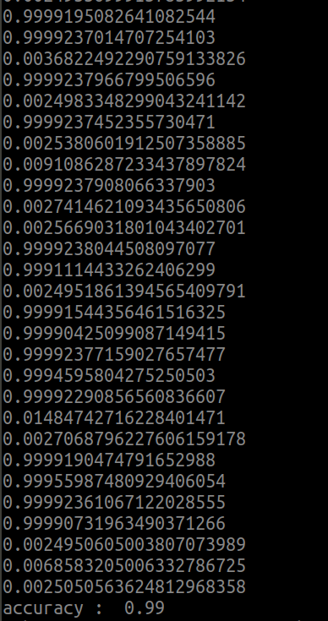
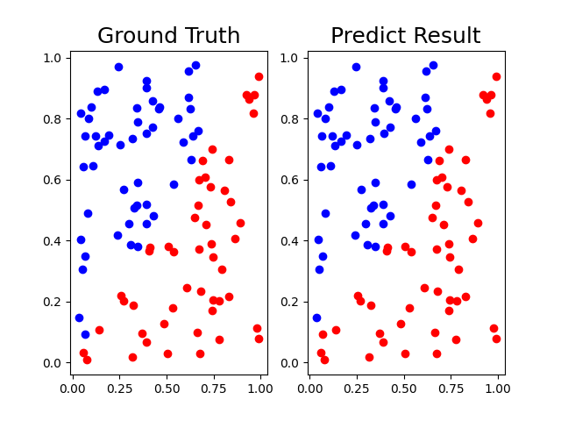

B.Show the accuracy of your prediction
正確率 : 0.99
C.Learning curve (loss, epoch curve)
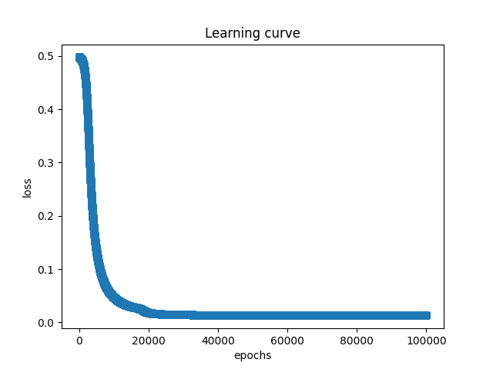

(2) xor
設定：
epochs : 300000
lr : 0.1
hidden_units : 2
batch_size : 8
activation_func : sigmoid
optimizers : GD
結果：
A.Screenshot and comparison figure
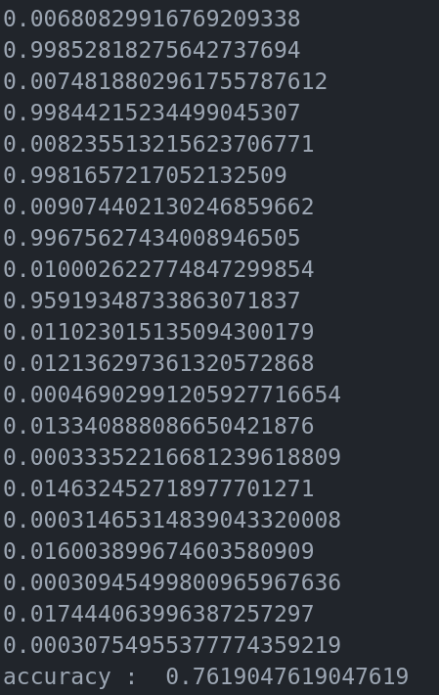
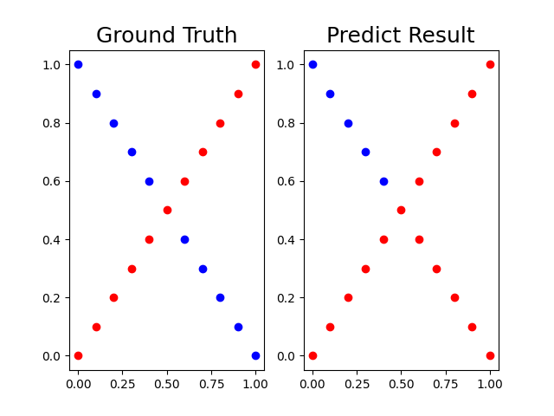

B.Show the accuracy of your prediction
正確率 : 0.76
C.Learning curve (loss, epoch curve)
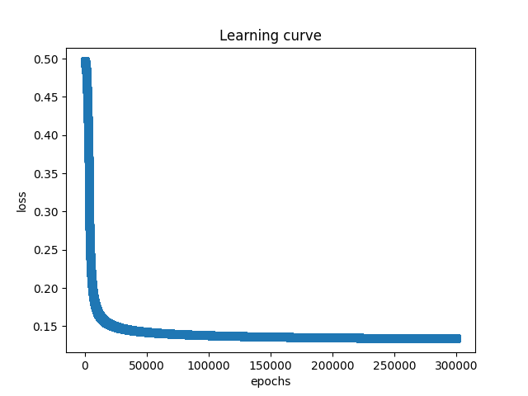

4.Discussion
A.Try different learning rates
B.Try different numbers of hidden units
C.Try without activation functions
D.Anything you want to share

