Лабораторная работа №6
Тема: Разработка и интеграция модулей проекта
Выполнил: Трутаев Никита пр23/2
Цель: разработать и интегрировать модуль базы данных проекта в Microsoft SQL Server, создать эффективную схему данных, обеспечивающую целостность и удобство хранения информации, а также подготовить основу для дальнейшей реализации бизнес-логики и взаимодействия с приложением с учетом командной работы.

Ход работы

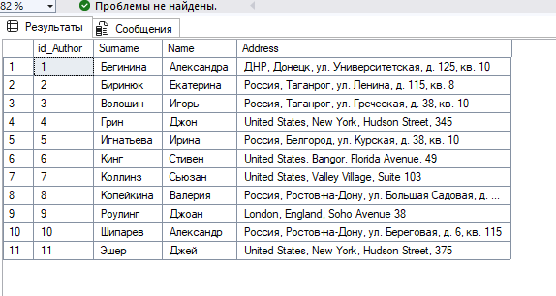
Рис. 1 – Таблица dbo.Authors

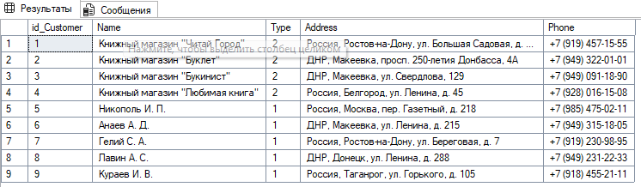
Рис. 2 - Таблица dbo.Customer

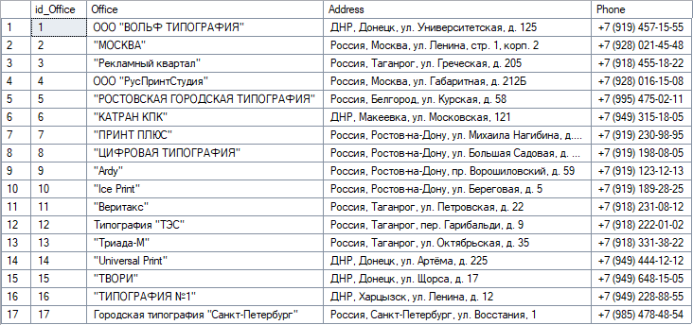
Рис. 3 - Таблица dbo.Offices

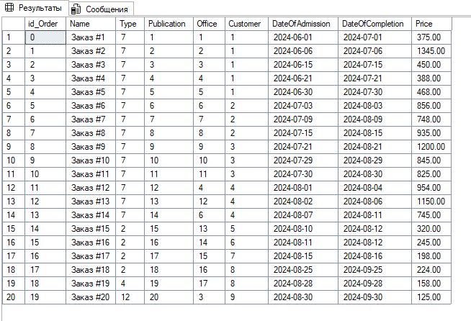
Рис. 4 - Таблица dbo.Orders

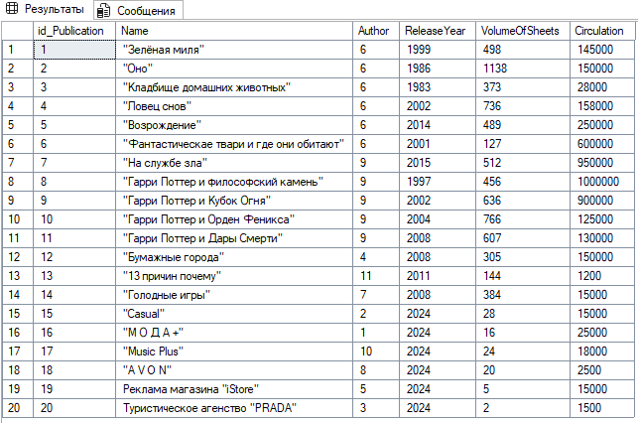
Рис. 6 - Таблица dbo.Publications

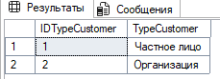
Рис. 7 - Таблица dbo.TypeCustomers

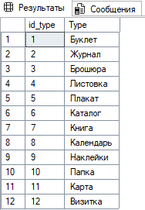
Рис. 8 - Таблица dbo.TypeOfProdyct

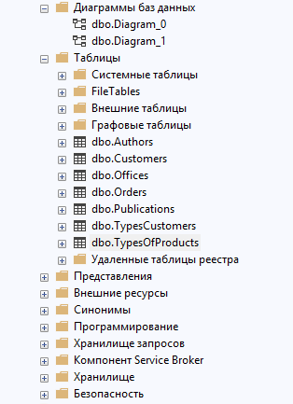
Рис. 9 - Структура БД

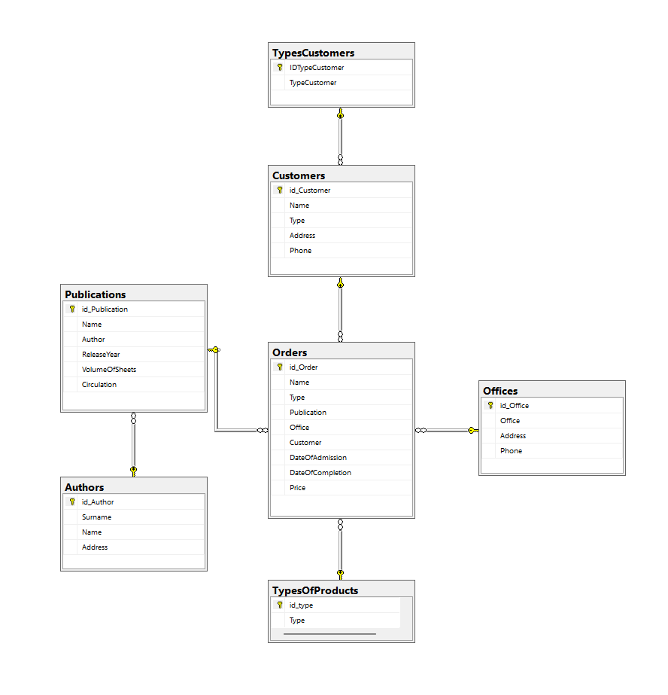
Рис.10 – Схема БД

Листинг кода:
USE [master]
GO

IF DB_ID('publishing') IS NOT NULL
DROP DATABASE [publishing]
GO

CREATE DATABASE [publishing]
CONTAINMENT = NONE
ON PRIMARY
( NAME = N'publishing', FILENAME = N'C:\Program Files\Microsoft SQL Server\MSSQL16.MSSQLSERVER\MSSQL\DATA\publishing.mdf' , SIZE = 8MB , MAXSIZE = UNLIMITED, FILEGROWTH = 64MB )
LOG ON
( NAME = N'publishing_log', FILENAME = N'C:\Program Files\Microsoft SQL Server\MSSQL16.MSSQLSERVER\MSSQL\DATA\publishing_log.ldf' , SIZE = 8MB , MAXSIZE = 2048GB , FILEGROWTH = 64MB )
WITH CATALOG_COLLATION = DATABASE_DEFAULT, LEDGER = OFF
GO

IF (FULLTEXTSERVICEPROPERTY('IsFullTextInstalled') = 1)
begin
EXEC [publishing].[dbo].[sp_fulltext_database] @action = 'enable'
end
GO

ALTER DATABASE [publishing] SET ANSI_NULL_DEFAULT OFF
GO

ALTER DATABASE [publishing] SET ANSI_NULLS OFF
GO

ALTER DATABASE [publishing] SET ANSI_PADDING OFF
GO

ALTER DATABASE [publishing] SET ANSI_WARNINGS OFF
GO

ALTER DATABASE [publishing] SET ARITHABORT OFF
GO

ALTER DATABASE [publishing] SET AUTO_CLOSE OFF
GO

ALTER DATABASE [publishing] SET AUTO_SHRINK OFF
GO

ALTER DATABASE [publishing] SET AUTO_UPDATE_STATISTICS ON
GO

ALTER DATABASE [publishing] SET CURSOR_CLOSE_ON_COMMIT OFF
GO

ALTER DATABASE [publishing] SET CURSOR_DEFAULT GLOBAL
GO

ALTER DATABASE [publishing] SET CONCAT_NULL_YIELDS_NULL OFF
GO

ALTER DATABASE [publishing] SET NUMERIC_ROUNDABORT OFF
GO

ALTER DATABASE [publishing] SET QUOTED_IDENTIFIER OFF
GO

ALTER DATABASE [publishing] SET RECURSIVE_TRIGGERS OFF
GO

ALTER DATABASE [publishing] SET ENABLE_BROKER
GO

ALTER DATABASE [publishing] SET AUTO_UPDATE_STATISTICS_ASYNC OFF
GO

ALTER DATABASE [publishing] SET DATE_CORRELATION_OPTIMIZATION OFF
GO

ALTER DATABASE [publishing] SET TRUSTWORTHY OFF
GO

ALTER DATABASE [publishing] SET ALLOW_SNAPSHOT_ISOLATION OFF
GO

ALTER DATABASE [publishing] SET PARAMETERIZATION SIMPLE
GO

ALTER DATABASE [publishing] SET READ_COMMITTED_SNAPSHOT OFF
GO

ALTER DATABASE [publishing] SET HONOR_BROKER_PRIORITY OFF
GO

ALTER DATABASE [publishing] SET RECOVERY FULL
GO

ALTER DATABASE [publishing] SET MULTI_USER
GO

ALTER DATABASE [publishing] SET PAGE_VERIFY CHECKSUM
GO

ALTER DATABASE [publishing] SET DB_CHAINING OFF
GO

ALTER DATABASE [publishing] SET FILESTREAM( NON_TRANSACTED_ACCESS = OFF )
GO

ALTER DATABASE [publishing] SET TARGET_RECOVERY_TIME = 60 SECONDS
GO

ALTER DATABASE [publishing] SET DELAYED_DURABILITY = DISABLED
GO

ALTER DATABASE [publishing] SET ACCELERATED_DATABASE_RECOVERY = OFF
GO

ALTER DATABASE [publishing] SET QUERY_STORE = ON
GO

ALTER DATABASE [publishing] SET QUERY_STORE (OPERATION_MODE = READ_WRITE, CLEANUP_POLICY = (STALE_QUERY_THRESHOLD_DAYS = 30), DATA_FLUSH_INTERVAL_SECONDS = 900, INTERVAL_LENGTH_MINUTES = 60, MAX_STORAGE_SIZE_MB = 1000, QUERY_CAPTURE_MODE = AUTO, SIZE_BASED_CLEANUP_MODE = AUTO, MAX_PLANS_PER_QUERY = 200, WAIT_STATS_CAPTURE_MODE = ON)
GO

ALTER DATABASE [publishing] SET READ_WRITE
GO

