Robotics
Design and Simulation of a Robot
abtahi kabir chowdhury (210011245) & Shahriar abdullah (210011139)
2026
Design and Simulation of a 4-DOF Robotic Painting
Manipulator Using MATLAB Simscape Multibody
and Robotics Toolbox

Problem Statement
Industrial painting operations require accurate and repeatable motion to achieve uniform surface coverage and reduce material wastage. Manual painting can lead to inconsistencies in paint thickness, reduced productivity, and operator fatigue. Therefore, there is a need for an automated robotic system capable of following predefined trajectories while maintaining smooth and precise movement.
The objective of this project is to design, model, and simulate a 4-degree-of-freedom (4-DOF) robotic manipulator that can perform painting operations by moving its end-effector along specified paths. The robot is developed using MATLAB Simscape Multibody and Robotics Toolbox, where inverse kinematics and trajectory planning are used to guide the end-effector through desired coordinates.

Robot Description
The developed robot is a serial-link articulated manipulator consisting of a fixed base, four links, four revolute joints, and a painting end-effector. The manipulator is designed to reach target positions within its workspace and perform painting tasks by following predefined trajectories.

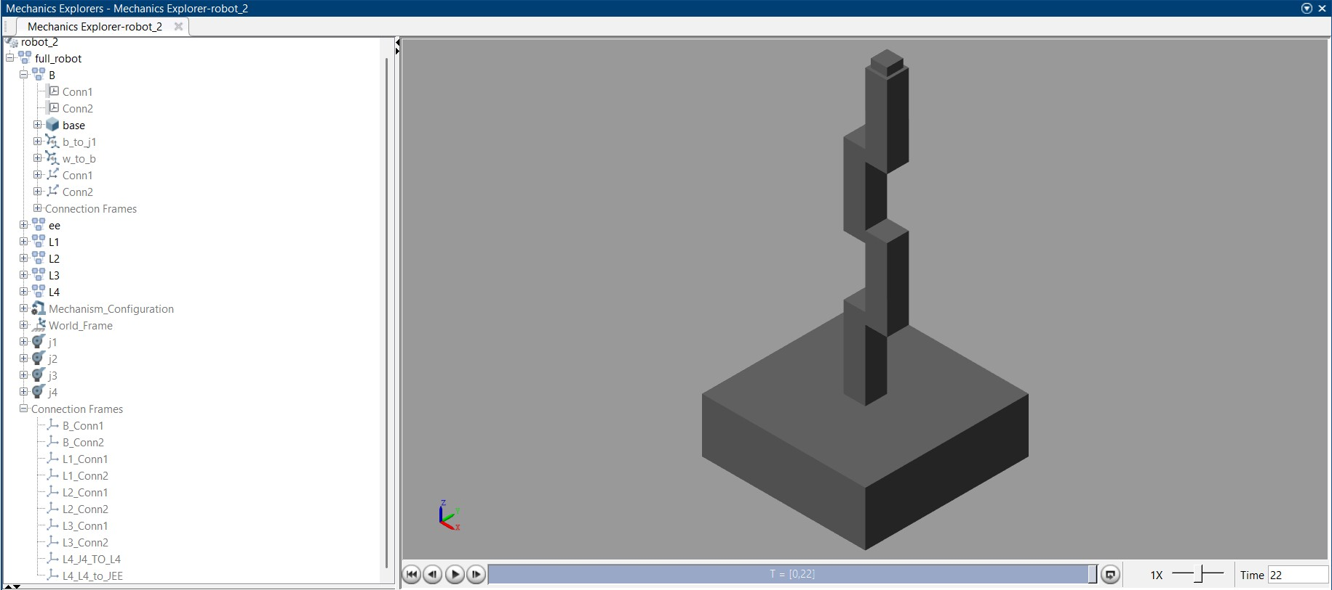
The robot structure consists of:
- Fixed Base: 1
- Moving Links: 4 (L1, L2, L3, and L4)
- Revolute Joints: 4 (J1, J2, J3, and J4)
- End Effector: 1 Painting Tool
The revolute joints provide rotational motion, enabling the end-effector to reach different positions and orientations within the workspace.

Number of Links, Joints and Degrees of Freedom
Parameter Value
Robot Type Articulated Serial Manipulator
Number of Links | 5
Number of Joints | 4 Revolute Joints
Degrees of Freedom  (DOF) | 4
Base | Fixed
End Effector | Painting Tool
Application | Automated Painting
The robot possesses four independent rotational joints, resulting in four degrees of freedom that allow positioning of the painting tool in three-dimensional space.

Task of the Robot
The primary task of the robot is automated painting. The robot receives a sequence of target coordinates and moves its end-effector along a predefined trajectory. By accurately following the specified path, the robot can paint surfaces while maintaining consistency and repeatability.
The trajectory used in this project is generated through predefined X, Y, and Z coordinate signals. These coordinates define the path that the end-effector must follow during the painting operation.

Brief Description of System Development
The robotic painting system was developed using MATLAB Simscape Multibody and Robotics Toolbox.
First, the mechanical structure of the robot was created using rigid bodies representing the base, links, and end-effector. Revolute joints were inserted between consecutive links to create a four-degree-of-freedom serial manipulator.
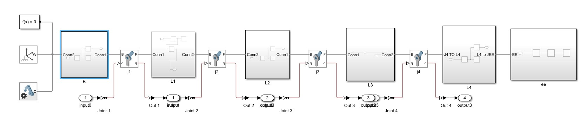
A trajectory generation module was then implemented using MATLAB Signal Editor, where X, Y, and Z coordinate signals define the desired painting path.
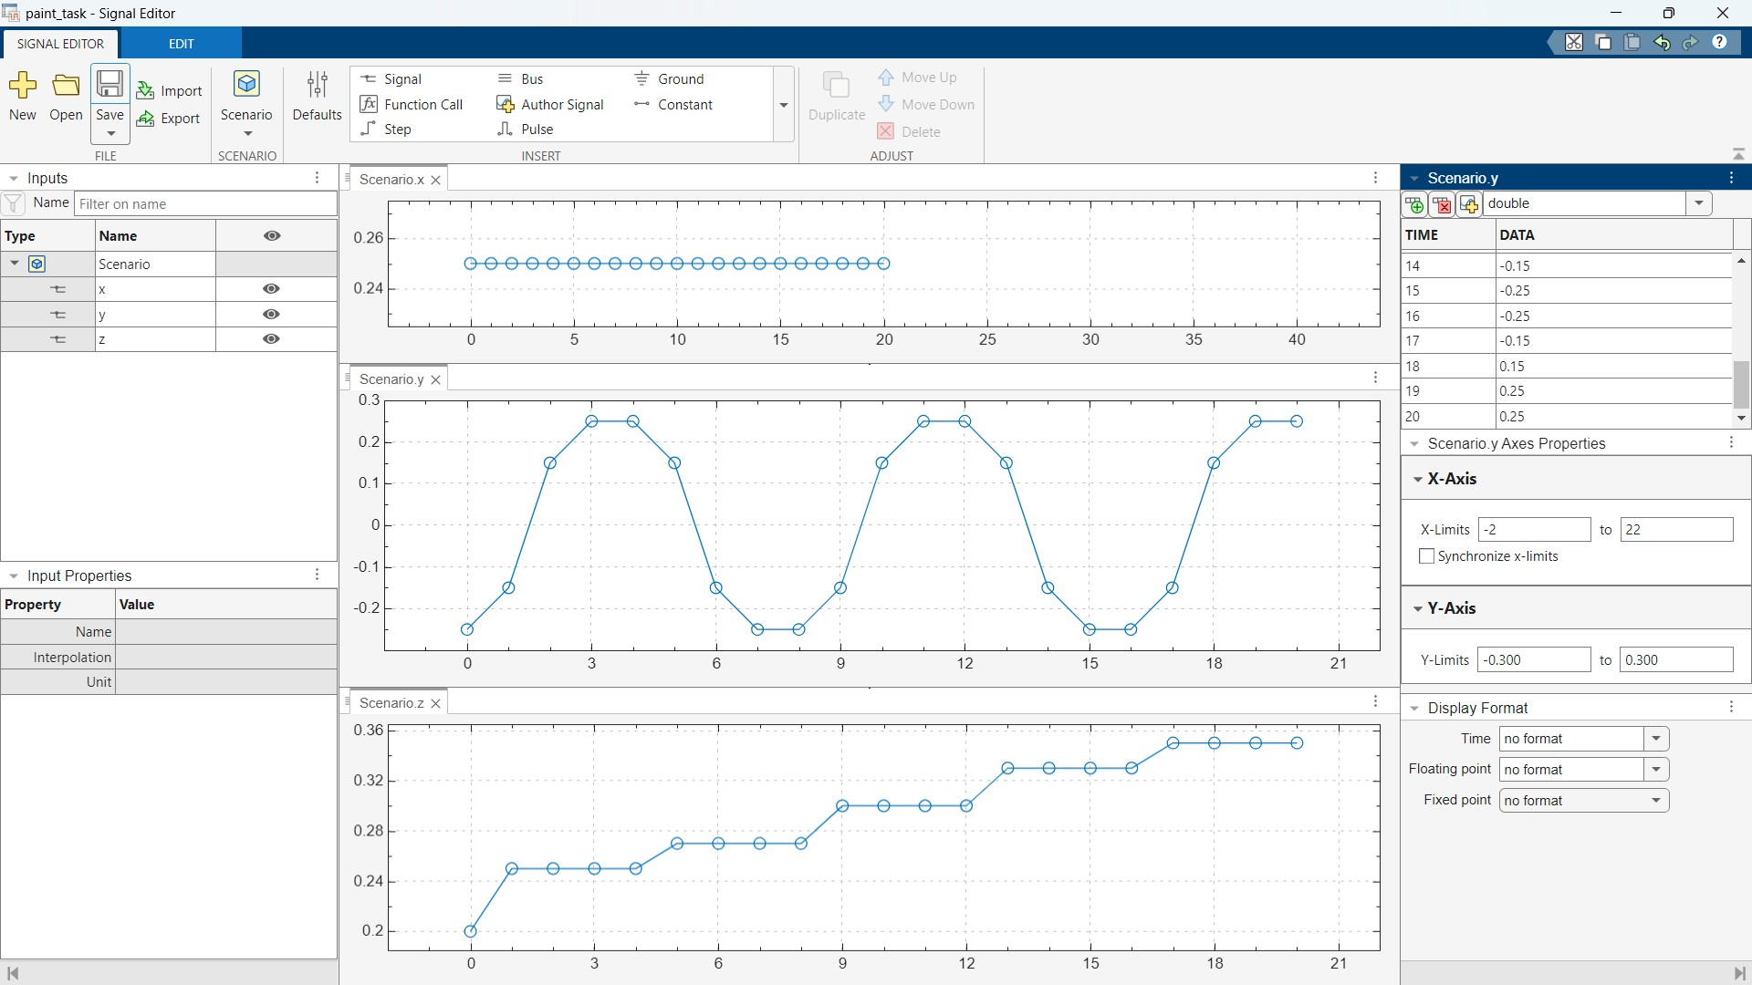
These coordinates are converted into pose information and passed to an inverse kinematics solver. The inverse kinematics block calculates the required joint angles for the manipulator to reach each target position.
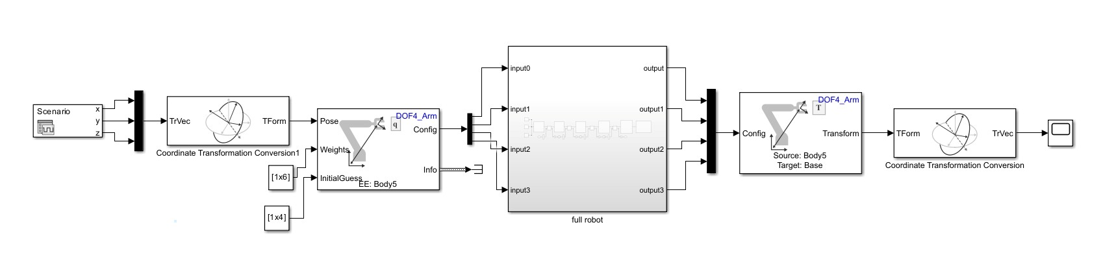
The calculated joint configurations are supplied to the Simscape robot model, causing the manipulator to move along the desired trajectory. Forward kinematics is then used to verify the resulting end-effector position and ensure accurate path tracking.

Inputs and Outputs
Inputs
- X-coordinate of target position
- Y-coordinate of target position
- Z-coordinate of target position
- Initial joint configuration
- End-effector pose requirements
Outputs
- Joint angles for J1, J2, J3, and J4
- Robot configuration
- End-effector position
- End-effector trajectory
- Simulated painting motion

Trajectory Tracking of a 4-DOF Painting Robot
