**Milestone 1 Requirements Document**

This is a Collaborative Learning Community (CLC) assignment.

One of the most important responsibilities of being a computer programmer is the ability to determine the specific requirements a business needs for the software they want you to build. Every business is unique and it is the job of the computer programmer to make sure the software to be developed meets the requirements for the company. Therefore, every project starts by consulting with the client to collect the specific requirements needed for the software that will be developed. In this assignment, your team will work together to gather the requirements for the software you will build for your enterprise.

Directions: Your team will work together to create a Requirements Document that contains all of the specific requirements needed for the inventory software you are creating for your enterprise. While every inventory software will contain similar features, it is important that you take into account the specific needs of your company and incorporate those into your software. Because the Requirements Document sets the scope for the entire project, it is essential that the Requirements Document is specific and detailed.

The requirements document should contain the following items:

1. A statement naming the business client and what particular departments and/or individuals would be using the inventory software (Human Resources, Accounting, Customer, etc.).
2. A list of questions the team will ask their client to determine the functional and non-functional system requirements.
3. Client responses to the questions.
4. The needs of the client based on the answers given.
5. Use cases (Use Case example, below)
6. A storyboard of end product. Your storyboard should show the flow of the application (e.g., user input, application output, example, below)

Create a folder in your team’s Git repository account. Call this folder CST116_InventoryProject. Create a subfolder called Milestone1. Push (submit) the following:

1. The Requirements Document
2. A ReadMe file for this milestone of your project.

In LoudCloud, each team member must submit an individual file, ReadMe_Milestone1, listing the details of your individual contribution to the project.

GCU style is not required, but solid academic writing is expected.

You are not required to submit this assignment to Turnitin.

This assignment uses a rubric. Please review the rubric prior to beginning the assignment to become familiar with the expectations for successful completion.

**Use Case Example**

The following is a use case example for a billing system. The illustration shows use cases for a user with the role of “administrator”.   
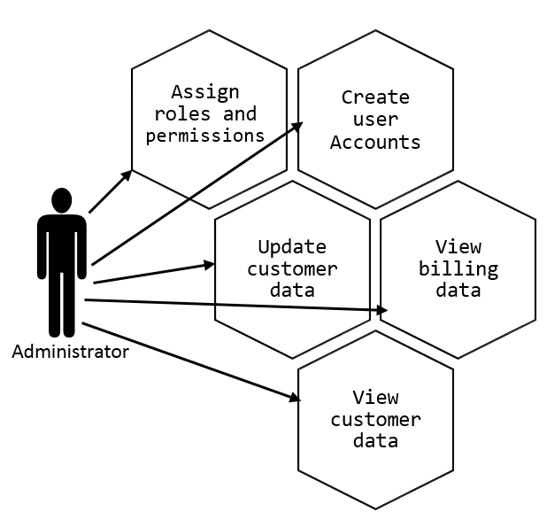

Your team should prepare use case diagrams for ALL user types.

Storyboard Example

A storyboard, sometimes called “use-case storyboard” describes (or depicts) the user interface meets serves the use case criteria; it illustrates the interaction between the user and the system. The following storyboard example illustrates one of the use-case scenarios shown above.

ADMINISTRATOR: VIEW CUSTOMER DATA

