

Faculty of Computer Studies

TM471: Graduation project

**<WorkWise>**

Elie Yammine | 190204 | April 2023

Supervisor: Dr. Khouloud Samrouth

Contents

Faculty of Computer Studies 1

TM471: Graduation project 1

Abstract 3

Chapter I: Introduction 3

The problem: 4

The solution: 4

Project Aim: 4

Modules: 5

Chapter II: Review 5

Introduction: 5

Existing Products 6

LinkedIn: 6

Glassdoor 6

Chapter III: Requirement and Analysis 7

General requirements: 7

Functional: 7

Non-functional: 7

Software, Hardware: 7

Design: 8

# Abstract

Since the dominance of the virtual world, the usage of newspaper starts to decrease, this results to the decrement of job searching via newspapers, such as in Lebanon “Al Waseet”.

A job search website is a platform that connects job seekers with potential employees. The website allows job seekers to search for job openings in many situations such as location, industry, job type, and experience level.

Job seekers can create a profile on the website, upload their resume, and apply for jobs. Employers can also create an account to post job openings and review resumes.

Job search and filtering: Job seekers can search for job openings based on various criteria such as location, industry, job title, and keywords.

# Chapter I: Introduction

A job search website should provide a user-friendly interface, effective search and filtering tool, and features that help job seekers and employers connect in a streamlined and efficient manner.

Other than registration and profile creation that we mentioned before, Job search website should have job application tracking, where job seekers can track status of their job applications, view which employers view their profile, and receive notifications when an employer has taken action on their application.

Employer features, employers can post job openings, review resumes and communicate with job seekers through the website, they may also have access to features such as applicant tracking, scheduling interviews, and messaging candidates.

Also the website should have additional resources to help job seekers with their job search, such as career advice, and job market trends.

## The problem:

Job searches in newspapers may not be very up-to-date or comprehensive. Newspapers typically have a limited amount of space to dedicate job listings, so they may only feature of small selection of job openings.

Additionally, job listings in newspapers may not be updated as frequently as online job boards or company websites.

This meant that some job openings may already be filled or no longer available by the time the newspaper is printed.

## The solution:

One solution to the problem of job searches in newspapers is for job seekers to supplement their searches with online resources. This can include using online job boards, company websites, and social media platforms to find job openings that may not be featured in newspapers. Many companies now post their job openings online, making it easier for job seekers to find and apply for relevant positions.

Online job search has been more effective solution for job seekers than newspapers, so everybody now can access to wider range of job opportunities, easy application process is that you can now apply for job listings in few clicks, (such in LinkedIn there are easy apply is used when you have already saved your CV in this app, so you can easy apply in just one click) Advanced search options, online job search platforms provide access to employer information, reviews, and ratings which can help job seekers research potential employers and make informed decisions about where to apply.

## Project Aim:

Creating a website that allows the job seekers to find their perfect job in a perfect way, the same way that the employers to post job opportunities and receive the best and qualified job seekers in the best way. This website should be designed to be user-friendly, easy to navigate, and provide job seekers with experience that matches their skills and interests with relevant job opportunities. The project should also aim to provide employers with range of tools and features to help them manage hiring process.

## Modules:

In this project, we will use php laravel as a fullstack web development framework. Basic HTML, CSS, JS and bootstrap will be used for the frontend in the blade templates.

As for the database connection, laravel makes it easy to connect to the MYSQL database very easily and the data will be manipulated by the laravel eloquent models.

# Chapter II: Review

## Introduction:

What is a website? Before we dive into technological terms, Websites are kind of like websites. Humans have eyes, ears, legs, and arms while websites have text, images, videos, and buttons. If we look deeper also, websites and humans are governed by a code. For humans, it’s our DNA. For websites, it’s HTML, HTML is a language that web browsers understand, interpret, and convert in order to display information that is understandable to users. Let’s talk about styles, most websites use CSS (Cascading Style Sheet). CSS is an intuitive shortcut that allows developers to make a change to one page and then have the rest of the website update automatically. CSS makes also the change of the colors. For example, developers can change the color palette on one page (your style sheet), and the rest of the pages will follow suit. CSS is the tool developers use to make simplified and uniform changes to a website. In addition, the websites need also servers to work and these servers require browsers such as Chrome, Firefox, Edge and can be accessed from any device such as mobile phones, computers, and tablets. Today's websites follow a certain design, so starting with the header at the top of the site, this section usually contains links to other pages besides navigation, each page of the site depends on the use of the same header, this will help.

To avoid code duplication and to make simple design that is easy to navigate and understand quickly. Text, the text of the web page, is the content that is frequently updated by each website. It can be said that each page has different, that is, its own unique content. Text can include objects, functions and information, and text. determined by the operation of the website. The footer is the same as the head, redesigned to avoid overlapping numbers, but includes external links to legal, sponsors, partners, terms of service, and privacy terms and conditions. Design for the website is recommended because now it can be accessed on mobile phones, while the old website can only be accessed on desktop and now design is needed on mobile phones as well.

After defining what is a website, now it’s time to talk about job search websites. Job search websites are platforms that allows the job seekers to search clearly for job opportunities and the job employers to post their own job requests. They offer a convenient and efficient way to connect job seekers with potential employers, they are free for job seekers improve their chances of finding employment, such as career advice articles, resume and cover letter templates, and salary information. Overall, job search websites have revolutionized the way people search for and apply to jobs, making it easier and more efficient to find employment opportunities that match their skills and interests.

Advantages:

* Wide range of job opportunities
* Time-saving
* Easy application process
* Customizable search criteria

Disadvantages:

* Limited information
* Competition
* Scams
* Limited personalization

Overall, job search website can be an excellent tool for job seekers to find job opportunities quickly and easily. It’s essential to be cautious and do your research before applying for any job postings on these websites to avoid any scams.

## Existing Products

In this section we will review different job searches websites such as LinkedIn, Glassdoor and Monster.

LinkedIn: LinkedIn is a social media platform primarily used for professional networking, job searching and career development. It allows users to create a profile that highlights their work experience, education, skills and accomplishments, and connect with other professionals in their industry and fields. Also we can add posts and share what is on our minds, search for companies, follow other users that may be an ideal for us. LinkedIn is considered one of the largest professional social networks in the world, with over 740 million registered users in more than 200 countries and territories.

For example, this following figure below shows the newsfeed of my profile of the LinkedIn’s page.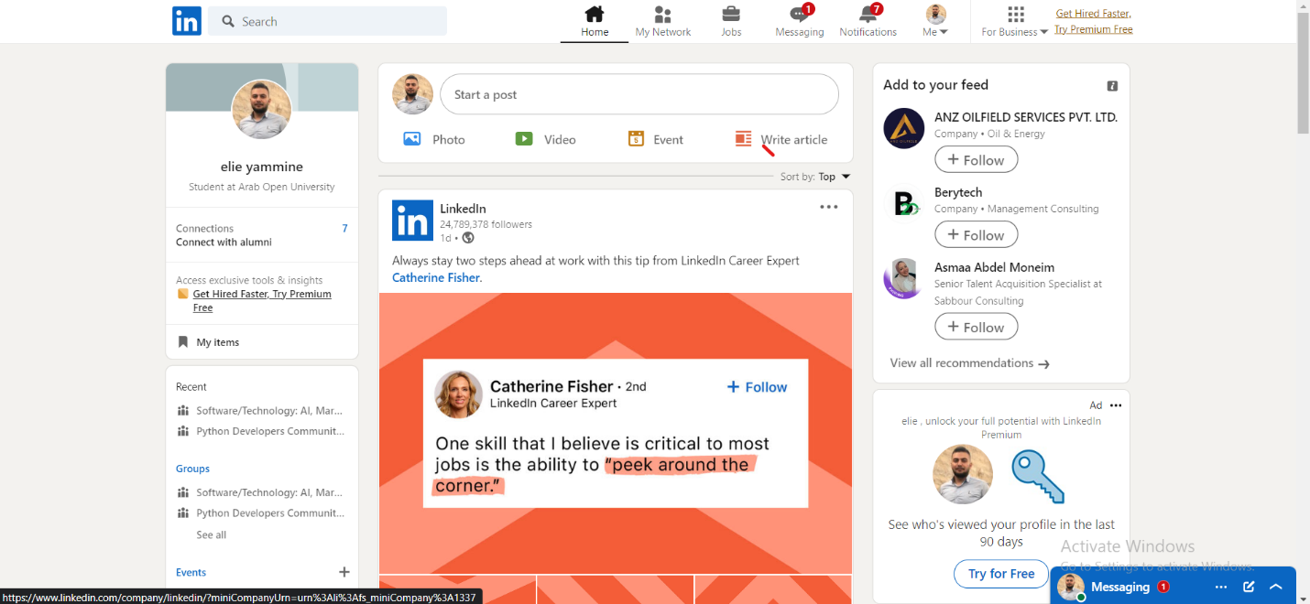

Glassdoor is also a platform for job search and career, it offers insights into companies, jobs, and salaries. It allows users to search for job listings, read company reviews and ratings, and access salary data and other information about specific employers. Glassdoor have a unique feature is company reviews, which are written anonymously by current and former employees. These reviews provide insights into the company, culture, work-life- balance, benefits, management, and more. This may help job seekers to be more informed decisions about employers. Glassdoor is a popular resource for job seekers and employers alike, with over than 55 million unique visitors per month in over than 200 countries and territories.

This is also a figure that shows the site of Glassdoor: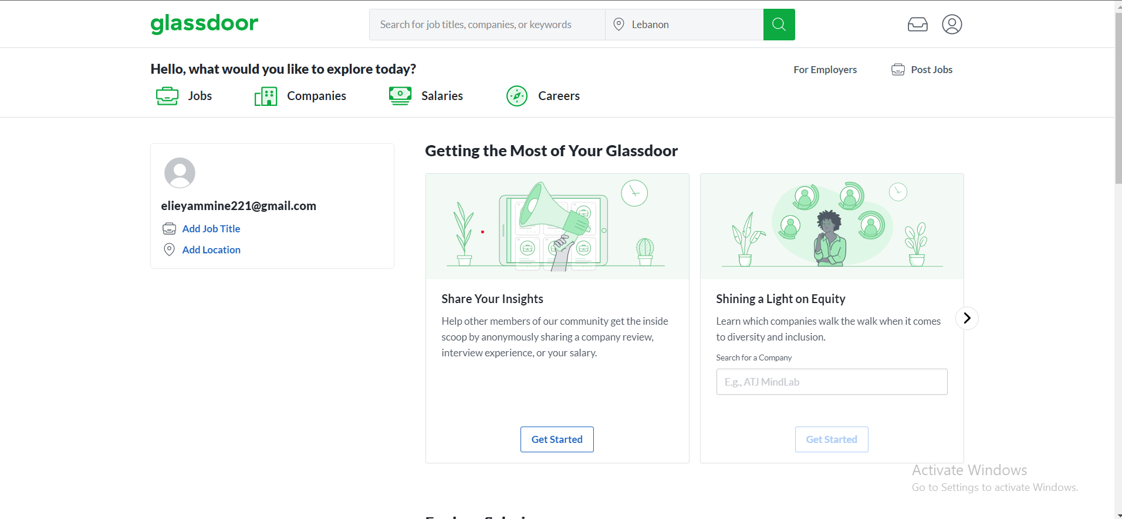

# Chapter III: Requirement and Analysis

In this section, we will show WorkWise’s features. We will also show how users can interact and permissions.

## General requirements:

### Functional:

* System allows users to register.
* System allows users to choose if they are job seekers or employers.
* System allows users to access website if they are registered only.
* System allows users to log in.
* System allows users to post job opportunities.
* System shows the username on the navigation bar.

### Non-functional:

* Easy design to use.
* Easy to learn.
* Simple to navigate between webpages.

### Software, Hardware:

* Using HTML and CSS, the most famous coding languages
* SQL for the backend.
* Visual studio will be our main program to write these languages mentioned above.
* Web browser such as Google Chrome, Microsoft Edge to test our codes and view it.
* Our PC will be Windows 11 operating system, with the use of keyboard and mouses.

## Design:

We’ll be using White Star UML to draw UML diagrams, to explain how the website works.

This figure below describes the way that the registration is being placed.

When a user registers to our website, he will be required to fill the fields like username, email, password.

Unsupported emails will not be accepted, and unsupported format for username and email.

