* [1 安装环境依赖](https://blog.csdn.net/weixin_41010198/article/details/106785253?ops_request_misc=%257B%2522request%255Fid%2522%253A%2522160730290919195283037337%2522%252C%2522scm%2522%253A%252220140713.130102334..%2522%257D&request_id=160730290919195283037337&biz_id=0&utm_medium=distribute.pc_search_result.none-task-blog-2~all~top_click~default-1-106785253.pc_search_result_no_baidu_js&utm_term=yolov5&spm=1018.2118.3001.4449" \l "1__25" \t "_self)

**本人环境声明：**

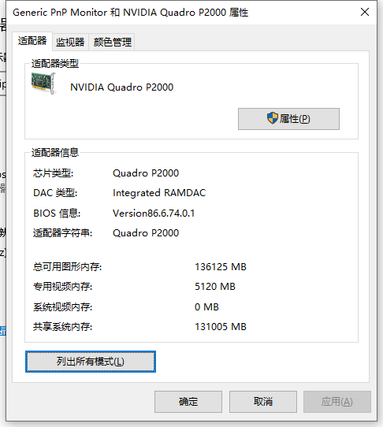

* 系统环境：Ubuntu18.04.1
* cuda版本：10.2.89
* cudnn版本：7.6.5
* pytorch版本：1.5.0
* torchvision版本：0.6.0
* 项目代码yolov5，[官网](https://github.com/ultralytics/yolov5)，项目开源的时间：20200601

subprocess.CalledProcessError: Command 'git tag' returned non-zero exit status 128.

'unzip' 不是内部或外部命令，也不是可运行的程序

urllib.error.URLError: <urlopen error [Errno 11001] getaddrinfo failed>

训练步骤

1. 改data/coco128.yaml文件：train和val以及nc和names那四行.
2. 改models/xxx.yaml（l,m,s,x）: nc
3. train.py里面选择l,m,s,x，以及配置data/coco128.yaml

同时最好是把anchors也修改为自己数据对应的anchors(需要自己提前聚类)

1. 训练口令：

python train.py --img 640 --batch 4 --epochs 1 --data ./data/coco128.yaml --cfg ./models/yolov5m.yaml --weights weights/yolov5m.pt

• --epochs：训练的epoch，默认值300

• --batch-size：默认值16

• --cfg：模型的配置文件，默认为yolov5s.yaml

• --data：数据集的配置文件，默认为data/coco128.yaml

• --weights ：预训练模型路径，默认值weights/yolov5s.pt

--cfg yolov5s.yaml --weights ''：从头开始训练

--cfg yolov5s.yaml --weights yolov5s.pt：从预训练的模型加载开始训练

(开发团队训练好的模型，用来进行迁移训练，你可以加上也可以不加，不加的话可能就是训练效果不好以及训练时长更长) 加快梯度下降的收敛速度，更有可能获得一个低模型误差，或者低泛化误差的模型，降低因未初始化或初始化不当导致的梯度消失或者梯度爆炸问题。此情况会导致模型训练速度变慢，崩溃，直至失败。其中随机初始化，可以打破对称性，从而保证不同的隐藏单元可以学习到不同的东西

训练结束后，会生成两个预训练的模型：

best.pt：保存的是中间一共比较好模型

last.pt：训练结束后保存的最后模型

1. 调用口令

python detect.py --source ./inference/images/ --weights ./runs/exp/weights/best.pt --conf 0.3

--conf-thres：对象的置信度阈值（object confidence threshold），默认值为：0.4

--save-txt ：把结果保存到\*.txt文件中

1. 可视化

训练损失（training losses）和性能指标（performance metrrics）被保存到Tensorboard和results.txt日志文件中。result.txt绘制训练完成之后的结果，保存为result.png。可以使用如下代码，绘制部分完成的results.txt

绘制代码

from utils.utils import plot\_results; plot\_results() # plot results.txt as results.png

Image(filename='./results.png', width=1000) # view results.png

1. 可视化结果分析

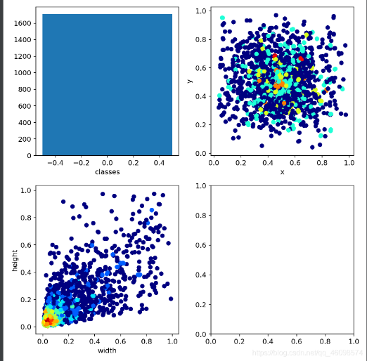

这幅图中，我们的类别只有1个，第三幅图显示了我们数据中的宽高比，归一化后，普遍在0.1左右，说明数据确实很小，也会面临模糊问题，导致数据质量降低。

Region Avg IOU：平均的IOU，代表预测的bounding box和ground truth的交集与并集之比，期望该值趋近于1。

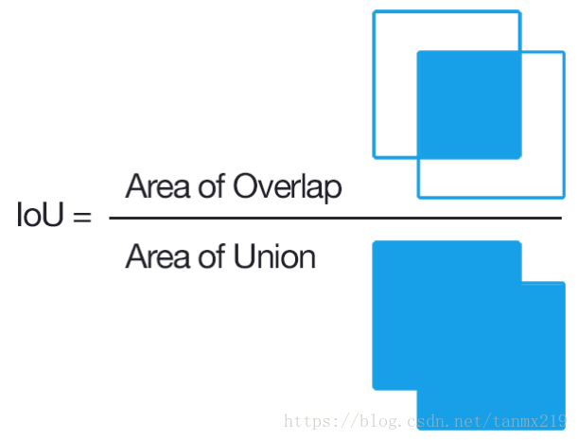

Class：是标注物体的概率，期望该值趋近于1. （找到了多少个类/共有多少个类）

Obj：期望该值趋近于1. 表示把正本判断为正本得到的平均confidence，该期望该值趋近于1.

No Obj：期望该值越来越小但不为零. 表示总confidence/总box数.

Avg Recall：期望该值趋近1

avg：平均损失，期望该值趋近于0

rate：当前学习率

Recall： 是被正确识别出来的飞机个数与测试集中所有飞机的个数的比值

AP：衡量的是学出来的模型在每个类别上的好坏

mAP：衡量的是学出的模型在所有类别上的好坏，取所有AP的平均值。

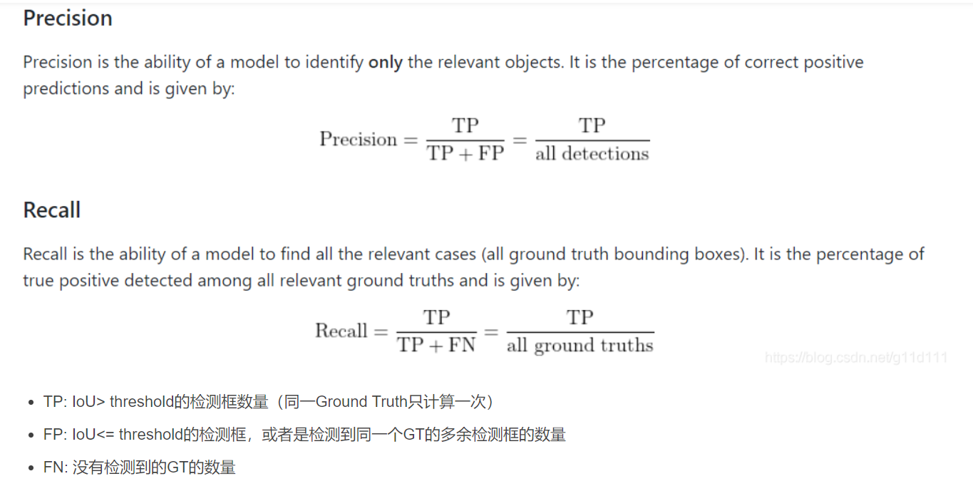

1. 优化
2. yolo对比分析

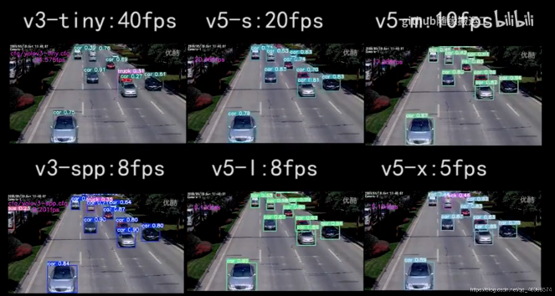

yolov5s的精度和yolov4差不多，但模型大小只有yolov4的11.77%（个人数据集，数据可能有点偏差，但还是能说明问题的）

实时对比

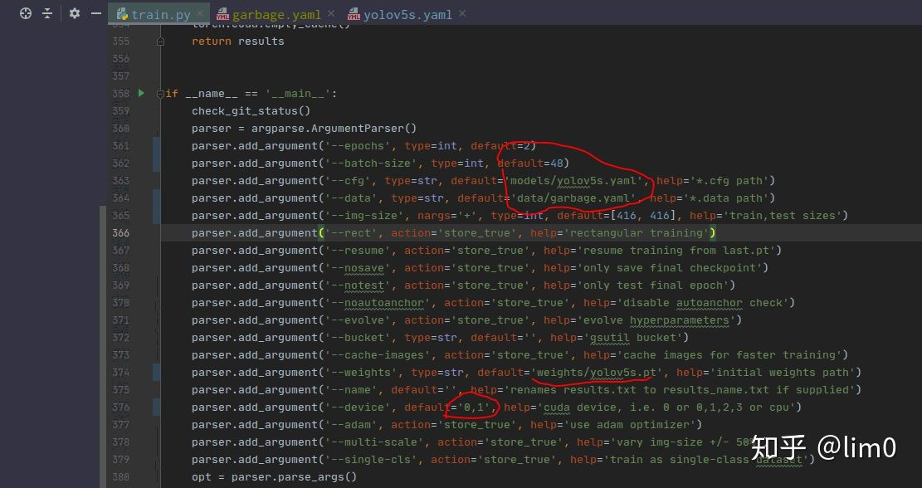

3. 改detect.py

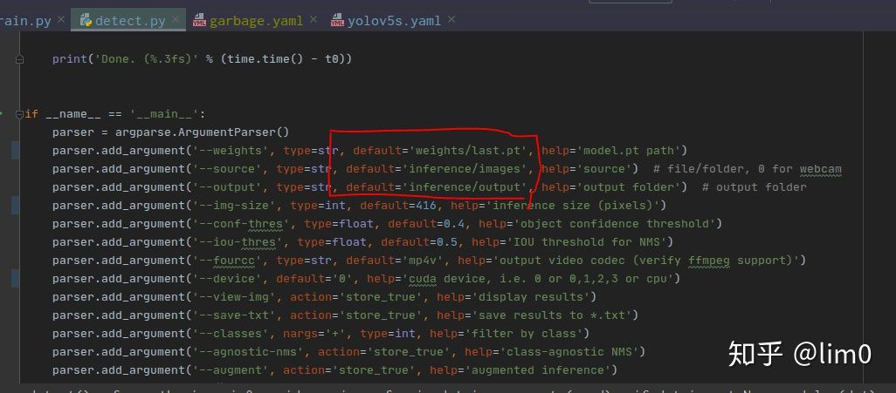

* + [1.1 克隆项目](https://blog.csdn.net/weixin_41010198/article/details/106785253?ops_request_misc=%257B%2522request%255Fid%2522%253A%2522160730290919195283037337%2522%252C%2522scm%2522%253A%252220140713.130102334..%2522%257D&request_id=160730290919195283037337&biz_id=0&utm_medium=distribute.pc_search_result.none-task-blog-2~all~top_click~default-1-106785253.pc_search_result_no_baidu_js&utm_term=yolov5&spm=1018.2118.3001.4449#11__28)
  + [1.2 安装必要的环境依赖](https://blog.csdn.net/weixin_41010198/article/details/106785253?ops_request_misc=%257B%2522request%255Fid%2522%253A%2522160730290919195283037337%2522%252C%2522scm%2522%253A%252220140713.130102334..%2522%257D&request_id=160730290919195283037337&biz_id=0&utm_medium=distribute.pc_search_result.none-task-blog-2~all~top_click~default-1-106785253.pc_search_result_no_baidu_js&utm_term=yolov5&spm=1018.2118.3001.4449#12__35)
* [2 下载预训练模型和标注的数据集](https://blog.csdn.net/weixin_41010198/article/details/106785253?ops_request_misc=%257B%2522request%255Fid%2522%253A%2522160730290919195283037337%2522%252C%2522scm%2522%253A%252220140713.130102334..%2522%257D&request_id=160730290919195283037337&biz_id=0&utm_medium=distribute.pc_search_result.none-task-blog-2~all~top_click~default-1-106785253.pc_search_result_no_baidu_js&utm_term=yolov5&spm=1018.2118.3001.4449#2__68)
  + [2.1 下载预训练模型](https://blog.csdn.net/weixin_41010198/article/details/106785253?ops_request_misc=%257B%2522request%255Fid%2522%253A%2522160730290919195283037337%2522%252C%2522scm%2522%253A%252220140713.130102334..%2522%257D&request_id=160730290919195283037337&biz_id=0&utm_medium=distribute.pc_search_result.none-task-blog-2~all~top_click~default-1-106785253.pc_search_result_no_baidu_js&utm_term=yolov5&spm=1018.2118.3001.4449#21__70)
    - [2.1.1 执行脚本下载预训练模型](https://blog.csdn.net/weixin_41010198/article/details/106785253?ops_request_misc=%257B%2522request%255Fid%2522%253A%2522160730290919195283037337%2522%252C%2522scm%2522%253A%252220140713.130102334..%2522%257D&request_id=160730290919195283037337&biz_id=0&utm_medium=distribute.pc_search_result.none-task-blog-2~all~top_click~default-1-106785253.pc_search_result_no_baidu_js&utm_term=yolov5&spm=1018.2118.3001.4449#211__72)
    - [2.1.2 直接下载预训练模型，然后保存到`/yolov5/weights`目录下即可，](https://blog.csdn.net/weixin_41010198/article/details/106785253?ops_request_misc=%257B%2522request%255Fid%2522%253A%2522160730290919195283037337%2522%252C%2522scm%2522%253A%252220140713.130102334..%2522%257D&request_id=160730290919195283037337&biz_id=0&utm_medium=distribute.pc_search_result.none-task-blog-2~all~top_click~default-1-106785253.pc_search_result_no_baidu_js&utm_term=yolov5&spm=1018.2118.3001.4449#212_yolov5weightsurl_86)
  + [2.2 下载标注的数据集](https://blog.csdn.net/weixin_41010198/article/details/106785253?ops_request_misc=%257B%2522request%255Fid%2522%253A%2522160730290919195283037337%2522%252C%2522scm%2522%253A%252220140713.130102334..%2522%257D&request_id=160730290919195283037337&biz_id=0&utm_medium=distribute.pc_search_result.none-task-blog-2~all~top_click~default-1-106785253.pc_search_result_no_baidu_js&utm_term=yolov5&spm=1018.2118.3001.4449#22__92)
    - [2.2.1 执行脚本下载](https://blog.csdn.net/weixin_41010198/article/details/106785253?ops_request_misc=%257B%2522request%255Fid%2522%253A%2522160730290919195283037337%2522%252C%2522scm%2522%253A%252220140713.130102334..%2522%257D&request_id=160730290919195283037337&biz_id=0&utm_medium=distribute.pc_search_result.none-task-blog-2~all~top_click~default-1-106785253.pc_search_result_no_baidu_js&utm_term=yolov5&spm=1018.2118.3001.4449#221__93)
    - [2.2.2 如果下载比较慢，也可以通过url链接直接下载`coco128.zip`](https://blog.csdn.net/weixin_41010198/article/details/106785253?ops_request_misc=%257B%2522request%255Fid%2522%253A%2522160730290919195283037337%2522%252C%2522scm%2522%253A%252220140713.130102334..%2522%257D&request_id=160730290919195283037337&biz_id=0&utm_medium=distribute.pc_search_result.none-task-blog-2~all~top_click~default-1-106785253.pc_search_result_no_baidu_js&utm_term=yolov5&spm=1018.2118.3001.4449#222_urlcoco128zip_211)
* [3 训练下载的coco128数据集](https://blog.csdn.net/weixin_41010198/article/details/106785253?ops_request_misc=%257B%2522request%255Fid%2522%253A%2522160730290919195283037337%2522%252C%2522scm%2522%253A%252220140713.130102334..%2522%257D&request_id=160730290919195283037337&biz_id=0&utm_medium=distribute.pc_search_result.none-task-blog-2~all~top_click~default-1-106785253.pc_search_result_no_baidu_js&utm_term=yolov5&spm=1018.2118.3001.4449#3_coco128_219)
  + [3.1 创建训练数据集的配置文件Dataset.yaml](https://blog.csdn.net/weixin_41010198/article/details/106785253?ops_request_misc=%257B%2522request%255Fid%2522%253A%2522160730290919195283037337%2522%252C%2522scm%2522%253A%252220140713.130102334..%2522%257D&request_id=160730290919195283037337&biz_id=0&utm_medium=distribute.pc_search_result.none-task-blog-2~all~top_click~default-1-106785253.pc_search_result_no_baidu_js&utm_term=yolov5&spm=1018.2118.3001.4449#31__Datasetyaml_220)
  + [3.2 创建标签（Labels）](https://blog.csdn.net/weixin_41010198/article/details/106785253?ops_request_misc=%257B%2522request%255Fid%2522%253A%2522160730290919195283037337%2522%252C%2522scm%2522%253A%252220140713.130102334..%2522%257D&request_id=160730290919195283037337&biz_id=0&utm_medium=distribute.pc_search_result.none-task-blog-2~all~top_click~default-1-106785253.pc_search_result_no_baidu_js&utm_term=yolov5&spm=1018.2118.3001.4449#32_Labels_259)
  + [3.3 组织文件结构](https://blog.csdn.net/weixin_41010198/article/details/106785253?ops_request_misc=%257B%2522request%255Fid%2522%253A%2522160730290919195283037337%2522%252C%2522scm%2522%253A%252220140713.130102334..%2522%257D&request_id=160730290919195283037337&biz_id=0&utm_medium=distribute.pc_search_result.none-task-blog-2~all~top_click~default-1-106785253.pc_search_result_no_baidu_js&utm_term=yolov5&spm=1018.2118.3001.4449#33__290)
  + [3.4 选择一个模型训练](https://blog.csdn.net/weixin_41010198/article/details/106785253?ops_request_misc=%257B%2522request%255Fid%2522%253A%2522160730290919195283037337%2522%252C%2522scm%2522%253A%252220140713.130102334..%2522%257D&request_id=160730290919195283037337&biz_id=0&utm_medium=distribute.pc_search_result.none-task-blog-2~all~top_click~default-1-106785253.pc_search_result_no_baidu_js&utm_term=yolov5&spm=1018.2118.3001.4449#34__294)
  + [3.5 开始训练](https://blog.csdn.net/weixin_41010198/article/details/106785253?ops_request_misc=%257B%2522request%255Fid%2522%253A%2522160730290919195283037337%2522%252C%2522scm%2522%253A%252220140713.130102334..%2522%257D&request_id=160730290919195283037337&biz_id=0&utm_medium=distribute.pc_search_result.none-task-blog-2~all~top_click~default-1-106785253.pc_search_result_no_baidu_js&utm_term=yolov5&spm=1018.2118.3001.4449#35__362)
  + [3.5.1 训练命令](https://blog.csdn.net/weixin_41010198/article/details/106785253?ops_request_misc=%257B%2522request%255Fid%2522%253A%2522160730290919195283037337%2522%252C%2522scm%2522%253A%252220140713.130102334..%2522%257D&request_id=160730290919195283037337&biz_id=0&utm_medium=distribute.pc_search_result.none-task-blog-2~all~top_click~default-1-106785253.pc_search_result_no_baidu_js&utm_term=yolov5&spm=1018.2118.3001.4449#351__364)
  + [3.5.2 训练常见错误1](https://blog.csdn.net/weixin_41010198/article/details/106785253?ops_request_misc=%257B%2522request%255Fid%2522%253A%2522160730290919195283037337%2522%252C%2522scm%2522%253A%252220140713.130102334..%2522%257D&request_id=160730290919195283037337&biz_id=0&utm_medium=distribute.pc_search_result.none-task-blog-2~all~top_click~default-1-106785253.pc_search_result_no_baidu_js&utm_term=yolov5&spm=1018.2118.3001.4449#352_1_398)
  + [3.5.3 训练常见错误2](https://blog.csdn.net/weixin_41010198/article/details/106785253?ops_request_misc=%257B%2522request%255Fid%2522%253A%2522160730290919195283037337%2522%252C%2522scm%2522%253A%252220140713.130102334..%2522%257D&request_id=160730290919195283037337&biz_id=0&utm_medium=distribute.pc_search_result.none-task-blog-2~all~top_click~default-1-106785253.pc_search_result_no_baidu_js&utm_term=yolov5&spm=1018.2118.3001.4449#353_2_406)
  + [3.5.4 训练常见错误3](https://blog.csdn.net/weixin_41010198/article/details/106785253?ops_request_misc=%257B%2522request%255Fid%2522%253A%2522160730290919195283037337%2522%252C%2522scm%2522%253A%252220140713.130102334..%2522%257D&request_id=160730290919195283037337&biz_id=0&utm_medium=distribute.pc_search_result.none-task-blog-2~all~top_click~default-1-106785253.pc_search_result_no_baidu_js&utm_term=yolov5&spm=1018.2118.3001.4449#354_3_413)
  + [3.6 使用tensorboard可视化结果](https://blog.csdn.net/weixin_41010198/article/details/106785253?ops_request_misc=%257B%2522request%255Fid%2522%253A%2522160730290919195283037337%2522%252C%2522scm%2522%253A%252220140713.130102334..%2522%257D&request_id=160730290919195283037337&biz_id=0&utm_medium=distribute.pc_search_result.none-task-blog-2~all~top_click~default-1-106785253.pc_search_result_no_baidu_js&utm_term=yolov5&spm=1018.2118.3001.4449#36_tensorboard_421)
  + [3.7 测试](https://blog.csdn.net/weixin_41010198/article/details/106785253?ops_request_misc=%257B%2522request%255Fid%2522%253A%2522160730290919195283037337%2522%252C%2522scm%2522%253A%252220140713.130102334..%2522%257D&request_id=160730290919195283037337&biz_id=0&utm_medium=distribute.pc_search_result.none-task-blog-2~all~top_click~default-1-106785253.pc_search_result_no_baidu_js&utm_term=yolov5&spm=1018.2118.3001.4449#37__435)
* [4 训练自己的数据集](https://blog.csdn.net/weixin_41010198/article/details/106785253?ops_request_misc=%257B%2522request%255Fid%2522%253A%2522160730290919195283037337%2522%252C%2522scm%2522%253A%252220140713.130102334..%2522%257D&request_id=160730290919195283037337&biz_id=0&utm_medium=distribute.pc_search_result.none-task-blog-2~all~top_click~default-1-106785253.pc_search_result_no_baidu_js&utm_term=yolov5&spm=1018.2118.3001.4449#4__458)
  + [4.1 准备数据集](https://blog.csdn.net/weixin_41010198/article/details/106785253?ops_request_misc=%257B%2522request%255Fid%2522%253A%2522160730290919195283037337%2522%252C%2522scm%2522%253A%252220140713.130102334..%2522%257D&request_id=160730290919195283037337&biz_id=0&utm_medium=distribute.pc_search_result.none-task-blog-2~all~top_click~default-1-106785253.pc_search_result_no_baidu_js&utm_term=yolov5&spm=1018.2118.3001.4449#41__464)
  + [4.2 修改数据和模型配置文件](https://blog.csdn.net/weixin_41010198/article/details/106785253?ops_request_misc=%257B%2522request%255Fid%2522%253A%2522160730290919195283037337%2522%252C%2522scm%2522%253A%252220140713.130102334..%2522%257D&request_id=160730290919195283037337&biz_id=0&utm_medium=distribute.pc_search_result.none-task-blog-2~all~top_click~default-1-106785253.pc_search_result_no_baidu_js&utm_term=yolov5&spm=1018.2118.3001.4449#42__507)
    - [4.2.1 修改数据配置文件](https://blog.csdn.net/weixin_41010198/article/details/106785253?ops_request_misc=%257B%2522request%255Fid%2522%253A%2522160730290919195283037337%2522%252C%2522scm%2522%253A%252220140713.130102334..%2522%257D&request_id=160730290919195283037337&biz_id=0&utm_medium=distribute.pc_search_result.none-task-blog-2~all~top_click~default-1-106785253.pc_search_result_no_baidu_js&utm_term=yolov5&spm=1018.2118.3001.4449#421__508)
    - [4.2.2 修改模型配置文件](https://blog.csdn.net/weixin_41010198/article/details/106785253?ops_request_misc=%257B%2522request%255Fid%2522%253A%2522160730290919195283037337%2522%252C%2522scm%2522%253A%252220140713.130102334..%2522%257D&request_id=160730290919195283037337&biz_id=0&utm_medium=distribute.pc_search_result.none-task-blog-2~all~top_click~default-1-106785253.pc_search_result_no_baidu_js&utm_term=yolov5&spm=1018.2118.3001.4449#422__593)
  + [4.3 训练自己的数据集](https://blog.csdn.net/weixin_41010198/article/details/106785253?ops_request_misc=%257B%2522request%255Fid%2522%253A%2522160730290919195283037337%2522%252C%2522scm%2522%253A%252220140713.130102334..%2522%257D&request_id=160730290919195283037337&biz_id=0&utm_medium=distribute.pc_search_result.none-task-blog-2~all~top_click~default-1-106785253.pc_search_result_no_baidu_js&utm_term=yolov5&spm=1018.2118.3001.4449#43__654)
  + [4.3.1 使用yolovs.pt预训练模型进行训练](https://blog.csdn.net/weixin_41010198/article/details/106785253?ops_request_misc=%257B%2522request%255Fid%2522%253A%2522160730290919195283037337%2522%252C%2522scm%2522%253A%252220140713.130102334..%2522%257D&request_id=160730290919195283037337&biz_id=0&utm_medium=distribute.pc_search_result.none-task-blog-2~all~top_click~default-1-106785253.pc_search_result_no_baidu_js&utm_term=yolov5&spm=1018.2118.3001.4449#431_yolovspt_655)
    - [4.3.2 使用yolov5l.pt预训练模型进行训练](https://blog.csdn.net/weixin_41010198/article/details/106785253?ops_request_misc=%257B%2522request%255Fid%2522%253A%2522160730290919195283037337%2522%252C%2522scm%2522%253A%252220140713.130102334..%2522%257D&request_id=160730290919195283037337&biz_id=0&utm_medium=distribute.pc_search_result.none-task-blog-2~all~top_click~default-1-106785253.pc_search_result_no_baidu_js&utm_term=yolov5&spm=1018.2118.3001.4449#432_yolov5lpt_683)
  + [4.4 使用训练好的预训练模型进行测试](https://blog.csdn.net/weixin_41010198/article/details/106785253?ops_request_misc=%257B%2522request%255Fid%2522%253A%2522160730290919195283037337%2522%252C%2522scm%2522%253A%252220140713.130102334..%2522%257D&request_id=160730290919195283037337&biz_id=0&utm_medium=distribute.pc_search_result.none-task-blog-2~all~top_click~default-1-106785253.pc_search_result_no_baidu_js&utm_term=yolov5&spm=1018.2118.3001.4449#44__692)
  + [4.5 在Tensorbaord上查看数据的训练过程中的一些指标](https://blog.csdn.net/weixin_41010198/article/details/106785253?ops_request_misc=%257B%2522request%255Fid%2522%253A%2522160730290919195283037337%2522%252C%2522scm%2522%253A%252220140713.130102334..%2522%257D&request_id=160730290919195283037337&biz_id=0&utm_medium=distribute.pc_search_result.none-task-blog-2~all~top_click~default-1-106785253.pc_search_result_no_baidu_js&utm_term=yolov5&spm=1018.2118.3001.4449#45_Tensorbaord_718)
* [5 推理测试](https://blog.csdn.net/weixin_41010198/article/details/106785253?ops_request_misc=%257B%2522request%255Fid%2522%253A%2522160730290919195283037337%2522%252C%2522scm%2522%253A%252220140713.130102334..%2522%257D&request_id=160730290919195283037337&biz_id=0&utm_medium=distribute.pc_search_result.none-task-blog-2~all~top_click~default-1-106785253.pc_search_result_no_baidu_js&utm_term=yolov5&spm=1018.2118.3001.4449#5__733)
  + [5.1 图像推理测试](https://blog.csdn.net/weixin_41010198/article/details/106785253?ops_request_misc=%257B%2522request%255Fid%2522%253A%2522160730290919195283037337%2522%252C%2522scm%2522%253A%252220140713.130102334..%2522%257D&request_id=160730290919195283037337&biz_id=0&utm_medium=distribute.pc_search_result.none-task-blog-2~all~top_click~default-1-106785253.pc_search_result_no_baidu_js&utm_term=yolov5&spm=1018.2118.3001.4449#51__782)
  + [5.2 目录推理测试](https://blog.csdn.net/weixin_41010198/article/details/106785253?ops_request_misc=%257B%2522request%255Fid%2522%253A%2522160730290919195283037337%2522%252C%2522scm%2522%253A%252220140713.130102334..%2522%257D&request_id=160730290919195283037337&biz_id=0&utm_medium=distribute.pc_search_result.none-task-blog-2~all~top_click~default-1-106785253.pc_search_result_no_baidu_js&utm_term=yolov5&spm=1018.2118.3001.4449#52__795)
  + [5.3 视频推理测试](https://blog.csdn.net/weixin_41010198/article/details/106785253?ops_request_misc=%257B%2522request%255Fid%2522%253A%2522160730290919195283037337%2522%252C%2522scm%2522%253A%252220140713.130102334..%2522%257D&request_id=160730290919195283037337&biz_id=0&utm_medium=distribute.pc_search_result.none-task-blog-2~all~top_click~default-1-106785253.pc_search_result_no_baidu_js&utm_term=yolov5&spm=1018.2118.3001.4449#53__807)
  + [5.4 网络摄像头推理测试](https://blog.csdn.net/weixin_41010198/article/details/106785253?ops_request_misc=%257B%2522request%255Fid%2522%253A%2522160730290919195283037337%2522%252C%2522scm%2522%253A%252220140713.130102334..%2522%257D&request_id=160730290919195283037337&biz_id=0&utm_medium=distribute.pc_search_result.none-task-blog-2~all~top_click~default-1-106785253.pc_search_result_no_baidu_js&utm_term=yolov5&spm=1018.2118.3001.4449#54__822)
  + [5.5 http流推理测试](https://blog.csdn.net/weixin_41010198/article/details/106785253?ops_request_misc=%257B%2522request%255Fid%2522%253A%2522160730290919195283037337%2522%252C%2522scm%2522%253A%252220140713.130102334..%2522%257D&request_id=160730290919195283037337&biz_id=0&utm_medium=distribute.pc_search_result.none-task-blog-2~all~top_click~default-1-106785253.pc_search_result_no_baidu_js&utm_term=yolov5&spm=1018.2118.3001.4449#55_http_825)
  + [5.6 rtsp流推理测试](https://blog.csdn.net/weixin_41010198/article/details/106785253?ops_request_misc=%257B%2522request%255Fid%2522%253A%2522160730290919195283037337%2522%252C%2522scm%2522%253A%252220140713.130102334..%2522%257D&request_id=160730290919195283037337&biz_id=0&utm_medium=distribute.pc_search_result.none-task-blog-2~all~top_click~default-1-106785253.pc_search_result_no_baidu_js&utm_term=yolov5&spm=1018.2118.3001.4449#56_rtsp_828)
* [6 可视化](https://blog.csdn.net/weixin_41010198/article/details/106785253?ops_request_misc=%257B%2522request%255Fid%2522%253A%2522160730290919195283037337%2522%252C%2522scm%2522%253A%252220140713.130102334..%2522%257D&request_id=160730290919195283037337&biz_id=0&utm_medium=distribute.pc_search_result.none-task-blog-2~all~top_click~default-1-106785253.pc_search_result_no_baidu_js&utm_term=yolov5&spm=1018.2118.3001.4449#6__842)
  + [6.1 训练的模型的测试表现可视化](https://blog.csdn.net/weixin_41010198/article/details/106785253?ops_request_misc=%257B%2522request%255Fid%2522%253A%2522160730290919195283037337%2522%252C%2522scm%2522%253A%252220140713.130102334..%2522%257D&request_id=160730290919195283037337&biz_id=0&utm_medium=distribute.pc_search_result.none-task-blog-2~all~top_click~default-1-106785253.pc_search_result_no_baidu_js&utm_term=yolov5&spm=1018.2118.3001.4449#61__844)
  + [6.2 训练损失和性能指标视化](https://blog.csdn.net/weixin_41010198/article/details/106785253?ops_request_misc=%257B%2522request%255Fid%2522%253A%2522160730290919195283037337%2522%252C%2522scm%2522%253A%252220140713.130102334..%2522%257D&request_id=160730290919195283037337&biz_id=0&utm_medium=distribute.pc_search_result.none-task-blog-2~all~top_click~default-1-106785253.pc_search_result_no_baidu_js&utm_term=yolov5&spm=1018.2118.3001.4449#62__862)

开发团队给了四个模型，这四个模型的效果如下所示：

yolov5官方的预训练权重是基于FP16的，训练的时候使用的是FP32，此处储存空间就增加了一倍；同时官方预训练权重是不包含optimizer参数的，而我们训练的时候是把optimizer参数保存了的，这个可以打印出来看一下，所以最终我们训练的权重比预训练权重大很多。速度越慢，fps越高，模型越大，ap值就越大，准确度就越高，你要根据你的应用场景去选择。

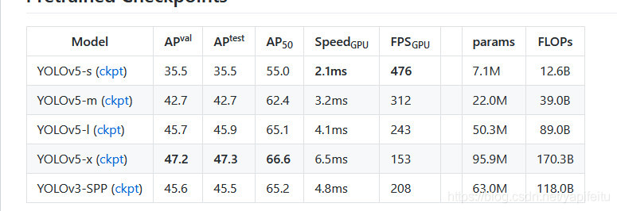

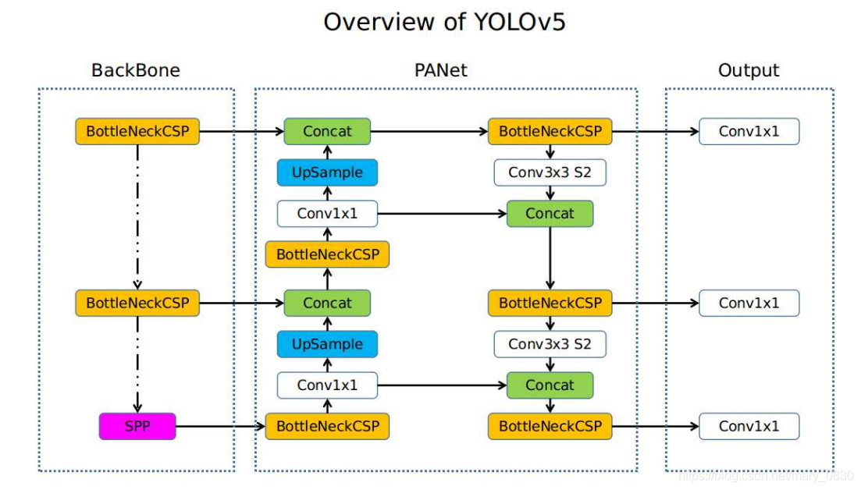

深度学习中经常看到epoch、 iteration和batchsize，下面按自己的理解说说这三个的区别：

（1）batchsize：批大小。在深度学习中，一般采用SGD训练，即每次训练在训练集中取batchsize个样本训练；  
（2）iteration：1个iteration等于使用batchsize个样本训练一次；  
（3）epoch：1个epoch等于使用训练集中的全部样本训练一次；

举个例子，训练集有1000个样本，batchsize=10，那么：  
训练完整个样本集需要：  
100次iteration，1次epoch。

引入学习率衰减的定义（训练神经网络时一般需要调整学习率，随着epoch的增加，学习率不断衰减），学习率如果太大，容易发生震荡，此时需要调小学习率，如果学习率太小，则训练的时间太长。学习率衰减yolov5中采用余弦退火方式。

学习率：https://zhuanlan.zhihu.com/p/93624972

