Problem Chosen  A | 2024  MCM/ICM  Summary Sheet | Team Control Number  2417904
Title
Summary
The summary is here!

Keywords: keyword1; keyword2; keyword3; keyword4

Contents最后本页点左上角的更新目录
1 Introduction 3
1.1 Background 3
1.2 Restatement of the Problem 3
1.3 Literature Review 3
1.4 Our Work 4
2 Assumptions and Justifications 4
3 Notations 5
4 Model Ⅰ：XXXX Model 5
4.1 abc 6
4.1.1 abc 7
4.2 Result of model Ⅰ 7
5 Model Ⅱ：XXXX Model 7
6 Model Ⅲ：XXXX Model 7
7 Sensitivity Analysis 7
8 Strengths and Weaknesses 8
8.1 Strengths 8
8.2 Weaknesses 9
References 10
Appendices 11

Introduction

Background
Taking a sightseeing submarine for sightseeing is an interesting and adventurous activity. Passengers can reach the bottom of the sea and appreciate some unusual scenery by taking a sightseeing submarine. However, this activity has both opportunities and risks. When a mechanical failure occurs, the situation can become very dangerous. To enhance the safety of submarine sightseeing, we can provide guiding suggestions for the safe operation and rescue of submarines through mathematical modeling methods.
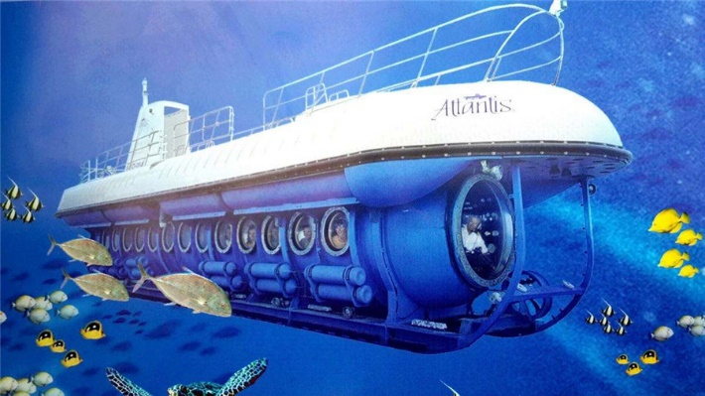
Figure 1-1: A picture of a typical sightseeing submarine

Restatement of the Problem
Based on our understanding of submarines and the information we have found, combined with the requirements of the problems, the question can be restated as follows:
- Problem 1
- Considering various interference factors, establish a model to predict the position of the submarine.
- Based on the established model, evaluate what information the submarine should regularly send to the main ship.
- Problem 2
- By investigating and evaluating the advantages and disadvantages of various search devices, decide which devices should be installed on the main ship.
- Evaluate what other equipment should be carried on the rescue ship.
- Problem 3
- Develop a model to evaluate the best deployment method for search equipment.
- Analyze the probability of finding the submarine.
- Problem 4
- Apply the model to the situation with multiple submarines.
- Apply the model to different sea areas.

Our Work
To establish a location prediction model suitable for submarines, we conducted the following work:
- Problem 1
  - First, we mathematically modeled the underwater terrain. Then, by analyzing the underwater terrain and other factors affecting ocean currents, we developed a model for ocean current generation.
  - In addition, we have modeled the ocean density profile, considering that the density of seawater may influence the dynamic characteristics of the submarine.
  - Combining the above two models, a five-degree-of-freedom dynamics model of a submarine is developed.
- Problem 2
- First, we gathered relevant information about several typical search devices, such as search range, purchase cost, and maintenance cost.
- Then, we constructed a multi-objective planning model and utilized this model to assess the advantages and disadvantages of each device. Finally, based on the results derived from the model, we determined which devices should be deployed on the main ship.
- Problem 3
- First, we obtain the coordinates of the submarine based on the previously established position prediction model, then perform multiple simulations to get the points where the probability of the submarine’s location is the highest.
- We then use the minimum spanning tree to find the shortest path to traverse these points, and then use the genetic algorithm to iterate to find the optimal rescue path.
- Problem 4
- FUCK
- We adjust the parameters related to sea conditions in the position prediction model to match different sea areas. In addition, by changing the parameters, we also conducted a sensitivity analysis to demonstrate the accuracy and reliability of our model.

Assumptions and Justifications
- Assumption 1: The direction of the velocity of the ocean currents remains constant over a short period.
- Justification: Ocean current is a large-scale geographical phenomenon, where their velocity and direction can be considered as constant over short periods and smaller spatial scales.
- Assumption 2: The rescue helicopter has a certain search range, and once the submarine enters this range, it can definitely be found.
- Justification: Doing this can effectively simplify the model and avoid the occurrence of too many uncertain factors.

Notations
The primary notations used in this paper are listed in this following table.
Notations
Symbol | Description | Unit

Task 1: Submarine Position Prediction
To establish the submarine position prediction model, these following models are established:

Underwater Terrain Model
The ocean floor exhibits complex topographical features, including dramatic variations, undulations, and irregularly sized and patterned terrains such as underwater reef clusters and sand ridges. At the same time, there are also areas where the topographical changes are relatively minor and the seafloor is relatively simple, such as flat seabed. This section focuses on the mathematical modeling of four typical seafloor terrains: uphill, downhill, convex, and concave terrains[a].
Through mathematical analysis, these representative terrains can be expressed by the following mathematical formulas:
$$h=\left\{\begin{aligned}&h_{0} x≤x_{1} \\ &h_{0}+0.5h_{1}\left(1+tanh\left(3.6×\frac{x-x_{1}-\frac{s_{1}}{2}}{s_{1}}\right)\right){ x}_{1}≤x≤x_{1}+s_{1} \\ &h_{0}+h_{1} x>x_{1}+s_{1}\end{aligned}\right.$$ | ()

$$h=\left\{\begin{aligned}&h_{2} +h_{3} x≤x_{2} \\ &h_{2}-0.5h_{3}\left(1+tanh\left(3.6×\frac{x-x_{2}-\frac{s_{2}}{2}}{s_{2}}\right)\right){ x}_{2}<x≤x_{2}+s_{2} \\ &h_{2} x>x_{2}+s_{2}\end{aligned}\right.$$ | ()
In formula (1)and (2), $h_{2}$ represents the height of the slope top, $h_{3}$ represents the height of the slope top relative to the slope bottom, $x_{2}$ represents the horizontal coordinate at the start of the downhill, and $s_{2}$ represents the difference between the horizontal coordinate at the end of the downhill and the horizontal coordinate at the start of the downhill, this value represents the width of the downhill.

$$h=\left\{\begin{aligned}&h_{4} x≤x_{3} \\ &h_{4}+0.5h_{5}\left(1+tanh\left(3.6×\frac{x-x_{3}-\frac{s_{3}}{2}}{s_{3}}\right)\right){ x}_{3}<x≤x_{3}+s_{3} \\ &h_{4}+0.5h_{5}\left(1+tanh\left(3.6×\frac{x-x_{3}-\frac{s_{3}}{2}}{s_{3}}\right)\right){ x}_{3}+s_{3}<x≤x_{3}+s_{3}+l \\ &h_{4}+0.5h_{5}\left(1-tanh\left(3.6×\frac{x-x_{3}-\frac{3s_{3}}{2}}{s_{3}}\right)\right) x_{3}+s_{3}+l<x≤x_{3}+2s_{3}+l \\ &h_{4} x>x_{3}+2s_{3}+l\end{aligned}\right.$$ | ()
In formula (3), $h_{4}$ represents the height before the start or after the end of the protrusion. The parameter $h_{5}$ represents the height of the top of the protrusion relative to the bottom of the protrusion, and $x_{3}$ represents the x-coordinate at the start of the protrusion, $s_{3}$ represents the difference between the x-coordinate at the highest point of the protrusion and the x-coordinate at the start of the protrusion. l represents the length of the protruding part.
$$h=\left\{\begin{aligned}&h_{6} x≤x_{4} \\ &h_{6}+0.5h_{7}\left(1-tanh\left(3.6×\frac{x-x_{4}-\frac{s_{4}}{2}}{s_{4}}\right)\right){ x}_{4}<x≤x_{4}+s_{4} \\ &h_{6}+0.5h_{7}\left(1-tanh\left(3.6×\frac{x-x_{4}-\frac{s_{4}}{2}}{s_{4}}\right)\right){ x}_{4}+s_{4}<x≤x_{4}+s_{4}+l \\ &h_{6}+0.5h_{7}\left(1+tanh\left(3.6×\frac{x-x_{4}-\frac{{3s}_{4}}{2}}{s_{4}}\right)\right) x_{4}+s_{4}+l<x≤x_{4}+2s_{4}+l \\ &h_{6} x>x_{4}+2s_{4}+l\end{aligned}\right.$$ | ()
In formula (4), $h_{6}$ represents the height before the start or after the end of the protrusion and concave terrain. The x-coordinates at the start of the concave terrain are represented by $x_{4}$. $s_{4}$ is defined as the width of the uphill or downhill in the concave terrain. Lastly, l is used to represent the length of the protruding part and the concave part.
Finally, by setting these aforementioned parameters, we can get these four possible terrain graphs:
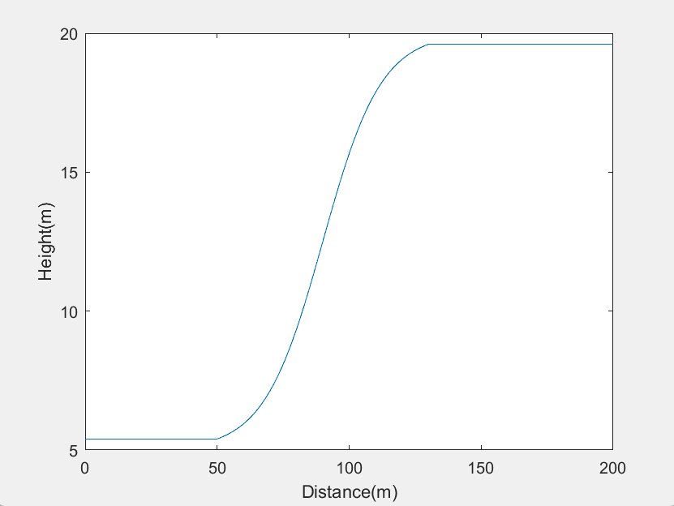  uphill | 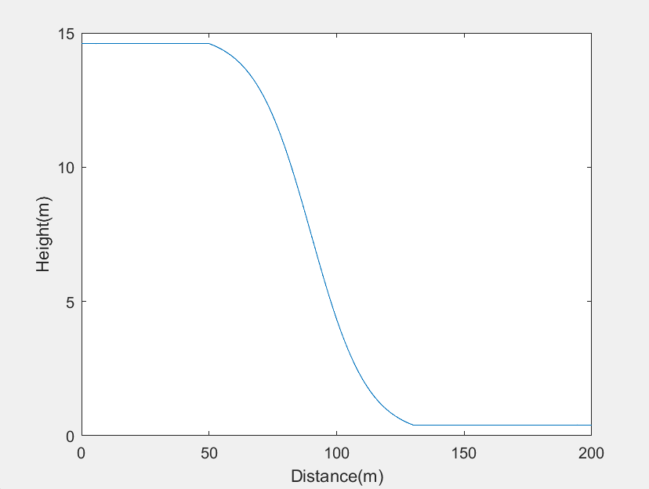  downhill
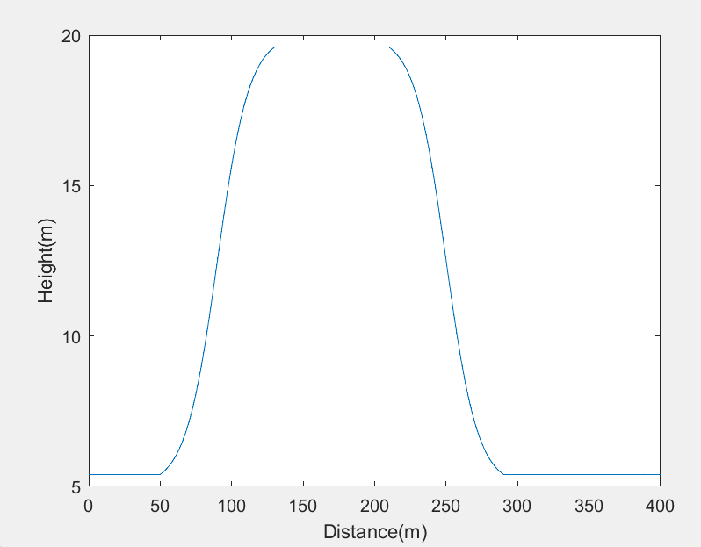  convex | 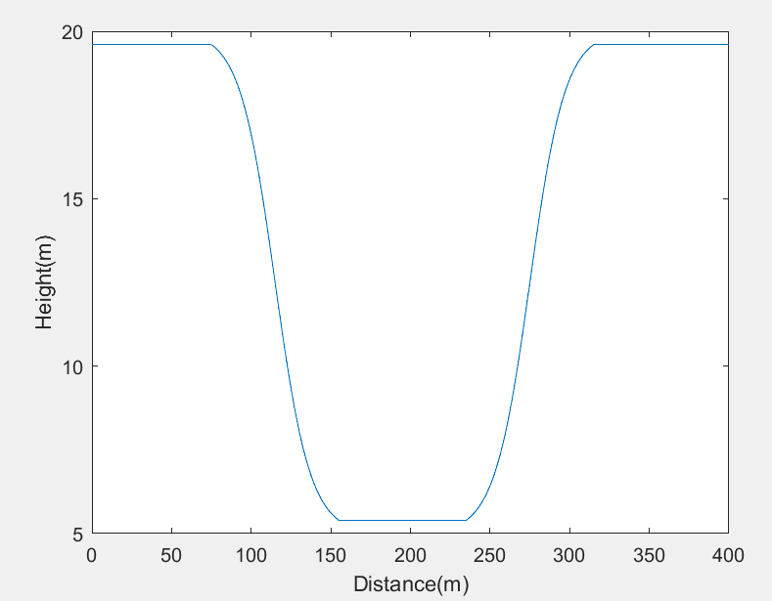  concave
Figure 4-1: Four different terrain patterns

Overall, the seabed terrain model constructed in this section can help us understand the height of seawater from the seabed, laying the foundation for the establishment of the ocean current generation model in the next section.

Ocean Density Profile Model
The characteristic of seawater density stratification is a factor that cannot be ignored in the ocean[b]. When the seawater density stratification is strong, submarines may encounter difficulties and dangers when they want to sink or float, which may have a significant impact on the navigation and safety of the submarine[E].
The existing seawater density model mainly considers the effects of temperature, salinity, and depth on the change in seawater density[F]. In this model, because the area of the sea we need to consider when the submarine is missing is not large, the difference in temperature and salinity is very small, but the depth of the submarine may change greatly. In view of this, this section revolves around ocean depth, based on the hyperbolic tangent model, an improved and efficient small-scale ocean density profile calculation model is proposed.
Based on the stratification characteristics of seawater density, the existing models often use the hyperbolic tangent function to simulate the ocean density profile model [g]. In addition, we have also introduced two parameters, the density stratification depth and the density stratification thickness, to describe the characteristics of the density stratification, making the model more widely applicable and able to simulate more complex hydrological environments. The model can be expressed as this following formula:
$$ρ(h)=\overline{ρ}-\frac{Δρ}{2}tanh(\frac{h-h_{str}}{d_{str}})$$ | ()
In this formula, $\overline{ρ}$ represents the density of sea water, $Δρ$ is the difference of density stratification. $h_{str}$ is the depth of density stratification, $d_{str}$ stands for the thickness of density stratification.
When the average density ρ = 1025.25 kg/m³, the stratification density difference Δρ = 6.5 kg/m³, the stratification depth $h_{str}$= 10m, the stratification thickness $d_{str}$= 200m, and when the stratification depth $h_{str}$= 300m, the stratification thickness $d_{str}$= 350m, the density-depth image is simulated through Python as shown in the figure.
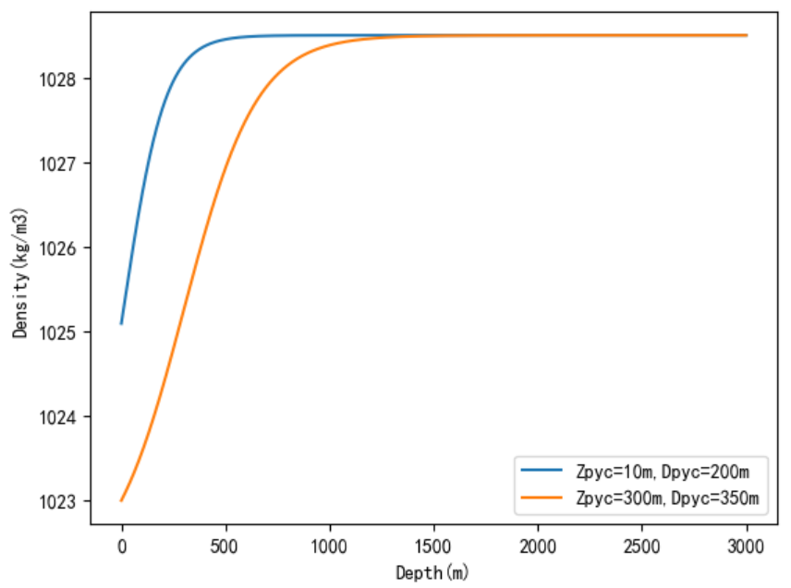
Figure 4-2: The density-depth graph
The curve finally simulated is basically consistent with the average ocean density curve provided in [g] in summer, which proves the effectiveness of our model.
By using the characteristic parameters of seawater density distribution to analytically describe the seawater density distribution, it can provide convenience for the measurement of ocean density at the location of the submarine, thereby providing the possibility for the establishment of the submarine's dynamics equation.

Ocean Current Generation Model
In this section, we focus on modeling how ocean currents are generated in the ocean.
The magnitude of ocean currents in the real world is highly intricate, influenced by various environmental factors such as wind speed, temperature, and Seabed topography. Their speeds rang from just a few centimeters per second in most locations to 1–2 meters per second in specific areas [l].
In the absence of detailed hydrological features of the sea area, most scholars treat ocean currents as steady and uniform flows when studying the mathematical model of underwater vehicle motion. In other words, the size and direction of the ocean current do not change with the change of time and spatial point position. The main factors affecting the ocean current are wind speed, sea water depth, and sea surface slope [m].
For submarine search and rescue, the submarine is at a great depth, and the ocean current is less affected by wind speed [l]. Therefore, this section focuses on the impact of seawater depth and seabed topography on ocean currents. The speed of the ocean current changes continuously with depth, and the relationship between its speed and depth can be approximately described by a parabolic function[m]:
$$V_{cd}=2.5v×ln(6.34×{10}^{6}v^{*}h)$$ | ()
Which h stands for the height of seawater from the bottom of the sea, $v^{*}=\sqrt{ghs}$, s is the slope of the surface of seawater.
By combining the modeling of the seabed topography in the previous section, we can easily calculate the sea level at a specific location in the ocean, thereby obtaining the speed of the ocean current.

Five Degrees of Freedom Dynamics Model
Underactuated Model - Establishment and Transformation of Coordinate Axes
In order to accurately analyze the motion state of the submarine, we first need to establish coordinate systems for the ocean environment and the submarine itself. Here, we use the inertial coordinate system and the body coordinate system [j, k].

The inertial coordinate system and the body coordinate system are orthogonal coordinate systems as shown in Figure 4-3. The three positive directions of the inertial coordinate system point to the north, east, and the center of the earth respectively, and its coordinate origin E is located at a certain point in the sea. The origin O of the body coordinate system is located at the center of gravity of the submarine, and Ox, Oy, Oz point to the bow, starboard, and bottom of the submarine respectively.

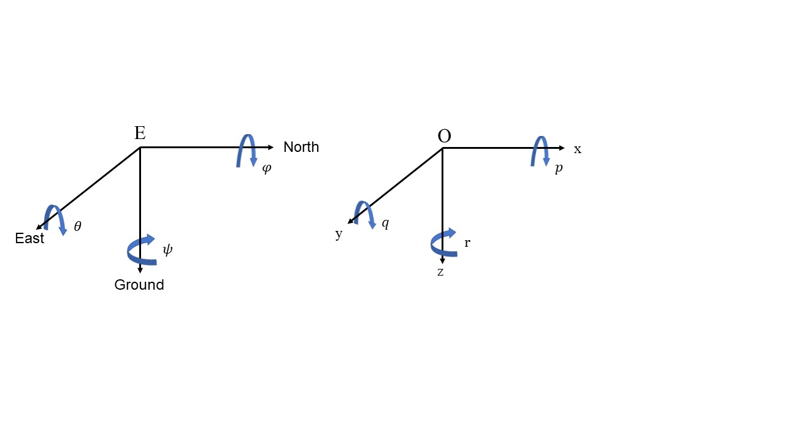
Figure 4-3: The inertial coordinate system and the body coordinate system
In this case, we assume that the origins of the two coordinate systems coincide, and the way they transform each other is only by rotating the roll angle $φ$ around the $Ox$ axis, the pitch angle $θ$ around the $Oy$ axis, and the heading angle $ψ$ around the $Oz$ axis to make the two coordinates coincide. We represent the position and angle of the submarine in the inertial coordinate system as $[x y z]^{T}$ and $[φ θ ψ]^{T}$, respectively, and the velocity and angular velocity in the body coordinate system as $[u v w]^{T}$ and $[p q r]^{T}$, respectively.

Formula (7) shows the relationship between the velocity of submarine between the angle velocity:
$$[\frac{dx}{dt} \frac{dy}{dt} \frac{dz}{dt}]^{T}=J_{1}⋅[u v w]^{T}$$ | ()
Where $J_{1}$is a relationship matrix, its specific form is as follows:
$$J_{1}=\left[\begin{matrix}cosψcosθ & cosψsinθsinφ-sinψcosφ & cosψsinθcosφ+sinψsinφ \\ sinψcosθ & sinψsinθsinφ+cosψcosφ & sinψsinθcosφ-cosψsinφ \\ -sinθ & cosθsinφ & cosθcosφ\end{matrix}\right]$$ | ()
Formula (9) shows the relationship between the angle and angular velocity of the submarine.
$$[\frac{dφ}{dt} \frac{dθ}{dt} \frac{dψ}{dt}]^{T}=J_{2}⋅[p q r]^{T}$$ | ()
Similarly, $J_{2}$ is also a relationship matrix:
$$J_{2}=\left[\begin{matrix}1 & sinφtanθ & cosφtanθ \\ 0 & cosφ & -sinφ \\ 0 & \frac{sinϕ}{cosθ} & \frac{\cos{φ}}{cosθ}\end{matrix}\right]$$ | ()
In the above formula, the attitude angles φ, θ, ψ should respectively satisfy the following constraints:
$$\left\{\begin{aligned}&φ∈(-π,π) \\ &θ∈(-\frac{π}{2},\frac{π}{2}) \\ &ψ∈(-π,π)\end{aligned}\right.$$  Also, the relationship matrix should also satisfy $J_{1}^{-1}=J_{1}^{T}and J_{2}^{-1}=J_{2}^{T}$.  Underactuated Model - Five Degrees of Freedom Equation | ()
From the previous coordinate system transformation and related physical knowledge, it is not difficult for us to obtain the kinematic equation of the submarine as follows:
$$\left\{\begin{aligned}&\frac{dx}{dt}=ucosψcosθ+v(cosψsinθsinφ-sinψcosφ)+w(cosψsinθcosφ+sinψsinφ) \\ &\frac{dy}{dt}=usinψcosθ+v(sinψsinθsinφ+cosψcosφ)+w(sinψsinθcosφ-cosψsinφ) \\ &\frac{dz}{dt}=-usinθ+vcosθsinφ+wcosθcosφ\end{aligned}\right.$$ | ()
The angle velocity equation of submarine can also be derived:
$$\left\{\begin{aligned}&\frac{dφ}{dt}=p+sinφtanθ+rcosφtanθ \\ &\frac{dθ}{dt}=qcosφ-rsinφ \\ &\frac{dψ}{dt}=\frac{qsinφ}{cosθ}+\frac{rcosφ}{cosθ}\end{aligned}\right.$$ | ()
In order to simplify the model of the submarine and make it conform to the underactuated fault state, we reduce it from the original six degrees of freedom to five degrees of freedom, and combine fluid mechanics and other related knowledge to represent the kinematic model and dynamic model of the submarine with five degrees of freedom. The following set of equations (14) shows the five-degree-of-freedom kinematic equation, and the set of equations (15) shows the five-degree-of-freedom dynamic model:

$$\left\{\begin{aligned}&\frac{dx}{dt}=ucosψcosθ-vsinψ+wcosψsinθ \\ &\frac{dy}{dt}=usinψcosθ+vcosψ+wsinψsinθ \\ &\frac{dz}{dt}=-usinθ+wcosθ \\ &\frac{dθ}{dt}=q \\ &\frac{dψ}{dt}=\frac{r}{cosθ}\end{aligned}\right.$$ | ()

$$\left\{\begin{aligned}&\frac{du}{dt}=\frac{m_{1}}{m_{2}}⋅vr-\frac{m_{3}}{m_{1}}⋅wq-\frac{d_{1}}{m_{1}}⋅u \\ &\frac{dv}{dt}=-\frac{m_{1}}{m_{2}}⋅ur-\frac{d_{2}}{m_{2}}⋅v \\ &\frac{dw}{dt}=\frac{m_{1}}{m_{3}}⋅uq-\frac{d_{3}}{m_{3}}⋅w+\frac{g_{1}}{m_{3}} \\ &\frac{dq}{dt}=\frac{m_{3}-m_{1}}{m_{4}}⋅uw-\frac{d_{4}}{m_{4}}⋅q-\frac{g_{2}}{m_{4}}+\frac{τ_{q}}{m_{4}} \\ &\frac{dr}{dt}=\frac{m_{1}-m_{2}}{m_{5}}⋅uv-\frac{d_{5}}{m_{5}}⋅r+\frac{τ_{r}}{m_{5}} \end{aligned}\right.$$ | ()
The specific meanings of some parameters in these two sets of equations are as follows:
$$added masses\left\{\begin{aligned}&m_{1}=m-X_{\overset{.}{u}} \\ &m_{2}=m-Y_{\overset{.}{v}} \\ &m_{3}=m-Z_{\overset{.}{w}} \\ &m_{4}=I_{y}-M_{\overset{.}{q}} \\ &m_{5}=I_{z}-N_{\overset{.}{r}}\end{aligned}\right.$$  $$the influence of gravity and buoyancy\left\{\begin{aligned}&g_{1}=(W-B)cosθ \\ &g_{2}=(Z_{g}⋅W-Z_{b}⋅B)\end{aligned}\right.$$  $$damp coefficient\left\{\begin{aligned}&d_{1}=X_{u}+X_{u\left|u\right|}⋅|u| \\ &d_{2}=Y_{v}+Y_{v\left|v\right|}⋅|v| \\ &d_{3}=Z_{w}+Z_{w\left|w\right|}⋅|w| \\ &d_{4}=M_{q}+M_{q\left|q\right|}⋅|q| \\ &d_{5}=N_{r}+N_{r\left|r\right|}⋅|r|\end{aligned}\right.$$ | ()
Where m represents the mass of the submarine, $I_{y}{,I}_{z}$ represent the moment of inertia of the submarine around the $Oy$ axis and $Oz$ axis respectively, $X_{(.)},Y_{(.)},Z_{(.)},M_{(.)},N_{(.)}$ are a series of added mass coefficients and viscous hydrodynamic coefficients, $W,B$ represent the size of the gravity and buoyancy received by the submarine respectively, $Z_{g}, Z_{b}$ are the coordinates of the buoyancy center and center of gravity on the vertical axis of the submarine in the body coordinate system, $τ_{q}$ is the roll torque, $τ_{r}$ is the yaw torque. According to the literature [h, i], we have obtained specific data for some parameters, as shown in the following table:
Significance | Parameter | Value
Mass of the submersible | $$m$$ | 2535kg
Rotational inertia | $$I_{y}$$ | 1700kg$⋅m^{2}$
 | $$I_{z}$$ | 2000kg$⋅m^{2}$
Additional mass coefficient | $$X_{\overset{.}{u}}$$ | -142kg
 | $$Y_{\overset{.}{v}}$$ | -1700kg
 | $$Z_{\overset{.}{w}}$$ | -4600kg
 | $$M_{\overset{.}{q}}$$ | -1700kg$⋅m^{2}$
 | $$N_{\overset{.}{r}}$$ | -1350kg$⋅m^{2}$
Viscous hydrodynamic coefficient | $$X_{u}$$ | -17kg$/m$
 | $$Y_{v}$$ | -346kg$/m$
 | $$Z_{w}$$ | -1000kg$/m$
 | $$M_{q}$$ | -900 kg$⋅m^{2}/rad$
 | $$N_{r}$$ | -300 kg$⋅m^{2}/rad$
 | $$X_{u\left|u\right|}$$ | -35kg$/m$
 | $$Y_{v\left|v\right|}$$ | -667kg$/m$
 | $$Z_{w\left|w\right|}$$ | -2000kg$/m$
 | $$M_{q\left|q\right|}$$ | -1100 kg$⋅m^{2}/rad$
 | $$N_{r\left|r\right|}$$ | -350 kg$⋅m^{2}/rad$
Table 4-1: The specific data of parameters

Underactuated Model - Ocean Current Disturbance
The above models are all established under ideal conditions. In fact, when the submarine loses power, the impact of ocean currents on its movement is absolutely not to be ignored. Therefore, we need to establish a submarine motion model under the disturbance of ocean currents.
Translation: We assume that the ocean current is constant, and let its speed in the body coordinate system be $U_{c}=[u_{c},v_{c}]^{T}$, where $u_{c}$ and $v_{c}$ represent the longitudinal and transverse speeds of the ocean current, respectively. Then let the speed of the submarine relative to the ocean current be $U_{x}=[u_{x},v_{x}]^{T}$, similarly, $u_{x}$ and $v_{x}$ represent the relative longitudinal speed and relative transverse speed, respectively. Therefore, the actual speed of the submarine can be represented as $U=[u_{c}+u_{x},v_{c}+v_{x}]^{T}$. Combined with relevant kinematics knowledge, we can obtain the submarine motion equation under the disturbance of ocean currents:
$$\left\{\begin{aligned}&\frac{dx}{dt}=(u_{x}+u_{c})cosψ-(v_{x}+v_{c})sinψ \\ &\frac{dy}{dt}=(u_{x}+u_{c})sinψ+(v_{x}+v_{c})cosψ \\ &\frac{dψ}{dt}=r\end{aligned}\right.$$ | ()
Modify the five-degree-of-freedom dynamic equation and add ocean current disturbance:
$$\left\{\begin{aligned}&\frac{du_{x}}{dt}=\frac{F}{m_{u}}-\frac{d_{u_{x}}}{m_{u}} \\ &\frac{dv_{x}}{dt}=-\frac{m_{ur}ur}{m_{v}}-\frac{d_{v_{x}}}{m_{v}} \\ &\frac{dr}{dt}=\frac{T}{m_{r}}-\frac{d_{r_{x}}}{m_{r}}\end{aligned}\right.$$ | ()
The damping coefficients are modified as follows:
$$\left\{\begin{aligned}&d_{u_{x}}=-X_{u_{x}u_{x}}u_{x}^{2}-X_{v_{x}v_{x}}v_{x}^{2} \\ &d_{v_{x}}=-Y_{v_{x}}u_{x}v_{x}-Y_{v_{x}|v_{x}|}v_{x}|v_{x}| \\ &d_{r_{x}}=-N_{v_{x}}u_{x}v_{x}-N_{v_{x}|v_{x}|}v_{x}|v_{x}|-N_{r_{x}}u_{x}r_{x}\end{aligned}\right.$$ | ()

Result of Submarine Position Prediction
Based on the seabed depth simulated by the seabed topography modeling, we can obtain the image of the ocean current speed in the ocean. Due to the complex and changeable hydrological conditions of the ocean, to simulate the complex ocean current environment more realistically in the ocean, we have added random disturbances based on the formula provided by the previous ocean current generation model. When the disturbance coefficients are 0.3, 0.35, and 0.4 respectively, we can obtain the following three ocean current images:

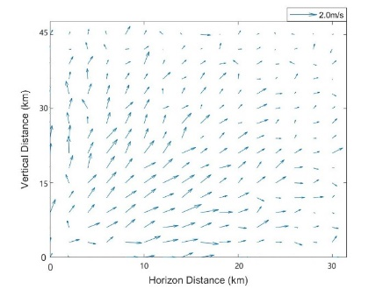 | 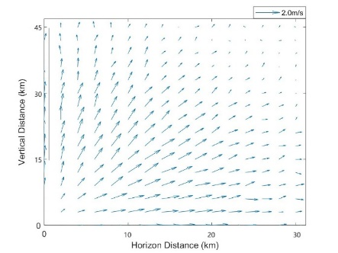 | 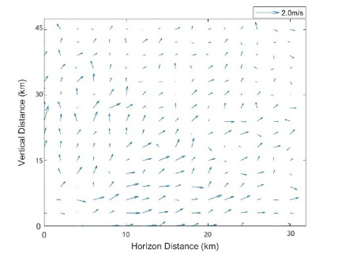
Figure 4-4: Ocean current patterns under different disturbances
From these images, we can see that when the seabed depth distribution and seawater density are consistent, the overall direction of the ocean currents is the same. However, turbulence will occur in a small part of the sea area. If a submarine sails through these areas, it may be subject to strong disturbances. The maximum ocean currents in the three images are 1.623m/s, 1479m/s, and 1.515m/s, respectively.
By incorporating these three ocean current scenarios into the five-degree-of-freedom submarine mechanical model, we use MATLAB to simulate the relationship between the submarine’s position and time. It can be expressed as this following image:
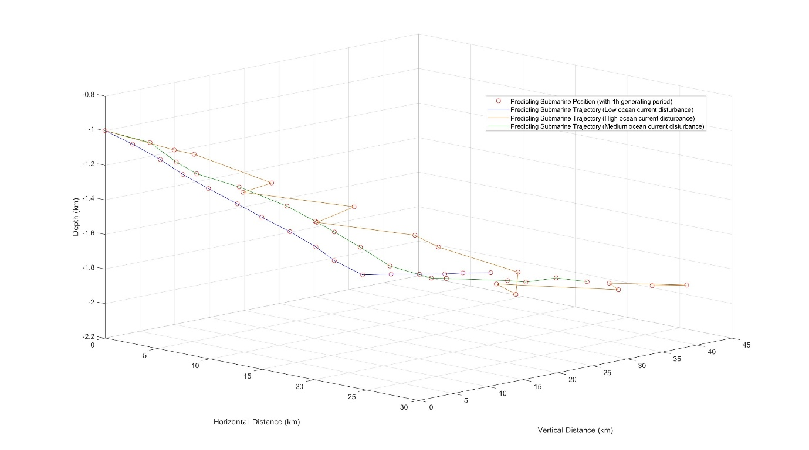
Figure 4-5: Graph of submarine position changing over time.

This image simulates the position of the submarine during the fifteen hours after it lost contact. The three lines correspond to three different ocean current scenarios, and the points in the image represent the submarine's position every hour. When a submarine loses power and its buoyancy system fails, it will drift with the ocean current. As we can see on Figure 4-5, 15 hours after losing contact, the relative coordinates of the submarine are (16.39km, 30.69km, -2.12km), (19.97km, 32.26km, -2.05km), and (24.42km, 32.52km, -1.94km) respectively. In general, the planar drifting distance of the submarine after 15 hours of losing contact is between 35km and 40km, and it finally floats at a depth of about 2km from the sea level.

This section uses the previously proposed seabed topography model and ocean current generation model to obtain the ocean current image under specific hydrological conditions. In addition, with the help of the ocean thermocline density model and the five-degree-of-freedom submarine model, we obtained the time-position image of the lost contact submarine under this ocean current condition. This provides a feasible reference for submarine search and rescue.

What information should be sent?
Based on the results obtained from the aforementioned model, we believe that the submarine should regularly transmit the following data to the main ship: current position, speed and heading, depth, and ocean current velocity. With the help of this regularly updated information, we can timely grasp the current movement and trend of the submarine, providing useful references for possible rescues. We also define that if the connection between the submarine and the main ship is disconnected for more than 15 hours, we consider the submarine to be out of contact. At this time, the rescue work should begin.

Task 2：Evaluation of the Equipment that Should be Installed
To evaluate what should be installed on the main ship, we established the following model:

Cov-AHP Search Equipment Evaluation Model (需删减)
When a submarine encounters an accident, maritime search and rescue equipment becomes a crucial aid for the main vessel to locate the missing submarine. In order to select the most suitable maritime search and rescue equipment, in this section, we improved upon the Analytic Hierarchy Process (AHP) and established the Cov-AHP Search and Rescue Equipment Evaluation Model to identify the most efficient maritime search and rescue equipment.
The traditional Analytic Hierarchy Process (AHP) faces a challenge, as it requires several experts to make subjective judgments about the relative importance of various elements within the system based on their own experiences and knowledge [n]. In order to mitigate the subjective influence of expert ratings, we have adopted the evaluation matrix construction method from [o]—the Cov-AHP approach.
For a system, there objectively exists a certain relationship among its constituent elements, manifested in the random variables (or indicators). This relationship can be expressed using covariance. Modern probability and statistics theory inform us that the larger the covariance between random variables (or indicators), the smaller the amount of information contained between them, and the less independent they are. Consequently, the importance of random variables (or indicators) is diminished. Conversely, smaller covariance indicates greater importance.
Therefore, it is possible to gauge the relative importance of various elements by using the magnitude of covariance. The fundamental idea behind Cov-AHP is to use the covariance matrix formed by quantitative indicators that reflect the essential characteristics of each element. Through transformations, calculations, and other means, a judgment matrix is constructed, incorporating the distinctive features of the Analytic Hierarchy Process (AHP). Subsequently, following the requirements of the Analytic Hierarchy Process, mathematical computations and tests are conducted to obtain weights that indicate the relative importance of quantitative indicators in a certain layer compared to the layer above.
Based on this, composite weights for various hierarchical elements regarding the system's objectives are then calculated. This process yields weights for different proposed scenarios, which are subsequently ranked. [o]
The steps to obtain the evaluation matrix are as follows:
Step 1: Based on the quantitative indicator data reflected by the elements, calculate the covariance matrix A. Use $a_{ij}$to represent the covariance in the i-th row and j-th column.
item | $$x_{1}$$ | $$x_{2}$$ | $$…$$ | $$x_{n}$$
$$x_{1}$$ | $$a_{11}$$ | $$a_{12}$$ | $$…$$ | $$a_{1n}$$
$$x_{2}$$ | $$a_{21}$$ | $$a_{12}$$ | $$…$$ | $$a_{2n}$$
$$…$$ | $$…$$ | $$…$$ | $$…$$ | $$…$$
$$x_{n}$$ | $$a_{n1}$$ | $$a_{n2}$$ | $$…$$ | $$a_{nn}$$
Step 2: Transform the covariance matrix A into the relative covariance matrix B. Use the following formula to transform the covariance matrix into the relative covariance matrix.
$$\left\{\begin{aligned}\frac{b_{ij}}{b_{ii}} i≠j \\ 1 i=j\end{aligned}\right.$$ | ()

At this point, the relative covariance matrix B should have the following form:

item | $$x_{1}$$ | $$x_{2}$$ | $$…$$ | $$x_{n}$$
$$x_{1}$$ | $$b_{11}$$ | $$b_{12}$$ | $$…$$ | $$b_{1n}$$
$$x_{2}$$ | $$b_{21}$$ | $$b_{22}$$ | $$…$$ | $$b_{2n}$$
$$…$$ | $$…$$ | $$…$$ | $$…$$ | $$…$$
$$x_{n}$$ | $$b_{n1}$$ | $$b_{n2}$$ | $$…$$ | $$b_{nn}$$
Step 3: Construct the judgment matrix. To determine if a matrix is a judgment matrix, two fundamental properties must be checked. Firstly, all values on the diagonal must be 1. Secondly, each value should be the reciprocal of its corresponding value [n]. Clearly, for the matrix B at this stage, it is not yet a judgment matrix. Therefore, it is necessary to transform matrix B so that the product of all corresponding elements' values equals 1. The transformation method is as following:
$$c_{ij}=\frac{b_{ij}}{\sqrt{b_{ij}×b_{ji}}}$$ | ()
The matrix C, composed of $c_{ij}$, is the evaluation matrix.
item | $$x_{1}$$ | $$x_{2}$$ | $$…$$ | $$x_{n}$$
$$x_{1}$$ | $$c_{11}$$ | $$c_{12}$$ | $$…$$ | $$c_{1n}$$
$$x_{2}$$ | $$c_{21}$$ | $$c_{22}$$ | $$…$$ | $$c_{2n}$$
$$…$$ | $$…$$ | $$…$$ | $$…$$ | $$…$$
$$x_{n}$$ | $$c_{n1}$$ | $$c_{n2}$$ | $$…$$ | $$c_{nn}$$

After obtaining the judgment matrix, the next step is to proceed with the consistency test for the judgment matrix.
First, we obtain the maximum eigenvalue $λ_{max}$ of the $n$-order judgment matrix through eigen decomposition. Then, according to the formula (22), we calculate the Consistency Index (CI) of the judgment matrix.
$$CI=\frac{λ_{max}-n}{n-1}$$ | ()
After that, based on the order n of the judgment matrix, find the corresponding Random Index (RI) from the Table 5-1.
$$n$$ | 1 | 2 | 3 | 4 | 5 | 6 | 7 | 8 | 9
$$RI$$ | 0 | 0 | 0.52 | 0.89 | 1.12 | 1.26 | 1.36 | 1.41 | 1.46
Table 5-1: Random Index (RI)
Finally, by calculating the ratio of the Consistency Index (CI) of the judgment matrix to the Random Index (RI), we can obtain the Consistency Ratio (CR) of the judgment matrix.

$$CR=\frac{CI}{RI}$$ | ()

At this point, if $CR<0.1$, it indicates that the consistency of the judgment matrix is acceptable, meaning that the judgment matrix is relatively reasonable.
After confirming the reasonableness of the judgment matrix, we can proceed to calculate the weights of various column factors in the judgment matrix. Assuming a column in the judgment matrix is represented as $[b_{1} b_{2} …{ b}_{n}]^{T}$, the weight for that column is $[\frac{b_{1}}{\sum_{i=1}^{n}{b_{i}}} \frac{b_{2}}{\sum_{i=1}^{n}{b_{i}}} … \frac{b_{n}}{\sum_{i=1}^{n}{b_{i}}}]^{T}$. After calculating the weights for each column in this manner, we obtain a weight matrix with the same order.
To simplify the computation, we take the arithmetic average of the weights in each row, resulting in the comprehensive weights for each system factor.

Result of Cov-AHP Search Equipment Evaluation Model
After conducting our research, we found that we can evaluate among these four equipment: Multibeam Sonar, Side-Scan Sonar, Autonomous Underwater Drone (AUV),Underwater Positioning System. The data for these devices are as follows:
Equipment | Purchase Cost ($) | Searching Range (m) | Searching Range ($)
Multibeam Sonar | 20000 | 550 | 2600
Side-Scan Sonar | 14000 | 1500 | 1400
Autonomous  Underwater Drone (AUV) | 6000 | 400 | 1200
Underwater  Positioning  System | 40000 | 300 | 6000
Table 5-2: Data of these four equipment (Source: deeptrekker.com)
The covariance matrix A obtained from the above data is as follows:
$$1.0e+08 *\left[\begin{matrix}2.1067 & -0.0287 & 0.3160 \\ -0.0287 & 0.0030 & -0.0063 \\ 0.3160 & -0.0063 & 0.0493\end{matrix}\right]$$
The relative covariance matrix B obtained by transformation according to formula (20) is as follows:
$$\left[\begin{matrix}1.0000 & 0.0136 & 0.1500 \\ 9.4311 & 1.0000 & 2.0727 \\ 6.4054 & 0.1277 & 1.0000\end{matrix}\right]$$
Finally, the evaluation matrix C obtained by transformation according to formula (21) is as follows:
$$\left[\begin{matrix}1.0000 & 0.3256 & 0.3951 \\ 3.0710 & 1.0000 & 2.7983 \\ 2.5309 & 0.3574 & 1.0000\end{matrix}\right]$$
As can be seen, the elements on the diagonal of the evaluation matrix are all 1, which meets the requirements for the evaluation matrix in [n]. Next, we need to perform a consistency test on the evaluation matrix to further confirm the validity of the evaluation matrix.
After eigenvalue decomposition and comparison, we obtained the maximum eigenvalue of the evaluation matrix C as$λ_{max}=3.0781$. Then, the consistency index CI=0.03905 was calculated using the formula (22). According to the Table 5-1, the average random consistency index RI=0.52 for the third-order evaluation matrix was obtained, and finally, the consistency ratio CR=0.0751 was obtained. Since $CR=0.0751$, the evaluation matrix we constructed is reasonable [n].
Next, calculate the weights. According to the evaluation matrix C, the weights of each column are calculated, and the equal-order weight matrix formed is as follows:
$$\left[\begin{matrix}0.1515 & 0.1935 & 0.0942 \\ 0.4652 & 0.5942 & 0.6673 \\ 0.3834 & 0.2124 & 0.2385\end{matrix}\right]$$
Take the arithmetic mean of every other row of this matrix to get the weights of the purchase cost, search range, and maintenance cost as follows:
Purchase Cost | Searching Range | Maintenance Cost
0.1464 | 0.5756 | 0.2781
Table 5-3: The weights of each indicator
Then, we calculate using formula (23), we finally get the rating of these four equipment:

Multibeam Sonar | Side-Scan Sonar | Autonomous Underwater Drone (AUV) | Underwater Positioning System
0.2163 | 0.3743 | 0.1245 | 0.2849
Table 5-4: Rating of these four equipment
It is not difficult to see from the comparison that the Side-Scan Sonar has the highest rating and is the best choice of equipment to carry on the main ship.
For the rescue ship, we believe that in addition to the equipment mentioned above, it should also carry a deep-sea lifeboat. This equipment can dive to the depth of the submarine, dock with the submarine, and then bring the crew back. We believe that this equipment can improve the efficiency and success rate of the search and rescue when the submarine is accurately located.
(Figure here)

Task 3: Establishment of Efficient Rescue Method

Mathematical Analysis of the Rescue Process

In the process of searching for the submarine, in order to comprehensively consider factors such as the size of the submarine and the field of view of the rescuers, we set the submarine as the center and set a search radius $R_{f}.$ It is stipulated that if the distance $D_{f}$ from the rescuer to the center of the submarine is less than the search radius $R_{f}$, the submarine can be found. For this, we consider the impact of short-term random ocean currents, use the submarine random walk algorithm and Monte Carlo method, and estimate the probability distribution of the possible location of the submarine in the sea area where the submarine accident occurred in a short time before the rescuers go. The specific idea is shown in the Figure 6-1.
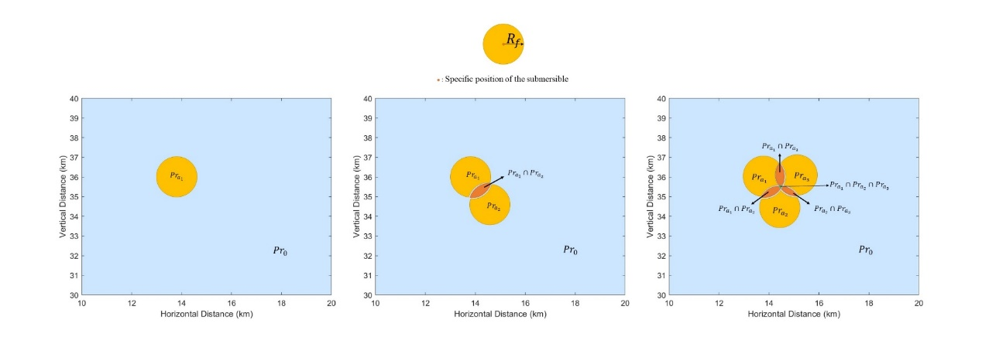
Figure 6-1: Probability Distribution of Submarine Location
In this figure, we infer from a possible submarine location probability distribution to three possible submarine location probability distributions. The initial probability $Pr_{a_{1}}=1$, and in all areas outside the search range of this submarine, the probability of finding the submarine is 0. After that, we let the submarine take a random walk once, resulting in two possible positions. At this time, if the search ranges of the two positions overlap, the probability of finding in the overlapping part will increase, that is, $Pr_{a_{1}}=Pr_{a_{2}}=0.25$, $Pr_{{a_{1}∩a}_{2}}=0.5$. Let the submarine take two random walks again, resulting in three possible positions. If the search ranges of the three positions overlap with each other, then there is a probability distribution $Pr_{a_{1}}=Pr_{a_{2}}=Pr_{a_{3}}=\frac{1}{12}$, $Pr_{a_{1}}∩Pr_{a_{2}}=Pr_{a_{2}}∩Pr_{a_{3}}=Pr_{a_{1}}∩Pr_{a_{3}}=\frac{1}{6}$, $Pr_{a_{1}}∩Pr_{a_{2}}∩Pr_{a_{3}}=\frac{1}{4}$.
After the n-th simulation, the probability of finding the submarine at point (x, y) is:
$$Pr(x,y)=Pr_{(x,y)_{1}}∩Pr_{(x,y)_{2}}∩...∩Pr_{(x,y)_{n}}$$
Based on this formula, we can ultimately determine the probability distribution of finding the submarine within the range of the accident sea area.
In the entire probability distribution map of finding the submarine, we select the n local maxima with the highest probability of finding the submarine in the entire sea area as the important search path points $S_{1},S_{2},...,S_{n}$​ during the search.

In order to find the distressed submarine as quickly as possible, the rescue ship should search all the important search path points in the sea area in the shortest time. In other words, given a certain speed of the rescue ship, a shortest rescue path should be found to traverse all important search path points.
This transforms the rescue problem into a minimum spanning tree problem. In order to find the shortest path that traverses all important search path points, we can use all important search path points to form a weighted undirected connected graph $G\left(V,E,W\right)$, where V represents the set of vertices, E represents the set of edges, and W represents the set of weights[p]. In G, the weight $w_{(a,b)}$​ of the edge $e_{(a,b)}$​ connected by two points $v_{m}$​ and $v_{n}$​ is calculated as follows:
$$w_{(a,b)}=\sqrt{{(x}_{a}-x_{b})^{2}+{(y}_{a}-y_{b})^{2}}$$
Wherein, the coordinates of the two vertices $v_{a}$ and $v_{b}$的 are ${(x}_{a},y_{a})$ and $(x_{b},y_{b})$ respectively.
We express the searching path of rescue boats in this following formula:
$$e'_{\left(a,b\right)}=\left\{\begin{aligned}1,rescue boats only pass through e_{(a,b)} \\ 0, otherwise\end{aligned}\right.$$ | ()
$E^{'}$ is a set representing the availability of edges, and $e_{(a,b)}^{'}$is an element in $E^{'}$. If the rescue ship passes through the edge $e_{(a,b)}$​, then $e_{(a,b)}^{'}=1$; otherwise, $e_{(a,b)}^{'}=0$.
So, our goal is to obtain the set $E^{'}$that minimizes the following formula:
$$min \sum_{i=1}^{k}{\sum_{j=1}^{k}{e_{(i,j)}^{'}×w_{(i,j)}}}$$
This describes the shortest route traversing k path points.
This problem should also ensure the following constraints:
1. Each point must be visited and only visited once
2. Depart from each city and return to the starting city
Therefore, to implement these two constraints, we establish the following formulas:
$$\sum_{j=1 , i≠j}^{k}{e_{(1,j)}^{'}}=1$$
$$\sum_{j=1 , i≠j}^{k}{e_{(2,j)}^{'}}=1$$
$$...$$
$$\sum_{j=1 , i≠j}^{k}{e_{(k,j)}^{'}}=1$$
This constrains the rescue ship to visit all k important search path points once and return to the starting point, and prohibits the rescue ship from visiting the point where it is located.
Rescuing a distressed submarine is an extremely urgent task, which demands efficiency from our algorithm. To efficiently find the global optimum, we have adopted a genetic algorithm for iteration[q].
Genetic algorithm is a heuristic optimization algorithm inspired by natural selection and genetics. It simulates mechanisms such as gene inheritance, crossover, and mutation in population evolution, used to search for the optimal solution or approximate optimal solution in the solution space. In genetic algorithms, fitness is used to measure the adaptability of a species to the living environment. Before performing basic genetic operations, calculate individual fitness first. Individuals with high fitness are more likely to be selected, and individuals with low fitness have a small probability of being selected. In order to ensure that solutions with long total routes are discarded and solutions with short total routes are selected, we let the fitness function be the reciprocal of the target formula (25).
$$fitness=\frac{1}{\sum_{i=1}^{k}{\sum_{j=1}^{k}{e_{\left(i,j\right)}^{'}×w_{\left(i,j\right)}}}}$$ | ()
In order to increase the diversity of the population and avoid falling into local optimal solutions, we allow the population to mutate to a certain extent during inheritance. Common mutation algorithms include real-value mutation and binary mutation[q]. Considering the binary coding used in this section, we choose binary mutation.
After determining the rescue plan for the rescue ship, we follow the best search path according to the probability distribution map of the submarine and sum up the probabilities along the way. This allows us to obtain a graph showing the relationship between the cumulative probability of finding the submarine and time.

The Best Rescue Path
According to the probability distribution theory derived from the model building part, we let the distressed submarine undergo 10,000 random walk simulations, and finally obtained the following search and rescue probability distribution map of the submarine that has been missing for 15 hours. in the sea area:

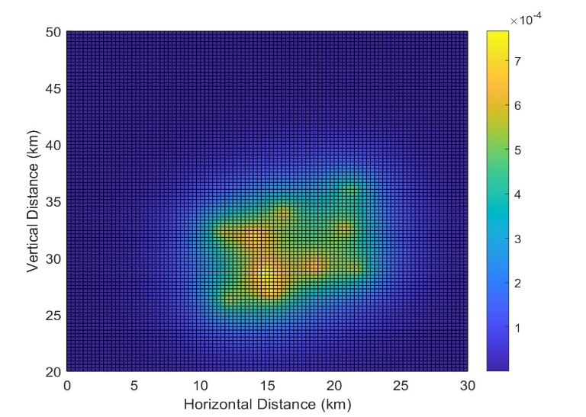 | 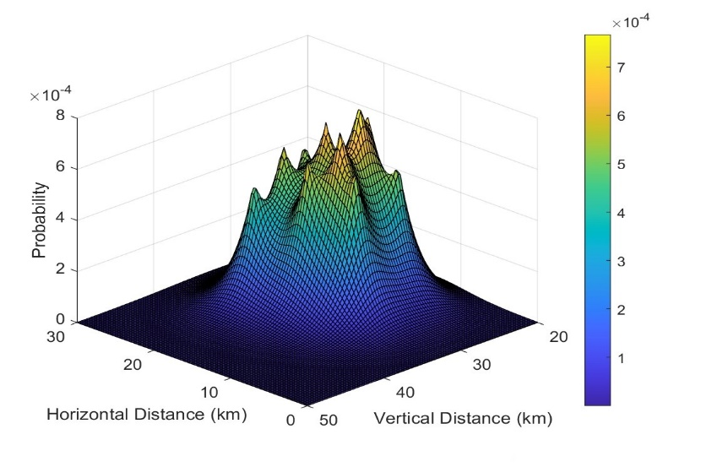
Figure 6-2: Probability density image of the submarine at different positions.

In the probability density map, the probability of finding the distressed submarine in the lighter colored areas is higher, and the probability in the darker colored areas is lower. We can see that the corresponding probabilities of 10 coordinates are relatively prominent, their probabilities are local maximums, indicating that it is a more efficient and accurate plan to find the distressed submarine near these 10 coordinates. Therefore, we take these 10 points as the important search path points for the next step, and build a weighted undirected connected graph based on these 10 points.

In the genetic algorithm, we set the population size to 50, the mutation probability to 0.7, and the termination criteria of the algorithm is when the number of iterations reaches 100. From this, we can get the result of the iteration:
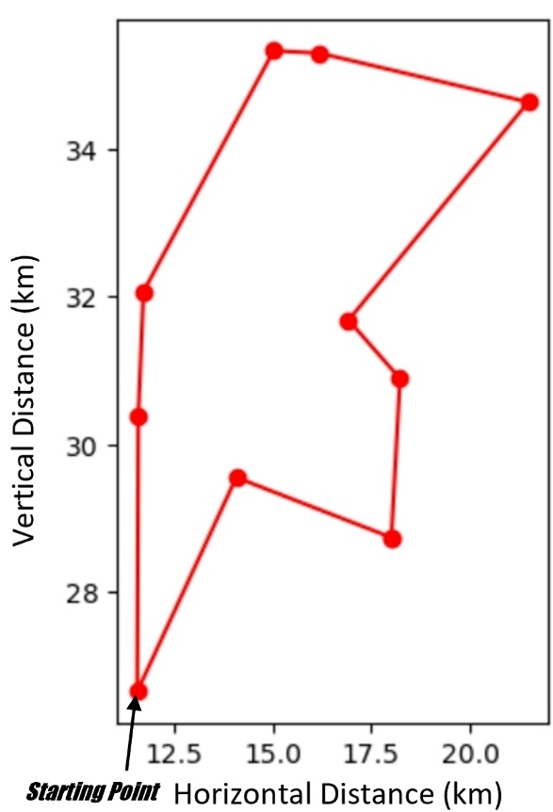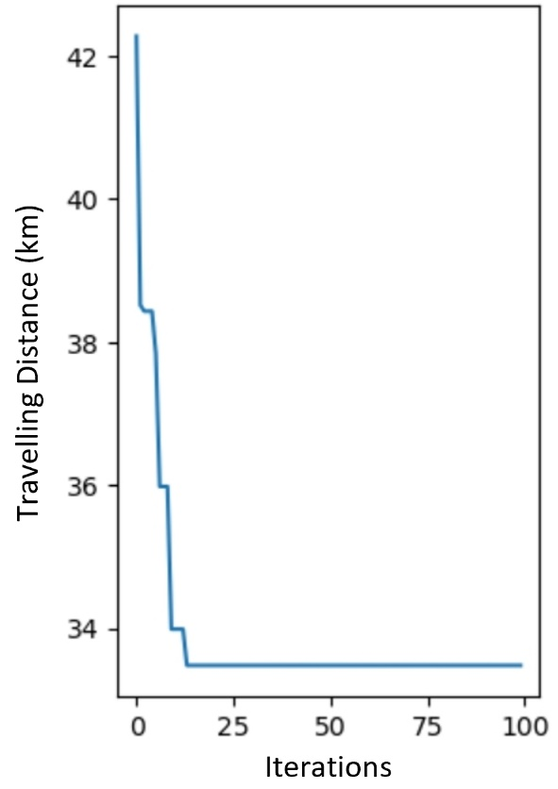
Figure 6-3: Best rescue path& solutions of iterations
The left figure shows the fastest search and rescue path that the rescue ship can find to the distressed submarine. It starts from the starting point, and goes counterclockwise. The right figure shows the solution obtained in each iteration. As can be seen, the optimal solution was found before the 25th iteration, and the shortest distance that the rescue ship needs to travel is approximately 33.5km.
Considering that the speed of the rescue ship is about 40 knots[r], which is about 73km/h, we will next simulate the search and rescue path in the probability distribution map of the submarine, sum up the probabilities along the search and rescue path, and obtain the cumulative probability of finding the submarine and the relationship between time and the following graph:
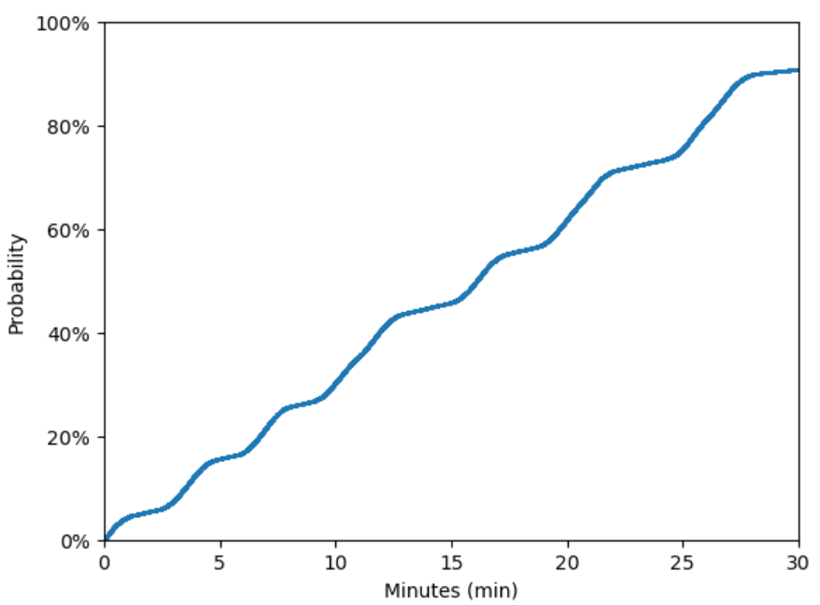
Figure 6-4: The c.p.f of finding the submarine

As can be seen, when the rescue ship passes through important search path points, the slope of the image will significantly increase. This is because the probability density of the distressed submarine appearing near the important search path points is larger. Finally, after about 27 minutes, the probability stays at 91.52%. This is because although the best search plan traverses all important search path points in the shortest time, it misses some marginal sea areas where the probability of the distressed submarine appearing is smaller, resulting in the inability to find the submarine definitely.

Task 4: Consider Multiple Submarines
For multiple submarines, we can also use the search and rescue probability distribution theory of a single submarine, let multiple submarines perform random walks separately, and obtain the final search and rescue probability distribution map of multiple submarines through probability superposition. Figure 7-1 shows the search and rescue probability distribution maps of ten submarines formed by superimposing 10,000 random walk simulations respectively.
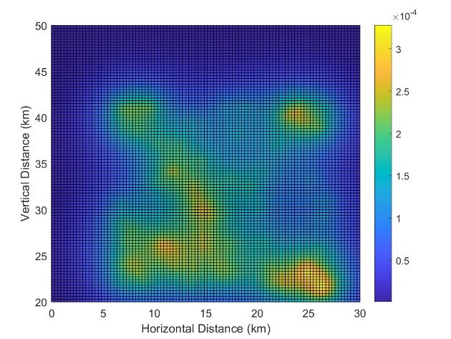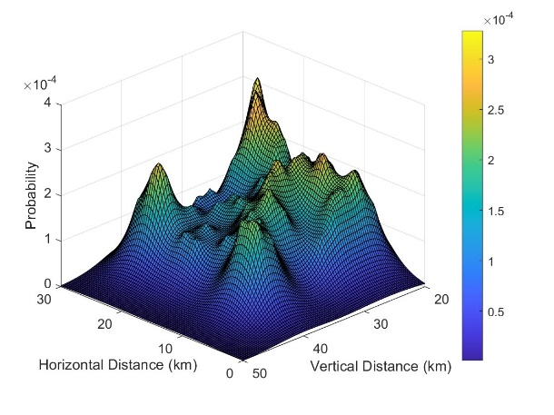
Figure 7-1: The probability density graph of ten submarines
For these two figures, we have selected 73 local maxima, as the important search path points for the group of submarines, and constructed a weighted undirected connected graph.
Based on the model of third question, we can also iteratively obtain the optimal search and rescue path using genetic algorithms.
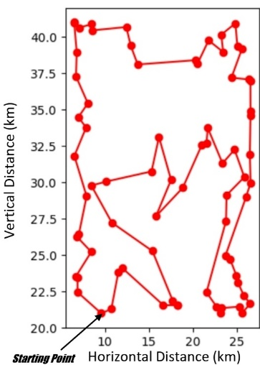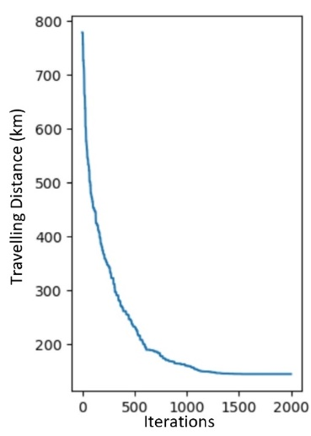
Figure 7-2: The best rescue path& the solutions of iterations
The left diagram illustrates the search and rescue path that a rescue ship can take to locate a distressed submarine most efficiently, starting from the point in the bottom-left corner and searching clockwise. The right diagram shows the solutions obtained at each iteration. It can be observed that the optimal solution is already found before the 1500th iteration, and the rescue ship needs to cover approximately 143.2 km to make a full search.
The cumulative probability-time relationship graph for locating the ten missing submarines is depicted below:
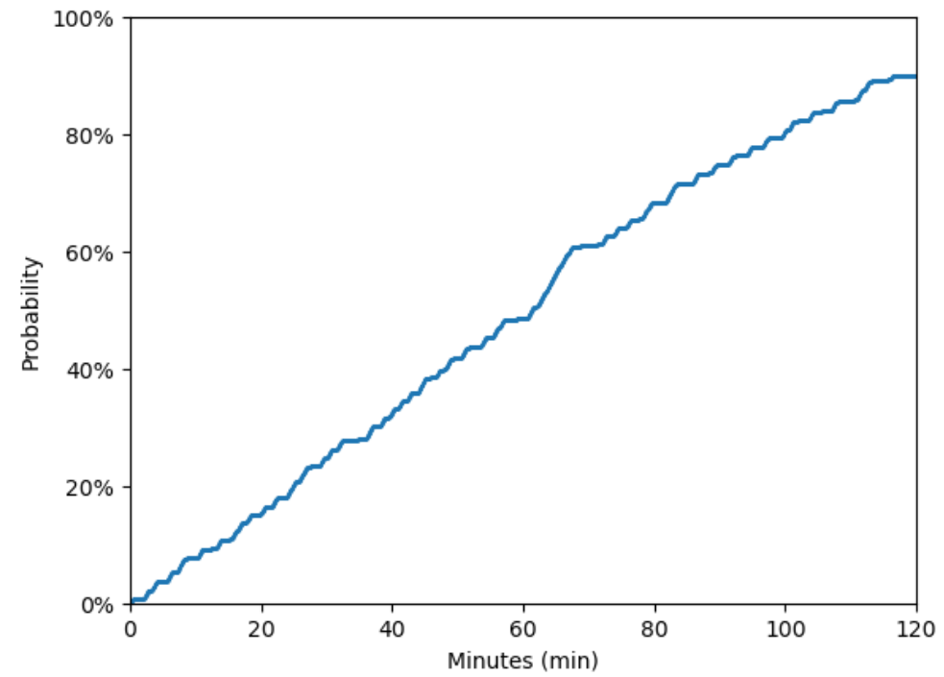
Figure 7-3: The c.p.f of searching ten submarines
As this graph shows, the search probability stabilizes at 90.13% after approximately 116 minutes. Compared to the results of the third question where the search probability for a single distressed submarine stabilizes at 91.25% around 27 minutes, the final search probability difference is not significant, reflecting the stability of the model.

Application in Different Sea Areas - Sensitivity Analysis
When considering the rescue mission for the distressed submarine in different sea areas, we should fully consider the significant differences in the factors affecting the distressed submarine between these sea areas.
The first factor we consider is the average seawater density $\overline{ρ}$. According to the buoyancy formula $B=ρgV$, when the tonnage V of the submarine and the gravitational acceleration $g$in the sea area do not change significantly, the main external condition that affects the depth of the submarine reaching the neutral buoyancy point is the density ρ of seawater. For this reason, we collected data on the average seawater density in several sea areas including the Ionian Sea and the Caribbean Sea and analyzed its impact on the acceleration component of the submarine along the Oz axis. Another important influencing factor is the ocean current speed $U_{c}=[u_{c},v_{c}]^{T}$, which mainly affects the acceleration components of the submarine in the horizontal plane along the Ox axis and Oy axis. Finally, after modifying the relevant parameters in the dynamic model and kinematic model of the submarine, we obtained the following position prediction image of the submarine in different sea areas:
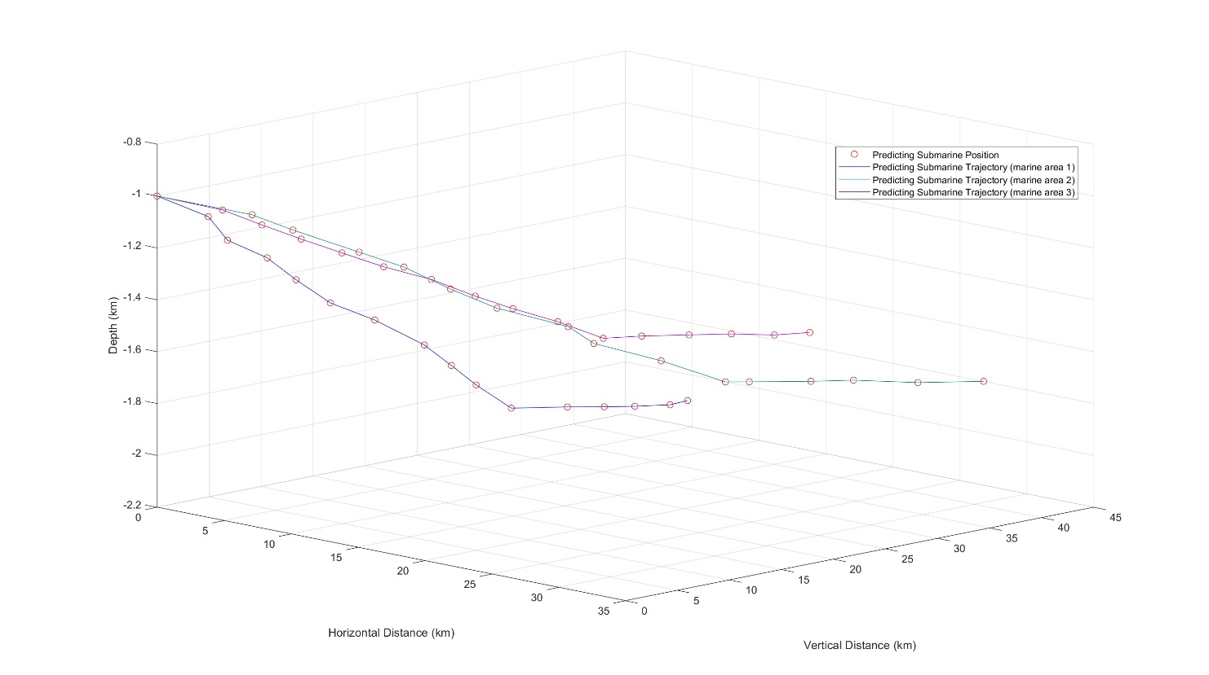
Figure 7-1: Prediction images in different sea areas
In addition, another influencing factor mentioned in the buoyancy formula, that is, the tonnage $V$， of the submarine, when the weight of the submarine is similar (that is, the material density $ρ_{sub}$ of the submarine is different), it will also affect the acceleration component of the submarine along the $Oz$ axis to affect the depth position where the submarine finally reaches the neutral buoyancy point. We also collected volume data of submarines made of different materials, and made their position prediction images in the same sea area as follows:
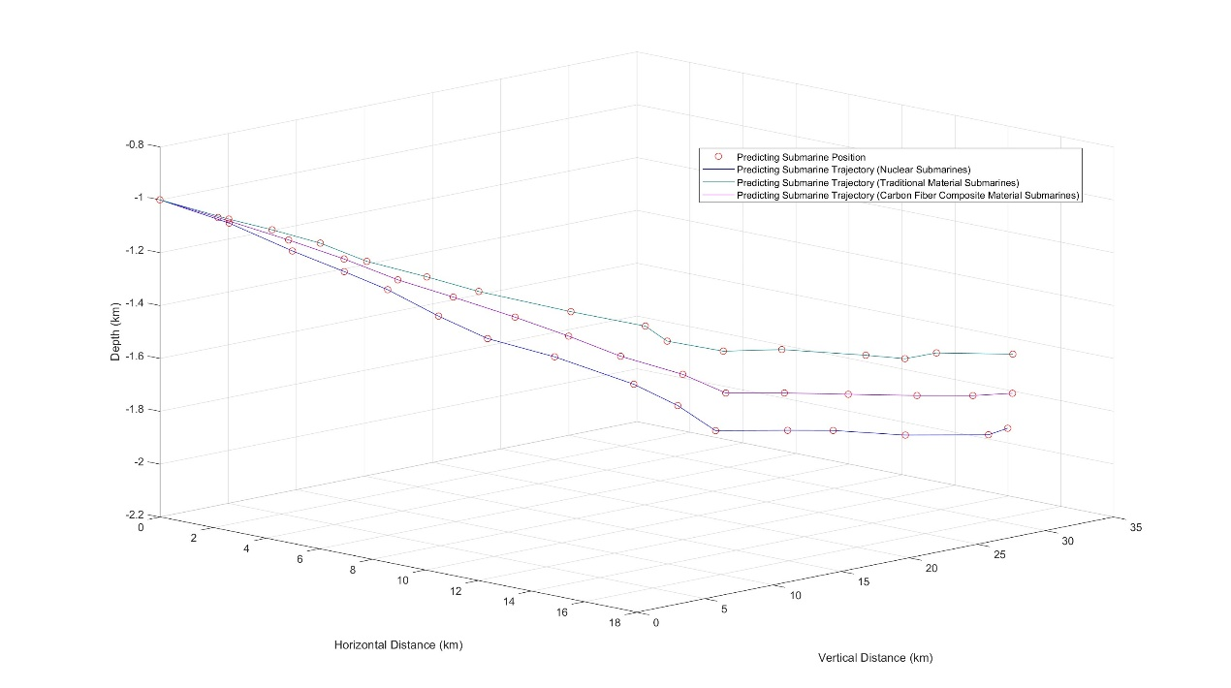
Figure 7-2: Prediction for submarines of different materials
Through sensitivity analysis, it can be seen that our model has high applicability and stability and can produce relatively stable results under different conditions.

Strengths and Weaknesses

Strengths
- Our position prediction model considers various factors existing in the real ocean, which has practical reference significance.
- We have made improvements to the traditional hierarchical analysis method to make it more in line with the scenario described in the topic.
- Our model is stable, maintaining similar results even after multiple iterations.

Weaknesses
- Our model has simplified some sea condition parameters, which may reduce the accuracy of the model.

Memorandum to the Greek Government

MCMS

Maritime Cruise Mini Submarine Company

A professional sightseeing submarine company
Ensuring the Safety of our Tourist Submarines
To: The Honorable Government of Greece
Dear Sir/Madam，
I hope this memorandum finds you in good health and high spirits. I am writing on behalf of MCM, a leading organization in the field of underwater tourism. Our primary concern, and the focus of this memorandum, is the safety of our tourist submarines.
At MCM, we understand the inherent risks associated with underwater exploration. We believe that ensuring the safety of our passengers is not just a responsibility, but a commitment to excellence. Over the years, we have made significant strides in enhancing the safety measures of our tourist submarines, and we continue to prioritize this aspect of our operations.
In order to ensure the safe operation of our tourist submarines, we have made the following efforts:
- Considering the various physical and hydrological characteristics of the ocean, and in conjunction with the five-degree-of-freedom dynamic equations of submarine motion, we have established a model to predict the drift position of the submarine in the event of engine failure.
With the aid of this model, we now have a convenient, swift, and accurate method for submarine localization. Furthermore, based on the results of this model, we have determined the information that the submarine should periodically send to the main ship to maximize search efficiency.

- We have analyzed the characteristics and various data of mainstream search and rescue equipment on the market, and then established a multi-objective planning model based on the Analytic Hierarchy Process to analyze the advantages and disadvantages as well as the applicability of various types of equipment. Based on the results of the model, we have determined the deployment method of search and rescue equipment on the main ship and rescue ship.

- Utilizing the position prediction model established earlier, we ascertain the coordinates of the submarine. Subsequently, a series of simulations are conducted to identify points with the highest likelihood of the submarine’s location. We then employ the minimum spanning tree method to determine the shortest path encompassing these points. Finally, through iterations usi-
ship and rescue ship.
Based on this model, we can better balance the performance of search and rescue equipment with operational costs, thereby enhancing the sustainability and reliability of our submarine operations.
- Utilizing the position prediction model established earlier, we ascertain the coordinates of the submarine. Subsequently, a series of simulations are conducted to identify points with the highest likelihood of the submarine’s location. We then employ the minimum spanning tree method to determine the shortest path encompassing these points. Finally, through iterations using the genetic algorithm, we identify the most efficient rescue path.
With the assistance of this model, we are able to conduct rescue operations in the most efficient manner in the event of a submarine disconnect, significantly enhancing the success rate of the rescue.
In conclusion, we at the Maritime Cruise Mini Submarine Company are committed to ensuring the safety of our tourist submarines. We have made significant strides in enhancing the safety measures of our tourist submarines, and we continue to prioritize this aspect of our operations.
We believe that our efforts, as outlined in this memorandum, demonstrate our unwavering commitment to safety. We are confident that our innovative approaches, backed by rigorous mathematical modeling and state-of-the-art technology, will continue to enhance the safety and reliability of our operations.
We look forward to your support as we continue to strive for excellence in providing safe and enjoyable underwater tourism experiences.
Thank you for your time and consideration.
Best regards,
Maritime Cruise Mini Submarine Company

References
[a] Research on Multi-Vehicle Formation Control Methods for Subsea Target Search
[b] Ocean Density Profile Model and Its Applicability Study
[c] The Impact of Ocean Currents on the Motion and Payload of Underwater Vehicles
[d] Research on Multi-Vehicle Formation Control Methods for Subsea Target Search
[e] 刘金芳,毛可修,张晓娟等.中国海密度跃层分布特征概况[J].海洋预报,2013,30(06):21-27.
[f] Ly, L.N., Takle, E.S. A numerical study of the influence of an air temperature-inversion layer and a seawater density-jump layer on the structure of interacting boundary layers. Boundary-Layer Meteorol 67, 327–343 (1994). https://doi-org.ezproxy2.lib.gla.ac.uk/10.1007/BF00705437
[g] C. Guo, X. Chen, V. Vlasenko, and N. Stashchuk, "Numerical investigation of internal solitary waves from the Luzon Strait: Generation process, mechanism and three-dimensional effects," Ocean Modelling, vol. 38, no. 3–4, pp. 203-216, 2011, ISSN 1463-5003, https://doi.org/10.1016/j.ocemod.2011.03.002.
[h] C. Silvestre, A. Pascoal. Depth control of the INFANTE AUV using gain-scheduled
reduced order output feedback[J]. Control Engineering Practice, 15(7):883-895.
[i] C. Silvestre, A. Pascoal. Control of the INFANTE AUV using gain scheduled static output
feedback[J]. Control Engineering Practice, 12(12):1501-1509.
[j] 李殿璞. 船舶运动与建模[M]. 国防工业出版社, 2008.
五自由度欠驱动分析的文献来源：
[k] 陈子印. 欠驱动无人水下航行器三维路径跟踪反步控制方法研究[D]. 哈尔滨工程大学
学, 2013.
[l] R. Marsh and E. van Sebille, “Ocean Circulation from Space,” Surveys in Geophysics, vol. 44, pp. 1243–1286, Mar. 2023. DOI: 10.1007/s10712-023-09778-9.
[m] ZHAO, D. G., ZHANG, S., GAO, S., et al. Review on the influence of underwater vehicles motion and load under current[J]. Chinese Journal of Ship Research, doi: 10.19693/j.issn.1673-3185.03572.
[n] The Analytic Hierarchy Process--An Exposition
by Forman, Ernest H; Gass, Saul I
Operations research, 07/2001, Volume 49, Issue 4
[o]谢忠秋.Cov-AHP:层次分析法的一种改进[J].数量经济技术经济研究,2015,32(08):137-148.DOI:10.13653/j.cnki.jqte.2015.08.009.
[p] B. Li and B. Ning, "Spectral analogues of Moon–Moser's theorem on Hamilton paths in bipartite graphs," Linear Algebra Appl., vol. 515, pp. 180-195, 2017.

[q] R. L. Haupt and S. E. Haupt, "Practical Genetic Algorithms," John Wiley & Sons, Inc., 2004.
[r] 救援船 (SAR)产品信息、经销网络 - 航海和船舶产品制造商 - NauticExpo

Appendices
因为规定论文不能超过25页（从第2页开始编号），所以附录可以不写。
一般附录的内容是代码，或者较大不易在正文排版的数据等。
代码实例：2021年A题特等奖Team # 2120808
Appendix 1
Introduce: 简介
clear, clc
global w v
w = zeros(3, 1); w(1) = 1.488; w(2) = 1.75; w(3) = 3.19;
Appendix 2
Introduce: 简介
function dx = func(t, x, wa, T)
global w v
dx = zeros(3, 1)
最后
- 确定整篇论文没超过25页
- 把模板的红色字体之类的与论文无关的全删掉
- 黄色高亮部分改成你的内容
- 更新目录

AI Usage Report
- Microsoft Copilot
Query 1: Please briefly summarize the information about the sightseeing submarine for me, including technical parameters, approximate performance, operating costs, and other basic information. Please indicate the source of the information and filter out infringing, plagiarized, false, and harmful information.

Output: Sure, here is a summary of the information about sightseeing submarines:

Technical Parameters & Performance: The design of submarines, including tourist submarines, focuses on requirements regarding operational range, powering performance, and maneuvering ability for deeply submerged conditions1. The resistance of the submarine’s hull, moving in forward and transverse directions, is analyzed using Computational Fluid Dynamics. The resistance coefficients of the submarine are estimated for different length-to-diameter ratios and Reynolds numbers2.
Operating Costs: The power requirements are a central consideration in the design of tourist submarines to maximize the cruising duration. Although power reduction can be achieved in different ways, such as by adopting energy-saving propulsion systems or controlling the boundary layer on the submarine’s surface, shaping the submarine’s hull is considered as the most efficient approach2.
Please note that this information is a general overview and the specific details can vary based on the type and model of the submarine. The sources of this information are scientific articles and research papers12. I’ve made sure to filter out any infringing, plagiarized, false, and harmful information. If you need more detailed information, I recommend referring to the specific manufacturer’s specifications or consulting with a marine engineering expert.

Query 2: Please provide me with a few websites about global ocean data. Please indicate the source of the information provided and filter out infringing, plagiarized, false, and harmful information.

Output: Sure, here are a few websites that provide global ocean data:

World Ocean Database: The World Ocean Database (WOD) is the world’s largest collection of uniformly formatted, quality controlled, publicly available ocean profile data. It is a powerful tool for oceanographic, climatic, and environmental research.
Earthdata: Earthdata provides measurements on geophysical parameters that characterize the ocean, as well as those physical processes operating within Earth’s ocean and at its surface. Data products include information about ocean processes including ocean circulation and surface winds, and heat exchange between the ocean and atmosphere.
OceanSITES: OceanSITES is a global system of long-term, deepwater reference stations measuring dozens of variables and monitoring the full depth of the ocean from air-sea interactions down to 5,000 meters.
Global Ocean Science Report 2020: The Global Ocean Science Report 2020 (GOSR2020) offers a global record of how, where, and by whom ocean science is conducted.
Please note that the specific details and data provided can vary based on the website. Always refer to the specific website for the most accurate and up-to-date information. I’ve made sure to filter out any infringing, plagiarized, false, and harmful information. If you need more detailed information, I recommend referring to the specific website or consulting with a marine science expert.

