Problem Chosen  B | 2021  MCM/ICM  Summary Sheet | Team Control Number  S226
Your Paper's Title
Summary
标题下面的Summary可要可不要，如果你觉得你摘要写的不够多，页面下方留白太大的话就加上，这样看起来稍微好看点。
注意：美赛要求英文写作，很多同学英文写作水平不够，可以先写成中文的论文，然后再进行翻译！

Keywords: LOOK algorithm; Time-Efficiency and Energy Consumption Coordination;

Contents
1 Introduction 3
1.1 Problem Background 3
1.2 Restatement of the Problem 3
1.3 Our Work 3
2 Assumptions and Justifications 4
3 Notations 5
4 Elevator dispatching model based on the LOOK algorithm 6
4.1 The Establishment of Passenger Flow Generation Model 6
4.2 The Establishment of Waiting Time Calculation Model 9
4.3 The Elevator Passenger Shortest Path Model 10
4.4 The Establishment of Energy Calculation Model 11
5 The Solution of the Aforementioned Models 16
5.1 Passenger Flow Generation Model 16
5.2 Waiting Time Calculation Model 17
5.3 Passenger Flow Generation Model 18
6 Sensitivity Analysis 18
6.1 Strengths 18
6.2 Weaknesses 18
6.3 Further Discussion 18
7 Conclusion 19
References 20
Appendices 21

Introduction

Problem Background
When you are in a hurry to get something done or go somewhere, you may find that the elevators are located very far away from your current position, making you wait for a significant amount of time. Such situations can be annoying. In modern society, high-rise buildings are prevalent, which means that proper elevator operation arrangements are crucial, has profound social impact, such as in energy efficiency and time efficiency [1, 2]. By studying how different factors impact elevator utilities, for example the passenger distribution and volume, we can develop effective strategies for elevator operation. Ultimately, a proper-designed scheduling optimization algorithm has the potential to enhance transportation efficiency and to reduce energy consumption.
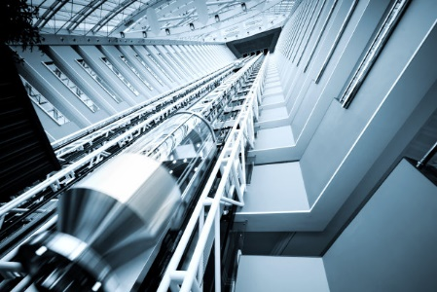
Figure 1: A picture of a typical elevator

Restatement of the Problem
Considering the background information and restricted conditions identified in the problem statement, we need to solve the following problems:
- Develop a model to give a method to operate elevators in an efficient way, which can minimize the waiting time for passengers to take the elevator as much as possible.
- Analyze how different factors can affect utilization of elevators.
- According to the model, determine what position an elevator to park.
- Extend this model to arbitrary situations.
- Improve the model we established to minimize the energy consumption while maximizing transportation efficiency.

Our Work
To sum up the whole article, we
- first referred to disk scheduling algorithms, likening elevator scheduling to disk scheduling.
- considering the actual situation, we have chosen the SCAN algorithm as the scheduling algorithm for the elevator.
- to optimize our algorithm, we employed the LOOK algorithm to enhance the performance of the model.
- discuss the factors about population. We considered about population in each floor, and the inter-floor distribution. These factors will significantly influence the scheduling strategy of the elevator.
- then we divided the whole traffic stream into three main parts: ascend traffic, descend traffic and inter-floor traffic. We can simulate different situations by controlling the proportion of these parts.
- according to these different traffic situations, we can get three types of traffic pattern: Up-flow pattern, Down-flow pattern and Inter-floor pattern.
- divided the energy consumption question into two parts: power consumption and time consumption. Considering these two parts, we can find a best point which has the highest efficiency and saves the most energy. Then, the initial floor can be determined.
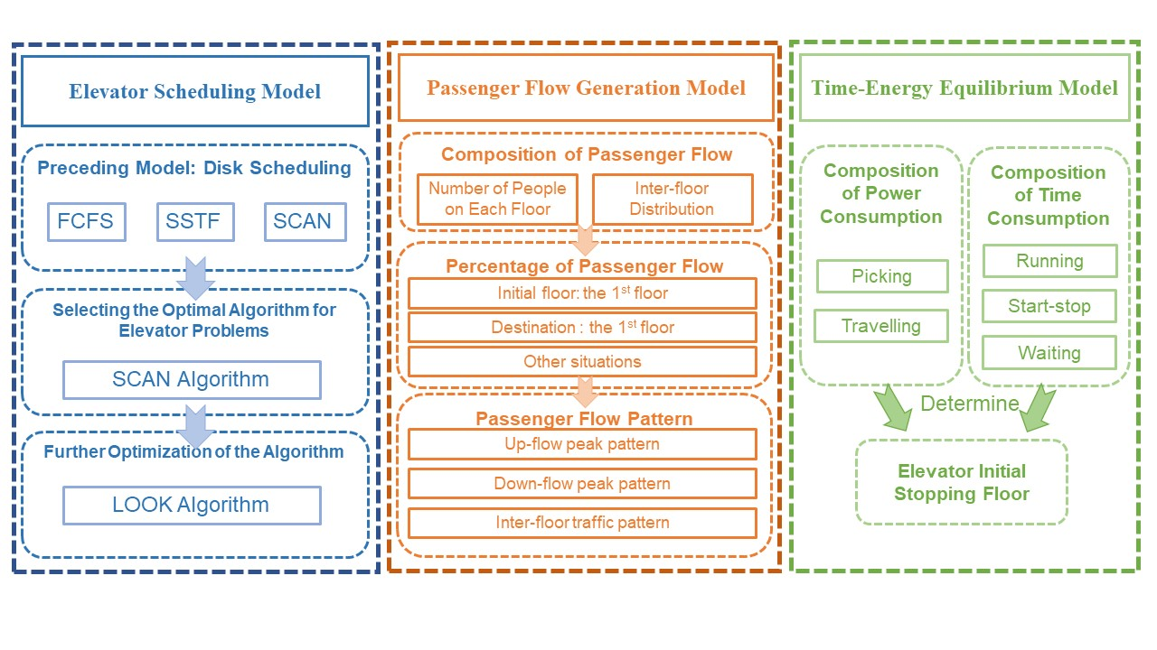
Figure 2: The flow chart of our work

Assumptions and Justifications
To simplify the modeling, we established a few fundamental assumptions, as well as provide justifications for them:
- Assumption 1：The time for passengers to board and alight from the elevator is constant and can be linearly added.
- Justification: In real-life, the time required for passengers to board and alight from the elevator is influenced by many factors. To simplify and make the model efficient, we ignored the relationship between the time taken by passengers to board and alight from the elevator and other factors and replaced this time with a constant value.
- Assumption 2: The acceleration and deceleration rates of elevators remain constant, and the operating velocity is also constant.
- Justification: The acceleration and deceleration periods are only a small part of elevator operation, to simplify the model, we assume the elevator only does constant accelerating, decelerating or ideal uniform motion.
- Assumption 3: The capacity of elevators is always sufficient.
- Justification: In most situations, the capacity of elevators remains sufficient. To simplify the model and focus on the main problem, we choose to ignore the capacity limitation of elevators.
- Assumption 4: The number of people on each floor is directly proportional to the number of passengers.
- Justification: In common experience, we believe that the more people on each floor, the greater the potential number of passengers.

Notations
The key mathematical notations used in this paper are listed in Table 1.
Table 1: Notations used in this paper
Symbols | Description
$$i$$ | The start level
$$j$$ | The destination level
$$n(i)$$ | The population in $i_{th}$ level
$$N$$ | The total number of levels
$$density(i)$$ | The initial density vector of $i_{th}$ level
$$ξ_{i}$$ | The proportion of population in $i_{th}$ level, in the population of the whole building, except the first level
$$x$$ | The proportion of population to go to other levels, from the first level
$$y$$ | The proportion of population that go to the first level, from other levels
$$z$$ | The population of inter-floor traffic
$$GUEST$$ | The Origin-Destination matrix
$$guest(i,j)$$ | The relative passenger flow from $i_{th}$ level to $j_{th}$ level
$$H$$ | The sum of initial density vector of each level
$$p_{i}$$ | The probability of level $i_{th}$ being the initial floor
$$p_{j}$$ | The cumulative probability of level $i_{th}$ being the initial floor
$$G(i)$$ | The sum of all elements in the $i_{th}$ row of the Origin-Destination matrix except for the target floor itself.
$$r_{ij}$$ | The probability of level $i_{th}$ being the initial floor and level j being the destination floor.
$$s_{ij}$$ | The cumulative probability of level $i_{th}$ being the initial floor and level j being the destination floor.
$$t_{1}$$ | The time consumption of elevator to pass one level
$$t_{2}$$ | The time consumption of elevator to park at one level
$$r_{i}$$ | During a dispatch in the peak hours of upward traffic, the $i_{th}$ dispatched elevator.
$$m_{car}$$ | The weight of elevator itself
$$m_{cwt}$$ | The weight of the counterweight
$$g$$ | Gravity acceleration
$$h_{p}(r_{i},t)$$ | The number of floors passed during the $i_{th}$start-stop iteration
$$\overline{m}$$ | The average weight of a passenger
$$n_{p0}(r_{i})$$ | The passenger number is the $i_{th}$ elevator, before response
$$n_{p}(r_{i},s)$$ | The number of passenger leaving the elevator from the $r_{i th}$ one during the $s_{th}$ initiation
$$μ$$ | The generation rate of new passengers
$$γ$$ | The time consumption of aborading elevator
$$β$$ | The time consumption of getting off elevator

Elevator dispatching model based on the LOOK algorithm

The Establishment of Passenger Flow Generation Model
There are so many ways to get the data of passenger flow volume, for example, use instruments to measure it. However, it is very hard to get precise data, and it also consumes a lot of time. To simulate the passenger flow of elevator system, we established the Passenger flow generation model.
We can use a matrix to describe the traffic flow in the whole building. We name it as GUEST matrix. We also introduced a new concept, the origin density vector, density. This vector is mainly decided by population in each levels and three different traffic modes’ proportion.
Assume that the number of levels is N, and the distribution of each level is pop(i), i=1, 2,3,…., N, the vector n can be described as:
$$\left\{\begin{aligned}n(1)=x \\ n\left(i\right)=\left(y+z\right)ξ_{i} i=2,3,…,N\end{aligned}\right.$$ | ()

$$ξ_{i}=\frac{n(i)}{\sum_{i=2}^{N}{n(i)}}$$ | ()

In this formula, i stands for level, n(i) stands for the initial density vector of $i_{th}$ floor, x represents the proportion of passengers departing from the first floor to the total number of passengers, y represents the proportion of passengers departing from each floor and arriving at the first floor to the total number of passengers, z represents the proportion of passengers using inter-floor transportation to the total number of passengers.
We define the Origin-Destination matrix GUEST, to describe the transportation information in the building, and it can be presented as follow:
$$GUEST=\left[\begin{matrix}guest(1,1) & guest(1,2) & ... & guest(1,N) \\ guest(2,1) & guest(2,2) & ... & guest(2,N) \\ ... & ... & ... & ... \\ guest(N,1) & guest(N,2) & ... & guest(N,N)\end{matrix}\right]$$ | ()
guest(i,j) represents for relative passenger flow from $i_{th}$ level to $j_{th}$ level.
We use following method to calculate all elements in this matrix:
When i=1, passengers start from the first floor and travel upwards to various floors. At this time, the GUEST matrix can be calculated as following formula:
$$guest(1,j)=\left\{\begin{aligned}0,i=1 \\ ξ_{j},j=2,3...,N\end{aligned}\right.$$ | ()
When j=1, passengers depart from different floors and go to the first floor. At this time, the GUEST matrix can be calculated as following formula:
$$guest(i,1)=\left\{\begin{aligned}0,i=1 \\ y/(y+z),j=2,3...,N\end{aligned}\right.$$ | ()
When i$≠$1 and j$≠$1, passengers only engage in inter-floor transportation. At this time, the GUEST matrix can be calculated as following formula:
$$guest(i,j)=\left\{\begin{aligned}0,i=j \\ zη_{ij}/(y+z),i≠j\end{aligned}\right.$$ | ()
In this formula, $η_{ij}=n(j)/\sum_{k=2 k≠j}^{N}{n(k)}$.
After we got all elements in the GUEST matrix, we can use Monte Carlo sampling method to determine the starting floor of the passengers. The specific steps are as follows:
- Calculate the sum of initial density vector of N floors:
$$H=\sum_{i=1}^{N}{density(i)}$$ | ()
- Calculate the probability of each floor being the starting floor:
$$p_{i}=\frac{density(i)}{H}(i=1,2,...,N)$$ | ()
- Calculate the cumulative probability of each floor being the starting floor:
$$q_{i}=\sum_{i=1}^{N}{p_{i}(i=1,2,…,N)}$$ | ()
- For every passenger, we generate a random number random in the interval [0,1], if random is less than $q_{1}$, then the first floor is the origin floor. When random is between $q_{i-1}$ and $q_{i}$, then the origin floor of this passenger is the $i_{th}$ floor.

The method to calculate the destination floor of the passenger is similar as the aforementioned method, the specific steps are as follow:
- Determine the origin floor i,
- Compute the sum of all elements in the $i_{th}$ row of the GUEST matrix where the destination floor is not equal to i.
$$G(i)=\sum_{j=1j≠1 }^{N}{guest(i,j)}$$ | ()
- Calculate the probability of the $j_{th}$ floor being the destination floor for a passenger.
$$r_{ij}=\frac{guest\left(i,j\right)}{G\left(i\right)}(i=1,2,...,N;j≠i)$$
- Calculate the cumulative probability for each floor being the destination floor.
$$s_{ij}=\sum_{k=1 }^{j}{r_{ij}(j=1,2,...,N;j≠i)}$$ | ()
- For every passenger, we generate a random number random in the interval [0,1], if random is less than $q_{1}$ and $i≠1,$ then the first floor is the destination floor. When random is between $q_{i-1}$ and $q_{i}$, and $j≠i$, then the destination floor of this passenger is the $i_{th}$ floor.
The procedure of generating passenger flow is as the following figure：
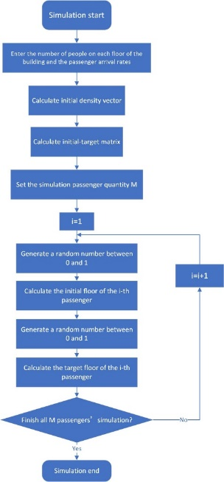

Figure 2: The procedure of generating the passenger flow

The Establishment of Waiting Time Calculation Model
For systems which have more than one elevator, we should minimize the maximum elevator response time. However, in most situations, we need to consider the calls from passengers on each floor as well as calls from passengers inside the elevator cabin. To solve this problem, we established the waiting time calculation model:
$$f_{k}=\left\{\begin{aligned}1,k∈{F^{'}}_{i} and (F_{i}-{F^{'}}_{i})D_{j}>0 \\ 0,k∉{F^{'}}_{i} and \left(F_{i}-{F^{'}}_{i}\right)D_{j}<0\end{aligned}\right.$$ | ()
In this formula, $f_{k}$ represents whether there is a command at floor k. k stands for the number of floor. ${F^{'}}_{i}$ represents the destination floor of passenger; $F_{i}$ represents the initial position of passenger; $D_{j}$ stands for the direction of elevator.
$$\left\{\begin{aligned}f_{i}=1, w_{ij}=(F_{i}-E){xt}_{1}+{yt}_{2} \\ f_{i}=0, w_{ij}=(Q-E){xt}_{2}+{(Q-F_{i})t}_{2}\end{aligned}\right.$$ | ()
In this aforementioned formula, $w_{ij}$ stands for the waiting time of passengers who goes from $i_{th}$ floor to $j_{th}$ floor, $t_{1}$stands for the time consumption to pass a floor, $t_{2}$ stands for time consumption to park at one floor, E is current floor, and N is the highest floor the elevator will reach.
The procedure of this model can be shown as following figure:
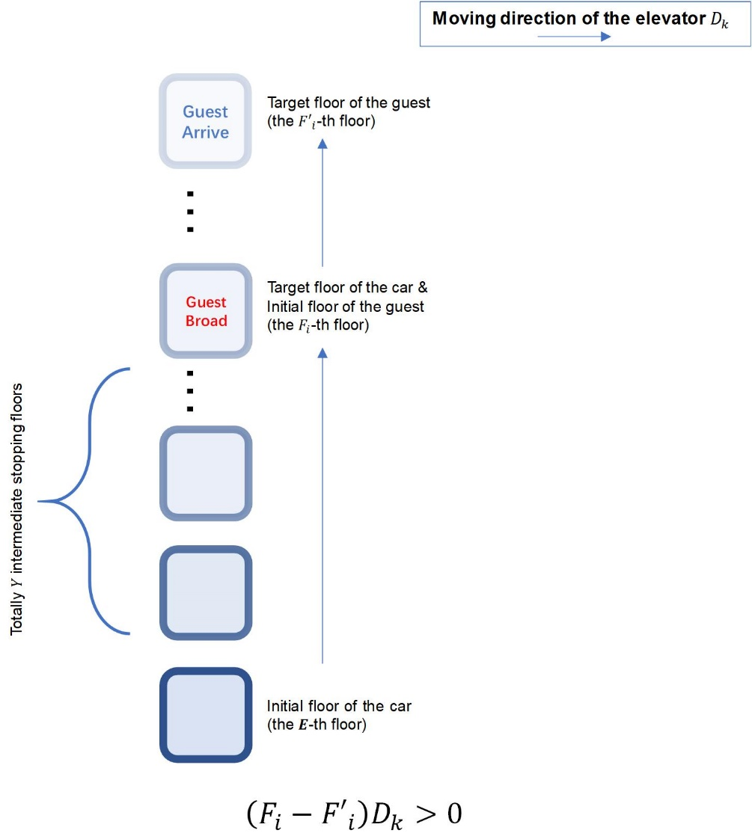
Figure 3: When $\left(F_{i}-{F^{'}}_{i}\right)D_{k}>0$
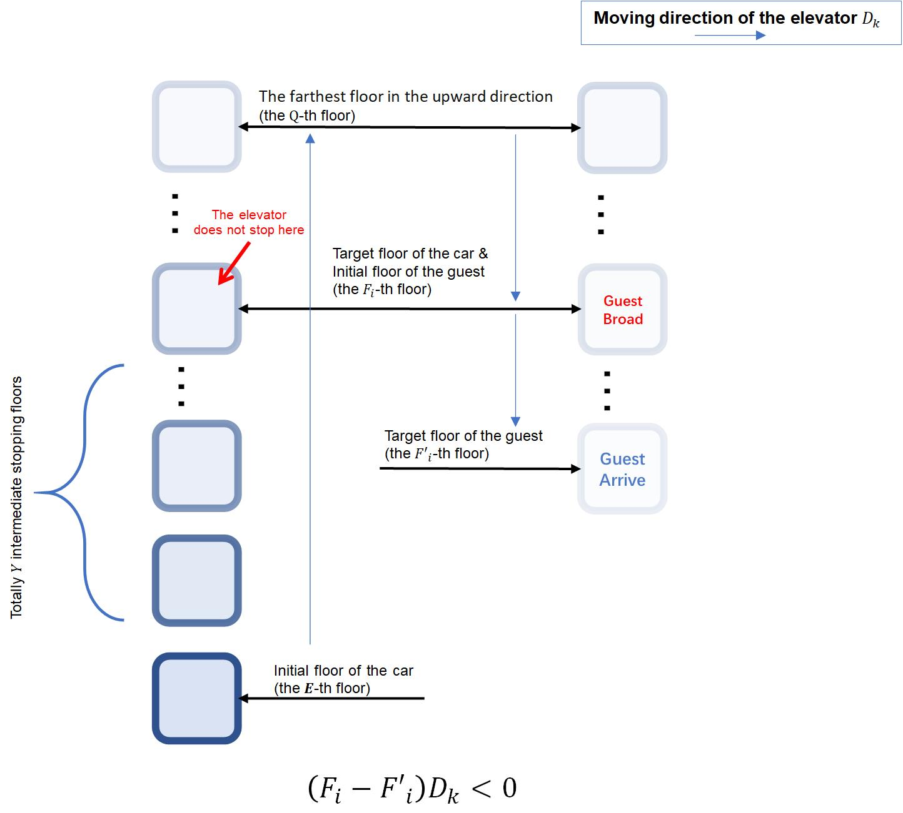
Figure 4: when$\left(F_{i}-{F^{'}}_{i}\right)D_{j}<0$

The Elevator Passenger Shortest Path Model
In situation which there are M elevators and N levels of floor, the model needs to be slightly changed. To solve this problem, we established the elevator passenger shortest path model. In this model, $d_{ij}$ refers to the floor number between $i_{th}$ and $j_{th}$ floor.
We introduce the following decision variables:
$$X_{i}=\left\{\begin{aligned}1, The elevator park at ith floor \\ 0, Other \end{aligned}\right.{ \atop }$$ | ()

$$Y_{ij}=\left\{\begin{aligned}1,Allow passengers on floor i to be served by the elevator stopped at floor j \\ 0, Other \end{aligned}\right.$$ | ()
In this model, $ω$ refers to the total number of floors for all passengers to reach the elevator. To minimize $ω$, the following equations are established:
$$\sum_{i=1}^{N}{X_{i}=M}, i=1,2...,N{ \atop }$$ | ()

$$Y_{ij}≤X_{i}, i,j=1,2...,N$$ | ()

$$\sum_{i=1}^{N}{Y_{ij}=1,}i=1,2...,N$$ | ()

$$ω=\sum_{i=1}^{N}{{d_{ij}Y}_{ij} }i,j=1,2…,N{ \atop }$$ | ()

$$Y_{ij},X_{i}∈\left\{0,1\right\},i,j=1,2…,N$$ | ()
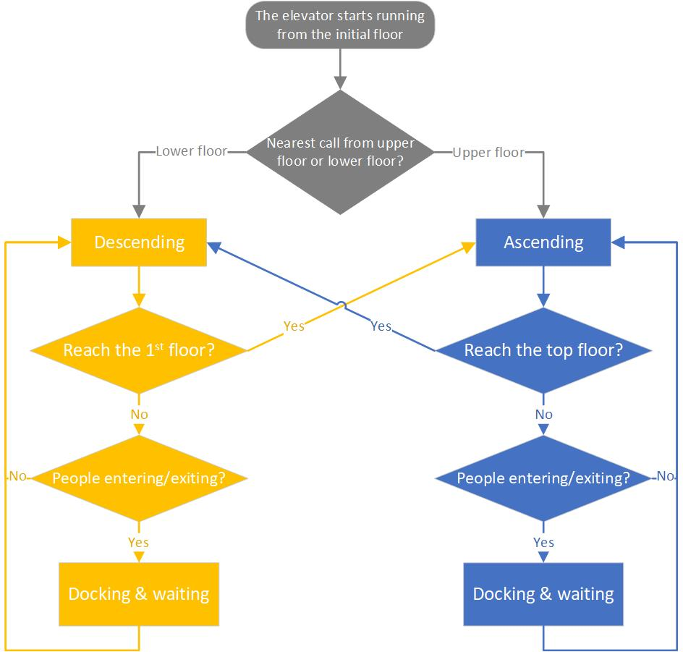
Figure 5: The flow chart of elevator arrangement algorithm

The Establishment of Energy Calculation Model
To calculate the energy consumption during elevator operation, we established a model to calculate a model, which can calculate the energy consumption:
$$E_{scheduling}=E_{picking}+ E_{travelling}$$ | ()
In this formula, $E_{picking}$ stands for the energy consumption of elevator to go from initial position to the first floor, $E_{travelling}$ stands for the energy used to transport passengers to their destination.
In $E_{picking }and E_{travelling}$, they have two parts: $E_{start-stop}$ and $E_{running}$. $E_{start-stop}$ represents the energy consumption in the procedure of accelerating and decelerating, $E_{running}$ stands for energy consumption of uniform motion.
In this model, we only consider about the peak time of upstream, because in this stage, the elevator system consumes the most energy.
Firstly, we consider about the acceleration and deceleration energy in stage of $E_{picking}$:
$$E_{p-1}(r_{i})=θ_{p}(r_{i})×E_{c}$$ | ()
In this formula, $E_{p-1}(r_{i})$ it represents the start-stop energy consumption in response calling signals.
In uniform motion, we also have a formula to describe the energy consumption:
$E_{p-2}(r_{i})=\sum_{t=1}^{θ_{p}(r_{i})}{[|(n_{p0}(r_{i})-\sum_{s=1}^{t-1}{n_{p}(r_{i},s)})×\overline{m}+m_{car}-m_{cwt}|×g×h_{p}(r_{i},t)}]$ | ()
In this formula, due to the elevator moving at a constant speed, we only consider the energy consumption caused by gravity. So, in one $E_{picking}$ movement, the energy consumption of the elevator can be derived from the following equation:
$$E_{p}=\sum_{i=1}^{M}{E_{p-1}\left(r_{i}\right)+E_{p-2}\left(r_{i}\right)}$$ | ()
Which also equals to:
$$\sum_{i=1}^{M}{\{θ_{p}(r_{i})×E_{c}+\sum_{t=1}^{θ_{p}\left(r_{i}\right)}{[|(n_{p0}(r_{i})-\sum_{s=1}^{t-1}{n_{p}\left(r_{i},s\right)})×\overline{m}+m_{car}-m_{cwt}|×g×h_{p}(r_{i},t)}]\}}$$ | ()
Then, we consider about the stage of $E_{travelling}$. Similar to the first stage, the $E_{travelling}$ stage is still composed of two parts: $E_{t-1}(r_{i})$, the start-stop energy consumption in travelling and $E_{t-2}\left(r_{i}\right)$, the gravity potential energy in travelling.
$$E_{t-1}(r_{i})=θ_{t}(r_{i})×E_{c}$$ | ()

$$E_{t-2}(r_{i})=\sum_{t=1}^{θ_{t}(r_{i})}{[|(n_{p0}(r_{i})-\sum_{s=1}^{t-1}{n_{p}(r_{i},s)})×\overline{m}+m_{car}-m_{cwt}|×g×h_{t}(r_{i},t)}]$$ | ()
And according to these aforementioned equations, the total energy consumption in travelling stage can be derived out:
$$\sum_{i=1}^{M}{E_{t-1}\left(r_{i}\right)+E_{t-2}\left(r_{i}\right)}$$ | ()
Which also equals to
$$\sum_{i=1}^{M}{\{θ_{t}(r_{i})×E_{c}+\sum_{t=1}^{θ_{t}\left(r_{i}\right)}{[|(n_{t0}(r_{i})-\sum_{s=1}^{t-1}{n_{t}\left(r_{i},s\right)})×\overline{m}+m_{car}-m_{cwt}|×g×h_{t}(r_{i},t)}]\}}$$ | ()
So, in the whole stage, the total energy consumption should be:
E=$E_{p}+E_{t}$ | ()
The waiting time for a passenger can be determined by the following three components: the time the passenger spent getting on and off the elevator in the last dispatch, the time the dispatched elevator spent moving at a constant speed, and the time the dispatched elevator consumed during acceleration and deceleration. It can be expressed by the following formula:
$$Δt(n+1)=\frac{(γ+β)μ⋅Δt(n)}{M}+\frac{\sum_{i=1}^{M}{(\frac{2L_{r_{i},max}(n)}{V})}}{M}+\frac{T_{s}⋅\sum_{i=1}^{M}{θ_{r_{i}}(n)}}{M}$$ | ()
In this formula, $\frac{(γ+β)μ⋅Δt(n)}{M}$ stands for the time the passenger spent getting on and off the elevator in the last dispatch, $\frac{T_{s}⋅\sum_{i=1}^{M}{θ_{r_{i}}(n)}}{M}$ stands for time the dispatched elevator consumed during acceleration and deceleration, and $\frac{\sum_{i=1}^{M}{(\frac{2L_{r_{i},max}(n)}{V})}}{M}$ stands for the time the dispatched elevator spent moving at a constant speed, in witch $L_{r_{i},max}(n)$ stands for the maximum floor the elevator can arrive, it was timed two because it completed a round trip.
In actual world, because of the uncertainty of passenger flow, it is very hard to measure the precise value of $μ$. We can use this interval to limit $μ$: $μ∈[\hat{μ}-\overline{μ},\hat{μ}+\overline{μ}]$. In this interval, $μ$ refers to the true value of arriving rate, and $\hat{μ}$ refers to the predicted arriving rate, and $\overline{μ}$ is noise.
The structure of the solution to this model can be represented as follows:
$$X=\sum_{i=1}^{M}{X_{i}}$$ | ()
and
$$r_{i}=X_{i(1×M^{o})}{{([1 2 ... M^{o}])}^{T}}_{(M^{o}×1)} i=1, 2, ... ,M$$ | ()
The general solution X is composed of M particular solutions $X_{i}$, each representing a specific elevator to be dispatched. The dimension of $X_{i}$ is $M^{o}×1$, which refers to all elevators in the group. From the second equation, we can obtain the indices of the elevators that can be dispatched represented by $X_{i}$.
The adaptive configuration mechanism of the elevator is represented by the following equation:
$$Δt(n+1)=\frac{(γ+β)(\overset{^}{μ}+\overline{μ})}{M}⋅Δt(n)+\frac{\frac{2\sum_{i=1}^{M}{L_{r_{i},max}}}{V}+T\sum_{i=1}^{M}{θ_{p}(r_{i})}}{M}$$ | ()
and
$$Δt\left(n+1\right)≤t_{l}$$ | ()
The first equation represents that the number of dispatched elevators M, is determined by the coupling relationship between time performance. The second equation signifies that the average predicted waiting time for passengers should not exceed a constant $t_{l}$. This is done while reducing energy consumption without significantly affecting time performance.
The optimization algorithm section can be represented by the following equations:
$E_{p}=\sum_{i=1}^{M}{\{p_{p}(r_{i})×E_{c}+\sum_{t=1}^{θ_{p}(r_{i})}{[|(n_{p0}(r_{i})-\sum_{s=1}^{t-1}{n_{p}(r_{i},s)})×\overline{m}+m_{car}-m_{cwt}|×g×h_{p}(r_{i},t)]}\}}$ | ()

$$E_{t}=\sum_{i=1}^{M}{\{p_{t}(r_{i})×E_{c}+\sum_{t=1}^{θ_{t}(r_{i})}{[|(n_{t0}(r_{i})-\sum_{s=1}^{t-1}{n_{t}(r_{i},s)})×\overline{m}+m_{car}-m_{cwt}|×g×h_{t}(r_{i},t)]}\}}$$ | ()

E=$E_{p}+E_{t}$ | ()

$$n_{p0}(r_{i})=\frac{B(n-1)}{M(n-1)}-\sum_{s^{'}=1}^{2r_{i}}{n_{p}^{'}(r^{i},s^{'})}$$ | ()

$$n_{t0}(r_{i})=\frac{B(n)}{M}=\frac{μ[t(n)-t(n-1)]}{M}$$ | ()
E=$E_{p}+E_{t}$ represented that the total energy consumption has two parts: Energy consumption for picking up passengers and energy consumption for dropping off passengers. The final two equations calculated the variable initial value $n_{t0}(r_{i})$ and $n_{p0}(r_{i})$. The initial number of passengers $n_{p0}(r_{i})$, when the elevator picks up passengers is equal to the average number of passengers allocated to each elevator in the previous round $\frac{B(n-1)}{M(n-1)}$, minus the number of people $\sum_{s^{'}=1}^{2r_{i}}{n_{p}^{'}(r^{i},s^{'})}$, who left the elevator before the current dispatch. $2r_{i}$ refers to the total number of start-stop, and $n_{p}^{'}(r^{i},s^{'})$ refers to passenger left in every start-stop process. The initial value of travel $n_{t0}(r_{i})$, equals the total number of waiting individuals $B(n)$, divided by the number of dispatched elevators M. The total number of waiting individuals $B(n)$, equals to the arrival rate of individuals $μ$ multiplied by the time interval $t(n)-t(n-1)$.
The scheduling constraints can be represented by the following equation:
$$X_{i⋅q}=\{0 , 1\} i=1, 2, ..., M q=1, 2, ..., M^{o}$$ | ()

$$X_{i(1×M^{0})}{({[1 1 ... 1]}^{T})}_{(M^{o}×1)}=1$$ | ()

$$r_{i}<r_{i+1}$$ | ()
The first equation can determine whether to send an elevator. This model transforms traditional group scheduling decisions into 0-1 integer programming. The second equation indicates that each specific solution $X_{i}$, represents only one dispatched elevator. The third equation signifies that, within each partial solution $X_{i}$, the elevator number $r_{i}$ should be arranged in ascending order.
$$Δt(n+1)=\frac{(γ+β)μ⋅Δt(n)}{M}+\frac{\sum_{i=1}^{M}{(\frac{2L_{r_{i},max}(n)}{V})}}{M}+\frac{T_{s}⋅\sum_{i=1}^{M}{θ_{r_{i}}(n)}}{M}$$ | ()

$$n_{t0}(r_{i})=\frac{B(n)}{M}=\frac{μ[t(n)-t(n-1)]}{M}$$ | ()
In the model, these two formulas have uncertain parameter $μ$, we need to use stable reference to transform them, transform uncertain optimization problems into deterministic optimization problems.
As we can do, the first equation can be transformed as follow:
$$Δt(n+1)=\frac{(γ+β)(\overset{^}{μ}+\overline{μ})}{M}⋅Δt(n)+\frac{\frac{2\sum_{i=1}^{M}{L_{r_{i},max}}}{V}+T\sum_{i=1}^{M}{θ_{p}(r_{i})}}{M}$$ | ()
And the second formula can be transformed as follow:
$$n_{t0}(r_{i})=\frac{B(n)}{M}=\frac{(\overset{^}{μ}+\overline{μ})[t(n)-t(n-1)]}{M}$$ | ()
The uncertainty $μ$ is amplified to $(\overset{^}{μ}+\overline{μ})$, corresponding to the passenger flow that results in the maximum energy consumption. In this worst-case scenario, the system handles a greater volume of passenger flow compared to the general case, thus saving more resources.
When elevators are being scheduled, the operation of each elevator is controlled by the following logic:
$$\left\{\begin{aligned}ABAA \\ DBAA \\ ABDA \\ DBDA\end{aligned}\right.$$ | ()
In this controlling logic, ABAA refers to the cabin is dispatched to transport the passengers from the previous trip, and upon completion, it returns to the lobby for the next scheduling; DBAA refers to the cabin is dispatched to address the idle state, initiating it from a standstill, and returning to the lobby for the next scheduling after completion; ABDA refers to the cabin is not dispatched, and it continues transporting passengers from the previous trip. Upon completion, it comes to a halt in its current position, awaiting the next scheduling. DBDA refers to
the cabin is not dispatched and remains in a stationary state. It stays halted, awaiting the next scheduling.

The Solution of the Aforementioned Models

Passenger Flow Generation Model
This section verifies that the model can generate passenger data meeting the desired criteria under various setting conditions. It is necessary to determine the proportions of x, y, and z in three modes, as shown in Table 5-1.
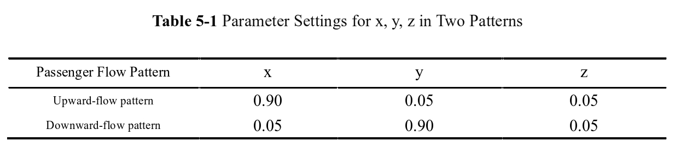
Subsequently, experiments are conducted in these three modes, generating information for 20 passengers each time. The simulated results for each mode are presented in Tables 5-2, and 5-3, respectively.
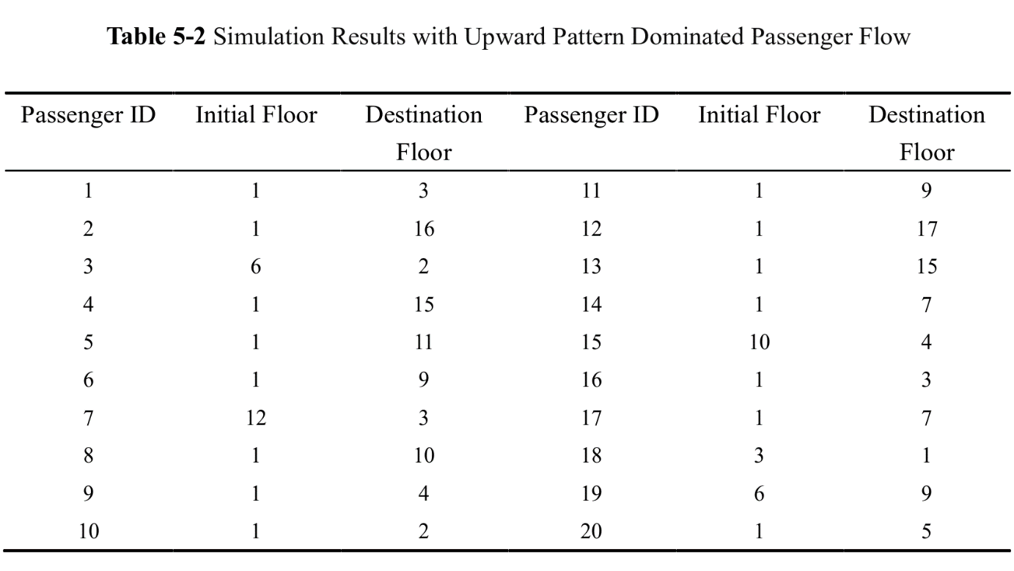
By examining the data presented in Table 5-2, it is evident that among the generated 20 elevator users, 15 passengers commence their elevator journey from the 1st floor and ascend. Consequently, this outcome aligns with the parameter requirements associated with the upward operational mode.
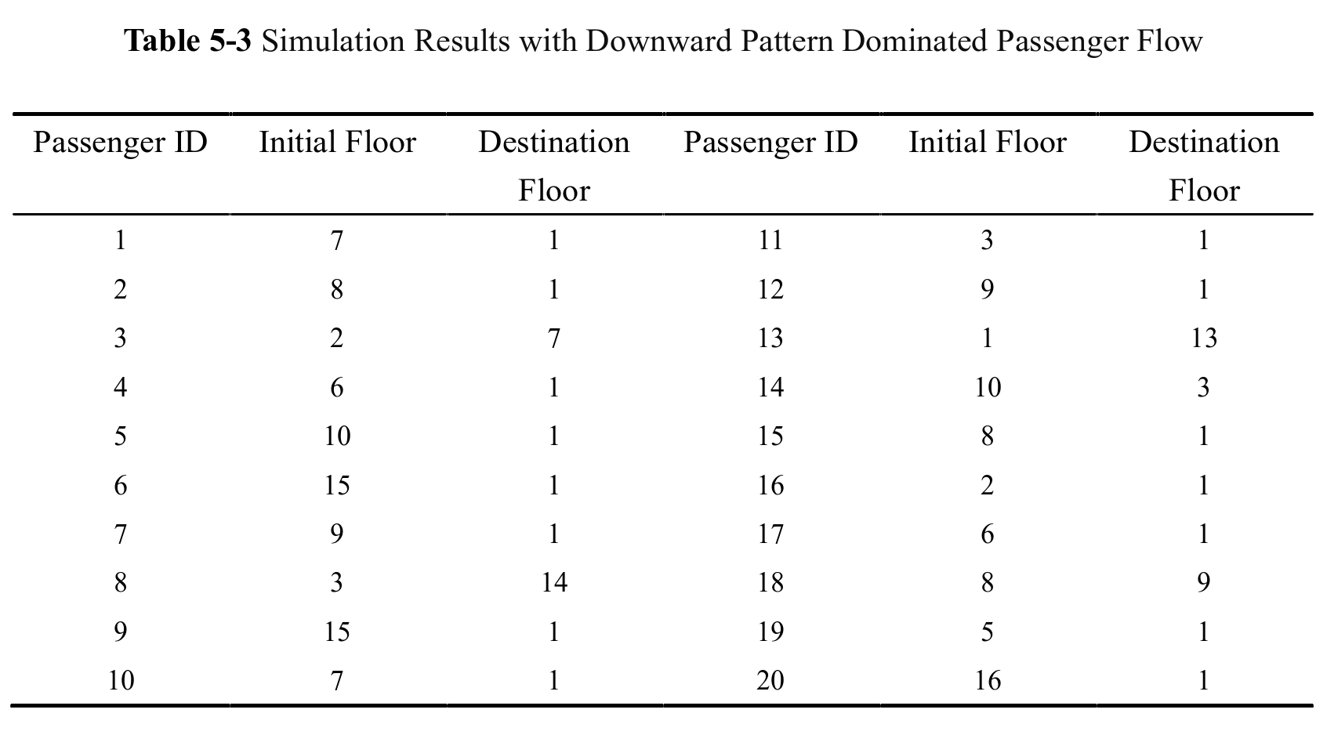
By examining the data in Table 5-3, it is evident that among the generated 20 elevator users, 15 passengers descend to the 1st floor. This observation is consistent with the parameter requirements associated with the downward operational mode.

Based on the results generated from the aforementioned passenger flow simulation experiments, it can be concluded that the passenger flow simulation model is capable of generating the required passenger flow information for application in group control systems. This lays a solid foundation for subsequent research.

Waiting Time Calculation Model
The primary principle governing elevator operation is not to pick up passengers whose destination floor is in the opposite direction to the direction in which the elevator is traveling. We imported the Passenger Flow Generation Model results obtained in Section 5.1 into the Waiting Time Calculation Model. The number of stories is set to 18, and there are two elevators. The simulation results are presented in the chart.

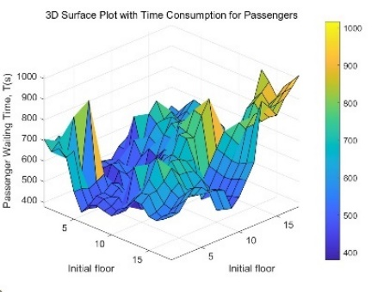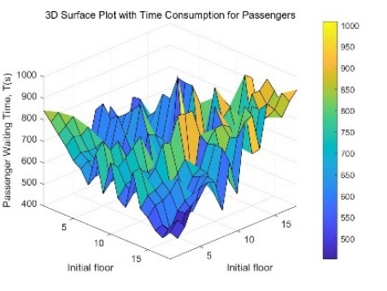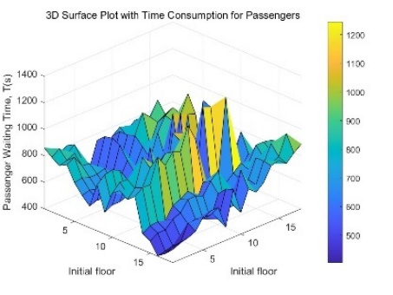
Figure 1-3. The total waiting time for passengers associated with the initial stopping floors of the two elevators in upward passenger flow.
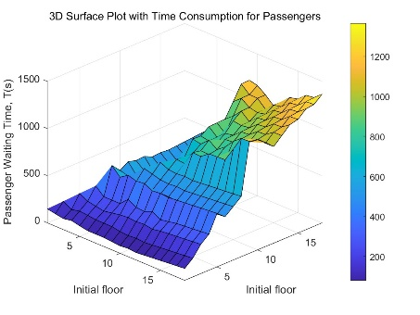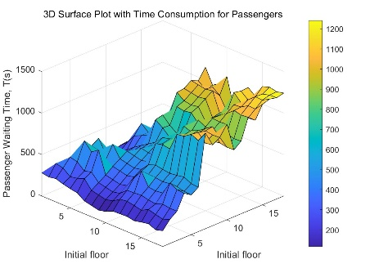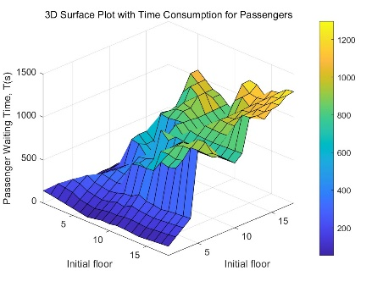
Figure 4-6. The total waiting time for passengers associated with the initial stopping floors of the two elevators in upward passenger flow.

Results illustrated that, in most cases, the optimal strategy for elevators is to stop at floors with high passenger traffic. It can be observed that as the initial floor of the elevator gradually moves away from floors with most passengers, the total waiting time for passengers gradually increases. According to the Passenger Flow Generation Model, it is evident that the passenger density on each floor is not uniformly distributed but is often correlated with residential density, and there is at least one peak. When the elevators stop at these peaks, it consistently minimizes the overall waiting time. For a residential building with 18 floors and two elevators, during the day when people wish to use the elevator to leave, the two elevators should stop at the floors with relatively higher residential population, resulting in the shortest total waiting time. This precisely corresponds to the scenario described in the figure 1-3. In the evening, when people finish their day's work and want to take the elevator home, the two elevators should stop at the 1st floor and another floor with a relatively higher residential population, ensuring the shortest total waiting time. This accurately aligns with the situation described in the figure 4-6.

Passenger Flow Generation Model

Sensitivity Analysis
注：本部分的标题需要根据你的内容进行调整，例如：如果你没有写进一步讨论的话，就直接把标题写成模型的评价。（优缺点一定要写）

Strengths
这里写论文或者模型的优点

Weaknesses
这里写缺点：缺点写的个数一般要比优点少

Further Discussion
进行进一步的讨论，这里可以写模型的改进和拓展：
模型的改进：主要是针对模型中缺点有哪些可以改进的地方；
模型的拓展：将原题的要求进行扩展，进一步讨论模型的实用性和可行性。

Conclusion
结论部分，这个部分在国赛论文很少见到，但在美赛中出现的频率很高。
这个部分可以是论文中心思想的重申、研究结果或主要观点的归纳，也可以是某些启示性的解释或考虑。

References
[1] “Energy and Buildings | Journal | ScienceDirect.com by Elsevier,” www.elsevier.com. https://www.elsevier.com/locate/enbuild
‌[2] A.T.P. So, S.K. Liu, An overall review of advanced elevator technologies, Elevator
World 44 (6) (1996) 96–101.

Appendices
Appendix 1
Introduce: 这里放上附录1的介绍

Appendix 2
Introduce: 这里放上附录2的介绍

本部分是附录部分，美赛对于附录不是特别看重，今年还限制了论文的页数（从第二页开始编号，不能超过25页）。
一般新起一页列出附录。
在不超过页数限制的条件下，附录中可以包括下面内容：
- 你们写的代码；
- 某一问题的详细证明或求解过程；
- 自己在网上找到的数据；
- 比较大的流程图；
- 较繁杂的图表或计算结果。

