UESTC3002: Machine Learning and AI (2024-2025)
Project Technical Report
Author: H
UESTC, Glasgow Hainan College
X@student.gla.ac.uk
Abstract. The objective of this project is to develop a genetic algorithm (GA) to solve a real-world engineering problem. Specifically, the goal is to identify the appropriate resistor from a catalog whose characteristics will allow the temperature-voltage curve of a thermistor network to closely match the ideal reference curve. This task is inherently a multivariable optimization problem, and a genetic algorithm offers a highly efficient approach to finding an optimal solution in a relatively short time. This paper introduces a tailored genetic algorithm to address this problem, and it provides an in-depth analysis of the optimization results. Furthermore, the paper offers a comprehensive discussion of the key parameter settings used in the genetic algorithm. In conclusion, we demonstrate that the genetic algorithm is particularly well-suited for solving the problem presented in this study.
Keywords: Genetic Algorithm, MATLAB programming, Thermistor network.
- Problem Formulation
  - Objective Function and Search Variables
The goal of the objective function in the problem is to optimize the selection of resistors and thermistors used in the circuit based on target data [1]. In this function, a vector containing standard resistor values, thermistor resistance values, and temperature coefficients is input as the search variable. In this problem, the temperature range is set from -40 to 85°C. Using the temperature data, the function will calculate the temperature-voltage response curve for the current input. Then, the temperature-voltage curve is compared with the standard curve (Eq. 1) to obtain the sum of squared residuals, which is the output of the function. Therefore, the key to solving this problem is to find the global minimum of this function.

$$V_{T}=0.1026-0.0001125⋅T+0.00001125⋅T^{2} \left(Eq.1\right)$$

In this problem, the input to the objective function is the index of the resistor parameters, so the search range is determined by the size of the standard component parameter table. In this case, the input variable is a vector of length 6. In this vector, the first four variables are the indices of the regular resistors, ranging from 1 to 70, while the last two variables are the indices of the thermistors, ranging from 1 to 9.
  - Circuit Network Topology
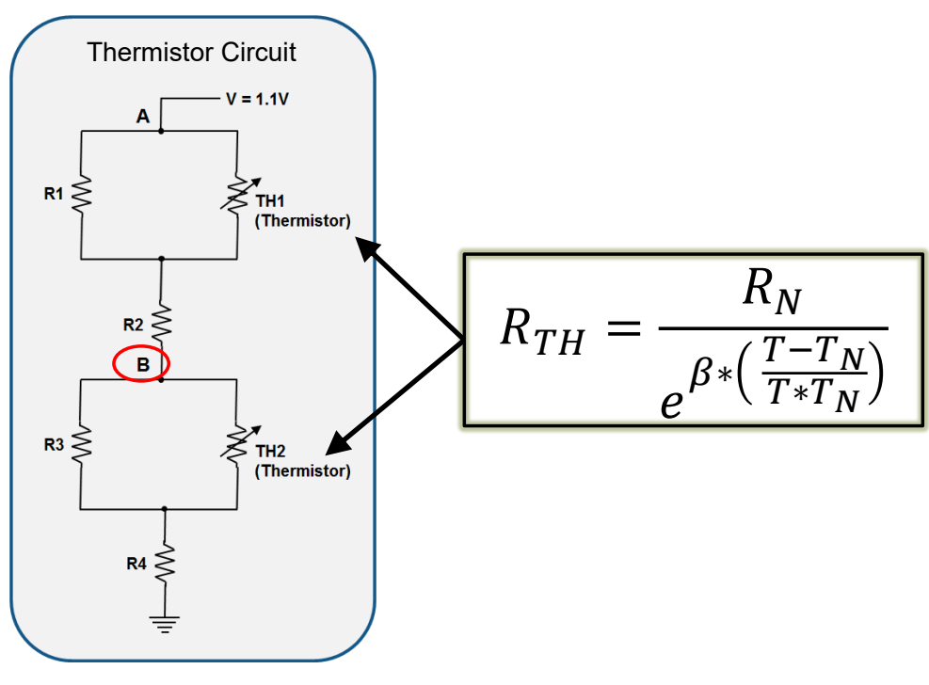
Figure 1: The circuit network topology, which contains 4 common resistors and 2 thermistors.
- Specific Algorithm Implementation and Discussion
  - MATLAB Codes
The code is as follows:
clc;
% Initializing Marco Data
Tdata = -40:5:85; % Temperature range
Vdata = 1.026E-1 + -1.125E-4 * Tdata + 1.125E-5 * Tdata.^2; % Objective voltage curve

% Load Components
load('StandardComponentValues.mat');

% Key Parameters
popSize = [190,200,210,220,230,240,250,260,270,280]; % Population size
Iteration = 100; % Max Generation
mutationRate = 0.1; % Mutation Rate
crossoverRate = 0.75; % Crossover rate
lb = [1 1 1 1 1 1]; % Lower Bound
ub = [70 70 70 70 9 9]; % Upper Bound
runs=10;

BestFitnessValues=zeros(1, runs);
AvgFitnessEachGen=zeros(runs,Iteration);

for loop=1:runs
% Initialize population
population = initializePopulation(popSize(loop), lb, ub);

% Fitness of every generation
fitnessHistory = zeros(Iteration, 1);

% Main loop
for gen = 1:Iteration
% Fitness calculation
fitness = zeros(popSize(loop), 1);
for i = 1:popSize(loop)
fitness(i) = objectiveFunction(population(i,:), Res, ThVal, ThBeta, Tdata, Vdata);
end

% Best fitness of every generation
fitnessHistory(gen) = min(fitness);

% RWS selection
selectedParents = selectParents(population, fitness, popSize(loop));

% Crossover
offspring = crossover(selectedParents, crossoverRate);

% Mutation
offspring = mutate(offspring, mutationRate, lb, ub);

% Refresh population
population = offspring;

% Fitness convergence figure
plotFitnessConvergence(fitnessHistory, gen);

AvgFitnessEachGen(runs,gen)=mean(fitness);% A matrix, which records the
% average fitness values of each generation in each loop
end

% Best solution
[~,bestIdx] = min(fitness);
bestSolution = population(bestIdx, :);
disp('Best solution：');
disp(bestSolution);

best=min(fitness);
worst=max(fitness);
mea=mean(fitness);

BestFitnessValues(loop)=best;
WorstFitnessValues(loop)=worst;
MeanFitnessValues(loop)=mea;

bestV = voltageCurve(Tdata, bestSolution, Res, ThVal, ThBeta);
figure;
plot(Tdata, Vdata, '-b*'); hold on;
plot(Tdata, bestV, '-or');
xlabel('Temperature (^oC)');
ylabel('Voltage (V)');
title('Best Solution - Thermistor Network Temperature Curve');
legend('Target Curve', 'GA Solution', 'Location', 'southeast');
grid on;
hold off;
end

bestp=min(BestFitnessValues);
disp('best fitness');
disp(bestp);
worstp=max(BestFitnessValues);
disp('worst fitness');
disp(worstp);
mediump=median(BestFitnessValues);
disp('medium fitness');
disp(mediump);

% Final Best solution
[~,bestIdx] = min(BestFitnessValues);
finalbestSolution = population(bestIdx, :);
disp('Final Best solution：');
disp(finalbestSolution);

%Decide Resistor values
disp('Resistor parameters are:');
disp(Res(finalbestSolution(1)));
disp(Res(finalbestSolution(2)));
disp(Res(finalbestSolution(3)));
disp(Res(finalbestSolution(4)));
disp(ThBeta(finalbestSolution(5)));
disp(ThVal(finalbestSolution(5)));
disp(ThBeta(finalbestSolution(6)));
disp(ThVal(finalbestSolution(6)));

avg=zeros(1,Iteration);

for i=1:Iteration
avg(i)=mean(AvgFitnessEachGen(:,i));
end

%Plot The Average Fitness of Each Generation in 10 Runs
plotdata=1:1:Iteration;
clf;
xlabel('Generation');
ylabel('Average Fitness Value');
plot(plotdata,avg,'m*--');
title('The Average Fitness of Each Generation in 10 Runs');

% Objective Function: Calculate fitness, this function is actually
% objectiveFunction.m
function fitness = objectiveFunction(x, Res, ThVal, ThBeta, Tdata, Vdata)
y = zeros(8, 1);
y(1) = Res(x(1));
y(2) = Res(x(2));
y(3) = Res(x(3));
y(4) = Res(x(4));
y(5) = ThVal(x(5));
y(6) = ThBeta(x(5));
y(7) = ThVal(x(6));
y(8) = ThBeta(x(6));

F = tempCompCurve(y, Tdata);
Residual = F(:) - Vdata(:);
Residual = Residual(1:2:26);
fitness = sum(Residual.^2);
end

% Function of Initialize Population
function population = initializePopulation(popSize, lb, ub)
population = zeros(popSize, length(lb));
for i = 1:popSize
for j = 1:length(lb)
population(i,j) = round(rand * (ub(j) - lb(j)) + lb(j));
end
end
end

% RWS Selection Function
function selectedParents = selectParents(population, fitness, popSize)
selectedParents = zeros(popSize, size(population, 2));
totalFitness = sum(1 ./ (fitness + 1e-5));
probs = (1 ./ (fitness + 1e-5)) / totalFitness;
for i = 1:popSize
r = rand;
cumulativeProb = 0;
for j = 1:popSize
cumulativeProb = cumulativeProb + probs(j);
if r <= cumulativeProb
selectedParents(i, :) = population(j, :);
break;
end
end
end
end

% Crossover: binary crossover
function offspring = crossover(parents, crossoverRate)
popSize = size(parents, 1);
offspring = parents;
for i = 1:2:popSize
if rand < crossoverRate
crossoverPoint = randi(size(parents, 2)-1);
offspring(i, crossoverPoint+1:end) = parents(i+1, crossoverPoint+1:end);
offspring(i+1, crossoverPoint+1:end) = parents(i, crossoverPoint+1:end);
end
end
end

% Mutation operation
function offspring = mutate(offspring, mutationRate, lb, ub)
[popSize, nGenes] = size(offspring);
for i = 1:popSize
for j = 1:nGenes
if rand < mutationRate
offspring(i,j) = round(rand * (ub(j) - lb(j)) + lb(j));
end
end
end
end

% Plot fitness convergence figure
function plotFitnessConvergence(fitnessHistory, gen)
figure(1);
plot(1:gen, fitnessHistory(1:gen), '-o');
xlabel('Generation');
ylabel('Best Fitness');
title('Convergence of 10 Runs');
drawnow;
hold on;
end

  - Program Results and Discussions

The results are as follows:
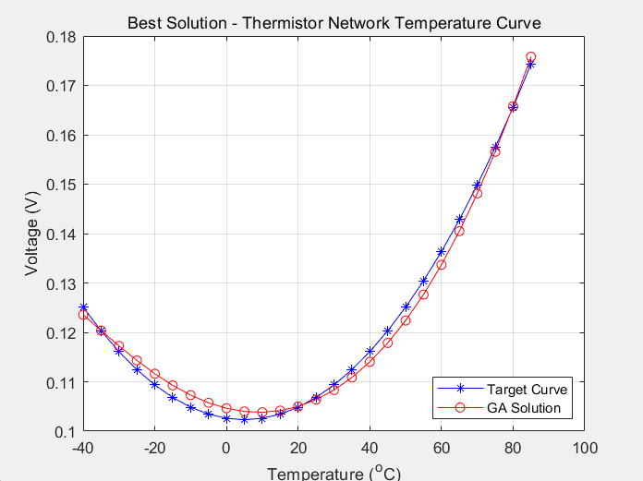
Figure 2: The curve corresponding to the optimal solution

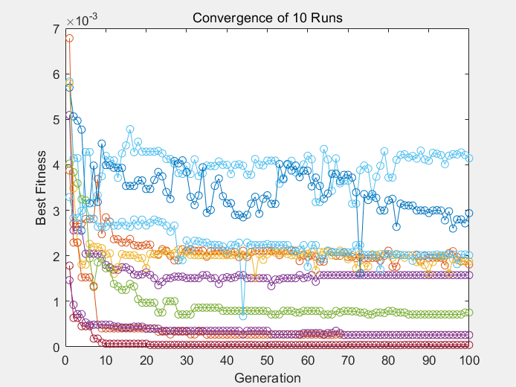
Figure 3: The convergence trend over 10 different GA settings
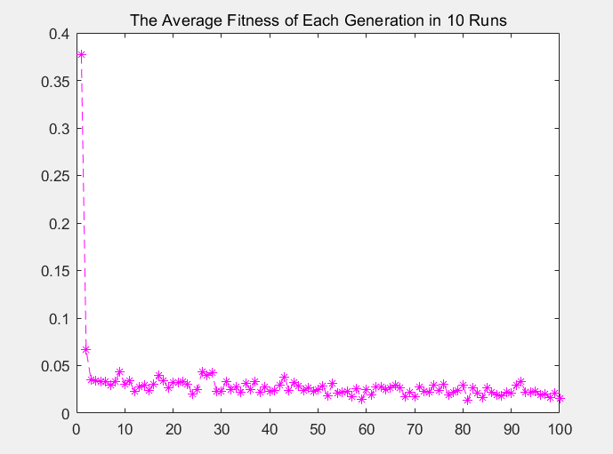
Figure 4: The average convergence trend over 10 different GA settings

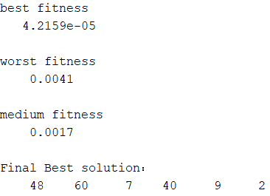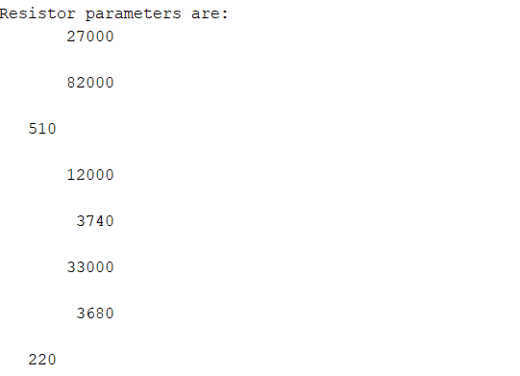
Figure 5: The final result and the overall best solution

Run | Population Size | Best Value | Worst Value | Mean Value
$$1$$ | 190 | 0.00184 | 4.7286 | 0.8722
$$2$$ | 200 | 0.00165 | 3.3960 | 0.2870
$$3$$ | 210 | 0.00413 | 10.974 | 0.5527
4 | 220 | 0.00297 | 11.587 | 0.4515
5 | 230 | 0.00192 | 8.7377 | 0.3940
6 | 240 | 0.00075 | 11.156 | 0.5638
7 | 250 | 0.00004 | 8.9805 | 0.2035
8 | 260 | 0.00026 | 11.587 | 0.5805
9 | 270 | 0.00025 | 8.7377 | 0.8063
10 | 280 | 0.00201 | 11.156 | 0.2144
Table 1: The results summary

The above graphs and tables clearly demonstrate the results of the genetic algorithm. It is evident that the algorithm performs very well and is able to converge to an optimal solution at a relatively fast rate. The results above highlight the effectiveness of the algorithm.
  - Discussion of GA Settings
In this genetic algorithm, I tested ten different population sizes to explore possible optimal solutions. The corresponding results can be seen in Table 1. As the number of runs increased, the population size also gradually grew. Initially, when the population size was small, we observed that the iteration results tended to converge to a relatively large value. This is because the number of individuals in the population was too small, making it difficult for the entire population to cover the search space. Furthermore, with a small population size, the probability of the entire population converging to a local optimal solution also increases. As the population size grew, we observed that the iteration results were converging towards increasingly lower values. However, as the population size continued to increase, the iteration results were no longer able to converge to the global optimal solution. This is because, with a very large population, genetic operations such as selection, crossover, and mutation may become less effective in improving the solution. In a large population, the differences between individuals are significant, which can lead to good genes being diluted by individuals with lower fitness. Additionally, an excessively large population may cause the algorithm to get stuck in multiple local optima, rather than quickly finding the global optimal solution.

References
- “Solving Mechanical Engineering Problems with MATLAB,” Mathworks.com, 2015, doi: https://doi.org/106114913842.woff2.

