UESTC3002: Machine Learning and AI
Lab Report 2
Abstract. In this lab session, we used an algorithm toolbox which was developed by the University of Sheffield to develop our GA (genetic algorithm) code. Here we showed a feasible method to construct a GA using this toolbox. To verify the effectiveness, the GA code was tested under the constraint of the PrG9c function and converged to the minimal value of this function. Furthermore, the selection of key parameters was also discussed in this article.
Keywords: Genetic Algorithm, Optimization
- Algorithm Establishment and Further Explanations
  - Parameters and Explanations
To achieve the best results of running, the selection of key parameters is very important. Here are the key parameters controlling the GA and the results.
Table 1. Key Parameters and Their Values and Explanations
Parameter | Significance | Explanation | Value
IterationNum | Iterate to Nth generations | The result gets the best value around 30 tries, so 50 tries is enough. | 50
PopulationSize | The size of the population | In this example, 500 individuals are enough to explore the search area. | 500
Crossover_Rate | Crossover possibility | The mixing of different chromes will lead to a higher population density. | 0.69
mutationRate | Mutation possibility | The mutation will increase the density. | [0.4, 0.85]
Runs | The number of loops | Run the test 20 times | 20
Penalty_Coefficient | Penalty coefficient | It is used to punish some individuals. | 2350
FieldDR | A vector which defines the upper bound and the lower bound of mutation | It covers the search range. | -10 to 10

  - Results and Analysis
The following figures show the results (see Fig. 1, 2, 3).
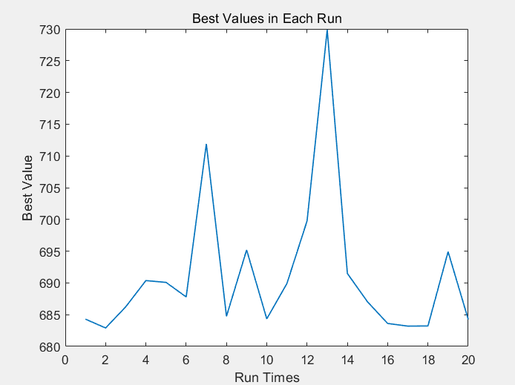
Fig. 1. The best values in 20 times of running, every run is individual.
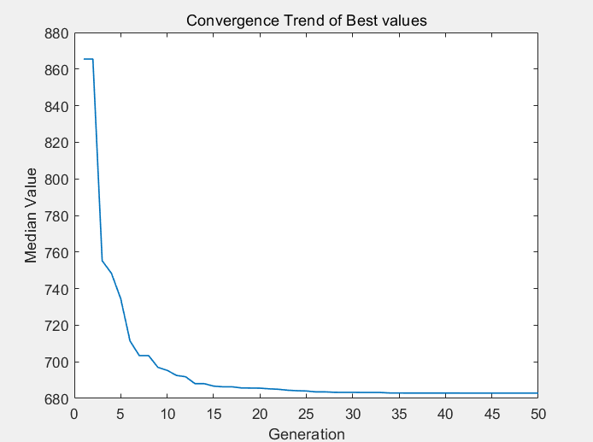
Fig. 2. The best values of each generation, which converge to the minimal value of objective function.
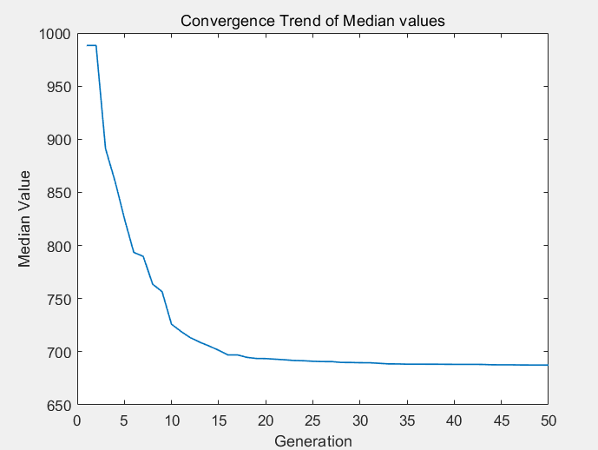
Fig. 3. The median values of each generation, which also converges.
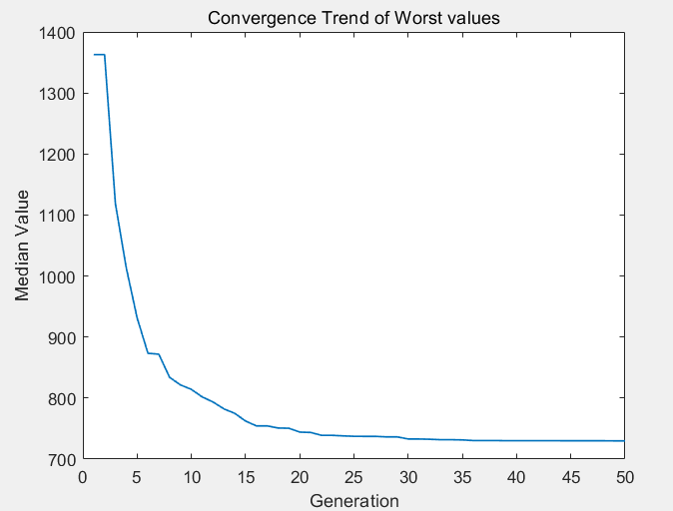
Fig. 4. The worst values of each generation, which also converge.
In the 20 runs, the optimization results converged well with the increase in generations. After 20 runs, the best individual from each run was compared, and the optimal individual was selected as the final optimization result. In the example of this article, the final optimization result was 682, which is very close to the global minimum value of the objective function, 680.
  - Codes
The code of main function is shown as following:
clc;
% Parameter settings
IterationNum=50; % Iteration generations
PopulationSize=500; % Size of population
Crossover_Rate=0.69; % Crossover possibility
mutationRate=[0.4,0.85]; % Mutation possibility and shrink coefficient
Runs=20; % Run times
Penalty_Coefficient=2350; % Penalty coefficient
FieldDR=[-10,-10,-10,-10,-10,-10,-10;10,10,10,10,10,10,10]% A vector which defines the upper bound and the lower bound of mutation

% Fitness values of each generation
allBestFitnessValues=zeros(Runs, IterationNum);

% Main loop, run Runs times
for run=1:Runs
% Initialize the population
population=-5 + 10 * rand(PopulationSize, 7);

% Initialize the fitness values
bestFitnessValues=zeros(1, IterationNum);

% Generation loops
for gen=1:IterationNum
% Calculate the fitness value
fitnessValues=arrayfun(@(i) PrG9f_withPenalty(population(i, :), Penalty_Coefficient), 1:PopulationSize);

% Storage the best fitness value of earlier generation
bestFitnessValues(gen)=min(fitnessValues);

% Storage the best individual at present
elite=population(find(fitnessValues==min(fitnessValues), 1), :);

% Selection operation using RWS
selectedPopulation=population(rws(fitnessValues, PopulationSize), :);

% Crossover operation using linear crossover
newPopulation=selectedPopulation;
for i=1:2:PopulationSize
crsover=[selectedPopulation(i, :), selectedPopulation(i+1, :)];
crossed=reclin(crsover,Crossover_Rate);
newPopulation(i, :)=crossed(1:7);
newPopulation(i+1, :)=crossed(8:14);
%end
end

% Real value mutation
for i=1:PopulationSize
if rand<mutationRate
newPopulation(i, :)=mutbga(newPopulation(i, :),FieldDR,mutationRate);
end
end
% Refresh the population and add elite individuals
population=newPopulation;
population(1, :)=elite;
end

% Storage the best fitness value of each generation
allBestFitnessValues(run, :)=bestFitnessValues;
end

% Calculate the medium value of each generation
medianBestFitnessValues=median(allBestFitnessValues);
% Calculate the best value of each generation
bestBestFitnessValues=min(allBestFitnessValues);
% Calculate the worst value of each generation
worstBestFitnessValues=max(allBestFitnessValues);

% Draw the median values with literation
figure;
plot(1:IterationNum, medianBestFitnessValues, 'LineWidth', 1);
xlabel('Generation');
ylabel('Median Value');
title('Convergence Trend of Median values');

% Draw the best values with literation
figure;
plot(1:IterationNum, bestBestFitnessValues, 'LineWidth', 1);
xlabel('Generation');
ylabel('Median Value');
title('Convergence Trend of Best values');

% Draw the median values with literation
figure;
plot(1:IterationNum, worstBestFitnessValues, 'LineWidth', 1);
xlabel('Generation');
ylabel('Median Value');
title('Convergence Trend of Worst values');

% Calculate the final best value
finalBestValues = allBestFitnessValues(:, end); % Find the best fitness of each iteration

% Draw the final best values with each run
figure;
plot(1:Runs, finalBestValues, 'LineWidth', 1);
xlabel('Run Times');
ylabel('Best Value');
title('Best Values in Each Run');

bestResult=min(finalBestValues);
worstResult=max(finalBestValues);
meanResult=mean(finalBestValues);
medianResult=median(finalBestValues);

% Print the best values
fprintf('BestValue of 20 Runs: %.4f\n', bestResult);
fprintf('WorstValue of 20 Runs: %.4f\n', worstResult);
fprintf('MeanValue of 20 Runs: %.4f\n', meanResult);
fprintf('MediumValue of 20 Runs: %.4f\n', medianResult);

% Define the objective function
% G9function, which contains the penalty
function y=PrG9f_withPenalty(x, penaltyFactor)
% Original function
y = (x(1)-10)^2 + 5*(x(2)-12)^2 + x(3)^4 + 3*(x(4)-11)^2 ...
+ 10*x(5)^6 + 7*x(6)^2 + x(7)^4 - 4*x(6)*x(7) - 10*x(6) - 8*x(7);

% Constrains and plenty values
constraints=PrG9c(x);
penalties=sum(max(0, constraints) .* penaltyFactor);
y=y + penalties;
end

% Function PrG9c
function y = PrG9c(x)
% Constrain defination
v1 = 2*x(1)^2;
v2 = x(2)^2;
y(1) = v1 + 3*v2^2 + x(3) + 4*x(4)^2 + 5*x(5) - 127;
y(2) = 7*x(1) + 3*x(2) + 10*x(3)^2 + x(4) - x(5) - 282;
y(3) = 23*x(1) + v2 + 6*x(6)^2 - 8*x(7) - 196;
y(4) = 2*v1 + v2 - 3*x(1)*x(2) + 2*x(3)^2 + 5*x(6) - 11*x(7);
% Lower bounds of variables
for j=1:7; y(j+4) = -x(j) - 10; end
% Upper bounds of variables
for j=1:7; y(j+11) = x(j) - 10; end
y = y';
end

References
- “Genetic Algorithms Toolbox,” Github.io, 2024. https://uos-codem.github.io/GA-Toolbox/ (accessed Nov. 12, 2024).
- “G9 Problem,” www-optima.amp.i.kyoto-u.ac.jp. http://www-optima.amp.i.kyoto-u.ac.jp/member/student/hedar/Hedar_files/TestGO_files/Page898.htm

