Prepare an application that will download from an external file users.json data and displays them in a table on the screen (as shown below)

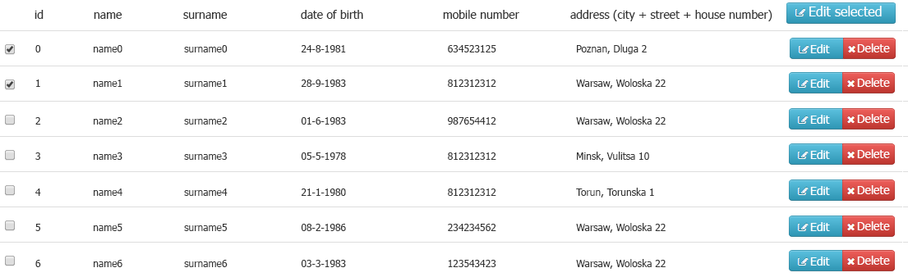

Buttons: "edit" and "delete" respectively edit and delete specific users. It should also be possible to edit multiple users at once (by selecting specific checkboxes and press the "Edit selected" button.

**use angularJS 1.x and jasmine test framework**

**mock/stub the datas**

**concentrate on proper design and clean code, rather than UI design**