IPass: Travel Order System for National Commission on Indigenous Peoples Regional Office 1

A Project Documentation
Presented to the Faculty of Information Technology
Saint Louis College
City of San Fernando, La Union

In Partial Fulfilment of the Requirements for the Course
IT122 Capstone Project 1

Submitted To:
Marie Ann G. Fontanilla, MIT

Submitted by:
ESTOESTA, Trisha Ann M.
MANZANO, Genielee V.
MERCIALES, John Edward M.
ROSARIO, Jezter S.
VILUAN, Jan Rey F.

July 2025
Acknowledgement

We, the researchers of this study, express our deepest gratitude to Almighty God for His guidance, wisdom, and strength, which have sustained us throughout the completion of this capstone project.
We are also thankful to the National Commission on Indigenous Peoples – Regional Office I for the opportunity to conduct this study within their agency. Their support has been instrumental in helping us develop practical insights and solutions relevant to their travel management process.
Our heartfelt appreciation goes to our dedicated and supportive Research Adviser, Ms. Marie Ann Fontanilla, for her consistent guidance, motivation, and invaluable feedback throughout the course of our study. We also extend our thanks to the Information Technology Faculty of Saint Louis College for the knowledge, skills, and mentorship they have imparted to us over the past academic years.
Lastly, we sincerely thank the personnel and staff of NCIP Regional Office I for their cooperation and for providing the necessary documents and information that made this research possible.

The Researcher
Dedication
We dedicate this capstone project to the personnel and leadership of the National Commission on Indigenous Peoples – Regional Office I, with the hope that our work may contribute to improving their processes and supporting the efficiency of their travel management system.
This study is also dedicated to our classmates and friends, whose encouragement and camaraderie inspired us throughout our capstone journey. We are truly grateful to our parents, guardians, and sponsors for their unwavering love and financial support, especially in allowing us to pursue our Research Methods course at Saint Louis College.
A heartfelt thank you goes to our capstone adviser, whose patience, guidance, and expertise helped shape this study and sharpen our research abilities.
Above all, we dedicate this work to Almighty God, whose wisdom, strength, and grace empowered us to complete this endeavour.

As we progressed in writing this manuscript, we often reflected on this quote as a reminder of effort and perseverance:

“The path to success is to take massive, determined action." - Tony Robbins
ABSTRACT

Efficient travel management is essential for maintaining productivity, accountability, and proper use of public resources in government agencies. However, the National Commission on Indigenous Peoples (NCIP) Regional Office I continues to rely on a manual travel order process, resulting in data inconsistencies, approval delays, and difficulties in generating reports. These challenges hinder administrative efficiency and transparency. To address these issues, this study developed IPASS: A Travel Order System, a centralized web-based application designed to streamline the creation, approval, monitoring, and liquidation of travel requests.
This study aims to automate and standardize the travel order workflow by implementing a role-based system accessible to employees, division heads, and approving authorities. The system minimizes human error, facilitates faster processing, and improves overall tracking of travel transactions. A descriptive and developmental research design was employed to assess the current manual system and guide the development of a digital alternative. Data were gathered through interviews, documentary analysis, and the review of relevant policies and forms provided by the NCIP.
IPASS features centralized data management, digital signature integration, real-time approval status tracking, automated report generation, and liquidation validation. The system's interface is designed for ease of use, ensuring accessibility across various user roles. Findings indicate that the proposed system enhances data accuracy, reduces administrative burden, and supports efficient compliance with government travel policies. This project contributes to the digital transformation of public service processes by offering a scalable solution for managing official travels in government offices.
Keywords: Travel Order System, Web-based Application, Digital Transformation, Automated Report Generation, Centralized Data Management, Digital Signature Integration, Real-time Approval Tracking, Automated Report, Automated Liquidation.

TABLE OF CONTENTS

Preliminaries | Pages
Title Page………………………………………………………………….. | i
Acknowledgement………………………………………………………. | ii
Dedication…………………………………………………………………. | iii
Abstract…………………………………………………………………….. | iv
Table of Contents……………………………………………………….. | vi
List of Figures……………………………………………………………. | viii
List of Appendices………………………………………………………. | ix
CHAPTER I: INTRODUCTION
Rationale……….…………………………………………………………… | 1
Conceptual Framework…………………………………………………. | 3
Problem Definition……………………………………………………….. | 8
Objectives of the Study………………………………………………….. | 9
Scope and Limitation…...……………………………………………….. | 11
Definition of Terms……..………………………………………………… | 14
Hardware and Software Requirements………………………………. | 16
CHAPTER II: DATA GATHERING METHOD
Research Design…………………………………………………………..  Locale of the Study……………………………………………………… | 17  18
Primary Source of Data…………………………………………………. | 19
Secondary Source of Data……………………………………………….  Ethical Consideration……………………………………………………. | 20  20
CHAPTER III: SYSTEM MODELS
Existing Process Flowchart…………………………………………….. | 22
Proposed Process Flowchart……………………………………………. | 23
Use Case Diagram………………………………………………………… | 28
Top Level Diagram……………………………………………………….. | 29
IPO Diagram……………………………………………………………….. | 30
Entity Relationship Diagram……………………………………………  Relational Database Schema……………………………………………  Logical Structure………………………………………………………….. | 33  34  35
CHAPTER IV: PROTOTYPES
Login...………………………………………………………………………. | 39
Dashboard (Admin view)….…………………………………………… | 39
Employee Travels…………………………………………………………. | 40
User Management………………………………………………………… | 40
Reports……….……………………………………………………………... | 41
Dashboard (Regional Director view)………………………………..… | 42
Dashboard (Employee view) …….………………………………………  My Travels…………………………………………………………………..  Travel Request Form……………………………………………………… | 44  44  45
REFERENCES…………………………………………………………………. | 48
APPENDICES………………………………………………………………….. | 51
INSTITUTIONAL VISION-MISSION………………………………………. | 59
LIST OF FIGURES

Figures | Pages
1 Hardware Requirements………………………………………… | 16
2 Software Requirements……………………………………..…… | 16
3 Use Case Diagram………………………………………………… | 28
4 Top Level Diagram………………………………………………... | 29
5 IPO Diagram……..…………………………………..…………….. | 30
6 Entity Relationship Diagram………………………………..…..  7 Relational Database Schema………………………….………..  8 Logical Data Structure……………………………………….….. | 33  34  35

LIST OF APPENDICES

Appendices |  | Pages
A | Letter of Request to Conduct Study……………………. | 51
B | Picture taken during the interview……………………… | 52
C | Letter of Invitation to External Panellist….…………… | 53
D | Interview Questions…….…………………………………. | 54
E  F  G  H | Sample Company Forms….……………………………...  Certification of Language Editor………………………...  Gantt Chart………………………………………………….  User Manual…………………………………………………. | 55  56  57  58

Chapter I

INTRODUCTION

Rationale
In today’s fast-paced business environment, where globalization and digitalization have accelerated the pace of decision-making and collaboration, optimizing the travel request and approval process has become a strategic imperative. The increasing integration of digital processes within various sectors, such as commerce, healthcare, education, and government, has clearly led to more efficient operations and better user experience. Furthermore, the use of IT in the workplace improves communication among employees enhances the quality of service provided. By integrating technology into traditional manual processes, organizations gain the ability to enhance overall efficiency. This can lead to faster transaction and processes.
Italy, one the largest telecom markets in Europe, with rapidly growing demand for faster and seamless connectivity. Promoting public-private partnerships to encourage collaboration and digital transformation among sectors, creating opportunities for companies to offer innovative solutions (Martucci, 2024). As different transactions among organizations continues to rise, seeking to enhance efficiency and cost-effectiveness in their operations, streamlining the travel request and appro0val process is of paramount importance. The process of requesting and approving travel expenses is a multifaceted and indispensable aspect of organizational management, influencing both the financial well-being and the operational agility of a company. It encompasses various activities, ranging from employees submitting travel requests to managers evaluating them, all the way to financial teams disbursing funds. Efficiently managing this workflow can result in significant benefits, such as minimizing unnecessary costs, reducing administrative burdens, and ensuring compliance with corporate policies and government regulations (Dogan and de Leoni, 2023).
Maderazo and Encarnacion (2024) conducted a study focusing on the development of a centralized travel and tour operation management system in Surigao City. Their research addressed issues such as fragmented processes and lack of integration in existing systems, proposing a comprehensive platform that incorporates booking management, customer relationship management, and analytics to enhance operational efficiency and customer satisfaction. The study utilized both qualitative and quantitative methods, including purposive sampling of local and international tourists, to identify challenges in the current booking processes and inform the system's design.
In Pangasinan State University, located in Region I of the Philippines, the institution implements travel order procedures as part of its operational requirements, particularly in support of research, extension, and innovation programs. The university requires personnel to submit a copy of an approved travel order, together with an itinerary and relevant documentation, to justify travel and ensure that expenses align with institutional goals. Despite the clear guidelines outlined in the university's REI Manual, the current processing of travel requests remains mostly traditional and paper-based. This manual method is prone to inefficiencies, delays, and increased administrative burden. As such, a web-based solution is recommended to modernize and streamline the travel order system. The integration of Information and Communications Technology (ICT) into administrative operations offers improved efficiency, faster processing, and better document management. By digitizing these workflows, academic institutions like PSU can enhance accountability, reduce manual errors, and adapt to modern standards of service delivery in the public education sector (Buted et al., 2023).
Currently, National Commission on Indigenous People – Region 1 uses a manual travel order. When an employee asks for an approval for travel request, the employee will then send the letter of request to their head office. Afterwards, the head office will review and send it to the AFSD head until it will reach the Regional Director. The NCIP-Region 1 considered this inefficient due to the amount of time and workforce they need to submit, review, and approve the travel request. The amount of effort to request a travel order can lead to decreasing productivity and delay.
Given the growing need for operational efficiency, transparency, and responsiveness in public agencies, the development of a digitized travel order system is not merely an innovation, it is a necessary step toward modern governance. Embracing a web-based solution will empower agencies like NCIP–Region 1 to reduce delays, eliminate redundancies, and ensure that public service delivery meets the demands of a fast-evolving digital era.

Conceptual Framework
Executive Order No. 77 “Prescribing Rules and Regulations and Rates of Expenses and Allowances for Official Local and Foreign Travels of Government Personnel” serves as a regulatory framework for official local and foreign travels of government personnel, ensuring the prudent and accountable use of public funds. This directive is significant as it standardizes travel protocols across a broad spectrum of government institutions, including National Government Agencies (NGAs), State Universities and Colleges (SUCs), Government-Owned or -Controlled Corporations (GOCCs), Government Financial Institutions (GFIs), the Congress of the Philippines, the Judiciary, Constitutional Commissions, the Office of the Ombudsman, and Local Government Units (LGUs). By encompassing both local and foreign travel, the order promotes uniformity and consistency in travel procedures and approvals, preventing abuse and unnecessary expenditures. Moreover, it reinforces the principle of transparency by requiring proper documentation, justification, and post-travel reports to validate the necessity and outcomes of official trips. The EO also emphasizes that all travels must be directly linked to the performance of official duties and aligned with the goals of the respective agencies. As such, it supports the government's commitment to fiscal discipline, while ensuring that official travel contributes meaningfully to public service delivery and institutional development.
(a) This order covers both local and foreign official travels. (b) It ensures that travel policies are uniformly applied across all covered government entities. (c) The order aims to promote accountability and efficiency in the use of government resources related to official travel.
This executive order served as a guideline in designing system features such as the automated approval process, mandatory travel documentation, and report generation. The system ensures that all travel requests submitted are aligned with official duties, as prescribed by EO No. 77.
COA Circular No. 2012-001 “Prescribing the Revised Guidelines and Documentary Requirements for Common Government Transactions” enhances fiscal discipline by mandating strict compliance with its documentary and procedural requirements to ensure transparency and accountability in official travel. It requires that all travel-related cash advances and liquidations be properly supported local or foreign with signed travel orders, itineraries, and official receipts, and that any previous travel advances must be fully liquidated before new ones are issued. The circular reinforces that foreign travel expenses are reimbursed only under specific and limited conditions such as for international commitments or training when local representation is not feasible and explicitly prohibits trips abroad for officials nearing retirement within a year, as stipulated by the FY 2012 General Appropriations Act. It further underscores that clothing allowances for travel have been suspended under Memorandum Circular No. 52, requiring travel allowances to be treated strictly as cash advances subject to full liquidation. Moreover, the circular reiterates foundational principles of public financial management such as legal authority for disbursements, approval by competent officials, and adherence to audit documentation to prevent irregular, unnecessary, or extravagant expenditures.
(a) Under Section 2 of Executive Order No. 248 dated May 29, 1995, as amended by EO No. 248-A (1995) and EO No. 298 (2004), official travels shall only cover those that are urgent and extremely necessary, involve minimum expenditure, and provide benefits to the agency concerned and/or the country. (b) No government funds shall be used to cover foreign travel expenses of government officials or employees, except for training, seminars, or conferences abroad when foreign mission personnel cannot effectively represent the country, or when travels are necessitated by international commitments. (c) Further, officials or employees, including uniformed personnel from the Department of the Interior and Local Government (DILG) and Department of National Defense (DND), who are due to retire within one year after the foreign travel, shall not be sent abroad for such purposes, as stated under Section 16(c) of the Fiscal Year 2012 General Appropriations Act. (d) Pursuant to Memorandum Circular No. 52 dated October 2, 2003, the grant of clothing allowance for all categories of trips is suspended indefinitely. (e) Traveling allowances granted are treated as cash advances, and no additional cash advance shall be issued unless the previous one has been fully liquidated and accounted for, according to Item 4.1.3(ii) of COA Circular No. 2009-002 dated May 18, 2009. (f) The guidelines on granting traveling allowances are detailed in COA Circular No. 96-004 dated April 19, 1996.
This circular guided the system's implementation of strict liquidation validation, including features to ensure all travel-related financial transactions are supported by digital records and documents. The system disallows submission of new travel orders without first completing and validating pending liquidations, thereby ensuring compliance with COA regulations.
Presidential Decree No. 1445 “Ordaining and Instituting a Government Auditing Code of the Philippines” establishes the fundamental principles that govern the financial transactions and operations of government agencies to ensure accountability and proper use of public funds. This decree underscores the importance of accountability, transparency, and proper management of public funds. It designates the Commission on Audit (COA) as the central auditing authority, granting it the mandate to examine, audit, and settle all accounts involving the receipt and expenditure of government funds. By doing so, COA ensures that public resources are utilized in accordance with laws and regulations and that public officials are held responsible for any misuse or inefficiency in financial operations.
(a) No money shall be paid out of any public treasury or depository except in pursuance of an appropriation law or other specific statutory authority. (b) Government funds or property shall be spent or used solely for public purposes. (c) Trust funds shall be available and may be spent only for the specific purpose for which the trust was created or the funds received. (d) Fiscal responsibility shall be shared to the greatest extent by all those exercising authority over the financial affairs, transactions, and operations of the government agency. (e) Disbursements or disposition of government funds or property shall invariably bear the approval of the proper officials. (f) Claims against government funds shall be supported with complete documentation. (g) All laws and regulations applicable to financial transactions shall be faithfully adhered to. (h) Generally accepted principles and practices of accounting as well as sound management and fiscal administration shall be observed, provided that they do not contravene existing laws and regulations.
This study used PD No. 1445 as the basis for building the system’s financial control features. The system ensures that all claims, approvals, and expense records are fully documented and auditable. It also promotes fiscal transparency by requiring proper authorization and role-based verification of all transactions and reports.

Problem Definition
The researchers proposed a Travel Order System for National Commission on Indigenous Peoples Regional Office to solve existing problems faced by NCIP employees.
The problems encountered are:
- Inconsistent and Error-Prone Data Handling. The NCIP Regional Office I still uses manual processes to manage travel orders, with employees filling out forms by hand or keeping separate files. This often leads to errors such as incorrect, missing, or duplicate information, making it hard to check records, prepare accurate reports, or track past travels. As a result, the process is slow, confusing, and prone to miscommunication between offices.
- Inadequate Monitoring of Travel Request Applications. At NCIP Regional Office I, travel requests are handled manually through forms, emails, or messaging apps, making it difficult to track their status and approvals. Without a centralized system, the process often causes delays, missed approvals, and confusion, leaving both employees and approvers with no clear way to monitor pending requests.
- Inefficient Liquidation Process. The liquidation of travel expenses at NCIP Regional Office I is slow because it is done manually. Employees submit forms or emails that are often incomplete or inconsistent, making it hard for accountants to check and process them on time. Without a single system to track liquidations, delays, missing documents, and possible misuse of funds can happen, which affects reports, audits, and accountability.

Objectives of the Study
The general objective of this study is to develop a Travel Order System for National Commission on Indigenous Peoples Regional Office.
Specifically, the study aims to:
- Develop a system that uses a centralized database to accurately manage and store travel order information. This system will ensure consistent, secure, and real-time access to travel details such as employee information, destinations, and develop a system of expenses based on user roles like Employees, CSC Heads, PO Heads, Division Chiefs, Regional Director, Bookkeeper, and Accountant.
- Develop a system that enables real-time monitoring and centralized tracking of travel request applications, allowing both employees and approvers to view the status, history, and progress of each request. The system will reduce delays, avoid missed approvals, and improve visibility and accountability throughout the travel request process.
- Develop a system that simplifies and organizes the liquidation process by allowing digital submission, validation, and tracking of travel expense reports to improve accuracy, accountability, and audit readiness.

Scope and Limitations
The Travel Order System that is being proposed is a computerized application and supports the automation and streamlining of the travel request, approval, and monitoring of the process among the offices and numerous levels of management.
The proposed system will have eight users, who are Normal User (Employee), Community Service Center Head, Provincial Office Head, Technical Management Services Division Chief, Administrative and Financial Services Division Chief, Regional Director, Bookkeeper, and Accountant. Each user has a different role and level of access depending on the user's position.
The Normal User (Employee) should log on to the system. The employees have access to the following features: (1) Create Travel Order, which is for the employee to enter the destination, dates, purpose, and estimated expenses. (2) Attach Digital Signature to verify identity. (3) Check the status of Travel Orders, where employees can check for approval or disapproval. (4) Edit Rejected Travel Orders, with this, the employees can change any rejected requests and resubmit those requests as needed. (5) Amend approved Travel Orders.
The Head of the CSC will also log into the system. Features available to the Head of the CSC include: (1) Review Submitted Travel Orders from CSC employees, (2) Approve or Disapprove Travel Orders, which clearly indicates a digital signature, or returning travel orders with comments for revision, and (3) Forward Approved Requests to the Head of PO for the next level of endorsement.
The PO Head has similar responsibilities. The PO Head will: (1) Review and endorse Travel Orders that CSC and PO employees submit. (2) Approve or Disapprove Requests, adding a digital signature and/or returning a disapproved order with remarks. (3) Email Approved Travel Orders to the AFSD Chief.
The TMSD Chief will use the system for the management of travel approvals. TMSD Chief Functions include: (1) Reviewing Travel Orders submitted by TMSD employees. (2) Approving or Disapproving and Endorsing travel orders with necessary comments. (3) Forwarding Endorsed Travel Orders to the AFSD Chief for review.
The AFSD Chief serves a broader oversight of travel orders. The duties of the AFSD Chief include: (1) Reviewing Endorsed Travel Orders submitted by PO Heads and TMSD Chief. (2) Ensuring compliance with financial guidelines and administrative orders. (3) Approving or disapproving requests and finalizing before forwarding to the Regional Director.
The Regional Director is the final approving authority in the travel order process. The Regional Director has access to: (1) Review fully endorsed and approved travel requests. (2) Approve or disapprove the travel order. However, it is important to note that the system currently has a limitation wherein the Regional Director cannot file their own travel order and must instead have it processed through manual means or by an authorized staff member.
The Bookkeeper is responsible for managing the liquidation process after the travel is completed. The Bookkeeper will: (1) Receive liquidation documents submitted by the person with the travel claim, such as the Certification of Travel Completed. (2) Review the Certificate of Appearance to verify that the employee reached the intended travel destination. (3) Ensure all required supporting documents are complete and forward them to the Accounting Personnel for validation.
The Accounting Personnel is tasked with verifying and recording the liquidation reports. The Accounting user will: (1) Review the After Travel Report to confirm that the objectives of the travel were accomplished. (2) Validate the accuracy and completeness of all supporting documentation submitted by the Bookkeeper. (3) Finalize and record travel expenses for proper auditing and reimbursement processes.
One limitation of the proposed Travel Order System is that it does not allow the Regional Director to submit or initiate their own travel order within the system. While the system accommodates multiple user roles such as Employees, Division Chiefs, and Accounting Personnel. The functionality for Regional Director Travel requests remains manual and must be processed through the Executive Director or an authorized staff member.
Another limitation of the system is that it does not have a built-in feature to automatically track discrepancies between the approved travel order amount and the actual expenses incurred during liquidation. It lacks the capability to detect whether there is an excess or deficiency in the amount spent, which could lead to challenges in accurately monitoring pending reimbursements or overpayments.
Another limitation is the system requires users to manually input the estimated distance for each travel request. This manual process may lead to inconsistencies in data, potential inaccuracies.
Another limitation of the system is that it does not currently support the processing or tracking of cash advances related to official travel. While the system handles travel requests, approvals, and liquidations, it lacks a feature to request, approve, or monitor cash advances issued to employees prior to travel. This may result in continued reliance on manual or external processes to handle cash advance transactions, which could affect the completeness of financial tracking and the integration of travel-related expenses within the system.
Finally, the Admin is only responsible for managing user accounts and does not have access to create or submit travel orders. Their role is focused on handling tasks such as adding users, editing account details, setting access levels, and managing account status. This setup clearly separates administrative tasks from the travel request process, ensuring that the admin cannot interfere with or participate in travel-related activities. This helps maintain fairness, transparency, and security within the system.

Definition of Terms
To facilitate the understanding of this study, different terms are defined herein.
Approval Hierarchy. In the IPass system, Approval Hierarchy is the step-by-step process by which travel requests pass through specific roles—CSC Head, PO Head, TMSD Chief, AFSD Chief, and Regional Director—for evaluation and approval.
Liquidation. Liquidation is the process handled within the IPass system after the travel is completed, where the employee submits required documents (e.g., Certificate of Appearance) for financial clearance and reimbursement.
Travel Order. In this study, Travel Order refers to a digital form submitted by an NCIP employee through the IPass system to request approval for official travel. It includes the traveler's details, destination, purpose, schedule, and estimated expenses.
Workflow Automation. This term refers to the automated sequence of actions from submission, approval, to monitoring of travel requests in the IPass system, replacing manual routing and paper-based tracking.

Hardware and Software Requirements
Hardware Requirements
Hardware | Server | Client
Processor | Intel Core i5 or higher | Intel Core i3 or higher
RAM | 16 GB or higher | 4 GB (8 GB recommended)
Storage | 512 GB SSD (1 TB recommended) | 100 GB HDD/SSD

Software Requirements
Hardware | Server | Client
Operating System | Ubuntu Server 22.04 LTS or Windows Server 2019 | Windows 10 / macOS / Linux
Web Browser | Google Chrome, Microsoft Edge | Google Chrome, Microsoft Edge
Database Software | MySQL 8
Database Server | MySQL Server

Chapter II

DATA GATHERING METHODS
Research Design
Descriptive research design involves observing and collecting data on a given topic without attempting to infer cause-and-effect relationships. The goal of descriptive research is to provide a comprehensive and accurate picture of the population or phenomenon being studied and to describe the relationships, patterns, and trends that exist within the data. (Sirisilla & Sirisilla, 2023). There are three basic approaches for gathering data in descriptive research: survey, which involves administering structured questionnaires or conducting interviews to collect data from individuals or groups. Observations: systematically observes and records behaviors, events, or phenomena in natural settings. Content Analysis: It examines textual, visual, or audio content to identify patterns, themes, or trends within the data. (Aggarwal, 2024).
Developmental research designs are systematic frameworks such as cross-sectional, longitudinal, and sequential designs used to examine how individuals evolve over time. These designs allow researchers to distinguish between age-related changes and influences from generational cohorts or testing periods, and to understand how factors like gender and socioeconomic status shape developmental trajectories (Lumen Learning, n.d.).

Locale of the Study
The National Commission on Indigenous Peoples (NCIP) plays a vital role in ensuring the protection and promotion of indigenous rights across the Philippines. The National Commission on Indigenous Peoples (NCIP) located in Sevilla, San Fernando, La Union operates under NCIP Region I, with its regional office located in San Fernando City, La Union. The agency is mandated by Republic Act No. 8371, also known as the Indigenous Peoples Rights Act (IPRA) of 1997, to protect and promote the rights, welfare, and cultural integrity of Indigenous Cultural Communities or Indigenous Peoples (ICCs/IPs) in the region.
The NCIP La Union is tasked with implementing national policies and programs that uphold the rights of Indigenous Cultural Communities and Indigenous Peoples (ICCs/IPs). One of its key responsibilities is the recognition of ancestral domains through the processing and issuance of Certificates of Ancestral Domain Titles (CADTs) and Certificates of Ancestral Land Titles (CALTs). The office ensures that indigenous communities are properly consulted and provide Free, Prior, and Informed Consent (FPIC) before any project that may affect their ancestral lands is initiated. In addition to protecting ancestral domains, NCIP La Union promotes the preservation of the rich cultural heritage, traditions, and practices of indigenous communities. It also actively facilitates development programs aimed at improving the socio-economic conditions of ICCs/IPs, focusing on areas such as education, health, and livelihood enhancement.
Primary Sources of Data
Interview
We gathered information through an interview. The researchers conducted an initial interview with the National Commission on Indigenous People Regional Office 1 to deeply understand the current operations and challenges the NCIP faces in terms of managing and tracking travel requests and expenses. The interview was conducted face-to-face on the 14th of April and 5th of May, 2025, with the NCIP Regional Office 1 ICT Focal Person. Participants were informed about the purpose of the study, ensuring the confidentiality of information shared. The interview provided a valuable insight into the operational inefficiencies and NCIP’s existing travel order process.

Documentary Analysis
Information was collected through the analysis of documents and records provided by the National Commission on Indigenous Peoples Regional Office I. The ICT Focal Person allowed the researchers to review several official travel forms used by the agency. Among the documents examined were the Travel Order Form, which is the standardized form used to authorize official field assignments of personnel. The Travel Order Form includes essential details such as the travel order number, name of the employee, position, destination, purpose of travel, duration, and the signature of the approving authority.
Secondary Sources of Data
Internet
Information was collected from online articles and websites that described how other government agencies manage their travel order. The researchers also reviewed a couple examples of digital systems that public offices use to improve how travel requests are processed. This information provided the information needed to develop recommendations on how to make the NCIP Travel Order System faster, more efficient and easier to use by employees working in the field.
Books
These books featured specific legislative frameworks, such as the Indigenous Peoples Rights Act (IPRA), the obligations of the National Commission on Indigenous Peoples (NCIP), and Indigenous Peoples' rights. The researchers reviewed these records to gain a better understanding of government processes, Indigenous cultural features, and best practices. The use of books to supplement primary data (document analysis and interviews) was stressed to improve and create a solid foundation for the NCIP trip order system.

Ethical Consideration
This study strictly followed institutional guidelines for conducting research and was reviewed and evaluated by the Research Ethics Review Board. The researchers informed the appropriate authorities and focal persons before conducting the study. Communication letters were prepared, duly signed, and acknowledged by the proper authorities. Participants were fully informed of the study's nature and purpose, and a briefing was provided.
Consent letters were given to participants prior to the interview, and permission to record the interviews was obtained. The information gathered from the interviews was handled with utmost confidentiality and used solely for this study. To ensure accuracy and ethical standards, Grammarly was employed for grammar checking, and Turnitin was used for plagiarism detection.

Chapter III

SYSTEM MODELS
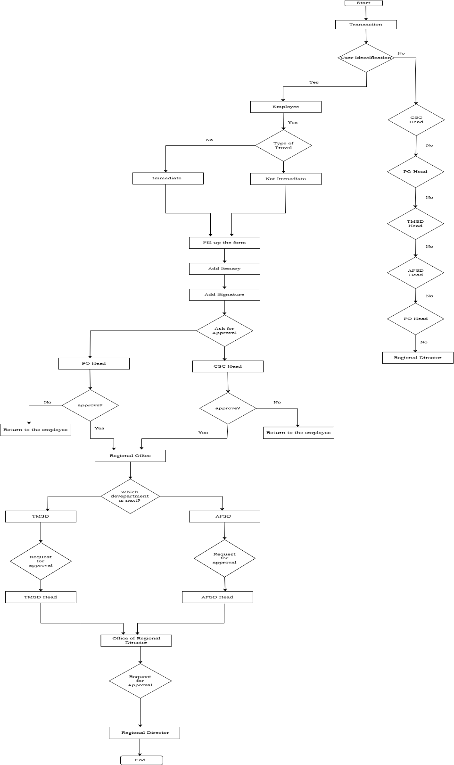
Existing Process Flow

Proposed Process Flow
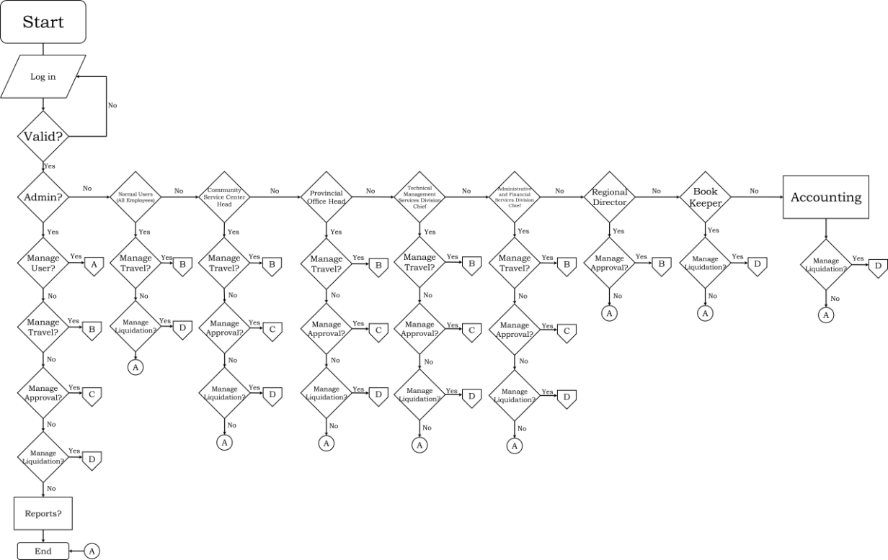
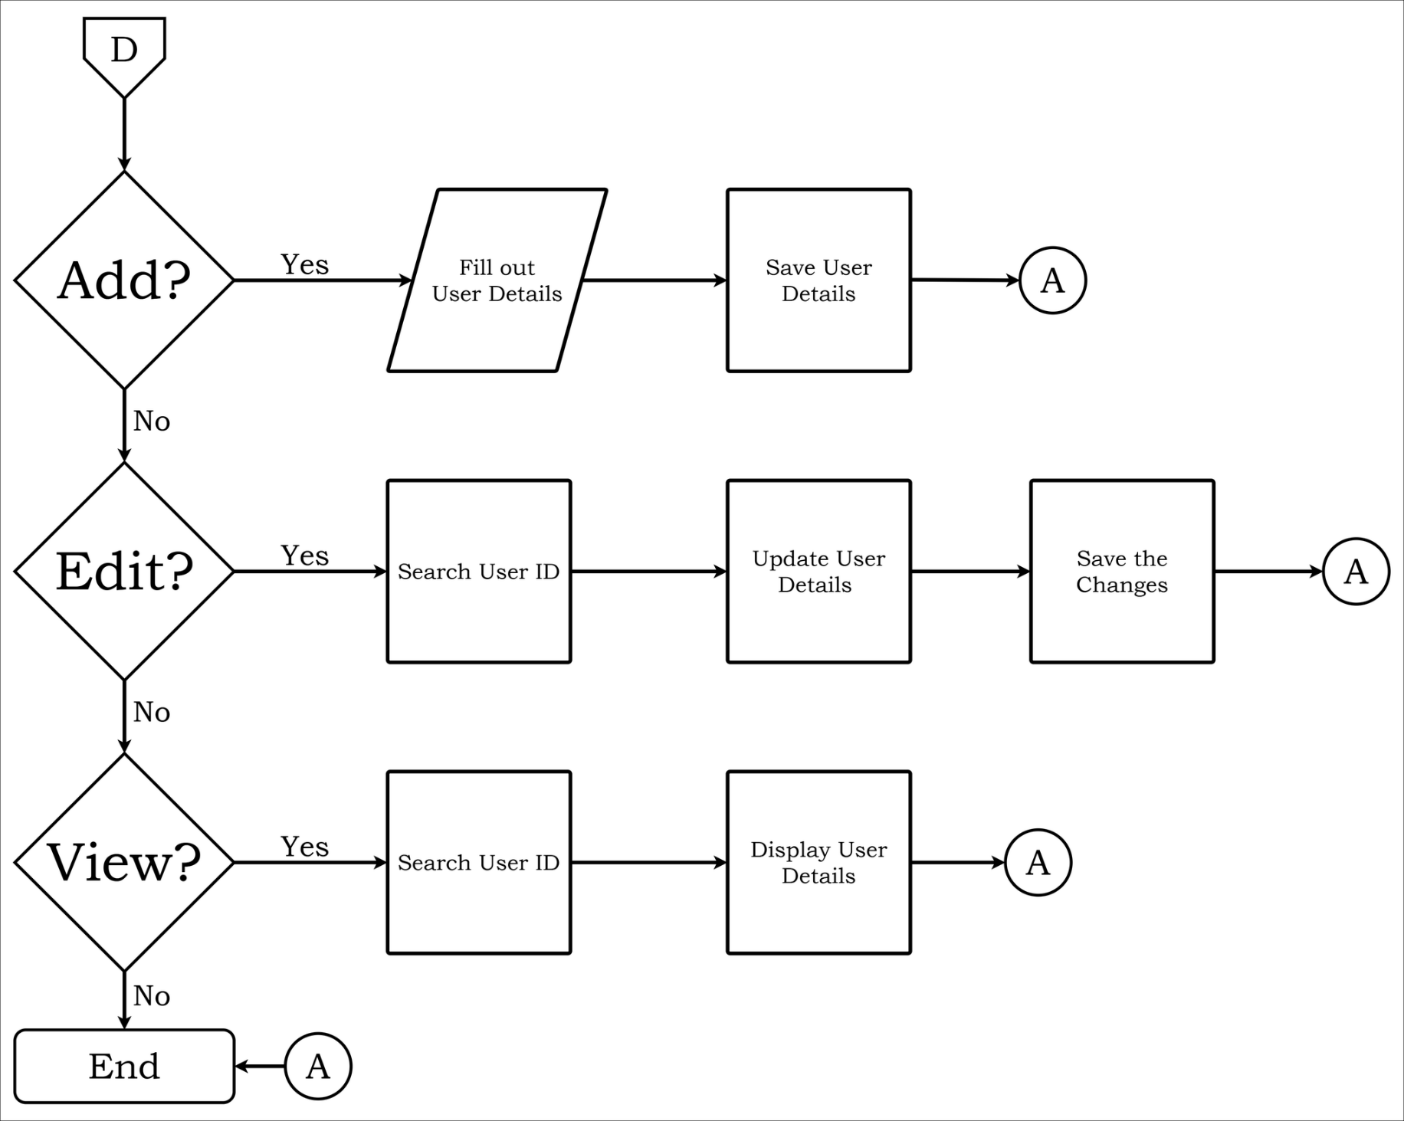
Manage User

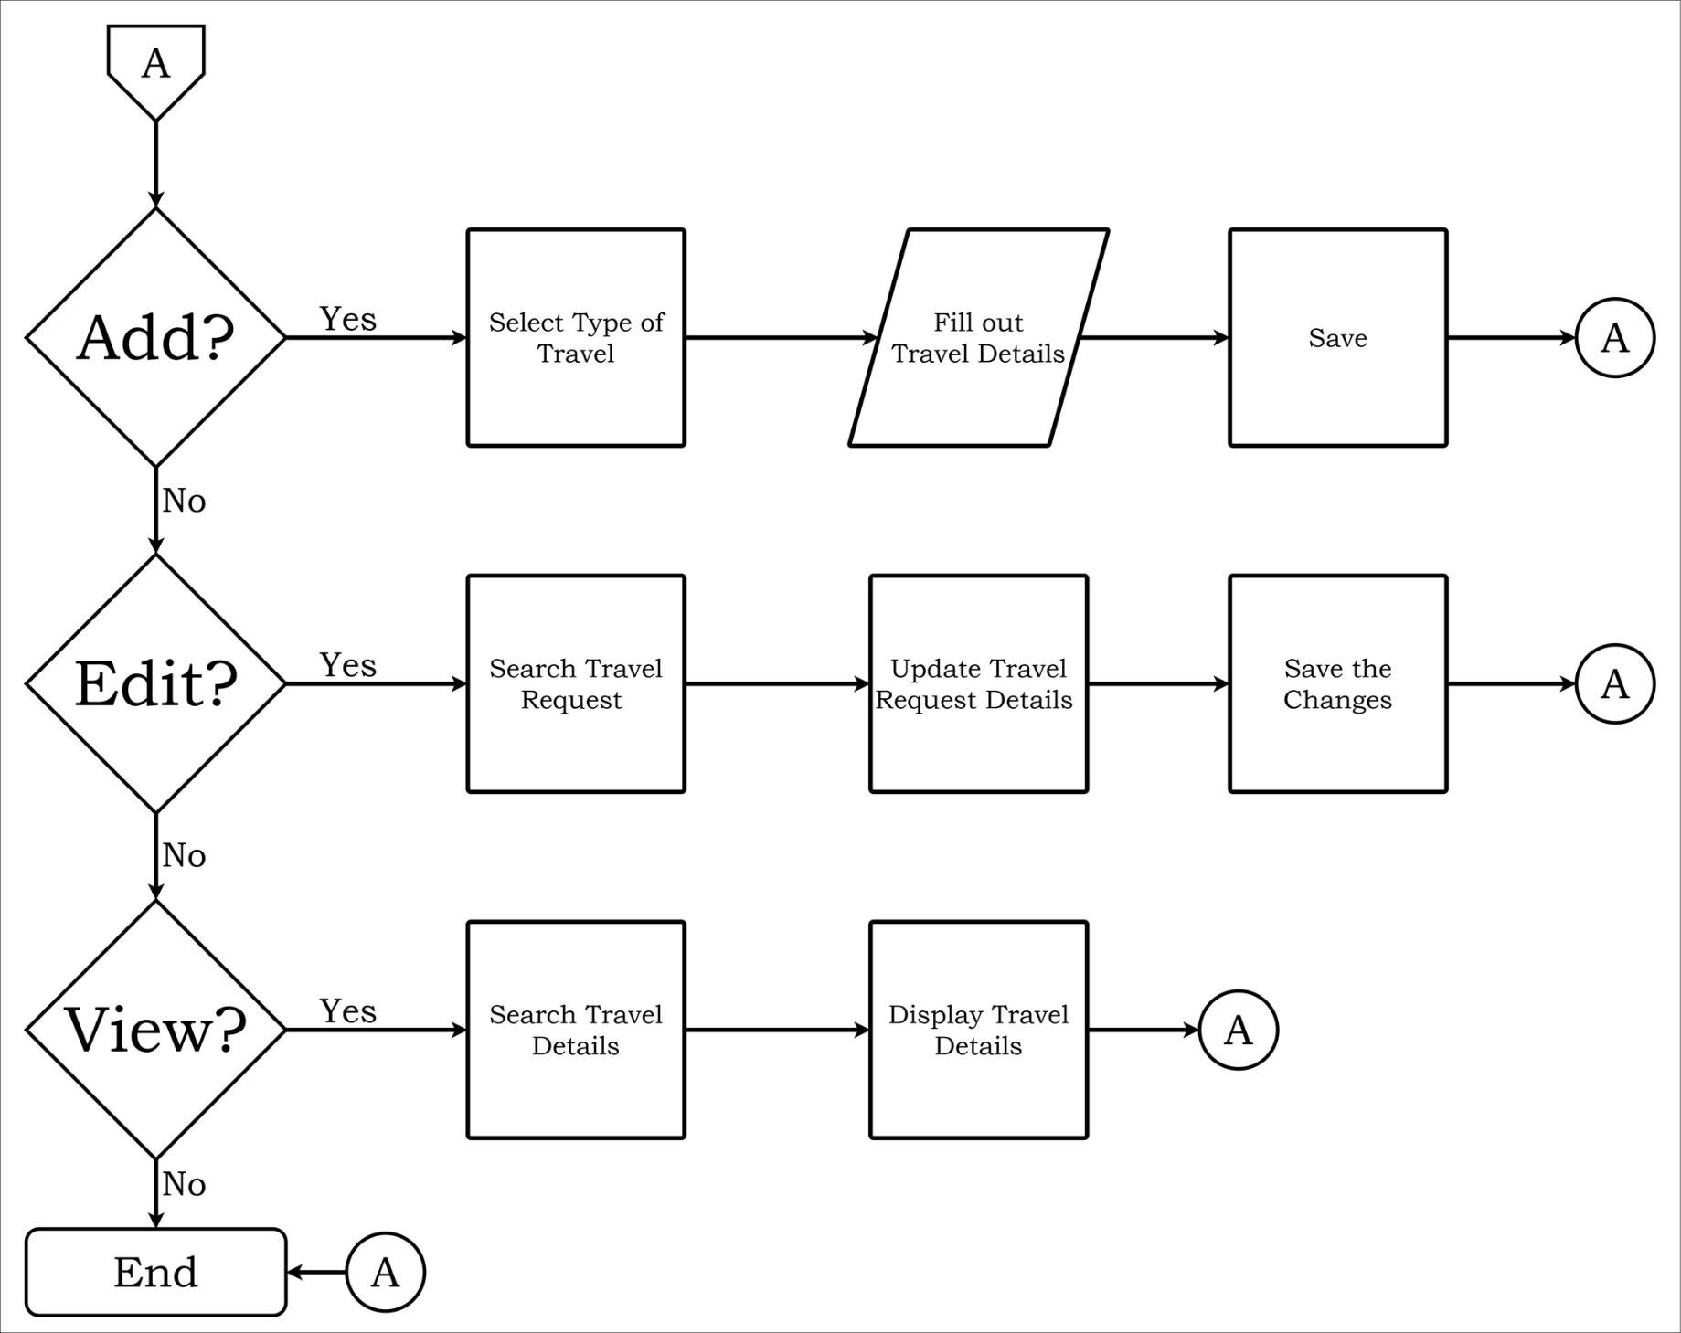
Manage Travel

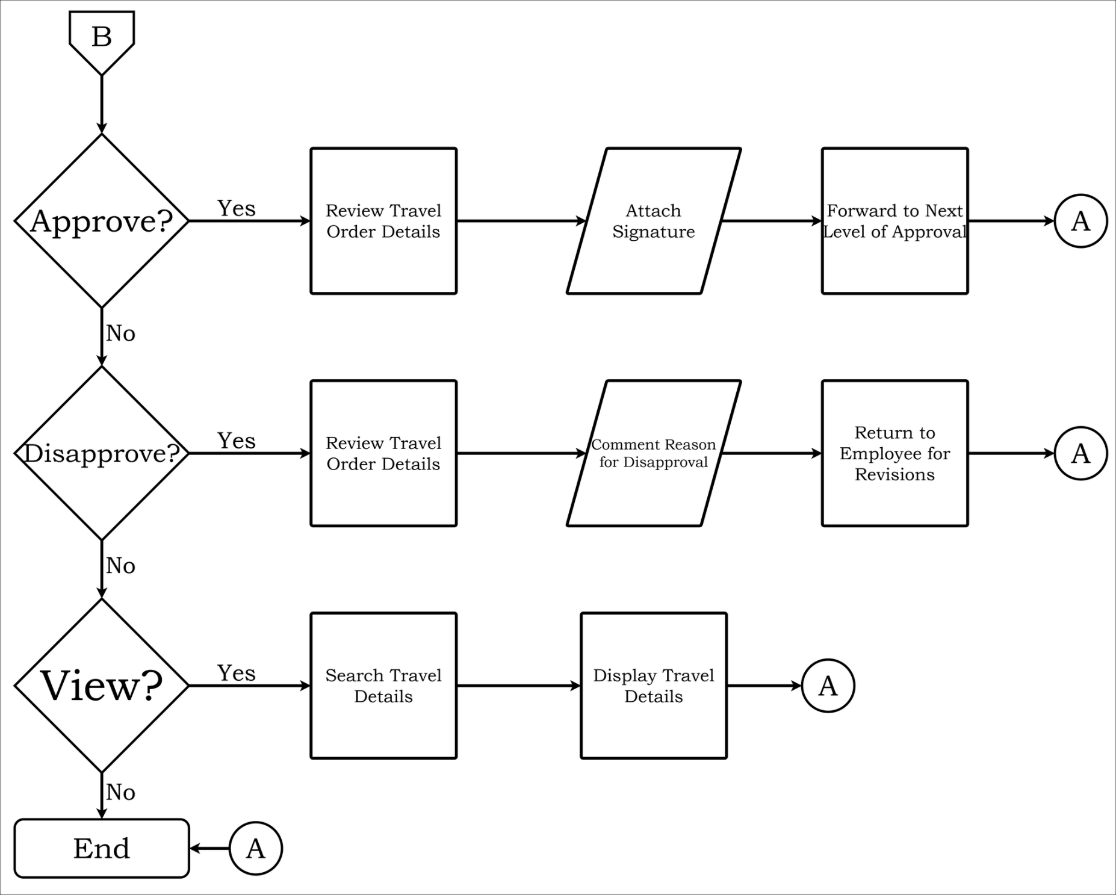
Manage Approval

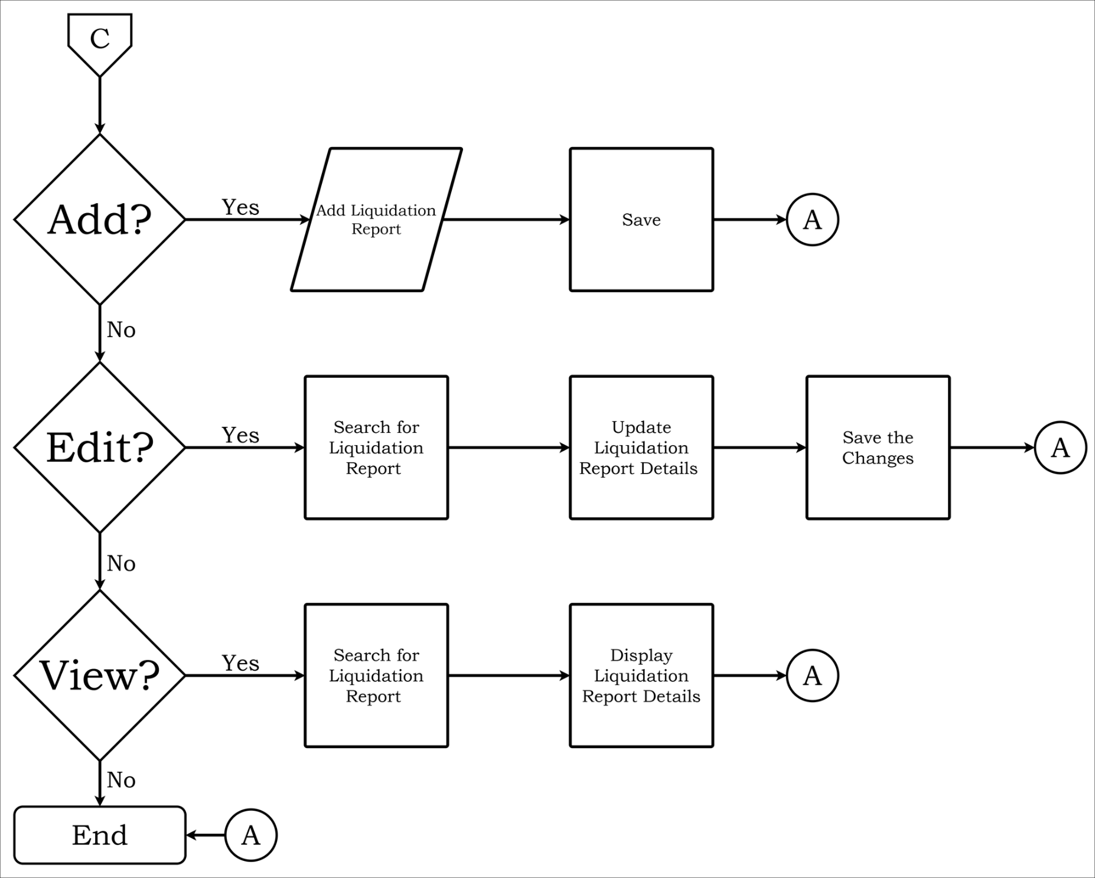
Manage Liquidation

Use Case Diagram
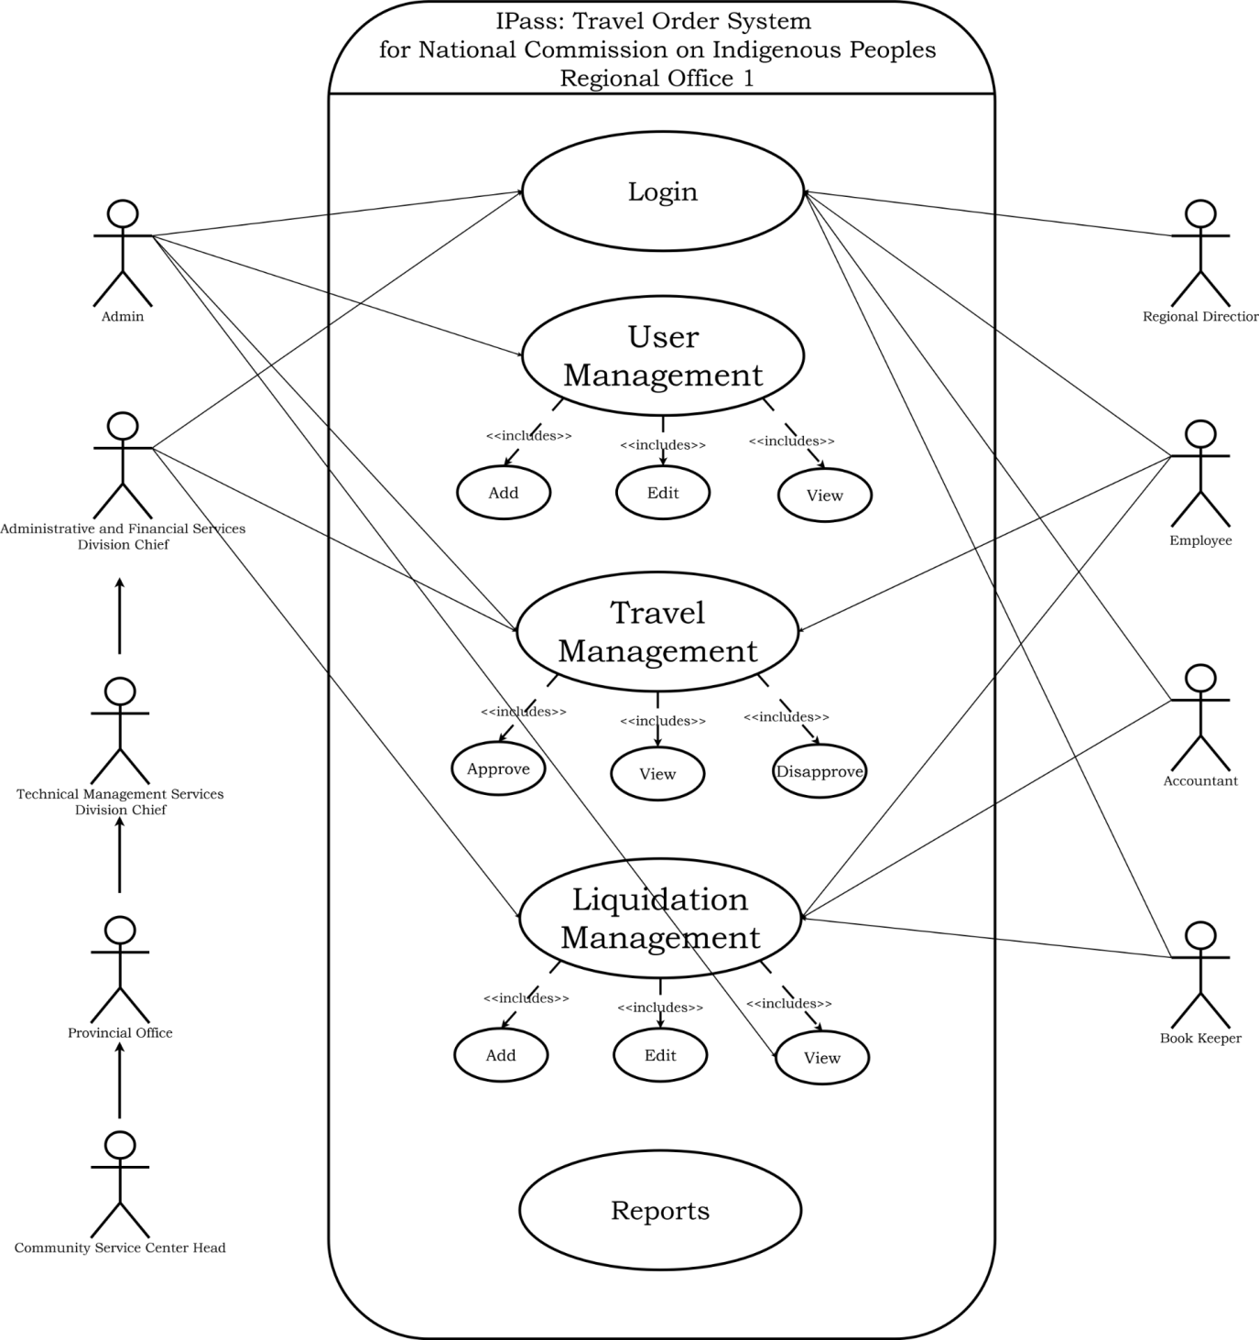

Top-Level Diagram
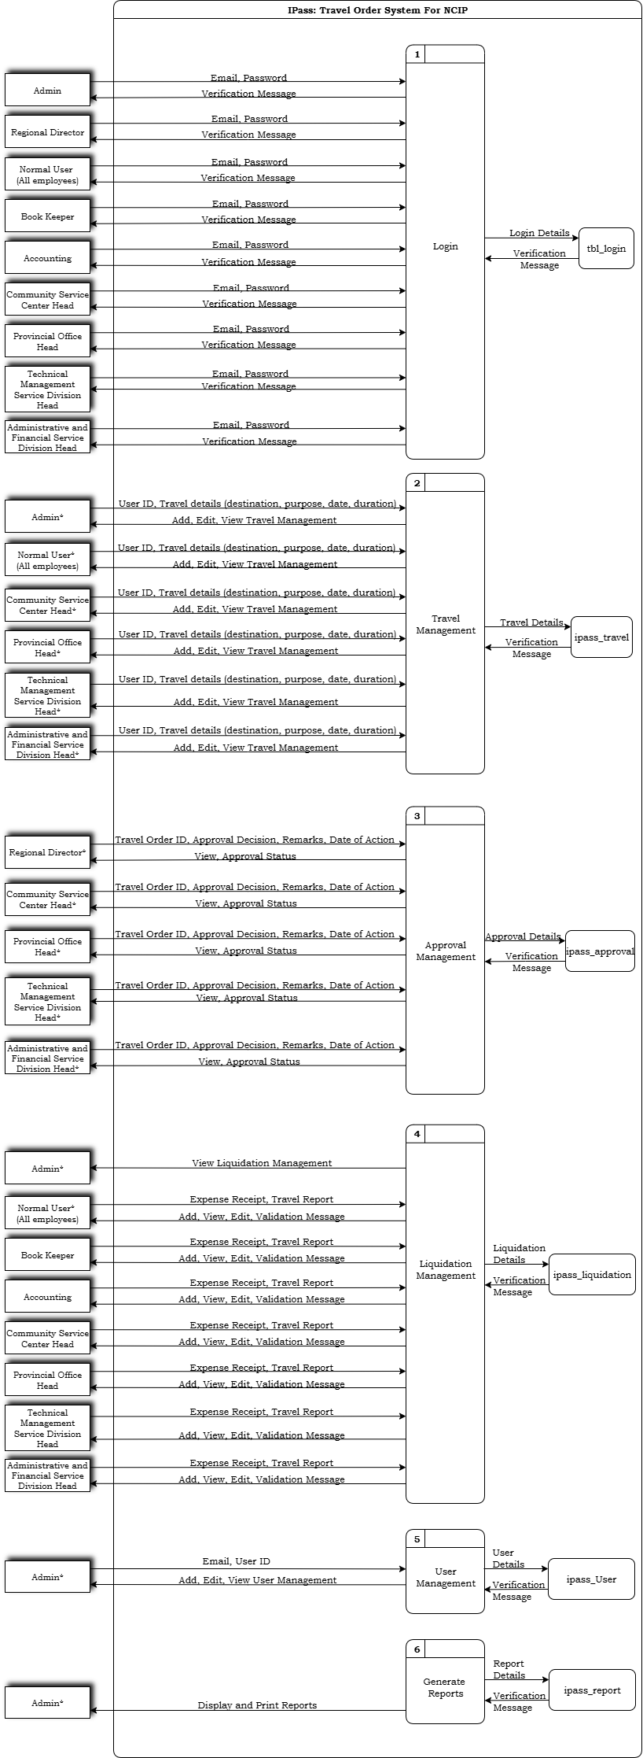
Input-Process-Output Diagram
Log in
Input | Process | Output
Email, Password | Validate username and password | Access to dashboard

Add User Management
Input | Process | Output
Email, Password, Prefix, Firstname, Lastname, Position | Validate input | User Successfully added

Edit User Management
Input | Process | Output
UserID | Update user details | Successfully updated

View User Management
Input | Process | Output
UserID | View details | Display details

Add Travel Management
Input | Process | Output
Purpose of travel, Identification, Employee details, Itinerary, Validation | Input travel details | Successfully added

Edit Travel Management
Input | Process | Output
TravelID | Update travel | Successfully updated

View Travel Managemnt
Input | Process | Output
TravelID | View existing travel | Display travel

Approve Approval Management
Input | Process | Output
Upload Signature | Validate details | Successfully Approved travel

Disapprove Approval Management
Input | Process | Output
Remarks | Validate details | Travel order rejected

View Approval Management
Input | Process | Output
TravelID | View Existing travel | Display Approval Travel

Add Liquidation Management
Input | Process | Output
Documents | Validate input | Successfully validated

Edit Liquidation Management
Input | Process | Output
LiquidationID | Edit liquidation | Successfully updated

View Liquidation Management
Input | Process | Output
liquidationID | View Existing Liquidation | Display details

Generate Reports
Input | Process | Output
Date Range,  Employee Details,  Travel Order Details,  Travel Status,  Signatory Information,  Mode of Transportation,  Financial Details,  User Role and Access Level | Validate to print report | Display/print report

Entity Relationship Diagram
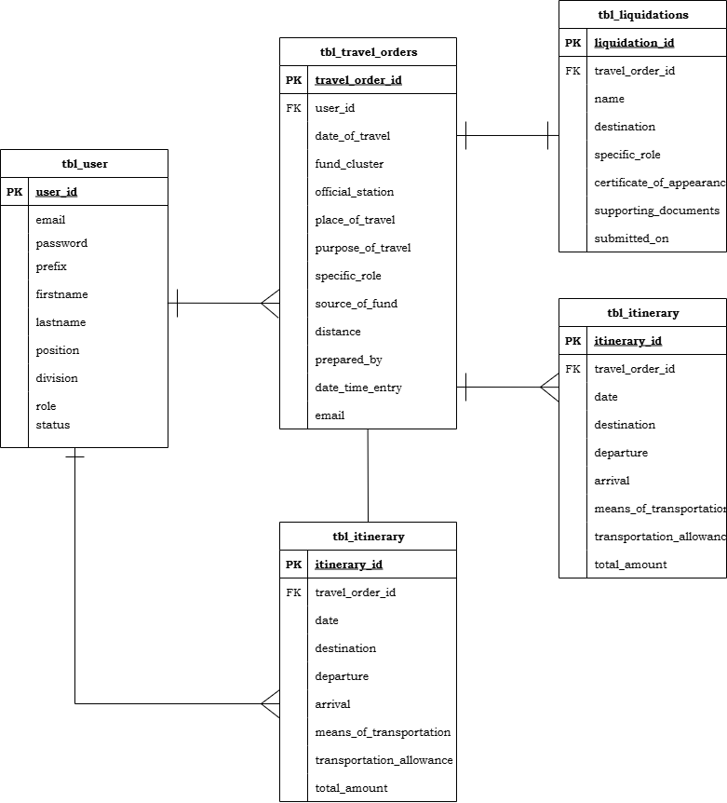

Relational Database Schema

tbl_user
{user_id(PK), username, pasword, prefix, firstname, lastname, position, division, role, status}

tbl_travel_orders
{ user_id(PK), dates_of_travel, fund_cluster, dates_of_official_travel, official_station, place_of_travel, purpose_of_travel, specific_role, source_of_fund, distance, prepared_by, position, date_time_entry, email}
tbl_itinerary
{travel_order_id(PK), date, destination,departure, arrival, means_of_transportation, transportation_allowance, per_diem, others, total_amount}

tbl_approvals
{approval_id(PK), travel_order_id(FK), approver_id(FK), level, decision, approval_date, comments, upload_signature}

tbl_liquidations
{travel_order_id(PK), name, destination, specific_role}

Logical Data Structure
tbl_user
Field Name | Data Type
user_id(PK) | int
email | varchar
password | varchar
prefix | varchar
firstname | varchar
lastname | varchar
position | varchar
division | varchar
role | enum
status | enum

tbl_travel_orders
Field Name | Data Type
user_id(pk) | int
date_of_travel | date
fund_cluster | varchar
dates_of_official_travel | date
official_station | varchar
place_of_travel | varchar
purpose_of_travel | varchar
specific_role | varchar
source_of_fund | varchar
distance | deciimal
prepared_by | varchar
position | varchar
date_time_entry | datetime
email | varchar

tbl_itinerary
Field Name | Data Type
travel_order_id(pk) | int
date | date
destination | varchar
arrival | time
means_of_transportation | int
transportation_allowance | int
per_diem | int
others | int
total_amount | int

tbl_approvals
Field Name | Date Type
travel_order_id | int
level | varchar
decision | enum
date_of_approval | date
remarks | text
upload_signiture | varchar

tbl_liquidation
Field Name | Data Type
travel_order_id | int
name | varchar
destination | varchar
specific_role | text

Chapter IV
PROTOTYPES

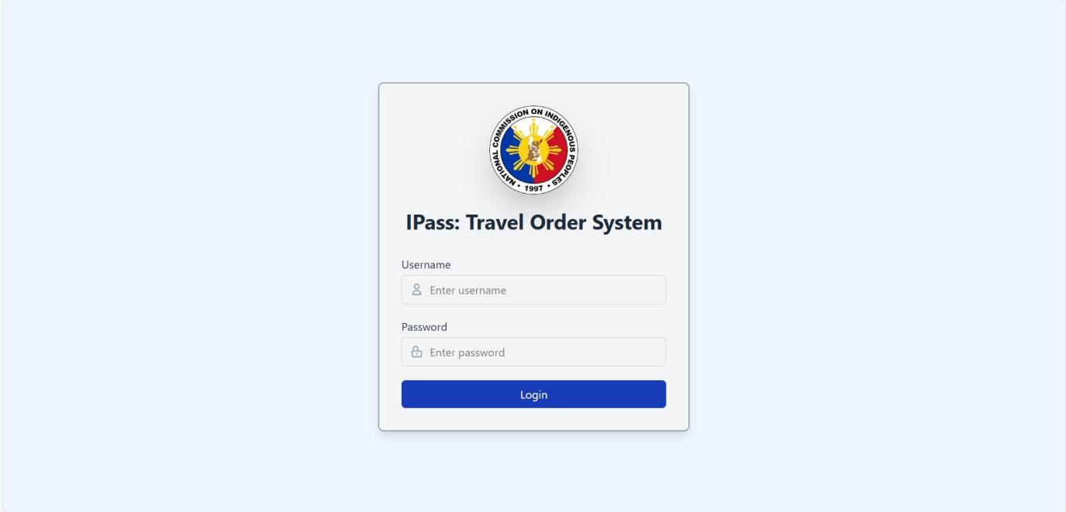
Log in

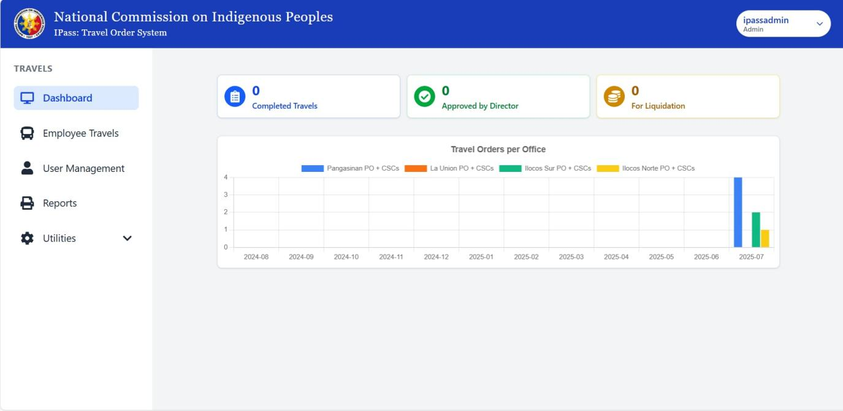
Dashboard (Admin View)

Employee Travels (Admin View)
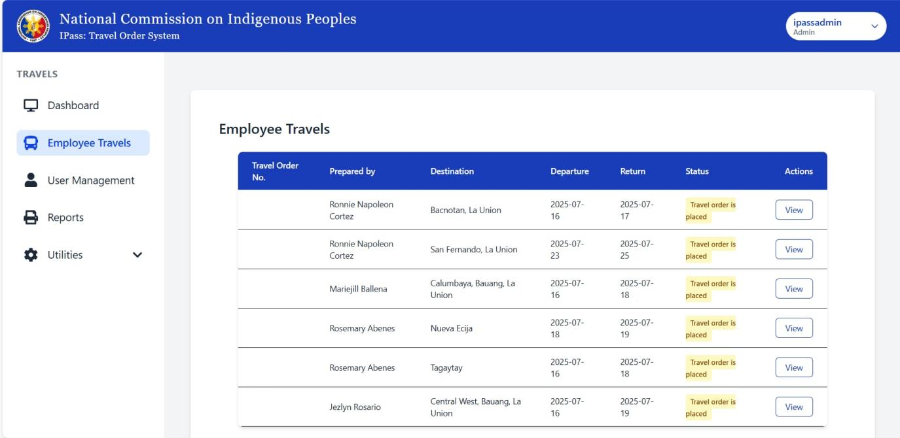
User Management (Admin View)
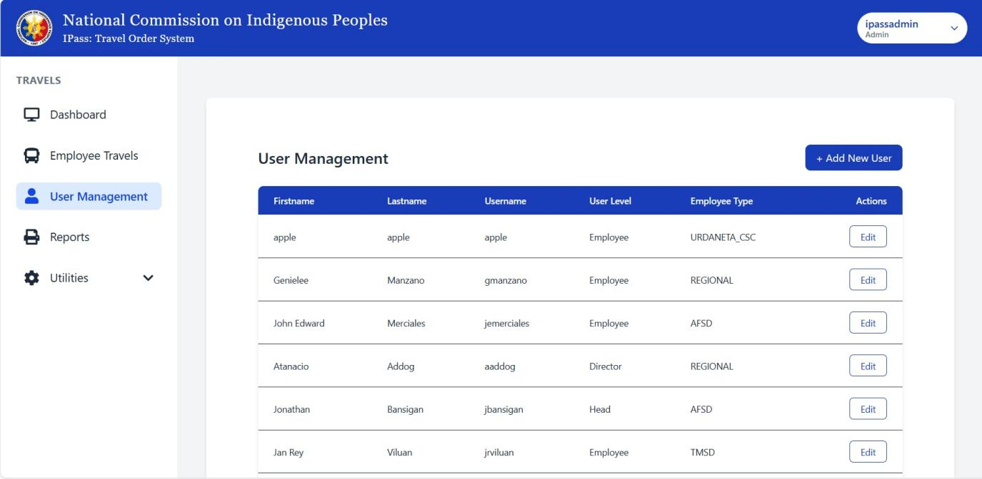

Add New User (Admin View)
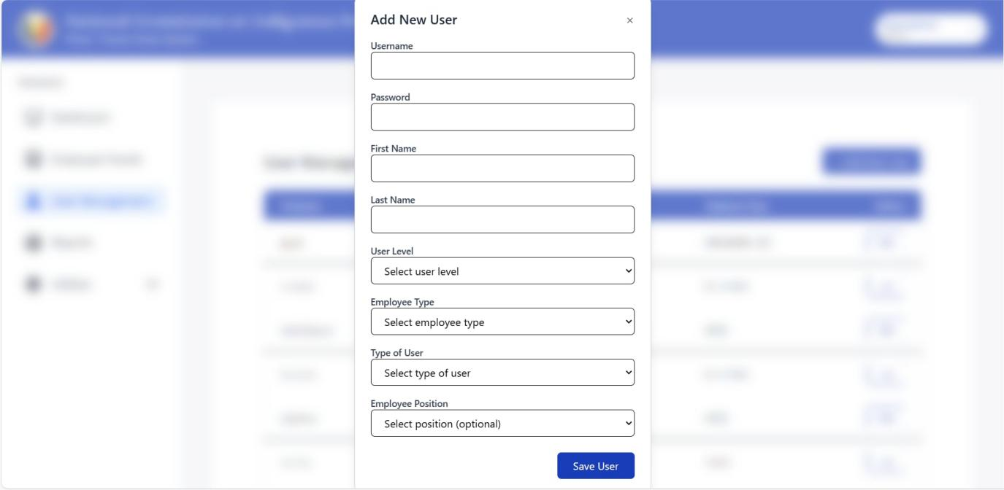
Reports (Admin View)
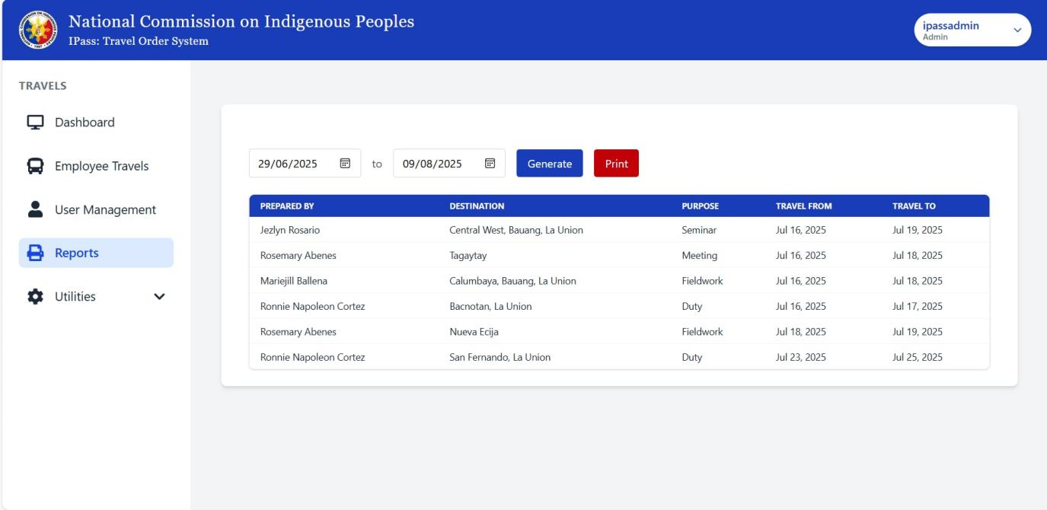

Print Reports (Admin view)
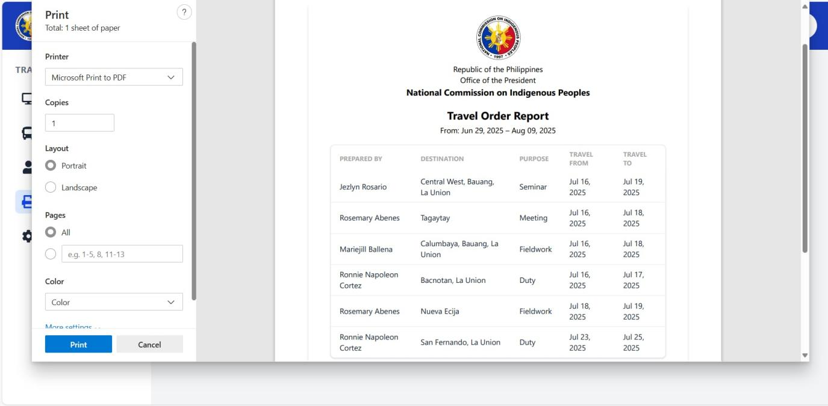

Dashboard (Regional Director view)
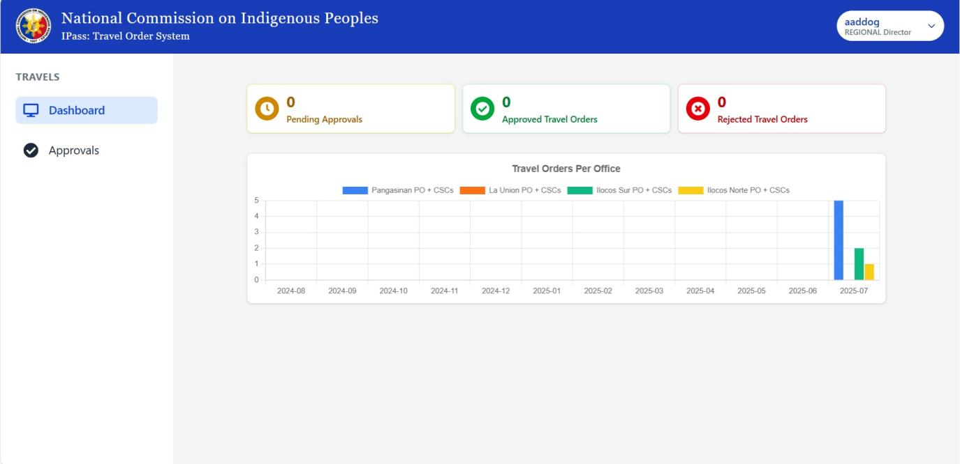

Dashboard (Head view)
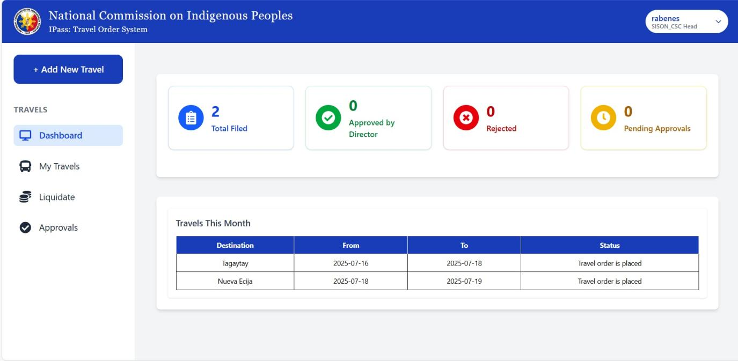

Approval (Head view)
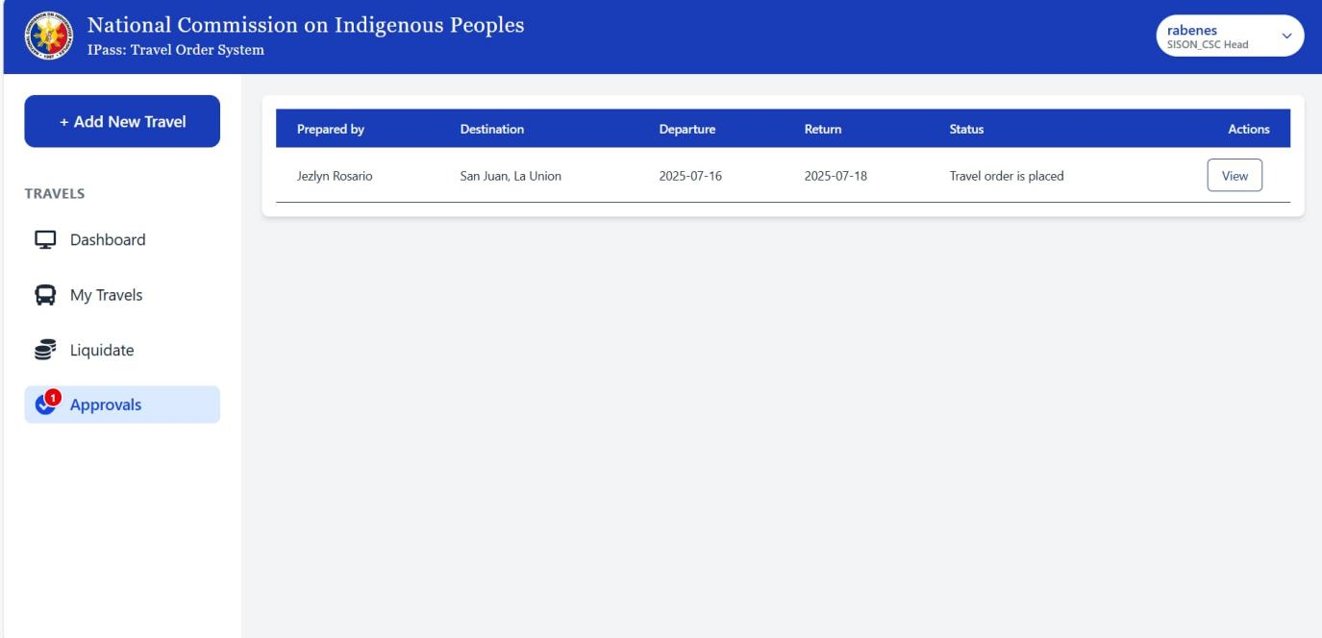

Dashboard (Employee view)
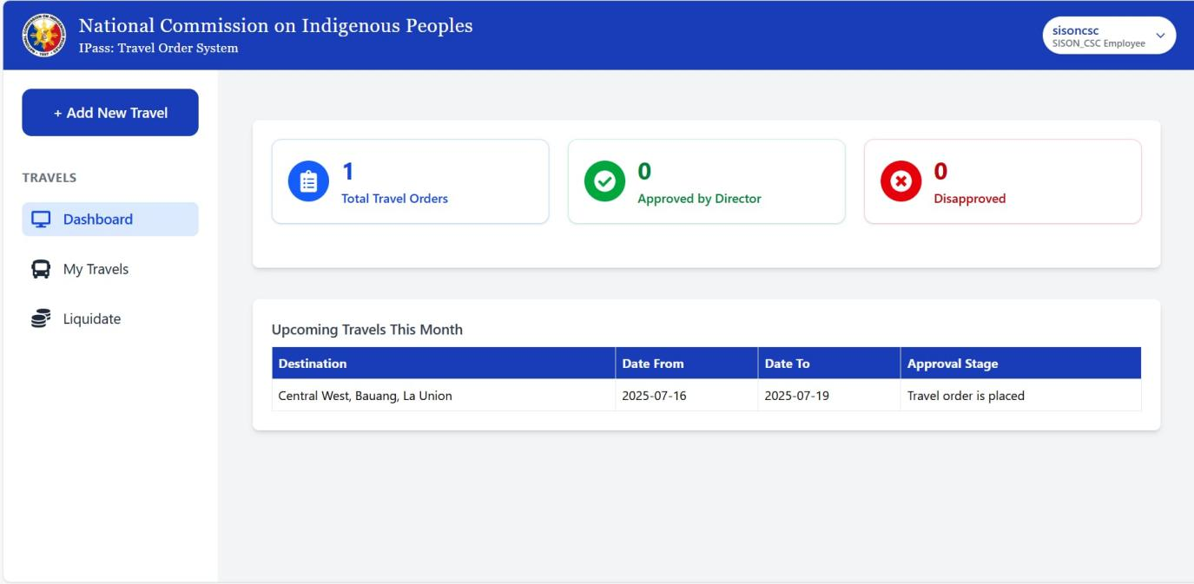

My Travels (Employee view)
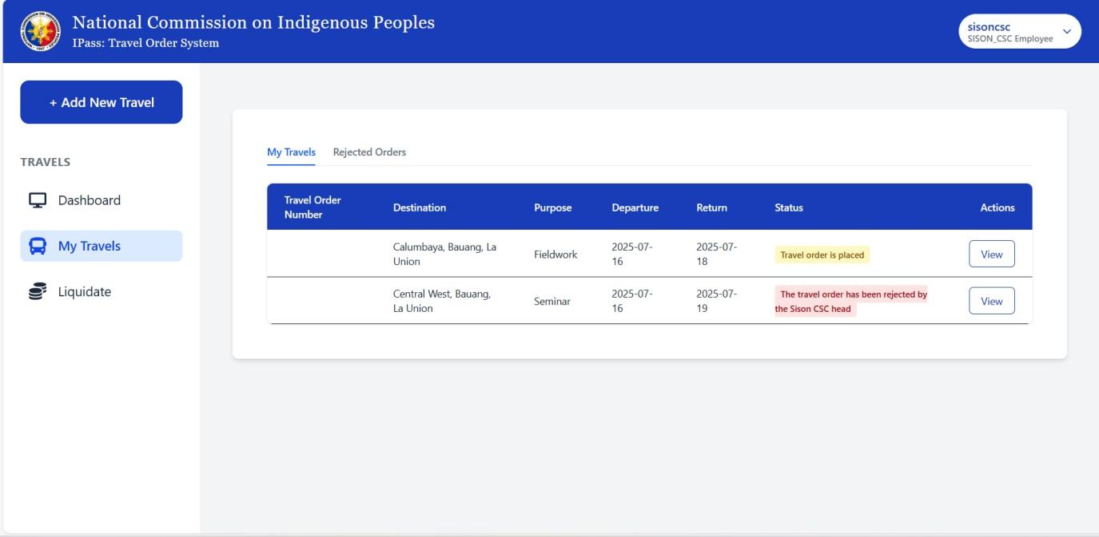

Rejected Orders (Employee view)
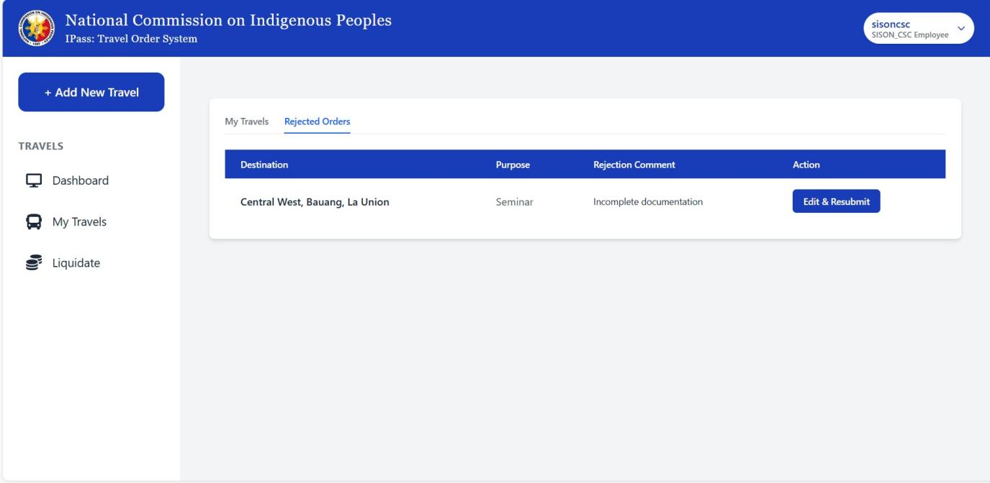

Travel Request Form (Identification)
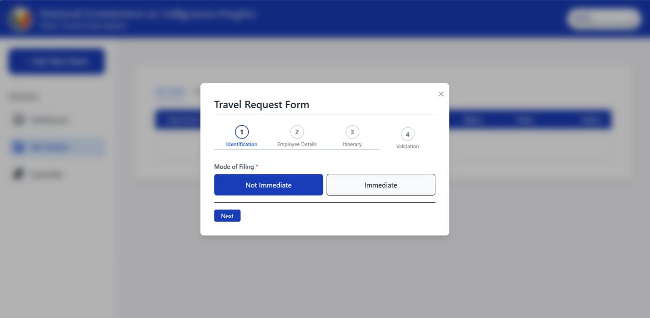

Travel Request Form (Employee details)
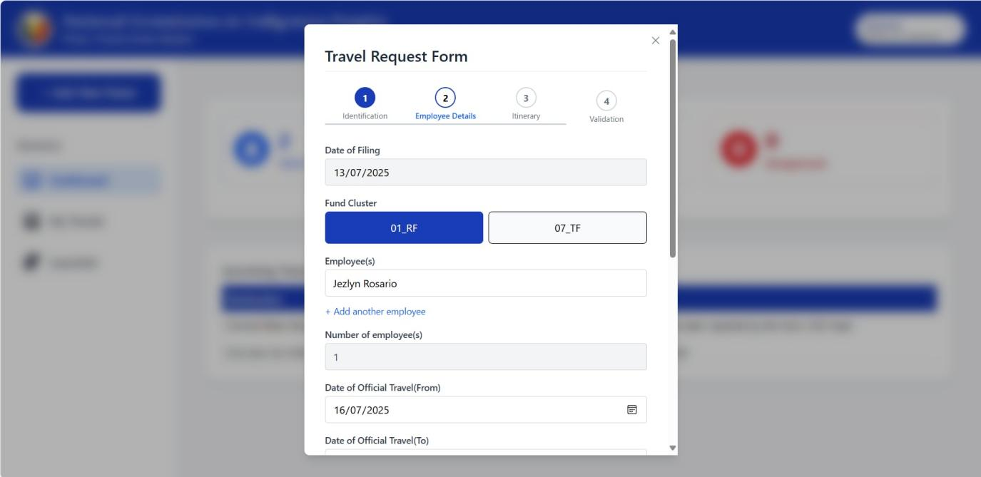

Travel Request Form (Itinerary)
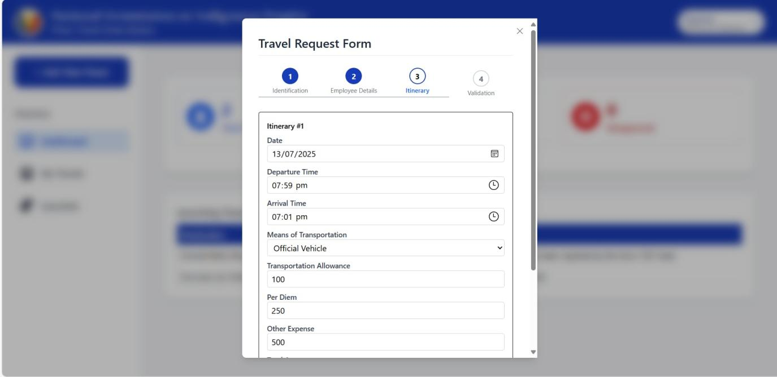

Travel Request Form (Validation)
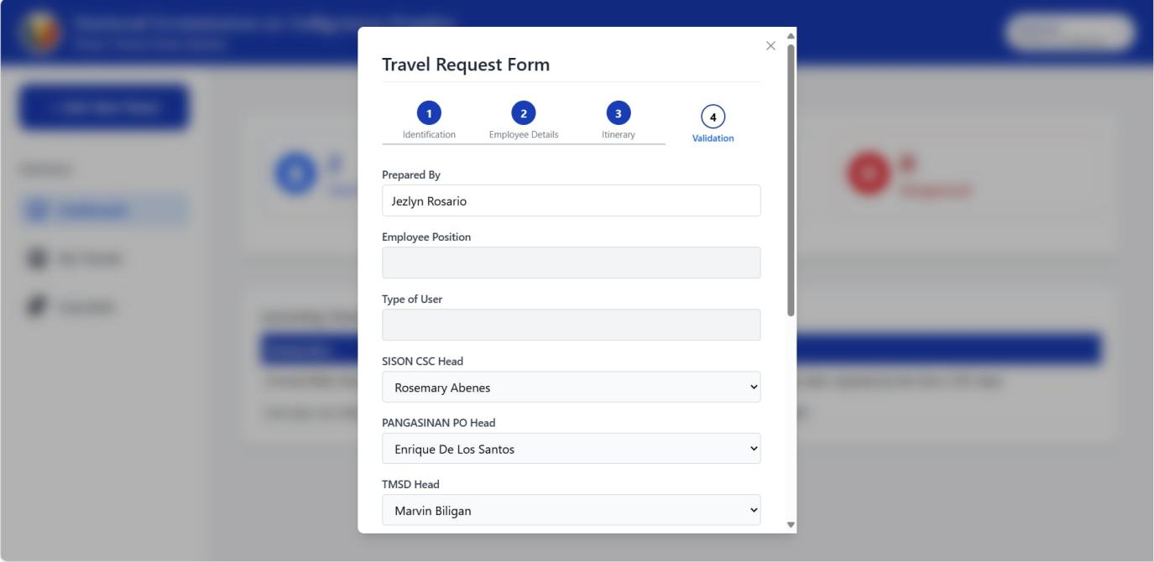

References

Aggarwal, C. (2024b, September 6). Descriptive Research: Meaning, design, and examples - Shiksha Online. Shiksha.com. https://www.shiksha.com/online-courses/articles/descriptive-research-meaning-design-and-examples/
Commission on Audit. (2012, June 14). COA Circular No. 2012-001: Prescribing the revised guidelines and documentary requirements for common government transactions. https://www.coa.gov.ph
Dogan, O. (2022). A process-centric performance management in a call center. Applied Intelligence, 53(3), 3304–3317. https://doi.org/10.1007/s10489-022-03740-9
Duterte, R. R. (2019, March 15). Executive Order No. 77: Prescribing rules and regulations and rates of expenses and allowances for official local and foreign travels of government personnel. Official Gazette of the Republic of the Philippines. https://www.officialgazette.gov.ph
Italy - Information and Communications Technology (ICT). (2024, January 23). International Trade Administration | Trade.gov. https://www.trade.gov/country-commercial-guides/italy-information-and-communications-technology-ict
Jordan, S., Zabukovšek, S., & Klančnik, I. (2023). Document management system – A way to digital transformation. https://tinyurl.com/329s99rb
Libretexts. (2025, February 18). 1.11: Developmental Research Designs. Social Sci LibreTexts. https://socialsci.libretexts.org/Bookshelves/Human_Development/Lifespan_Development_(Lumen)/01%3A_Lifespan_Development/1.11%3A_Developmental_Research_Designs
Lumen Learning. (n.d.). Developmental research designs. In Lifespan development. Retrieved June 22, 2025, from https://courses.lumenlearning.com/wm-lifespandevelopment/chapter/developmental-research-designs/
Maderazo, R. T., & Encarnacion, R. E. (2024). Assessing the travel industry: Basis for a centralized travel and tour operation management system. International Journal of Advanced Research in Science, Communication and Technology, 4(3). https://www.researchgate.net/publication/381747797_Assessing_the_Travel_Industry_Basis_for_a_Centralized_Travel_and_Tour_Operation_Management_System
Marcos, F. E. (1978, June 11). Presidential Decree No. 1445: Government Auditing Code of the Philippines. Official Gazette of the Republic of the Philippines. https://www.officialgazette.gov.ph
May, J., Mangubat, L., Van, K., Reubal, P., Francis, J., Caluya, M., Klien, J., Pepito, B., Lester, M., Catungal, P., & Encarnacion, P. (2023). Online Student Clearance Management System. International Journal of Science and Applied Information Technology, 12(5), 38–43. https://doi.org/10.30534/ijsait/2023/011252023
Sirisilla, S., & Sirisilla, S. (2023b, February 9). Bridging the Gap: Overcome these 7 flaws in descriptive research design. Enago Academy. https://www.enago.com/academy/descriptive-research-design/

Appendix A
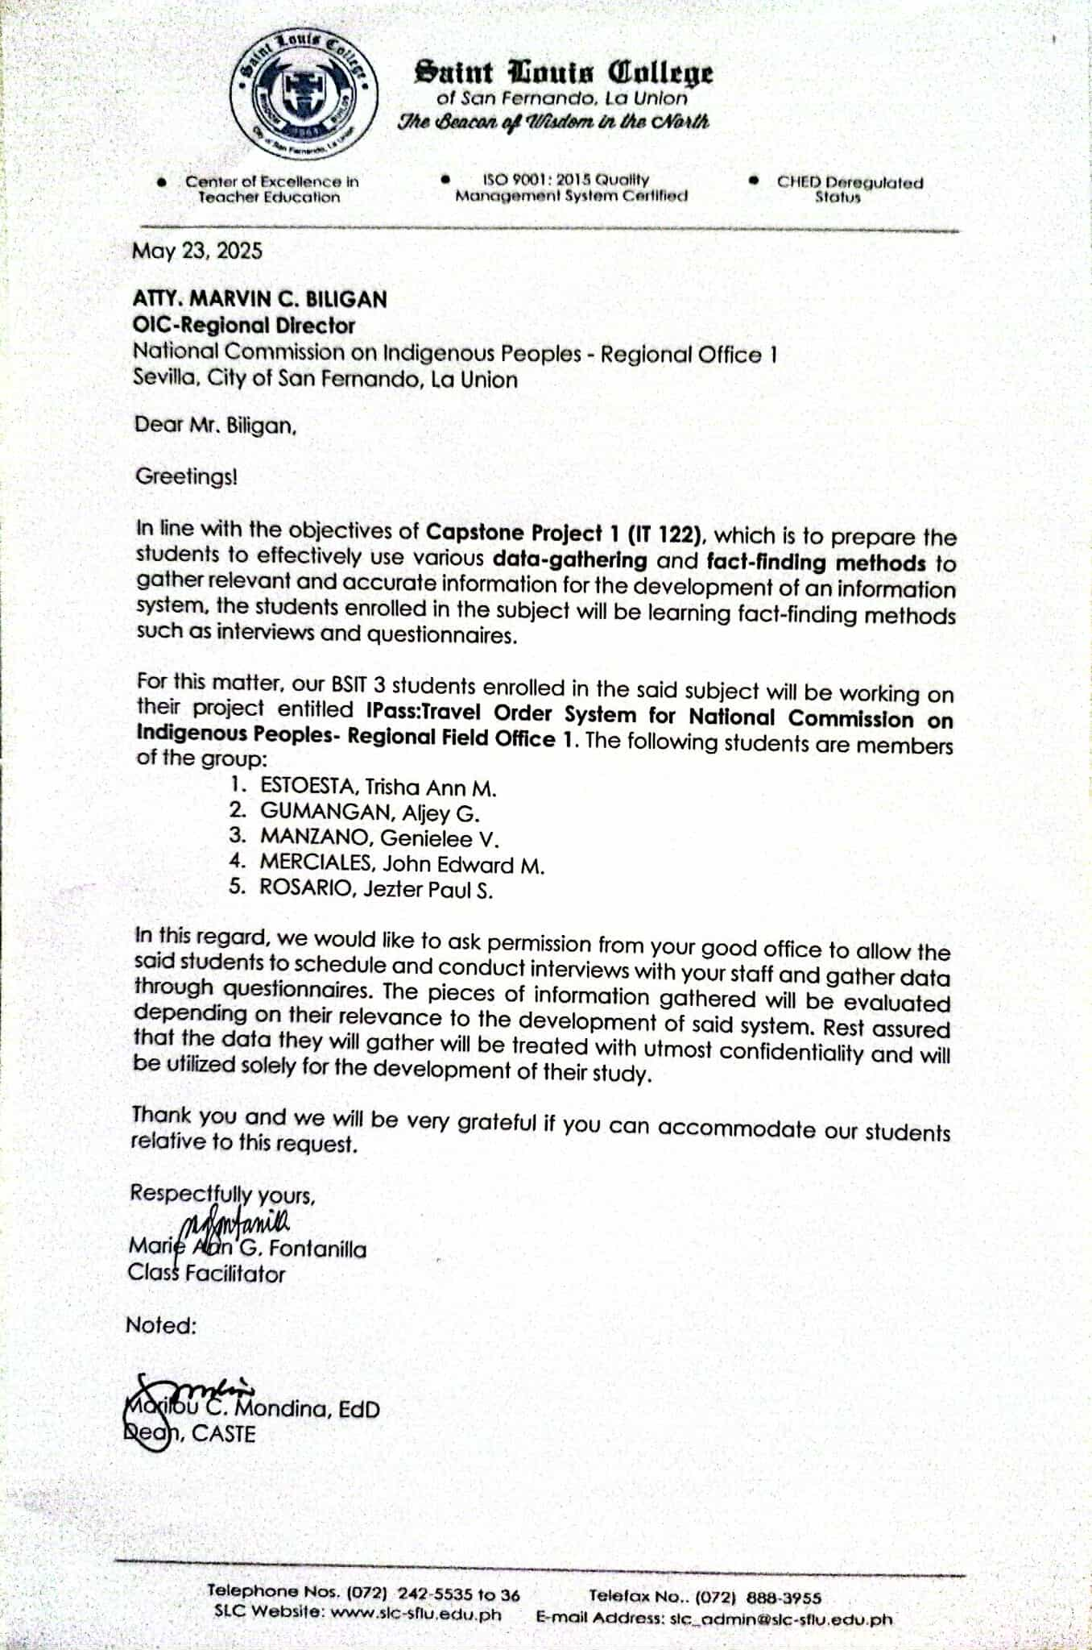
Letter of request to conduct a study.
Appendix B
Picture taken during interview


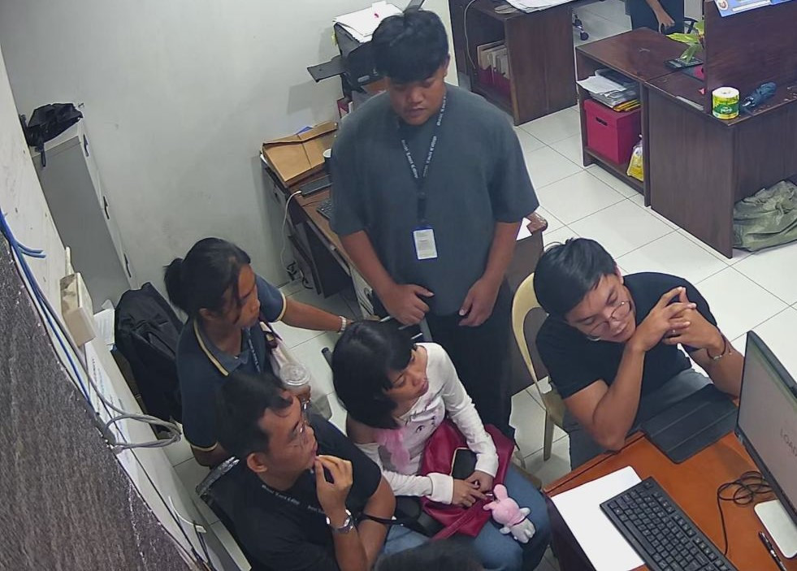

Appendix C
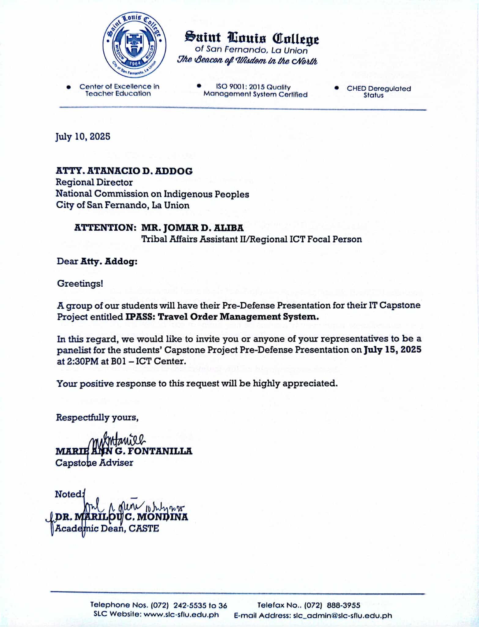
Letter of Invitation to External Panelist
Appendix D
Interview questions

Interview Questions

- Do you have a system that you would like to developed?
- What problems are you currently experiencing with the existing system or manual process?
- Which part of the travel order process takes the most time or causes the most delays?
- What manual tasks would you like to be automated in the new system?
- What are the things you want to integrate in your system?
- Who are the users of your system?
- How long does it usually take your travel order?
- How long does it usually take your liquidation?
- How many levels of approval is required?
- Should users be able to track the status of their requests? How?

Appendix E
Sample company forms
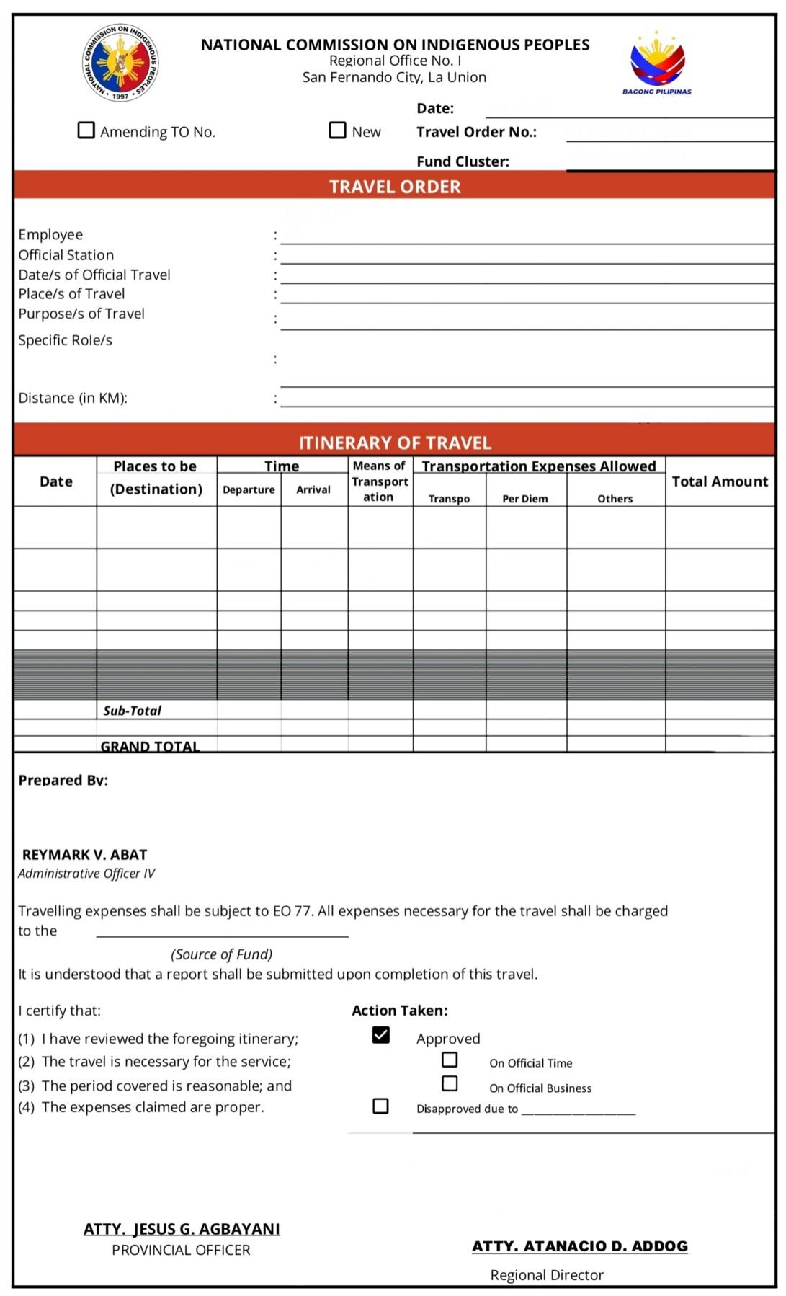
Appendix F

Appendix G
Gantt chart
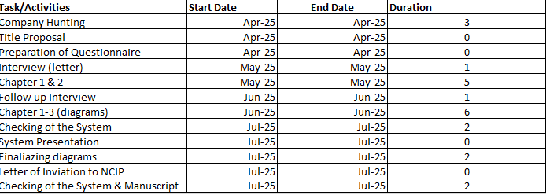

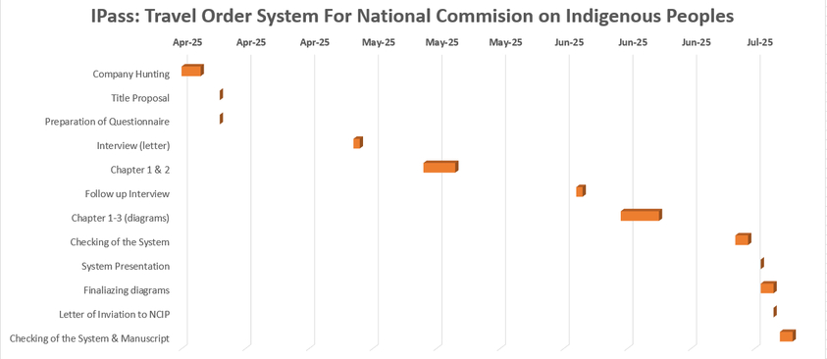

Appendix H

INSTITUTIONAL VISION-MISSION
We, the Saint Louis College of the City of San Fernando, La Union, a collaborative Missionary community commit to the integral human formation of the Youth to become Christ-centered and competent leaders responsive to the needs of Church and society by providing quality and transformative instruction, animating campus ministry, engaging in relevant researches and sustainable extension programs, forging ties with partner agencies, and
Fostering justice, peace, and integrity of creation.

Core Values
Christ-centeredness
Excellence
Missionary

