Creating queue using solace cli--🡪Queue name---quecli01-🡪subscription topic 🡪abcd

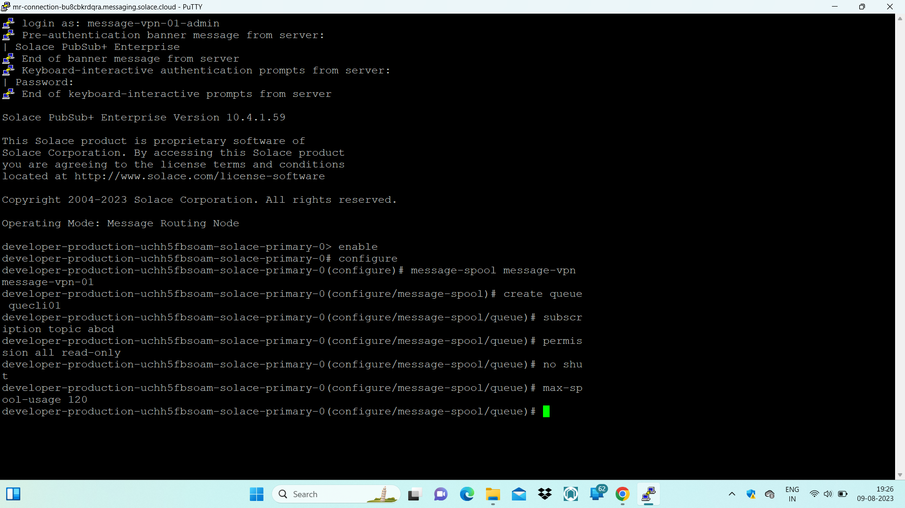

Verifying Queue is Created or not by looking into solace console

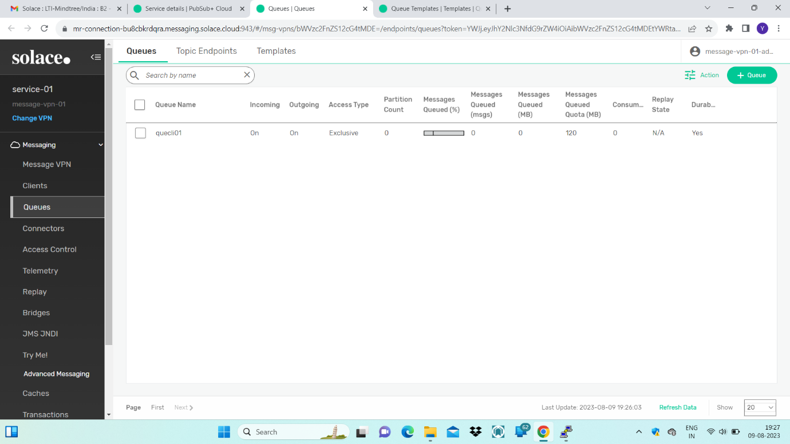

Subscription Topic-🡪abcd

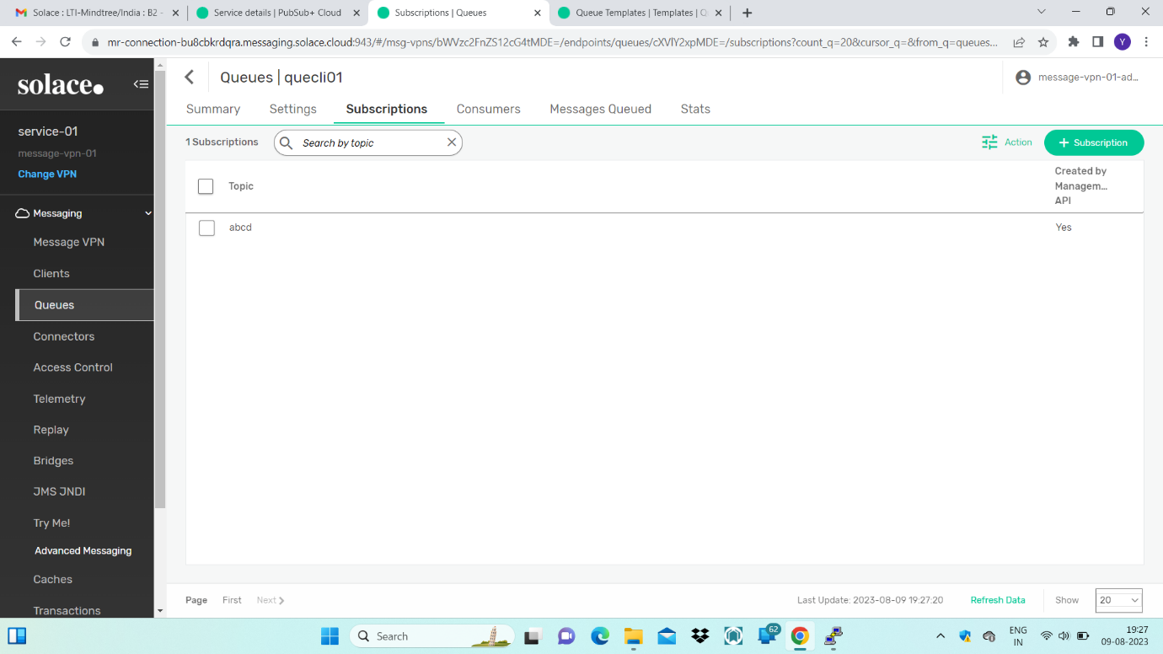

Verifying the properties of queue altered using cli

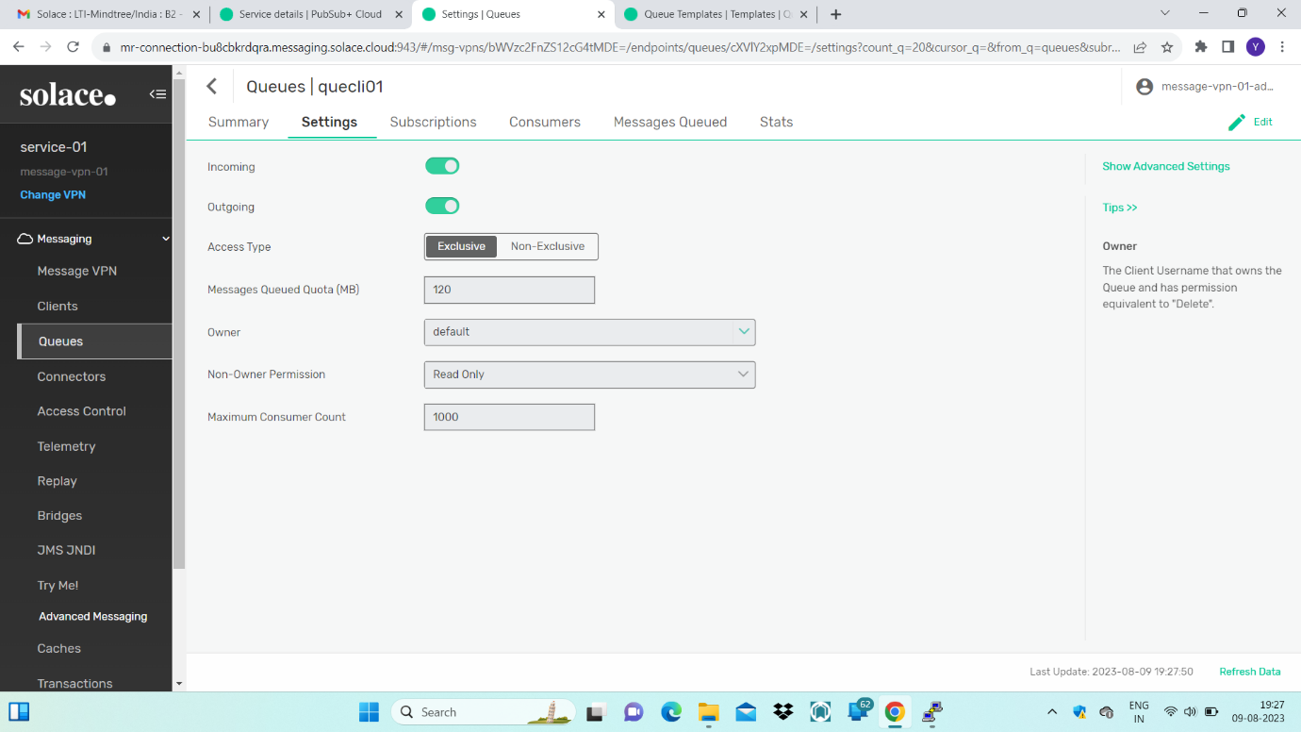

Message are published to queue -🡪which subscribed to topic🡪abcd/persistent/pub

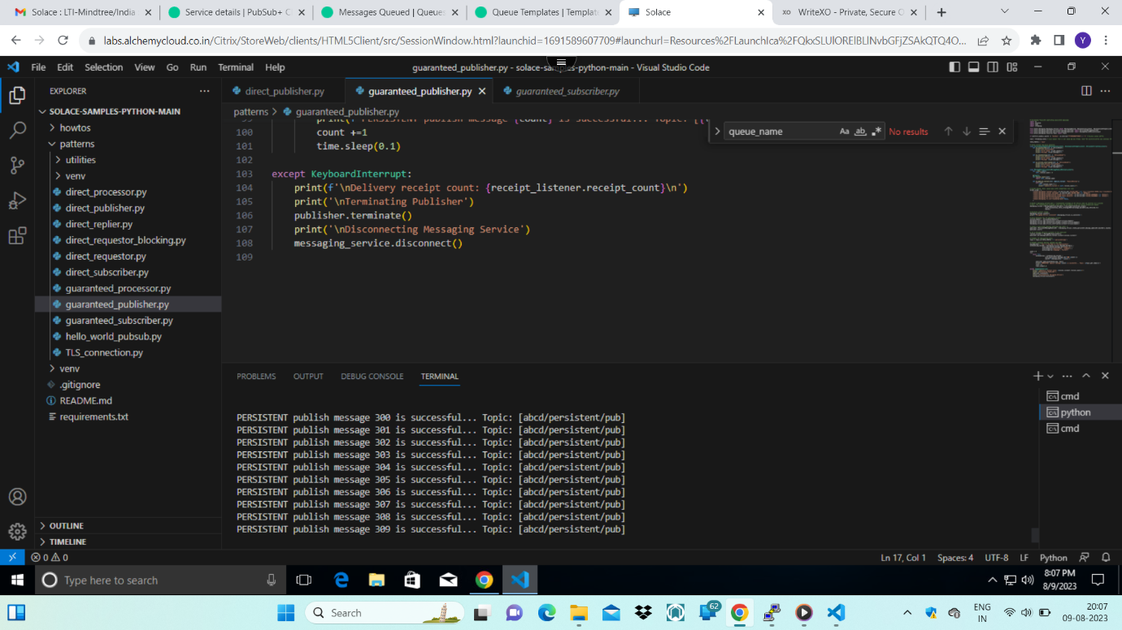

Message are queued in queue

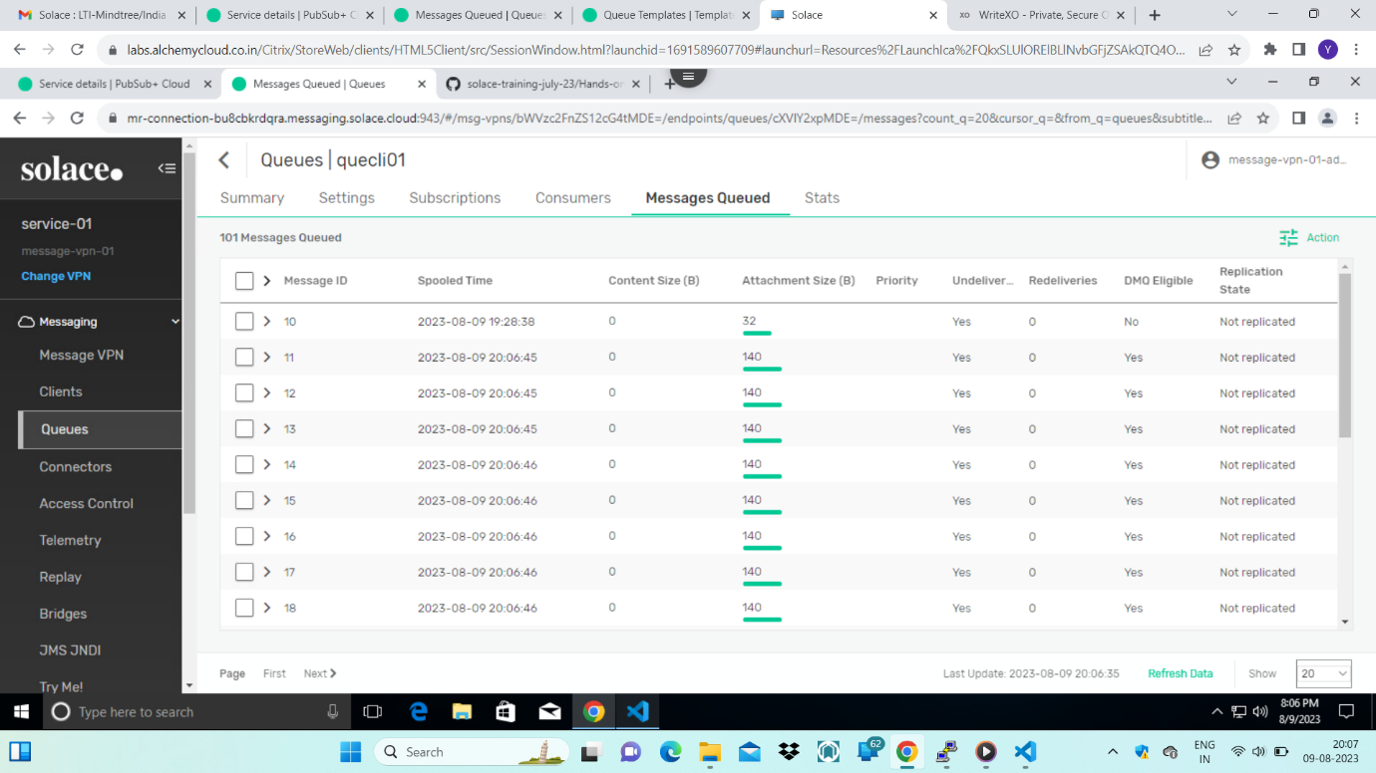

Creating queue-template using GUI🡪

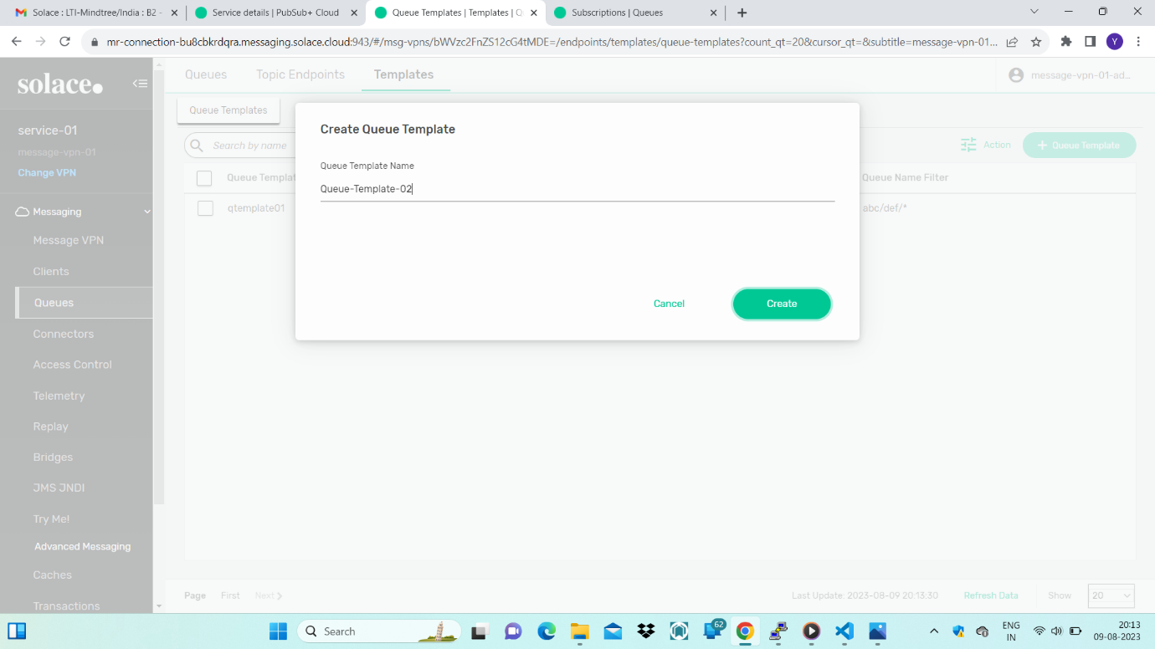

Changing the properties of queue-template using GUI

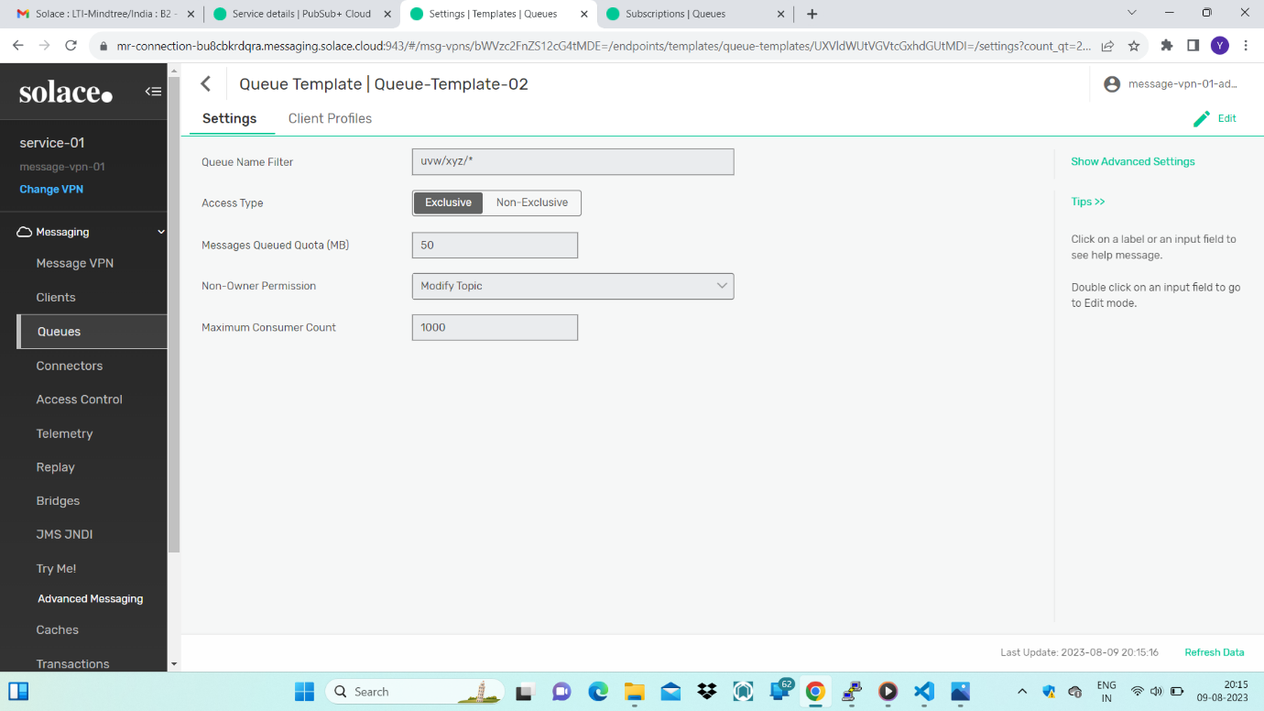

Creating queue-template using CLI and changing some of its setting

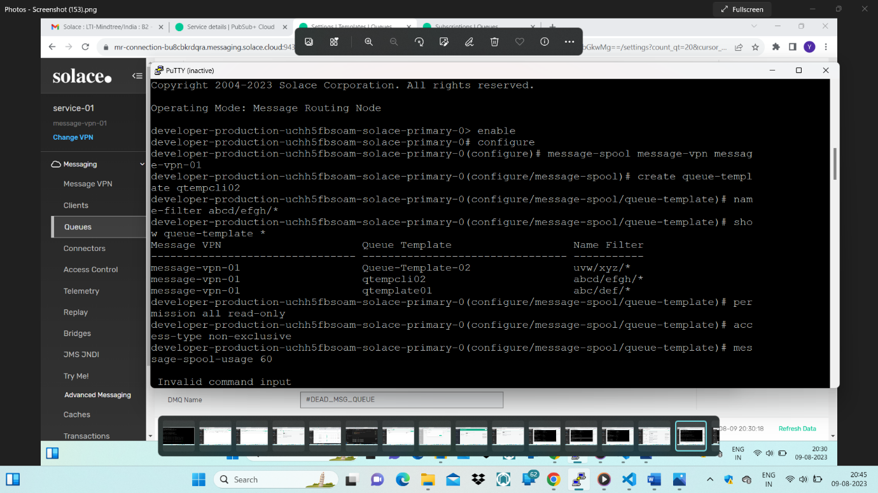

Displaying details about queue-template-🡪Observe the consumer ack propagation🡪No

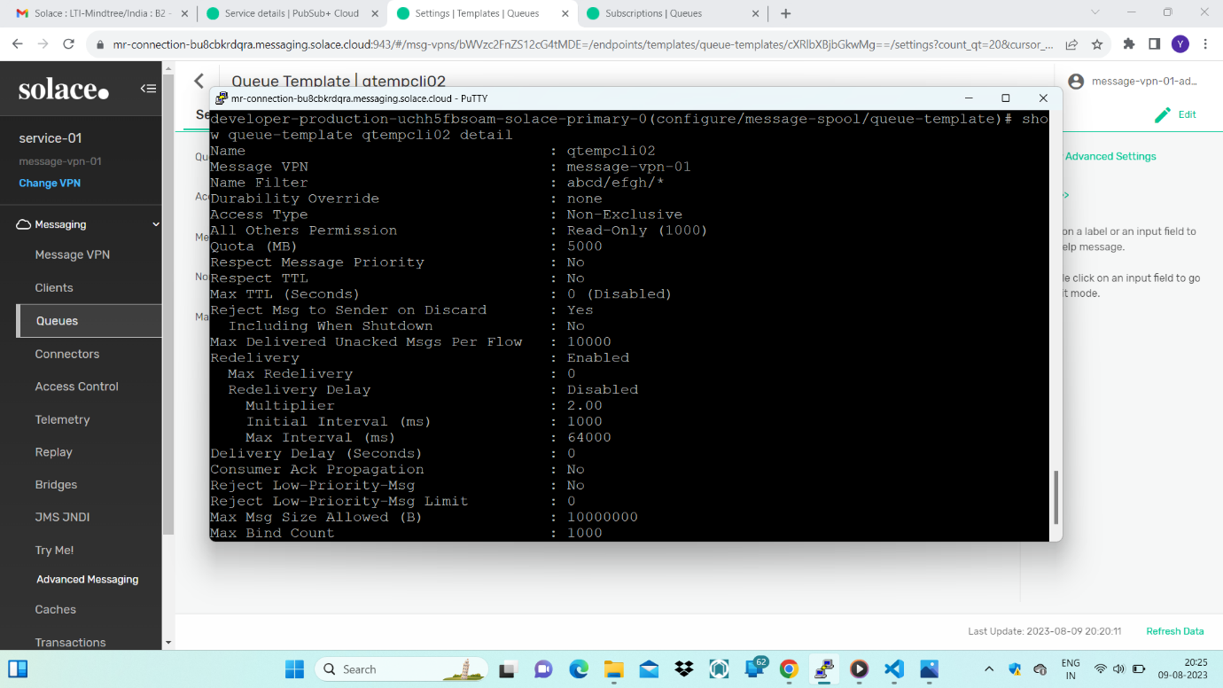

Consumer ack propagation-🡪yes

Achieved by firing a command-🡪no consumer-ack-propagation

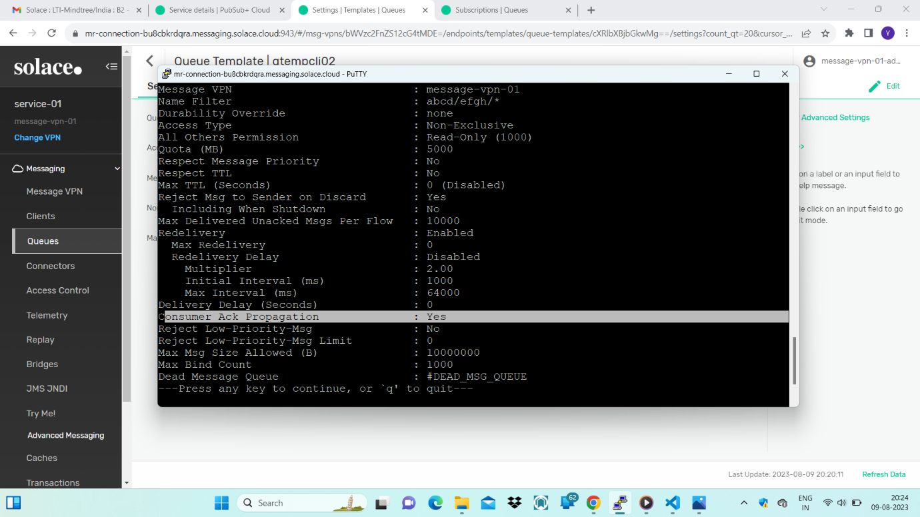

Durability-override is changed to non-durable from none-🡪Achieved by firing a command -🡪

durability-override non-durable

