Task 3: Visual Studio Project Setup Diary

Install Visual Studio and create a new project using a template relevant to your learning goals. Document each step with screenshots in a "setup diary". If you encounter any setup issues, note down the problem and how you resolved it.

**Step 1 - Make sure your computer is ready for Visual Studio**

Check the [system requirements](https://learn.microsoft.com/en-us/visualstudio/releases/2022/system-requirements). These requirements help you know whether your computer supports Visual Studio 2022.

Goto chrome and

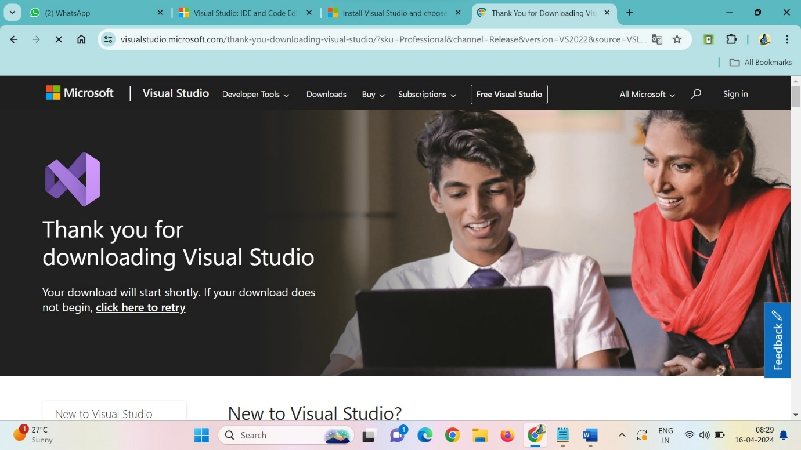

And click on visual studio and select version 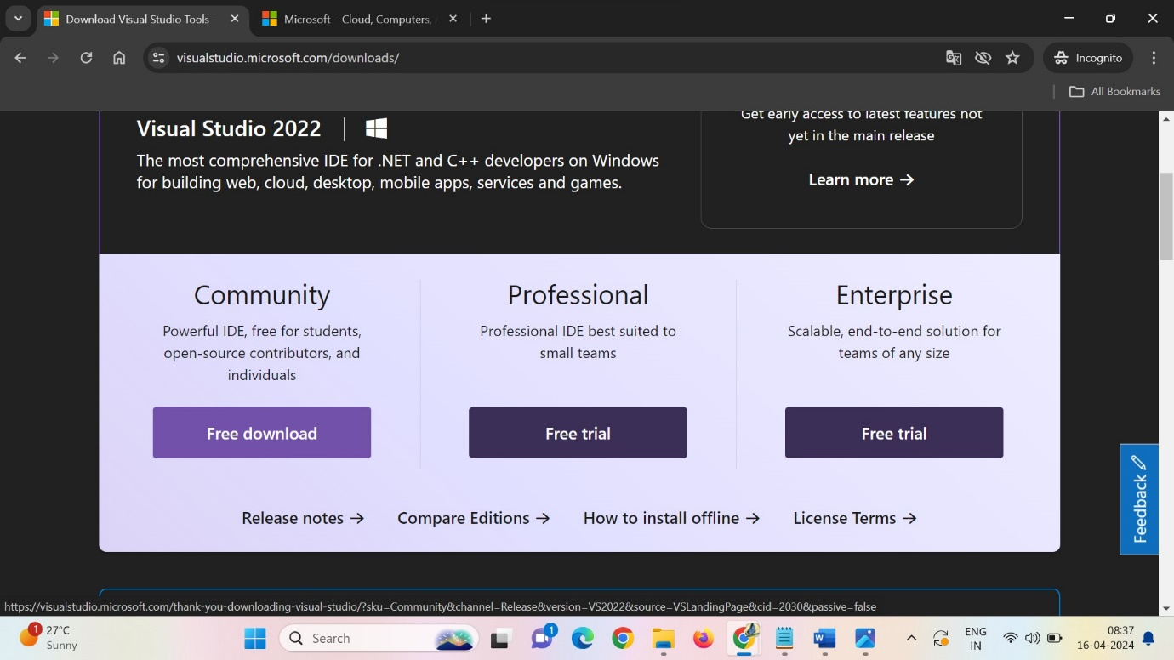

Step2: Downloading VM

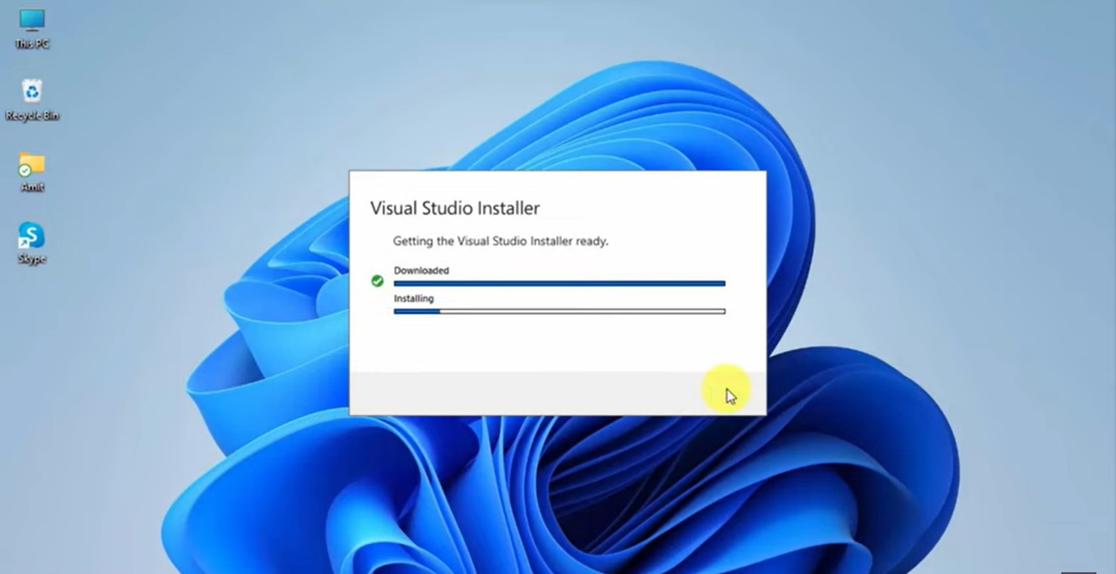

Step3:

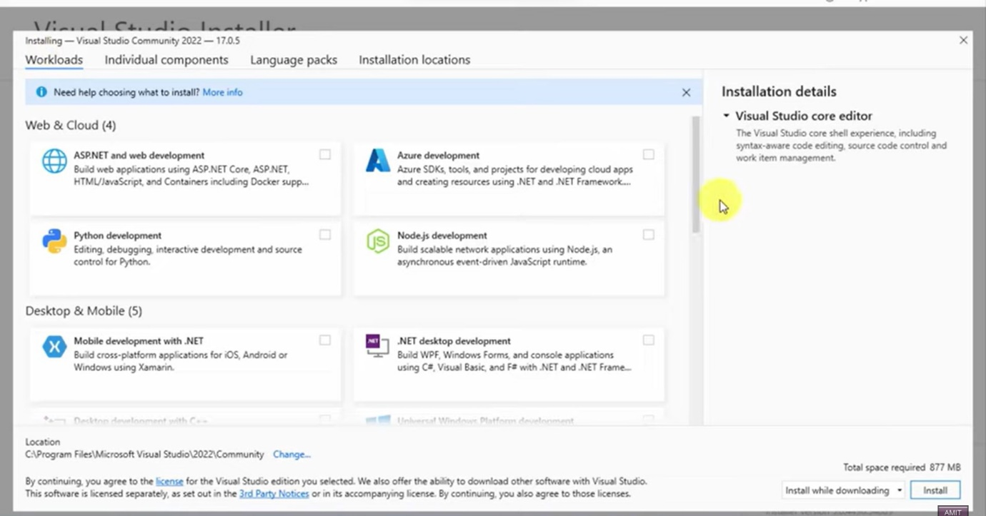

Step4:

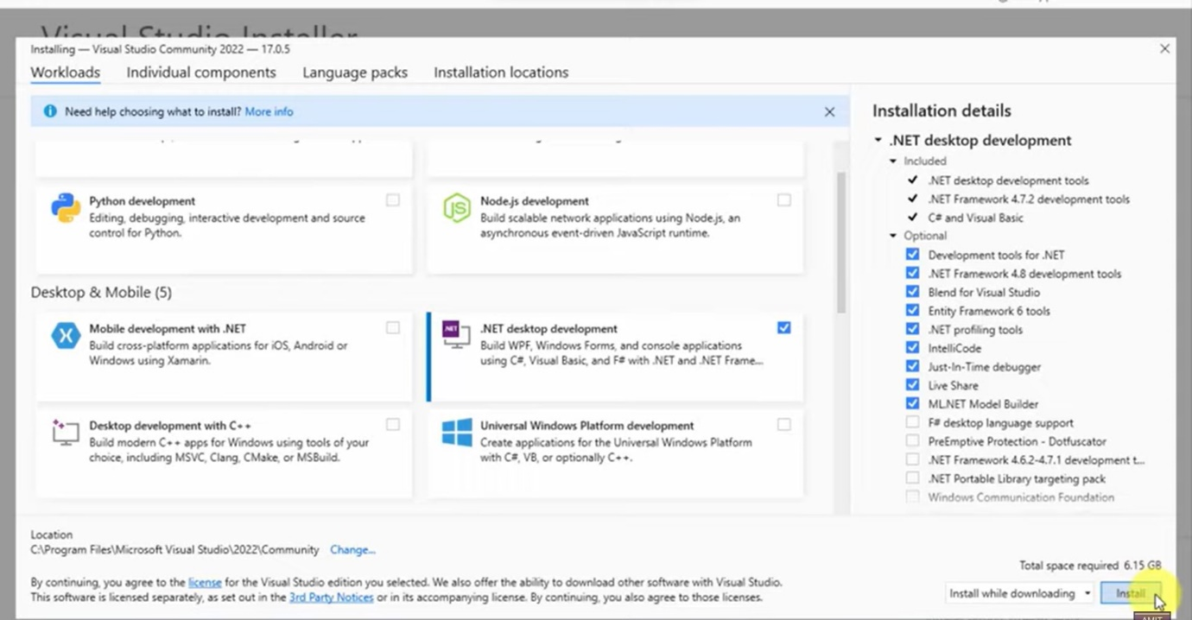

Step5:

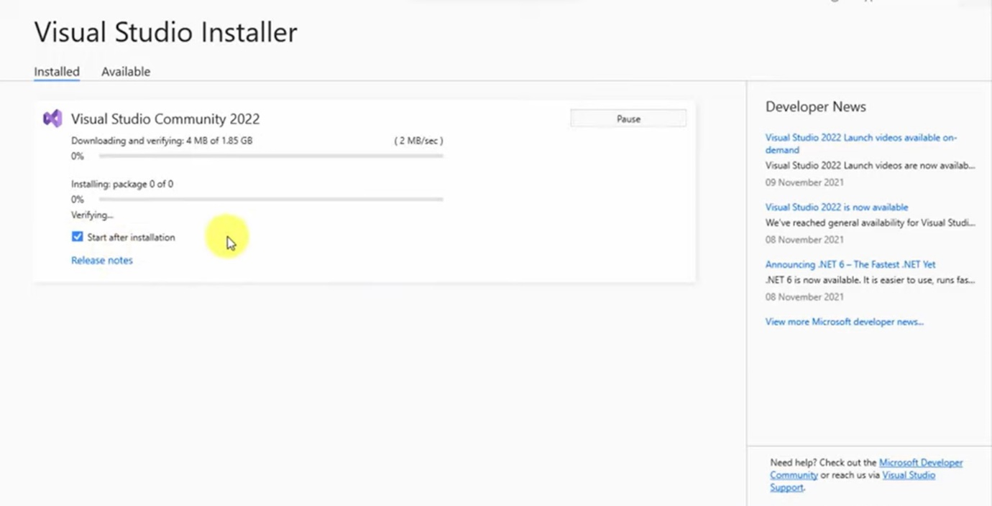

Step6:

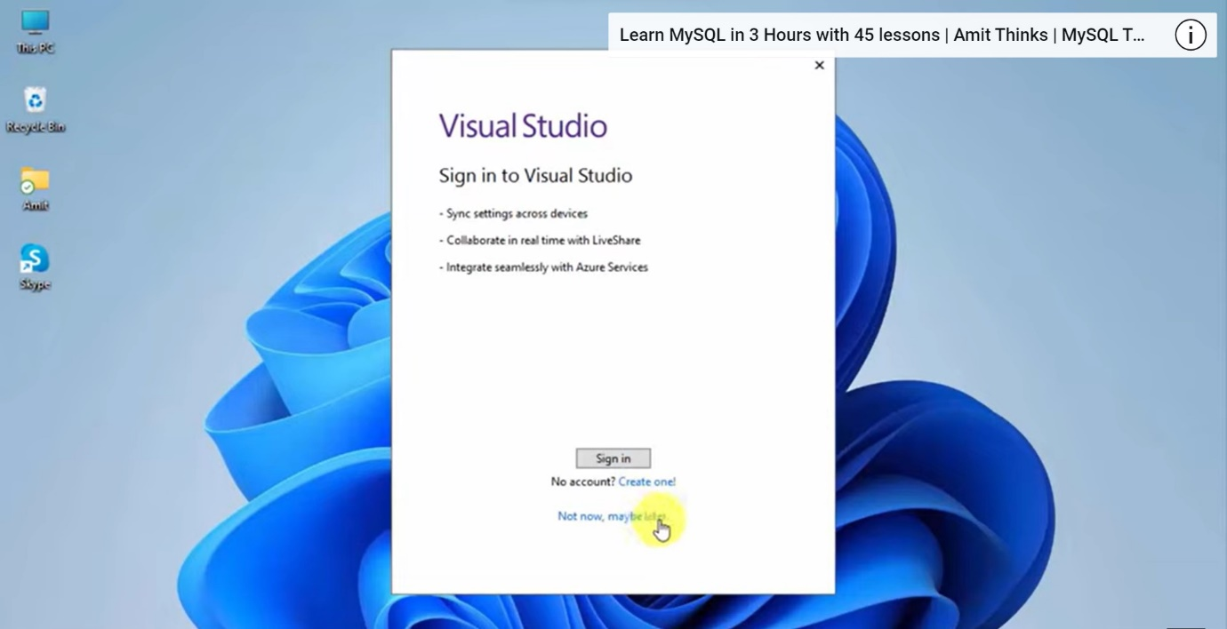

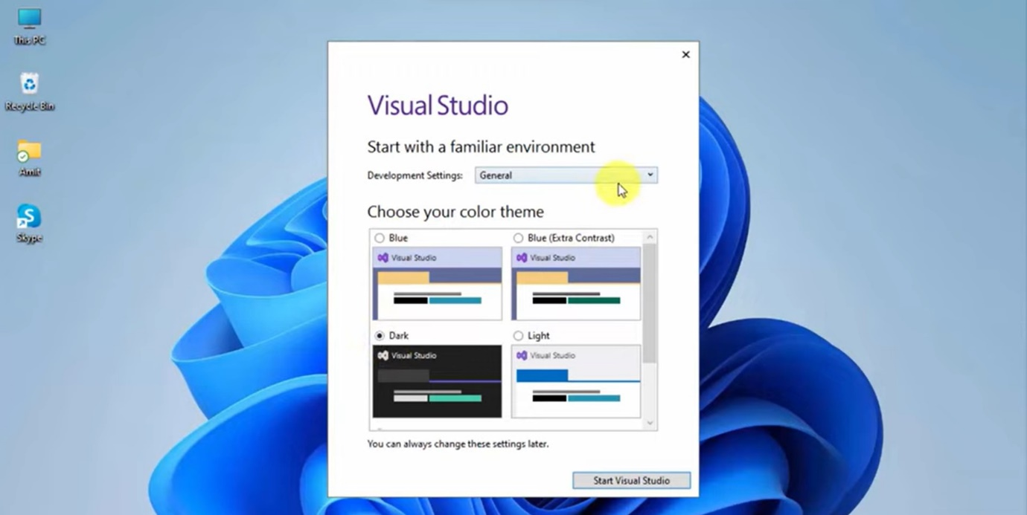

Step7: Creating a new project

