**CHAPTER ONE**

**INTRODUCTION**

**1.1 Introduction**

A transcript system is an inventory of the courses taken and grades earned of a student throughout a course of study. There are official transcripts and transcripts which can be made by the student and verified and attested by an authorized person.A computerized information management for transcript management will help to over-come the undesirable problem associated with misplacement of student records, student’s grades, slow and strenuous accessibility of student report and record, inaccurate record keeping and poor information management within the schools. Here the aims and objectives of the study will be easily retrieved with increased data security, and there will be reduction in the amount of resources, which will lower the cost of processing of student transcript, since information is stored in a database with reduced data redundancy. This will also prevent over-working of personnel and reduce in the bulkiness of file and record. This program developed/designed will ensure easy flow of information in the school (caritas university), and accurate information management in all school. There were three fundamentally distinct education systems in Nigeria in 1990; the indigenous system, Quranic Schools and formal European style education institutions. In the rural areas where the majority lived, children learned the skills of farming and other work, as well as the duties of adulthood from participation in the community; this process was often supplemented by age-based schools in which groups of young boys were instructed in community responsibilities by mature men. By the 1970s, education experts were asking how the system could be integrated into the more formal schooling of the young, but the question remained unresolved by 1990 until Western-style education came to Nigeria with the missionaries in the mid-Nineteenth century. Although the first mission school was founded in 1843 by Methodists, it was the Anglican Church Missionary society that pushed forward in the early 1850s to found a chain of missions and schools. Followed quickly in the late 1850s by the Roman Catholics in 1887 in what is now Southern Nigeria, an education department was founded that began setting curriculum requirement and administered grants to the mission societies. By 1914, when North and South were united into one colony, there were fifty-nine government and ninety-one mission primary schools in the South; all eleven secondary schools, except for Kings College in Lagos, work run by the missions. The education system focused strongly on examinations. In 1916, Fredrick Lugard, first governor of the Unified Colony, set up a school inspectorate. Discipline, building and adequacy of teaching staff were to be inspected, but the most points given to a school’s performance went to the numbers and ranking of its examinations results. This stress on examination was still used in 1990 to judge educational results and to obtain qualification for jobs in government and the private sector. As more information is made available in a variety of formats and media and in a variety of locations, the need to manage information/data efficiently becomes more and more critical. Both staff and public users want access to stored information and want to access it more efficiently.

It is the university’s policy to improve both the efficiency and effectiveness of result processing operations (student record/grades), and services through the implementation of a computerized transcript management system.

**1.2 Background of the Study**

Ladoke Akintola University of Technology, Ogbomosho, Oyo State, is a state-owned university. In 1987, Governor Adetunji Olurin, the then Military Governor of Oyo State (now split into two states: Oyo and Osun), received a request from the Governing Council of The Polytechnic Ibadan to establish a State University. He set up a committee in 1988 that recommended the creation of the University. By March 13, 1990, Nigeria's federal military government accepted the State's request. The edict establishing Oyo State University of Technology was signed on April 23, 1990 by Colonel Oresanya. The first Vice-Chancellor of the University was Olusegun Ladimeji Oke. During the time, Late Bashorun M.K.O Abiola became the first Chancellor in January 1991. The University began its first academic session on October 19, 1990 with a total of 436 candidates enrolled in four faculties, namely Agricultural Sciences, Environmental Sciences, Engineering and Management Sciences, and Pure and Applied Sciences. A College of Health Sciences was established a year later. The name of the University was changed to Ladoke Akintola University of Technology after the separation of Osun State from Oyo State. The university enrolls nearly 20,000 students in six faculties and a college. For two consecutive seasons, in 2003 and 2004, the Nigerian Universities Commission (NUC) rated LAUTECH as the best state university in Nigeria.

The main campus is in Oyo State. This campus is the site of the university's administration, as well as home to five faculties and the post-graduate school. Fields of study include Pure and Applied Science, Medicine, Agriculture; Engineering and Technology, and Environmental science. Another campus is located in Oshogbo, home to the College of Health Sciences. Departments of Medicine and Surgery, Medical Laboratory Science and Nursing are housed there. Medical students presently shovel between the College of Health Sciences at Oshogbo, and the recently built teaching hospital - LAUTECH Teaching Hospital (LTH) - at Ogbomosho, Oyo state.

**1.3 Statement of Problem**

This project research was exclusively conducted in Ladoke Akintola University of Technology (LAUTECH) located in a highly populated area that attends to too many students at a time. Hence, this research was able to track problem such as misplacement of student records, student’s grades, slow and strenuous accessibility to students report and record, inaccurate record keeping and poor information management within the schools.

**1.4 Aims and Objectives of the Study**

The aim of this study is to identify the problems inherent in the existing system of transcript management systems, and to proffer a remedy to the existing problem. The solutions are as follows:

* Record and reports of students will be easily retrieved with increased data security.
* There will be reduction in the amount of resources, which in turn will lower the cost of processing of student’s transcripts, since information will be stored in a database with reduced data Redundancy.
* School personnel can attend to many students without being over worked.
* There will be reduction in time used in retrieval of student’s files.
* Reduction in bulkiness of files and record.
* It will make available the storage room that was used for storage of files.

**1.5 Significance of the Study**

The project research hasn’t identified the problem that was existing in the old system of operation. It is designed specifically to come up with a more resound and effective system that will not only counteract this problem but also provides a detailed future plan that will give room for more information technological improvement in the transcript sector.

**1.6 Scope of the Study**

This research work is limited to providing a digital transcript’s information management system that will electronically handle both students and staff record, to enable easy accessibility and information flow within the university.

**1.7 Limitation of the Study**

This research work is limited to providing a more reliable information management system that will electronically handle the record of both student and staff within the university.

**1.8 Organization of the Study**

This project work is specifically arranged in Chapters, hence it follows the order: Chapter One: Introduction; Chapter Two: Literature Review; Chapter Three: System Analysis and Design Chapter Four: System Implementation and Documentation; Chapter Five: Summary, Conclusion and Recommendation.

**CHAPTER TWO**

**LITERATURE REVIEW**

**2.1 Introduction**

The introduction of computer into information technology has massively improved the information need of organization; the success of this machine is dependent on the knowledge base. Therefore, one can be prompted to ask aloud “what is a computer”? Funk E. C. (1980) defined a computer as an electronic device that can perform automatically and at a high speed a sequence of logical operations according to instructions given to it in form of a pre-arranged program. Another author, Anigbogu, S.D. (2000) defined a computer as an electronic device capable of accepting data and instructions, processing the data based on the instructions to generate result or output in such a manner that is yet to be equaled by any other known machine to mankind.

Similarly, another author Chimezie, F.O. (1990) defined it by saying that “computers are looked +upon as obedient servants who are ever ready to free man from tedious procedures and produce results as compared with human computing time”. Yet another author, Obilikwu, P. (1995) defined computer as a machine that is capable of accepting input data, store and process the data based on instructions given by the computer user and in this way produce expected results, generally called output. These definitions of computer would lead us to answer the question “what is a program?. In his definition, Obilikwu, P. (1995) defined a program as a sequence of instructions given to the computer to perform a specific operation. From Encarta Encyclopedia, computer program is a set of instructions that directs a computer perform some processing function or combination of functions. This above definitions of computer clearly demonstrated the limitless area of operation of computer in as much as such task is programmable computer is applicable in virtually all areas of human endeavour ranging from Agriculture, education, business, sports, entertainment, medicine, constriction and military etc. French, C.S. (1992) in his book titled “Computer Science” fourth edition, he relates the relevance of computer to management and stated that “a company needs information in which to base decisions concerning the current operations and future plans. It requires the information to be timely and accurate”. He then cited the example of the use of computer in the area of management control to production and stated “production must be able to respond quickly to changes in demand and other circumstances to do so requires the provision of up to date information which is accurate and timely”. Aluko, A.O. (1991) in a paper stated that “in virtually any job whether clerical, technical, business or professional, whether it is a banking, medicine, education etc. Computers are useful tools” and that “computers are tools with which we calculate, measure, assess, store, retrieve, regulate and monitor information. Hence, the blood and life wire of any system is information. A typical system (Education, management etc) cannot survive without good management information system (MIS).

Management information systems (MIS) are information systems, typically computer-based that are used without an organization. The concept of management information system is a complex variable although Murdick, R. (1971) simplified it when he said “there is probably no more challenging and diversified subject than management theory, system theory and computer science”. Computerization is a social process for proving access to and support for computer equipment to be used in activities such as teaching, accounting, writing, designing, circuits, file processing etc. Computerization entails social choices about the level of appropriate investment and control over equipment and expertise, as well as choices of equipments. Dunlop and Kling (1991), by the early 1990’s computing and telecommunications accounted for half of the capital investments made by private firms. However, paper (1980), Fergenbaum and McCorduck (1983) and Yourdon (1986) stated that the most fervent advocates of computerization have argued that the actual pace of computerization in schools, factories and homes is too slow. Taylor (1980), computer-based education includes both computer-assisted instruction programs that interact with students in a dialogue and a broader array of educational computer applications such as simulations or instruction. In computer programming, there is major national push for extended application of computer-based education at educational levels. For example, in the mid 1980s private several colleges and universities required all their freshmen students to buy a specific kind of micro computers, and other invested heavily in visions of “wired campus”.

Kling (1983), computer-based education has been promoted with two different underlying ideologies in all levels of education. Some educators argue that computer-based instructional approaches can help fulfill the traditional values of progressive education, the simulation of intellectual curiosity, initiative and democratic experience. For examples, Cyert (1984) has argued that computerized universities are qualitatively different than traditional universities. University students with micro computers in their dorm room will be more stimulated to learn because they will have easy access to instructional materials and more interesting problems to solve. Papert (1979) argues that in a new computer base school cultivate, students will no longer simply be taught mathematics. These visions portray an enchanted social order transformed by advanced computing technologies. Other advocates are a bit less romantic, but not less enthusiastic. For example, Cole (1972) argues. Because of the insatiable desire of students for more and more information at a higher level of complexity and more sophisticated level of utilization…. More effective means of communication must be used…. Computers can provide a unique vehicle for this transmission. King (1986), others emphasize a labour – market pragmatism that we label “vocational matching.” In this view people will need computer skills, such as programming, to compete in future labour markets and to participate in a highly automated society; a responsible school will teach some of these skills today.

Kling (1986), advocate of computer-based education promote a utopian image of computer-using schools as places where students learn in a cheerful, cooperative setting and where all teachers can be supportive, enthusiastic mentors. Hence, it is important to note that computer based education goes a long way in helping the students as well as the staff to effectively make use of the computerized management system. It also helps in convincing the stakeholders of the importance and need for adopting the computerized transcript management system as it provides effective and accurate handling of student’s files. Therefore, a computerized transcript management system is usually a system, which is implemented with a computer to achieve the utmost efficiency and desired goals in well developed countries, where education system are computerized. Thus a personalized software that captures the entire education business process and makes all operation accessible via the web, thus allowing schools to effectively serve all stakeholders students, lectures, administrators and percent. But in this case (Transcript Management System) it provides functionalities including Grading, Records keeping, information management within the school, easy retrieval and data security.

**2.2 The Role of Management Information System in Decision Making in the University**

The role of information in decision making cannot be overemphasized. Effective decision making demands accurate, timely and relevant information. According to Aminu (1986), information resource is one of the major issues and indices of university planning. Where the relevant information required for planning are not available at the appropriate time, there is bound to be poor planning, inappropriate decision making, poor priority of needs, defective programming or scheduling of activities. Hence, the university system will not be efficient and effective in its operation. Poor management information systems have been identified as a bottleneck in the successful management of universities in Nigeria (NUC, 1987). The more complex an organization’s structure is, the greater the need for coordination within and between sections and departments. However, central to the needed coordination is information. This view is buttressed by Murdick and Ross (1971), when they opined that: Information is absolutely essential to the survival of an organization. As organization grow, the pressure of scale, complexity and an increased rate of change make adequate information processing capacity inevitable, if effective control, consequent upon coordinate of individual activities is to be achieved. Thus, the information needed for effective decision making in universities cannot be provided from people’s often deficient memories. Moreover, it is impossible to plan activities over a long period of time effectively without effective information. Information is supposed to be created through the discipline of enquiry and research with peer moderation to ensure, validity and societal influence. The knowledge to be created or established must be stored to ensure continuity of reason, and adaptive academic pursuit. The stored information must then be recalled at will and be disseminated for use in taking decisions, which are in the interest of the society at large. According to Knight (2005), there are mechanisms that drive continuous investment in bricks and mortar education and deny the expenditures that would establish virtual universities by means of telecommunication networks. Even if they wanted to, administrators are restricted in their freedom to move in this direction by traditional funding formulae. Promotion and tenure procedures are seen as banners in the universities. In many institutions, the primary requirements for promotion and for tenure procedures are publications in traditional journals and teaching in traditional classrooms. A major federal government contribution is its booster plan to computerized information in the United Schools (Ekere, 1990). With these improvements, the information resource still presents a major issue on educational management in the country. Particularly with the universities, one wonders the essence of their acquiring communication gadgets and the scope of their applications. Studies have revealed that in most sophisticated organization both manual and computer based system are used; in fact both are held to be complementary in information handling procedures. (Sanders, 1983). Obi (2003), Fabunmi (2003) and Adebayo (2007) has stressed the need for management information systems in making effective decisions in education institutions. In recognition of the important role of information to the survival of the university system, the NUC introduced the computerized management information system to the Nigerian universities. The MIS idea was conceived during a conference jointly organized by NUC and the British Council in Kaduna in 1987. In conjunction with Overseas Development Administration (ODA), the project took in 1989 in four pilot universities, namely Federal University of technology, mina, and university of Ilorin, University of Lagos and University of Nigeria, Nsukka. The importance of MIS in decision making can be realized from its aims and objectives. The aim of MIS is to develop a viable system to maximize the effective use of modern data approach to management practices. It is also aimed assisting managers and operating personnel, to produce timely and accurate information not only to decide present and future operations, but also to pinpoint potential problems that need to be rectified. According to NUC (1987), the objectives of MIS project in the universities are:

a) To standardize the system of obtaining reports and statistical information from the various universities on students, stall financial matters and library.

b) To record such information on diskettes or tapes at the universities and send to NUC for budgeting, information storage, analysis and retrieval purposes.

c) To ensure that such information are accurate and timely.

d) To organize information for planning, budgeting and decision making.

e) To help the universities put in place effective management system and improve utilization of resources.

Based on these objectives, it is expected that MIS will assist the universities in decision making on various issues in their operations. To this end, efforts are made by the universities in the areas of the acquisition and use of computers in information processing, computer literacy, establishment of computer services units among others.

**2.3**  **Information and the MIS concept**

### Information is a set of classified and interpreted data used in decision making. It has also been defined as 'some tangible or intangible entity which serves to reduce uncertainty about future state or events' (Lucas, 1978). A management information system (MIS) is 'an integrated user-machine system for providing information to support operations, management and decision making functions in an organization. The system utilizes computers, manual procedures, models for analysis, planning, control and decision making, and a database' (Davis and Olson, 1984). MIS facilitates managerial functioning. Management information is an important input at every level in the organization for decision making, planning, organizing, implementing, and monitoring and controlling. MIS is valuable because of its content, form and timing of presentation. In the context of different levels of decision making, information can be described as:

* Source,
* Data,
* Inferences and predictions drawn from data,
* Value and choices (evaluation of inferences with regard to the objectives and then choosing a course of action), and
* Action which involves course of action.

The MIS concept comprises three interrelated and interdependent key elements: management, system and information (Murdick and Ross, 1975).

### 2.4 Management and the MIS process

An MIS is directed towards the managerial functions of planning, controlling and monitoring, and decision making.

**Planning**

Planning consists of five sequential and interactive steps (Kumar, 1989). These are:

* selecting objectives;
* identification of the activities which are required to achieve the stipulated objectives;
* detailing the resources - including the various skills - required to undertake the activities;
* determining the duration of each activity to be performed;
* defining the sequence of the activities

**Monitoring and controlling**

Controlling compels events to conform to plans' (Murdick and Ross, 1975). It involves:

* establishing standards of performance in order to reach the objective;
* measuring actual performance against the set standards;
* keeping actions on course by correcting deviations as they appear (mid-course corrections).

**Decision making**

Decision making is the process of selecting the most desirable or optimum alternative to solve a problem or achieve an objective. The quality and soundness of managerial decisions is largely contingent upon the information available to the decision-maker. Gorry and Scott Morton (1971) classified decision making on three levels of a continuum:

* *Strategic* decisions are future-oriented because of uncertainty. They are part of the planning activity.
* *Tactical* decision making combines planning activities with controlling. It is for short-term activities and associated allocation of resources to them to achieve the objectives.
* *Technical* decision making is a process of ensuring efficient and effective implementation of specific tasks.

### 2.5 Systems approach

Modern management is based upon a systems approach to the organization. The systems approach views an organization as a set of interrelated sub-systems in which variables are mutually dependent. A system can be perceived as having:

* Some components, functions and the processes performed by these various components;
* Relationships among the components that uniquely bind them together into a conceptual assembly which is called a system; and
* An organizing principle that gives it a purpose (Albrecht, 1983).

The organizing system has five basic parts, which are interdependent (Murdick and Ross, 1975). They are:

* the individual;
* ·the formal and informal organization;
* patterns of behavior arising out of role demands of the organization;
* the role perception of the individuals; and
* the physical environment in which individuals work.

The interrelationship of the sub-systems within an organization is fundamental to the systems approach. The different components of the organization have to operate in a coordinated manner to attain common organizational goals. This results in synergic effects. The term *synergy* means that when different sub-systems work together they tend to be more efficient than if they work in isolation (Murdick and Ross, 1975). Thus, the output of a system with well integrated sub-systems would be much more than the sum of the outputs of the independent sub-systems working in isolation. The systems approach provides a total view of the organization. It enables analysis of an organization in a scientific manner, so that operating management systems can be developed and an appropriate MIS designed (Murdick and Ross, 1975).By providing the required information, an MIS can help interrelate, coordinate and integrate different sub-systems within an organization, thus facilitating and increasing coordinated working of the sub-systems, with consequent synergism. The interaction between different components of the organization depends upon integration, communication and decision making. Together they create a linking process in the organization. Integration ensures that different sub-systems work towards the common goal. Coordination and integration are useful controlling mechanisms which ensure smooth functioning in the organization, particularly as organizations become large and increasingly complex. As organizations face environmental complexity, diversity and change, they need more and more internal differentiation, and specialization becomes complex and diverse. The need for integration also increases as structural dimensions increase. Communication integrates different sub-systems (specialized units) at different levels in an organization. It is thus a basic element of the organizational structure necessary for achieving the organization's goals.

**2.6 Advantages of using Management Information System**

i) Provides an inclusive picture of an organization

ii) MIS enhance the operational productivity of an organization.

iii) Add value to the existing products, motivates innovation and improve product development, and assists the manager to make better decisions.

iv) Reports like employee’s performance record, annual revenue generated helps an organization to evaluate their assets and limitations, thereby, identifying these facets the organization can improve its methods and  operations.

v) Assists as a communication and planning tool.

vi) Customer data report helps in planning better and effective marketing strategies and promotional activities.

vii) Management information system helps an organization to achieve a competitive advantage.

viii) It helps in effective decision making, thereby reducing the time for actionable items.

**CHAPTER THREE**

**SYSTEM ANALYSIS AND DESIGN**

**3.1 Introduction**

System analysis is defined as the comprehensive study of an existing system to discover the

areas of its functional limitation. This is the tool that helps me a lot in gaining an understanding

of the existing system and what is required of it. It is a structural process that I used in collecting

and analyzing facts in respect to systems operation of transcript information systems and

procedures in order to get a full appreciation of the situation so that an effective computerized

information management system may be designed and implemented.(Bill, 2009)

**3.2 Aims of system analysis**

The best objectives of system analysis is to find the mode of operation of the existing system

of transcript information and its limitation so that a computer based system can be designed

and fully implemented in order to solve the problems associated with the existing system.

**3.3 Analysis of the old system of transcript information system**

Higher institutions has four main missions to achieve, which are to increase amount of graduate, to research, to serve society, and to preserve the arts and culture . In order to increase amount of graduate with outstanding quality and meet the needs of employers, the students need to be equipped with knowledge, ability, intelligence, and ability to work with colleagues. Nowadays, students graduated with only certificates or academic transcripts which is not enough to ensure their qualifications. Activities transcript is one of the importance factors for the employers consider when making an employment. As a result, this study was conducted regard to the importance of activities transcript preparation process, which is a complicated process. Therefore, I build the Online Transcript Management System (TRMS) to follow up the record of student activities and assist in reporting the activities transcript

**3.4 PROBLEM ASSOCIATED WITH CURRENT SYSTEM**

During my analysis of the existing system of transcript information system in the course of my

Project Research, I observed some problems that were inherent in the existing system and there

are listed below as follows:

1. Monotonous storage of record

2. Bulkiness and heaviness of files

3. Misplacement of student grade record due to negligence on the part of workers.

4. Slow and strenuous retrieval of records and report of students.

5. The system is not cost effective

6. Inaccurate diagnoses due to wrong record keeping

Discriminate capability and reliability among users have been major problems in previous transcript analysis work. Discriminate capability means a coding instrument readily and unambiguously permits placing of conference content into discrete and useful categories. It has not proven to be easy to achieve, as demonstrated by the prevalence of admitted coding problems in transcript research. Gunawardena et al. (1997), for example, found problems using Henri's (1992) model to distinguish between cognitive and metacognitive activities in conferences. They concluded that a large number of units could have been coded as either (p. 404). As a result of this experience, Gunawardena et al. developed their own analytic tool, but concluded that it was a poor discriminator: over 90 percent of transcript postings fell into a single category (p. 425). In another study, Kanuka and Anderson (1998) reported two problems attributable to weak discriminate capability of their instrument: an "overwhelming" number of messages were coded into one category, and messages could often be coded into more than one category (p. 65). Zhu (1996) also had acknowledged that her classification system permitted postings to fit into several categories (p. 837).

Reliability is directly affected by lack of discriminate capability: if categories are not clear, discrepancies in coding will occur. In fact, reliability is often either low or not simply mentioned at all in published reports of transcript analysis research, and to improve reliability researchers often resort to convenient but inefficient and expensive strategies such as collaborative coding (Kanuka and Anderson, 1997; Rourke et al., 1999). Such strategies may meet the need for consensus in an specific research context, but they do not argue for the reliability of the coding instrument. Problems with discriminate capability may be attributed to two causes: complexity of the instrument (both too many categories or codes, and lack of mutual exclusiveness among them), and use of an inappropriate unit of analysis (anything other than the sentence).Complexity is directly related to the number of codes available. Some coding tools simply contain too many categories, forcing users to make many excessively fine discriminations. Gunawardena et al.'s (1997) model included over twenty categories grouped into five "phases"; Cookson and Chang (1995) employed four main groups of criteria, with each further subdivided into four more categories; Higgins' (1998) model used as many as twenty; Rourke's (1999) model has twelve indicators, in three groups; and Zhu (1996) used 8 categories. Obviously, with more categories there is more likelihood of ambiguity, definitions of differences among categories must be made unambiguously clear, and there is more need for training and practice for potential users.

**3.5 Objective of the new system**

Because of the problems inherent in the existing system in the transcript system, the need for

computerization becomes imperatives. These are listed below as follows:

➢ Record and reports of students will be easily retrieved with increased data security.

➢ There will be reduction in the amount of resources, which in turn will lower the cost of

medical service, since information will be stored in a database with reduced data Redundancy.

➢ School personnel can attend to students without being over worked.

➢ There will be reduction in time used in retrieval of student files.

➢ Reduction in bulkiness of files and record.

➢ It will make available the storage room that was used for storage of files.

**3.6 Main Menu Specification**

**3.6.1 Input Design**

This involves the steps of algorithm that was used to design the input of the new system i.e.

inputting data into the system.

**3.6.2 Output Design**

This design brings out the feedback of the result of any input that is captured and processed in the system.

The design is shown in just one form:

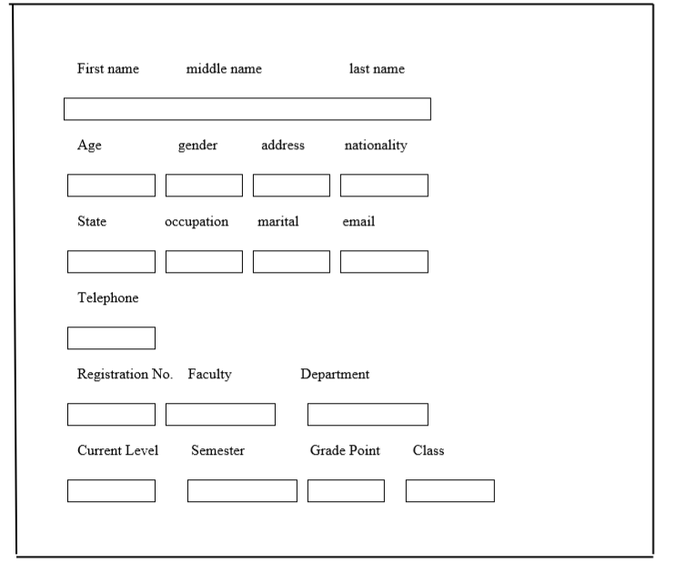

**Overview of the System Free hand chart**

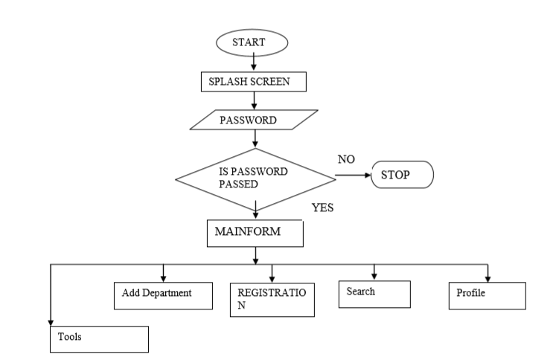

**3.7 System design**

This is the process of designing or building the new system after a detailed study of the

objectives of higher institutions. It is stage in which the research actually plans the life cycle of a

system and all the work associated with the various stages of the system life cycle. The

main aim of this design is to achieve a new system that is better than the old system in

terms of efficiency and service with the introduction of a computer aided system. The

design will make extensive use of the menu driven approach, which routes program of

interest and ensure that the user inputs is not inconsistent for easy access path information.

Overall System

The need for computerized information management system for the transcript process is of

great importance, due to some of the problem that were encountered with the old system due

to that, in the course of my Project Research, I tried to develop a system that will counteract

some of these problems, the system was built in JavaScript, a programming language

that I termed will best solve most of the problem that were encountered in the old system.

The new system was designed considering the evaluation of already existing process of

information processing, the system was not meant to add or remove from the already existing

process, but it was meant to improve the way that these information are been processed, to

enhance speed and accuracy in the system.

**3.8 Procedural Flowchart**

**3.8.1 Input Processing**

With respect to the input of data, it has to undergo certain degree of data processing before

it could give the required output with this at hand we can conclude that all input in this system

needs to be processed.

**3.8.1.1Flowchart: The flowchart below shows the input processing.**

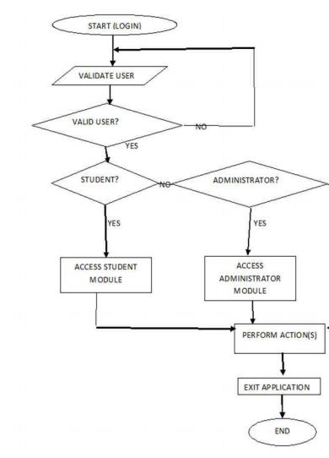

**3.8.2 Output Design**

This is what is given out specifically when a particular data that is inputted into the computer

are processed, hence for output process to be complete and to take place effectively there is a

necessity for the input to be feed into the computer for processing to effectively take place.

**3.9 Data Collection**

**Method and Source**

-Searching for relevant books, libraries and World Wide Web(WWW)

-Personal observations and getting relevant data from various related

Research reports.

-Meetings with professional, students and colleagues

**CHAPTER FOUR**

**SYSTEM IMPLEMENTATION AND DOCUMENTATION**

**4.1 System implementation**

**4.1.1 language implementation**

The need for computerized information management system is of great importance, due to some of the problem that were encountered with the old system due to that, in the course of my project research, I tried to develop a system that will counteract some of these problems, the system was built in JavaScript, a programming languagethat I termed will best solve most of the problem that were encountered in the old system. The new system was designed considering the evaluation of already existing process of information processing, the system was not meant to add or remove from the already existing process, but it was meant to improve the way that these information are been processed.

**4.1.2 Input Specification**

Hence in the input specification of the program, there are many functions that are specifically

designed to handle the input processing of the program and ensure that it gets to database at

any point in time after processing of the data. Some of the input specification of this program is

as follows: Add Full Name, Course, Year of study, Registration.

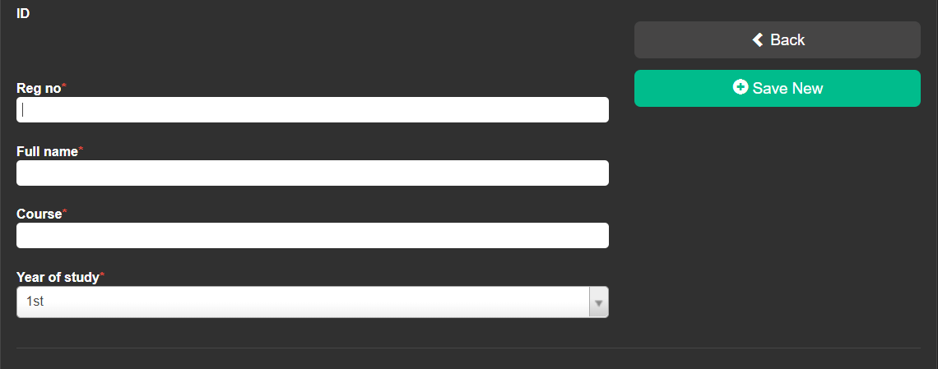

**4.1.3 Output Specification**

This has to do specifically with those controls and component that are responsible for the

view of the result of the data stored in the database after processing, this specification to be

represented effectively in the program, there are some of the component of the program that

portrays the output specification of the program and some of this components are: Search,

Profile, Approve.

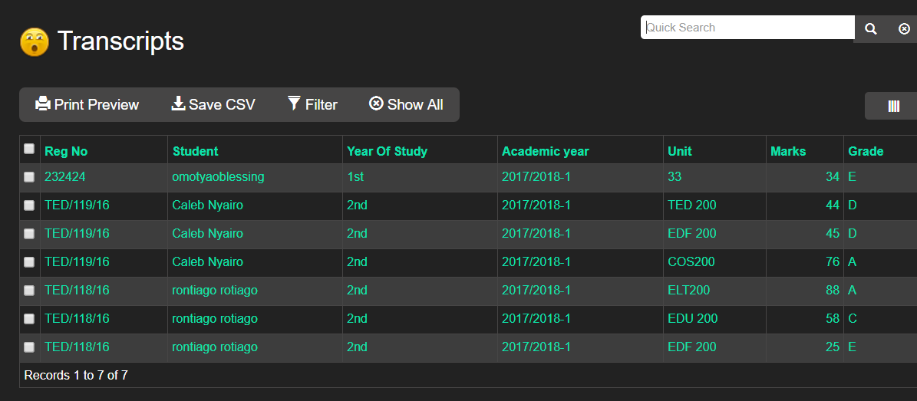

**4.1.4 Implementation of the new system**

Implementation is the period when the new system is put into use. For the system

Implementation to be effective, the following areas of activities were to be carried out Effective.

They include:

➢ Conversion of old files

➢ Education and training of staff

➢ Change over procedure

**4.1.5 Conversion of Files**

This process involves converting records of physical files to electronic files according to

the laid down procedures. It requires plenty of time and carefulness because there are many

files, where each files contains many records.

**4.1.6 Education and Training of staff**

It is vital that the staff of the user department have extensive knowledge of the new system

functions. It is important for the effective use of the new system in the school.

**4.2 System Requirement**

System requirement are those things, needed for the efficient working of the new system. These include:

➢ Software Requirement

➢ Hard Requirement

**4.3 Software Requirement**

Software refers to a set of program that is executable by the computer to perform a task. software

Requirement: are those software that are required by the new system for its effective function.

Windows 10 operating system is most preferable for the new system to function.

**4.4 Hardware Requirement**

Hardware refers to the physical component of the computer. This houses the software, the

combinations of hardware and software is vital for the effective running of the new system that

was designed for transcript management. The hardware requirements that are needed for the

effective running of the new system are stipulated below as follows:

➢ Monitor

➢ Keyboard

➢ Server

➢ LAN Network

**4.5 System Test-Run**

System Testing completes the system work, which has been able to change the manual ways

Information management in school, to a computerized method. It serves as a great improvement,

eliminating the inefficiency in the manual method.

**4.6 System Changeover**

To use the system the following task should be performed, as listed below are as follow:

➢ Plug the socket very well and all the connectors to the system.

➢ Boot your computer

➢ Run the program

**CHAPTER FIVE**

**SUMMARY, RECOMMENDATION AND CONCLUSION**

**5.1 Summary**

In the course of my Project Research, I find out that a computer aided information management

makes it more convenient, efficient and produces an accurate information management generally

in all Universities. This is opposed to the manual method, which is stressful, time consuming

prone to mistakes due to human nature and inconvenient. This will not only facilitate information

processing in the school, but will go a long way in improving the overall general service of the

university, since information department is the pillar post of the schools

**5. 3 Conclusion**

In conclusion, i have carried out a detailed and comprehensive research on schools as institution ,

there by laying down the problems that this institution faces as regards to information

management and dissemination which in essence is one of the paramount needs of schools, a

system was design which encompasses and counteract many of this problems that was observed

on the old system, hence all schools is now been advice to make use of this valuable tool to

improve to a great extent, the information requirement of this information which in essence will

improve efficiency. In this research, I developed the Transcript activities report management system (TRMS). The TRMS provides facilitate and minimize the redundancy in student activities evaluation process. The system is a useful and effective tool for instructors to follow up and disseminate the student activities information. Besides that, in the same way, this system has ability to evaluate the student activities scores, reduce the mistake and complication of information, and provide an easy way to collect/check the document in systematic manner. Lastly, the students are simply able to follow their student activities and activities score.

**5.4 Recommendation**

Having seen the usefulness of a computer based transcript management system to higher Institutions, I recommend the following to the schools, stipulated below as follows:

➢ They should computerize all the department of the school, to ensure easy flow of information

in the schools.

➢ They should ensure that all the staff of the user department are adequately trained to ensure

smooth implementation of the new system.

➢ Even after computerization of the whole department, they ensure that all the system are

linked to one central local network, protected with high security measures

➢ Advocate and educate stake holders and service providers to use transcript’s information for

planning.

➢ Formulation and development of policy guidelines on the use of information, data collection.

**REFERENCES**

Anigbogu, S. O. (2010). Computer application and operation First Edition. Awka, Anambra: Optimum Press.

Adebayo, F. A. (2017). Management Information System for Managers. Ado Ekiti : Green Line Publishers.

Bill, T. (2019). Echrome Transcript Management System. London: Princeton University Press.

Benly, H. C., & Brusell, G. C. (2008). School Computerization, 6th Edition. U.S.A: Kleen University Press.

Blementhal, S. C. (2000). Management Information System . New Jersey: Prentice Hall Inc.

Caplinskas, A. (2012). Program Systems Engineering Fundamentals. Institute of Mathematics and Informatics , Vol. 2. Vilnius, Literriania.

Electronic School Information, www.myschool.com.

Ekwere C.E. (2010). Evaluation of Management Information System in Universities. Lagos: Longman Publishers. Garrison, Randy. (2008). Theoretical Challenges for Distance Education in the Twenty-First Century: A shift from structural to transactional issues. International Review of Research in Open And Distance Learning 1(1).

**APPENDIX A**

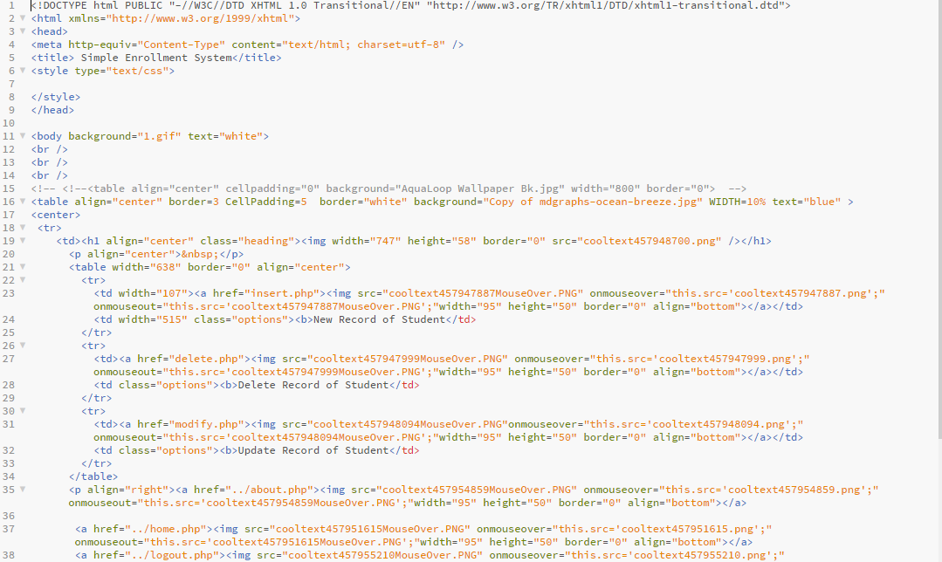

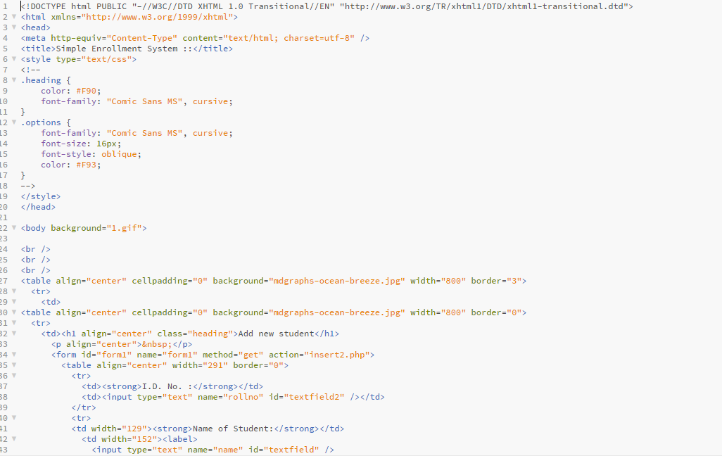

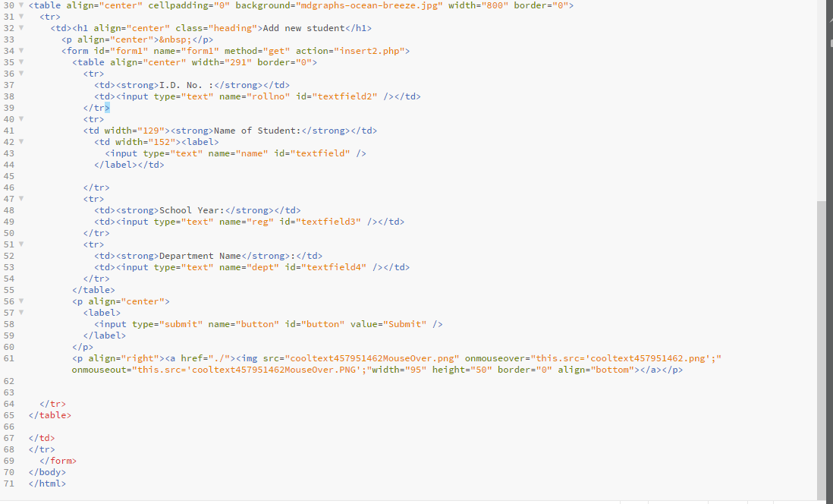

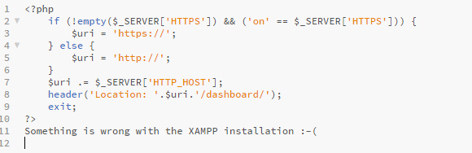

**APPENDIX B**

