**Usage Manual**

To configure Evernote integration user need to make sure to register himself on Evernote. To enable Evernote integration for a Teamchat group write keyword “help” in your group. The Evernote Bot will list all the commands available for the room. Following are the commands available for this integration:

* connect: connect your evernote
* myevernote: to perform desired task
* disconnect: disconnect your evernote

If you want to access multiple evernote accounts you need to type "disconnect" and then type "connect" to reconnect to different account.

To perform different task type keyword “myevernote”, a chatlet is thrown by the bot asking the user to select task from dropdown list.

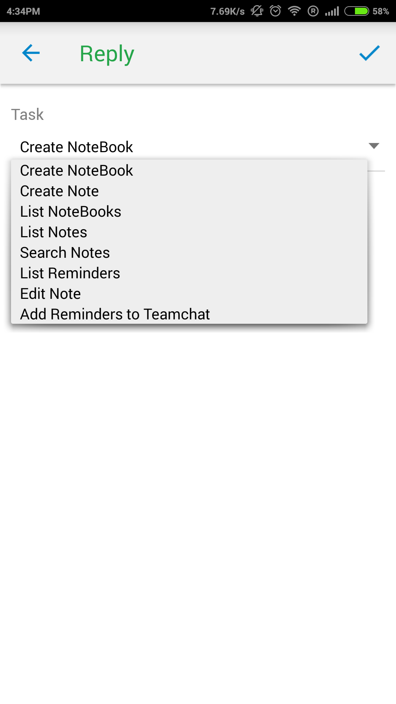

Create NoteBook: Enter the name of the Notebook and it is created.

Create Note: Select the Notebook and add title,content and tag to create note in that Notebook.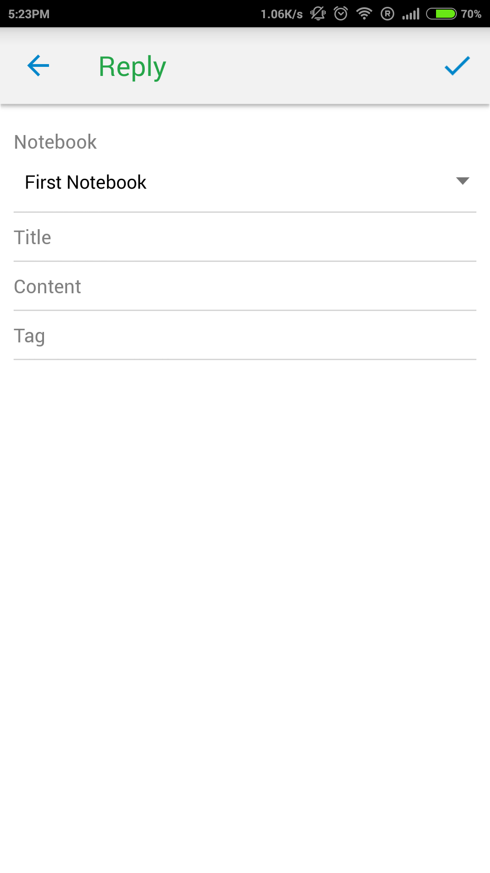

List Notebooks: Show all the Notebook present in your evernote.

List Notes: Shows all the notes present in the Notebooks corresponding to the notebook.

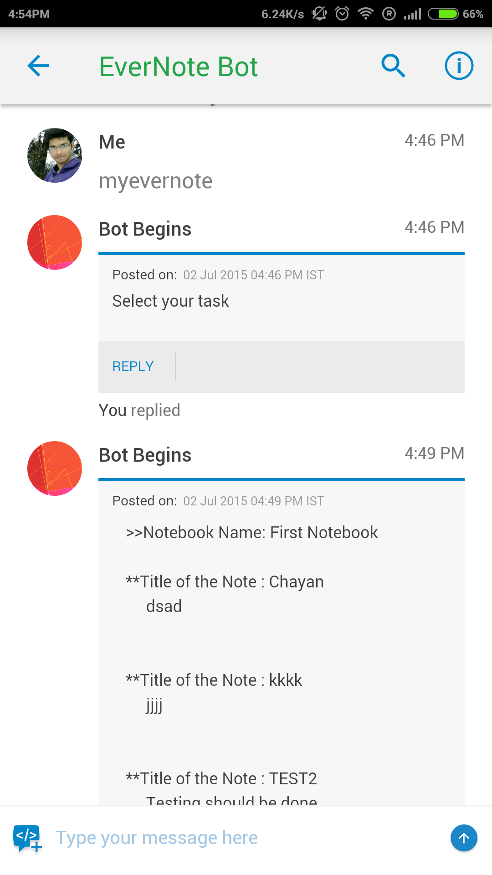

Search Notes: search through all the notes in your evernote

Edit Notes: Edit notes through teamchat via selecting the Notebook and then select the note you want to edit

Add reminder: Add remainder to your evernote account and get notified on teamchat also receive alert on teamchat.

List reminder: List all the remainder of your account.