**Integrating the Twilio with Teamchat**

As the Twilio provides the Helper Libraries in various languages like java ,php,etc

one can these helper libraries from

**https://www.twilio.com/docs/libraries**

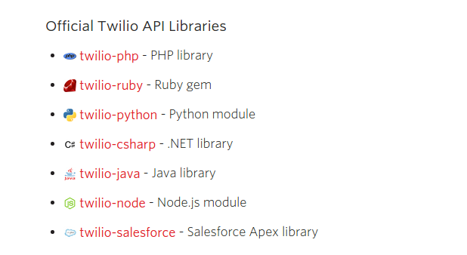

After that one can find the build in jars at Central Repostiroy the link is

**http://search.maven.org/#browse%7C-1416163511**

After downloading the jar one can login in there twilio account and explore there account one can find there **Account Sid** and **Account Token**

The Account Sid can needs to be different for the different user but the authtoken can be used the same for every account so

when there is an upgraded account twilio provides there own methid of authentication

by providing a **CONNECT BUTTON**

One can create a connect button by going to this link and filling up the details. After getting logged in his twilio account(developer account)

**https://www.twilio.com/user/account/connect/apps**

After filling the details in the form the Twilio generates the CONNECT BUTTON html code

that needs to be placed on the webpage where you need to have the authentication with the twilio mainly the getting the user logged in through there twilio account in order to get the **account sid**

and the corresponding developers **auth token** can be used along that account sid

The connect button contains this form:

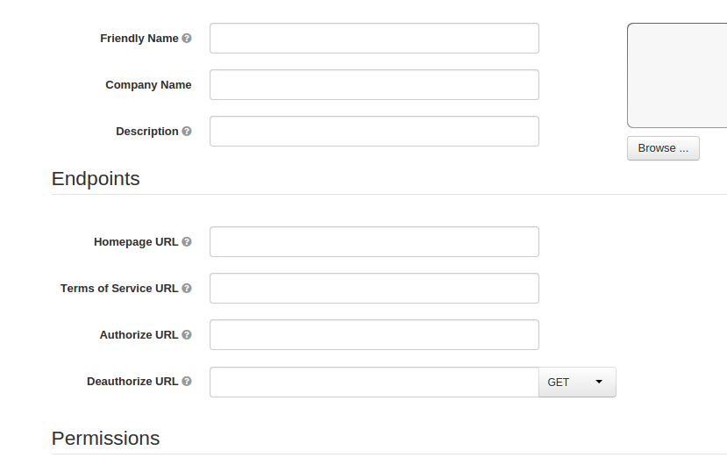

* After the servlet that will be hit in the AUTHORIZE url the developer can then get the parameter as twilio passes the account sid for corresponding email and password enter through the connect button.
* But for if the account is the trial account then you should ask the user there account sid and there twilio number.
* Inoder to have the functions working properly.
* You can store your account token and passes it whenever need in any functions

**Step 2:**

After the authentication part one can explore the api provided by the twilio.

From this url

[**https://www.twilio.com/user/account/developer-tools/api-explorer**](https://www.twilio.com/user/account/developer-tools/api-explorer)

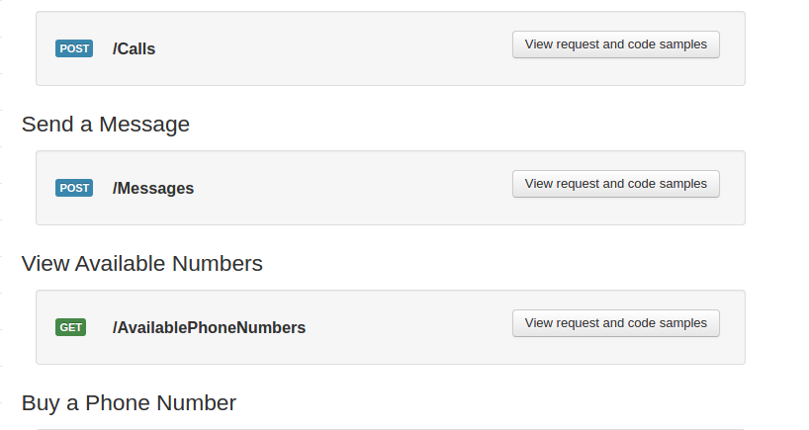

**So the integration contains the**

**1) send a message**  that can be found at

[**https://www.twilio.com/user/account/developer-tools/api-explorer/message-create**](https://www.twilio.com/user/account/developer-tools/api-explorer/message-create)

along with this you need to enter the users

**account sid**

**user twilio number**

**and receivers numbers.**

**And Developers Authtoken**

**There samples Codes given along with api that can be explored too.**

**Step 3:**

**Similar with the reminder concept**

**Step 4:**

**Make a call**

the url can be found there only

[**https://www.twilio.com/user/account/developer-tools/api-explorer/call-create**](https://www.twilio.com/user/account/developer-tools/api-explorer/call-create)

**you need to pass along with this the same values as above.**

**But along with developer authtoken application id also needs to be passed .**