**一、檔案配置位置:**

將hw2_data.txt放置於與程式相同路徑下。

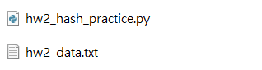

**二、執行結果:**

包含Hash內容、不重複的字彙數目、每種字彙分別出現的次數。

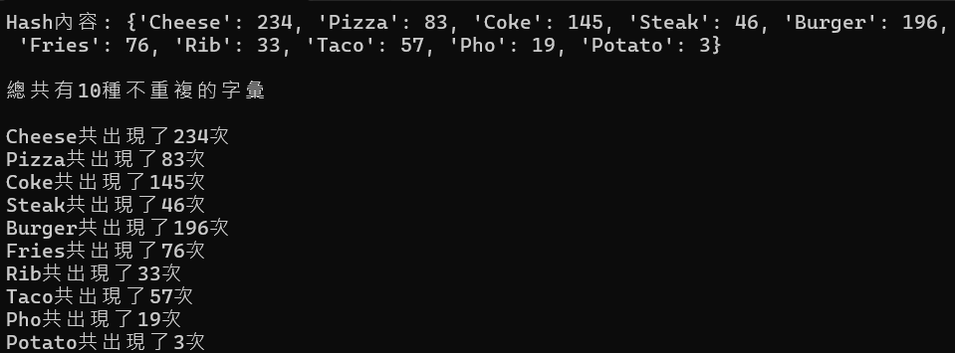

**三、程式碼**

word_output = {}

with open("./hw2_data.txt","r",encoding="utf-8") as file:

for line in file:

one_word = str(line).replace("\n","")

if one_word not in word_output:

word_output[one_word] = 1

else:

word_output[one_word] = word_output[one_word] + 1

file.close()

print(f"Hash內容: {word_output}\n")

print(f"總共有{len(word_output)}種不重複的字彙\n")

for word in word_output:

print(f"{word}共出現了{word_output[word]}次")  
**四、github專案網址**

https://github.com/Yen-Ling-127/HW2_hash_practice.git