**一、初始畫面:**



**二、正常輸入:**

1.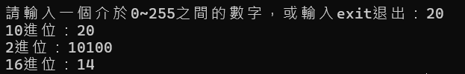

2.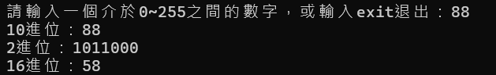

3.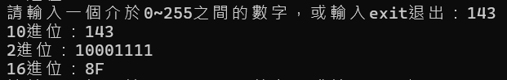

4.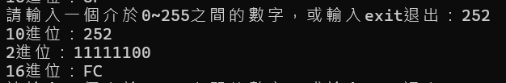

5.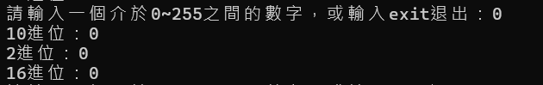

6.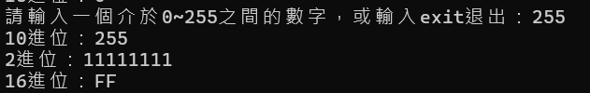

**三、異常輸入:**

**數值範圍錯誤:**

1.

2.

3.

**數值型態錯誤:**

1.

2.

**四、支援連續執行**

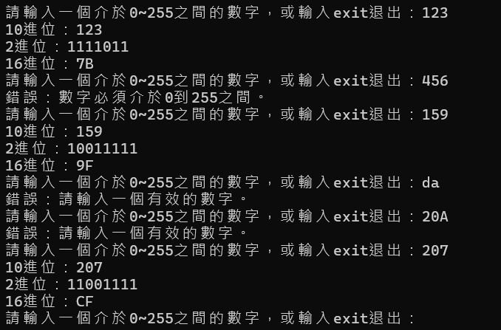

**五、退出**



**六、程式碼**

while True:

input_str = input("請輸入一個介於0~255之間的數字，或輸入exit退出：")

if input_str == "exit":

print("程式已結束。")

break

try:

int(input_str)

except:

print("錯誤：請輸入一個有效的數字。")

continue

num = int(input_str)

if not 0 <= num <= 255:

print("錯誤：數字必須介於0到255之間。")

continue

binary = ""

num_for_binary = num

while num_for_binary > 0:

binary = str(num_for_binary % 2) + binary

num_for_binary = num_for_binary // 2

hexadecimal = ""

num_for_hexadecimal = num

hex_chars = "0123456789ABCDEF"

while num_for_hexadecimal > 0:

hexadecimal = hex_chars[num_for_hexadecimal % 16] + hexadecimal

num_for_hexadecimal = num_for_hexadecimal // 16

if num == 0:

binary = "0"

hexadecimal = "0"

print(f"10進位：{num}")

print(f"2進位：{binary}")

print(f"16進位：{hexadecimal}")  
  
**七、github專案網址**

https://github.com/Yen-Ling-127/hw1_binary_hex_converter.git