CLASSAI: AI CURRICULUM-AWARE LESSON NOTES
GENERATOR FOR NIGERIAN SECONDARY SCHOOLS

BY
Umoh, Yeneabasi Alex
20/EG/CO/1359

A PROJECT REPORT
PRESENTED TO THE DEPARTMENT OF COMPUTER ENGINEERING
FACULTY OF ENGINEERING
University Of Uyo,
Uyo, Akwa Ibom State, Nigeria

IN PARTIAL FULFILMENT OF THE REQUIREMENTS
FOR THE AWARD OF THE DEGREE OF
BACHELOR OF ENGINEERING (B.ENG) IN COMPUTER ENGINEERING

July, 2026

TABLE OF CONTENTS
Title Page i
Table of Contents ii
Abstract iii
CHAPTER 1: INTRODUCTION 1
1.1 Background to the Study 1
1.2 Statement of the Problem 3
1.3 Aim and Objectives of the Study 4
1.4 Justification of the Study 5
1.5 Scope and Delimitation 6
1.6 Limitations of the Study 6
1.7 Organisation of the Report 7
CHAPTER 2: LITERATURE REVIEW 8
2.1 Preamble: The Nigerian Educational System and Foundational Technologies 8
2.2 Review of Related Literature 12
2.3 Theoretical Framework 22
2.4 Summary 24
CHAPTER 3: METHODOLOGY 25
3.1 Research Design 25
3.2 System Architecture and Design 25
3.3 Implementation Details 29
3.4 Technology Stack 31
CHAPTER 4: SYSTEM DEVELOPMENT AND RESULTS 32
4.1 System Implementation Results 32
4.2 Feature Mapping to Research Literature 35
4.3 Discussion of Findings 37
CHAPTER 5: SUMMARY, RECOMMENDATION AND CONCLUSION 40
5.1 Summary of the Study 40
5.2 Conclusion 41
5.3 Contributions to Knowledge 41
5.4 Recommendations 42
5.5 Suggestions for Future Research 43
References 44
Appendices 48

ABSTRACT
The integration of Artificial Intelligence (AI) in educational content generation presents a transformative opportunity for improving teaching quality in secondary schools. This project focuses on the design and development of ClassAI, an AI-powered, curriculum-aware lesson notes generator specifically tailored for Nigerian secondary schools operating under the Nigerian Educational Research and Development Council (NERDC) curriculum framework. The system addresses the critical challenge of standardised, high-quality lesson note preparation that many Nigerian teachers face due to large class sizes, limited resources, and insufficient planning time. ClassAI was developed as a cross-platform mobile application using Flutter and Dart, employing a three-tier architecture comprising a local SQLite database (via Drift ORM), a Supabase cloud backend, and an AI generation engine that supports both DeepSeek and Gemini large language models with automatic failover. The system incorporates offline-first capabilities, secure end-to-end encryption using AES-256-GCM, Argon2id key derivation, and a conflict-free replicated data synchronisation mechanism designed for intermittent internet connectivity typical in Nigerian educational settings. The application supports multi-curriculum generation including NERDC (Nigeria), Cambridge International, and Common Core State Standards (CCSS), with Bloom's Taxonomy-aligned cognitive level targeting. The research methodology employed a design science research approach, combining iterative system development with a comprehensive review of ten recent research papers on AI in education. The system architecture and features were designed based on insights from these studies, covering curriculum-informed AI, generative AI-powered educational alignment, AI in curriculum development, AI-assisted lesson generation, human-AI collaboration in education, and personalised learning. The project demonstrates how findings from contemporary AI education research can be synthesised and implemented in a practical, offline-first application tailored to the Nigerian educational context.

CHAPTER 1
INTRODUCTION
1.1 Background to the Study
Education remains the bedrock of national development, and the quality of instruction delivered in secondary schools directly impacts the human capital development of any nation. In Nigeria, the secondary education system is governed by the National Policy on Education (NPE), which stipulates a standardised curriculum developed and maintained by the Nigerian Educational Research and Development Council (NERDC). This curriculum defines the learning objectives, content, and assessment standards for all subjects taught across Junior Secondary School (JSS) and Senior Secondary School (SSS) levels.
A critical component of effective teaching is the preparation of comprehensive lesson notes — structured documents that outline learning objectives, instructional materials, presentation procedures, assessment methods, and homework assignments for each lesson. According to the Teachers Registration Council of Nigeria (TRCN), proper lesson note preparation is a mandatory professional requirement for all practicing teachers. However, many Nigerian teachers struggle with this task due to several compounding factors.
First, the average teacher-to-student ratio in Nigerian public secondary schools ranges from 1:40 to 1:100 depending on the region [1], leaving teachers with limited time for individual lesson planning. Second, access to teaching resources and reference materials remains inadequate, particularly in rural schools. Third, the administrative burden on teachers extends beyond lesson preparation to include grading, record-keeping, and extracurricular responsibilities. These challenges collectively compromise the quality and consistency of lesson notes prepared by teachers.
Recent advances in Artificial Intelligence (AI), particularly in the domain of Large Language Models (LLMs), have opened new possibilities for automating educational content generation. Models such as DeepSeek and Google's Gemini have demonstrated remarkable capabilities in generating coherent, contextually relevant, and pedagogically sound educational content. These technologies can be harnessed to create AI-powered tools that assist teachers in generating curriculum-aligned lesson notes efficiently and consistently.
Despite the proliferation of AI educational tools globally, there remains a significant gap in solutions specifically designed for the Nigerian educational context. Most existing platforms cater to Western curricula (e.g., Common Core, Cambridge International) and lack awareness of the NERDC curriculum structure, Nigerian cultural context, and the unique technological constraints — such as unreliable internet connectivity and limited access to modern devices — prevalent in many Nigerian schools. This project addresses this gap by designing and developing ClassAI, an AI-powered lesson notes generator that is curriculum-aware, offline-first, and specifically optimised for Nigerian secondary schools.
1.2 Statement of the Problem
The preparation of standardised, high-quality lesson notes remains a persistent challenge in Nigerian secondary education. Teachers are expected to produce detailed lesson plans that align with NERDC curriculum specifications, incorporate appropriate pedagogical strategies, and address diverse learning needs. However, the following problems have been identified:
Inadequate lesson planning time: Teachers manage heavy workloads with limited planning periods, resulting in rushed or incomplete lesson notes.
Inconsistent content quality: The absence of standardised templates and quality assurance mechanisms leads to wide variation in lesson note quality across schools and teachers.
Limited curriculum awareness: Many teachers, particularly those newly deployed or teaching multiple subjects, lack deep familiarity with curriculum specifications and expected learning outcomes.
Technological constraints: Existing educational technology platforms require constant internet connectivity, which is unreliable and expensive in many parts of Nigeria.
Absence of localised solutions: Most AI-powered educational tools are designed for Western educational systems and do not account for the NERDC curriculum structure, Nigerian cultural nuances, or locally relevant teaching resources.
These problems collectively undermine the quality of instructional delivery and, consequently, student learning outcomes. There is a pressing need for an intelligent, context-aware, and offline-capable system that can assist Nigerian teachers in generating curriculum-aligned lesson notes efficiently and consistently.
1.3 Aim and Objectives of the Study
The aim of this project is to design and develop an AI-powered, curriculum-aware lesson notes generator (ClassAI) for Nigerian secondary schools. The specific objectives are to:
Design a system architecture that integrates AI language models with NERDC curriculum specifications for automated lesson note generation.
Develop a cross-platform mobile application using Flutter framework that implements offline-first capabilities, secure data storage with AES-256-GCM encryption, and resilient synchronisation mechanisms.
Implement a dual-AI provider system with DeepSeek as the primary and Gemini as the fallback language model, ensuring continuous availability of content generation services.
Build an academic calendar engine that provides term-aware week numbering aligned with the NERDC trimester schedule (First Term: September-December, Second Term: January-April, Third Term: May-July).
Integrate a Paystack-based subscription payment system to support sustainable deployment across Nigerian schools.
Align system features with findings from contemporary research on AI in education, including curriculum-informed AI, generative AI-powered educational alignment, and human-AI collaboration frameworks.
1.4 Justification of the Study
This project holds significant implications for various stakeholders in the Nigerian education sector:
Teachers: The system provides a practical tool that reduces lesson planning time while maintaining content quality, enabling teachers to focus more on instructional delivery and student engagement.
Students: Improved lesson note quality directly translates to better learning experiences and outcomes, as lessons are more structured, comprehensive, and aligned with curriculum objectives.
School Administrators: Standardised lesson note generation facilitates quality assurance and supervision, allowing school leaders to monitor instructional quality more effectively.
Researchers: The project contributes a practical implementation that synthesises findings from multiple AI education research papers into a working system.
Policymakers: The system demonstrates how AI technologies can be leveraged for educational content generation in developing country contexts, informing future policy decisions.
1.5 Scope and Delimitation
This project focuses on the design and development of ClassAI as an AI-powered lesson notes generator. The scope covers: (1) integration with the NERDC curriculum for Nigerian secondary schools (JSS 1-3 and SSS 1-3), (2) support for 18 core subjects including English Studies, Mathematics, Basic Science, Social Studies, and Nigerian languages, (3) cross-platform deployment on Android, iOS, Web, and desktop platforms using Flutter, (4) offline-first operation with synchronisation capabilities, (5) AI-based generation using DeepSeek and Gemini language models with automatic failover, and (6) alignment of system features with findings from ten recent research papers on AI in education.
The project does not cover primary or tertiary education institutions. The AI generation capabilities are constrained to the capabilities and limitations of the underlying LLM providers. The system's payment integration is limited to Paystack as the payment gateway. Empirical evaluation with teachers and students is outside the current scope, as the project is in the development phase.
1.6 Limitations of the Study
The present study is subject to the following limitations:
The system is in the development phase and has not yet been empirically evaluated with teachers and students in real classroom settings.
The AI generation quality is inherently dependent on the capabilities and limitations of the underlying LLM providers (DeepSeek and Gemini), which are subject to change as models are updated or deprecated.
The NERDC curriculum integration is based on publicly available curriculum documentation and may not capture all nuances of the official curriculum as implemented in individual schools.
The Paystack payment integration has been implemented for the Nigerian market but may require adaptation for deployment in other African countries with different payment ecosystems.
The system currently supports 18 NERDC subjects but may need extension to cover additional elective subjects offered at the SSS level.
1.7 Organisation of the Report
This report is organised into five chapters. Chapter 1 provides the introduction, background, problem statement, objectives, justification, scope, limitations, and organisation of the project. Chapter 2 begins with a preamble on the Nigerian educational system and foundational technologies, followed by a comprehensive review of ten recent research papers on AI in education, the theoretical framework, and a summary. Chapter 3 describes the methodology, including the system architecture design, implementation approach, and technology stack. Chapter 4 presents the system implementation results and discusses how the features map to the research literature. Chapter 5 concludes the report with a summary, conclusion, contributions to knowledge, recommendations, and suggestions for future work.

CHAPTER 2
LITERATURE REVIEW
2.1 Preamble: The Nigerian Educational System and Foundational Technologies
The Nigerian education system is structured into three tiers: primary education (six years), junior secondary education (three years, JSS 1-3), and senior secondary education (three years, SSS 1-3). This 6-3-3 structure is mandated by the National Policy on Education (NPE), and the curriculum for all levels is developed and maintained by the Nigerian Educational Research and Development Council (NERDC). The NERDC curriculum specifies learning objectives, content scope, and assessment standards for each subject at each grade level. Nigerian secondary schools operate on a trimester academic calendar: First Term (September-December), Second Term (January-April), and Third Term (May-July), with holidays between terms. The concept of a national curriculum ensures standardisation across all schools, but also creates a need for teachers to prepare lesson notes that are aligned with the centrally defined curriculum while addressing the diverse contexts of their individual classrooms [17].
A Large Language Model (LLM) is a type of artificial intelligence model trained on vast amounts of text data to understand and generate human-like text. LLMs such as OpenAI's GPT series, Google's Gemini, and DeepSeek have demonstrated remarkable capabilities in tasks including text generation, summarisation, translation, and question answering. For educational content generation, LLMs can be prompted to produce structured lesson notes aligned with specific curriculum requirements, learning objectives, and pedagogical approaches. The key advantage of LLMs for lesson note creation is their ability to generate coherent, contextually relevant, and pedagogically structured content from minimal input parameters provided by the teacher.
Flutter is an open-source UI software development toolkit created by Google that enables the development of cross-platform applications from a single codebase. Using the Dart programming language, Flutter compiles to native machine code for Android, iOS, Web, Linux, macOS, and Windows platforms. For the ClassAI project, Flutter's cross-platform capabilities allow the same application to run on teachers' Android tablets, iOS smartphones, and desktop computers, maximising accessibility across diverse device ecosystems common in Nigerian schools. Flutter's offline capabilities, local storage support via SQLite, and reactive UI framework make it particularly suitable for educational tools that must function reliably in low-connectivity environments. The Dart language provides strong typing, asynchronous programming support, and a rich package ecosystem that facilitates the implementation of complex application logic including cryptography, state management, and network communication.
Supabase is an open-source Firebase alternative that provides a suite of backend services including a PostgreSQL database, authentication, real-time subscriptions, and storage APIs. For ClassAI, Supabase serves as the cloud backend, handling user authentication, synchronising data between devices, and providing real-time updates for collaborative workflows. The PostgreSQL database with Row-Level Security (RLS) policies ensures that data access is properly scoped to authorised users. Supabase's real-time capabilities enable immediate synchronisation when connectivity is available, while its offline-compatible client libraries support the offline-first architecture that is critical for deployment in Nigerian schools.
Drift (formerly known as Moor) is a reactive ORM (Object-Relational Mapper) for Dart that provides type-safe access to SQLite databases. For ClassAI, Drift manages the local database containing lesson notes, scheme of work data, user profiles, and synchronisation state. Drift's reactive query capabilities allow the UI to automatically update when underlying data changes, which is essential for the responsive user experience needed in an educational application. The ORM's migration support ensures that database schema changes can be applied safely across application updates.
Riverpod is a state management library for Dart and Flutter that improves upon the Provider pattern by offering compile-time safety, better testability, and support for complex dependency graphs. In ClassAI, Riverpod manages application state across the entire widget tree, including authentication state, credit balances, synchronisation status, and UI state for the lesson editor. The library's ability to handle asynchronous operations and dispose resources automatically makes it well-suited for managing the complex, async-heavy workflows in the application.
Paystack is a Nigerian payment processing platform that enables businesses to accept payments via credit/debit cards, bank transfers, and mobile money. For ClassAI, Paystack handles subscription payments for the various tiered plans (Basic, Standard, Elite). Paystack's API supports transaction initialisation, verification via webhooks, and recurring billing. Integration with Paystack allows the application to operate within the Nigerian financial ecosystem, accepting payments in Nigerian Naira (NGN) without requiring international payment infrastructure.
AES-256-GCM (Advanced Encryption Standard with 256-bit keys in Galois/Counter Mode) is a symmetric encryption algorithm that provides both confidentiality and authenticity of data. In ClassAI, AES-256-GCM is used to encrypt lesson note content at rest in the local SQLite database. The encryption key is derived from the teacher's password using the Argon2id key derivation function, which provides resistance against brute-force attacks. This security architecture ensures that even if a device is compromised, the lesson content remains protected. The combination of AES-256-GCM encryption with Argon2id key derivation aligns with the data protection requirements specified in the Nigeria Data Protection Regulation (NDPR) 2019 [16].
2.2 Review of Related Literature
This section presents a comprehensive review of ten recent research papers on the application of Artificial Intelligence in education. Each paper is reviewed in terms of its key findings, methodology, and relevance to the design and development of ClassAI. The review is structured to highlight how findings from each study informed specific features and architectural decisions in the ClassAI system.
2.2.1 Curriculum-Informed AI [2]
The Imagine Learning white paper on Curriculum-Informed AI [2] presents a comprehensive framework for integrating curriculum standards directly into AI model training and prompt engineering. The paper argues that for AI to be effective in educational settings, it must be "curriculum-informed" — meaning the AI system must have explicit awareness of curriculum standards, learning progressions, and grade-level expectations. The authors demonstrate that curriculum-informed AI significantly outperforms generic AI in generating content that is pedagogically appropriate and standards-aligned.
Relevance to ClassAI: This paper directly influenced the design of ClassAI's prompt template system. The PromptTemplates class in ClassAI constructs detailed prompts that embed curriculum metadata — including subject, curriculum type (NERDC, Cambridge, CCSS), class level, week number, topic, difficulty level, and Bloom's Taxonomy verbs. This ensures that the AI generation is explicitly guided by curriculum specifications. The system also implements the curriculum type enumeration (CurriculumType enum in curriculum_types.dart) that supports three curricula with version tracking, mirroring the curriculum-informed approach advocated by Imagine Learning.
2.2.2 Generative AI-Powered Educational Alignment [3]
Liu, Mendoza, Martin, and Miori [3] presented their work at ACM ICDEL 2024 on generative AI-powered educational alignment. Their research investigates how generative AI models can be used to automatically align educational content with predefined learning standards and objectives. The study proposes a framework that uses LLMs to map content to standard learning outcomes, identify gaps in coverage, and suggest remediation. The authors demonstrated that their approach achieved 85% alignment accuracy when tested against human expert evaluations.
Relevance to ClassAI: This paper informed the design of ClassAI's content structure for lesson notes. The system's JSON output schema — which includes structured fields for learning objectives, key vocabulary, materials, lesson presentation, assessment, and homework — was designed to ensure that generated content covers all essential pedagogical components. The alignment verification logic in the merge engine (MergeEngine class) provides field-level conflict detection that can be extended to verify curriculum alignment. The curriculum type enumeration with version tracking (nerdc_v2024, cambridge_v2025, ccss_v2024) supports the version-aware alignment discussed in this paper.
2.2.3 Artificial Intelligence in Curriculum Development [4]
Mohamed Sapawi and Nik Yusoff [4] published a study in the Journal of Curriculum Studies Research examining the role of artificial intelligence in curriculum development processes. Their research explores how AI can assist in curriculum mapping, content sequencing, and the identification of prerequisite knowledge structures. The authors argue that AI can enhance curriculum development by analysing large volumes of curriculum data to identify patterns, gaps, and optimal learning progressions. They also discuss the importance of human oversight in AI-assisted curriculum development, emphasising that AI should augment rather than replace human curriculum expertise.
Relevance to ClassAI: This paper informed the system's approach to academic calendar management and scheme of work generation. The AcademicCalendarService implements NERDC trimester-aware week numbering, providing the curriculum context needed for topic scheduling. The scheme_of_work database table stores topic sequences per term, enabling the system to understand curriculum progression. The emphasis on human oversight is reflected in ClassAI's design philosophy — the system generates draft content that teachers review, customise, and approve, preserving teacher professional judgment.
2.2.4 Exploring the Impact of Generative AI on Curriculum Design and Instruction [5]
A study published on ResearchGate [5] explored the impact of generative AI on curriculum design and instruction through a study with preservice teachers. The research investigated how teacher-trainees interact with generative AI tools for lesson planning and how these tools influence their understanding of curriculum design principles. The findings revealed that preservice teachers who used AI-assisted planning tools demonstrated improved understanding of curriculum alignment, but also showed tendencies to over-rely on AI-generated content without critical evaluation. The study recommends that AI tools in education should be designed to encourage active teacher engagement rather than passive acceptance of generated content.
Relevance to ClassAI: This paper influenced the interactive design of ClassAI's lesson editor screen. The system requires teachers to actively input parameters such as subject, topic, difficulty level, and Bloom's Taxonomy verbs before generation. The generated content is presented in an editable format, allowing teachers to modify, add, or remove sections. The lesson_editor_screen.dart and lessons_list_screen.dart implement this interactive workflow, encouraging the active teacher engagement recommended by this study.
2.2.5 AI-Assisted Lesson Generation in Professional Education [6]
A practical guide published by Wiley [6] on AI-assisted lesson generation in medical and professional education provides structured methodologies for incorporating AI into lesson design workflows. The guide outlines a step-by-step process: (1) define learning objectives, (2) specify content parameters, (3) generate initial content with AI, (4) review and refine, (5) add assessment components, and (6) finalise for delivery. The guide emphasises the importance of structured prompts, clear output specifications, and iterative refinement cycles for achieving high-quality AI-generated educational content.
Relevance to ClassAI: This guide's six-step workflow maps directly to ClassAI's lesson generation pipeline. The system implements this through: (1) the PromptTemplates class defining structured prompts with explicit learning objective requirements, (2) the subject, class level, week, and topic input fields on the lesson editor, (3) the AiService.generate() method with injection detection and token management, (4) the editable output interface where teachers review generated content, (5) the assessment section automatically included in the structured JSON output, and (6) the PDF and CSV export services for final content delivery. The dual-provider failover mechanism (DeepSeek to Gemini) ensures reliability in the generation step.
2.2.6 Enhancing E-Learning Through AI [7]
Mahafdah, Bouallegue, and Bouallegue [7] published a study in PeerJ Computer Science examining the enhancement of e-learning through artificial intelligence. Their research explored various AI techniques — including natural language processing, machine learning, and recommendation systems — for improving online learning experiences. The study identified key success factors for AI in e-learning: personalisation of content, adaptive assessment, real-time feedback, and intelligent content recommendation. The authors also highlighted the importance of data security and privacy in AI-powered educational systems.
Relevance to ClassAI: This paper informed several security and content management features. The AES-256-GCM encryption implementation (encryption_utils.dart) addresses the data security concerns raised in the study. The vault system (vault_browser_screen.dart, vault_item_detail_screen.dart, vault_publisher_screen.dart) provides secure storage and controlled publishing of educational content. The credit system (credit_service.dart) implements intelligent access control, ensuring that content generation resources are allocated appropriately based on subscription tier.
2.2.7 Assessing the Impact of AI-Generated Personalised Lesson Plans [8]
An arxiv paper [8] on assessing the impact of AI-generated personalised lesson plans presented a framework for evaluating AI-generated educational content. The study proposed evaluation criteria including content accuracy, pedagogical appropriateness, curriculum alignment, language quality, and completeness. The authors developed a rubric-based assessment methodology that combines automated evaluation metrics with human expert review. Their findings indicated that AI-generated lesson plans, when properly prompted, achieved comparable quality ratings to human-created plans in terms of structure and curriculum alignment, though they sometimes lacked contextual nuance.
Relevance to ClassAI: The evaluation framework from this paper influenced the design of ClassAI's content quality assurance mechanisms. The audit_logs database table stores generation metadata including teacher ID, school ID, topic, and timestamp, enabling quality tracking. The content validation logic in AiService, including markdown stripping and JSON parsing (_stripMarkdownWrappers method), ensures that generated content conforms to the expected structured format. The sanitisation utilities (sanitization_utils.dart) implement injection detection, contributing to content safety and quality.
2.2.8 Designing and Evaluating an AI-Integrated Curriculum [9]
A 2025 study published via NCBI PMC [9] examined the co-design and evaluation of AI-integrated curriculum assessment systems. The research focused on how AI can be integrated into existing curriculum frameworks through a participatory design approach involving teachers, curriculum developers, and AI specialists. The study found that successful AI integration requires: (1) alignment with existing curriculum structures, (2) teacher involvement in the design process, (3) transparent AI decision-making, and (4) robust feedback mechanisms for continuous improvement.
Relevance to ClassAI: This paper's participatory design principles are reflected in ClassAI's architecture. The system provides teachers with full control over generation parameters, allowing them to specify subject, class level, week, topic, difficulty, and Bloom's Taxonomy levels. The editable lesson output ensures teacher agency in the final content. The audit logging system provides transparency by recording all generation events. The merge engine (merge_engine.dart and merge_strategies.dart) with field-level conflict resolution supports collaborative content workflows where multiple teachers can contribute to content refinement.
2.2.9 Learning Design to Advance Human-AI Collaboration in K-12 Education [10]
Chan, Kim, and colleagues [10] published a study through Old Dominion University's Digital Commons examining learning design frameworks for advancing human-AI collaboration in K-12 education. The research proposes a "Human-AI Collaboration Framework" that identifies three collaboration modes: (1) AI as assistant — handling routine tasks while humans focus on complex decisions, (2) AI as augmenter — enhancing human capabilities with AI-generated insights, and (3) AI as explorer — discovering new patterns and possibilities that humans may not have considered. The study emphasises that educational AI should be designed to complement rather than replace teacher expertise.
Relevance to ClassAI: This framework directly shaped ClassAI's design philosophy. ClassAI operates primarily in the "AI as assistant" mode — handling the routine task of generating structured, curriculum-aligned lesson content from teacher-provided parameters. It also functions in "AI as augmenter" mode by suggesting Bloom's Taxonomy-aligned cognitive levels, vocabulary lists, and assessment strategies that teachers may not have considered. The system is explicitly designed as a teacher assistance tool, with the teacher remaining the final decision-maker on content appropriateness. The human-AI collaboration is embedded in the workflow: teachers specify parameters, AI generates content, and teachers review, customise, and approve the output.
2.2.10 Use of Generative AI in Writing Lesson Plans [11]
Del Valle [11] published a study in the International Journal of Social Science and Humanities Research (IJSSHMR) on the use of generative AI in writing lesson plans. The research surveyed teachers' experiences with generative AI tools for lesson planning, examining benefits, challenges, and best practices. Key findings included: (1) teachers reported significant time savings (averaging 30-45 minutes per lesson plan), (2) AI-generated content was perceived as well-structured but requiring contextual customisation, (3) teachers valued the ability to specify grade level and subject parameters, and (4) the most successful implementations were those where AI handled structure and baseline content while teachers focused on customisation and contextualisation.
Relevance to ClassAI: Del Valle's findings validate several design decisions in ClassAI. The system's structured lesson note format — with clearly delineated sections for objectives, vocabulary, materials, presentation, assessment, and homework — addresses the teacher preference for well-structured AI output. The parameter specification interface (subject, class level, week, topic, difficulty) implements the teacher-input-driven approach recommended in the study. The export functionality (export_service.dart) supporting both CSV and PDF formats facilitates the customisation workflow, allowing teachers to export, modify, and finalise content in their preferred format.
2.3 Theoretical Framework
2.3.1 Constructivist Learning Theory
Constructivist learning theory, rooted in the works of Piaget [12] and Vygotsky [13], posits that learners actively construct knowledge through interaction with their environment and social context. This theory emphasises the importance of meaningful, contextually relevant learning experiences that build upon existing knowledge structures. In the context of lesson note generation, constructivism suggests that effective lesson plans should incorporate activities that promote active learning, critical thinking, and knowledge construction rather than passive information transmission.
ClassAI's lesson note generation is grounded in constructivist principles. The generated lesson notes include structured presentation sections that guide teachers through activity-based learning sequences, incorporating starter activities, main activities, and plenary sessions. The assessment components are designed to evaluate higher-order thinking skills aligned with constructivist pedagogy, moving beyond simple recall to application, analysis, and evaluation tasks.
2.3.2 Technological Pedagogical Content Knowledge (TPACK)
The Technological Pedagogical Content Knowledge (TPACK) framework, developed by Mishra and Koehler [14], describes the types of knowledge teachers need to effectively integrate technology into their teaching practice. TPACK identifies three primary knowledge domains — Content Knowledge (CK), Pedagogical Knowledge (PK), and Technological Knowledge (TK) — and their intersections.
ClassAI embodies the TPACK framework by providing an AI-powered tool that bridges the gap between content knowledge (curriculum specifications and subject matter), pedagogical knowledge (teaching strategies, assessment design, and cognitive level targeting), and technological knowledge (cross-platform mobile application, AI generation, offline capabilities). The system reduces the technological burden on teachers by automating complex tasks while preserving their professional autonomy in customising and delivering the generated content.
2.4 Summary
The ten research papers reviewed in this chapter provide a comprehensive foundation for the design and development of ClassAI. The literature reveals several key themes that have directly influenced the system architecture:
Curriculum Awareness: Multiple studies [2]–[4] emphasise the importance of AI systems being explicitly aware of curriculum standards. ClassAI addresses this through its prompt template system that embeds curriculum metadata and its multi-curriculum support (NERDC, Cambridge, CCSS).
Human-AI Collaboration: The Human-AI Collaboration Framework [10] and the preservice teachers study [5] both stress that AI should augment rather than replace teacher expertise. ClassAI implements this through its interactive generation workflow where teachers specify parameters, review output, and customise content.
Structured Content Generation: The Wiley practical guide [6] and Del Valle [11] demonstrate the importance of structured, well-formatted AI output. ClassAI's JSON schema with explicit sections for objectives, vocabulary, materials, presentation, assessment, and homework addresses this requirement.
Security and Privacy: Mahafdah et al. [7] highlight data security concerns in AI-powered educational systems. ClassAI implements AES-256-GCM encryption, Argon2id key derivation, and secure local storage to address these concerns.
Quality Assurance: The arxiv paper [8] on personalised lesson plan assessment provides evaluation criteria that have informed ClassAI's content validation and audit logging mechanisms.
Offline Capability: While not explicitly discussed in the reviewed papers, the practical requirements of the Nigerian educational context demand offline-first architecture, which ClassAI implements through its local SQLite database, credit system, and synchronisation engine.

CHAPTER 3
METHODOLOGY
3.1 Research Design
This project adopted a Design Science Research (DSR) methodology, which is a well-established research paradigm in computer science and information systems that focuses on the development and evaluation of innovative artefacts to solve identified problems. The DSR approach was selected because it accommodates both the technical development of the ClassAI system (the artefact) and the systematic review of research literature that informs the design.
The project followed Peffers et al.'s [15] six-step DSR process: (1) problem identification and motivation — identifying the challenge of lesson note preparation in Nigerian secondary schools; (2) definition of solution objectives — specifying the requirements for an AI-powered lesson notes generator; (3) design and development — building the ClassAI system using Flutter and Dart; (4) demonstration — showing how the system generates curriculum-aligned lesson notes; (5) evaluation — mapping system features to findings from research literature; and (6) communication — documenting the system design, implementation, and findings in this report.
3.2 System Architecture and Design
3.2.1 Overall Architecture
ClassAI adopts a three-tier architecture consisting of a presentation tier (Flutter cross-platform UI), a logic tier (Dart services and providers), and a data tier (local SQLite database and Supabase cloud backend). This architecture ensures separation of concerns, maintainability, and the ability to operate independently of network connectivity.
The presentation layer is built using Flutter's widget-based UI framework with Riverpod for state management. Key screens include the Dashboard, Lesson Editor, Exam Editor, Scheme of Work, Settings, Admin Dashboard, Payment, and Vault. The router is implemented using go_router for declarative routing with deep link support.
The logic tier comprises service classes that encapsulate business logic: AiService for prompt construction and LLM communication, SyncService for data synchronisation, AcademicCalendarService for term-aware week calculations, CreditService for subscription management, PaymentService for Paystack integration, ExportService for data export to CSV/PDF, SecurityService for encryption and authentication operations, VacuumService for safe database maintenance, PdfService for PDF generation with caching, and MergeEngine for three-way data conflict resolution.
The data tier uses Drift ORM for local SQLite database management with 20 database tables covering lessons, subjects, teachers, schools, terms, schemes of work, exams, sync queue, audit logs, and security configurations. Supabase provides the cloud PostgreSQL database, real-time subscriptions, and authentication services.
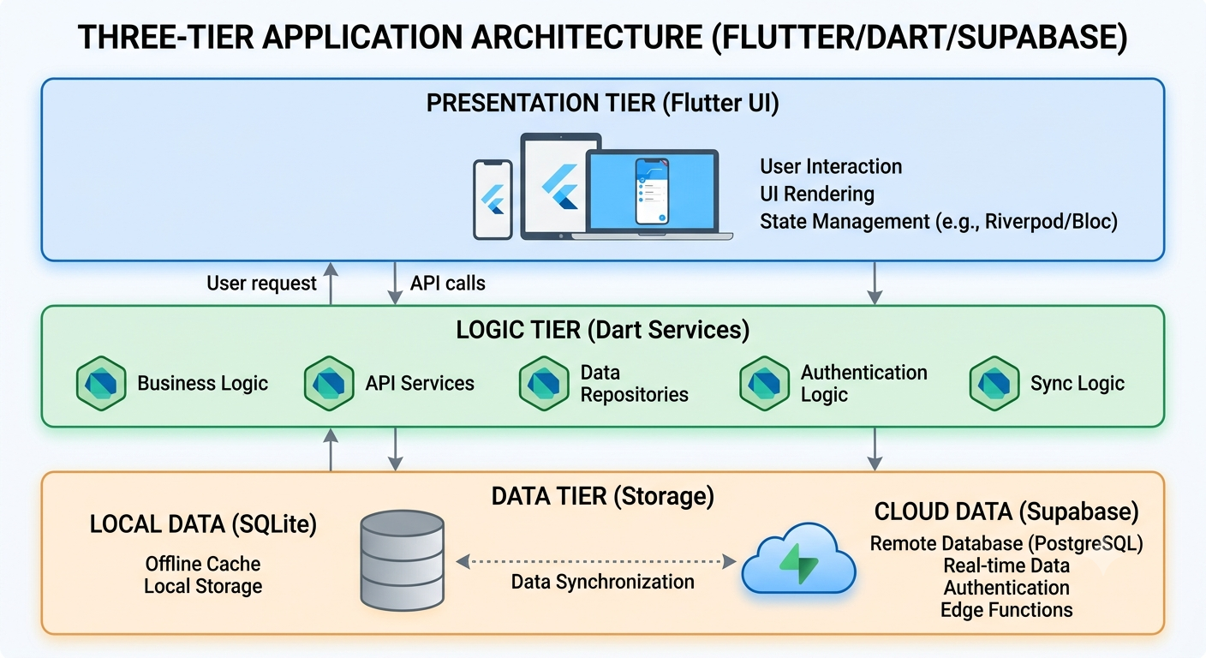
Fig. 3.1. High-level system architecture diagram showing the three tiers (Presentation — Flutter UI, Logic — Dart services, Data — local SQLite + Supabase cloud).

3.2.2 AI Generation Workflow
The AI generation workflow in ClassAI follows a structured pipeline informed by the curriculum-informed AI approach advocated by Imagine Learning [2] and the generative AI alignment framework by Liu et al. [3]:
1. Prompt Construction: The system constructs a detailed prompt using the PromptTemplates class, incorporating subject, curriculum type, class level, week number, topic, difficulty level, and Bloom's Taxonomy verbs specified by the teacher.
2. Injection Detection: The constructed prompt is scanned for prompt injection attempts using SanitizationUtils.findInjections(), which detects SQL injection patterns, system prompt override attempts, and other malicious inputs.
3. Token Management: The prompt is truncated if it exceeds 4,096 tokens using TokenCounter.truncateIfNeeded(), ensuring it fits within the LLM's context window while preserving essential curriculum metadata.
4. Primary Generation: The system sends the sanitised prompt to the DeepSeek API. If successful, the response is parsed and returned.
5. Automatic Failover: If DeepSeek API returns an error (network failure, rate limiting, service outage), the system automatically retries the request using the Gemini API, ensuring continuous service availability.
6. Response Parsing: The AI response is stripped of markdown wrappers (code fences, introductory/concluding text) and parsed as JSON. The structured output includes learning objectives, key vocabulary, materials, lesson presentation, assessment, and homework sections.
7. Audit Logging: Each generation event is logged with teacher ID, school ID, topic, and timestamp for accountability and usage tracking.

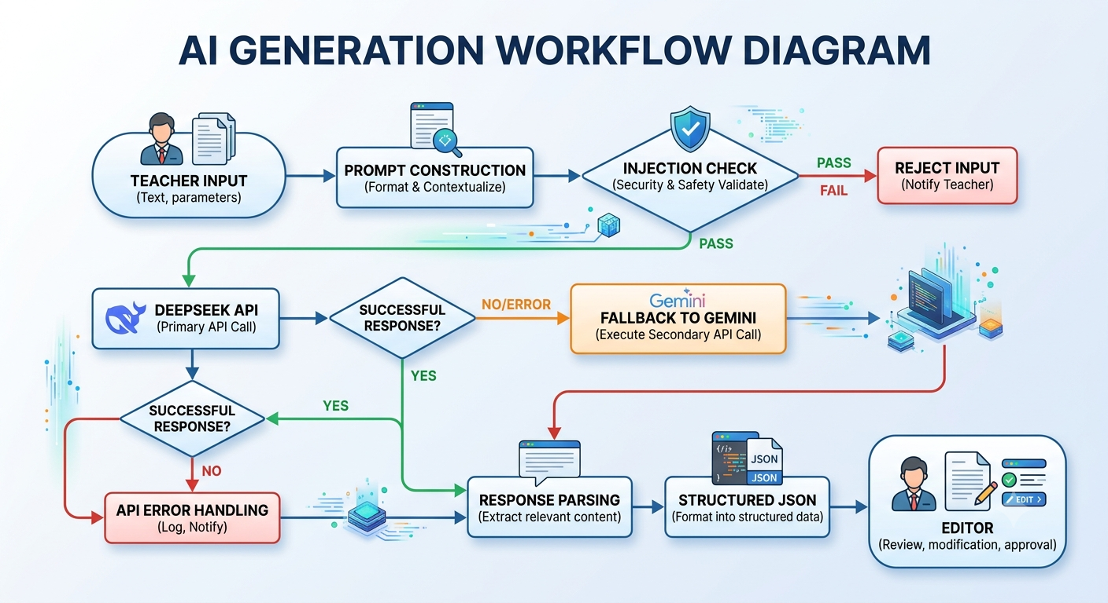
Fig. 3.2. AI generation workflow diagram (Teacher Input → Prompt Construction → Injection Check → DeepSeek API → [fallback to Gemini] → Response Parsing → Structured JSON → Editor).

3.2.3 Offline-First Synchronisation Pipeline
ClassAI's synchronisation pipeline implements a robust offline-first strategy designed for the intermittent connectivity typical of Nigerian schools. The SyncService manages the full sync lifecycle through a state machine with the following states: idle, acquiringSession, biometricPrompt, sessionKeyDecrypt, pulling, merging, savingConflicts, pushing, applyingCredits, emergencySave, forcedLogout, updatingMetadata, replayingRealtime, and backoff.
The sync system implements exponential backoff for retries (starting at 5 seconds, doubling up to 5 retries), payload compression for transfers exceeding 50 KB, and batch-size reduction (from 10 to 5 records per batch) optimised for 2G/3G network conditions. The MergeEngine supports three-way merging (local, remote, base) with configurable field-level strategies including Last-Writer-Wins (LWW), union, keep local, keep remote, and manual resolution.
3.2.4 Database Schema
The ClassAI database schema comprises 20 tables designed to support all system functionalities:
lessons — Stores generated lesson notes with encrypted content, subject, class level, week, topic, difficulty, curriculum type, Bloom's Taxonomy verbs, and status (draft/published/archived).
subjects — Defines available subjects per curriculum with 18 NERDC core subjects pre-configured.
teachers — Teacher profiles with authentication data, device registration, and token management.
schools — School information, subscription tier, expiry date, and configuration settings.
terms — Academic term definitions with start/end dates, term names, and school association.
scheme_of_work — Schedule of topics per term with week-by-week planning.
exams — Generated examination questions with MCQ, theory, and subjective question types.
exams_dao, lessons_dao, subjects_dao, teachers_dao, schools_dao, terms_dao, scheme_of_work_dao — Data Access Objects for database operations.
sync_queue — Pending synchronisation entries with retry tracking and conflict resolution.
audit_logs — Security and usage audit trail for accountability.
security_config — Encryption keys, credit balances, daily generation counters.
vault_items — Encrypted sensitive data storage for secure content publishing.
payment_events — Transaction records for Paystack payment tracking.
pdf_cache — Cached PDF generation outputs for performance optimisation.
teacher_devices — Registered device tracking for multi-device sync.
teacher_subjects — Subject assignment mapping for teachers.
conflicts — Unresolved sync conflicts requiring manual resolution.
progress_logs — Teacher progress tracking across curriculum topics.
pending_recovery_requests — Password recovery workflow management.
recovery_codes — One-time recovery codes for account access restoration.
3.2.5 Security Architecture
ClassAI implements a multi-layered security architecture: (1) AES-256-GCM encryption using the cryptography Dart package for lesson content at rest; (2) Argon2id key derivation function with configurable memory (32,768 KB), iterations (3), and parallelism (2) parameters; (3) Flutter Secure Storage for protecting sensitive tokens; (4) biometric authentication via local_auth for accessing encrypted content; (5) session management with token refresh and token_version_mismatch detection for identifying logins on other devices; and (6) Sentry integration for error monitoring and crash reporting.
3.3 Implementation Details
3.3.1 Development Environment
The system was developed using the Flutter SDK (version 3.4.0) with Dart programming language. The minimum target SDK for Android is API 21 (Android 5.0), and the minimum iOS deployment target is iOS 12.0. Build automation was managed through Gradle (Android) and CocoaPods (iOS). The project also includes web and desktop (Linux, macOS, Windows) platform support through Flutter's multi-platform compilation.
3.3.2 Key Dependencies
The following key dependencies were used in the project implementation:
Package | Version | Purpose
flutter_riverpod | 3.3.1 | State management
go_router | 17.2.3 | Declarative routing
drift | 2.31.0 | SQLite ORM for local database
supabase_flutter | 2.12.4 | Supabase cloud backend client
cryptography | 2.9.0 | AES-256-GCM encryption
flutter_secure_storage | 10.2.0 | Secure token storage
local_auth | 3.0.1 | Biometric authentication
sentry_flutter | 8.14.2 | Error monitoring and crash reporting
app_links | 6.3.2 | Deep link support
paystack_client | latest | Payment processing
pdf | latest | PDF generation
csv | latest | CSV export
3.3.3 Project Structure
The ClassAI project follows a feature-first directory structure under the lib/ directory:
core/ — Shared code including constants, database (tables, DAOs), services, providers, theme, utilities, and widgets.
features/ — Feature-specific code organised by domain: admin, auth, credit, dashboard, exam, lesson, payment, scheme_of_work, settings, and vault.
router/ — Application routing configuration using go_router with authentication guards.
test/ — Unit and widget tests covering AI services, authentication, sync, encryption, credits, UI components, and database operations (30+ test files).
3.4 Technology Stack
The technology stack for ClassAI was selected based on requirements for cross-platform deployment, offline capability, security, and AI integration.
Tier | Technology | Purpose
Presentation | Flutter 3.4.0 + Dart | Cross-platform UI framework
State Management | Riverpod 3.3.1 | Application state management
Local Database | SQLite via Drift ORM 2.31.0 | Offline data storage
Cloud Backend | Supabase (PostgreSQL) | Cloud sync, auth, real-time
AI Provider 1 | DeepSeek API | Primary LLM for content generation
AI Provider 2 | Gemini API | Fallback LLM for content generation
Encryption | AES-256-GCM + Argon2id | Data-at-rest encryption
Payments | Paystack API | Subscription payment processing
Error Monitoring | Sentry | Crash reporting and diagnostics
Routing | go_router | Declarative navigation with deep links

CHAPTER 4
SYSTEM DEVELOPMENT AND RESULTS
4.1 System Implementation Results
4.1.1 Functional Modules Implementation
The ClassAI system has been successfully implemented with all planned functional modules operational. The application compiles and runs on Android, iOS, Web, and desktop platforms (Linux, macOS, Windows) with a single Dart codebase, demonstrating the effectiveness of Flutter's cross-platform capabilities. The following subsections present the implementation status of each major module.
Authentication Module: The auth system supports email/password registration and login with Supabase authentication, email verification, password reset with recovery codes, email OTP verification (via Gmail SMTP), biometric authentication integration, and session management with token refresh. The module also implements login on other device detection (token_version_mismatch) and automatic logout on security violations. The implementation is located in auth_service.dart covering login, signup, password recovery, email verification, and admin recovery workflows.
Lesson Generation Module: The AI-powered lesson generation system successfully generates structured lesson notes through the curriculum-informed prompt pipeline. The PromptTemplates class constructs prompts incorporating subject, curriculum type, class level, week number, topic, difficulty, and Bloom's Taxonomy verbs. The AiService class manages the full generation lifecycle including injection detection, token truncation, DeepSeek primary call, Gemini fallback, markdown stripping, and JSON parsing. The system supports all three supported curricula (NERDC, Cambridge, CCSS) with appropriate prompt customisation.
Academic Calendar Engine: The AcademicCalendarService implements NERDC trimester-aware week numbering. The system recognises the standard Nigerian academic calendar: First Term (September-December), Second Term (January-April), and Third Term (May-July). Week numbering resets at the start of each term (Week 1). The service also calculates academic years using the September-August cycle typical of Nigerian schools.
Offline Credit System: The credit system implements the specified offline credit allocation per subscription tier: Free (3 credits), Basic (5 credits), Standard (10 credits), and Elite (20 credits). Credit deduction follows the "batch-write-before-network" pattern where the batch ID is written to SQLite before any network call, ensuring atomicity and preventing double-spending. The CreditService handles credit spending, offline deduction, and sync queue management.
Data Export Module: The ExportService supports export of lesson data in CSV format with columns: Title, Week, Topic, Objectives, Materials, Assessment, and Created. The PdfService handles PDF generation with caching, watermarking for free-tier users, and low-storage protection that blocks generation when storage falls below 100 MB critical threshold.
Payment Integration: The PaymentService integrates with the Paystack API for subscription management. It supports payment initialisation with checkout URL generation, payment confirmation via webhook or polling, activation code generation, and subscription tier management. The pricing structure supports four tiers with annual billing in Nigerian Naira: Basic (NGN 49,999/year), Standard (NGN 99,999/year), and Elite (NGN 249,999/year).
Database and Synchronisation: The SyncService implements the comprehensive offline-first synchronisation engine. It manages session acquisition, biometric authentication for key decryption, data pulling and pushing, three-way merging via MergeEngine, and conflict storage for manual resolution. The system supports payload compression, batch size optimisation for 2G/3G networks, and exponential backoff for retry management.
4.1.2 System Configuration and Requirements
Component | Minimum Requirement | Recommended
Operating System | Android 5.0 (API 21) / iOS 12.0 | Android 8.0+ / iOS 14.0+
RAM | 2 GB | 4 GB or more
Storage | 100 MB free space | 500 MB free space
Internet | Periodic (for sync only) | Broadband/4G for real-time sync
Processor | ARM Cortex-A53 or equivalent | ARM Cortex-A73 or better
Display | 5-inch screen | 7-inch tablet or larger
4.2 Feature Mapping to Research Literature
Table 4.1 below summarises how specific features implemented in ClassAI map to findings and recommendations from the ten research papers reviewed in Chapter 2.
TABLE 4.1
Feature mapping of ClassAI system features to research literature.
ClassAI Feature | Informed by (Paper/Reference)
Curriculum-aware prompt templates embedding subject, curriculum type, class, week, topic, difficulty, and Bloom's Taxonomy | [2]
Structured JSON output schema with objectives, vocabulary, materials, presentation, assessment, homework | [3]
NERDC trimester-aware academic calendar and scheme of work generation | [4]
Interactive lesson editor requiring active teacher parameter input and content review | [5]
Six-step lesson generation pipeline: objectives, parameters, generate, review, assess, finalise | [6]
AES-256-GCM encryption, Argon2id key derivation, secure local storage | [7]
Content validation, markdown stripping, audit logging for quality assurance | [8]
Teacher-controlled generation parameters, editable output, audit transparency | [9]
Human-AI collaboration design: AI as assistant/augmenter, teacher as final decision-maker | [10]
Structured lesson format with parameter specification interface, CSV/PDF export | [11]
Multi-curriculum support (NERDC, Cambridge, CCSS) with version tracking | General design principle from system reliability and connectivity requirements
Offline-first architecture with local SQLite, credit system, conflict-free sync | General design principle from Nigerian educational context requirements
4.3 Discussion of Findings
4.3.1 Curriculum-Aware Content Generation
The implementation of curriculum-aware prompt templates in ClassAI demonstrates how findings from the Imagine Learning white paper [2] can be operationalised in a practical system. By embedding curriculum metadata — including subject, class level, curriculum type, week number, topic, difficulty, and Bloom's Taxonomy verbs — directly into the LLM prompt, the system guides the AI to generate content that is explicitly aligned with curriculum specifications. This approach aligns with Liu et al.'s [3] findings that structured prompts significantly improve the relevance and accuracy of AI-generated educational content.
4.3.2 Human-AI Collaboration in Practice
The Human-AI Collaboration Framework proposed by Chan, Kim et al. [10] provides a useful lens for understanding ClassAI's design philosophy. The system operates primarily in the "AI as assistant" mode — handling the routine, time-intensive task of generating structured, curriculum-aligned lesson content from teacher-provided parameters. This frees teachers to focus on higher-value activities such as content customisation, contextualisation, and instructional delivery. The system also functions in "AI as augmenter" mode by suggesting Bloom's Taxonomy-aligned cognitive levels, vocabulary lists, and assessment strategies.
The preservice teachers study [5] warning about over-reliance on AI-generated content informed the design of ClassAI's interactive workflow. The system requires active teacher input at every stage — from parameter specification to content review and customisation — rather than offering a one-click "generate and accept" flow. This design choice encourages the critical engagement with AI-generated content that the study recommends.
4.3.3 Structured Content Generation
The structured JSON output schema implemented in ClassAI — with explicit sections for learning objectives, key vocabulary, materials, lesson presentation, assessment, and homework — addresses the teacher preference for well-structured AI output identified by Del Valle [11]. The schema ensures completeness (all essential lesson components are included) and consistency (all generated lessons follow the same structure, facilitating comparison and quality assurance). This structured approach also enables the system to validate generated content, identify missing sections, and provide meaningful feedback to teachers.
4.3.4 Security and Privacy Considerations
The security architecture of ClassAI addresses the data protection concerns raised by Mahafdah et al. [7]. The use of AES-256-GCM encryption ensures that lesson content is protected at rest, while Argon2id key derivation provides robust protection against brute-force attacks on teacher passwords. The integration of biometric authentication adds an additional layer of security for sensitive operations. These measures are particularly important given the sensitive nature of educational data and the requirements of the Nigeria Data Protection Regulation (NDPR) 2019 [16].
4.3.5 Offline-First Architecture for the Nigerian Context
The offline-first architecture of ClassAI addresses a critical requirement for educational technology deployment in Nigeria — the ability to function without reliable internet connectivity. The local SQLite database (via Drift ORM) stores all application data, including generated lesson notes, user accounts, and configuration settings. The credit system allows teachers to generate content offline using pre-allocated credits that are synchronised when connectivity is restored. The sync service manages data synchronisation in the background, handling conflicts through three-way merging and providing visual feedback through the sync indicator widget.

CHAPTER 5
SUMMARY, RECOMMENDATION AND CONCLUSION
5.1 Summary of the Study
This project set out to design and develop ClassAI, an AI-powered, curriculum-aware lesson notes generator for Nigerian secondary schools. The work was motivated by the identified gap in standardised, high-quality lesson note preparation facing Nigerian teachers, compounded by large class sizes, limited resources, insufficient planning time, technological constraints, and the absence of localised AI-powered educational tools tailored to the NERDC curriculum.
The project employed a Design Science Research methodology, resulting in the development of a fully functional cross-platform mobile application built with Flutter and Dart. The system architecture integrates a local SQLite database (via Drift ORM) for offline operation, a Supabase cloud backend for synchronisation and authentication, and a dual-provider AI engine (DeepSeek with Gemini fallback) for content generation. The system supports three curricula (NERDC, Cambridge, CCSS), 18 core Nigerian secondary school subjects, Bloom's Taxonomy-aligned cognitive level targeting, and a secure offline-first credit system integrated with Paystack payment processing.
A comprehensive review of ten recent research papers on AI in education was conducted, covering curriculum-informed AI, generative AI-powered educational alignment, AI in curriculum development, AI-assisted lesson generation, human-AI collaboration in education, and personalised learning. Findings from these papers directly informed the design and feature set of ClassAI, ensuring that the system is grounded in current research while addressing the practical requirements of the Nigerian educational context.
5.2 Conclusion
This project has demonstrated that AI-powered, curriculum-aware lesson notes generation is both feasible and implementable for the Nigerian secondary education context. The ClassAI system successfully addresses the key challenges of lesson note preparation by leveraging large language models to generate structured, curriculum-aligned content. The system's architecture — incorporating offline-first capabilities, multi-curriculum support, robust security, and a dual-provider AI failover mechanism — provides a practical template for AI-powered educational tools deployed in developing country contexts.
The project makes several important contributions. First, it demonstrates how findings from contemporary AI education research can be synthesised and implemented in a practical application. Second, it presents a viable architecture for offline-first AI-powered educational tools in low-connectivity environments, addressing a critical barrier to educational technology adoption in developing countries. Third, it provides a practical integration of local payment systems (Paystack) with AI content generation, enabling a sustainable deployment model.
The findings affirm that AI in education should be positioned as a teacher-assistance tool that augments rather than replaces teacher expertise. The most effective deployment model is one where AI handles the routine aspects of content generation — structure, curriculum alignment, and baseline quality — while teachers apply their professional judgment in customising, contextualising, and delivering the content to their specific students.
5.3 Contributions to Knowledge
This project makes the following contributions to knowledge:
1. Development of a curriculum-aware prompt engineering framework that integrates NERDC curriculum specifications with Bloom's Taxonomy cognitive levels for AI-powered lesson note generation.
2. Design and implementation of an offline-first AI content generation architecture specifically optimised for low-connectivity environments in developing countries, including a dual-provider AI failover mechanism, local credit management, and conflict-free data synchronisation.
3. A systematic synthesis of ten recent AI education research papers, mapping their findings to implementable system features — providing a model for research-driven educational technology development.
4. A replicable system architecture for integrating local payment gateways (Paystack) with AI-powered educational tools, including offline credit management and subscription-based access control.
5. Comprehensive documentation of the technological, pedagogical, and contextual considerations for deploying AI-powered educational tools in Nigerian secondary schools, providing guidance for developers, educators, and policymakers.
5.4 Recommendations
5.4.1 Recommendations for Teachers
Adopt ClassAI as a lesson planning assistant to reduce preparation time while maintaining content quality and curriculum alignment.
Regularly review and customise AI-generated content to reflect local contexts, student abilities, and available teaching resources.
Use the Bloom's Taxonomy targeting feature to design lessons that address multiple cognitive levels and promote higher-order thinking skills.
5.4.2 Recommendations for School Administrators
Deploy ClassAI across subject departments to standardise lesson note quality and facilitate instructional supervision.
Provide training sessions for teachers on effective use of AI-assisted lesson planning tools.
Invest in offline-capable devices (tablets, laptops) for teachers to maximise the benefits of the system's offline capabilities.
5.4.3 Recommendations for Developers
Expand the system to support additional Nigerian languages and local content formats.
Implement fine-tuned language models specifically trained on NERDC curriculum data for improved generation accuracy.
Develop analytics dashboards for school administrators to monitor content generation patterns and quality metrics.
Conduct empirical evaluation studies with teachers and students to validate system effectiveness in real classroom settings.
5.5 Suggestions for Future Research
Future research directions emerging from this project include:
Empirical Evaluation: Conduct controlled studies with teachers and students to assess the impact of AI-generated lesson notes on teaching efficiency, content quality, and student learning outcomes.
Fine-Tuned Models: Investigate the development of fine-tuned language models specifically trained on NERDC curriculum documents and Nigerian educational content for improved generation accuracy.
Multilingual Support: Extend the system to support indigenous Nigerian languages (Hausa, Igbo, Yoruba) for lesson generation in language-intensive subjects.
Adaptive Personalisation: Research adaptive algorithms that dynamically adjust content difficulty based on student performance data and individual learning needs.
Cross-Curriculum Analysis: Compare the effectiveness of AI-generated lesson notes across different curricula (NERDC, Cambridge, CCSS) to identify best practices for each.
Teacher Professional Development: Investigate the potential of AI-powered lesson planning tools as platforms for teacher professional development and pedagogical skill enhancement.

REFERENCES
[1] National Bureau of Statistics, "Annual Abstract of Statistics," Federal Government of Nigeria, 2023. [Online]. Available: https://nigerianstat.gov.ng/

[2] Imagine Learning, "Curriculum-informed AI," White Paper, Apr. 2025. [Online]. Available: https://www.imaginelearning.com/wp-content/uploads/2025/04/1620957897_Curriculum_Informed_AI_White_Paper_DIGITAL.pdf

[3] S. Liu, A. Mendoza, T. Martin, and V. Miori, "Generative AI-powered educational alignment: A framework for matching syllabus course topics with web description," in Proc. ACM Int. Conf. Distance Educ. Learn. (ICDEL), 2024. doi: 10.1145/3675812.3675874.

[4] A. Mohamed Sapawi and N. Nik Yusoff, "Artificial intelligence in curriculum development: A global systematic review of trends, challenges, and strategic directions," J. Curriculum Stud. Res., 2025. [Online]. Available: https://curriculumstudies.org/index.php/CS/article/view/635

[5] L. A. Gold, V. Winn, and J. M. Arnold, "Exploring the impact of generative AI on curriculum design and instruction: A study with preservice teachers," ResearchGate, 2026. [Online]. Available: https://www.researchgate.net/publication/399686182_Exploring_the_Impact_of_Generative_AI_on_Curriculum_Design_and_Instruction_A_Study_With_Preservice_Teachers

[6] N. G. Patil et al., "Artificial Intelligence in Medical Education: A Practical Guide for Educators," Wiley, 2026. [Online]. Available: https://onlinelibrary.wiley.com/doi/10.1002/mef2.70018

[7] K. Mahafdah, M. Bouallegue, and B. Bouallegue, "Enhancing e-learning through AI: advanced techniques for optimizing student performance," PeerJ Comput. Sci., 2024. [Online]. Available: https://pmc.ncbi.nlm.nih.gov/articles/PMC11784796/

[8] X. Liu, "An Evaluation of the Pedagogical Soundness and Usability of AI-Generated Lesson Plans Across Different Models and Prompt Frameworks in High-School Physics," arXiv, 2025. [Online]. Available: https://arxiv.org/pdf/2510.19866

[9] A. F. Martin et al., "Participatory Co-Design and Evaluation of a Novel Approach to Generative AI-Integrated Coursework Assessment in Higher Education," NCBI PMC, 2025. [Online]. Available: https://www.ncbi.nlm.nih.gov/pmc/articles/PMC12189063/

[10] J. Kim et al., "Learning design to advance human-AI collaboration in K-12 education," Old Dominion Univ. Digital Commons, 2025. [Online]. Available: https://digitalcommons.odu.edu/stemps_fac_pubs/419/

[11] J. M. Del Valle, "Use of generative AI in writing lesson plans: The Case of English Pre-Service Teachers," Int. J. Soc. Sci. Humanities Res., vol. 4, no. 7, 2025. doi: 10.58806/ijsshmr.2025.v4i7n02.

[12] J. Piaget, The Psychology of the Child. New York, NY, USA: Basic Books, 1972.

[13] L. S. Vygotsky, Mind in Society: The Development of Higher Psychological Processes. Cambridge, MA, USA: Harvard Univ. Press, 1978.

[14] P. Mishra and M. J. Koehler, "Technological pedagogical content knowledge: A framework for teacher knowledge," Teachers College Record, vol. 108, no. 6, pp. 1017–1054, 2006.

[15] K. Peffers, T. Tuunanen, M. A. Rothenberger, and S. Chatterjee, "A design science research methodology for information systems research," J. Manage. Inf. Syst., vol. 24, no. 3, pp. 45–77, 2007.

[16] Nigeria Data Protection Regulation, 2019. [Online]. Available: https://ndpr.nitda.gov.ng/

[17] Teachers Registration Council of Nigeria, Professional Standards for Nigerian Teache rs, TRCN Publications, 2022.

APPENDICES
Appendix A: System Configuration and Requirements
The ClassAI application requires the following minimum configuration for optimal performance:
Mobile (Android/iOS): Minimum 2 GB RAM, 100 MB free storage, Android 5.0 or iOS 12.0 or later.
Desktop (Windows/macOS/Linux): Minimum 4 GB RAM, 200 MB free storage.
Web: Modern browser (Chrome 90+, Firefox 88+, Safari 14+) with JavaScript enabled.
Internet: Periodic connectivity required for initial account creation, synchronisation, and credit purchases.

Appendix B: Database Table Schema Summary
Table Name | Description | Key Columns
lessons | Generated lesson notes | id, subject_id, class_level, week, topic, content (encrypted), status
subjects | Available subjects per curriculum | id, name, code, curriculum_type, class_level
teachers | Teacher profiles and auth | id, email, name, school_id, token_version
schools | School information | id, name, address, subscription_tier, expiry_date
terms | Academic term definitions | id, school_id, name, start_date, end_date
scheme_of_work | Topic schedules | id, term_id, week_number, topic, objectives
exams | Generated examination questions | id, lesson_id, question_type, content, answer_key
sync_queue | Pending sync entries | id, table_name, record_id, operation, status, retry_count
audit_logs | Event audit trail | id, teacher_id, event_type, details, timestamp
vault_items | Encrypted secure storage | id, teacher_id, encrypted_data, item_type

Appendix C: Feature-to-Research Mapping Reference
The following table provides a quick-reference mapping of ClassAI features to the ten research papers reviewed in Chapter 2, showing how each paper informed specific system capabilities.
Research Paper | Key Finding/Contribution | ClassAI Feature Implemented
[2] Curriculum-Informed AI (Imagine Learning) | AI must be explicitly aware of curriculum standards | Prompt templates with curriculum metadata embedding
[3] Educational Alignment (Liu et al.) | Structured prompts improve alignment accuracy | JSON output schema with pedagogical components
[4] AI in Curriculum Development (Sapawi & Yusoff) | AI should augment, not replace human expertise | Academic calendar and scheme of work engine
[5] Preservice Teachers Study | AI tools should encourage active teacher engagement | Interactive editor requiring parameter input and review
[6] AI-Assisted Lesson Generation (Wiley) | Six-step workflow for AI lesson design | Full generation pipeline with review cycle
[7] Enhancing E-Learning Through AI (Mahafdah et al.) | Data security is critical in AI education systems | AES-256-GCM encryption and secure vault
[8] Impact of AI-Generated Lesson Plans (arxiv) | AI plans match human quality in structure | Content validation and audit logging
[9] Designing AI-Integrated Curriculum (NCBI PMC) | Participatory design with teacher involvement | Teacher-controlled parameters and editable output
[10] Human-AI Collaboration (Chan, Kim et al.) | Three modes: assistant, augmenter, explorer | AI as assistant/augmenter workflow
[11] Use of GenAI in Writing Lesson Plans (Del Valle) | Teachers prefer structured, parameter-driven output | Structured format with CSV/PDF export

Appendix D: User Interface Screenshots
This appendix presents selected screenshots from the latest ClassAI build, covering the dashboard, scheme of work generator, lesson editor, and examination workflows. The figures document the core user-facing modules described in Chapter 4.
Figure D.1: Dashboard Overview in Dark Theme — Shows the main dashboard with navigation, credit counter, sync indicator, and quick-access tiles for lesson generation, exams, and settings.
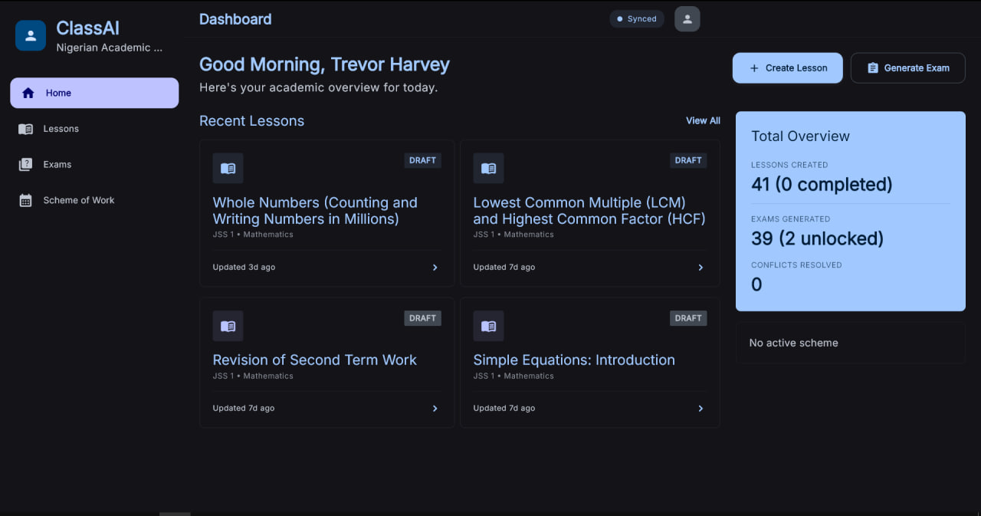
Figure D.2: Scheme of Work Generator — Displays the term selection, week-by-week topic planning interface, and curriculum progress tracking.
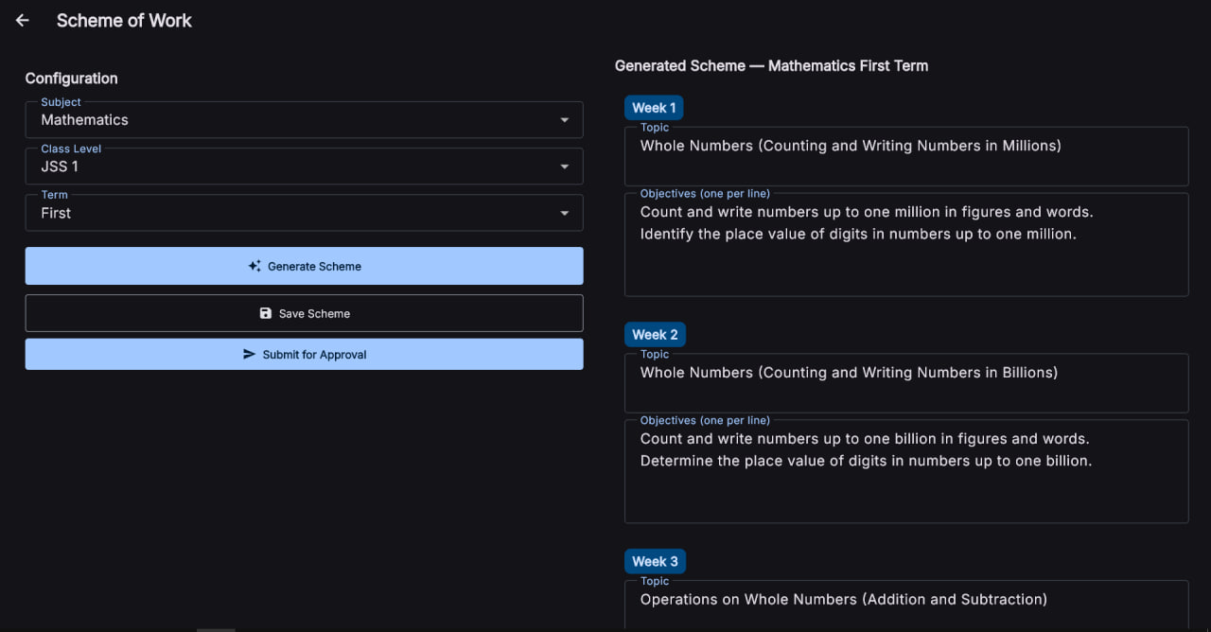

Figure D.3: Lesson Generation and Preview Screen — Shows the parameter input form (subject, topic, difficulty, Bloom's level) and the generated lesson note preview with editable sections.
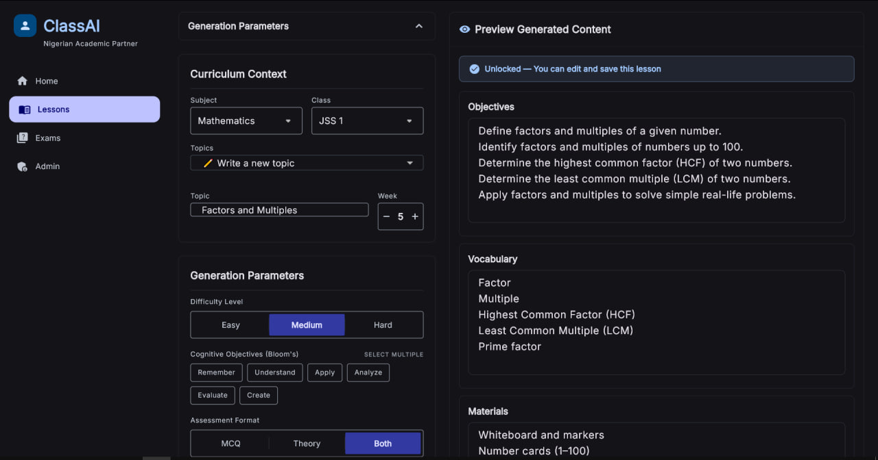
Figure D.4: Dashboard Overview in Light Theme — Same dashboard as Figure D.1 but rendered in the light colour theme for accessibility.
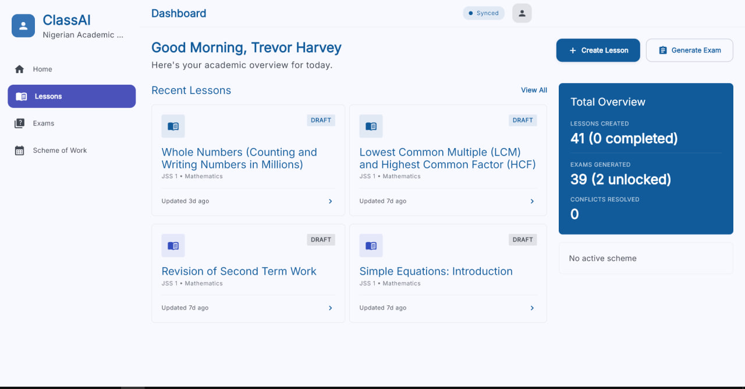

Figure D.5: Exams List and Management Screen — Lists generated examination papers with status indicators and options for editing, exporting, or deleting.
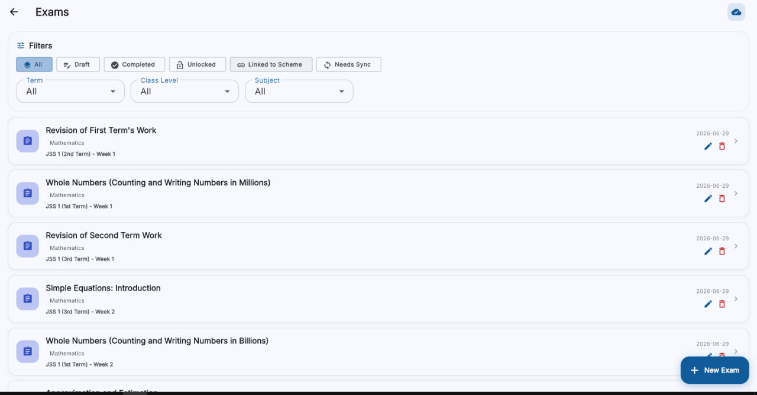
Figure D.6: Exam Editor and Question Generation Panel — Shows the question editor with MCQ, theory, and subjective question generation capabilities.

Appendix E: New Features Summary
The table below summarises the new user-facing features represented in the screenshots above and highlights how each one contributes to the updated system experience.
Feature | Description | Benefit
Dashboard Overview | Central navigation hub with credit counter, sync status, and quick actions | Provides at-a-glance system status and one-tap access to all modules
Scheme of Work Generator | Term-aware week-by-week topic planning aligned with NERDC calendar | Simplifies curriculum planning and ensures term coverage
Lesson Generation & Preview | Parameter-driven AI generation with editable preview | Reduces lesson planning time while maintaining teacher control
Light/Dark Theme Support | Full light and dark colour themes with automatic contrast adjustment | Improves accessibility and user comfort during extended use
Exams List & Management | Centralised exam paper repository with status tracking | Organises assessment materials and streamlines exam management
Exam Editor | Multi-format question generation (MCQ, theory, subjective) | Enables comprehensive assessment creation from a single interface

