COSC2670: Practical Data Science

Assignment 2: YouTube and spam classification modelling

Due midday on Thursday, 18 May 2017

Submitted by:

Max Yendall (3436993)

Table of Contents

1. An abstract/executive summary 1

2. Introduction 1

3. Methodology 1

4. Results 2

5. Discussion 3

6. Conclusion 3

7. References 4

Table of Tables

Table of Figures

# An abstract/executive summary

#

*Guidance: A paragraph-length summary of the key arguments and findings*

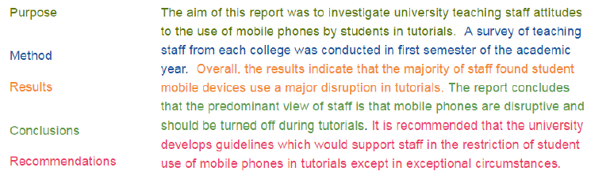

# Introduction

#

*Guidance:*

* *Explanation of the problem*
* *Particularly important since many readers might not be experts in the topic area, or the analytical methods that were applied*
* *Often includes a literature review*
* *Explain what’s already known, as well as gaps in knowledge*

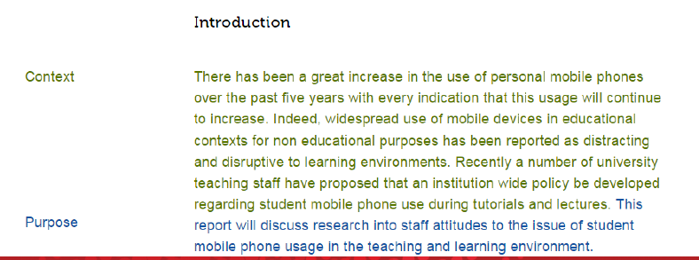

# Methodology

#

*Guidance:*

* *Explanation of the research methods and data sources used*
  + *Data collection process (particularly if new data was gathered)*
  + *Choice of variables used for analysis*
  + *Analytical techniques and models used*

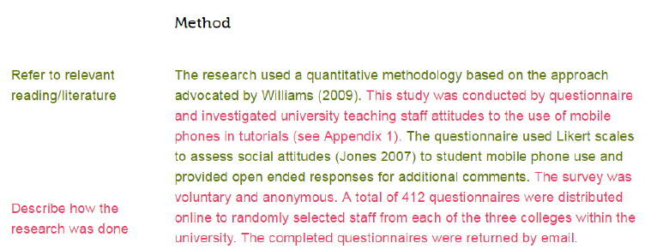

# Results

#

*Guidance:*

* *Present the empirical findings of the analysis*
* *Typically includes*
  + *Descriptive statistics*
  + *Visualisations (graphs, charts, illustrative graphics)*
  + *Analytical / model outcomes*

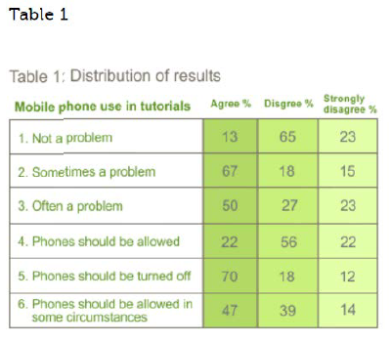

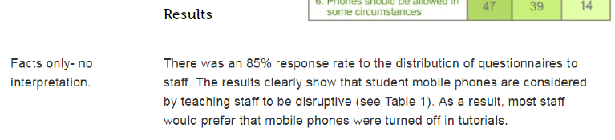

# Discussion

#

*Guidance:*

* *Presentation of main argument*
* *Explains how the results address knowledge gaps and answer the research question*

# Conclusion

#

*Guidance:*

* *Summarise findings*
* *Explain wider applicability of results*
* *Identify possible future developments and applications*
* *New research questions that have opened up*

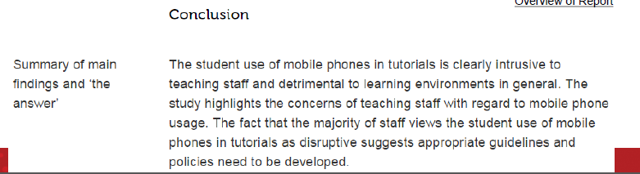

# References

#