Inventory management system :
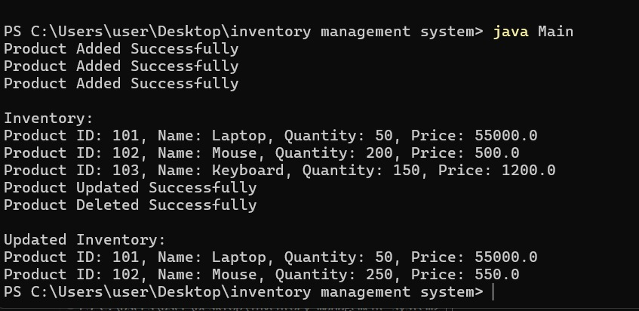

E-commerce Platform Search Function :

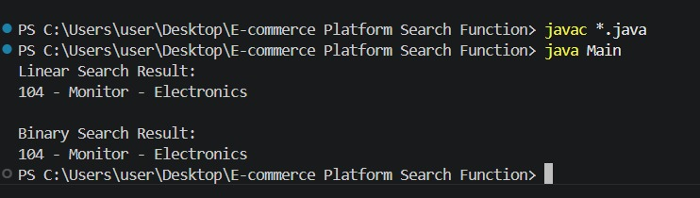

Sorting Customer Orders :
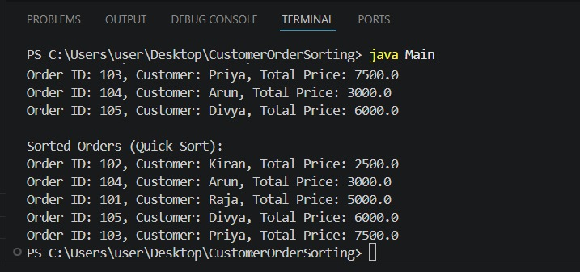

Employee Management System :
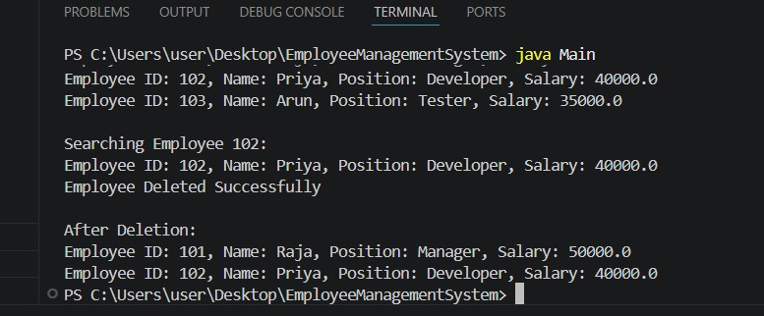

Task Management System :
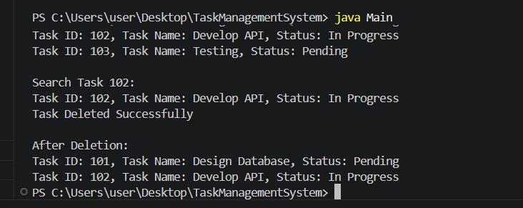

Library Management System :
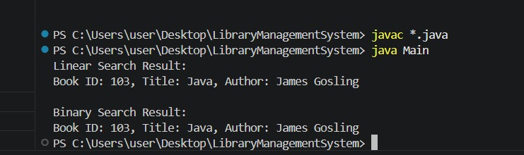
Financial Forecasting :
