Task 14: Microservices System with Two Independent Services (Spring Boot)

Aim
To implement two independent microservices using Java Spring Boot that communicate using REST API.

Introduction
Microservices architecture splits application into small independent services. Each service runs separately and communicates using HTTP REST APIs.

Algorithm
1. Create User Service Spring Boot project.
2. Create Order Service Spring Boot project.
3. Run User Service on port 8081.
4. Run Order Service on port 8082.
5. Order Service calls User Service API.
6. Test using Postman.
7. Verify JSON output.

Program 1: User Service (Port 8081)
@RestController
@RequestMapping("/user")
public class UserController {
@PostMapping("/register")
public Map<String,Object> registerUser(@RequestBody Map<String,String> data){
Map<String,Object> res = new HashMap<>();
res.put("name", data.get("name"));
res.put("message","Registered successfully");
res.put("userId",1);
return res;
}
}

Program 2: Order Service (Port 8082)
@RestController
@RequestMapping("/order")
public class OrderController {
@GetMapping("/{id}")
public Map<String,Object> getOrder(@PathVariable int id){
RestTemplate rt = new RestTemplate();
String url = "http://localhost:8081/user/" + id;
Map user = rt.getForObject(url, Map.class);
Map<String,Object> order = new HashMap<>();
order.put("orderId", id);
order.put("userDetails", user);
return order;
}
}

Output
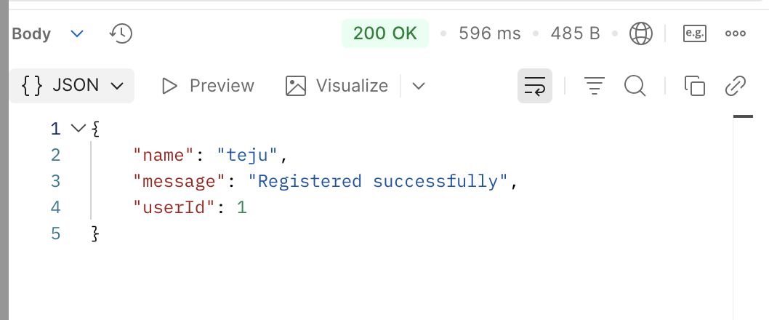

Result
Two independent microservices were created successfully using Spring Boot. Both services communicated using REST API and produced correct JSON output.

