Task 24: Vibe Coding using Generative AI for Cloud-based Feature

AIM
To build a complete cloud-based REST API feature using Generative AI by writing iterative prompts, refining outputs, and improving code quality, scalability, and security.

ALGORITHM
1. Define the problem statement and required cloud-based feature.
2. Write an initial prompt to generate a REST API using Generative AI.
3. Analyze the generated output for correctness and completeness.
4. Refine the prompt to improve API structure and functionality.
5. Generate cloud deployment steps using iterative prompts.
6. Validate deployment configuration for scalability.
7. Generate security configurations (authentication, authorization, etc.).
8. Improve prompts to enhance security and robustness.
9. Test the API locally and on cloud.
10. Document prompt versions and improvements.
11. Compare outputs and evaluate performance.
12. Finalize optimized API and deployment setup.

CODE
Sample REST API using Node.js (Express)
const express = require('express');
const app = express();
app.use(express.json());
app.get('/', (req, res) => {
res.send('API is running');
});
app.post('/data', (req, res) => {
const data = req.body;
res.json({ message: 'Data received', data: data });
});
app.listen(3000, () => {
console.log('Server running on port 3000');
});

PROMPT ENGINEERING

Prompt v1
Generate a simple REST API using Node.js and Express with one GET and one POST endpoint.
Output Analysis: Basic API was generated but lacked structure, validation, and scalability.

Prompt v2
Generate a structured REST API using Node.js and Express with proper routing, middleware, and error handling. Include validation for input data and organize code into modular format.
Output Analysis: Better structured code with middleware and error handling, but still missing cloud deployment and security.

Prompt v3
Generate a production-ready REST API using Node.js and Express with MVC architecture, input validation, JWT authentication, and environment configuration. Also provide steps to deploy on cloud (AWS/Heroku) and include security best practices like HTTPS, rate limiting, and CORS configuration.
Output Analysis: High-quality scalable API with proper architecture, security, and deployment steps.

OUTPUT SCREENSHOT

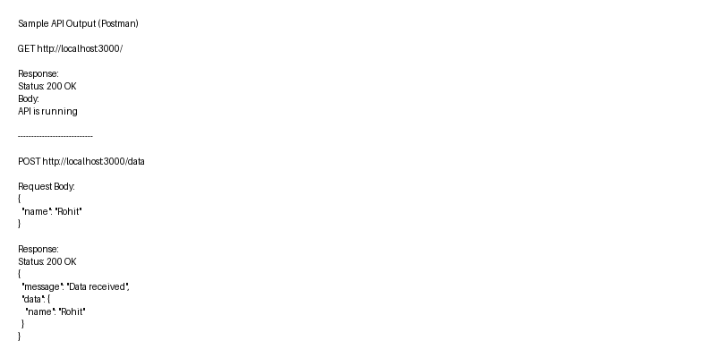

RESULT
Successfully built and deployed a cloud-based REST API using Generative AI. Iterative prompt engineering improved code accuracy, scalability, and real-world usability.

