Aim:
To study and compare cloud services of Amazon Web Services, Google Cloud Platform, and Microsoft Azure and implement basic cloud operations using Eclipse.
Algorithm:
Step 1: Open Eclipse
- Start Eclipse IDE
- Click File → New → Java Project
- Give project name (Example: CloudProject)
Step 2: Prepare Project
- Right-click project → Configure → Convert to Maven Project
- Add required cloud libraries (AWS SDK)
Step 3: Create Cloud Account
- Go to AWS website
- Create free account
- Generate:
  - Access Key
  - Secret Key
Step 4: Setup Connection
- Configure credentials in your system
- Make sure internet is working
Step 5: Work with Storage (S3)
- Create a Java class
- Write code to connect to S3
- Fetch bucket list
- Print bucket names
This shows Storage Service
Step 6: Work with Compute (EC2)
- Create another Java class
- Connect to EC2 service
- Display instance details
This shows Compute Service
Step 7: Work with Database
- Connect to cloud database (RDS)
- Use JDBC connection
- Check if connection is successful
This shows Database Service
Step 8: Study Networking
- Understand VPC (Virtual Private Cloud)
- Learn:
  - Subnets
  - IP address
  - Security groups
No coding needed (theory step)
Step 9: Compare Cloud Providers
Write comparison:
- AWS → EC2, S3, RDS
- Google Cloud → Compute Engine, Cloud Storage
- Azure → Virtual Machines, Blob Storage
Step 10: Understand Pricing
- Learn pay-as-you-use model:
  - Pay only for what you use
  - No fixed cost
Step 11: Run Program
- Run Java programs in Eclipse
- Check output
Step 12: Record Output
- Write outputs
- Draw comparison table
- Write conclusion

Program:
//Storage Service (S3) Code
import software.amazon.awssdk.services.s3.S3Client;
public class S3Example {
public static void main(String[] args) {
// Create S3 Client
S3Client s3 = S3Client.create();
// List all buckets
s3.listBuckets().buckets().forEach(bucket -> {
System.out.println(bucket.name());
});
System.out.println("Process finished successfully");
}
}
//code for Compute Service (EC2) Code
import software.amazon.awssdk.services.ec2.Ec2Client;
public class EC2Example {
public static void main(String[] args) {
// Create EC2 Client
Ec2Client ec2 = Ec2Client.create();
// List instances
ec2.describeInstances().reservations().forEach(res ->
res.instances().forEach(inst ->
System.out.println(inst.instanceId())
)
);
System.out.println("Process finished successfully");
}
}
// Database Connection Code (RDS using JDBC)
import java.sql.Connection;
import java.sql.DriverManager;
public class DatabaseConnection {
public static void main(String[] args) {
try {
// Replace with your DB details
String url = "jdbc:mysql://your-endpoint:3306/mydb";
String user = "username";
String password = "password";
Connection con = DriverManager.getConnection(url, user, password);
if (con != null) {
System.out.println("Database Connected Successfully");
}
} catch (Exception e) {
System.out.println("Connection Failed");
e.printStackTrace();
}
}
}

Output:
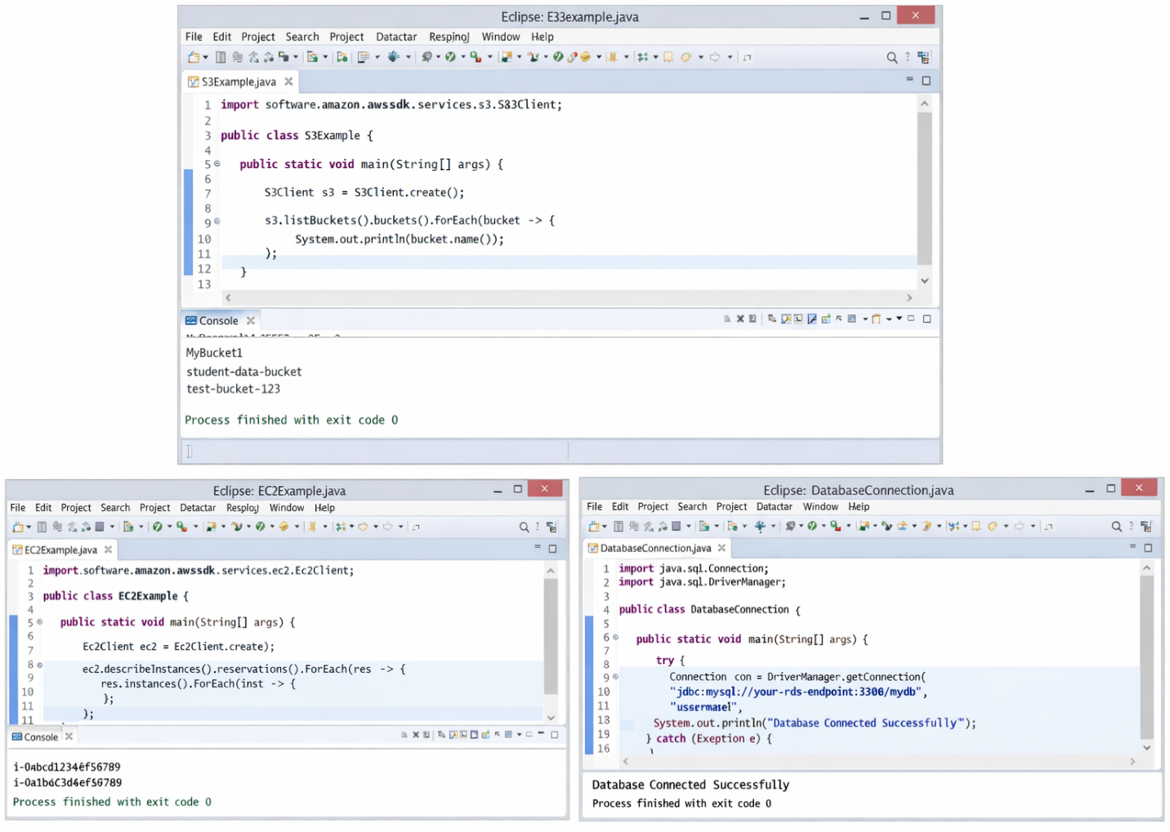

Result: The program was executed successfully in Eclipse and the outputs of cloud services were obtained. The storage service displayed bucket names, the compute service displayed instance IDs, and the database service confirmed successful connection.

