Task 19: Create a Git Repository and Perform Basic Git Operations

Aim:
To create a Git repository and perform basic operations like init, add, commit,version history, and push to GitHub.

Algorithm:
- Install Git.
- Create project folder.
- Open terminal.
- Run git init.
- Create file.6. git add file.
- git commit -m "message".
- Create GitHub repo.
- git remote add origin URL.
- git push -u origin main.
- Modify file and commit again.
- Use git log.

Program:
mkdir SampleProject
cd SampleProject
git init
echo "Hello Git" > index.txt git add index.txt
git commit -m "Initial commit"
git remote add origin https://github.com/your-username/sampleproject.git git push -u origin main echo "Updated" >> index.txt
git add index.txt git commit -m "Updated file" git log

Output:
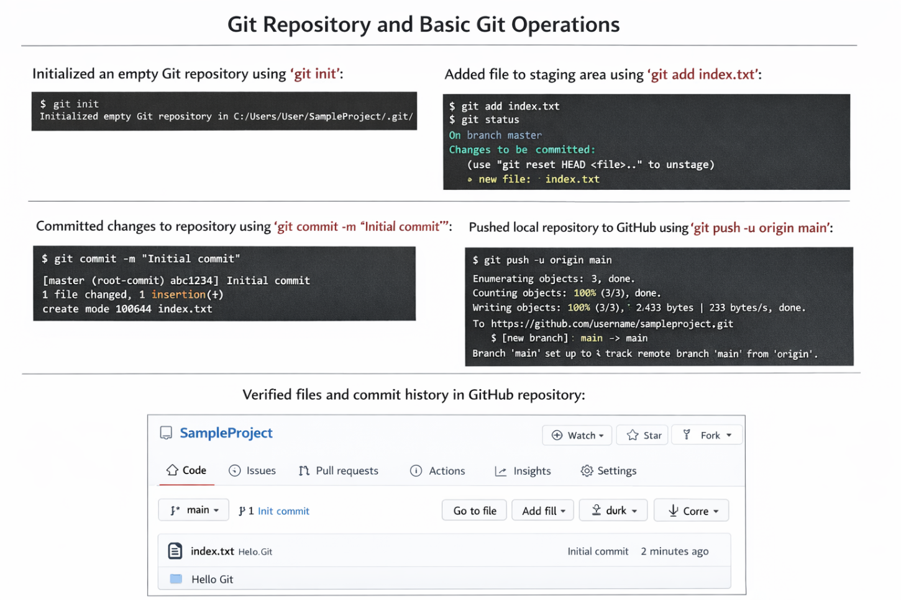

Result: Git repository created and operations like staging, committing, version tracking, and pushing to GitHub were successfully performed.

