Homework-1 CS-149

1. The interrupt request of a device is connected to IR-7 of a slave 8259 and another device interrupt request is at IR-3 of Master 8259 within the PC architecture. Which device has a higher interrupt priority and what is your reason?

**Answer:** The slave has a higher interrupt priority within PC architecture because it has a lower IR registry number. Although 7 is greater than 3, slaves are usually connected to IR2, making the slave’s interrupt take priority.



**Answer:** The purpose of an interrupt is to suspend the current execution that the CPU is working on so that it can compute another task first, then go back to its previous state seamlessly. In addition, interrupts are hardware generated. They generally occur when the device controller informs the CPU that it has completed its task, by contrast, a trap is a software generated interrupt, often caused by errors or user requests. Traps can be generated intentionally. It can be used to prevent arithmetic error and call operating system routines.

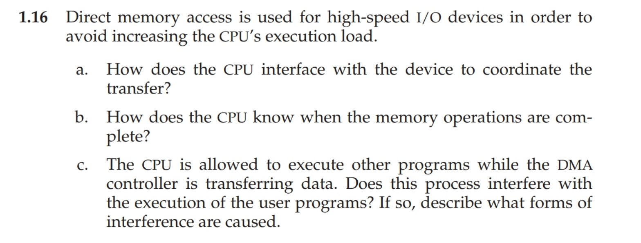

**Answer:**

1. The CPU interfaces with the device by writing values into special registers which can be accessed independently from the device (I/O ports). This initiates direct memory access and allows the device to have direct memory access with the corresponding operations once it has received the command from the CPU
2. The CPU knows when the memory operations are complete when the device sends it an interrupt
3. The memory is accessible to the device and CPU at the same time. This can hinder the CPU's performance as access to the memory bus has to be shared.

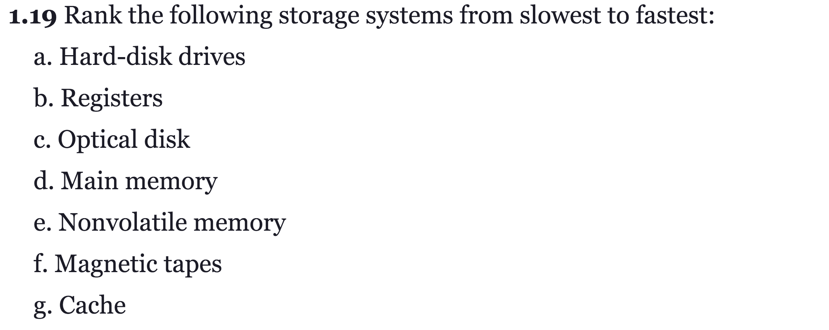

**Answer:**f. Magnetic tapes

c. Optical disk

a. Hard-disk drives

e. Nonvolatile memory

d. Main memory

g. Cache

b. Registers