Hand Gesture with CNN output

To run project double click on ‘run.bat’ file to get below screen

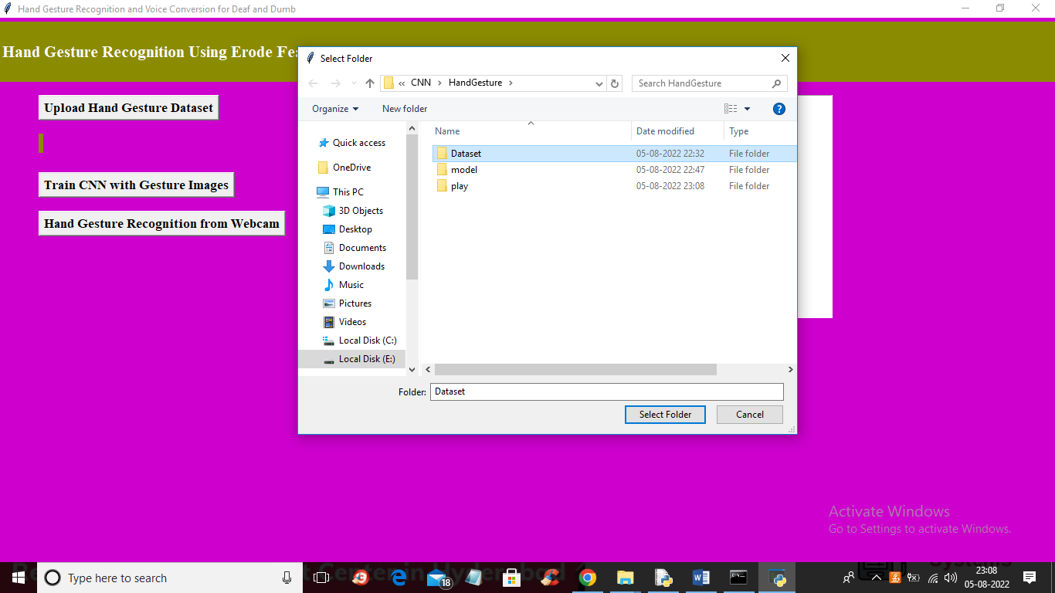

In above screen clicking on ‘Upload Hand Gesture Dataset’ button to upload dataset and then selecting and uploading Dataset folder to get below screen

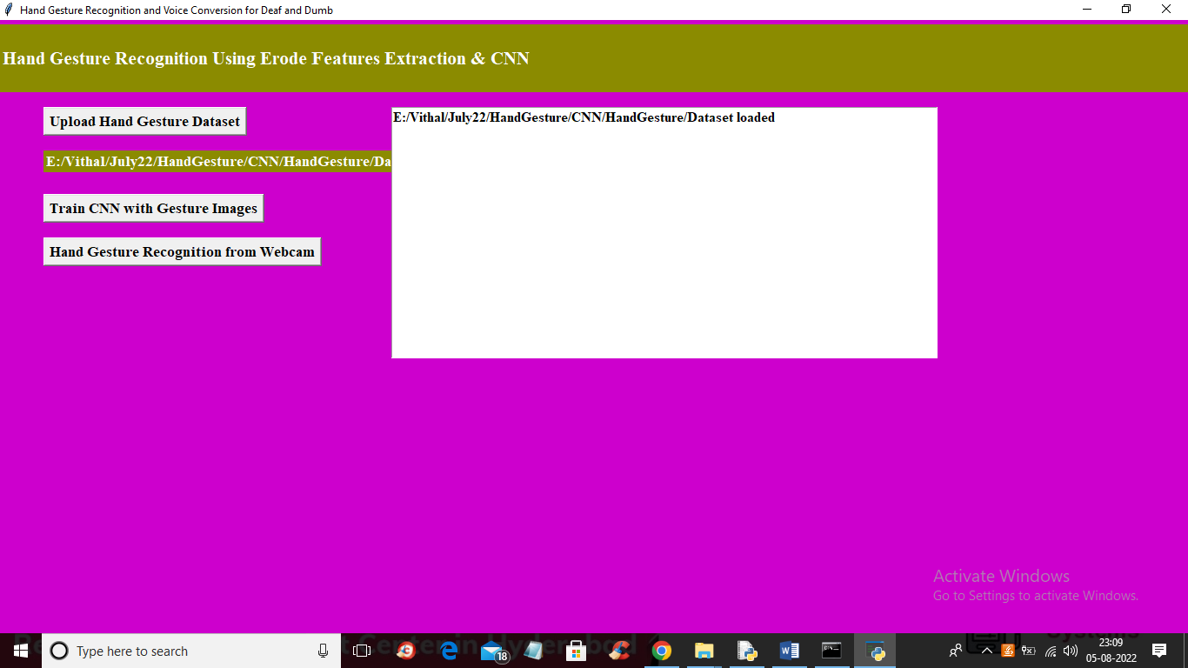

In above screen dataset loaded and now click on ‘Train CNN with Gesture Images’ button to train CNN and get below output

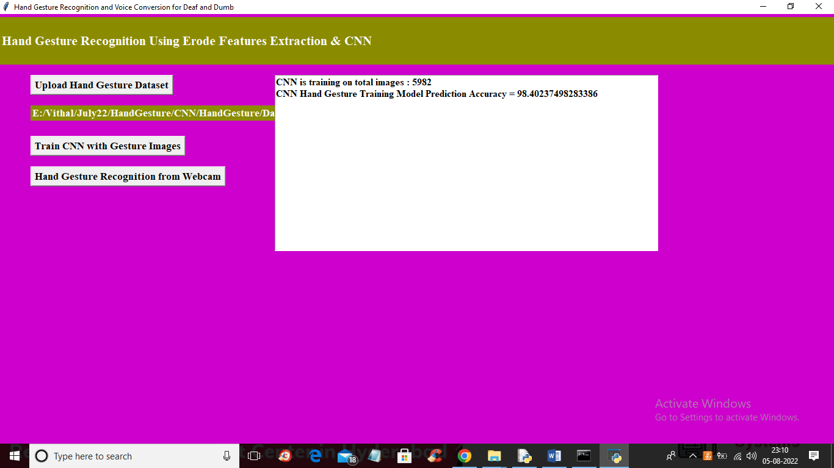

In above screen training is completed and we got CNN accuracy as 98% and now click on ‘Hand Gesture Recognition from webcam’ button to start webcam and get below output

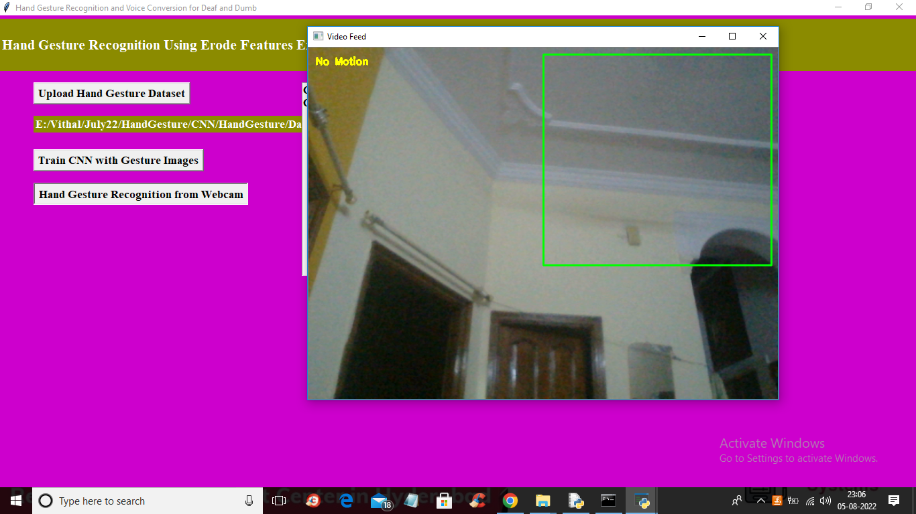

In above screen when no hand gesture visible then will get output as ‘No Motion’.

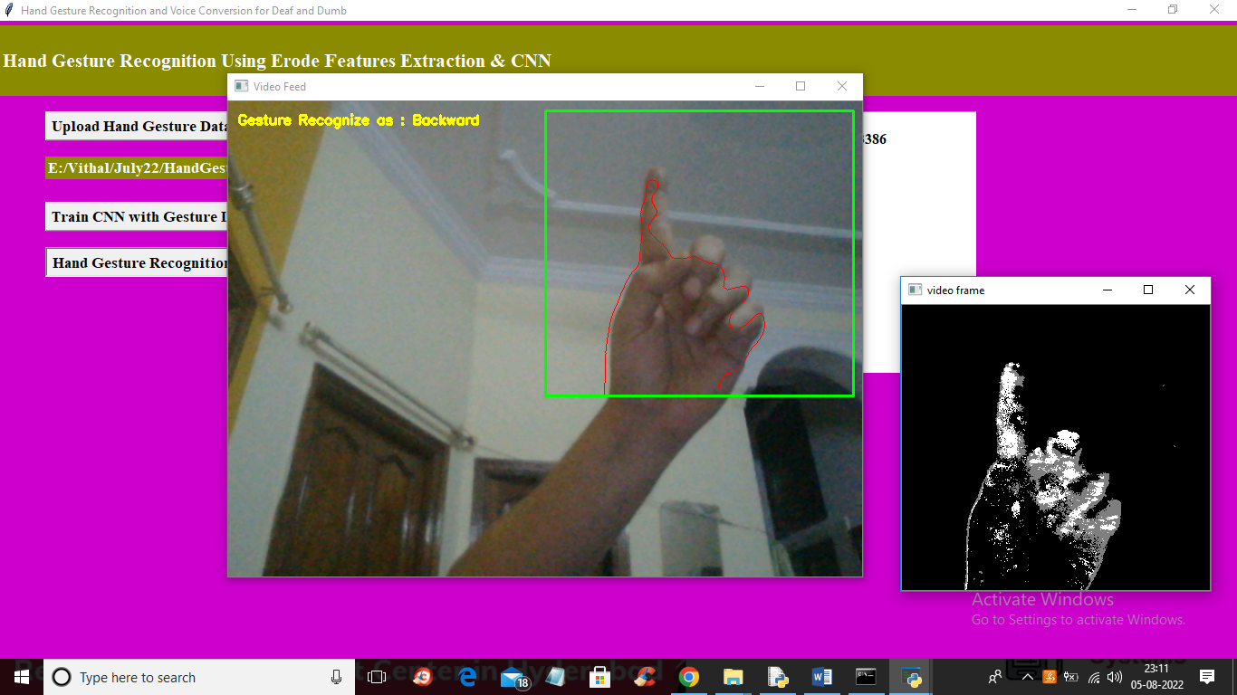

In above screen we got output as Backward for shown gesture and you need to show hand gesture inside green colour rectangle box

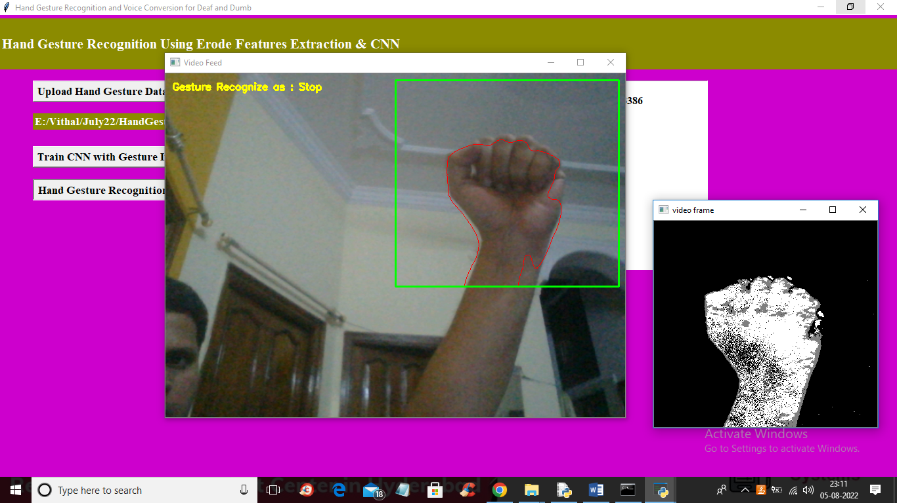

In above screen got output as Stop

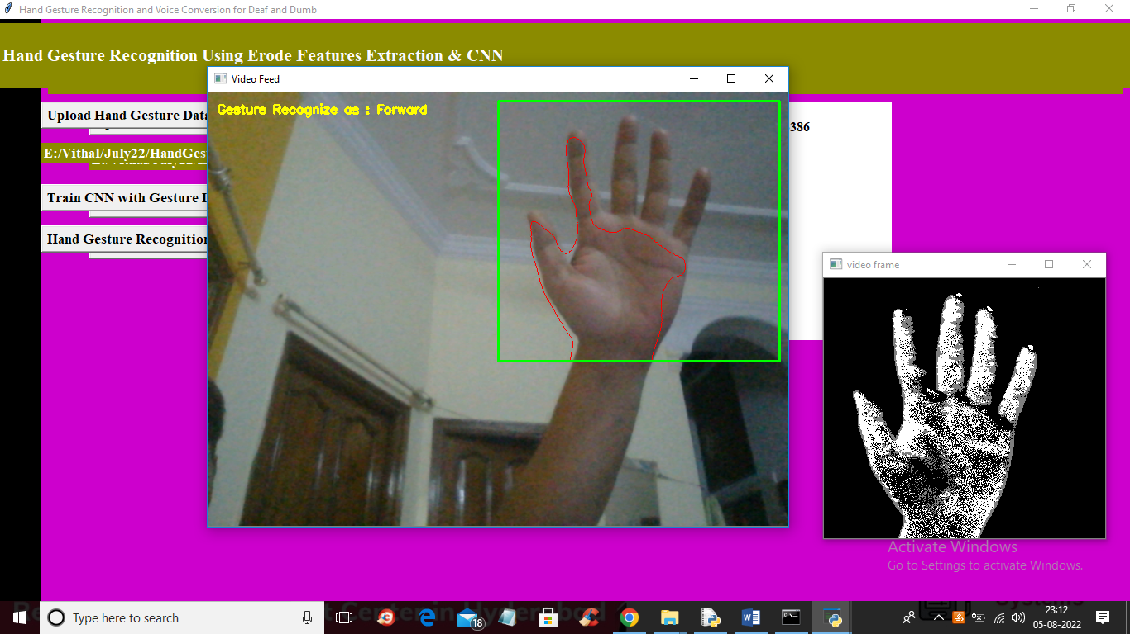

In above screen got output as forward and similarly show other gestures and while showing gestures your hand must be proper gesture type