**SMART SWITCH**

# EE INDEPENDENT PROJECT (EE171)

# **MEMBERS**: 1) Prince Patidar

# 2) Anuj Gupta

# 3)Ankit Arya

# 4) Y Nitin Sree Venkat

# **Project Advisor**: Dr. Arzad Alam Kherani

**INTRODUCTION**

Our project is to create a smart switchboard that will be operated via a mobile application. We will use Bluetooth to communicate with our system. We can connect this switchboard to the home circuit system. This device will convert all your appliances into smart devices right under your fingertips. Such a circuit system can be integrated into the walls’ interiority, providing better safety for everyone.

In our project, we are using Arduino uno, a Relay module, JDY-31 Bluetooth module, Jumper wires Bulb/electrical appliances. We will discuss the working of the project and each of its components.

**WORKING OF COMPOENETS**

* **ARDUINO UNO**

An Arduino is a microcontroller board, which is essentially an entire computer on a chip. It has a processing core, memory, and input and output controls all in one chip. This is the heart of the project. We have programmed and connected it so that it receives the signal via the Bluetooth module and turns on the relay module, which turns on the bulb/appliance.



* **Relay Module**

A relay is an electrical switch that can be used to control devices and systems that use higher voltages. Essentially, relay module works on the mechanism of an electromagnet. We use it as a switch here in our project. When the Arduino sends the signal to the relay module, the electromagnet turns on and connects the secondary circuit.

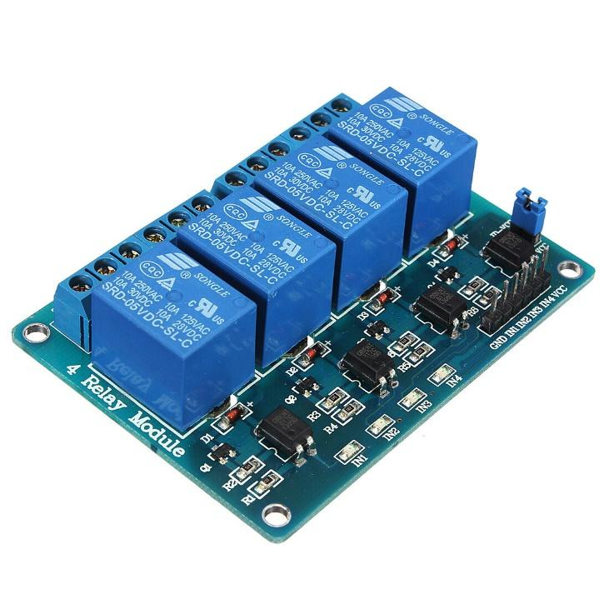

* **Bluetooth Module**

A Bluetooth module is a device that uses radio waves to wirelessly connect two or more electronic devices. Bluetooth modules typically use very little power, making them ideal for portable electronic devices. We are using Bluetooth as our communication medium between mobile and Arduino board.

